Indie Game Development
  - Lecture 5c Lab Tutorial Exercise

Game 2

Objectives
In this exercise, you will create a state machine for your TPC scene.

Creating the Animator Controller
- Open up the third person character game from the previous exercise.
- Note: you will need to complete step 1 of the exercise on moodle first – create an enum to define the character states first.
- In the Assets folder create a new folder called Animator Controllers or Animators or AC or similar.
- Make note of the name of your chosen droid character that you are using.
- Open up the newly created folder and right-click and select Create Animator Controller.
- Give the Animator Controller a name relating to your droid character e.g.
  - AssaultDroidAnimatorController
  - AssaultDroidAC
- Double-click to open up the Animator.
- Select the parameters tab, so that you can add new parameter values and add the following parameters:
  - Speed – float
  - ShootBurst – Boolean
  - CharacterState – integer
  - DeathType - integer
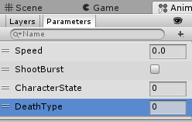
- Now go to the BattleDroids animation folder container the droid assets that you imported and locate the folder for your chosen droid character.
  - Expand the folder
  - Locate the idle animation, expand it and drag the idle animation into the animator controller window.
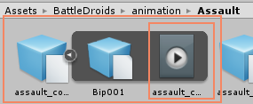
  - You should have a view similar to the following:
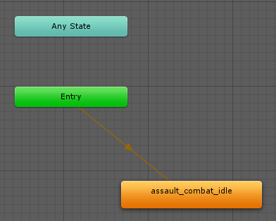
- To make a transition from Idle Walk State
  - Go back to the folder containing the animations for your droid character.
  - Locate the Walk animation
  - Expand it and drag the animation to the animation controller window as before.
  - To create the transition from Idle to Move, right-click on the Idle state and select Make Transition and drag to the Move state and release mouse.
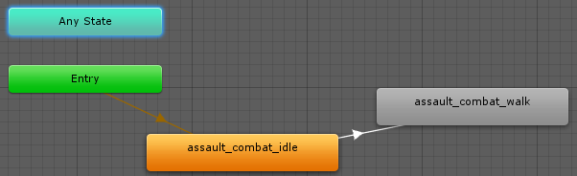
  - Next you need to define the condition under which the transition should happen.
    - Select the transition line and locate the Inspector window.
    - Has Exit Time: uncheck this box as you want the animation state change to happen immediately when the condition is met (otherwise the previous animation will play out before the state change).
    - In the Conditions, you need two conditions:
      - Speed is greater than 0.1f
      - Character State is now Walking (equals 1)
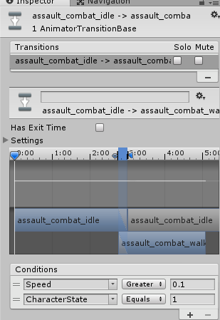
- To view the animation state change, you can drag your droid model to the Preview window at the bottom of the Inspector window.
- Now create a reverse transition from Move Idle
  - Has Exit Time: uncheck again
  - Conditions:
    - Speed is less than 0.1f
    - Character state is back to Idle (equals 0)

- The following screen shot shows you the complete animation state machine I created for the Assault_Droid that I am using. Complete the state machine for your chosen dropid character. Note that it may vary slightly from mine as the animations provided are slightly different for each of the droids. Note: Idle Walking is not shown (and vice versa).
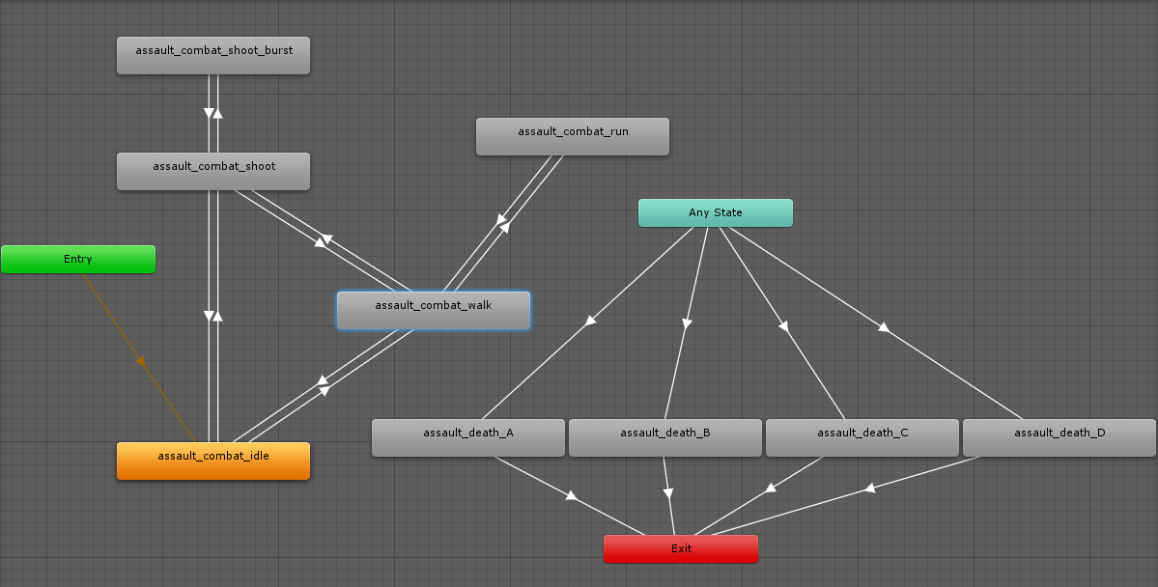
State = Dead
DeathType = 4
State = Dead
DeathType = 3
State = Dead
DeathType = 2
State = Dead
DeathType = 1
State = Walking and Attacking
State = Walking
State = Idle
State = Attacking
ShootBurst = False
ShootBurst = True
Speed > 5.99
State = Running
Speed < 5.99
State = Walking

- Remember to uncheck Has Exit Time if you think the animation should be interrupted immediately. Otherwise, check it. For example, Dead Exit probably requires the Has Exit Time to remain checked.
See more here: State Machine Interruptions
- In the hierarchy window, expand the Third Person character game object and locate your droid character object and select it.
- Go to the Inspector Window and locate the Animator Component attached to it.
  - Change Controller to your new Animator Controller.
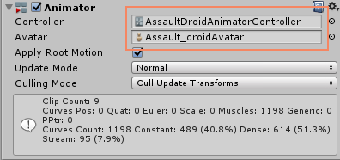
- Important: The Player Character now has two animator controllers attached to it. You need to disable one of them.
  - Click on the root player game object in the hierarchy window. This is the TPC from the Standard Assets.
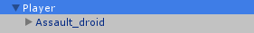
  - Go to the Inspector window and uncheck the Animator component attached to this root game object.
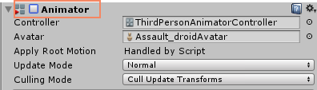
- Go back to Moodle. If you need to tweak your animation, you can return later.

Tweaking your animations:
Some tips to tweak the animations.
- When you click on a transition, you get the timeline of the transition change. You can adjust this to change the start time of the next animation state by dragging the timeline markers.
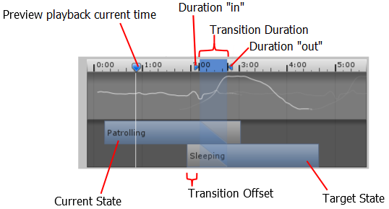
Figure 1: The Transition settings and graph as shown in the inspector (source: https://docs.unity3d.com/Manual/class-Transition.html)
  - Drag the Duration “out” marker to change the Duration of the transition.
  - Drag the Duration “in” marker to change the duration of the transition and the Exit Time.
  - Drag the target transition to adjust the Transition Offset.
  - Drag the preview playback marker to scrub through the animation blend in the preview window at the bottom of the Inspector.
See more: https://docs.unity3d.com/Manual/class-Transition.html
- You may also want to adjust the Speed (how fast or slow an animation state plays). If you select the node of interest, you should see the Speed setting in the Inspector window.
  - 1 is normal playback speed.

