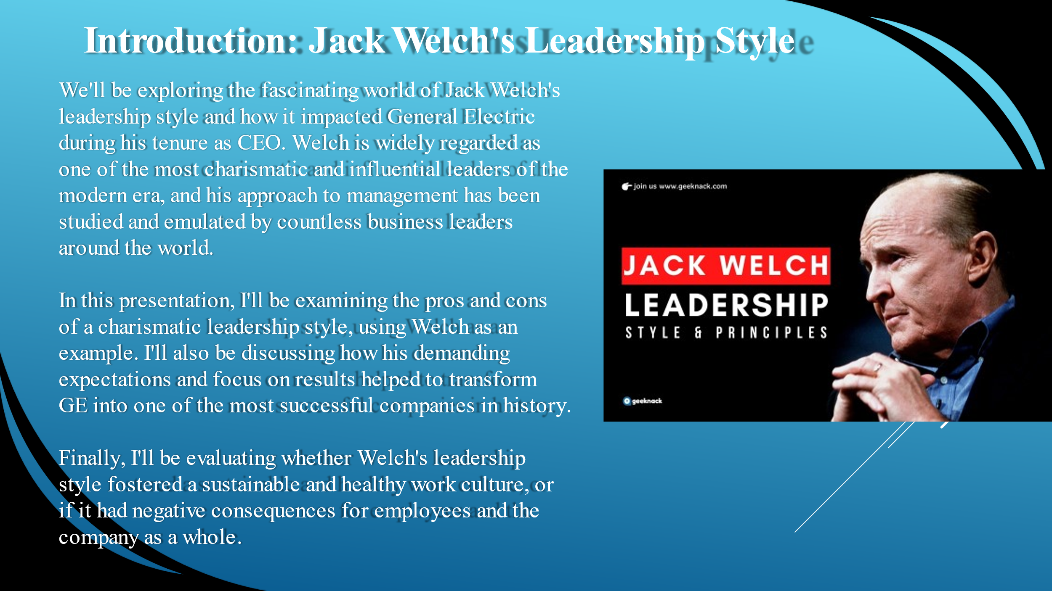
Ladies and gentleman today me and my group we'll be exploring the fascinating world of Jack Welch's leadership style and how it impacted General Electric during his tenure as CEO. Welch is widely regarded as one of the most charismatic and influential leaders of the modern era, and his approach to management has been studied and emulated by countless business leaders around the world.
In the first part of this presentation, I'll be examining the pros and cons of a charismatic leadership style, using Welch as an example. I'll also be discussing how his demanding expectations and focus on results helped to transform GE into one of the most successful companies in history.
Finally, I'll be evaluating whether Welch's leadership style fostered a sustainable and healthy work culture, or if it had negative consequences for employees and the company as a whole.
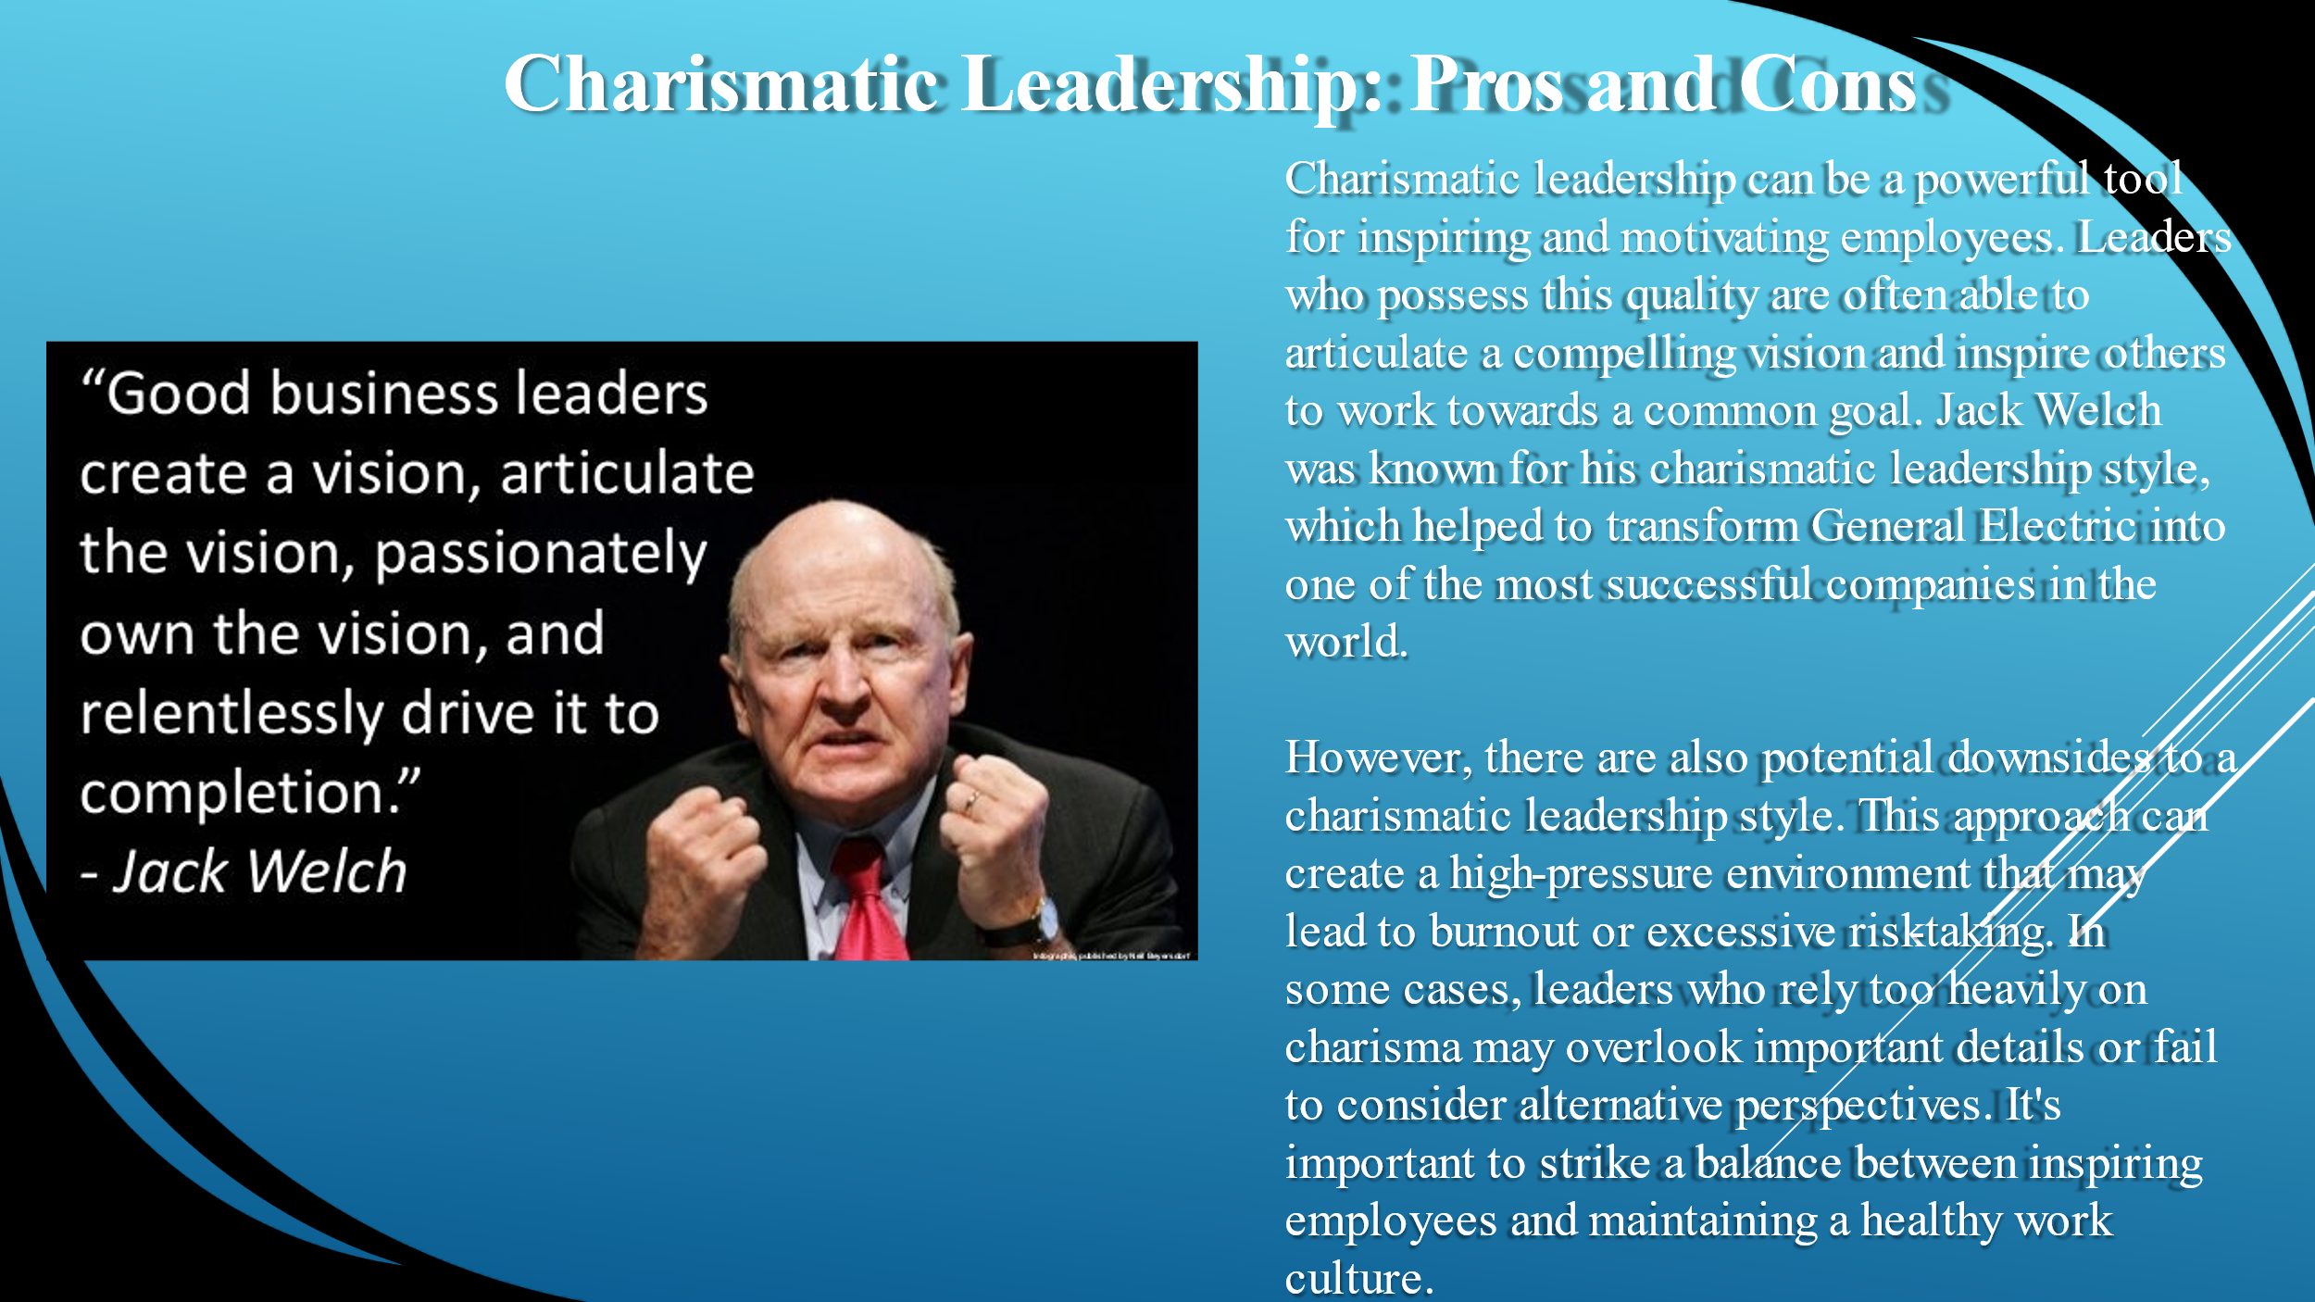
Charismatic leadership can be a powerful tool for inspiring and motivating employees. Leaders who possess this quality are often able to articulate a compelling vision and inspire others to work towards a common goal. Jack Welch was known for his charismatic leadership style, which helped to transform General Electric into one of the most successful companies in the world.
One of the many wise quotes from Jack Welch
“Good business leaders create a vision, passionately own the vision, and relentlessly drive it to completion”
However, there are also potential downsides to a charismatic leadership style. This approach can create a high-pressure environment that may lead to burnout or excessive risk-taking. In some cases, leaders who rely too heavily on charisma may overlook important details or fail to consider alternative perspectives. It's important to strike a balance between inspiring employees and maintaining a healthy work culture. Onto the next slide.
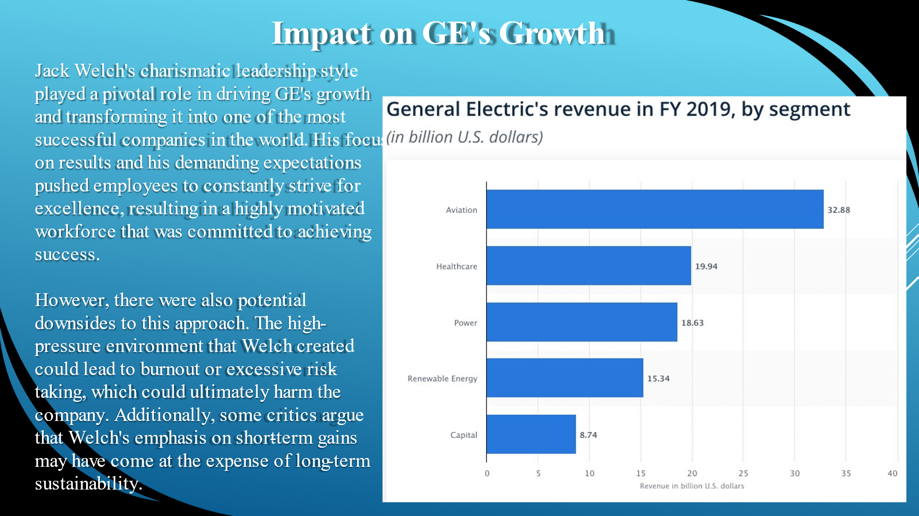
On this slide we can see how Jack Welch's charismatic leadership style played a pivotal role in driving GE's growth and transforming it into one of the most successful companies in the world. His focus on results and his demanding expectations pushed employees to constantly strive for excellence, resulting in a highly motivated workforce that was committed to achieving success.
However, there were also potential downsides to this approach. The high-pressure environment that Welch created could lead to burnout or excessive risk-taking, which could ultimately harm the company. Additionally, some critics argue that Welch's emphasis on short-term gains may have come at the expense of long-term sustainability. Needless to say most of the people didn’t agree with his approach.
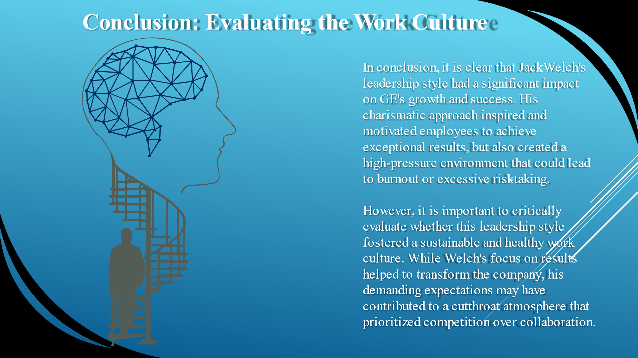
In conclusion, it is clear that Jack Welch's leadership style had a significant impact on GE's growth and success. His charismatic approach inspired and motivated employees to achieve exceptional results, but also created a high-pressure environment that could lead to burnout or excessive risk-taking.
However, it is important to critically evaluate whether this leadership style fostered a sustainable and healthy work culture. While Welch's focus on results helped to transform the company, his demanding expectations may have contributed to a cutthroat atmosphere that prioritized competition over collaboration.

