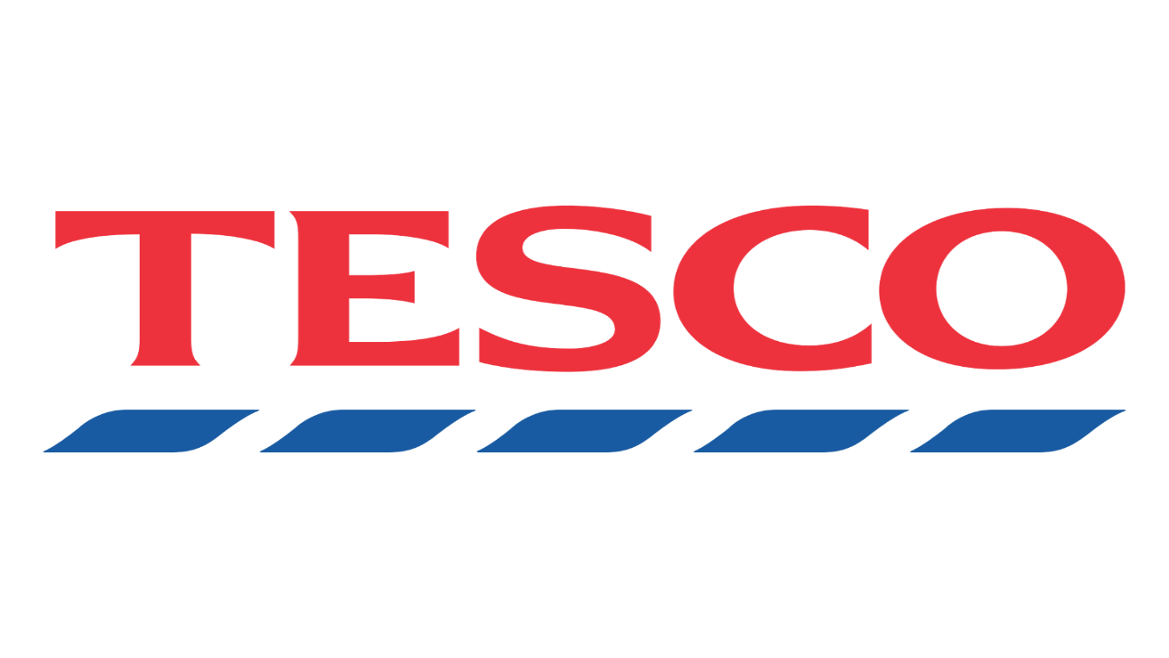

PROBLEM SOLVING AND
DECISION MAKING
LECTURE: MARIA HEFFERNAN
STUDENT NAME: OXLEY ROGER BALASUBRAMANIAM
STUDENT ID : 1806360

Executive Summary

In the current business world how Tesco could survive with heaviest competitive with other same market business and how they could manage along with a high volume of employers and employee. They are huge productivity bring up into the markets from foreign countries to survive in this market. But Now Tesco facing major issues with the Europe suppliers due to the Brexit. Also need to look for Customer requirements such as quality products with cheap prices.
However, When the vital issues are discovered, the subsequent stage is to utilize the end to recognize key issues. It is in this phase members choose which issues are basic to the accomplishment of the organization and its fantasy of improving the marketing methodologies.
Main focus of assignment is how Tesco could over come from all these pressures and ongoing issues in market
Will be Attempt a SWOT analysis to recognize why the Tesco is looked with its present issues. Recognize zones inside the SWOT that may enable them to determine these issues. Also going to use PESTLE to identify issues that perhaps affecting on the Tesco and adding to its issues. Finally will be explain how could stakeholder would make different within organisation.

Contents
1.0 Term of Reference 4
Findings 4
3.1 Brief introduction to the organisation 4
3.2 Attempts has been taken part to resolve problems 5
3.3 scope of the current problems 6
3.4 Analysis of Tesco 7
3.4.1 SWOT Analysis 7
3.4.2 PESTLE Analysis 9
3.4.3 Stakeholders Analysis 10
3.4.4 Stakeholder Analysis diagram 11
3.4.5 Particular stakeholders Influence and impacts 12
4.0 Conclusion 13
4.1 the current situation of the organisation in terms of strengths /weaknesses 13
4.2 main areas of concern to the organisation 13
4.3 strength of the Main stakeholders and resolve the problems 14
5.0 Options 15
7.0 Acknowledgements 15
8.0 Reference 16
9.0 Bibliography 17

1.0 Term of Reference
Tesco is one of the main super market in UK. they are searching for an answer to defeat from their issues do confront every day base inside the management group and the staffs. For this situation they been demand the report from human recourses on 12th of February 2019. Where Tesco the executives could work it out with the shortcoming and where to Improve their business level. Right now board of directors, management group and staffs battling for the organisation success, while ongoing heavy competition in business environment. Tesco anticipating that a superior and proficient report should be submitted on 29th of march 2019.

Findings

3.1 Brief introduction to the organisation
Tesco plc, trading as Tesco, is a British multinational groceries and general merchandise retailer with headquarters in Welwyn Garden City, Hertfordshire, England, United Kingdom [1]. It is the third-largest retailer in the world measured by gross revenues and is the ninth-largest retailer in the world measured by revenues [2].
Tesco was founded in 1919 by Jack Cohen as a group of market stalls. The Tesco name first appeared in 1924, after Cohen purchased a shipment of tea from T. E. Stockwell and combined those initials with the first two letters of his surname, and the first Tesco shop opened in 1931 in Burnt Oak, Barnet [3].
The brand continued its rise in the 1930s when Mr Cohen built a headquarters and warehouse in North London, and in 1932 Tesco became a private limited company. In 1947 Tesco Stores (Holdings) Ltd floated on the stock exchange with a share price of 25p. [4]
Tesco currently does provide so many product and services, which are Groceries, F&F clothing, club card, banking service, mobile service, photo service, own magazine and deliver service. Etc

3.2 Attempts has been taken part to resolve problems
The discounters Aldi and Lidl, with their lower base costs, a socially acceptable spot to shop. Anyway Tesco has been moderate footed in its response to this new threat, with the £200m cost cuts movement proclaimed in the relatively recent past regarded less of what was normal. cost cutting system including staff working hours, over occasions, cutting down the amount of staffs on shifts and some fresh products lines. fundamentally cut is probably going to originate from middle management staff and staffs who working behind the deli and fresh meat and fish departments also planning close down the Tesco cafes. In 2018 Tesco made a big move to make changes on the current problems by merges with wholesaler Booker group who big giant supplier, where Tesco can bring up better products at lower price to the customers.

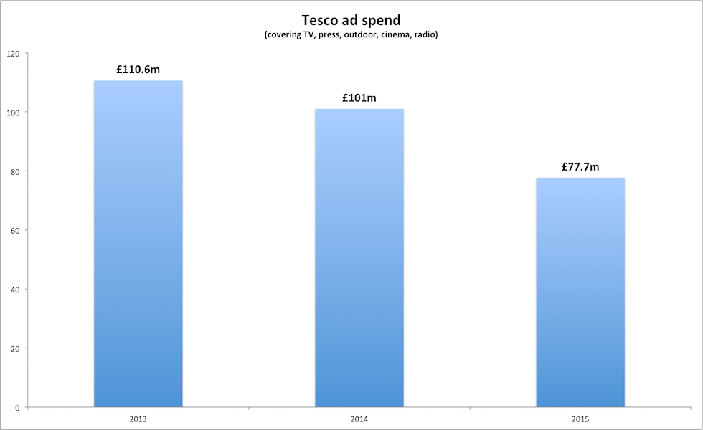

According to this draft tesco has monitored high investment on the advertisement at the early stage and its been cut down in recent years where tesco can avoid the unwanted expenses on adverts.
Also tessco stared making their own label products and loyalty such as F&F, tesco simply value and Clubcard. tesco could sale them to customer for lower price and make more margin out of it.

3.3 scope of the current problems

Tesco's decrease is by all accounts proceeding as it reported yearly misfortunes totalling £6.4bn, one of the greatest deficiencies in British corporate history. With the organization's esteem sinking by an astounding £7bn pounds and the 2014/15 exchanging benefit dropping by practically 60%, the Big Four grocery store proceeds with its sharp fall since its halcyon decade of development during the 2000s. by looking at these figures Tesco hardly dropping down which means losing customers. In retail market customers is the heart of the business all other supermarkets working hard to build the customer flow, and some get success in it.
The basic need retail area has seen a checked change in buyer shopping propensities, brought about by the monetary downturn and present day way of life. In the course of the most recent two years, customers have changed from the expansive week by week shop to a comfort demonstrate, halting off at their local stores in transit home from work as opposed to visit a supermarket." Alongside this, cost cognizant purchasers are shopping at the discounters, exploiting the less expensive costs. The costs are encouraged by lower cost models, less capital consumption and a decreased scope of items which empowers up to half limits on equal items in Tesco. Aldi and Lidl stock a high amount of own brand items which empowers them to contend on cost.
In the UK, Aldi has won the Supermarket of the Year by Which? for a long time in succession (2012/13), and in 2013 Aldi won the Grocer of the Year Award. Buyers that need to search for amazing extents will go to grocery stores like Waitrose and Marks and Spencer, known for quality and administration. The majority of the these variables have impacted the pattern which demonstrates that the retailers that sit in the 'middle ground' are losing their fortress in the UK retail basic need business. Also tesco is struggling with too many stores, staffs and departments while annual sales levels are dropping down. Tesco currently having major fear on Brexit heads of the organisation having lots of pressures by European supplier and the coast price would be push up.

3.4 Analysis of Tesco

3.4.1 SWOT Analysis

The purpose of SWOT is to create a strategy that benefits you from distinguishing yourself from your competitors to be successful in your market. It is powerful as it will show you the opportunities to exploit.
STRENGTH | WEAKNESS | OPPORTUNITIES | THREATS
Strong brand image: Tesco is well known for its name. | Failure to lead city centre market: The leading instability of the company is the loss to lead the city centre market. | The increase in demand for the private products:  To increase the amount of loyal customers, we need to satisfy them by getting the private labelled products. | Low price supermarkets:  It is a threat having other businesses coming up with lower prices and discounts.
Market leader: The company takes the lead in the retail business as third position. | The Lack in the marketing approach:  There is shortfall in approaching the marketing industry. | Diversified market appeal:  There are numerous fields where the company has opportunities to grow which still hasn’t been identified. | Economic conditions:  Factors like economical changes of the condition will turn into threats as it will affect the market share and the profit of the company.
Diversified business over the entire world: The operations of the company are in numerous areas spread over the entire world. |  |  | New entrants:  Introducing new business magnets into the marketing industry would create a challenge for the marketing operation.

mission of the organization To create esteem included items for the customer, all together acquire their long term loyalty.

Objectives for current Problems

The destinations of the organization are vital and that also if there should be an occurrence of Tesco it is basic for the organization to accomplish a noteworthy share in market. The goal must be centred around the SMART example that implies specific, measurable, attainable, reliable target. The marketing and corporate destinations of the organization must be both business just as customer situated which is promising in the business perspective. They are as per the following:

Corporate Objectives | Marketing Objectives
To develop the staff production | To acquire the primary position in retail industry
The staff is provided adequate training and thus the business operations are aligned. | Inside a year the piece of the overall industry to be supported up to 40%.
Reaction rate in expanded to build the customer loyalty. | In a year the deals should build 70 to 80%
Building up the stores in new areas | To expand customer base inside a year
 | To expand the incomes and the benefit up to 40% inside a year.
 | To Increase the mindfulness about reasonable exchange item.

The detailed objectives has mentioned above that are for the most part to encase the real piece of the market planning. After the accomplishment of the above said objectives, the organization will almost certainly underwrite ample open doors which are available in the retailing business.

3.4.2 PESTLE Analysis

- Economic

Monetary components are of worry to Tesco. since they are probably going to impact request, costs, price and benefits. A standout amongst the most persuasive factors on the economy is high joblessness levels, which diminishes the compelling interest for some merchandise, unfavourably influencing the interest required to create such products.

These economic factors are to a great extent outside the control of the organization, yet their consequences for execution and the showcasing blend can be significant. the organization is still exceedingly reliant on the UK market. Consequently, Tesco would be seriously influenced by any slowdown in the UK grocery market and are presented to Market focus dangers.

- Social

Social factors are mostly include lifestyle changes, education. Living conditions, death rates etc

INCREASED BIRTH RATE: Tesco may Start to see offering Children's toys or items to open another market which in the run will inevitably make more profit since they will have an additional market that guardians and kids are keen on.

EDUCATION: Tesco will also focus on education. As seen on adverts they already sell school uniform for children that are a certain age which is mostly primary school. They will also sell school equipment for all ages from primary to secondary and even to college This opens a whole new market.

DEATH RATES: It Can also focus on death rates, Tesco's itself have a funeral service that is open to any family that wish to organise a funeral for a loved one. The higher the death rate goes the more money Tesco's will most likely make if family's choose Tesco's funeral service.

- Legal
Different government Legislations and approaches directly affect the execution of Tesco. For example, the Food Retailing Commission (FRC) recommended an enforceable Code of Practice ought to be set up forbidding a large number of the present practices, for example, requesting payment from providers and changing concurred costs reflectively or without notice. The nearness of strong competitors with built up brands makes a risk of serious price wars and solid prerequisites for product differentiation.

3.4.3 Stakeholders Analysis

- Suppliers
They supply products to the business which then allows the business to sell the products to customers and consumers this there fore make profit for both the suppliers and the business, the suppliers are essential for the business to operate.

- Customers
the customers provide a profit to the business which allows them to not only pay staff wages but also creating chances to introduce more products into the market, have higher supplies of the products and tesco possibly will rebuild stores in more areas with the profit that they gain.
- Government
The government may have to ignore the public’s interest to intervene with the business, this way ensuring that there are a wide variety of job positions available to the community and more tax opportunities.

- Owners / shareholders
The owners affect the business because they have to control how the business runs, the staff that are recruited through selective qualities, the products that are provided to the publics interest and the customer service provided to have high quality. These steps would increase the customer flow in daily base business.

- Employees
The employees making major impact to current problem of the business by providing best service to the customers for the business which gives good reputation to organisation, the employees affect the business by helping the organisation to become more recognised in the community.

- Local community
The community affect the business by letting the organisation to know their views on the business and how its running, the community can also be customers and consumers for the business.

3.4.4 Stakeholder Analysis diagram

Low Interest Hight
Power
Hight
Low
Minimal effort | Keep informed  Customers  communities
Keep satisfied  Government | Key players  Employees  Suppliers  Owners/Shareholders

3.4.5 Particular stakeholders Influence and impacts
- Customers
Customers are of big influence in the diagram of the stakeholder diagram. The customers put a high level of interest in the company because it provides them a service or a product. However they do have a low level of influence on business because the customers will not try to make a change but are rather interested in the products and services provided. For example the customers might buy their primary goods during the week as usual. This won’t affect the business as it not going to change because they just buy the supplements that they need. They will only be interested in discounts, quality and quantity of the products.

- Employees
Staff are at different sections on the diagram.
There is a group of staff for example the cleaning staff who will not be interested in the growth or has any influence in the industry. This is the so called minimal effort. On the other hand there are customer service staffs who will have a high influence and a low level of interest, this could also be called keep satisfied. There is also a group of technical staff who will be the main players because they will have the highest interest and influence in the business. Every staff would normally be a key player because they represent the company as what it is.

- Suppliers
Suppliers are having one of the biggest influences within the business because the business are dependent on the provision of the supplies because without the supplies the business cannot operate. Suppliers will try to get profit from them by wanting regular orders and are the key players for the business on the influence of stakeholders diagram. Without the supplies the business will suffer a large decrease in sales.

4.0 Conclusion

4.1 the current situation of the organisation in terms of strengths /weaknesses

Tesco has collided with the greatest misfortune at any point recorded on the UK high street, drooping £6.4bn into the red because of enormous compose downs on the estimation of its property portfolio and stock.
Following quite a while of development in the UK, Tesco endured five benefit admonitions a year ago as examiners said it had opened an excessive number of large stores, let costs rise and shop floor gauges slip. All grocery stores are feeling the squeeze as customers change to the web, little local shops and discounters, for example, Aldi and Lidl, however Tesco has been hardest hit because of its scale.

4.2 main areas of concern to the organisation

From the majority of the investigation, it is discovered that Tesco PLC is working in exceedingly competitive industry where there are numerous large organizations in a similar industry. Be that as it may, Tesco has effectively managed with the methodologies as a result of its distinctive techniques to make more an incentive for the customers. The organisation has, numerous chances and qualities that helped the organisation contend with these companies. The esteem chain investigation of the organization recommended that Tesco has effectively utilized its everything expected contributions to make more qualities for the association through both cost leadership and product differentiation. Thus, Tesco has predominant qualities and upper hands than different competitions like Sainsbury's, ASDA, Lidl and Aldi etc.

4.3 strength of the Main stakeholders and resolve the problems

Customer
Without customers the organization can't endure so in practically all circumstances the customer needs would take major part. The customer can generally to take his business to a contender so it is fundamental to keep on advancing, to offer great product and services also great incentive for cash. Bring more customer into business would be the recover from all the lost and way to success.
Employees
The employees are the ones who make and convey the products or services that the customers expend. On the off chance lose or offend best staffs, at that point customer services will endure so have to take care of them. On the off chance need to draw in and hold top ability at all dimensions, at that point organisation bring to the table terms and conditions that are appealing. When employees happy at work organisation could achieve the goals, by archiving the targets possibly recover from all lost Tesco has went through past years.
Suppliers
Supplier are come under the external stakeholders, suppliers who taking major part to solve the current problems by making good quality products for lower cost price, so tesco could get back to the Leader ship position in market and compete Aldi and Lidl.

5.0 Options
In busy world customers got no time for visiting to store and do their daily base shopping and looks for the deals and offers. There is the time customers turns to the local shop for their shopping on the way home. On this situation Tesco need to develop the online shopping and brings up the best deals and offers, after the purchase also need to do fast delivery services make customers life easier.

7.0 Acknowledgements
I deeply want to offer my earnest thanks to collaborators and individuals who worked and backing to full fill this report in successful way. Which additionally to assist me with doing the many research about Tesco. I am extremely great full I had great journey with my group.
Thanks again to my all team for the supports.

8.0 Reference
https://www.ukessays.com/essays/marketing/identification-of-strategic-problems-of-tesco-marketing-essay.php (20/03/19)
https://www.telegraph.co.uk/finance/markets/2788089/A-history-of-Tesco-The-rise-of-Britains-biggest-supermarket.html (20/03/19)
https://www.theguardian.com/business/2014/jul/21/five-probems-tesco-dave-lewis(23/03/19)
https://www.marketingweek.com/2016/04/18/how-the-tesco-brand-bounced-back-from-crisis/ (23/03/19)
https://www.tutorsindia.com/library/essay-index/assignment-marketing/marketing-strategy-of-tesco/ (24/03/19)
https://prezi.com/3vd5fqnqm5le/tesco-pestel-analysis/ (24/03/19)
https://www.slideshare.net/LewisAppleton/stakeholder-influence (26/03/19)
https://www.slideshare.net/LewisAppleton/stakeholder-influence-further (27/03/19)
https://www.academia.edu/6616602/Strategic_Management_on_Tesco_PLC (28/03/19)
https://www.theguardian.com/business/2015/apr/22/tesco-suffers-record-64bn-loss (29/03/19)
https://www.destination-innovation.com/who-are-a-companys-most-important-stakeholders/ (29/03/19)

9.0 Bibliography
[1] Wikipedia- Tesco.
[2]. https://en.wikipedia.org - tesco
[3]. https://en.wikipedia.org - Tesco
[4].https://www.telegraph.co.uk/finance/markets/2788089/A-history-of-Tesco-The-rise-of-Britains-biggest-supermarket.html

