Module Title – Introduction to Health and social care
Student Study Module Code – LCHS 4003
Name – Tayyaba Arshad
Number – 2437578
Lecturer’s Name – Mumtaz Goolam
Assignment Title – Poster and Essay Component 1

Date 20th October 2025

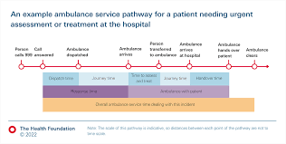
Ambulance services are an important part of the UK’s healthcare system, providing emergency medical care and transport to individuals in urgent need. They respond to 999 calls, assess and treat patients at the any scene, and ensure safe transfer of patients to hospitals. The services are delivered by NHS ambulance trusts and include road ambulances, air ambulances and rapid response teams, addition to this they also support non-emergency care. This service is used by variety of aged people from newborn to old, aged pensioners. The ambulance service is delivered at any emergency or non-emergency scene where it can be the home of the patient to a road where someone is injured so basically it can be delivered anywhere within UK. This service is very important to the people as it provides treatment to injured and no injured patient and can help them in surviving,

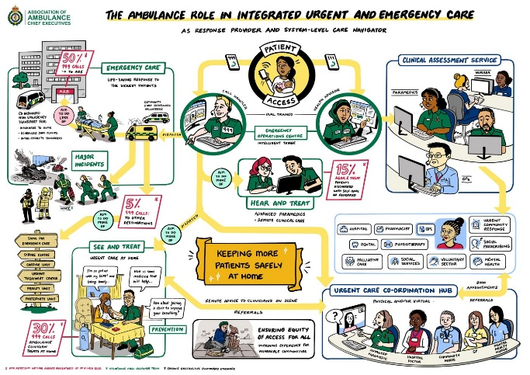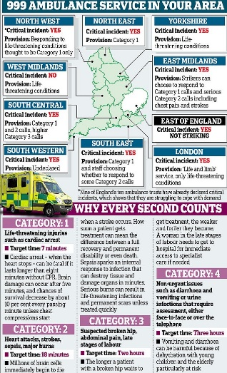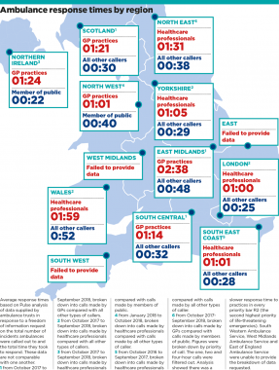

Challenges
There are several challenges that the Ambulance service is facing:
Rising demand – the number of calls is increasing Ambulance r=services faced enormous pressures dua to the pandemic dealing with COVID 19 cases alongside usual emergencies.
Staff shortages – Staff are feeling the pressure, getting burnt out which is affecting their mental health issues and infection risks staff shortages due to sickness or self-isolation which means they go off sick, and the pay is low.
Increased violence and abuse – Staff are facing hight level of violence and abuse.
Lack of hospital beds – Delays for the hospital in discharging the patients contribute to handover delays due to hospital staff delaying in discharging patients which impacts the service.
Hospital handover delays – Ambulance staff tend to get stuck in the hospital for extended periods due to bed shortages and this prevents them from responding to new emergencies.
Misused calls - Ambulance staff face non-emergency calls for minor issues, which diverts resources to those who require them. Meeting targets response times especially in rural or congested areas is a constant challenge factors like traffic distance an ambulance can reach patient
Ambulance services are at the heart of urgent and emergency care system in 2017 (NHS England) the NHS introduced new ambulance standards to ensure the best most appropriate response is provided for each patient first time.

Function of Ambulance services: Main Functions:
Responding to 999 calls- received emergency calls and dispatch medical staff to provide immediate care to patients.
Provide medical care - Staff are equipped and train to assess and treat the patient with a range of illnesses and injuries from non-life threatening to life threatening
Rapid transport – trained to get help as quickly as possible by using the sirens.
Patient Transport- Transporting patients to hospitals and or between facilities
Emergency Medical treatment- delivering treatments to patients such as CPR, airways management and medication administration before they transport to hospital.

History
In 1977 Scotland has its 1st ambulance service using sedan chairs (Liverpool medical institute- history of the ambulance)
1887 -St Johns ambulance brigade was formed (EMSUK Learning) In the wars the British red cross operated in the battlefield ambulance services.
1948 the NHS was formed and the ambulance services integrated brought under local authority control as part of the public healthcare.
1974 the ambulance service was reorganized into regional structures.
Air ambulance service was introduced in the 1960-1970
1991 the services merged into the NHS ambulance service (EMSUK Learning)
2006 NHS foundation trust were created giving the ambulance services autonomy over their finances and management.
And today the ambulance services used GPS dispatch, paramedic- led care and integrated call centres 999

This Photo by Unknown Author is licensed under CC BY
The National Health Service (NHS UK is one of the most transformative social institutions in British history. The NHS was Established in 1948, it was born from out of a post-war vision for a fairer society, offering healthcare services free at the point of use to all citizens not just the rich. Before that, you either had to pay, rely charities, or hope your local government helped. Its founding principles—universality, equity, and collective responsibility—continue to shape public expectations, even as the system faces increasing pressures.
The NHS was launched on 5 July 1948 under the leadership of Aneurin Bevan, Minister of Health in the Labour government. The NHS’s creation was heavily influenced by the 1942 Beveridge Report, which identified five general “giant evils”: Want, Disease, Ignorance, Squalor, and Idleness. The report proposed a comprehensive welfare state, with healthcare as a central pillar (Beveridge, 1942).
Prior to the NHS, healthcare provision in Britain was broken and unequal. Access depended largely on income, with many working-class families relying on charitable hospitals or foregoing treatment altogether. Bevan’s vision was radical: a publicly funded system offering healthcare to all, financed through general taxation. He famously asserted, “No society can legitimately call itself civilised if a sick person is denied medical aid because of lack of means” (Bevan, 1948).
The NHS was founded on three core principles:
- It would be free at the point of delivery.
- It would be available to everyone.
- It would be funded through taxation.
Although opposition from some medical professionals concerned about autonomy and remuneration, the NHS was implemented with widespread public support and quickly became a foundation of British life
Today, the NHS operates as four distinct systems in England, Scotland, Wales, and Northern Ireland. In England, services are contracted by Integrated Care Boards (ICBs), which replaced Clinical Commissioning Groups in 2022. These boards collaborate with local authorities and providers to plan services tailored to population needs (NHS England, 2022).
The NHS in England has structured tiers:
- Primary care: General practitioners (GPs), dentists, pharmacists, and opticians.
- Secondary care: Hospital-based services, including outpatient and inpatient care.
- Tertiary care: Specialist services such as oncology and neurosurgery.
- Community care: Services delivered outside hospital settings, including mental health and district nursing.
Despite its enduring values, the NHS faces significant challenges:
- Funding pressures: Although the NHS budget reached £165.9 billion in 2023–24, demand continues to outpace resources (HM Treasury, 2023).
- Workforce shortages: Over 100,000 vacancies have been reported, contributing to staff burnout and service delays (NHS Digital, 2023).
- Access and waiting times: In August 2023, over 7.7 million people were on hospital waiting lists, reflecting systemic strain (BBC News, 2023).
Efforts to modernise the NHS include digital transformation, integrated care models, and a greater emphasis on preventative health. However, critics argue that reforms often lack strategic coherence and fail to address underlying inequalities, particularly in deprived regions (Health Foundation, 2023).
The NHS was founded on a vision of universal healthcare and remains a symbol of social solidarity. While its principles persist, the system must evolve to meet contemporary demands. Strategic investment, workforce support, and a renewed focus on equity are essential to safeguarding its future. As Britain confronts demographic shifts and economic constraints, the NHS must balance tradition with innovation to remain fit for purpose and it will be.

References
Beveridge, W. (1942). Social Insurance and Allied Services. HMSO.
Bevan, A. (1948). Speech at the launch of the NHS.
NHS England. (2022). Integrated Care Boards: Overview.
NHS England. (2023). The NHS Constitution for England.
HM Treasury. (2023). Budget Report 2023–24.
NHS Digital. (2023). Workforce Statistics.
BBC News. (2023). NHS waiting list hits record high.
The Health Foundation. (2023). Tackling inequalities in health and care.
The King’s Fund. (2022). How does the NHS in England work?
EMSUK Learning
NHS England

