Name: Miguel

Student Number: 2515293
__________________________________________________________

WORKSHEET 3 – TESTING (Lap Times)

- Original code:
[Copy and paste your original code from Moodle into this box. Do not change it.]

print("welcome to the racing stats program!")

lapTimes = []

for counter in range(0,5,1):
while True:
try:
lap = float(input(f"lap {counter + 1}: "))
if 28 <= lap <= 200:
lapTimes.append(lap)
break
else:
print("That doesn't seem quite right. Please try again.")
except ValueError:
print("Please enter a number.")

while True:
try:
targetTime = float(input("what is your target time?"))
if sorted(lapTimes)[4] >= targetTime > 28:
break
else:
print("that target time is either too high for you or impossible.")
except ValueError:
print("this isn't a number")

totalLap = sum(lapTimes)
print("1. your overall time for the 5 laps was: ", totalLap)

averageLap = totalLap / 5
print("\n2. Average lap time was: ", averageLap)

bestTime = sorted(lapTimes)[0]
bestTimeLap = lapTimes.index(bestTime)
print("\n3. The fastest lap was lap ", bestTimeLap, " in ", bestTime)

slowestTime = sorted(lapTimes)[4]
slowestTimeLap = lapTimes.index(slowestTime)
print("\n4. The slowest lap was lap ", slowestTimeLap, " in ", slowestTime)

lapsOnTarget = 0
for counter in range(0,len(lapTimes), 1):
if lapTimes[counter] <= targetTime:
lapsOnTarget = lapsOnTarget +1
print("\n5. ", lapsOnTarget, "of your laps were better or equal to your target time")

currentLap = lapTimes[0]
print("\n6. \nlap 1 was", currentLap)
for counter in range(1,len(lapTimes),1):
newTime = lapTimes[counter]
if newTime < currentLap:
print("lap", counter+1,"was", newTime, "which was faster than the previous lap")
elif newTime > currentLap:
print("lap", counter+1,"was", newTime, "which was slower than the previous lap")
else:
print("lap", counter+1,"was", newTime, "which was equal to the previous lap")
currentLap = newTime

- Code Testing
For each test below, run your code and show the results of the scenarios below. Present a screenshot of what happened when the programme ran. Did the programme behave correctly or did it do something unexpected, and if so, why?

- Test a lap time for your programme:
- 42 seconds
- 2 seconds
- -4 seconds
- 53444 seconds
- Test the target lap time – show that the values entered are reasonable

- Using the same five lap times as the sample output ie

Lap 1: 42.3
Lap 2: 42.1
Lap 3: 44
Lap 4: 44
Lap 5: 39.4

Examine each statistic (1-6) and comment on whether the correct answer(s) are displayed or not. (If any statistics were incomplete after Phase 1 (code completed in class) simply write “Unfinished”)

- Test two further sets of lap times of your own choice.

Template for tests:
Test:
42 seconds

Screenshot(s) of output:
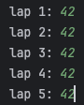
Result: Did the programme behave as expected ie syntactically and logically correct?

YES, the program accepted a correct response.

Test:
2 seconds

Screenshot(s) of output:
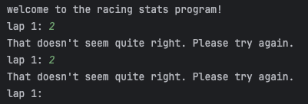
Result: Did the programme behave as expected ie syntactically and logically correct?

YES, 2 seconds is very unrealistic for a driver to complete a lap in. So, the response from the program is correct.
One way I could improve this program is by making the response more descriptive.
The current response doesn’t explain to the user what is wrong. The user may become confused and frustrated.

Test:
-4 seconds

Screenshot(s) of output:
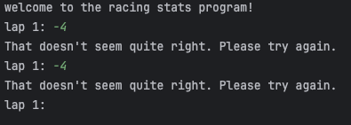
Result: Did the programme behave as expected ie syntactically and logically correct?
YES, similar to the previous test the program is correct and does not accept this value, but again I could make the response more descriptive.

Test:
53444 seconds
Screenshot(s) of output:
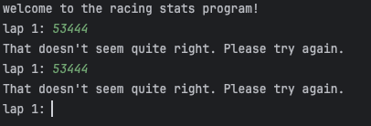
Result: Did the programme behave as expected ie syntactically and logically correct?
YES, again, just like the previous two tests, the program is correct to realise that there is something wrong with the input.
This is another angle the program will need to consider. Technically a user could take “53444” seconds to complete a lap. But we would class this as a DNF(did not finish).
I will improve this and the previous two tests by adding different validation possibilities.

Test:
Test the target lap time – show that the values entered are reasonable

Screenshot(s) of output:
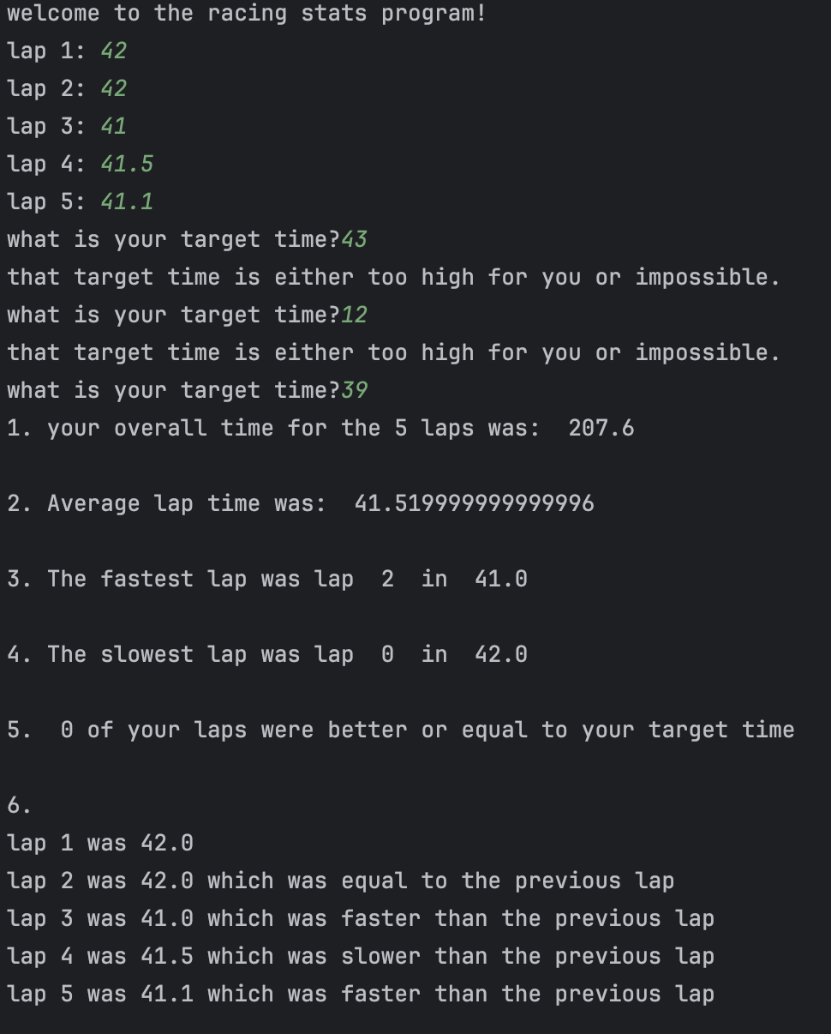
Result: Did the programme behave as expected ie syntactically and logically correct?
Yes, as shown in the above demonstration, the program will not allow a user to enter a value that is higher than their highest lap time. The program also doesn’t allow a user to enter a lap time that is basically impossible. One way this program and response could be improved is by making the response more detailed.

Test: Examine each statistic (1-6) and comment on whether the correct answer(s) are displayed or not.

Screenshot(s) of output:

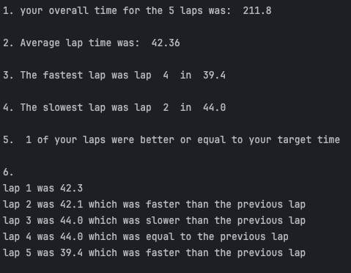

Result: Did the programme behave as expected ie syntactically and logically correct?
No, The main issue here is that the fastest lap and slowest lap are wrong instead of 2 it should be 3 and instead of 0 it should be 1. This is because an array starts with position 0. All the other outputs are correct.

Test:
2 more of the previous test

Screenshot(s) of output:
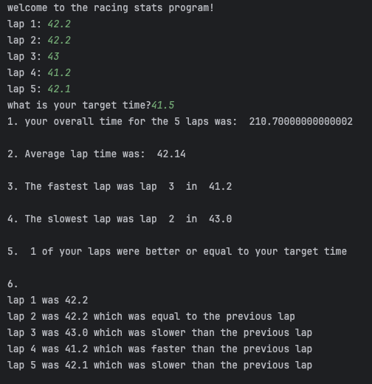
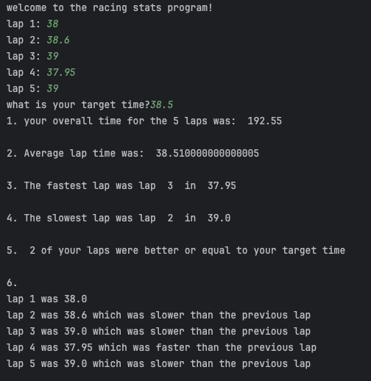

Result: Did the programme behave as expected ie syntactically and logically correct?
No, again The main issue here is that the fastest lap and slowest lap are wrong instead of 2 it should be 3 and instead of 0 it should be 1. This is because an array starts with position 0. Everything else that the program output in the 2 screenshots is correct. One improvement that will be made is average lap time will be 2 decimal place and overall lap time also only have 2 decimal places.

(Copy and paste box above for each of the rest of the tests)
- Consider the results of the above tests and revisit your original code in order to address any tests that failed and/or improve code efficiency.

(Note: you may not be able to solve all of the problems that were encountered, but solve as many as you can.)

Paste your full revised code here :

[Copy and paste your full revised code here – note, do not use a screenshot]
print("welcome to the racing stats program!")
lapTimes = []
for counter in range(0,5,1):
while True:
try:
lap = float(input(f"lap {counter + 1}: "))
if 25 <= lap <= 100:
lapTimes.append(lap)
break
elif lap < 25:
print("The lap can not be done in under 25 seconds, that impossible")
else:
print("your time is over 100. This counts as a did not finish, retake the lap!")
except ValueError:
print("Please enter a number.")
while True:
try:
targetTime = float(input("what is your target time?"))
if sorted(lapTimes)[4] >= targetTime > 28:
break
elif targetTime < 25:
print("that target time is impossible. Your target time must be over 25 seconds")
else:
print("This target time is too high for you, you are better than this.")
except ValueError:
print("this isn't a number")
totalLap = sum(lapTimes)
print("1. your overall time for the 5 laps was: ", round(totalLap, 2))
averageLap = totalLap / 5
print("\n2. Average lap time was: ", round(averageLap, 2))
bestTime = sorted(lapTimes)[0]
bestTimeLap = lapTimes.index(bestTime) + 1
print("\n3. The fastest lap was lap ", bestTimeLap, " in ", bestTime)
slowestTime = sorted(lapTimes)[4]
slowestTimeLap = lapTimes.index(slowestTime) + 1
print("\n4. The slowest lap was lap ", slowestTimeLap, " in ", slowestTime)
lapsOnTarget = 0
for counter in range(0,len(lapTimes), 1):
if lapTimes[counter] <= targetTime:
lapsOnTarget = lapsOnTarget +1
print("\n5. ", lapsOnTarget, "of your laps were better or equal to your target time")
currentLap = lapTimes[0]
print("\n6. \nlap 1 was", currentLap)
for counter in range(1,len(lapTimes),1):
newTime = lapTimes[counter]
if newTime < currentLap:
print("lap", counter+1,"was", newTime, "which was faster than the previous lap")
elif newTime > currentLap:
print("lap", counter+1,"was", newTime, "which was slower than the previous lap")
else:
print("lap", counter+1,"was", newTime, "which was equal to the previous lap")
currentLap = newTime

