Module Name: -

M.FOSTER – 1807714 – LONDON OVAL
Problem Solving and Decision Making BMSK4004_LON
LECTURER: AFZAL MUNNA

ASSIGNMENT:
“A PROBLEM WITHIN THE WORKPLACE”.

Table of Contents

- Introduction………………………………………………………………………………………………………………………………...3
- Shift handover and the purpose of them……………………………………………………………………………………………….3
- Advantages of effective shift handover…………………………………………………………………………………………………4
- Workplace communication……………………………………………………………………………………………………………….4
- Disadvantages of workplace communication…………………………………………………………………………………………. 4
- Advantages of workplace communication………………………………………………………………………………………………4
- My chosen problem (Ineffective communication on shift handover) ……………………………………………………………….5
- Shannon & Weaver model of communication theory………………………………………………………………………………….6
- Different problem-solving techniques……………………………………………………………………………………………………7
- Fishbone analysis……………………………………………………………………………………………………………………….7,8
- 7 steps to effective problem solving….……………………………………………………………………………………………. 9,10
- Types of decisions……………………………………………………………………………………………………………………….10
- Factors affecting decision making …………………………………………………………………………………………………….11
- Ingredients of good decision-making………………………………………………………………………………………………….11
- Decision making tool - SWOT & PMI………………………………………………………………………………………………12,13
- Decision making tool – PESTLE……………………………………………………………………………………………………….13
- 1st proposal for solution & Evaluation………………………………………………………………………………………………….14
- 2nd proposal for solution & Evaluation…………………………………………………………………………………………………14
- Implemented plan for proposed solution……………………………………………………………………………………………….15
- Monitor & review of implemented plan………………………………………………………………………………………………...16
- Porters five forces analysis …………………………………………………………………………………………………………….16
- Stakeholders………………………………………………………………………………………………………………………………16
- Conclusion…………………………………………………………………………………………………………………………………17
- References……………………………………………………………………………………………………………………………17,18

Diagrams within this assignment…………………………………………………………………………………………………………………

- Figure:1 – Shannon & Weaver Communication Model……………………………………………………………………………….6
- Figure:2 - Different problem-solving techniques ………………………………………………………………………………………7
- Figure:3 – Fishbone Analysis……………………………………………………………………………………………………………8
- Figure:4 - SWOT Analysis………………………………………………………………………………………………………………12
- Figure:5 – PMI Chart…………………………………………………………………………………………………………………….13
- Figure:6 – PESTLE Analysis………………………………………………………………………………………………………… 13
- Figure:7 – SWOT Analysis – 1st proposal…………………………………………………………………………………………….14
- Figure:8 – SWOT Analysis – 2nd proposal……………………………………………………………………………………………14
- Figure:9 – Task to do checklist (Solution to problem) ……………………………………………………………………………….15

Introduction
The purpose of this assignment is to look at a workplace problem (a situation that is not right and needs to be changed) in this case the poor communication in handing over a shift. We will look at the Shannon & Weaver communication model, workplace communication, the disadvantages and advantages of workplace communication, the different problem solving techniques we can use to solve the problem (such as the 7 steps for effective problem solving process and the fishbone analysis) also the decision making (deciding between two or more options) process techniques used to help make our decision, namely the SWOT and PMI. The PESTLE decision making tool is another tool I will discuss but it is used more for marketing decisions. As like the PESTLE, Porter’s five forces analysis tool is used in a marketing way to discover how businesses can consistently sustain profitability. Many decisions made within a business affects stakeholders and real big changes will need communicating to them. I will propose a solution to my problem which will be implemented and put in place, then monitored to see if this course of action was the correct decision for the problem.
What is a problem
We all have problems, and for every problem lays a solution. But not all problems can be solved with same solution. There are a lot of things in life we are exposed to at work, college or even our homes – opportunities. Many of these opportunities are missed and not taken. When were not sure how to cease this opportunity to take this advantage it creates a barrier – this barrier can turn a positive situation into a negative one, a Problem?
Shift handover and the purpose of them
The purpose of a shift handover is to ensure relevant communication related to task are changed between shifts ensuring that task is continued in a safe and effective way. There are three main points to remember when handing over a shift
- Ensure the outgoing shift has had enough preparation time to get task done before shift ends.
- Ensure communication is exchanged between outgoing and in coming shift relating to complete / incomplete tasks.
- Information must be cross checked by in coming shift as they will be assuming responsibility for task.
We need to change shifts when a process is continuous, because shifts cannot be automated and is regarded as a huge risk process, it relies on human behaviour. What we hope to achieve from a handover is responsibility, accountability and continuity. The concerned teams work schedules are done in the form of rosters and some daily operational task happen at various times during the day and sometimes require different teams and can take two or more shifts.
Changing shifts is a requirement in any continuous process. Shift handover should be regarded as a high-risk process because it cannot be automated and relies on human behaviour. The goal of the handover process is to maintain continuity and the formal transfer of responsibility and accountability between the respective parties. A shift roster is typically set up in advance to accommodate the need for people to work to a schedule. Shift changeover times are planned. The reality of day to day operations is that certain tasks happen on their own time scale. These tasks, sometimes involving different teams can take place during two or more shifts (Bolshoff, 2019)
Advantages of effective shift handover
- It is very easy to assume that on a changeover shift that all prescribed task will have been done, but without communication with the outgoing shift how will you know
- The intended communication must first be encoded and physically transmitted in the form of a signal, which may be written, spoken, or gestured.
- Written communication is facilitated by design of documents which consider the information needs of the user, support the communication task and demand inclusion of relevant categories/types of information.
Workplace communication
Effective communication in the workplace is very important to a business’s success, it helps build better relationships both as a company and with your clients and customers. This positive communication effectively increases team efficiency. In addition to this when communication is not communicated effectively in the workplace it can have terrible consequences.
The disadvantages of Workplace communication
- Delay or failure to complete projects
- Missed performance goals
- Increased stress
The advantages of Workplace communication
- When teams effectively communicate, information flows freely
- If a teammate learns of an important change, he or she can quickly assess which tasks will be impacted and who needs to know.
- When leaders and teams are communicating effectively there are no surprises at daily, weekly, monthly reviews.
My chosen problem
Poor communication in shift handover.
Whilst working within a small family courier business, I have noticed that there is no communication from the morning shift regarding shift handover to the late shift. There are jobs not being done by the morning shift which need doing for the business to run affectively, efficiently, and smoothly. The failure of not communicating properly what has and hasn’t been done in the morning runs over into the late shift which in turn causes a knock on effect that interferes with the late shifts work pattern and work performances because the evening shift has to do these task which should have been done in the morning. The morning side of the business consists of unloading freight (Parcels) from lorries, getting them scanned and sorted into driver rounds for London deliveries .The morning sortation shift starts at 3am finishes 12 midday, it consists of 10 team members and a morning supervisor, the shift averages around 3,000 parcels daily and the company employs around 30 drivers to deliver. The late shift starts from 12 midday to 21:00 and will set up warehouse for the imputing / import of customers parcels coming into depot to be delivered through our network to outer London destinations on our next day delivery service, which has a timed deadline cut off point, 21:00 at which point the lorry has to leave depot to make its allocated arrival time at the main hub centre in Coventry. How this affects me as part of the late shift is that because various task have not been done such as the depot being scanned, parcels for deliveries that didn’t go out haven’t been dealt with properly, Mis sorts that have been delivered to our depot instead of the designated depot have not been bought to the other depots attention, these task which are subjected to the morning shift, impacts on me on my shift and takes a lot of time out of my day every day to correct because they weren’t bought to my attention at the beginning of the shift by morning staff.
Established in London back in 1977, rush couriers were formed from a passion for dedicated motorbikes, cycle, and van carry services for the London business community. Since 1944 as a founding share holder of APC Overnight we have been offering wholesale and retail customers access to the most extensive UK Overnight parcel network, with an average of 1 service centre per postcode area - 120 depots- throughout the UK (couriers, 2015).
Shannon and Weaver Communication Model Theory
Figure:1

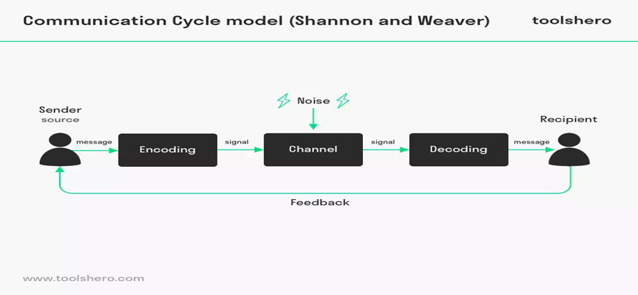

The Communication Cycle model may be a linear model of communication that has a schematic illustration of the relation between sender, message, medium/media, and recipient. It had been developed by Claude Elwood Shannon and Warren Weaver. Communication may be a terribly complicated method that happens orally, in written type as well as non-verbal type, and within which the message that is being sent, takes place in a certain context. Each the sender and the recipient will answer one another during this model, with the sender and recipient alternating roles. There are 8 variables with the Shannon and Weaver communication model. Sender – The information source from individual to another. The Encoder – Where the information is put in one context or another. The Message – The information transmitted to receiver. The Channel – The message transmission whether it be verbal, written, video or audio. The Noise – Interference of message which can cause distortion or make a message misunderstood. The Decoder – Where the message is understood. The Receiver- Where the message is received. Feedback - Receiver tells sender he or she has received message it has been interpreted correctly.
Different problem-solving Techniques
There are various problem-solving techniques we can use to solve problems such as: Mind mapping this captures the thoughts you are thinking in your head from a central theme to then break the theme down smaller and smaller. Brainstorming: Usually a group suggesting different ideas to solve a problem. SWOT analysis: A planning technique for problems where you distinguish where the strengths, weaknesses, opportunities, and threats are. PESTLE analysis: This technique is more geared towards a business structural approach to ensure your business falls within the political, economic, social, technical, legal, and environmental realms requirement. The Fishbone Diagram: A theory where you define the problem and break it down to discover the cause of that problem.
Figure:2
The fishbone analysis Theory
The fishbone diagram is an easy tool that allows quick and effective root reasons to be understood in the pursuit of corrective actions. Often called a cause and effect diagram or Ishikawa, it’s an easy root reason analysis device that is used for brainstorming problems and reasons. In a fishbone diagram the numerous causes are grouped into categories and the reasons cascade from the main categories flowing in the direction of the effect, forming what resembles a fishbone look. The idea is to brainstorm possibilities of problems then slim them right down to the issues which can be causing this difficulty. Once determined, rule them out, it enables you to recognise why the problem took place. Below is my fishbone analysis of my work-related problem, ineffective communication with shift handover. Figure:3
POOR COMMUNICATION IN SHIFT HANDOVER
1. Insufficient communication & time management skills. 2.Shortage of staff members, no employee training.

1.Not adhering to the business operation / duties, deadlines & service

SKILLS
ENVIRONMENT
POLICY
STRUCTURE
7 steps to effective Problem Solving
THE FISHBONE DIAGRAM
1.The work culture is low, 2. Lack of motivation.
.
1.Managers, supervisors, operatives not doing roles. 2.Lack of adequate I.T equipment, Handover logbook, Notice board.

Problem Solving may be a valuable skill that may only be learnt, and perfected, through continual practice. A wide range of problem-solving models and techniques are available to assist in evaluating and solving diverse problems of varying degrees of complexity. Herein I have linked my chosen problem, my solution and planned implementation. The problem-solving model 7 steps to problem solving is by Dr Shoji Shiba.
- Definition - The problem.

Non communication regarding handover, whereas task haven’t been completed in its entirety before end of early shift and there’s no communication relating to that vital part of changeover.

- Data collection – What hasn’t been done.

Mis sorts are not done (not reported to request depot that their customer goods are in wrong depot), bulk freight hasn’t been podded off (not reported to sending depot that goods wont be delivered today), cages for sortation hasn’t been laid out to specification for incoming parcels, depot hasn’t been scanned before early shift departs.

- Cause analysis – Communication and Time management skills.

Lack of communication skills between the early shift team. Not allowing enough time to complete required task within the allocated hours, so time management skills needed looking at. In addition to this staff weren’t fully trained adequately and employee training scheduled.

- Solution planning and Implementation.

Proposing having a checklist of tasks to be done before shift finishes was one solution, as well as having time management and communication training scheduled was another and considering introducing a 3rd shift to the operation was another solution, an early, middle, and late shift.
- Evaluation of implementation.

Having a task to do checklist worked well, it allowed all task to be transparent for all shift employees, so everyone will be aware of duties to complete before shift finishes.

- Standardisation.
The checklist or things to do proposal was also introduced to the many drivers who were unaware of certain procedures regarding leaving items with a neighbour, or safe whilst out delivering.

- Evaluation of the process.
Since implementing the process, it has been monitored and favoured that going forward this was an adequate plan that has worked well and efficiently.

Types of decisions
All of us strive to make the best decisions we can, but we are usually limited by certain constraints .sometimes we don’t have enough information or enough time or we just aren’t sure what we need to do to develop an optimal answer. we would like to make the most reasonable, logical and objective decision possible, but we seldom able to arrive at an optimal solution. Most of the time to the extent possible, we try to be as rational as we can by using what economists term the rational decision making process, a problem solving approach that involves the following sequence of events, problem identification – criteria definition – alternative generation and evaluation (Andrew Maund, 2017).
There are several different types of decisions:
Tactical – usually decided by top management, such as operations locations, production and distribution
Innovative - where problems are unclear and require creative solution
Adaptive – unusual where solutions are not understood, e.g. Such as being given a day off studying in summer because it is too hot
Routine – where company policy, rules and procedure can resolve issue. I will be looking at taking a tactical view to resolve my chosen problem, where I will put applications in place to resolve any issues.
Factors affecting decision making
Personal factors such as age, gender, education, occupation, and experience can affect decision making e.g. If for instance say, I preferred to employ a younger candidate as opposed to an older candidate because of past experiences where I found with older candidates they lacked motivation to work but loved to have conversations with any and everybody, I am now more geared to go for a more younger motivated candidate, so age was the factor that led to that particular decision being made. Same examples can be used if your preference is geared more towards hiring a male employee as opposed to a female one etc.
Ingredients of good decision making
There are a few steps we can consider before making decisions: 1. Consider circumstances: take time to consider circumstances and ensure you are in the right frame of mind before making decisions.2. Define the question: ensure you are asking the right question, for example, you know you want to start a business, so ask yourself a more definite question, such as “how best to achieve my dream of owning a business ” as opposed to whether or not to start a business you always wanted to start. 3.Define objectives: knowing what you want to achieve makes decision making easier. 4.Brainstorming: new ideas from different perspectives such as mind mapping and group sessions helps to see ideas you may not have considered. 5.Organise idea: from suggested ideas prioritise the ones that closely match your objectives.6.Opinions and feedback: speak to others and get their opinion of your idea, for example as used earlier, you want to start a business so ask small business owners about how they started and compare their ideas with yours.7.Evaluate your options: consider which decision or idea works well for you, and be honest about it, for example, you have a great idea for a business but it’s going to cost a lot of money to start up and you don’t have it, it’s likely not to happen as you don’t have all that money to start with.8. Make a choice: after all the discussions and brainstorming, it is time to choose the idea or decision your more comfortable with.9Take action: inform others of your decision and explain why this was best action.10. Evaluate decision: after implementing the decision check what worked and what did not, check if you would have done anything different so you know if it is to be repeated in the future.
Decision Making Tool - Swot Analysis for ineffective communication
Strengths  - Effective communication  (face to face, written, verbal)  - Good time management skills  - Good organisational skills  - Shift logbook / task sheet  - Transparent information | Weaknesses  - No communication  - Poor management  - Lack of training  - Shortage of staff  - Insufficient tools, equipment
Opportunity  - Additional training  - Information technology  - More staff | Threats  - Losing customers  - Knowledge  - Competitors

Figure:4
The SWOT analysis used for strategic planning shows the strengths, weaknesses, opportunities, and threats derived from my chosen problem of ineffective communication in shift handover
Plus, Minus & Interesting (PMI) Chart
The PMI tool helps you improve your thinking and appreciate an idea without rejecting it straight away. It also helps too access, choose, and create a practical idea. Below I have stated what I think are the plus, minus and interesting factors for my idea to solve the ineffective communication on shift handover at my place of work. The PMI decision making tool was developed by Dr Edward de Bono. The four steps to using the PMI chart for making a decision is firstly put the positive ideas in the plus column, the negative ideas in the minus column, the interesting points you can think of in the interesting column, then make your decision.

Plus  - All tasks on sheet  - Easy to follow instructions  - Does not require additional cost  - Transparency for all | Minus  - Not having enough stationary on hand always  - Using lots of paper is not considered environmentally friendly | Interesting  - With Information technology a spreadsheet can be created and modified daily

Figure:5
PESTLE Analysis
Another popular decision-making tool is the P.E.S.T.L.E which is more a framework geared towards examining the external marketing environment of any business. As a worker in the delivery distribution trade, the points inserted below in boxes would relate to my workplace, it is an unnecessary tool for my problem but essential if I were to say looking at the points listed in box.
Political  - Trade protectionism | Economical  - Stock market uncertainty | Social  - Obesity – food delivery | Technological  - State of art equipment for top service | Legal  - Misleading claims | Environmental  - Emissions
(Diamond,2017). (Samson and badkar,2017). (Bedard,2017) (Sind and Roe,2017). (Daily Mail,2017). (Gunther,2016).
Figure:6
1st proposed solution & Evaluation
Strengths  - Introduce task checklist sheet | Weaknesses  - Using a lot of stationary (paper, pens, clipboards)
Opportunities  - More efficient / transparency for all to see and do | Threats  - Employees / instructions not being carried out
Figure:7
My first proposed solution for an effective communication shift handover will be to introduce a list of things to do list or a task checklist. This list will include all task to be undertaken on shift, and simply ticked checked when completed and signed off by shift supervisor at end of shift and placed in done tray. This form of communication is written.
2nd proposed solution & Evaluation
Strengths  - Introduction of a 3rd / middle shift | Weaknesses  - Financial impact (bigger depot / recruit more staff)  - Does not help to resolve communication problems
Opportunities  - More shifts will increase more time to get tasks done | Threats  - Stretching a small team to run around the clock 24hr delivery distribution service
Figure:8
My second proposed solution for an effective communication shift handover will be to introduce a third or middle shift. This solution will expand the business, offer more business opportunities, and extends allocated times for shift task to be completed. The downside to this solution is that as a small firm, running a 24hr operation (6am – 2pm / 2pm – 10pm / 10pm – 6am) can cause a strain on the business and have financial obligation which the company could not afford.
Implemented plan for proposed solution
The implemented plan chosen which was devised by the shift leader on the late shift was the “list of tasks to do”. It was the most practical of the two solutions and did not require a lot of planning or disruption to the business. A list of tasks was put together after information was gathered regarding task that were not done and also several safety checks before handover The list has opened a more transparent and open form of written communication and face to face communication which can clearly be instructed and followed not just by the supervisor but each member on the team.
Figure:9

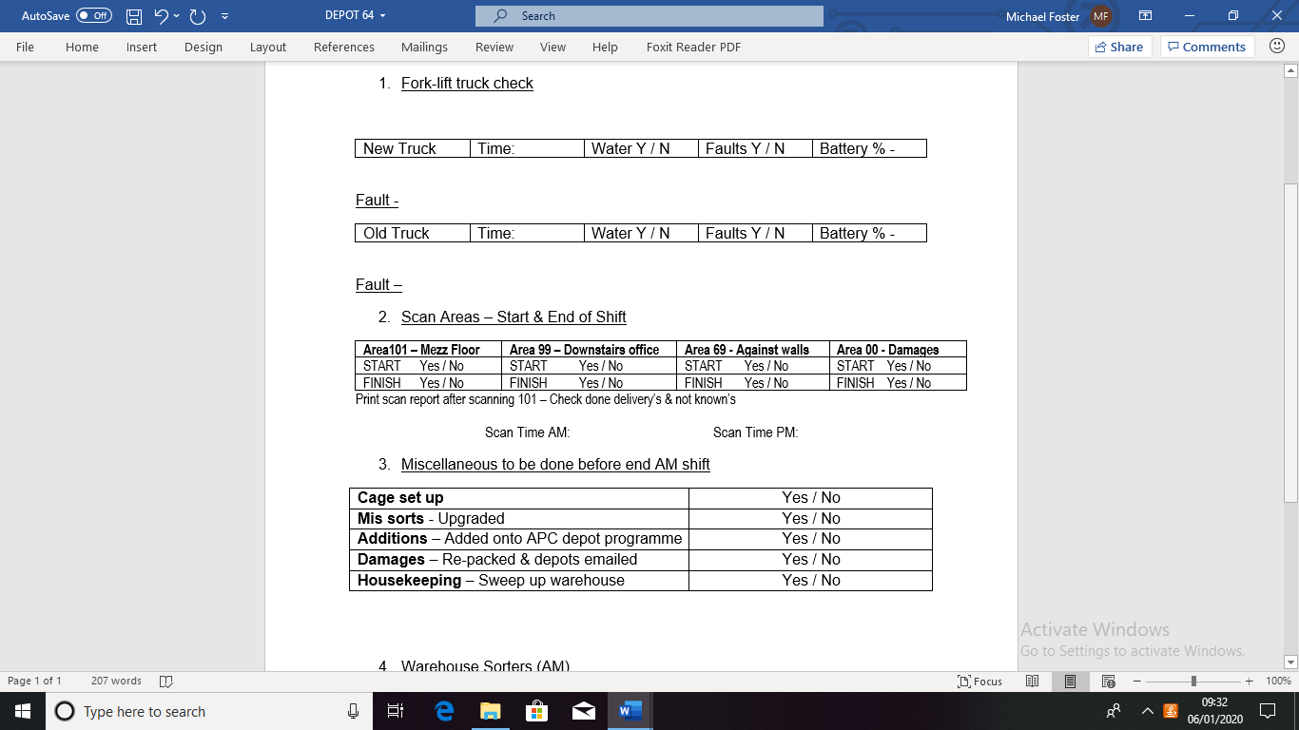
Monitor and review of implemented plan
- Time was set aside to prepare for the handover
- The handover was conducted face-to-face
- The handover was free from distractions
- The person giving the handover
- Gave an overview of the handover content
- Made a positive / negative statement of safety issues
- Talked through log items
4. Summarised the handover at the end
The plan implemented has been monitored over last couple of months and has really affected the workplace in a positive way. Communication ( Written, face to face, verbally) is much more obvious and abundant and clearly has boost moral within the depot. Due to the simple creation of a checklist for the morning shift, a similar list was constructed geared more towards the delivery drivers and the processes they need to go through on their daily deliveries and on returning items back to depot.
Who are the Stakeholders?
A stakeholder is an individual who is interested in the performance of a business and how that business uses its resources. These usually include shareholders, customers and suppliers who are referred to as external stakeholders and the employee, manager and owner who are referred to as internal stakeholders.
Porter’s five forces Analysis
Porters five forces analysis is about profitability defined by five competitive forces: The buyers - who love to pay less but get more. Then there are the suppliers who like to get paid more but deliver less. Substitute products or services providers are the next of the forces to offer competition which has the same needs as yourself. New rivals are another force to contend with, and your existing rivals too. These five forces define industry structure ( (freisner, 2014)

Conclusion
Irrelevant of the size of business or the business itself, there is no question that communication is by no means a vital skill required to ensure every employee, member of staff is aware of what information is needed to carry out their task for the working day.
Shift handover is one such critical process that relies on effective communication. Dedication to company policy and to work within requirements of the business must be coordinated with the shift handover procedures to ensure that jobs continue to take place under safe conditions, even when teams change (Bolshoff, 2019)

References
- Bolshoff, G. H. a. H., 2019. Shift handover and the permit to work. [Online]
Available at: https://www.intellipermit.com/shift-handover-and-the-permit-to-work/
[Accessed 30 November 2019]
- Couriers, R., 2015. Welcome to rush - Rush courier. [Online]
Available at: https://www.rushcourier.co.uk/wp-content/uploads/2015/01/Welcome-to-RUSH_email.pdf
[Accessed 27 November 2019]
- Andrew Maund, M. S. P. k. T., 2017. The rational decision process. In: M. S. P. k. T. Andrew Maund, ed. Certificate in higher education: skills for the workplace student yearbook. London: sage publication ltd, p. 185.
- freisner, T., 2014. Marketing teacher.com. [Online]
Available at: https://www.marketingteacher.com/five-forces-analysis/
[Accessed 06 01 2020].
- Bedard, P. (2017) ‘Obesity becomes worldwide epidemic, US is the fattest.’ Washington Examiner. [Online] [Accessed on 27 November 2019] http://www.washingtonexaminer.com/obesity-becomes-worldwide-epidemic-us-is-the-fattest/article/2629712
- Daily Mail. (2017) ‘REVEALED: Amazon is under federal investigation for selling goods to someone on the terrorism list and possible US sanctions violations.’ Daily Mail. [Online] [Accessed on 27 November 2019] http://www.dailymail.co.uk/news/article-4743386/Amazon-investigated-selling-possible-terrorist.html#ixzz4oKcpcYnT
- Diamond, J. (2017) ‘Striking protectionist tone, Trump touts US-made products.’ CNN. [Online] [Accessed on 27 November 2019] http://edition.cnn.com/2017/07/17/politics/donald-trump-made-in-america-showcase-protectionist-rhetoric//
- Gunther, M. (2016) ‘Can Amazon’s new ‘dream team’ fix the company’s sustainability reputation?’ The Guardian. [Online] [Accessed on 27 November 2019] https://www.theguardian.com/sustainable-business/2016/feb/02/amazon-sustainability-edf-epa-best-buy-walmart-apple-microsoft-csr-child-labor
- Sindy, S. and Roe, M. (2017) ‘The Evolution of Supply Chains and Logistics.’ In: Strategic Supply Chain Management (pp. 7-25). Springer International Publishing.

