

Assessment 1 – Reading Task Template
PART 1: Upload your photo of your A3 in-class notes here:

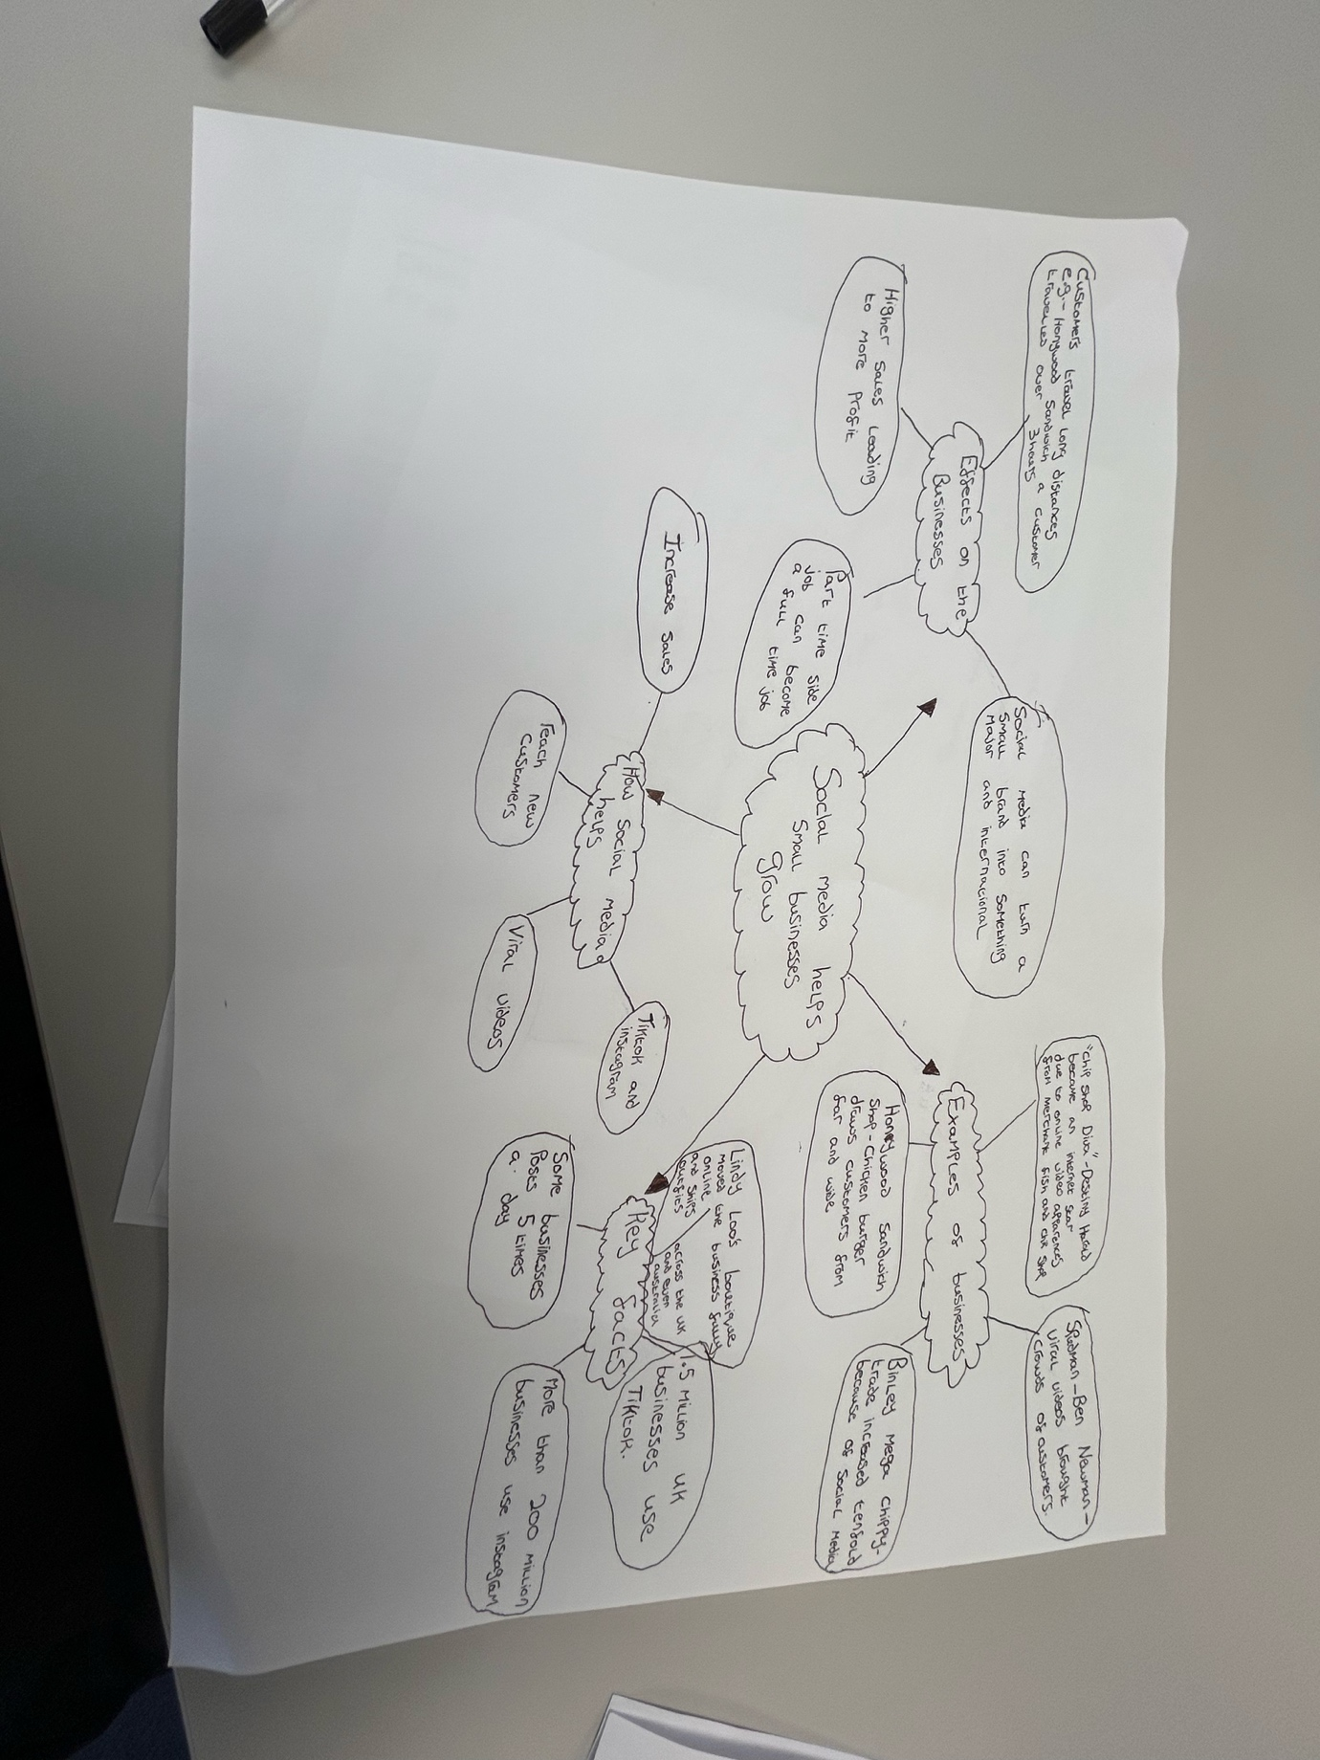

PART 2:
- Answer every question below in 1-3 full sentences.
- Use your own words. Do not use generative AI to answer these questions.
- Include a specific detail from the text when asked.
REMINDER
- The main idea is the overall message of the whole text.
- A key point helps to explain the main idea.
- A specific detail or example from the text shows that the key point is true.

- What is the main idea of the whole text?

The main idea of the text is to show how social media apps such as instagram, TikTok and Facebook can help develop a business by increasing customers due to people viewing the videos.

- What is one key point that supports the main idea, and which specific example from the text shows this?
One key point is social media can increase a businesses customers and sales. An example of this is honywood sandwich shop whose chicken burger became popular online and had attracted customers from over 3 hours away to try it.

- What is a different key point that supports the main idea, and which specific example from the text shows this?
Another key point is social media attracts customers from worldwide. An example of this is Lindy Loos boutique as they ship outfits across the uk and Australia

- Which part of the text do you think is most important, and why?
The most important part of the text was where it said 1.5 million businesses in the uk use TikTok as this shows a lot of businesses rely on views/engagement from TikTok to promote the business.

Reflection:
- What did you find difficult in this task (including in-class components), and why was it difficult?
I found it a bit difficult to read the paragraphs and to be able to only take out the key main facts as I thought there was quite a bit.

- What helped you with this difficulty, and how did it help you?
By skimming the text I was able to identify the key facts in the whole context and shorten it down.

