Chapter 4- Presentation and analysis of data
This chapter will be focusing on the analysis and presentation of data which was collected from the survey that was discussed in Chapter three.
The information gathered from the data aims to identify the following points:
- To explore public opinion/perspective on routinely arming the police in England and Wales.
- To evaluate whether routinely arming officers increases public confidence in the police
- To explore the impact of routinely armed officers in neighbouring countries
To ensure anonymity during the survey, only information relating to age range and gender was sought . No other personal data was collected. In total the survey received 22 respondents and was made public for 4 weeks. The survey was targeted at UK residents who are not currently associated with any UK police force.
The demographics of the respondents can be seen as follows;
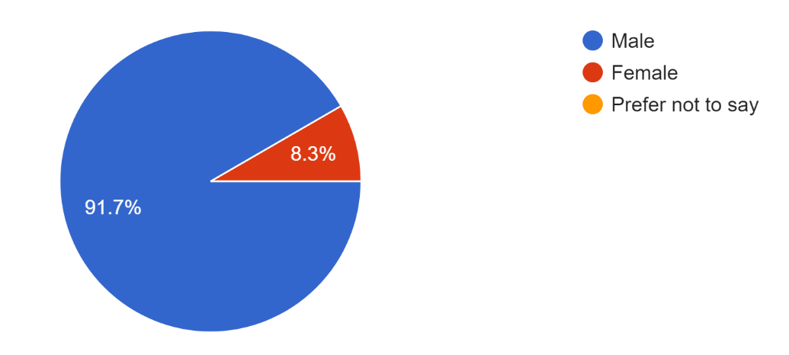

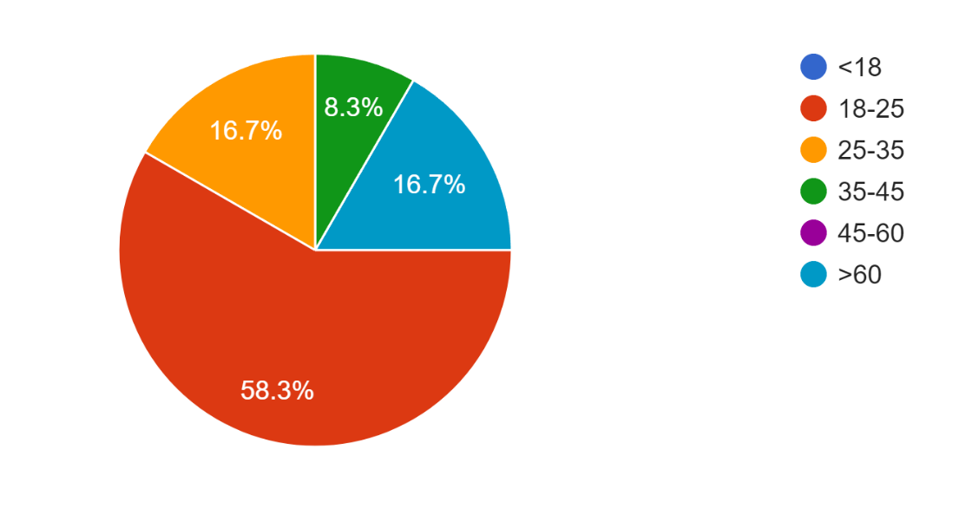

Looking at this data, it can be seen that 91.7% of respondents were male with most of these being aged 18-25.
Perspective on routinely arming police officers
When asked whether they believe that British police officers are currently appropriately equipped, 75% of respondents said that they believe that they are.
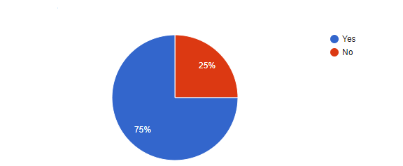

When asked why they thought that British police are currently appropriately equipped one participant stated that ‘They adequately respond to all types of situations today’ while another stated that ‘They have tasers and batons to contain a violent person. They do not need anything else’. This appears to be the consensus among participants who state that the police are currently appropriately equipped.
However, 25% of respondents stated that they do not believe that the police are currently appropriately equipped. Many respondents provided reasons for this opinion. One participant who believed this stated ‘They are literally at risk of being stabbed by kids every single day, they need more protection’.
The data collected from my survey clearly shows that the majority of respondents think that the police currently carry the correct level of equipment to police effectively in the UK.
Similar research was carried out in 2015 by BMG Research. Data collected from their survey concluded that 58% of participants said that they “believed police officers should be routinely armed, whereas 42% were opposed” (BMG Research, 2015). These results could be due to several factors which include, but are not limited to, sample size and the demographic of people surveyed. The data from the survey was also collected around the time when numerous terror attacks were taking place. This could have impacted their opinions; however further research would need to be conducted to draw an exact conclusion to this.

Following on from this question, participants were asked whether they would support British officers carrying a firearm as part of routine equipment. The results can be seen below;
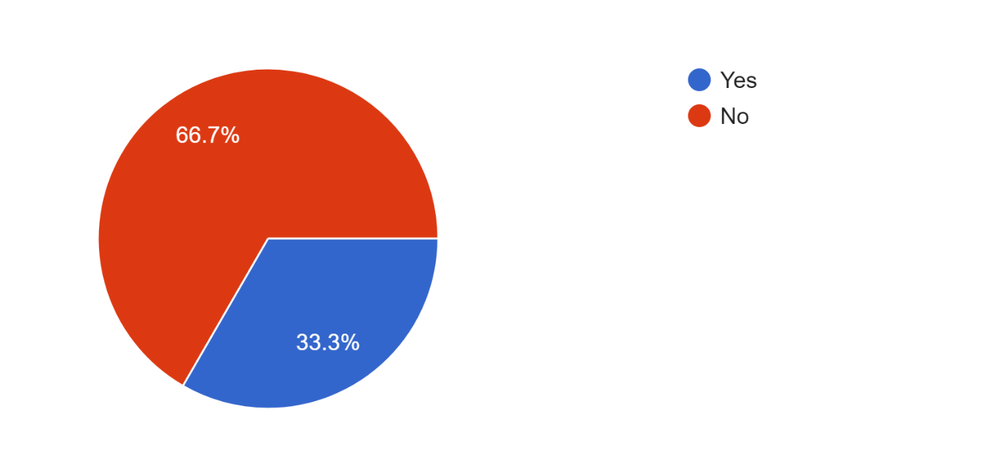
The data shows that 66.7% of respondents do not believe that officers should routinely carry a firearm while 33.3% believe they should. These percentages are very similar to the previous question, however some people who previously stated that they believe that officers are already appropriately equipped, would still support officers becoming routinely armed.
Respondents were again asked for reasons for their choices. One respondent who does not believe that officers should be routinely armed stated ‘Considering that criminals in the UK are rarely armed with guns, I don't see any reason to equip policemen with guns either. In the occasional situation where guns are needed, firearms officers tend to be incredibly quick, so there's no reason for beat officers to carry them’.
Another respondent also suggested something similar by saying ‘Arming the police makes it more likely that serious criminals will be armed’. These are just a few of the reasons provided by respondents as to why police should not be routinely armed. These opinions are echoed multiple times and appears to be one of the main arguments against arming officers.
Respondents who support arming officers also provided reasons for their opinion. These included but are not limited to the belief that it would ‘Enable police to protect the vulnerable more easily and safely’. Another prominent opinion was ‘Police would be able to deal with acts of terrorism and violent offenders without risking the safety of others’. These results show that the most echoed argument provided by supporters of routinely arming police revolves around protecting themselves and the public from acts of terrorism.

The next question in the survey asked participants if they believed that officers would ever become armed in the UK. The results can be seen below.

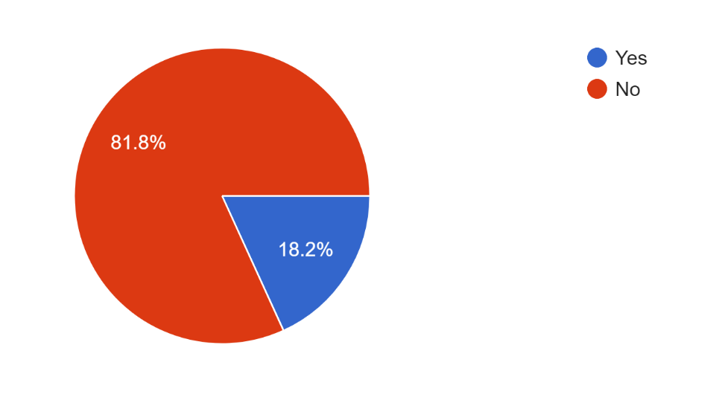

Interestingly, looking at the responses to this question, 81.8% of respondents did not believe UK police would ever be routinely armed. Analysing these results further it can be seen that, even the majority of those who support arming officers, do not believe that routine arming would ever take place. Some of the reasons provided for this include ‘most people in Britain would not support this out of fear of Britain becoming like the USA where police shoot many innocent people’ and ‘British officers are traditionally unarmed and arming officers would completely ruin this image’

How would routinely arming officers’ effect the public confidence and police image.
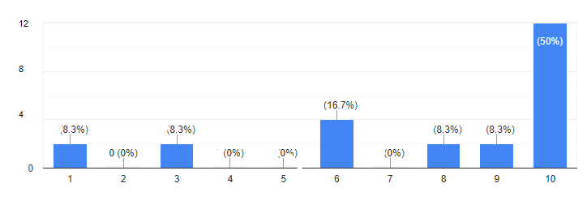
Participants in the survey were asked how comfortable they feel approaching officers currently. The results can be seen in the graph below.
No. Participants
Level of confidence

This graph shows that 50% of respondents are very comfortable approaching officers while only 8.3% feel very uncomfortable. The rest of the respondents lay somewhere in between with the majority (83%) feeling somewhat comfortable with approaching officers.

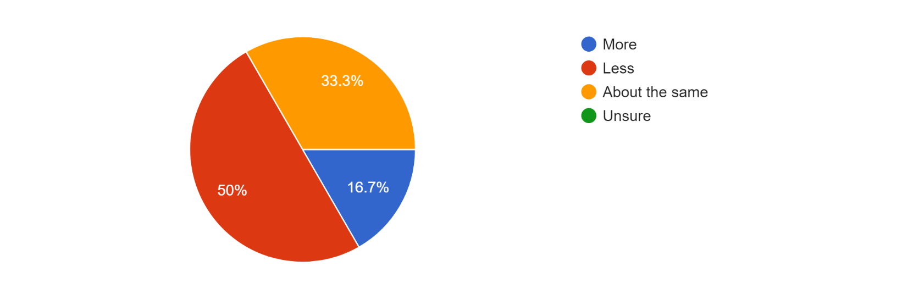
The participants were next asked if they would feel more or less comfortable approaching officers if they were armed.

When answering this question, 50% stated that they would feel less comfortable approaching officers if they were armed, while 16.7% stated that they would feel more comfortable. The remainder of the respondents (33%) said they would be as comfortable approaching officers regardless of whether they were armed or not.

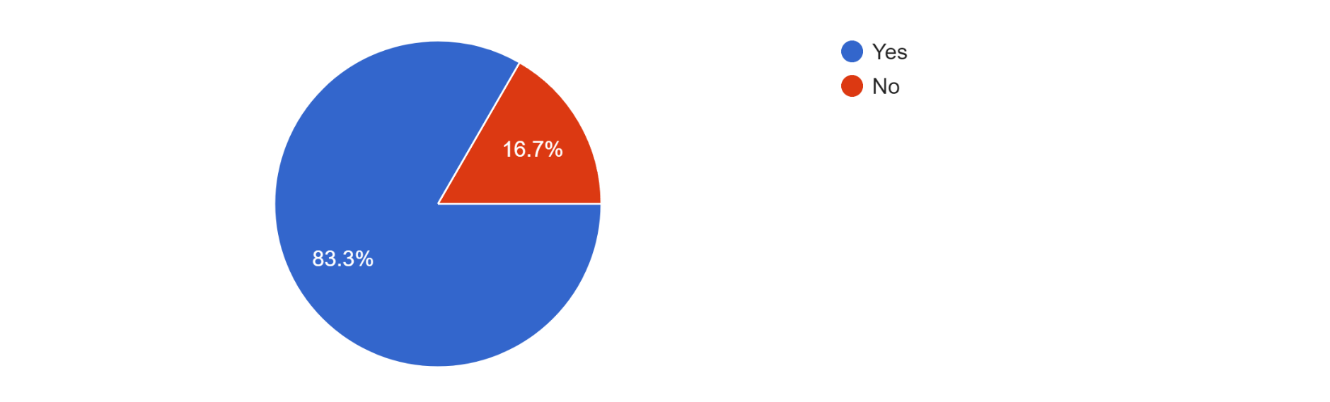

83.3% of respondents also stated they believed that public confidence in police would decrease if they were armed with 83.3% also believing that police involved shootings would increase.
Some of the reasons provided for confidence decreasing included the following quotes: ‘I don't trust them with deadly weapons, to be honest. Most of them probably wouldn't kill anybody, but that's not good enough’ and ‘It is unnecessary and would inevitably lead to the deaths of innocent people’
This data appears to agree with previous research. Yesberg, Bradford and Dawson (2021) stated public acceptance of armed officers is often linked to a strong emotional response rather than a logical one. When “Lacking direct knowledge of what armed police can do and achieve, people fall back on emotion, feeling, and trust to form preferences about policy” (Yesberg, Bradford and Dawson, 2021).
Although it cannot be fully proven, in this instance it would appear that this is the case in these responses as there is no data to suggest that routinely arming officers would lead to an increased number of police shootings.

The final question in the survey related to the perception respondents had of routinely armed officers while travelling abroad.

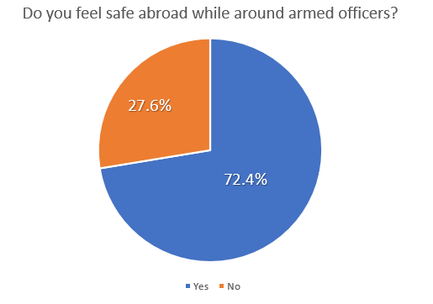

The results were extremely interesting with the vast majority of participants 72.4% indicating that they did feel safe around armed officers. This is in complete contrast to the result of the earlier question when 50% of people replied that they would feel less comfortable if UK police officers were routinely armed. I feel this is an area that would benefit from further research in order to try to establish the reasons why people tend to feel secure and comfortable around routinely armed police abroad but not at home in the UK.

1278 word count

