
University of Wales Trinity Saint David

Assignment 1 – Report from the Line Manager of ‘DRINK, SHOP & DO’ for the inclusive business communicational skills, theories, and tackled barriers in diverse workplace

Module Name: International Business Communication
Module Code: LCBB6001

Student Name: Pavlinka Todorova Veleva
Student Number: 2028165

Lecturer Name: Riaz Bhatti
Date: 20.08.2023

Table of Contents

Introduction of British business communication 3
About the company – ‘DRINK, SHOP & DO’ 3
Application of intercultural and international communicational theories 4
Different communication barriers experienced by a diverse workforce in the UK 7
Providing an appropriate communication strategies and relevant recommendations to enable the organisation to succeed and providing a positive environment for everyone 7
Conclusion 8
References 8

Introduction of British business communication

Communication is a skill that takes up a massive part of everyone’s life in every aspect from everydayness to the workplace. Communication is a tool that can connect two or more people. But for successful communication, it is important to be inclusive, to remove all tackles, and it has to promote equality and diversity. We can communicate in two ways – verbal and non-verbal:
- Verbal communication is every type that uses words and can be spoken – phone calls, conversations, or presentations, or written – emails, letters, or texts.
British people are self-deprecation and indirect communicators – that means they are so polite and discrete in making a conversation without ‘rocking the boat’, but usually people have to read through the lines because the answer is not directly said. Also, British humor is involved a lot in the conversations.
- Non-verbal communication – every type which doesn’t use words – visual or body language.
British people usually are keeping their faces straight and serious face, even if they have been offended. They appreciate the personal space and wouldn’t like this to be impaired. The physical contact and the gestures are quite reserved.
It depends on what type of information the audience should understand we should influence our way of communication.
Inclusive communication should not discriminate or exclude anyone. Also, we have to know that people are different, but all should be treated in the same good way (William B. Gudykunst, Bella Mody, 2022). This type of communication is extremely important in the workplace to ensure the well-being of all employees or customers. The effectiveness of this process will ensure the business's success. As a line manager, I aim to empower all colleagues to communicate effectively.. (Watts, 2022)

About the company – ‘DRINK, SHOP & DO’
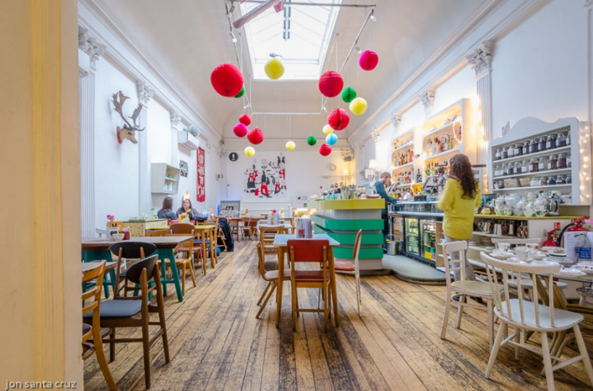
Drink, Shop & Do’ opened its doors temporarily in 2009 around Christmas and permanently in 2010 in King’s Cross, Nort London. ‘Drink, Shop & Do’ is a shop, craft place, café by day and bar by night with a lot of fun activities at all times to do. Coralie Sleap and Kristie Bishop are friends from their childhood and the founders of the organization.
The idea of launching the café came from their childlike, nostalgia-laden activity nights which as a result differentiated the living room into a successful business. After life made them and their friends’ successful people with great careers, they found out that the night in the house basically has the potential to be a great escapist and magical place where to have fun and break up the monotony of the rushed adult life.
At first, they opened the café to see if it was going to work outside of their friends’ group because at that time nobody had done something similar as business. The café has a simple menu – afternoon teas, cocktails, cake trays, sweets, sandwiches, salads, and breakfast food.
As a shop, ‘Drink, Shop & Do’ are selling everything from tables and chairs to everything on the walls, even the cup which you have been served in could be bought.
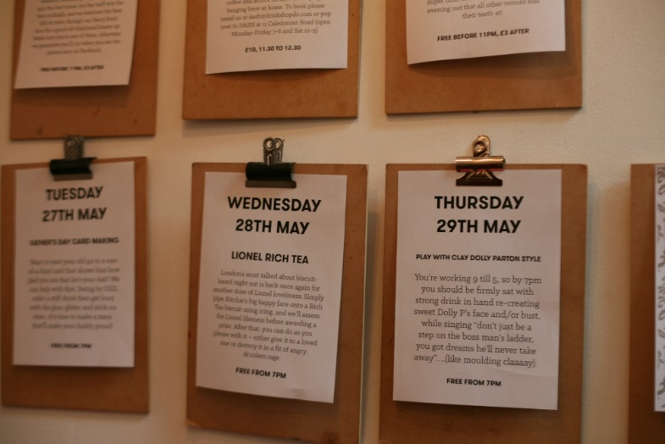
As a craft place, people can make gifts, cards or stationery, and coffee books.
This local institution became popular with its hen parties, big crowds, and the prizes ‘Timeout’s Top 5 Nightclubs in London’ and ‘Restaurant and bar design awards’.
The organisation has 36 employees and mostly they are from different counties like the United Kingdom, Poland, Portugal, Belgium, Greece, and Switzerland.

Application of intercultural and international communicational theories

Intercultural communication is required in the workplace, especially in companies with staff coming from different nationalities. This type of communication includes a wide range of processes and problems in organizations with people from different social, ethnic, and educational backgrounds. The aim is to support those with differences. (Panocova, 2020)
In ‘Drink, Shop & Do’ there are 25 employees from England, 3 from Poland, 4 from Greece, 2 from Belgium and 2 from Switzerland.
These differences could be overcome by one of the applications of International communicational theories called Hofstede cultural dimension theory – this model is published in 1970 by Dr Geert Hofstede after big research in 50 countries around the world. Since its launch, the model became standard for recognizing and minimizing the differences between people with different cultures. It is divided into 6 dimensions:
- Power Distance – this index measures how is spread the power through society. In the UK, it is low (35) which means the structure of the organization is flat and the hierarchy system is only for convenience. British people believe that general inequality should be removed. Switzerland has a score of 34 which is the same as the UK. The difference in Greece, Poland, and Belgium have an index around 60 which means in their countries the managers are telling the subordinates what to do, hence the Greek, Polish, and Belgium employees will have different understandings of ‘managing’ which has to be made to work in one way;
- Individualism – UK score is high (89), which means British people take care a lot for themselves and their families, and also they appreciate privacy. Poland, Belgium, and Switzerland score around 60, so they will not have huge differences with the UK. In difference, Greek people score low (35) and have an interest in group values ahead of their own. They have to adopt this individualism and apply it within the company.;
- Masculinity vs Femininity – it is considered fairly ‘Masculinity’ with a high score (66) in the UK. British people value competition, achievements, and success. Greece, Poland, Belgium, and Switzerland also score high – around 65, so here they do not have any differences in this aspect;
- Uncertainly Avoidance – UK shows low interest (35), which means the British are feeling comfortable with unknown futures and uncertainty. Greece, Poland, and Belgium scored 100, 95, and 94, so they prefer to avoid uncertain situations. For these two nationalities could be difficult to deal with UK norms and this difference should be removed in order for a smooth process. Switzerland are neutralist in this aspect, which means they will adopt the differences easily;
- Long-term orientation – UK scores neutrally (51) which means it reconciles with the challenges in the present but also saves the links with the past. Greece and Poland have almost the same score so here they may not have challenges. Belgium and Switzerland score 85 and 74, so they are more pragmatic and accommodating of change for the benefit of solving present challenges;
- Indulgence – the UK has a high score (69) and low impulse control and the tendency to try to make true its desires. Greece and Belgium are staying in the middle with around 55 score – they prefer to give the same importance to both – leisure and career. Poland has a score of 29 so they need to take the work seriously and not spend too much time on leisure;
Cultural sensitivity means the company should know that the differences like behavior, learning, and communication style exist between the individuals and hence there could be issues if it is not suggested link to connect all of them. The United Kingdom is multi-ethnic and diverse country, and that is why the companies prefer to open an office or to settle their company there. That is one of the reasons why the staff of ‘Drink, Shop & Do’ is multi-national.
The UK business culture is influenced by the following:
- Principles like Politeness, punctuality, and discipline;
- Top to down oriented hierarchical system – managers stay on side at a distance, but there are different levels in the organization, which helps in the decision-making process;
- Not too high level of importance of personal relationships – British people may enjoy working among people with the same interest as theirs;
- Long-term relationships, including pub/restaurant lunch or office meet;
- ‘Tongue-in-cheek’ – humorous and sarcastic way of speaking in serious manner;
Meeting management – usually starts with small talk to break the ice. The arguments should be accompanied by examples. The final decision is not made at the first meeting.
Time management – punctuality and being on time are highly respected. In case of being late, the person should inform the participants and apology. A strictly scheduled meeting is required at least a few days in advance.
First contact – communication by email, face-to-face meetings, or conference calls. British people respect the acquaintance of the partner.
Greetings – firm handshake with direct eye contact. If the person tells you their first name then say: Mr./Mrs. … If not Mr./Mrs. and their surname.
Gift policy – the gift is not necessary, but if there is a gift it should be not too expensive or not too cheap.
Dress code – formal business suits.

Here are some advantages of the culturally diverse company:
- Different perspectives can inspire innovation and creativity’;
- Lead to more effective marketing strategies;
- More acceptable range of products and services due to different skill base;
- More productive teams and better performing;
Here are some disadvantages of cultural sensitivity company:
- Some employees could felt not enough empowered to contribute;
- Different prejudice – Different cultural stereotypes;
- Professional communication could be difficult to be understand;
- Different understanding of business etiquette could be an issue; (Martin, 2014)

In my opinion if there is effective international communication at the workplace and brief introduction to all of the laws, restrictions and norms, nothing could be a problem within one company.

Different communication barriers experienced by a diverse workforce in the UK

Sometime could be difficult for one company to become inclusive because of the barriers sitting somewhere there like:
- Unconscious bias/judging – the preference for these individuals who are similar to us in terms of age, gender orientation, or race. However, educational courses are available for those who want to overcome this barrier.
- Shortage of important positions – teams made from the same gender or race are not welcoming for somebody who is different from them.
- Communication barrier – language issues among with differences in time management and personal life schedules.
- Shortage of training – if the education it is not enough there could be challenges between the employees. (Demudu Naidu Jureddi, 2016)

Providing an appropriate communication strategies and relevant recommendations to enable the organisation to succeed and providing a positive environment for everyone

Better communication and accepting everyone what it is in a diverse workplace are core elements for enabling the organization to succeed. There are some strategies that every HR Manger has to use in order to have sticked team:
Using clear and straightforward language when communicating with diverse audiences is important as well as slower talking and keeping smiling. Also, avoid jargon phrases and everyday chat. For example, you could say, “That sales report was fantastic!” Instead of, “That sales report was a slam dunk!”
Surprisingly the body language is also different for different nationalities – for the UK the handshake is a common thing, and some nationalities could take this greeting as disrespectful as well as eye contact. Also, different nationalities have different levels of comfort and personal space zone.
Repeating and paraphrasing words is always good because can avoid mistakes and misunderstandings.
Be open to other cultures – staying in touch with your employee’s traditions makes the relationship between you two deeper. (LifeWorks, 2021)

Conclusion

A culturally inclusive and diverse workplace is a modern aspect of the company’s growth which guarantees more innovation, effectiveness, and becoming a better place for work. But on this journey, the company is faced with different challenges and barriers which could be easily removed. In conclusion, I assumed that in the workplace everyone should be valued and comfortable, no matter the differences like age, nationality, gender and etc. In ensuring a diverse and inclusive workplace, employees are giving all of themselves in order to company and business success. When I tried to get familiar with all my colleagues, my most important aim was to approach everyone one by one and learn about their listening and communication styles. Then I became an inclusive speaker, and active listener, and left sympathy aside. I believe effective communication is the key to business growth and maintaining community well-being.

References

Demudu Naidu Jureddi, N. (2016). BARRIERS TO EFFECTIVE COMMUNICATION. VEDA’S Journal of English language and literature, 115.
LifeWorks. (2021, 04 1). Effective Communication in a Culturally Diverse Workplace. Retrieved from Heartbeat: https://wellbeing.lifeworks.com/au/newsletter-content/effective-communication-in-a-culturally-diverse-workplace/
Martin, G. C. (2014). The Effects Of CulturalDiversity In The Workplace . Journal of Diversity Management, 89-90.
Panocova, R. (2020). THEORIES OF INTERCULTURAL COMMUNICATIONS. Kosovo.
Watts, C. (2022, 07 27). How to Promote Inclusive Communication in the Workplace. Retrieved from High Speed Training: https://www.highspeedtraining.co.uk/hub/inclusive-communication-in-the-workplace/
William B. Gudykunst, Bella Mody. (2022). Handbook of International and Intercultural Communication, 2nd edition. California: Sage Publications.

