
Module: Marketing Management
Module Code: LCMB7024
Developing A Sustainable Brand Extension Marketing Strategy for Apple Ecopods
Student Name: Unnatiben manojbhai patel
Student Id: 2532975

Table of Contents
Element 1: Sustainable Brand Extension Poster Presentation 3
Element 2: Develop a Segmentation, Targeting, Differentiation, and Positioning (STDP) 4
Element 3: Marketing Mix (4Ps) 8
3.1 Product 8
3.2 Price 9
3.3 Place 10
3.4 Promotion 11
Element 4: Reflection (Gibbs Reflective Cycle) 12
4.1 Description 12
4.2 Feelings 12
4.3 Evaluation 12
4.4 Analysis 13
4.5 Conclusion 13
4.6 Action Plan 13
References 14
Appendix: Element 1 content 18

Element 1: Sustainable Brand Extension Poster Presentation
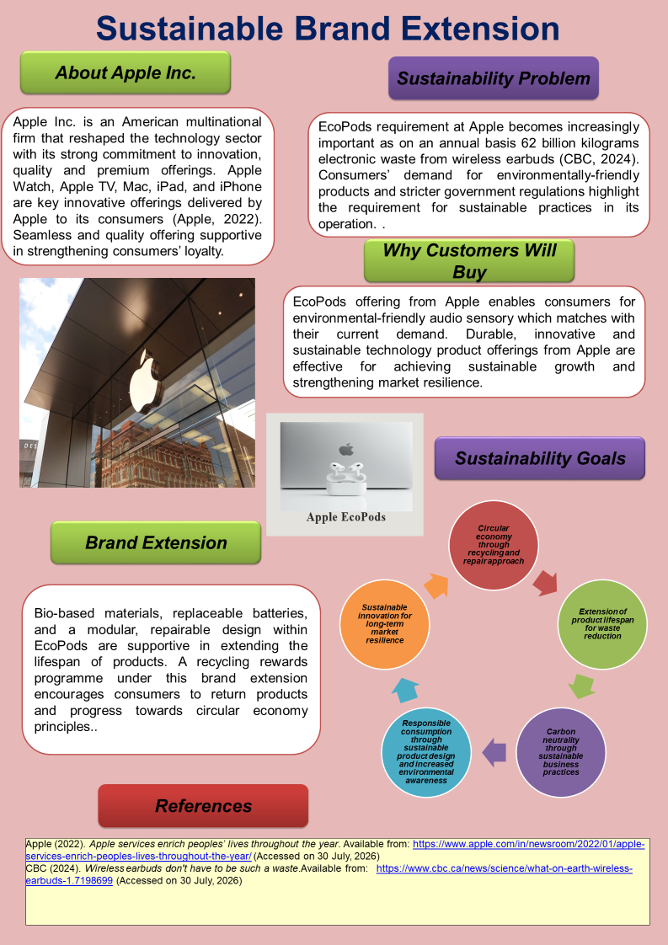

Element 2: Develop a Segmentation, Targeting, Differentiation, and Positioning (STDP)
1. Segmentation
Segmentation is the process of grouping consumers with similar kinds of interest and characteristics to develop effective marketing strategies (Chaubey and Subramanian, 2023). Geographic, demographic, psychographic, and behavioural segmentation have been done for finding ideal consumers for Apple’s EcoPods.
Geographic Segmentation: Apple’s strong consumer base is in countries such as the UK, USA, Japan, Germany, Australia and the Netherlands, where there is high-level environmental awareness and purchasing power, which makes suitable choice for the initial target for brand expansion (Kotabe and Helsen, 2022). Brand recognition and strong infrastructure support for sustainable brand success.
Demographic Segmentation: Under this segmentation process, it targets consumers who are aged between 18 and 45, including both males and females. Educated and technologically aware remote workers, students, entrepreneurs and middle- to high-income professionals are key targets.
Psychographic Segmentation: Innovation, sustainability, long-term product life span, and ethical consumption are highly valued by consumers who prefer a premium lifestyle (Vuong, 2022). Aligning with the modern lifestyle, this firm targets these consumers, which is effective for easy growth.
Behavioural Segmentation: Heavy wireless earbud users are key targets under this segmentation for Apple EcoPods expansion. There is a growing level of preference for sustainable, extended battery life, reparability, and premium sound quality from fitness enthusiasts, office workers and commuters. The main behavioural segment for its product is Apple One subscribers and users with Apple’s ecosystem who are willing to pay for premium products as they have to upgrade their devices on a regular basis (Herzer, 2026).
From a critical view point segmentation approach is supportive for Apple in building a robust marketing approach that easily captures audiences and supports the growth in business and strengthens resilience in a dynamic and competitive business market.
2. Target Market
Target Market | Consumer Groups | Reason for selection
Primary Target | Existing Apple users including younger generations like Millennials, Gen Z and professionals with higher level eco-consciousness | These groups are mainly targeted for EcoPods sales as their strong environmental awareness and trust for brands support business growth (Jalalzadeh and Momeni, 2024)
Secondary Target | Students, fitness enthusiasts and corporate sustainability buyers | Sustainable and durable wireless audio devices are demanded from this group with growing awareness on sustainaibility
Table 1: Target Market
(Source: Self-developed)
Differentiated targeting approach adoption is the priority for Apple's EcoPods. As it targets consumers who highly prefer premium sustainable technology in their daily life usage. Innovative and environmentally responsible products are key preferences among existing consumers in Apple, including eco-conscious consumers, which makes them its primary target consumer (Lal and Bhardwaj, 2025). While Students, fitness enthusiasts and corporate sustainability buyers also seek environmentally responsible products, which makes them Apple’s secondary target consumers. Sustainable product offerings with superior features are effective for capturing the attention of this group achieve significant growth and enhanced share in the market.
3. Differentiation
Premium audio technology with a sustainability focus in Apple EcoPods offerings helps it maintain a unique market position and differentiation over its competitors like JBL, Samsung, Sony, Bose and Nothing. Product lifespan from Apple’s EcoPods is enhanced due to its replaceable batteries and modular, repairable design. Environmental value is enhanced with the use of bio-based materials and a biodegradable charging process (Okolie et al., 2023). A superior and seamless experience can be received by consumers as EcoPods are well integrated with the Apple ecosystem. Its advanced features, including Siri compatibility, spatial audio, and automatic device switching, cannot be replaced by its competitors, that strengths its resilient market position. Premium brand position and successful expansion in business are supported by its business processes, like AppleCare+ support. Apple Rewards recycling programme and battery replacement services. Within the premium wireless earbud market, this firm thus can receive significant market growth, a resilient position and competitiveness.
4. Positioning
Apple EcoPods' position is as sustainable and premium pods that is built responsibly and ethically. Today’s consumers are increasingly demanding earbuds that are durable, have superior sound quality and have long-lasting performance (Jaeger-Erben et al., 2023). All such demands are well matched to the offering through EcoPods. Bio-based materials use, recycling and reusable batteries help in decreasing electronic waste and achieving sustainability in operation. Besides progressing towards circular economy principles, it also ensures a premium experience to its consumers that supports strategic operational growth and competitive positioning within this dynamic and technologically advanced business market.
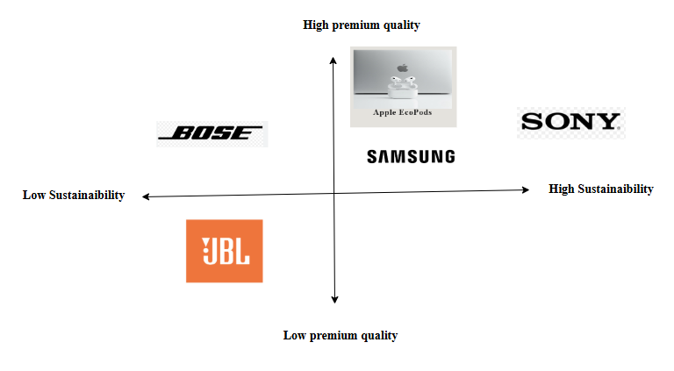
Figure 1: Positioning map
(Source: Self-developed)
The above positioning map reflects that Apple EcoPods have both premium quality and a sustainability focus that provide a better consumer experience and also protect the environment from degradation, reducing waste levels. Samsung and Sony also prioritise quality and sustainable performance from their offerings. Bose’s offering is of high quality, though it prioritises less on sustainability. Whereas a low-premium and low-sustainability offering is seen in the operation of Bose. Overall, Apple’s priority for both quality and sustainability is supportive for achieving a higher level of operational growth and maintaining a competitive position.

Element 3: Marketing Mix (4Ps)
The marketing mix offers a strategic framework for successfully introducing the Apple Ecopods as a sustainable brand extension. This section effectively applies the 4Ps such as product, price, place and promotion to showcase how each element supports customer value, fortifies the competitive positioning of Apple, and also closely aligns with the sustainability objectives as well as the long-term business growth strategy of the company.
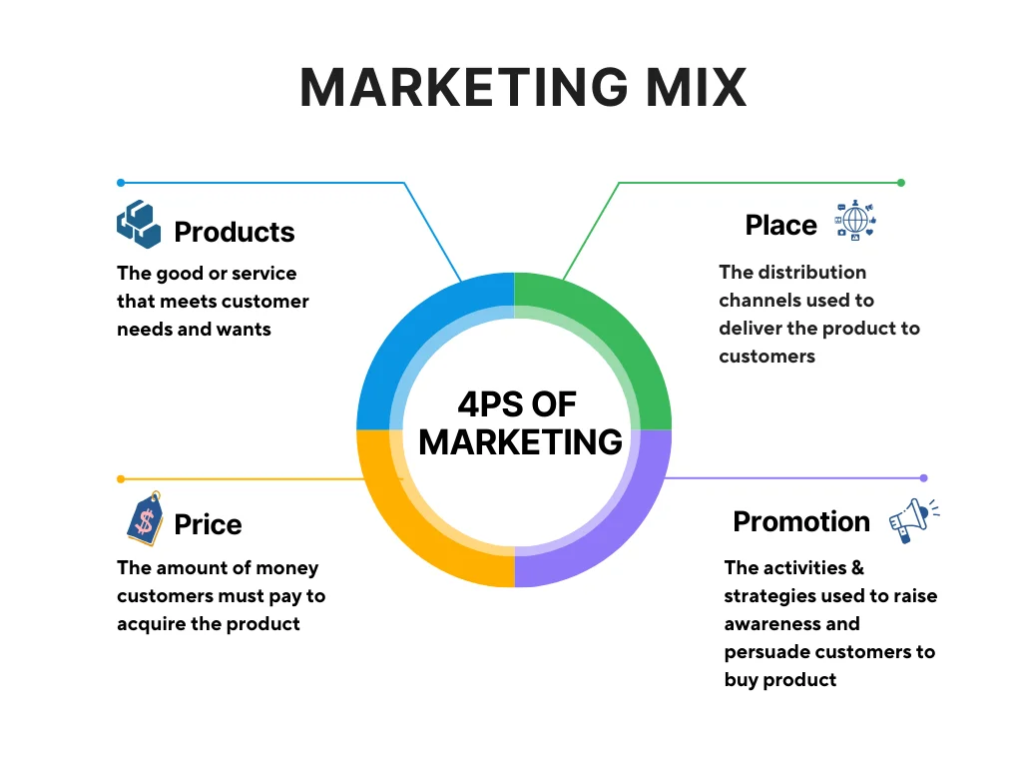

Figure 2: 4 Ps of Marketing
(Source: Nguyen, 2025)

3.1 Product
The product strategy for Apple EcoPods is solely on extending the premium audio portfolio of Apple while addressing the growing environmental concerns through the help of sustainable innovation. Unlike the conventional wireless earbuds from the key competitors like JBL and Sony, which basically have limited repair options as well as non-replaceable batteries, Apple EcoPods will include bio-based materials, replaceable batteries, modular components, along with a biodegradable charging case to extend the lifespan of the product while diminishing electronic waste (Miragenews, 2026). These features closely align with the sustainability commitments of Apple through supporting the circular economy principles as well as responsible consumption while maintaining the high-quality sound performance, Active Noise Cancellation, Transparency Mode, and thus offer an immersive ecosystem integration which is expected by Apple users.
The research work of Sohaib et al., (2023) revealed that the product strategy needs to develop a sense of superior customer value through satisfying the functional, emotional, along with the societal needs of the key users. Compared with the standard premium earbuds, which encourage frequent replacement, EcoPods foster long-term ownership through the help of repairability, AppleCare+, Trade-In, and Recycling Rewards programmes, and thus not only diminish the lifecycle costs but also fortify customer loyalty. This approach showcases that sustainability can boost instead of compromising the overall quality of the products. It reinforces the premium brand positioning of Apple while differentiating the EcoPods through the help of innovation, environmental responsibility and long-term value creation as well.

3.2 Price
Apple EcoPods will embrace a premium yet value-based pricing strategy with an estimated launch price of US$299, which reflects the advanced technological features, sustainable design and ultimately the strong brand reputation of Apple. Consistent with the existing pricing approach of Apple, the higher prices of the products convey both the innovation and superior quality of Apple (Nagle et al., 2023). However, unlike many competing wireless earbuds from popular brands like the Nothing and JBL, which initially compete through their lower pricing strategies, EcoPods justify their premium through presenting replaceable batteries, repairable components and finally the environmentally friendly materials, which maximise the long-term value. Despite the initial purchasing cost of this product being very high, users get advantages from the lower lifetime ownership costs because the product can be repaired and managed rather than being frequently replaced (Roskladka et al., 2023). From a value-based pricing perspective, customers showcase their willingness to pay more when they perceive greater functional, emotional, as well as environmental advantages. Moreover, the premium pricing also supports the investment across sustainable materials, recycling initiatives and finally the circular production practices and thus reinforces the environmental commitments of Apple to achieving carbon neutrality across its entire carbon footprint by 2030 (Negro, 2025). In essence, it can be asserted that pricing strategy not only strengthens the premium market positioning of Apple but also closely aligns with the sustainable brand extension through balancing a sense of profitability, customer value, along with responsible consumption and thus generates a competitive advantage over lower-priced alternatives.

3.3 Place
Apple EcoPods will embrace an Omni channel distribution strategy through utilising the extensive global retail as well as digital network of Apple incorporating more than 530 Apple stores across the world, the Apple websites, Apple store app and finally the authorised retailers like the as Best Buy, Currys, Amazon, and Reliance Digital (Apple, 2025). Compared with the key competitors like JBL and Nothing which basically dependent on third-party distribution, the integrated retail ecosystem of this company presents a sense of greater control over the customer experience, after sales supports and sustainability initiatives as well. This allow the potential customers to easily access towards the battery replacement services, in combination with the Trade-In programmes, recycling rewards and thus supports the principles of circular economy.
Moreover, Apple’s distribution strategy also closely aligns with its environment commitment of Apple 2030 to become the carbon neutral within its entire value chain by the end of 2030. Not only this, the organisation has also transitioned to 100% fibre based packaging, maximised the utilisations of the renewable energy across its retail operations and supply chain and continues to invest across its lower-carbon transportation and logistics (Apple, 2026). These initiatives not only diminish the environmental influence of the product distribution but also manages the global availability. Therefore, unlike the competitors which primarily compete on distribution reach, the place strategy of the Apple closely amalgams the accessibility with measurable sustainability commitments, fortifying the EcoPods brand extension and reinforcing its premium market positioning.

3.4 Promotion
Apple EcopPods will be promoted through an integrated marketing communications (IMC) strategy which amalgamates digital advertising, public relations, social media, influencer partnerships and finally sales promotions in order to communicate both the premium quality and sustainability. Unlike competitors including Samsung and Sony, which often highlight technical performance, Apple can differentiate the EcoPods through emphasising its environmental value along with innovation (Amiri et al., 2025). Promotional activities will incorporate Apple Events, the Apple website, YouTube, Instagram, TikTok, and finally collaborations with technology reviewers to showcase the sustainable yet repairable features of the EcoPods.
Moreover, the trade-In, recycling rewards and student discounts will further motivate responsible consumption among the users. Moreover, supporting Apple’s 2030 commitments to carbon neutrality, the campaign message such as "Hear the Future. Sustain the Present." reinforces both the environmental as well as premium value of the product. This integrated promotional strategy not only strengthens the brand credibility but also customer engagement, along with the success of the sustainable brand extension.
Overall, the integrated marketing mix allows Apple EcoPods to strengthen its sustainable brand extension through developing superior customer value, supporting the environmental objectives and finally managing the long-term competitive edge.

Element 4: Reflection (Gibbs Reflective Cycle)

4.1 Description
By drawing a poster presentation, I analyse Apple EcoPods' impacts in the evolving marketplace that strengthen its sustainable brand extension through raising superior customer value. It helps me to gain knowledge about marketing theories. Therefore, the study helps me to develop a marketing mix model like STDP and build a brief marketing strategy. Besides that, I restructured and demonstrated a poster that includes the significant features like strategic positioning, target market, and sustainability benefits of Apple EcoPods in a visually appealing and concise manner.

4.2 Feelings
At the start of the project, I felt nervous and interested (inspired by Nurmasadah et al. 2022). Since I know about the company Apple, the sustainable brand extensions need me to think about something that goes beyond conventional marketing concepts and research on social and environmental aspects. After that, I became confused as to how to incorporate sustainability into a company’s premium branding without compromising the product quality. With the progression of the study, my confidence rose as I acquired better knowledge about the circular economy principles and sustainable marketing. On the other hand, I felt pressure in the time poster preparation stage, as demonstrating the critical data in an engaging and transparent format was challenging.

4.3 Evaluation
I gained a positive learning experience as the 4Ps, such as product, price, place and promotion, to showcase how each element supports customer value and fortifies the competitive positioning of Apple. As a result, I became able to identify my key strengths, such as analytical and research skills. Besides, I successfully collected information from company publication an industry reports, along with academic journals, an apply it with in study. Therefore, other key areas, such as my strategic thinking skills, assist me to connect Apple's long-term business goals and premium brand image with sustainability objectives
In spite of these strengths, I find out my weaknesses, such as time management (inspired by van Sluijs and Matzat, 2024) As I take longer time to collect data an analysis the sources which decreases the time to make an efficient poster. Therefore, the presentation confidence lowers my confidence, and I am unable to understand the content appropriately. As a result, I was not able to present my ideas properly, and it impacts the communication effectiveness (inspired by Leon, 2023).

4.4 Analysis
With the progression of the study, I realised that this project raised my understanding about the marketing mix and STP analysis. Therefore, I gained knowledge about sustainability, which can be implemented within premium brand strategy without lowering the user value. The utilisation of academic research also developed a more competitive and realistic marketing strategy and made evidence-based decisions for the Apple EcoPods.

4.5 Conclusion
By analysing the whole think it is concluded that this project raised my knowledge and understanding about strategic marketing and brand development. Therefore, as it raised my problem-solving, analytical and research skills, whole raise my knowledge about business that can manage environmental, profitable, and innovative way.

4.6 Action Plan
In future projects, I will raise my time management skills through giving more time for closely monitoring my work and building a structured work schedule. Therefore, I will raise my presentation confidence with the help of feedback and regular practice. In the end, I will plan to give comprehensive competitor analysis and utilise more market data to raise future marketing insights.

References
Amiri, S.M.H., Goswami, P., Barmmon, C.K., Islam, M.M., Hossen, M.S., Hasan, S.M. and Amiri, N.A., (2025). ‘The Green Tech Revolution: Balancing Innovation and Environmental Protection’. https://www.researchgate.net/profile/Sayed-Mahbub-Hasan-Amiri-2/publication/394889084_The_Green_Tech_Revolution_Balancing_Innovation_and_Environmental_Protection/links/68ab45006327cf7b63d90bd1/The-Green-Tech-Revolution-Balancing-Innovation-and-Environmental-Protection.pdf
Apple (2022). Apple services enrich peoples’ lives throughout the year. Available from: https://www.apple.com/in/newsroom/2022/01/apple-services-enrich-peoples-lives-throughout-the-year/ (Accessed on 30 July, 2026)
Apple (2025). Apple’s Global App Store Ecosystem and Its Growth, 2025. Available from:https://www.apple.com/newsroom/pdfs/Apples_Global_App_Store_Ecosystem_and_Its_Growth_2025.pdf. (Accessed on 30 July, 2026)
Apple (2026). ‘Apple accelerates environmental progress with highest-ever recycled material in its products’. Available from:https://www.apple.com/in/newsroom/2026/04/apple-accelerates-progress-with-highest-ever-recycled-material-in-its-products/. (Accessed on 30 July, 2026)
CBC (2024). Wireless earbuds don't have to be such a waste.Available from: https://www.cbc.ca/news/science/what-on-earth-wireless-earbuds-1.7198699 (Accessed on 30 July, 2026)
Chaubey, D.S. and Subramanian, K.R., (2023). ‘Market Segmentation and its Impact on Productivity’. Management Convergence, 14(1), pp.8-20. https://www.researchgate.net/profile/Dhani-Chaubey/publication/369031211_Market_Segmentation_and_its_Impact_on_Productivitypdf/data/64060fb90d98a97717e2f520/Market-Segmentation-and-its-Impact-on-Productivity.pdf
Herzer, M., (2026). ‘Apple in 2025, with and beyond the iphone-apple's ecosystem advantage in China: strategic implications of weaker lock-in’. https://run.unl.pt/bitstreams/31a9952f-6211-433c-810a-f7f3b6f482f1/download
Jaeger-Erben, M., Proske, M. and Hielscher, S., (2023). 8. ‘Scalability and durability, or: is modular the new durable? The case of smartphones’. Labor and Organization Volume 10, p.201. https://www.ssoar.info/ssoar/bitstream/handle/document/89974/ssoar-2023-jaeger-erben_et_al-Durable_Economies_Organizing_the_Material.pdf?sequence=1#page=203
Jalalzadeh, S.R. and Momeni, A., (2024). ‘The impact of a brand's country of origin and manufacturer on customers' perceptions of a country's institutional environment and their purchasing decisions taking into account the moderating role of beliefs arising from customer trust’. https://www.sid.ir/en/VEWSSID/J_pdf/1806-315143-en-1444581.pdf
Kotabe, M.M. and Helsen, K., (2022). Global marketing management. John Wiley & Sons. https://studentebookhub.com/wp-content/uploads/2024/preview/9781119563112.pdf
Lal, S. and Bhardwaj, P., 2025. Green Marketing: Strategies to Influence Eco-Conscious Consumer Behavior–Trends, Challenges, and Innovations in Promoting Sustainable Products and Services. " Navigating Green Economy through Innovations, Policies and Strategies on Sustainable Practices, p.477. https://www.researchgate.net/profile/Raveenthiran-Vivekanantharasa/publication/394832515_Navigating_Artificial_Intelligence_in_the_Successful_Implementation_of_Inclusive_Education_Practice/links/68a7fec82c7d3e0029b2b510/Navigating-Artificial-Intelligence-in-the-Successful-Implementation-of-Inclusive-Education-Practice.pdf#page=479
Leon, L.I., (2023). ‘Teaching academic writing as a method of improving communication skills. Acta Marisiensis’. Philologia, 5(5), pp.70-76.https://sciendo.com/pdf/10.2478/amph-2023-0086
Miragenews (2026). Apple Boosts Recycled Material in Products. Available from:https://www.miragenews.com/apple-boosts-recycled-material-in-products-1656743/. (Accessed on 30 July, 2026)
Nagle, T.T., Müller, G. and Gruyaert, E., (2023). ‘The strategy and tactics of pricing: A guide to growing more profitably’. Routledge. https://api.taylorfrancis.com/content/books/mono/download?identifierName=doi&identifierValue=10.4324/9781003179566&type=googlepdf
Negro, G.D., (2025). ‘Bridging Methodologies for Sustainability: A Review of Environmental Assessment Frameworks’. https://studenttheses.uu.nl/bitstream/handle/20.500.12932/48606/WAssignmentGiacomoDelNegroPK.pdf?sequence=1
Nguyen. S., (2025). The 4 Ps of Marketing: Definition, Role, and Questions to Consider. Available from:https://www.mageplaza.com/blog/4-ps-of-marketing.html. (Accessed on 30 July, 2026)
Nurmasadah, D., Supiani, S. and Dayu, A.T., (2022). ‘WE FEEL ANXIOUS AND NERVOUS”: THE UNDERGRADUATE ENGLISH STUDENTS’EMOTIONAL EXPERIENCES IN LEARNING TO SPEAK ENGL’. https://ojs.uniska-bjm.ac.id/index.php/PIUOK/article/viewFile/6715/3661
Okolie, O., Kumar, A., Edwards, C., Lawton, L.A., Oke, A., McDonald, S., Thakur, V.K. and Njuguna, J., (2023). ‘Bio-based sustainable polymers and materials: From processing to biodegradation’. Journal of Composites Science, 7(6), p.213. https://www.mdpi.com/2504-477X/7/6/213
Roskladka, N., Jaegler, A. and Miragliotta, G., (2023). ‘From “right to repair” to “willingness to repair”: Exploring consumer's perspective to product lifecycle extension’. Journal of Cleaner Production, 432, p.139705. https://www.sciencedirect.com/science/article/pii/S0959652623038635
Sohaib, M., Mlynarski, J. and Wu, R., (2023). ‘Building Brand Equity: The Impact of Brand Experience, Brand Love, and Brand Engagement—A Case Study of Customers' Perception of the Apple Brand in China’. Sustainability (2071-1050), 15(1). https://www.mdpi.com/2071-1050/15/1/746
van Sluijs, M. and Matzat, U., (2024). ‘Predicting time‐management skills from learning analytics’. Journal of Computer Assisted Learning, 40(2), pp.525-537. https://onlinelibrary.wiley.com/doi/pdf/10.1111/jcal.12893
Vuong, Q.H., (2022), ‘December. Perception of environment sustainability, lifestyle, green purchasing behavior, and eco-innovation’. In IOP Conference Series: Earth and Environmental Science (Vol. 1121, No. 1, p. 012003). IOP Publishing. https://iopscience.iop.org/article/10.1088/1755-1315/1121/1/012003/pdf

Appendix: Element 1 content
Company Introduction
Apple Inc. is an American multinational firm that reshaped the technology sector with its strong commitment to innovation, quality and premium offerings. Apple Watch, Apple TV, Mac, iPad, and iPhone are key innovative offerings delivered by Apple to its consumers (Apple, 2022). Seamless and quality offering supportive in strengthening consumers’ loyalty.
Sustainability Problem
EcoPods requirement at Apple becomes increasingly important as on an annual basis 62 billion kilograms electronic waste from wireless earbuds (CBC, 2024). Consumers’ demand for environmentally-friendly products and stricter government regulations highlight the requirement for sustainable practices in its operation.
Brand Extension
Bio-based materials, replaceable batteries, and a modular, repairable design within EcoPods are supportive in extending the lifespan of products. A recycling rewards programme under this brand extension encourages consumers to return products and progress towards circular economy principles.
Why Customers Will Buy
EcoPods offering from Apple enables consumers for environmental-friendly audio sensory which matches with their current demand. Durable, innovative and sustainable technology product offerings from Apple are effective for achieving sustainable growth and strengthening market resilience.
Sustainability Goals
- Circular economy through recycling and repair approach
- Extension of product lifespan for waste reduction
- Carbon neutrality through sustainable business practices
- Responsible consumption through sustainable product design and increased environmental awareness
- Sustainable innovation for long-term market resilience

