Question 4:
Question Four- Outline a current environmental, political, or social issue that requires redesign. Explain how you will solve this issue over the duration of your future design career. Underline the tools and approaches you will use and discuss how and why.
Name: Orla White
Student Number: 2305399
Module Course: Research in context ADAD5003
Course: BA (hons) Surface Pattern and Textiles
Word Count: 2,388
Lecturer: Julia Lockheart

One current environmental issue that requires redesign is the problem of textile waste and pollution in the fashion industry. The fast fashion model that is being used more leads to a significant amount of clothing being discarded each year, contributing to landfill overflow and environmental degradation. According to Greenpeace (2019) “85% of all textiles globally go to dumps each year.” This waste not only contributes to landfill but also releases harmful chemicals into the soil and water as the materials break down. To tackle this issue over the duration of my textiles career, I would focus on sustainable design practices and the development of eco-friendly materials.
Figure One:
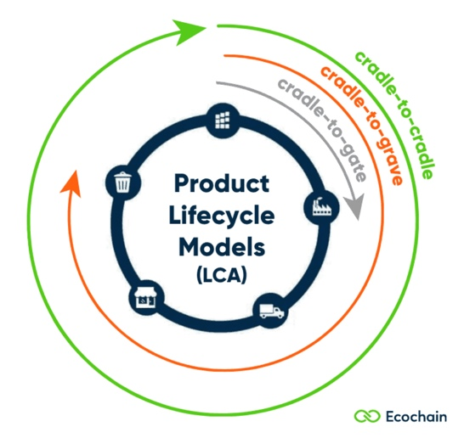
One main redesign that I would implement in my career would be using circular design principles. The circular design theory according to The Interaction Design Foundation is “the practice of creating durable, reusable, repairable and recyclable products that generate zero waste to support a circular economy.” In the book Cradle to Cradle, Mcdonnaugh and Braungart look at the Eco Effectiveness of a cherry tree and state, “The tree makes Copious blossoms and fruits without depleting its environment. Once they fall on the ground, their materials decompose and break down into nutrients that nourish microorganisms, insects, plants, animals, and the soil.” (2009, p.31) This would then lead to more trees being grown as the broken-down trees are now starting there cycle again by nourishing the soil ready to begin the process again. The idea that the cherry tree follows a similar format to the circular design theory in the sense that it generates zero waste and is a recyclable cycle of a broken or decaying thing feeding into the creation of a new product. This idea would be very beneficial for the environment in my future design career and I would imply it through creating garments that can be easily repaired or recycled into something new in the hopes that although trends change very quickly the products that I will be making can be changed to fit new styles without having to get rid of an old garment and making a whole new one. I would also focus on designing pieces that encourage longevity and can be dissembled for recycling at the end of their life cycle.
For designers, the idea of a lifecycle is recursive meaning its circular and the end feeds into the beginning. So, each iteration is linked to growth. Growth in design is a way that something progresses from start to finish and showing the lifecycle of a garment and how its created and then how it may deteriorate and reform a new product. In contrast to the extraction model in economics as a form of growth also but is more of a taking from below and making that increase as a form of growth. John Wood looks at this idea through “The logic of mining and money has made it hard to imagine and economy based on what is shown as the ‘living’ world.” (2022, p.7). Looking at the idea of mining as a resemblance of growth shows the idea of taking something from below and making it grow and increase without putting anything back into what you started with. This contrasts the idea of growth in design and the circular design theory as these create a repetitive circle system that links the beginning of a process to the end rather than starting from the start every time. Ingold says “I want to think of making as a process of growth” (2013, p.21) this aligns perfectly with circular design because it emphasises the lifecycle of a product and its relationship with the environment. In circular design each item is not just created and discarded but instead it is seen as a part of a broader ecosystem where materials can be regenerated and transformed. This perspective encourages designers to consider how their creations can evolve over time, weather through repair, reuse, or recycling. By viewing making as a growth process, you can focus on developing products that contribute positively to the environment, enhance resource efficiency, and foster a culture of sustainability. This approach not only helps the planet but also enriches the creative process, allowing for innovation and a deeper connection to the materials and methods used in design. This could involve using modular designs that allow consumers to customise their clothing or easily replace worn out parts. By promoting repairability and adaptability, I can help consumers see the value in keeping their garments for longer periods, reducing the overall demand for new clothing. This would be beneficial as it would help to increase the waste reduction of fabrics, by using designs that can be repurposed reduces the amount of textile waste that ends up in landfills, which is an incredibly significant issue in the fashion industry. A union that focuses on this as their priority is the UCRF (Union of Concerned Researchers in Fashion), there focus is creating a “Activist Knowledge Ecology” which is a “a system of knowledge about fashion sustainability geared towards taking action and fostering authentic change” and advocating for systems change. These are both great ideas to apply to my future design career as they will give a good source of education that can then be passed forward to consumers but also will help reduce the amount of negative impact that my designs and production will do to the environment.
Another tool that I would apply to my future career would be the use of digital design tools. Using digital software like Adobe Illustrator and Swatch Editor will help to visualise patterns on fabric and garments as prototypes before any production on actual fabrics is done. This will allow the waste of fabrics to reduce by minimising the number of physical samples tested and not used as a final product, therefore adding to waste and landfill. Online pattern prototyping allows for rapid alterations and adjustments to be made to designs if a mistake is spotted with no fabric being wasted in the process. Still ensuring that the final product is both functional and visually appealing whilst removing the need for excessive physical recourses which is seen in a lot of cases now. According to the Guardian, as of 2023 “92 million tonnes of textiles waste are created annually” so by reducing waste in the production of products will hopefully allow that number to increase. Also, by doing this and making it known this will help to educate others and this idea to larger companies that produce higher quantities of product therefore creating larger masses of waste and encourage them to follow a similar approach to help further decrease the amount of waste that the textiles industry is creating. Alongside using digital software, I will also explore different techniques to digitally print fabrics like UV printing or using a fabric printer. Using these methods in replace of traditional dyeing and printing methods can reduce water usage and chemical waste which are also major factors that affect the current state of our environment. Although conventional ways of printing like screen printing or methods like acid dying to dye fabrics do create a nice raw effect there are many negatives that come with using these techniques. Chemical pollution is a big issue when it comes to fabric dyeing because many dyes contain toxic chemicals such as heavy metals and nonylphenol ethoxylates (NPEOs) which are big factors to contaminating water and soils. As well as chemical pollution the amount of water that is used to use these traditional techniques is “responsible for 20% of the worlds industrial water pollution” said by the BBC. Exchanging these techniques that are detrimental for the environment for more modern printing and dying processes like UV printing or fabric printing would reduce the amount of water used and chemicals exposed into the environment through textiles design creating a positive impact on the environment in the future.
A strong tool that would be applied to my future design career would be looking at material innovation and how that would be beneficial for my work and for the environment. I would look at fabrics that are more sustainable like organic cotton, bamboo, or preloved recycled materials and develop these fabrics into textiles. By taking the time to research fibres that are grown without pesticides and synthetic fertilizers I can significantly reduce the negative environmental footprint of my garments making sure that the material being used in my work is sustainable and not leaving a negative impact on the environment. Nylon and polyester, two fabrics found a lot in most fast fashion garments, have the most negative impact on the environment. According to GreenChoices “Nylon manufacture creates nitrous oxide, a greenhouse gas 310 times more potent than carbon dioxide.”. Reducing the use of these fabrics in my work to zero although will only be a small impact in the larger picture it will hopefully also influence others to follow this format. Additionally, incorporating recycled fabrics into my work like post-consumer plastics or recycled fabric scraps can help divert waste from going to landfill and being reused for something more beneficial and that can be used again. This approach not only conserves resource and promotes the use of sustainable fabrics but it also applies a circular economy. Alongside this would have to be a lot of education on what fabrics are better or worse for the environment, I would also use my platform to educate consumers on the importance of sustainable fashion and the impact of their choices and encourage then to pick sustainable over fast fashion. This could be through workshops, social media campaigns or collaborations with organisations focused on sustainability and helping the environment. By raising awareness of the consequences of feeding into fast fashion but also giving them a direct, sustainable alternative, I can encourage consumers to make a more informed decision and support brands that prioritize environmental responsibility.

Figure Two:
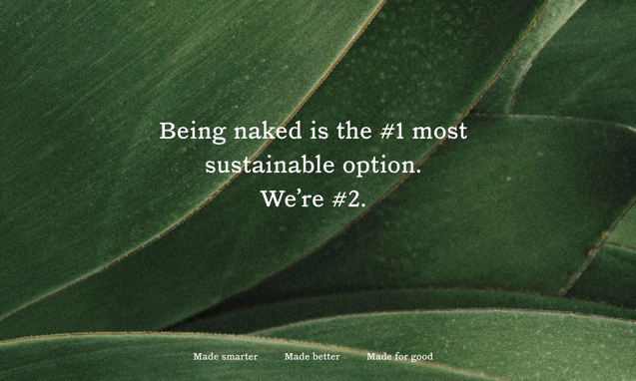
One brand that has pathed the way for sustainability in fashion is Reformation, they focus on making circularity the priority in their company making high efforts to remove the use of new fabrics and stick to only using recycled materials to help them become a climate positive company. Reformation's main goal is to source one hundred percent of their fabrics from recycled and renewable materials by 2025. As well as material innovation they have acknowledged the damage the dyeing industry using traditional dyeing methods is having on the environment. Because of this acknowledgement, they have been able to apply practices to their work that will reduce the amount of damage caused. Such as, testing their products against their Restricted Substance List (RSL) to confirm there are no hazardous chemicals on their products, they have joined a collection of brands that are committed to clean dyeing processes by adopting the Manufacturing Restricted Substances List (MRSL) which is a list of materials that should be restricted in the production of materials and also using ”OEKO-TEX 100 to check for the presence of hazardous chemicals, carcinogens, azo dyes and other chemical limits in accordance with the European REACH standards”. These are all practices that I would like to apply to my work when making my own textiles products as I believe Reformation as a brand has already shown that these do work to reduce the amount of negative a company applies to the environment. A big part of Reformation becoming sustainable was their high effort to reduce waste in there manufacturing of their products. According to Reformations website” Over 40 billion garments made each year are never sold and textiles waste is predicted to go up another 60% by 2030.". To avoid their garments becoming part of that statistic, Reformation releases limited edition collections that are only made in limited numbers and will only make more of those products if they see the demand for it through direct data like signups for waitlists and feedback from purchases. They call this the limited production model, and it keeps them as a company from over producing products and allows their products to keep a sense of uniqueness to the customer as they know only a few of their design has been sold. The limited production model is something that would be applied to the production of my company to follow the outcome of not overproducing products to reduce the contribution to land fill. Kate Fletcher talks about a similar model called Slow Design in her book Design Journeys (2014) she says” re-evaluate our relationship with quantitative abundance and speed and normally to slow it down.” (2014, p.203) this is a similar idea to how Reformation do not rush to mass produce any of their products. Finally, Reformation has all their information on sustainability easily accessible on their website which is also a strategy I would follow in my future practice to educate consumers directly on what is wrong with fast fashion and how it impacts the environment but also how choosing sustainable alternatives creates such a positive impact directly on the environment. It is also beneficial that they break down all the sections of what they are doing making it easy to understand to your average consumer. There webpage is filled with lots of information in a way that is quite immersive which is good to keep a consumer engaged as environmental issues is a topic that can sometimes become quite dull, they have found a way to keep it engaging. Finally, the terms that are used throughout their website are ones that would appeal to a younger audience for example "plus, it means no one at the party will be wearing the same dress as you.” This attracts an audience that is mostly contributing to the issue of fast fashion on waste in fashion and giving them reasons to shop more sustainably while also educating them about why it is beneficial which they may not normally go out and do themselves.
By focusing on these strategies in my work, I aim to create a positive impact on the environment through my textiles design career, promoting and making a shift towards a more sustainable and responsible fashion industry. Through following circular design principles, applying digital design tools to my work, material innovation and education I know that I will be able to transform the way textiles are designed, produced, and consumed, ultimately leading to a healthier planet for future generations.

Bibliography
Braungart. M. & McDonough. W. (2002) Cradle to Cradle
BBC (5/11/2024) Why colouring clothes has a big environmental impact. Available at:https://www.bbc.co.uk/news/articles/c870j92p82wo.amp Accessed on 4/12/24
Fletcher. K. (2014) Sustainable fashion and textiles: design journey
Greenpeace.org (2019) The dark side of fast fashion. Available at:https://www.greenpeace.org/aotearoa/story/the-dark-side-of-fast-fashion/ Accessed on 1/12/24
Greenchoices.org Enviromental Impacts. Available at:https://www.greenchoices.org/green-living/clothes/environmental-impacts#:~:text=Nylon%20and%20polyester&text=Nylon%20manufacture%20creates%20nitrous%20oxide,become%20a%20source%20of%20contamination Accessed on 9/12/24
Ingold. T. (2013) Making: Anthropology, archaeology, art, and architecture. London Routledge
The Interaction Design Foundation (2024) Circular Design. Available at:https://www.interaction-design.org/literature/topics/circular-design?srsltid=AfmBOord1vZb65R9RyPdfKbjW7UZDGJebpgiJeg5ZNRNM0m2SH1cTas1 Accessed on 1/12/24
The Reformation (2024) Sustainability at Ref. Available at:https://www.thereformation.com/sustainability.html?_gl=1*x0xc7l*_up*MQ..*_gs*MQ..&gclid=EAIaIQobChMIg7CRhpGbigMVNZVQBh1L9i3TEAAYASAAEgJX7PD_BwE&gbraid=0AAAAABnwCwe2cMmCgZtyonXBK5J3JqxuH Accessed on 9/12/24
The Guardian (2023) ‘We turn waste into something golden’: the creatives transforming rags into riches. Available at: textile-waste-landfill-creatives-transform-rags-to-riches-upcycling-ghana-chile-pakistan Accessed on 5/12/24
Wood. J. (2022) MetaDesigning in the anthropocene

Figures:
Figure One:https://ecochain.com/blog/cradle-to-cradle-in-lca/#:~:text=Cradle%2Dto%2Dcradle%20means%20a,and%20reduces%20their%20environmental%20impacts.
Figure Two:https://www.thereformation.com/sustainability.html

