

Engineering Management & Law
Module M6X00943_Q

Modern Leadership Theory and QinetiQ
For Dr John Rees

Report by
Kenny Johnston (P148567)

Abstract.
Modern management theory isn’t. Modern management theory is the collection, discussion and understanding of lessons from history, some over a thousand years old. Modern management theory is the application of practiced management methods with the understanding and use of the modern science of psychology. Steve Wadey, QinetiQ C.E.O., believes he can transform the organisation from a hierarchical, ex-military mind-set into a forward thinking, inclusive organisation fit for modern business – and profit.

Contents.
1 Figures. 4
2 Introduction. 5
3 Modern Leadership Theories. 6
4 Implementing Change. 10
5 Summary. 16
6 Conclusion. 17
7 Bibliography. 18
8 References. 19

Figures.
Figure 1: Situational Leadership Model 7
Figure 2: Traditional Hebrides Hierarchical Organisation 10
Figure 3: Scheduled Master Maintenance Record 11
Figure 4: Group Hierarchy 12
Figure 5: SMIS login screen 14
Figure 6: Alpha-numeric codes 14
Figure 7: Identifying a maintenance task 14
Figure 8: Copying a maintenance code 15
Figure 9: Data entry screen 15

Introduction.
2.1 Modern management theories are as varied as the situations that require them. Many will only work in one situation, most will fail in all other situations they were not designed for. A few can be applied to multiple situations and work but fewer still use many theories combined.
2.2 In this paper we discuss some modern theories and their applicability and how these theories and the change they require have impacted staff and management personnel at the MoD Hebrides guided missile testing range operated by QinetiQ.

Modern Leadership Theories.
3.1 Lessons from history are still present in modern leadership theories. Famous leaders like Genghis Khan, Adolf Hitler and Winston Churchill demonstrated leadership traits that are valued in modern theories.
3.2 Genghis Khan valued honesty and loyalty from his subjects, trusted his subordinates and allowed them to make important decisions when operating far from home ^{[1]}. Winston Churchill is often portrayed as abrupt and demanding with his subordinates but was a man “who worked hard himself, drove them equally hard, but did so with humour and kindness, alert to their personal needs...” ^{[2]} And while the most infamous dictator Adolf Hitler is not seen to have many positive traits, his ambition and charismatic oratory are notable parts of modern leadership theory. ^{[3]}
3.3 While there are many theories of leadership there are three of note that will be discussed: Transformational, Transactional and Situational.
3.4 Transformational Leadership, first described by James MacGregor Burns ^{[4]} is very much like a journey. The leader has a vision or goal for the organisation (or team) and is personally motivated to ensure this is realised. This transformation may be quite radical and as such the leader must be charismatic, articulate and inspirational. To enact such a transformation requires the motivated participation of other members of the organisation. These staff members, once motivated become followers who “can easily identify with the leader and its purpose” ^{[5]} “The followers of such a
leader feel trust, admiration, loyalty and respect for the leader” ^{[6]} Without this trust, Transformation cannot succeed.
3.5 QinetiQ is currently undergoing a transformation process under the guidance of our C.E.O.
3.6 Transactional Leadership “focuses on the role of supervision, organization, and group performance” ^{[7]} and relies on rewards and punishments to gain compliance. This theory requires a clear chain of command with commensurate degrees of authority. The employee is rewarded (paid) to complete tasks as assigned by those deemed to be their superior and punished when tasks are not completed or fail. Transactional leadership is the most traditional method still used as, quite simply, it works. F.W. Taylor surmised that workers are motivated by money stating “give the workman what he most wants – high wages – and the employer what he wants – a low labour cost” ^{[8]} This is as applicable today as when it was first written and is traditionally how QinetiQ have operated.
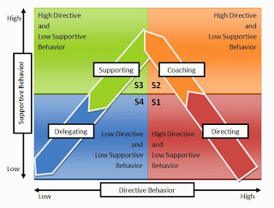
3.7 Hersey-Blanchard Situational Leadership Theory ^{[9]} is an amalgam of different leadership styles. The theory is based on the idea that a Leader is capable of choosing an appropriate leadership methodology based on many different factors including capability, motivation, intelligence, maturity and self-perception. The four styles indicated (S1-4) Directing, Selling, Supporting and Delegating. These are matched to the employee Maturity level (M1-4) where M1 is without knowledge, skills or confidence in the task and M4 is a confident, skilled and motivated individual. The skill in leadership is to choose the correct level of direction and support to give to the individual – a highly skilled and motivated employee will be quick to anger if micromanaged and an individual lacking skill or confidence to become quickly frustrated at a lack of instruction or supervision.

Figure 1: Situational Leadership Model
3.8 QinetiQ, formerly the Defence Evaluation and Research Agency (DERA) was born from the Civil Service, a supporting agency to the Ministry of Defence (MoD). As a result, most middle and senior management within QinetiQ have direct experience of the military command structure or have worked with military personnel for several years and firmly believe in the ultimate authority of ones’ superior within the organisation. Friction and incomprehension are evident when presented with employees who do not subscribe to that mentality and have the audacity to ask “Why?”
3.9 Transformation within QinetiQ - As mentioned in para 3.5, QinetiQ is currently undergoing a Transformation period under the guidance of our CEO. The Transformation message is being delivered directly to employees via electronic messages, daily blogs and weekly motivational messages.
3.10 Recently our CEO visited each UK site to have an employee engagement session direct and in person. The sessions began with a presentation of what ‘The Goal’ was, and how we are expected to get there. It was advertised as a no-holds barred, anything goes question and answer session in an effort to engage directly with employees.
3.11 The first question asked was “When are we rejecting SMIS” The Strategic Management and Information System is a bespoke, computer-based application containing all Engineering data – this includes Maintenance documentation and scheduling, Fault reporting and recording, Stores management and accounting and many other aspects of daily working life in QinetiQ.
3.12 SMIS is sponsored by a senior director within the company (An ex senior officer in the Royal Logistics Corps), has cost in excess of £5 million to develop, has had four different project managers in the two-year development phase, required thousands of hours of programming and testing and generates multiple outbursts of frustration in technical, stores and supervisory staff every day.
3.13 Steve’s response was “What’s SMIS?”
3.14 It is fair to say that within QinetiQ we have many personalities and many motivations. Our Leader believes in what he is doing for the company (and the shareholders). How can a transformational leader gain the trust of the employees when he, the company and the employees on the ground are being undermined by senior management who are busy realising their own agenda?
3.15 Transform, transformation or Transformational leadership is not a single application exercise but a method of continuous improvement that needs constant work and commitment from all employees and management.

Implementing Change.
4.1 The Hebrides Range organisation has traditionally been a hierarchical, top-down structure.
4.2 The Range Manager was responsible to Senior Management but had ultimate authority within the Range itself, a level of autonomy granted through trust, skill and experience.
4.3 The Range organisation was split into three departments – Engineering, Support and Operations, each with a department Manager responsible to the Range Manager. Each department was split into as many Sections as discipline or specialisation required. A simplified organisational chart is shown below.
Figure 2: Traditional Hebrides Hierarchical Organisation

4.4 The Engineering Department is responsible for the maintenance and repair (and when particularly complex equipment is involved, operation) of Range instrumentation for the safe conduct of the practice and live firing of guided weapon systems. This includes tracking and surveillance radars, radio communication systems, command and control systems and other hardware.
4.5 Each piece of equipment has a specific, mandated maintenance policy which defines each maintenance procedure and the periodicity it is to be completed. Traditionally, these procedures have been managed annually using a Scheduled Master Maintenance Record (see Figure 3 below).
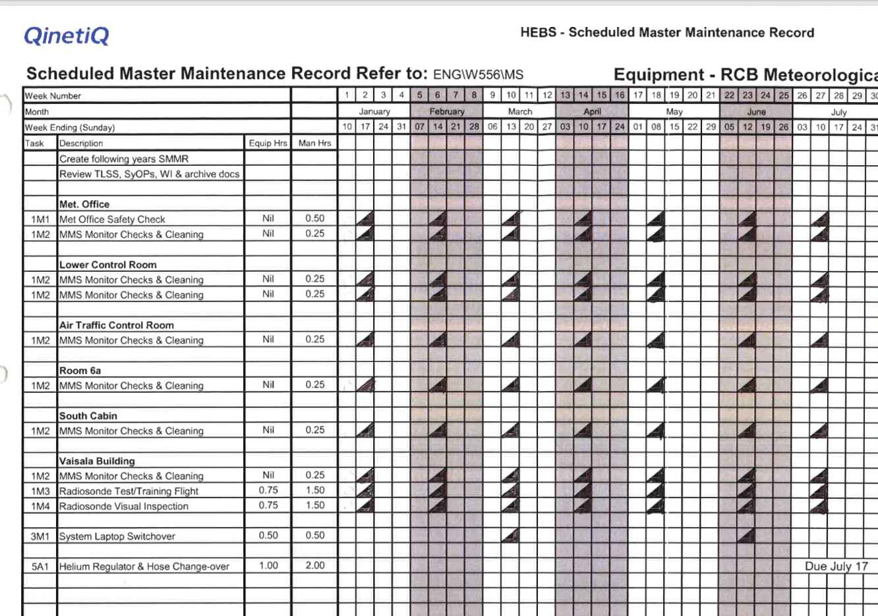
4.6 Scheduled maintenance tasks are indicated by a diagonal line with a filled black triangle indicating a completed task.
Figure 3: Scheduled Master Maintenance Record
4.7 The recent economic downturn plus natural wastage has reduced the number of staff in all departments, including Engineering. This slow process has resulted in fewer staff with a greater number of responsibilities and commensurate increase in maintenance tasks to be completed.
4.8 Transformation ^{[10]} was seen to be the solution to this problem. Transformation is divided into six distinct elements:
Business Winning: To increase the skillsets and capabilities of the business team who bring customers to QinetiQ so increasing revenue and profit.
Engineering & Operations (E&O): Develop E&O disciplines by cross-training staff at other sites, identify and adopt good working practices across sites and work to develop individuals’ careers.
Performance Excellence: Standardise project control, planning and reporting and develop an integrated resource planning tool across the business.
Governance & Processes: Streamline business processes and ensure legislative compliance.
Developing our organisation: Engage with all employees, develop a culture and mind-set that puts the customer first. Create and apply leadership and management development skills programmes. (LDP and MDP).
4.9 These broad statements describe Steve Wadeys’ vision of the future of QinetiQ.
4.10 After a two-year programme of Transformation few of these desires have been realised in the Engineering Department in the Hebrides Range.
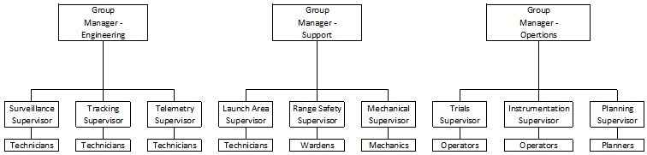
Figure 4: Group Hierarchy

4.11 One major change to come from Transform is the appointment of Group Managers responsible for a small portion of Range equipment and personnel. However, each Group Manager is now responsible for several small portions of various sites throughout QinetiQ UK that conduct similar activities.
4.12 This has had little effect on the main workforce but has now resulted in an off-site, faceless management culture that results in significant frustration for the Supervisory level staff.
4.13 The Strategic Management and Information System (SMIS) as discussed in paragraphs 3.9 and 3.10 was conceived as an electronic forecasting and information management application. Every piece of equipment within QinetiQ was uniquely identified and assigned a position on a hierarchical tree. Any sub-assemblies within the equipment were identified as children and if the equipment was in itself a sub-assembly, any parents were also identified.
4.14 Information relevant to that equipment was also identified – serial numbers, cost, lead-times for replacements, unit cost, etc.
4.15 If the equipment has maintenance tasks these were also identified and input, again, with a unique number. As with the equipment record, the maintenance plan accounts for the number of hours planned annually, consumables, test equipment, etc. required to complete every task.
4.16 If a fault is found a report is generated and assigned to an appropriate person or group to rectify. The electronic fault report is used to record any work done, consumables used and the time it takes to complete each activity while rectifying the fault.
4.17 SMIS was promised to be the solution to all of QinetiQs’ inevitable information management differences between so many disparate organisations and cultures. SMIS was rolled out over an eighteen-month programme, finally reaching the Hebrides in January of this year.
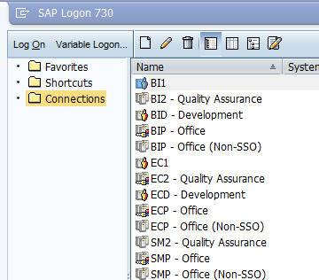
4.18 A two-day training course was required before access to the system was permitted.
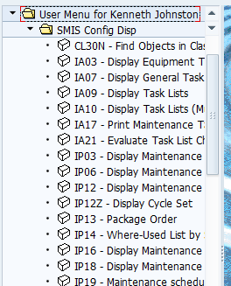
4.19 SMIS is a system that has no user-friendly functions. There is no graphical user interface, no help button or bubbles, the commands required are not intuitive, one command will only perform one function; assets, locations and sites have alphanumeric codes created by someone who has never seen or used what they’re describing and none of these issues are being addressed due to the sheer cost of the project so far.
Figure 5: SMIS login screen
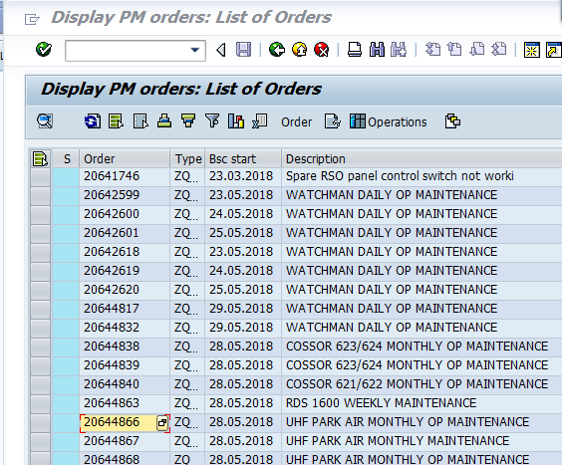
4.20 The opinion of most QinetiQ staff is that the introduction of SMIS has caused average work outputs to drop due to the increase in time required to enter data compared with the previous electronic versions; levels of frustration have also increased due to the complicated three and four number/letter code combinations required to navigate, the multiple windows that require data input for even the simplest of tasks and the unwieldy process that must be navigated should an incorrect entry occur.
Figure 6: Alpha-numeric codes

Figure 7: Identifying a maintenance taskFigure 8: Alpha-numeric codes
Figure 9: Identifying a maintenance task
4.21 A standard fifteen-minute task is now being
logged in SMIS as requiring one hour to complete.
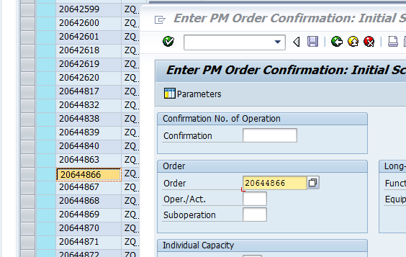
4.22 Four windows and three codes are required to access a simple maintenance notification: ECP -Office, IW39 and IW41. It’s not until this point a user can enter data regarding the completion of a task.
4.23 The information displayed does not inform the user of the handbook, actions, tools or consumables required.
Figure 10: Copying a maintenance code
4.24 From direct observation and discussions with staff from other sites in the UK, the overall result of this project has been to deliver an unwieldy and frustrating system filled with codes and nuances that are both confusing and unintuitive.
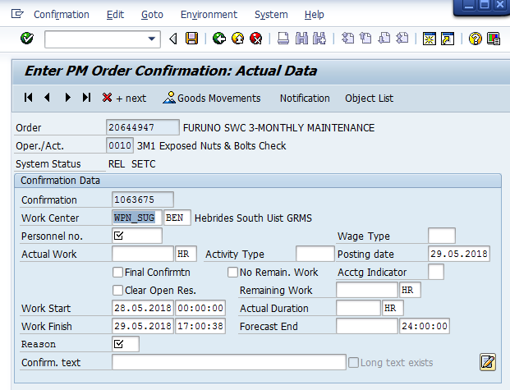
Figure 11: Data entry screen
4.25 In a recent article Elon Musk is reported to have informed employees “Don’t use acronyms or nonsense words for objects, software or processes at Tesla. In general, anything that requires an explanation inhibits communication. We don’t want people to have to memorise a glossary just to function at Tesla.” ^{[11]} and that “Any product that needs a manual to work is broken” ^{[12]}

Summary.

5.1 There are many modern management theories all of which are solutions to a specific problem, but most are not suited to all.
5.2 An authoritarian style is as valid as transactional or transformational. While ordering civilian personnel to complete tasks might work, a more transactional based approach would probably yield a more positive reception.
5.3 Good management is recognising the skills, the needs and the motivations of staff and adopting a suitable management style – adapting to each situation as required, ‘one small step’ ^{[13]} in personal development, motivation or education – while beneficial to all concerned does take time.
5.4 Transformational management might be considered as that ‘one giant leap’^{[13]}, requiring a significant shift in thinking, managing and operating. It requires a highly motivated and charismatic leader to enthuse an entire staff as only great leaders can. It can also fail if any part of the organisation does not embrace change.

Conclusion.

6.1 The Military and then Civil Service management of the Hebrides Range have moved on but the militaristic, rigid nature of those who remained have governed the operation and management ever since.
6.2 While natural wastage removes some die-hards from the company the very nature of the services provided by QinetiQ attract and even demand ex-military personnel and in some, the instinctive belief in hierarchical authority and the willingness to wield it is strong.
6.3 Change of any kind is difficult. It’s difficult to implement, manage and accept. Change for its’ own sake isn’t necessary but in this modern, capitalist world, the share-price is everything and QinetiQ must change to survive.

Bibliography.
- N. Nayab. “Modern Leadership styles in the Modern World” Internet: https://www.brighthub.com/office/home/articles/73968.aspx, 20/05/11 [08/05/18]
- http://www.leadership-central.com/situational-leadership-theory.html#axzz5GEVNVT6h, [08/05/18]
- “Fredrick Taylor and Scientific Management: Understanding Taylorism and Early Management Theory” Internet: https://www.mindtools.com/pages/article/newTMM_Taylor.htm, [08/05/18]

References.
- “Genghis Khan's personality” Internet: https://www.google.co.uk/url?sa=t&rct=j&q=&esrc=s&source=web&cd=4&cad=rja&uact=8&ved=0ahUKEwit7-C356vbAhUBWsAKHbWEDogQFghHMAM&url=https%3A%2F%2Fwww.utc.edu%2Fasia-program%2Fdocs%2F2017lessons%2Fhill%2Fgenghiskhanspersonalitysourcenewworldencyclopedia.docx&usg=AOvVaw2zTJa1pJ89kgzS2QmigrSQ, [08/05/18]
- S.F. Hayward. “Churchill’s Personal Traits” Internet: http://www.theceoadvantage.com/journal/2010/churchills-personal-traits/, 04/01/10 [08/05/18]
- A. Macias “Why Hitler was such a successful orator” Internet: http://www.businessinsider.com/why-hitler-was-such-a-successful-orator-2015-5?IR=T, 13/05/15 [08/05/18]
- “Burns Transformational Leadership Theory” Internet: http://www.leadership-central.com/burns-transformational-leadership-theory.html#axzz5Gvednxlv, [09/05/18]
- “Leadership Theories” Internet: http://www.leadership-central.com/leadership-theories.html#axzz5GEVNVT6h, [09/05/18]
- “Transformational Leadership” Online: https://www.langston.edu/sites/default/files/basic.../TransformationalLeadership.pdf [08/05/18]
- J. Bernier. “Modern Leadership Theories Presentation” Internet: https://prezi.com/aseolrds9t9y/modern-leadership-theories-presentation/, 31/07/16 [08/05/18]
- F.W. Taylor. “The Principles of Scientific Management” Internet: http://www.gutenberg.org/cache/epub/6435/pg6435-images.html 1911, [08/05/18]
- E. Franceschi. “Leadership Style: Hersey-Blanchard Situational Leadership Theory” Internet: http://tlmacademy.blogspot.co.uk/2014/02/leadership-stylehersey-blanchard.html, 22/04/14 [08/05/18]
- S. Burgin. “How we’re transforming” QinetiQ intranet: https://portal.qinetiq.com/Our-Company/About-us/Transformation-Hub/How-we-are-transforming, 03/01/18 [11/05/18]
- Narjas Zatat. “5 ways to be more productive, according to an email Elon Musk sent staff” Internet: https://indy100.com/article/5-ways-to-be-more-productive-according-to-tesla-email-sent-staff-elon-musk-8316661, Apr 2018, [11/05/18]
- “Elon Musk Quotes” Internet: https://www.brainyquote.com/quotes/elon_musk_567244, [11/05/18]
- NASA Content Administrator. “Apollo 11” Internet: https://www.nasa.gov/mission_pages/apollo/apollo11.html, 07/08/17, [11/05/18]

