  Component One:  What are the key skills required when working in the housekeeping team? 750 words (+/- 10%)  Contribution to Overall Module Assessment: 25% | Student No: | 2211874
 | Module Title: | Hotel Placement- Operating Hotel Facilities
 | Module Code: | BMIH4006
 | Lecturer: | Lola Villard
Each hotel housekeeping department is responsible for the cleanliness of the hotel, from which will then derive the satisfaction of the hotel’s guests, therefore the team plays a key role in the success of the business. Furthermore, to ensure that the success is guaranteed there are several skills that contribute to the achievement of it, and each associate of the housekeeping department must show these skills. However, the set of skills will vary depending on the role, meaning that the housekeeping department manager set of skills will have differ from the set of skills of a housekeeping attendant; to go into more details, the responsibilities will obviously differ as well. A manager will be responsible for supervising and managing the department entirely, and that implies creating the rota for the staff, managing the finances of the department, ensuring a close communication with the front desk department in order to facilitate guest’s special requests, and also solving customer complaints that are related to housekeeping. On the other side, a housekeeping associate is responsible for the cleanliness of the rooms, restocking if and where necessary, escalate any damages, and everything while following the hotel’s privacy, confidentiality, and security policies and procedures.
In general, the skills required are communication, organization, teamwork, attention to detail, flexibility (these are the most important ones, not all the ones required).
Communication: this is a critical skill, as without it, anything would be impossible to achieve. The team members must understand what is required or expected of them, they must be able to understand the guests, the supervisors, they must communicate with other departments, and they have to communicate efficiently with their colleagues as well, everything for the purpose of ensuring the housekeeping department runs smoothly and al the goals are achieved.
Organization: a housekeeping team member will need this skill to able to complete all the tasks given in a day, and also to know what specific task needs to be completed at what specific time. For example, in one of the days during y placement I noticed a room with a “Do not disturb” card, and the associate had to organize the other rooms to ensure returning to the DND room to clean it.
Teamwork: all the members of the team must communicate effectively to ensure that they cooperate, help out each other and cover for each other.
Attention to detail: it is important that an associate has attention to detail, as this ensure the prevention of errors and improves the quality standards. I witnessed the importance of this skill when I shadowed an associate and we entered a room that looked very clean to me, however she quickly noticed some marks on the mirror, an unused cup but that has dust on it, and a linen freshly washed but that has some small stains and she rejected it and sent it to be washed again.
Flexibility: a hotel is not a laniary business, there are days that are busier than others, therefore an associate must show flexibility towards the cleanings schedule that varies, or in situations like guest’s short notice requests.
To conclude, the skills required when working in the housekeeping team are directly proportional with the responsibilities that a particular member of the team has. In other words, a supervisorial role will require more skills than an associate role, as well as a supervisor will have more responsibilities than an associate. However, there is a way in which the company can show appreciation towards the staff skills, and it is beneficial for the business- higher profits, increased customer satisfaction and retention, and the employees- feeling valued, appreciated, at the same time, it is ‘work engagement’. Engagement takes place when a company functions effectively, and promotes a good relationship with its employees, the result will be that employees will attach emotionally to the business and they are more likely to be loyal to the business and even perform their job better, and by that the business will gain more satisfied customers and automatically higher profits. (Bakker, Leiter, 2019, pp.1-12). I strongly agree that engagement is beneficial, as during my work placement I witnessed ‘appreciation week’ (each day the hotel would prepare food from another culture, there would be an additional break, and all staff would participate) and I have seen myself how happy the employees were and how they discussed after lunch just how much they love working for this hotel because they feel valued and appreciated.
I am very grateful that I had the experience of working in a hotel’s housekeeping department as now the theory and my personal research is strengthened by the fact that I have seen with my eyes that what I have read is accurate and when I will myself work within hospitality, I will have a vast knowledge that will help me thrive.

Word Count | 804

Component Two:
Contribution to Overall Module Assessment: 25%
In this scenario – You have just been promoted to team leader for a floor within the hotel. A guest complains that on their arrival, their room had not been properly cleaned. Create an action plan and answer the following questions.

Problem | Why did it happen? | What are you going to do? | How will you prevent this from happening in the future? | What measures would you introduce to improve team effectiveness?
A complaint was received stating that the bathroom is not cleaned properly, there were marks and stains on the mirror, on the shower and on the sink. | The staff allocated and the supervisors were too busy, therefore it wasn’t cleaned properly, and supervisors did not pick it up. | First step is to communicate with front desk in order to offer the guest another room and perhaps free drinks or alternatives to compensate for the inconvenience caused. Then, the second one, immediately after making sure the guest is satisfied, is to start an investigation, find out who cleaned the room, why wasn’t the bathroom cleaned properly, who was the supervisor that had the responsibility to check the guest rooms, why wasn’t it noticed and rectified. The third step, and the most vital one, would be to find a way to welcome the problem by gaining from it an insight into what I can improve in the department I supervise. | I would arrange a meeting with all the housekeeping team members where I would refresh the importance of cleaning. Also, after identifying the person that had cleaned the room, I would ensure to check her rooms more thoroughly, offer some extra training, and also offer her the opportunity to shadow the employees that has the longest time working for the hotel as this might show her different ways of cleaning and different techniques, so she would experience good habits and the power of a good example. | I would create extra spreadsheets for the supervisors to ensure that the rooms are checked in reality and not just ticked as if they would be checked although it did not happen. Also, I will encourage the team to advise if they feel under pressure of if it is too busy, as we can always ask the evening housekeepers to support. Another measure would be refreshing the training that refers to the importance of cleaning yearly for all employees.

Component Three:
Contribution to Overall Module Assessment: 50%
Your task is to create and prepare a presentation following the detailed scenario provided below.

As the floor housekeeping manager and given the recent guest complaints you need to put together a basic training presentation for your colleagues within the housekeeping team to get the best out of them, ensure that brand standard is being achieved and that Health and Safety procedures are also being followed.

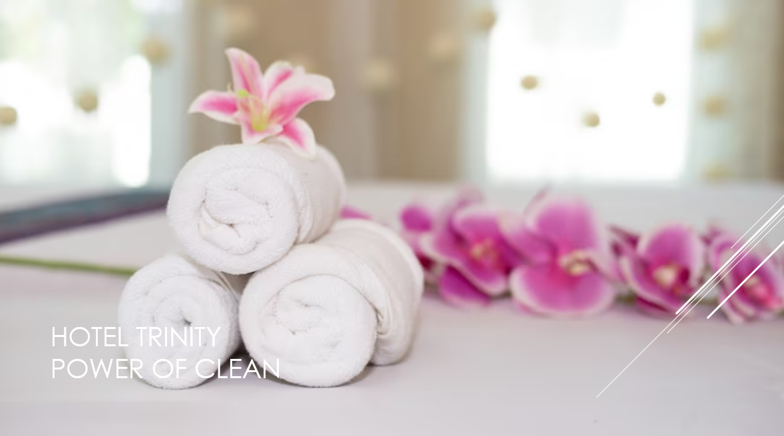

Training Notes: Hello and welcome to Hotel Trinity cleaning procedure presented today to you. This will be a short and concise presentation; however, it will offer you crucial information, helpful tips, and conclusive example, everything with the purpose to support you in your day-to-day tasks as a housekeeper.
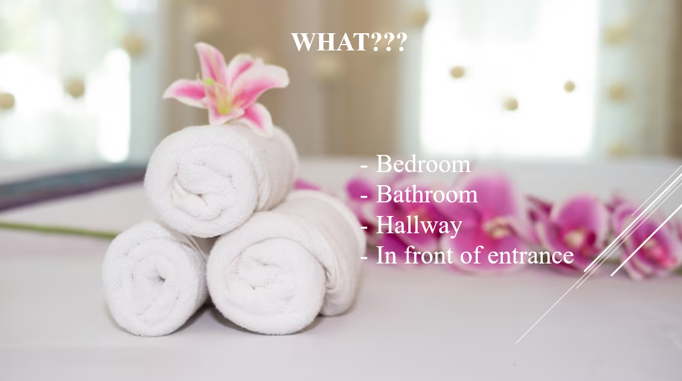

Training Notes: First, lets answer the question “What do I need to clean?”. Well, the answer is that housekeeper must clean the guest room bedroom- stripping old bedding and replacing with fresh, clean ones, dusting, and vacuuming, bathroom- scrubbing bathtub, toilet, and sink, replacing used towels with clean ones, restocking shampoo, hand cream, shoer cap, toilet paper, if necessary, hallway- restocking cupboard with tea, coffee, sugar, biscuits if necessary, in front of entrance- dusting door, and vacuuming the area.
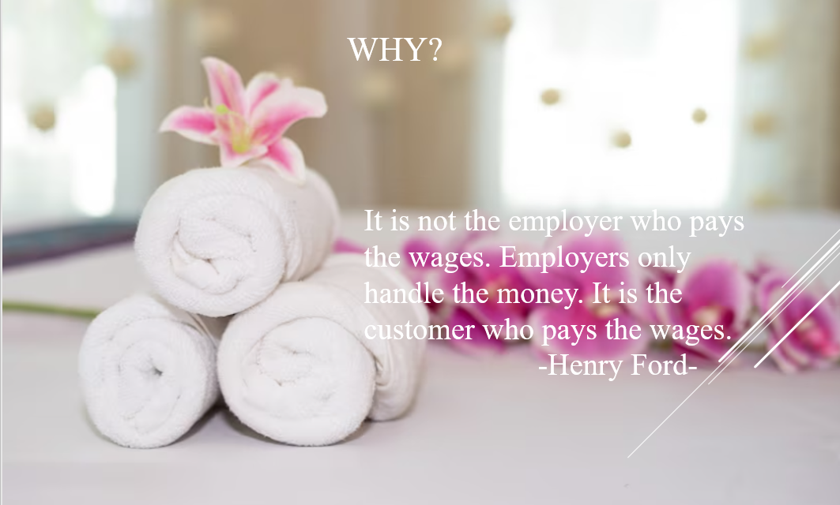

Training Notes: secondly, I would like to answer to answer you the question “Why should I clean thoroughly every time”? I used a quote that I really hope will became as of now a leading thought in your mind every single time you are cleaning a room. I want you to imagine that on one occasion you don’t clean a room properly, and there will be a guest that will be accommodated in the room you are cleaned, and if that guest is not happy, he will very likely raise a complaint, which will lead to a negative image of the hotel, which will lead in a decrease of the profit, and if the situation is repeated and more customers are unhappy the business will close down and you will remain unemployed. Therefore, cleaning is crucial, please always remember that happy customers keeps us in business.
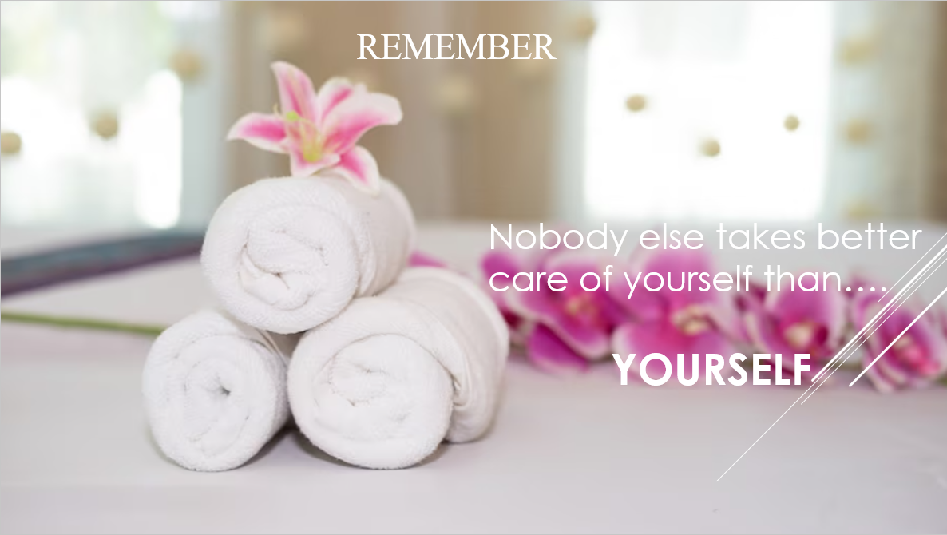

Training Notes: Although your role as a housekeeper is vital for the business, we ALWAYS want you to remember that you must keep yourself safe. Please remember that you are responsible for yourself and only you know when something is not alright with you. But what exactly do we do as a company to protect you?
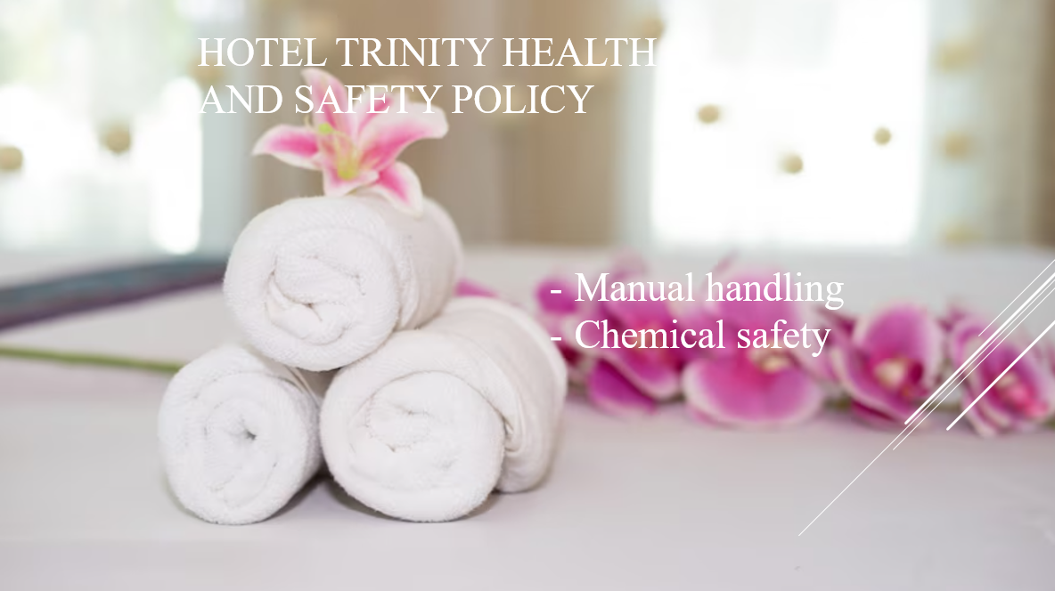

Training Notes: We comply as a company with Health and Safety legislation to ensure that all our associates are safe at their workplace. What is important for you to keep in mind, although it has several areas, are two components, manual handling, and chemical safety, as these are the ones that apply to housekeeping department.

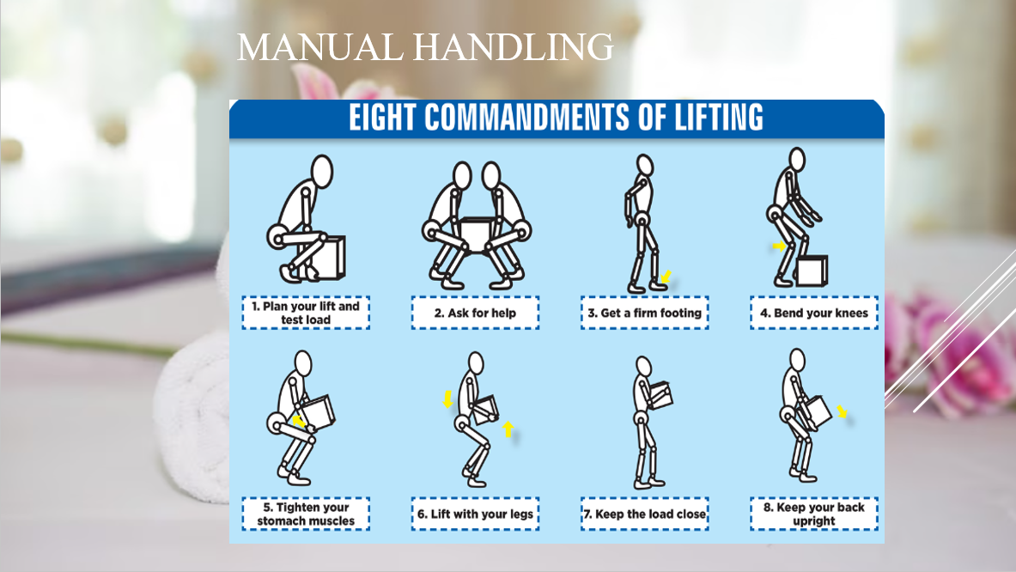

Training Notes: It is important that you always take care of yourself, and please, if you consider that there is a load that is too heavy for you, ask for help, never try to perform it on your own, otherwise you risk injuring yourself and our goal is to protect you.
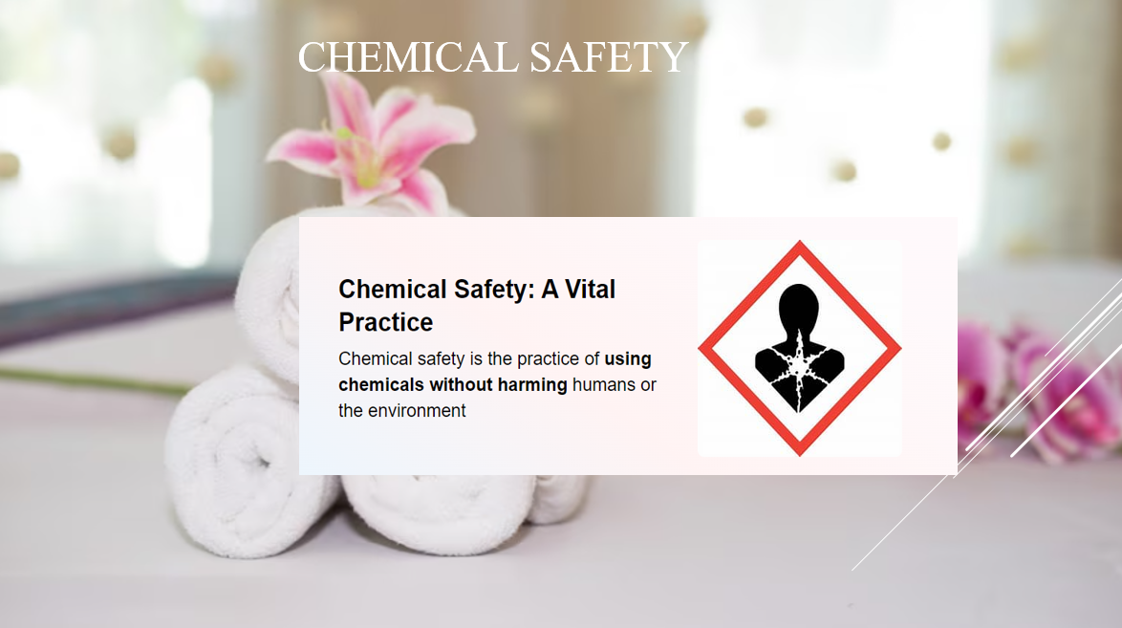

Training Notes: We ensured that all the solutions that you are using daily when you are cleaning are safe for you to use and are not harmful for your health or our guests. However, we encourage you to wear gloves (especially if you have sensitive skin) and wash your hands whenever you finish using the solutions (especially before your lunch break).
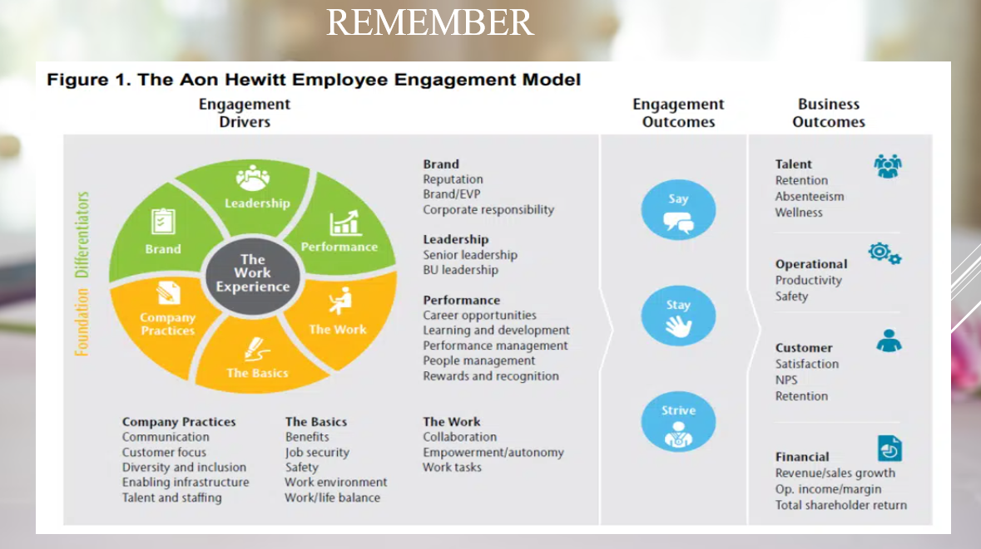

Training Notes: Yes, we realize that this diagram may be a little bit too much for you, and don’t worry, we don’t even expect you to remember it. What we need to focus on is that the work experience is in both our hands as company and your hands as an associate. We are a hotel- the brand as the diagram shows, that offers you the basics- job security, work environment and the other elements that you can see on the diagram, we also offer company practices- for example diversity, you might have noticed that all our associates come from different cultural backgrounds, we also put on the table performance- we always reward our associates and offer marvellous career opportunities, and then lastly, we can see on the diagram the element work- here comes in your part, we want you to follow work tasks while respecting company policies and procedures.
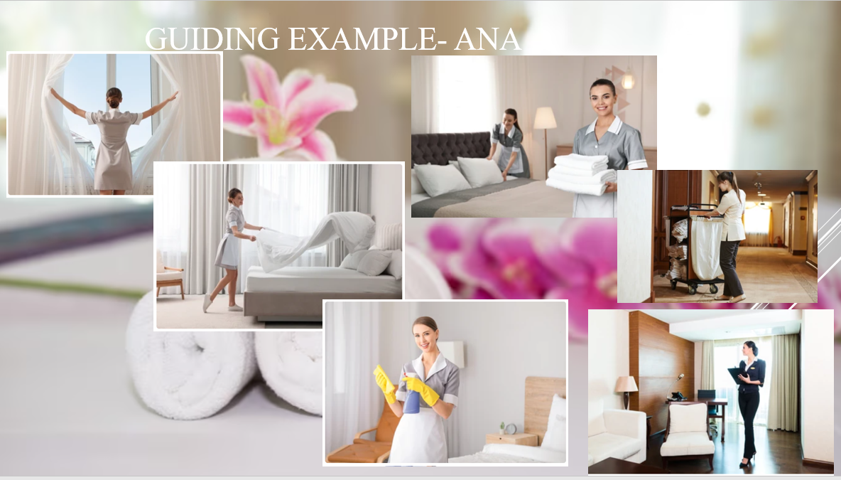

Training Notes: We know that the last slide contains a lot of information for you to take in, so we tried to make things a lot easier for you. Let’s imagine Ana will show you how a normal day at work should look. Firstly, Ana makes sure to open the windows as soon as she enters the space she has to clean- the fresh air will benefit her, energize her, and also, after she leaves, the guests will also benefit from an airy room. Then she can carry on with her cleaning tasks while ensuring she is following chemical safety procedures. Then Ana always checks on the other members of the team and offers her help as soon as she finishes her task knowing that teamwork is very important and also knowing that perhaps in the future, she will be the one needing help from her colleagues. When finishing all the rooms she was assigned, she carries the dirty linen to the laundry room bearing in mind manual handling. Lastly, Ana’s work is checked by the supervisor and the purpose of this is to ensure that the cleaning standards are met.
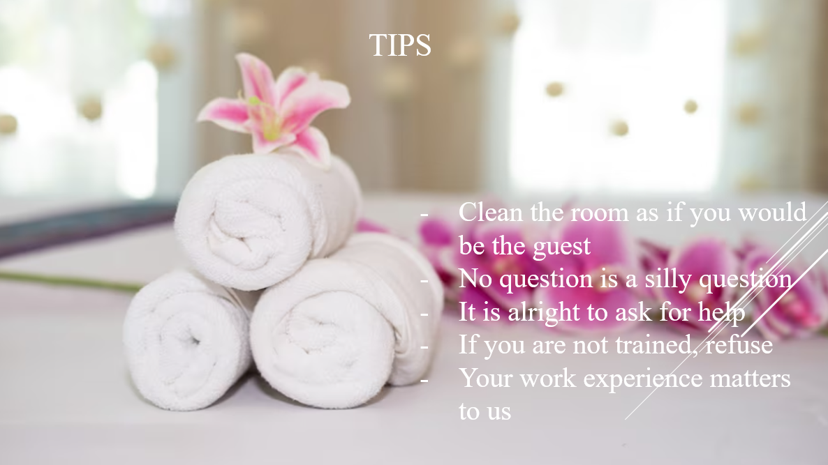

Training Notes: And here we are at the end of the presentation, we would like to offer you of five tips that we hope you will find useful.
- Please remember that our guests’ experience is at the core of our business, therefore if we welcome them in a clean space, they will be happy. If at any point
- If at any point you are unsure of something, or need guidance, you can always find a supervisor or a manager that will be happy to support you. It is always best to ask before then to repair an error.
- If you feel overwhelmed, or if your circumstances require it, please ask for help. We are all a big team and as a company we value each associate.
- Very importantly, if you are ever asked to perform a task that requires training that you didn’t receive you must say it and do not handle any machinery that you weren’t trained to use.
- Lastly, please always keep in mind that through feedback we can improve, so it is vital that you share with us your opinion, otherwise if we don’t know something we cannot do anything about it.

References
AZ quotes (2023) Top 25 wages quotes. Available at: https://www.azquotes.com/quotes/topics/wages.html (Accessed: 09th June 2023).
Bakker, A., B., Leiter, M., P. (2010) Work engagement: a handbook of essential theory and research. London: Hove.
Bethesda, M., D. (2020) Marriott International statement on cleaning protocols. Available at: https://news.marriott.com/news/2020/03/10/marriott-international-statement-on-cleaning-protocols (Accessed: 08th June 2023).
Hollander, J. (2022) Hotel housekeeping duties: a day in the life. Available at: Hotel Housekeeping Duties: A Day in the Life (hoteltechreport.com) (Accessed: 06th June 2023).
Jones, T., J., A., Ed. D., R., E., H. (2007) Professional management of housekeeping operations. Hoboken: John Wiley & sons.
Marriott official website (updated November 2022) Commitment to clean. Available at: https://clean.marriott.com/ (Accessed: 08th June 2023).
Resume Cat editorial team (2022) 12 Housekeeping attendant skills: definition and examples. Available at: 12 Housekeeping Attendant Skills: Definition and Examples (resumecat.com) (Accessed: 06th June 2023).
Robert, J. (2012) Service operations management: improving service delivery. 4th edn. London: Pearson Education.
Wood, R., C. (2013) Key concepts in hospitality management. London: SAGE Publications Ltd.

