Name: Garett Talbot
Student number: 1803311
BA course title: automotive design 90 credit
Word count: 1503
Tutors name: andre
Scooter X Sport Go-Kart frame
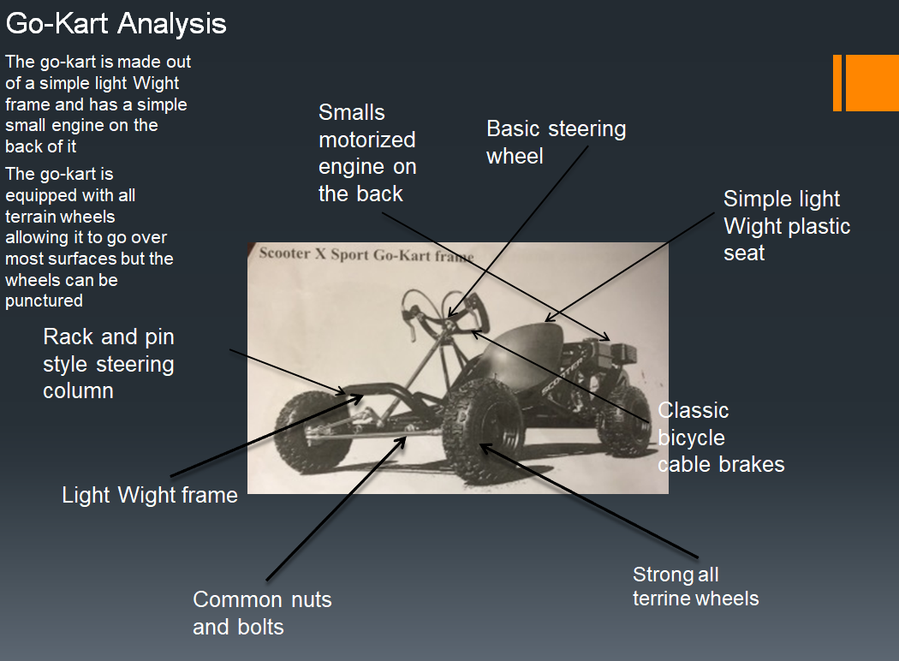
I will be redesigning a Go-Kart for use in space, the Go-Kart must be light Weight so it can be used to explore the surface of mars, the buggy must also be compact enough to be taken up to space in a rocket so it must be transportable. The buggy is also required to have off -road ability’s. The buggy is going to be used to drive on the surface of mars so it is going to need a few alterations to make it more suited to this role such as improved suspension, improved wheels, stronger and reliable electric powered engine. The buggy is going to be used to transport astronauts back and forth from the space ship and different parts of mars which they will be exploring. The buggy will be in an environment that is going to be dusty and oxygen deprived. Mars is a hilly and has a ruff surface so the buggy will need to be able to traverse the hills and surfaces that the planet has this means that the buggy will need up rates suspension and the wheels will need to be able to absorb the surfaces and not puncher as easy as standard wheels. The buggy is going to need a lot of different upgrades, first I think it will need improved tires. The new tires on the buggy are going to have to have a dense and strong foam inside the tires which will stop the buggy from getting punchers and risking a deflated tired. The outer skin on the tires will be made out of classic rubber which will help absorb the impact from the surrounding environment. The frame of the buggy is going to need strengthening and lightening at the same time this will ensure that then buggy is not too heavy for the rocket, strengthening the frame will make sure that the buggy can withstand shock and remain durable for the time it is going to be used on mars. Storage is another thing on the buggy is going to need to be redesigned, this is because when exploring the surface of mars, equipment and various other objects are going to need to be transported from the rocket to desired locations. The welds on the buggy will need to be enhanced and the material will need to be upgraded or reinforced. The classic petrol engine on the buggy is going to have to be replaced with electric engine because of the conditions on mars, the lack of oxygen on the planet’s surface prohibits combustion in the engine leaving the engine unable to start up.
New part design
The frame of the buggy is going to be made out of a magnesium alloy which is super light but very strong material. Super Magnesium is an all-new proprietary alloy that is claimed to be 33% lighter than aluminum as well as being stiffer and stronger also is less expensive than carbon fiber, this will insure that the buggy can withstand the Weight of the astronauts and it can deal with the harsh conditions on the surface of mars. The welds of the fame will be reinforced just to insure that the buggy will not brake while up in space. The frame work is going to have to be enlarged to accommodate another seat for another a second member.
The new tires on the buggy are going to have to be made stronger and more durable as well, the new tires are going to have a foam hose within them instead of conventional tires which consist of a rubber outer shell and an inner tube filled with air which has an equivalent air pressure of 0.9 bar. This will ensure that the tire pressure never goes down and it cannot suffer from a puncher. By doing this gives the buggy a much more long lasting life with barely any maintenance for the owner.
Storage is going to be a big part of this buggy the Storage for passengers, objects and machinery will need to be able to fit in the buggy while up in space the buggy will also be used to transport the astronauts from one location to another. So it needs to be able to carry various items to and from the station for instance. At the front and back of the buggy there will be boxes which will be made out of carbon fiber this is so that they are light for the astronauts to be able to move them around but at the same time are strong, each box will be a 100 liter storage box. This is big enough to carry lots of items but not too big to effect the buggy’s performance.
There will be two seats in the buggy. The fame work of the buggy is going to be enlarged in width and length to insure space for another seat, the seats themselves are going to be made out of carbon fiber as well just like the boxes to insure a low Weight as I don’t want the performance of the buggy to be effected especially after storage items and two astronauts are in the vehicle.
The engine of the buggy is going to have to be fully electric due to the environment. The engine on the buggy at the moment is a petrol engine which will not work in on the surface of mars. This is because of the lack of oxygen in the air which prohibits combustion in the engine. The buggy will be fitted with a new and improved full electric motor with solo panels that recharge the buggy’s system. The battery that will be used on the buggy will be a new high-density lithium-ion battery which will give the buggy 621 miles on a single charge. Allowing for the buggy to travel huge distances without stopping, the buggy will have various solar panels on it which will fold out of the body work. These solar panels are going to be the source which the batteries will recharge from. The solar panels will fold out when the buggy is stationery allowing it to collect as much sun light as possible.
Manufacturing
The frame for the buggy going to be welded together using magnesium tig welding because it is strong and gives a durable joint This means the whole fame of the buggy is going to be made this way for strength and durability.
The new foam inserts which will be going in the tires will be made using a metal mold, a liquid foam will be poured into the mold to create the shape of the insert.
The storage boxes which will be crucial to this design will be made out of carbon fiber and the carbon fiber will be layered piece after piece to create the strong boxes needed for the buggy.
The new full electric engine and batteries will be created in a factory using large scale machines. All of this manufacturing will be one off or batch depending on how many buggy’s are needed.
Advantages and cost
The advantages of all of these upgrades to the buggy are going to be highly beneficial, because it is going to be much lighter allowing for easy transport from earth to mars, also it will be much more durable and there will be less of a need to maintain it. It’s going to be able to travel much longer distances opening up so many more possibilities for exploration. The upgraded storage and extra seat allow for more samples to be collected and more tools taken from more locations to another and it will allow for two astronauts to travel together, minimalizing the risk and danger of travelling alone. The overall cost of the buggy is not going too be cheap as the carbon fiber and the upgraded frame materials. It is going to cost more than a regular and simple go kart, the engine itself is going to cost between $10,000 to $15,000 due to the fact that the engine uses high tech and new technology to supply its power. The solar panels on the vehicle are going to be expensive as well they will cost $5000 this is because the solar panels will have the ability to fold out when the vehicle is stationary and will also absorb sunlight, the solar panels will fold back in when the vehicle is mobile. The overall cost of the whole project will approximately cost around $50,000 to $70,000 depending on the material costs and manufacturing requirements the main reason for the project to be expensive is simply due to the fact that the buggy will be batch production if required or a one off production, As there will not be many models made because the amount manufactured will depend on the amount needed, the buggy will be rare and limited unlike any other vehicle.

