Charlie Williams (2235685)
Computing (Networks and Cyber Security)
L5 - Network Operating Systems and Services (ACCA5023)

Research, Build and Deploy a Virtualised Network

Table of Contents
- Introduction
- Research Report
- Hypervisor
- Architecture
- Hardware Requirements
- Advantages
- IP Addressing and Network Infrastructure Research
- Ipv4
- Ipv6
- Subnets
- Switches
- Routing
- IP Addressing and Network Infrastructure Research
- VPN
- DHCP
- Active Directory Domain Services
- Certificate Authorities
- Task 2: Virtualised Environment
  - Network Design and Topology
  - Virtual Switch Configuration
  - Windows Server Configuration
  - Windows Client
  - Linux server and client
  - Ping attempts
- Personal Reflection
- Reference List

- Introduction
This is my research report and deployment of a virtualised network. Herein, I will detail my findings and how they contribute toward the final deployment of my network. Justifications of the formatting of this report are as follows:
- Text is in the “Aptos” font. I chose this as it is clear, concise, and easy to read.
- Text size varies throughout the report, but it is mostly consistent, with 11 or 12 for the body and slightly larger for headings and subheadings. I could go and change these to be 100% consistent but that would be a waste of time.
- Line spacing is done automatically. It looks fine to me, if it is too big I will adjust.
- Text should be all black on white background and white on black backgrounds. While writing my report I used some text in red, these are ENTIRELY notes to myself, and should not be considered part of the report, aside from the references, which are entirely in red just for clarity when I’m writing.

- Research Report

- Hypervisor

- Architecture
Redhat.com [2] describes a hypervisor as:

“a hypervisor is software that pools computing resources- like processing, memory, and storage- and reallocates them among virtual machines (VMs.)”

By utilising resources present on the physical hardware of a device, hypervisors/virtualisation can enable one, single instance of hardware to effectively run and manage several instances of machines at once. This capability has numerous advantages and use cases, which I will cover in more detail later in my research report, but one immediate and significant advantage for hypervisors is their scalability.

The relationship between the CPU, hypervisor and virtual machine can be summarised as a typical working environment. The CPU is the budget - it is where all the resources needed for work are contained, which in this instance, are processing, memory, and storage. The virtual machine is an employee - they receive resources and use them to complete tasks. The hypervisor is the intermediate between the two. It manages the employees and allocates resources to them as necessary for them to complete their tasks.

Hypervisors are made up of two distinct types:
- Type 1 – Type 1 hypervisors, also known as bare metal and native hypervisors, operate off the host’s hardware. For this type of hypervisor, it replaces the host’s operating system, meaning it is a device dedicated purely to virtualisation, and cannot be used otherwise. The VM resources are scheduled directly to the VMs running on the machine by the hypervisor [2]. These types of hypervisors are typically found running on servers, operating a high number of VMs at any given time. Some examples of hypervisors of this type are NVM, Microsoft Hyper-V and VMware vSphere [2].
- Type 2 - Otherwise known as a hosted hypervisor, type 2 hypervisors are run off the existing operating system. Resources required are provided by the host’s hardware. Some examples of type 2 hypervisors are Oracle VirtualBox or VMWare Fusion.

- Hardware Requirements
Another quote from Redhat.com [2] says:
“The hypervisor gives each virtual machine the resources that have been allocated and manages the scheduling of VM resources against the physical resources. The physical hardware still does the execution, so CPU is still executing CPU instructions as requested by the VMs, for example, while the hypervisor manages the schedule.”
As the above illustrates, any and all processing power required to run a VM will come up from the hardware the VM is running off. Type 2 hypervisors like Oracle VirtualBox may struggle to run on a less powerful device. Type 1 hypervisors which are solely used for the purpose of virtualisation are better designed for running several VMs at once, but require a high degree of cooling, and due to their often high criticality within organisations, high levels of physical security. These requirements usually relegate them to dedicated data centres.

- Advantages
There is a myriad of advantages for effectively implementing virtualisation into an environment.

- Reduced costs - most times, running several VMs off of a physical server is considerably cheaper than buying several, separate servers. [4]
- Faster disaster recovery - features like VM cloning, snapshots etc. mean that mistakes made on VMs by engineers or other kinds of disasters can be rectified easily without considerable disturbance to any services being provided.[4]
- Efficiency - physical servers will typically waste considerable resources during down time. Virtual machines can have resources shared between them, meaning there is less wasted processing power. This ties into the reduced cost as mentioned before, but is also more eco-friendly. [5]
[3]
- IP Addressing and Network Infrastructure Research

To explain how data is transferred from one computer to another via the internet, I will use an analogy in which data travelling over the internet is described like a postal system. Suppose the computers are two houses sending letters to one another.

- The house (computer) has written a letter to be sent to another house. The letter contains some information and a destination address (IP address).
- The letter is picked up by the postman (the router) who looks at the destination address for the letter. The postman may already know where the destination is, but if not, he will need to ask around with the other postmen (other routers) to see if they know where this destination is. This network of postmen/routers is the internet. The postman closest to the destination address is given the letter repeatedly until the letter reaches it’s desired destination.
- It is worth mentioning that the sender house may wish to receive a confirmation letter from the recipient house, which would use the same process.
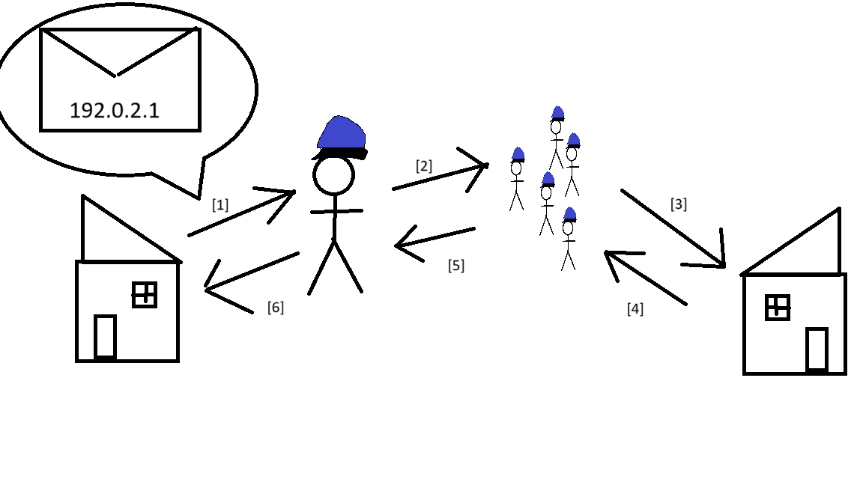
Illustrated above is a diagram of my design describing the process of packet transfer as previously discussed.
PLEASE READ: The following is part of the diagram and as such I do not believe should contribute to the allocated word count for this report. Ideally, it would have been included on the diagram, however I made it with Paint, which is incredibly limited in what it can do, so I have elected to type it out here for clarity’s sake.
[1] Client sends a packet to the router to be sent to 192.0.2.1
[2] Router contacts other routers and attempts to find one closer to 192.0.2.1. Once one is found, it takes the packet and repeats the process until the destination is reached.
[3] The packet reaches the destination. A confirmation of reception is requested, so the recipient sends back a packet to confirm the first packet was received.
[4] [5] Same process as [2] and [3], only reversed.
[6] The client confirms the packet was received by the recipient.

[8][6] (these are references)

- IPv4
As the diagram above illustrates, IP addresses act as unique identifiers that allow clients to receive packets accurately and efficiently [9]. IPv4 addresses are made up of four octets, with each one containing up to 256 potential values from 0-255 (we include 0, so 256 values).

- IPv6

IPv4 is stored in a binary format, while IPv6 is stored in a 128-bit alphanumeric format [d]. This means that IPv6 has a far greater number of values and thus is more scalable than IPv4.

- Subnets

Subnets are used to segment a network. There are many varied advantages to subnetting, so it is implemented in most enterprise networks.

- Efficiency - subnetting allows for quicker routes that packets can take to reach their destinations. As networks grow, so do the travel times for packets. Subnetting can assist with this as it prevents all data from travelling along the same route (bottlenecking). [10]
- Security - subnets bolster the security of networks.
“With subnets, devices will not be able to access the whole network, and companies can dictate which hardware and users have access to more sensitive data.” - [10]
This almost acts as an additional layer of access control. Cyber security is all about adding layers of security, and subnetting is yet another layer that should be implemented.

- Switches

Switches have considerably more ports and are used to connect devices within a network, as opposed to connecting to other networks like a router does [b]. In most instances, a switch will never directly touch the internet.
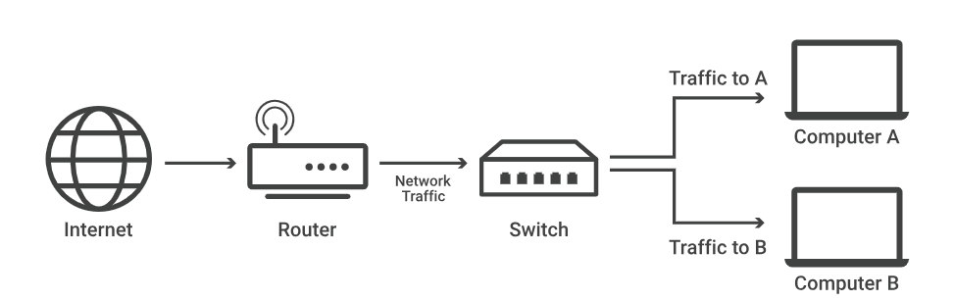[B], diagram taken from Cloudflare’s article on network switches

- Routing
Routing protocols determine how routers on a network transfer data. They instruct the router on how best to reach it’s destination in a way that is efficient, using the most optimal path available. Different protocols are available depending on the scenario.[11] [13]
Some examples of these protocols are:
“
- Routing Information Protocol (RIP)
- Interior Gateway Protocol (IGRP)
- Open Shortest Path First (OSPF)
- Exterior Gateway Protocol (EGP)
- Enhanced Interior Gateway Routing Protocol (EIGRP)
- Border Gateway Protocol (BGP)
- Intermediate System-to-Intermediate System (IS-IS)
“[12]
These protocols have different roles and functions within a network.
Before a router can send packets to a destination, it first needs a route. If it doesn’t already have one, it must begin route discovery. According to digi.com[14],
“Route discovery is a process that occurs when:
- The source node does not have a route to the requested destination.
- A route fails. This happens when the source node uses up its network retries without receiving an ACK.”[14]

This process is akin to postman diagram from earlier- where a source broadcasts a route request to any intermediate nodes, which may either drop the packet or continue broadcasting onward. Whether they drop or forward the packet is dependant on whether the intermediate possesses a more optimal route back to the source. This process continues until the destination receives the original broadcast from the source, forwarded on by the intermediates, in which case it sends a packet back along the path carved out by the intermediates (which will be the most optimal path) back to the source, indicating to the source the most optimal path to take to reach that destination. [14] This information is used to help build out routing tables present in routers. Efficient routing is critical for optimised network performance.

These automatically discovered routes, better known as dynamic routes, are often used in conjunction with static routes created by network engineers. Static routes are non-adaptive, meaning they do not change, no matter what changes occur to the network. There are a few advantages of using static routing :
- Less CPU is required for the router due to the lack of dynamic routing capability. This effectively results in static routing being economically and environmentally better - organisations can save money both on the router itself by purchasing a lower end router and will also save money on electricity.
- Heightened security due to routes not changing unless an administrator manually does so.[15]
The issue with static routing lies in it’s practically in larger networks. Network changes happen frequently, and as networks grow it stops being feasible to manually adjust routes every time it is necessary. It also requires a solid understanding of the network the engineer is routing, which is not the case of dynamic routing, which is easy to set up.

- IP Addressing and Network Infrastructure Research

- VPN
A VPN, or virtual private network, creates a tunnel from an endpoint to a remote server. This tunnel serves as an alternate point of access for that endpoint, and while the VPN is connected, network traffic will flow through the tunnel, which is encrypted. There are countless applications for this technology, I will list some example scenarios below: [16]
- Using VPN on insecure networks to encrypt traffic
- Using VPN to bypass firewalls
- Using VPN to remotely access a corporate network

- DHCP
According to learn.microsoft.com [17],
“Dynamic Host Configuration Protocol (DHCP) is a client/server protocol that automatically provides an Internet Protocol (IP) host with its IP address and other related configuration information such as the subnet mask and default gateway.”
DHCP servers are practically essential in larger networks. In smaller networks, network engineers can personally allocate IP addresses to each client in a realistic manner, but this is not the case in larger networks. This is doubly true as manually added IP addresses must be manually reclaimed [17], which is not the case if a DHCP server is in use. This is the main advantage of DHCP - considerably less manual configuration required from engineers.

- Active Directory Domain Services
Active Directory Domain services (or AD/AD DS) is a hierarchical structure [18] that acts as a repository for objects present within a given network. AD is used by many organisations as a means to organise their user accounts, devices, user groups etc. All of these are stored in the directory and can be accessed and managed by an administrator with a single sign in [18]. Policy based or role based administration is also possible, for example, one can define what an administrator can manage based on an object’s OU (organisational unit).
Although AD is primarily used within environments comprised mainly of Windows devices, it can be used with other operating systems such as MacOS.
- Certificate Authorities
Certificate Authorities (CAs) have a very important role within internet security. They act as intermediates between clients and websites that vet the site and grant it a TLS/SSL certificate based on the trustworthiness of the site [19]. The certification reveals information like the CA, organisation holder, website domain etc. Websites verified by CAs have traffic passed between internet browsers and verified sites encrypted, which is essential for sites that handle sensitive/personal information such as passwords etc. (which is most sites).
They are not infallible, however. Many compromised or phishing sites retain a certificate, giving the impression that they are legitimate.

Task 2: Virtualised Environment

- Network Design and Topology

Here is my network design:
Hostname | IP Addresses | Subnet Mask | Operating System | In what subnet?
S-DC  Se0/0/0  Gig0/1 | 192.53.2.65  192.168.47.1 | /30  /24 | Windows Server 2022 Datacenter 21H2 Desktop Experience | Subnet 3  Subnet 1
C-Server  Se0/0/0  Gig0/1 | 192.53.2.66  172.64.0.1 | /30  /24 | Debian Linux 12.5.0 | Subnet 3  Subnet 2
ClientS1 | DHCP | /24 | Win 10 | Subnet 1
ClientC1 | DHCP | /24 | Deb Lin 12.5.0 | Subnet 2

Below is a diagram depicting the topology I intend to use:
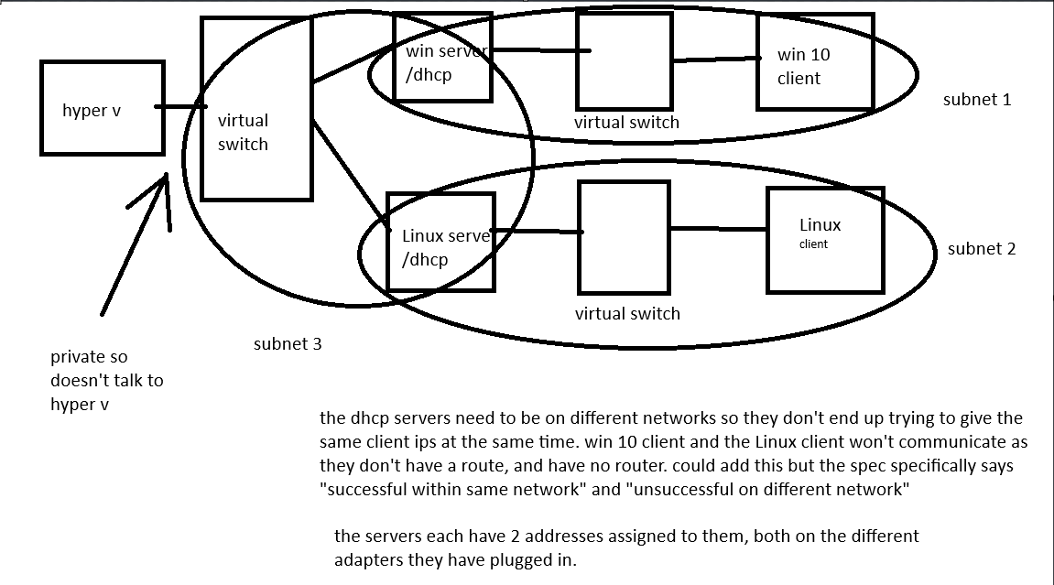

Originally, I did not intend to use switches for my topology, but I have since decided that it would be best to do so. This is a more realistic design that may actually be used in a network environment, while connecting all the devices through NIC is not as realistic.
Additionally, I considered a design where both the Win 10 and Linux clients would be connected to one switch, but then the Linux and Windows DHCP servers would clash, and may mix up the IPs and subnets I intend to assign the clients to.
I intend to use a private network switch as opposed to a public or internal one. This is so the hypervisor does not interact with the network and essentially causes it to be isolated.
For my hypervisor of choice, I am going to be using Microsoft’s Hyper-V. There are a few reasons I’ve decided to use Hyper-V:
- There is a substantial amount of support and documentation that I can use to assist me in the set up of my virtual environment with Hyper-V. I use Microsoft’s documentation very frequently and trust it over most others.
- Hyper-V is an industry standard hypervisor.
- My colleagues in work are familiar with Hyper-V and will be able to support me better should I require it.
Here is the documentation I intend to refer to: [20]
https://learn.microsoft.com/en-us/windows-server/virtualization/hyper-v/get-started/install-hyper-v?pivots=windows-server
Luckily for me, I don’t need to go about installing Hyper-V as it is already present on the virtual machine. The time included in all screenshots is accurate to the time it was taken.
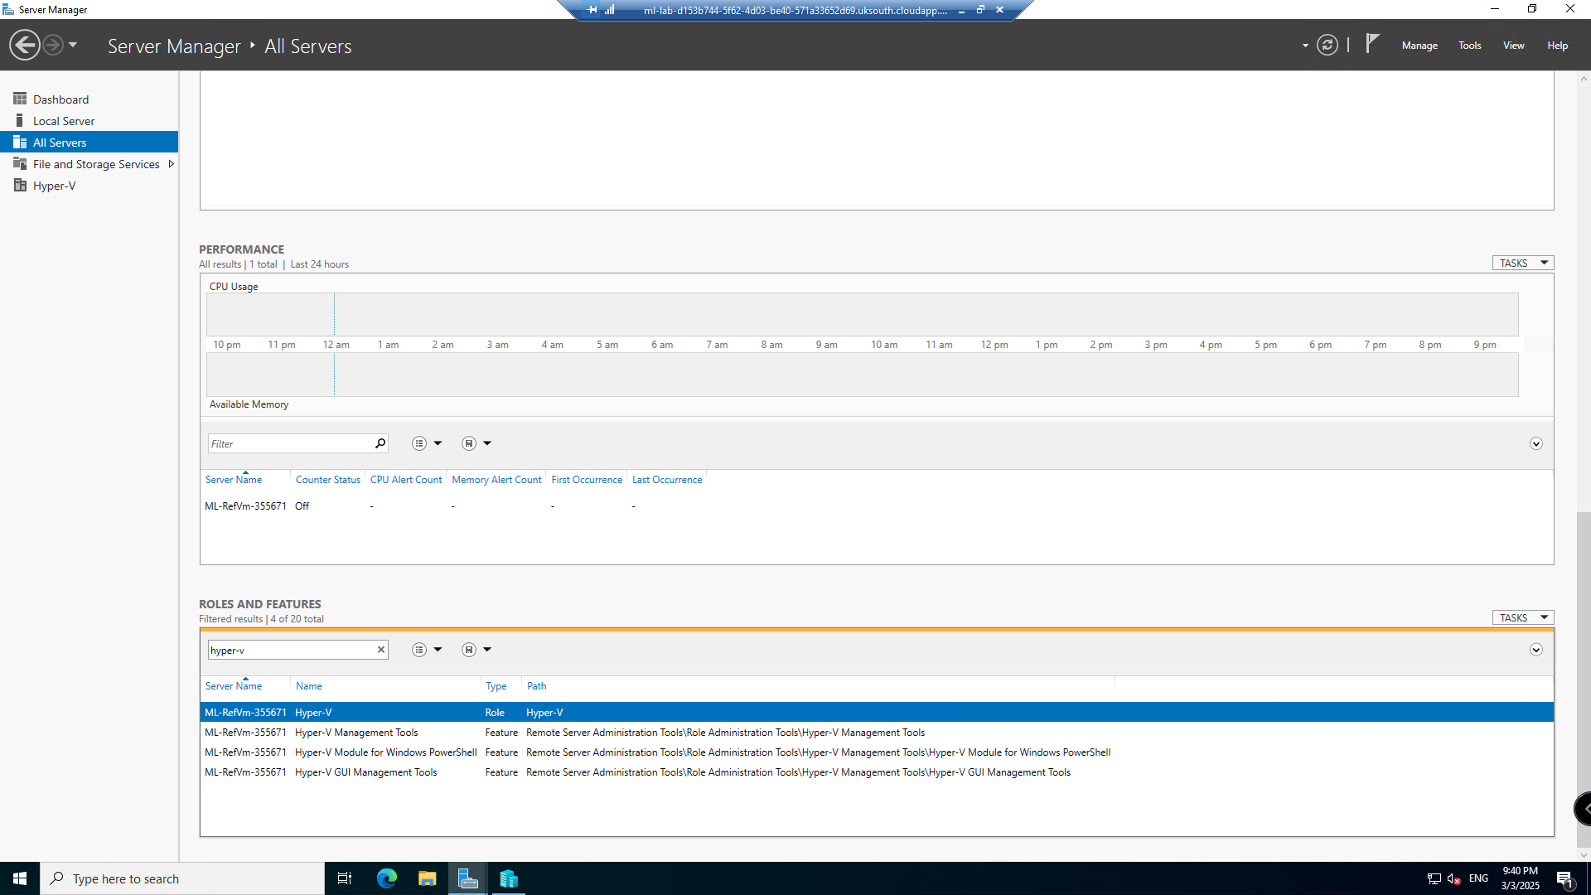

- Virtual Switch Configuration
As mentioned in the topology, I need to create 3 virtual switches for my network. This section is where I will document the process of doing so.
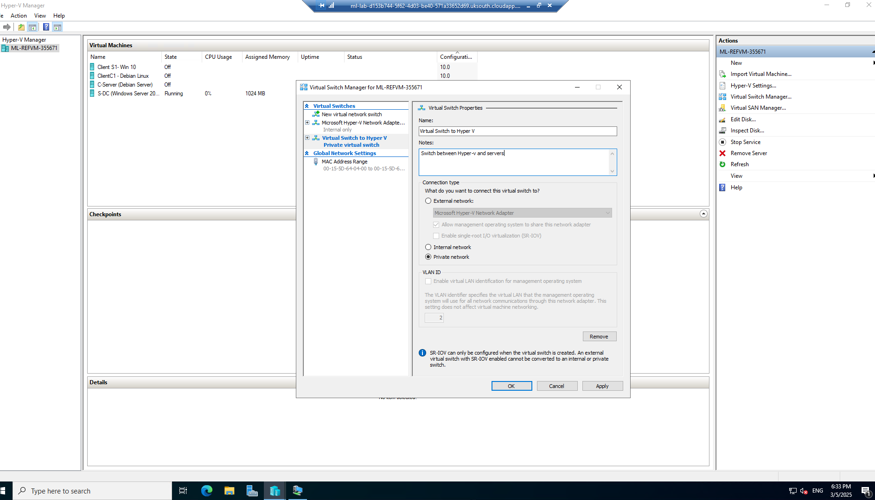
I’m going to add descriptions to each switch to help me keep track of which is which.
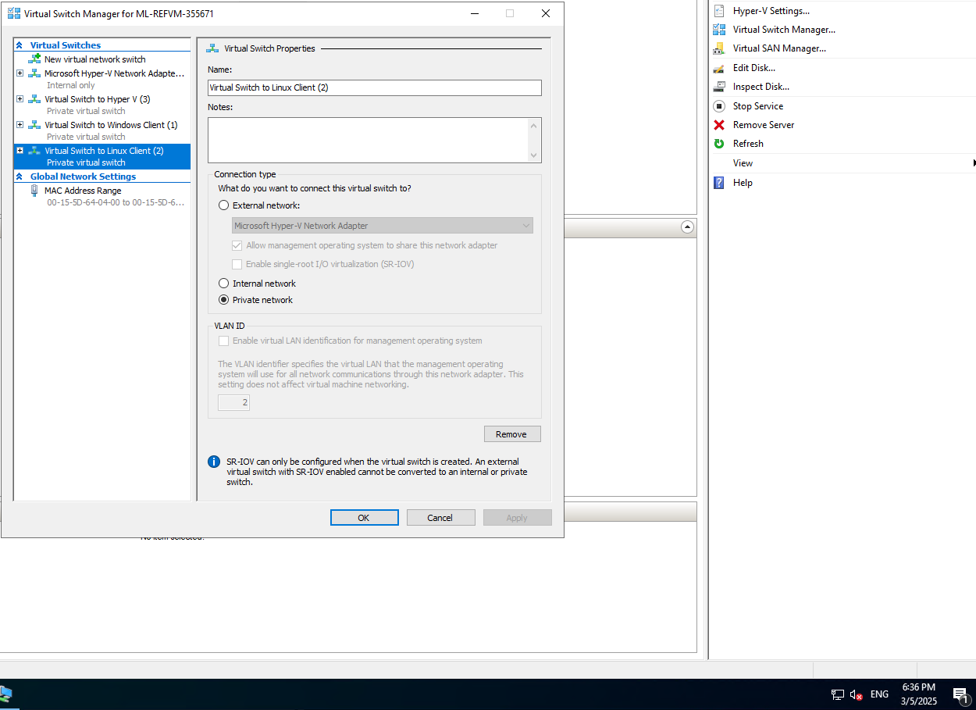
- Windows Server Configuration
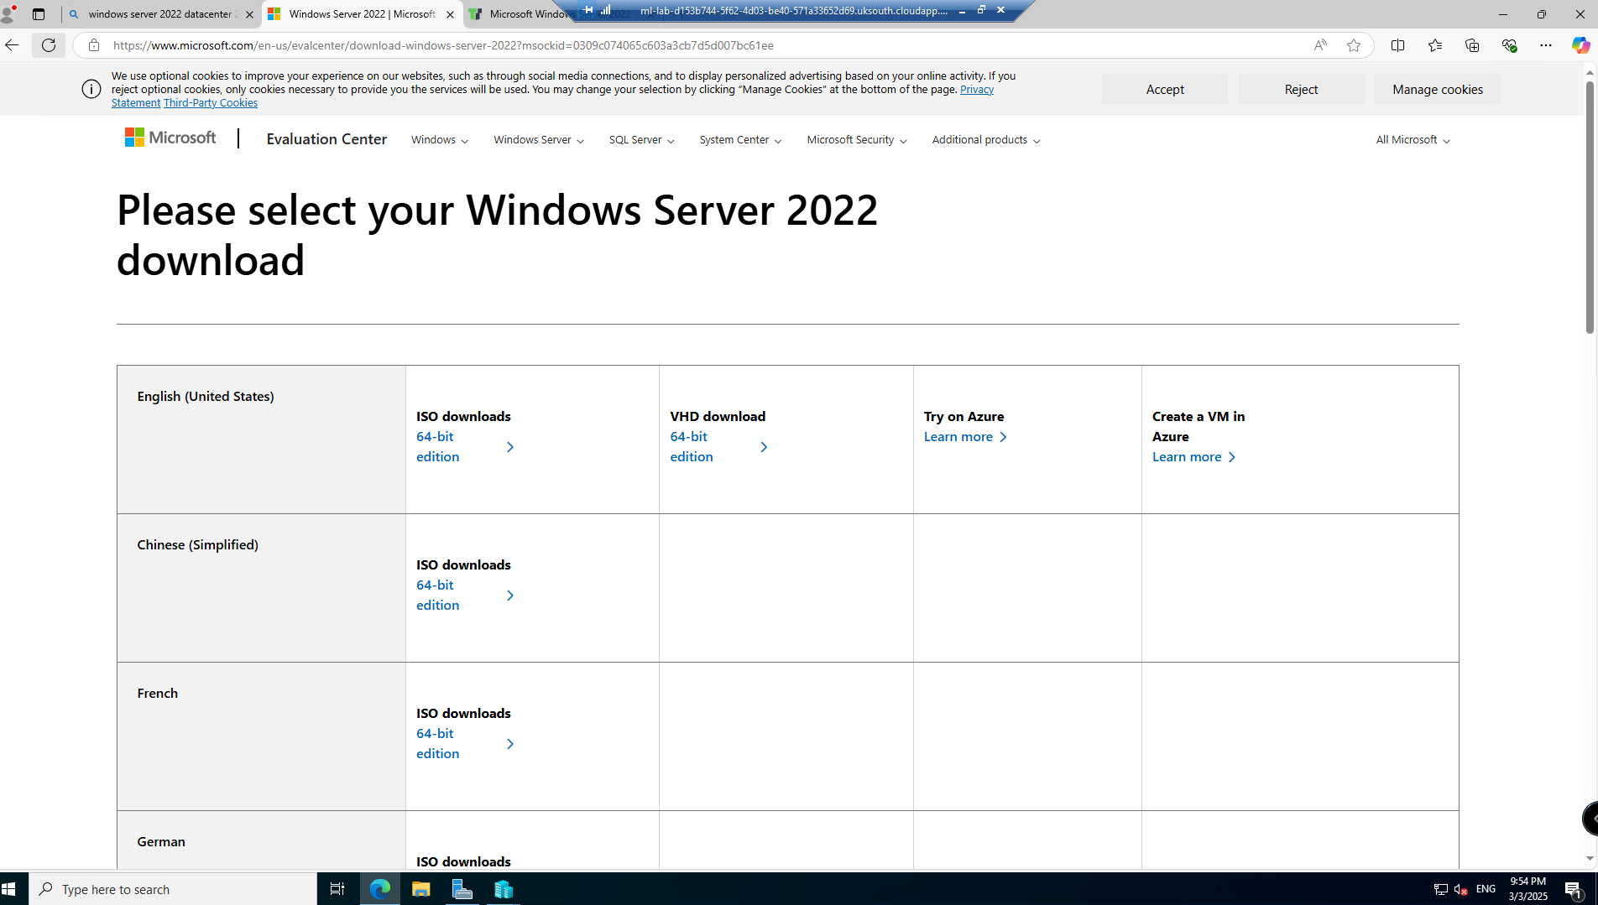
Here, I am presented with the choice to create the VMs as either gen 1 or gen 2. Upon reading the documentation provided by Microsoft on this topic [21], I’ve decided to use gen 2. Debian Linux and Windows (enterprise and server) are both compatible with UEFI, and are supported by gen 2, so I will take advantage of the benefits provided by choosing a gen 2 virtual machine.
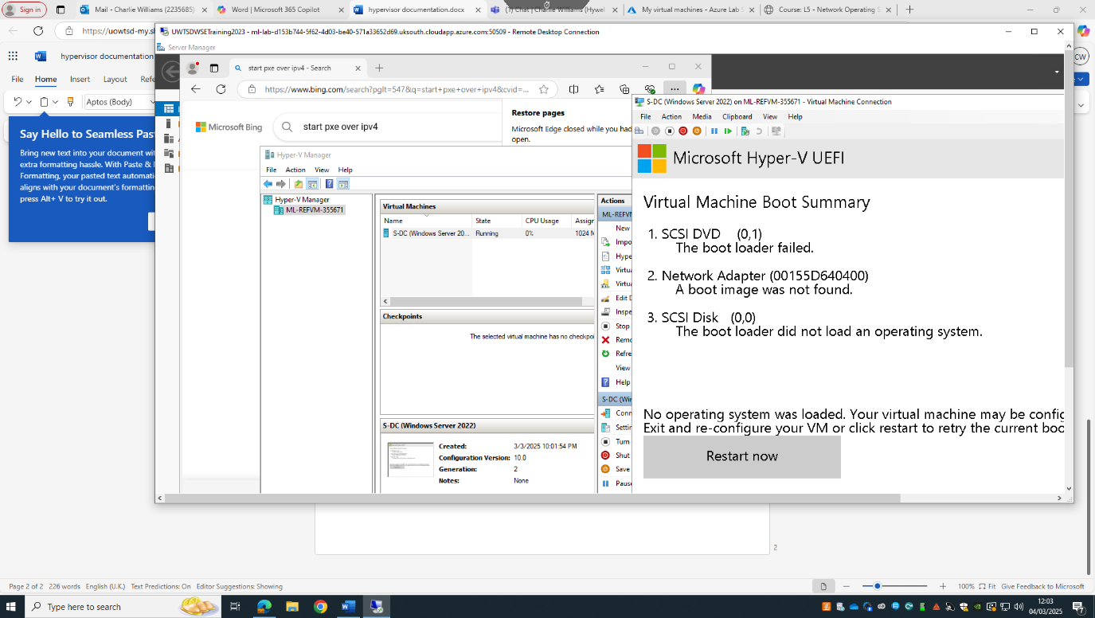
This was the first speedbump I came across. I originally thought the issue might be with the fact that I was attempting to create a gen 2 machine, especially given the aforementioned UEFI compatibility, but this is not the case as Windows Server 2022 definitely supports UEFI.
I also checked the boot order, as sources online suggested the issue I was having was because it was trying to boot over the network, but this doesnt appear to be the case either.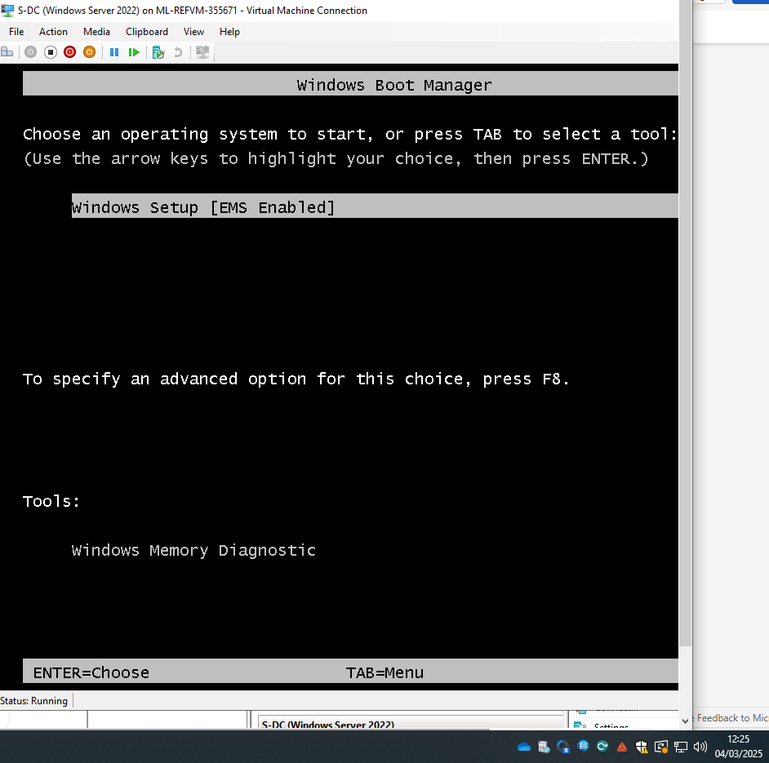I eventually figured out it was an issue on my end. I was trying to connect to the wrong virtual machine, this is due to my inexperience with Hyper-V. I won’t make this mistake again.
Windows server password: UWTSDnoss2025
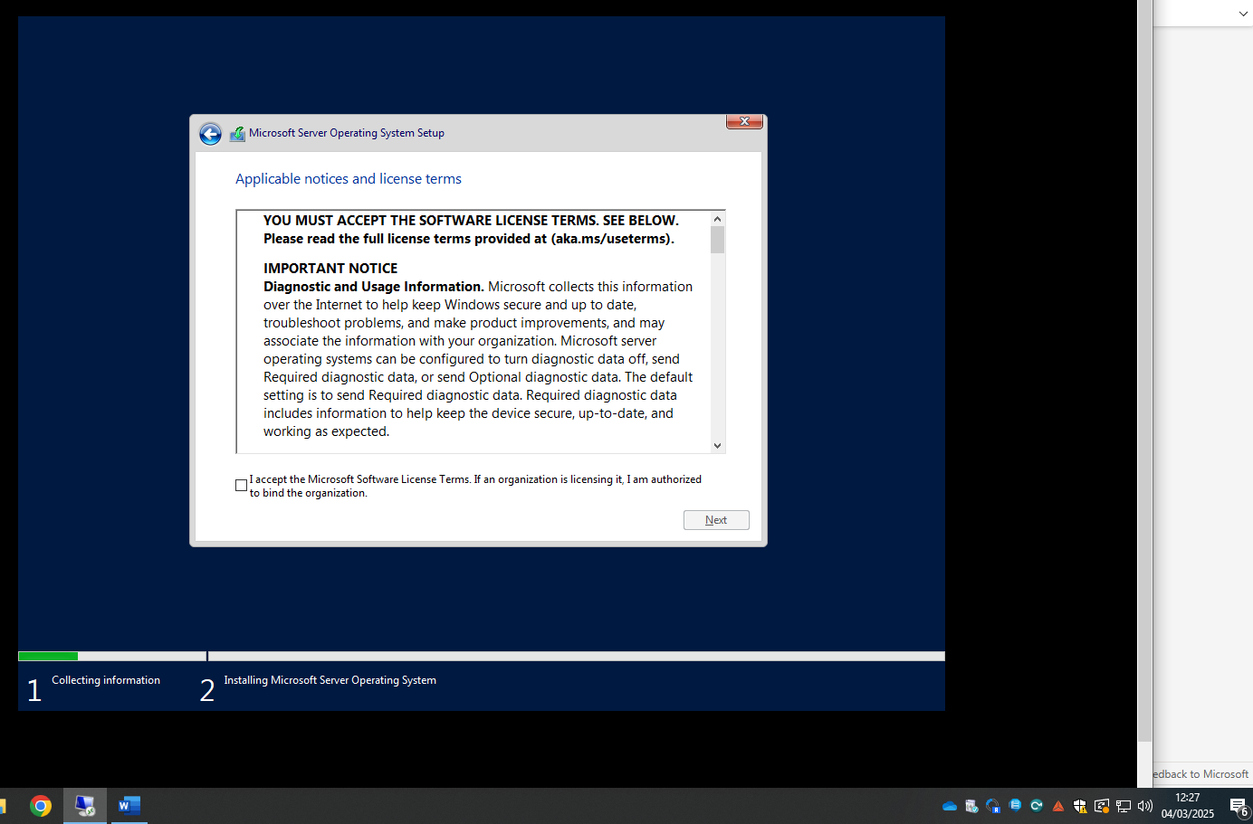
The next issue I had is that it said “ctrl+alt+delete” to log in, and when I press this, either my host OS or the Hyper-V OS reacts. To circumvent this, I had to go into Hyper-V manager and then actions, and then “ctrl+alt+delete”.
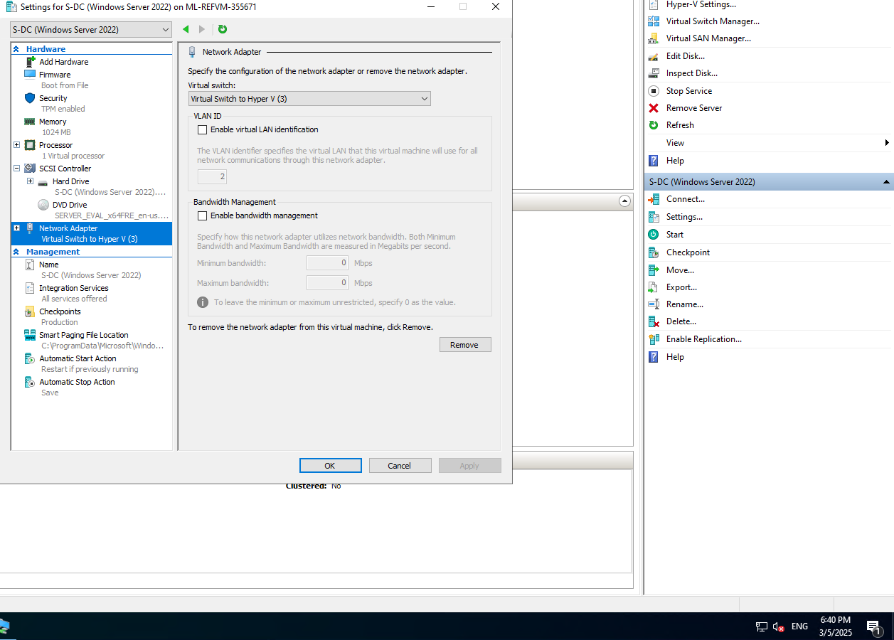
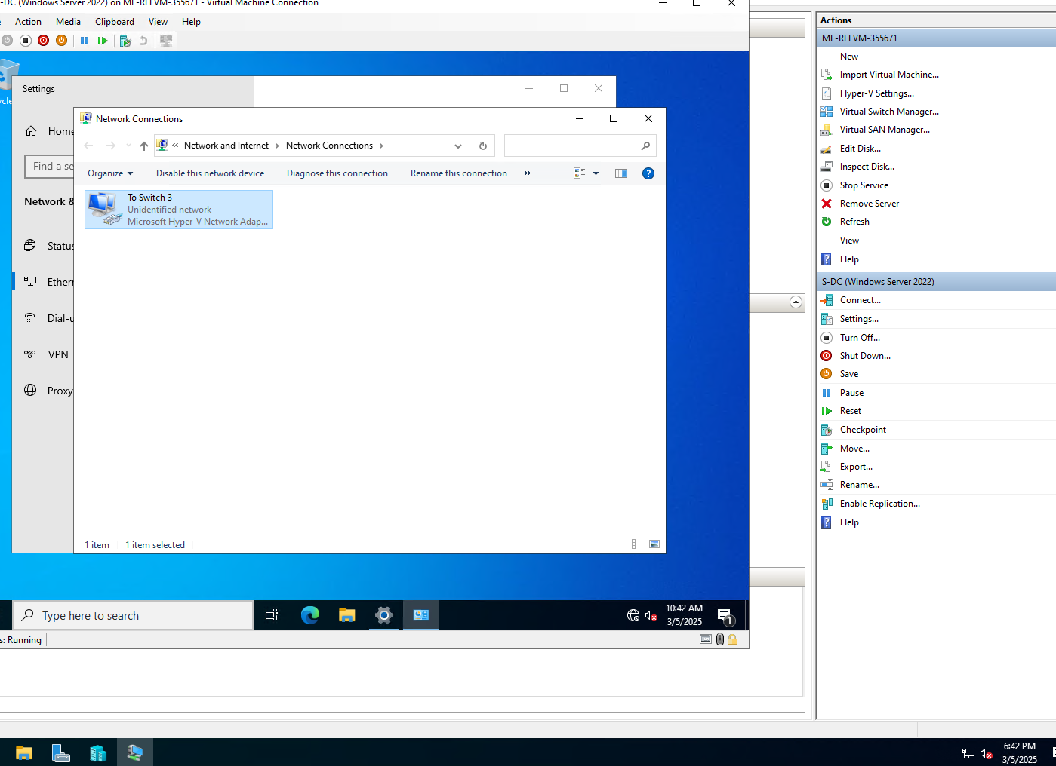
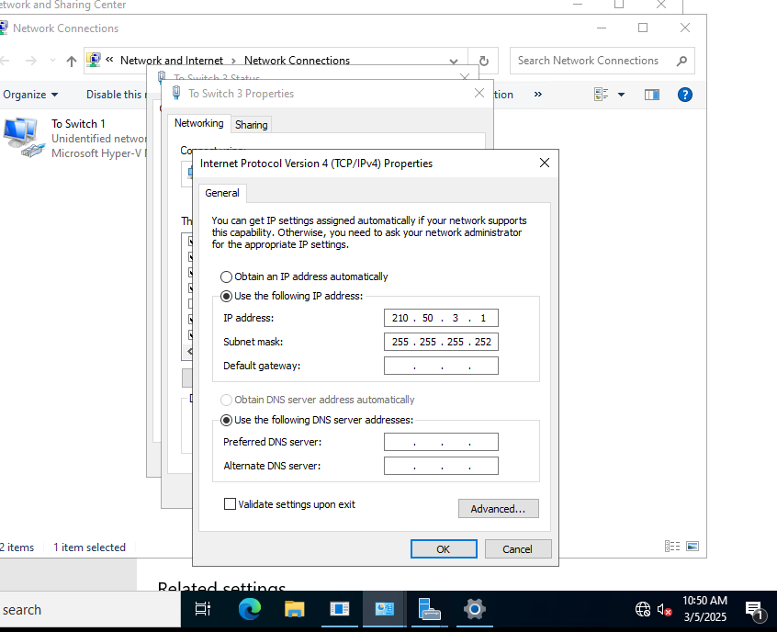

Setting up DHCP is a fairly straightforward process from what I can tell. Again, I’m using Microsoft’s documentation. This is common sense really given I’m using their DHCP tools on Windows Server. [21]
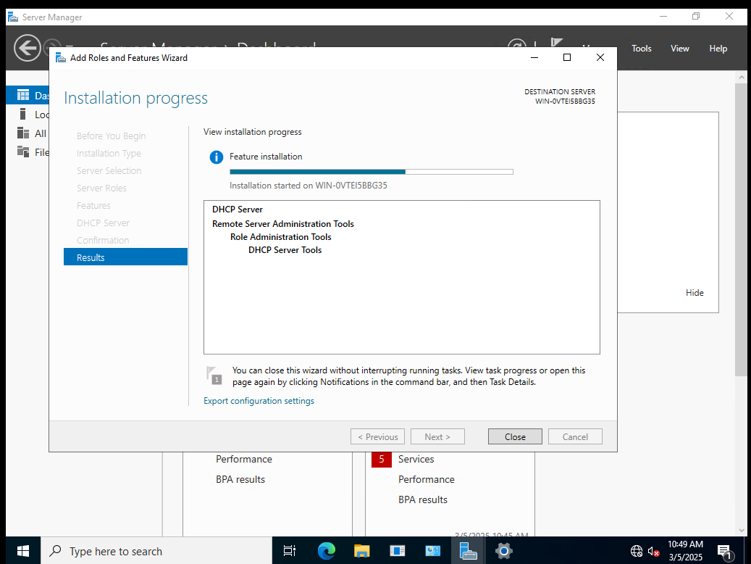
I’ve just realised the VM’s date and time is no longer accurate. Everything related to DHCP, virtual networks and the network adapters was taken from 6pm to 7pm on 05/03/2025. Apologies, I’ll be sure to include them correctly going forward.
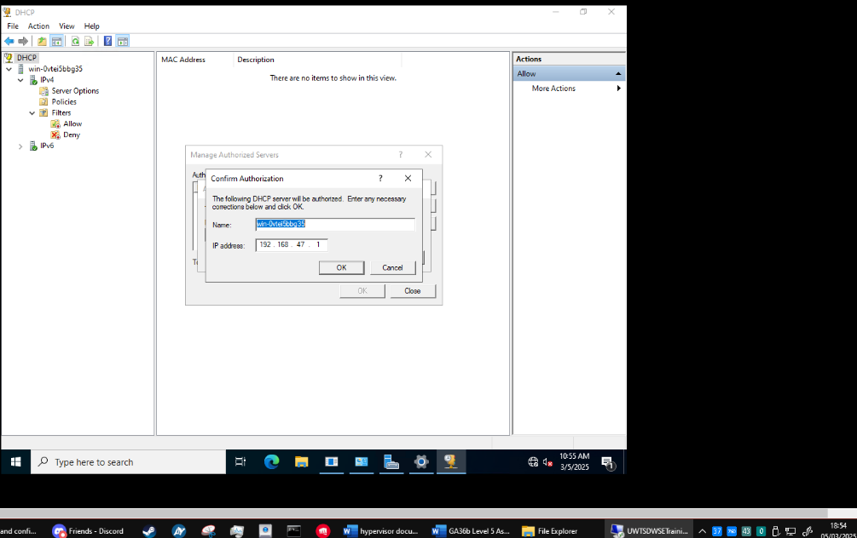

Authorizing my DHCP server in Windows Administrative Tools, as per the documentation in [22]

Upon trying to authorize my DHCP server, Windows came up with an error message to let me know that it is was unable to contact the active directory. I did not realise this was a pre-requisite for being able to create a DHCP server, so I will go about setting this up now.
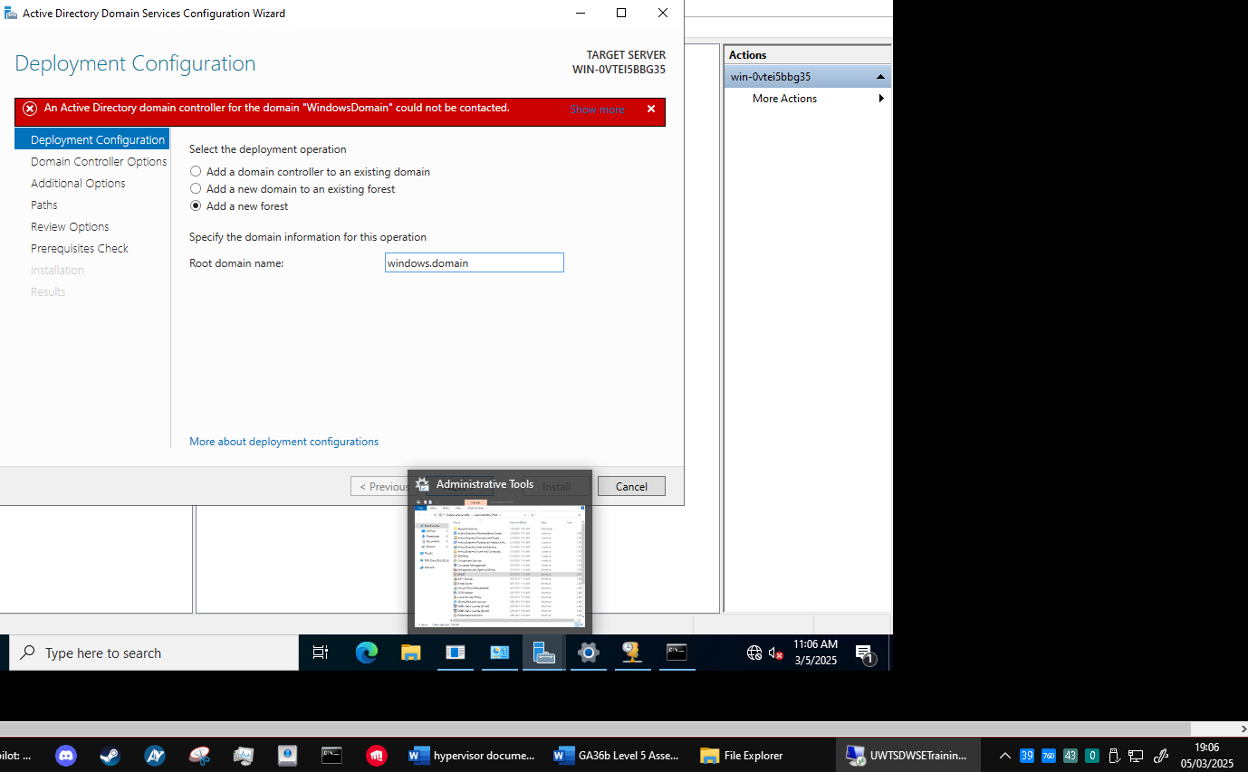
Once this is done, I can go into the DHCP configuration again and authorize my DHCP server.
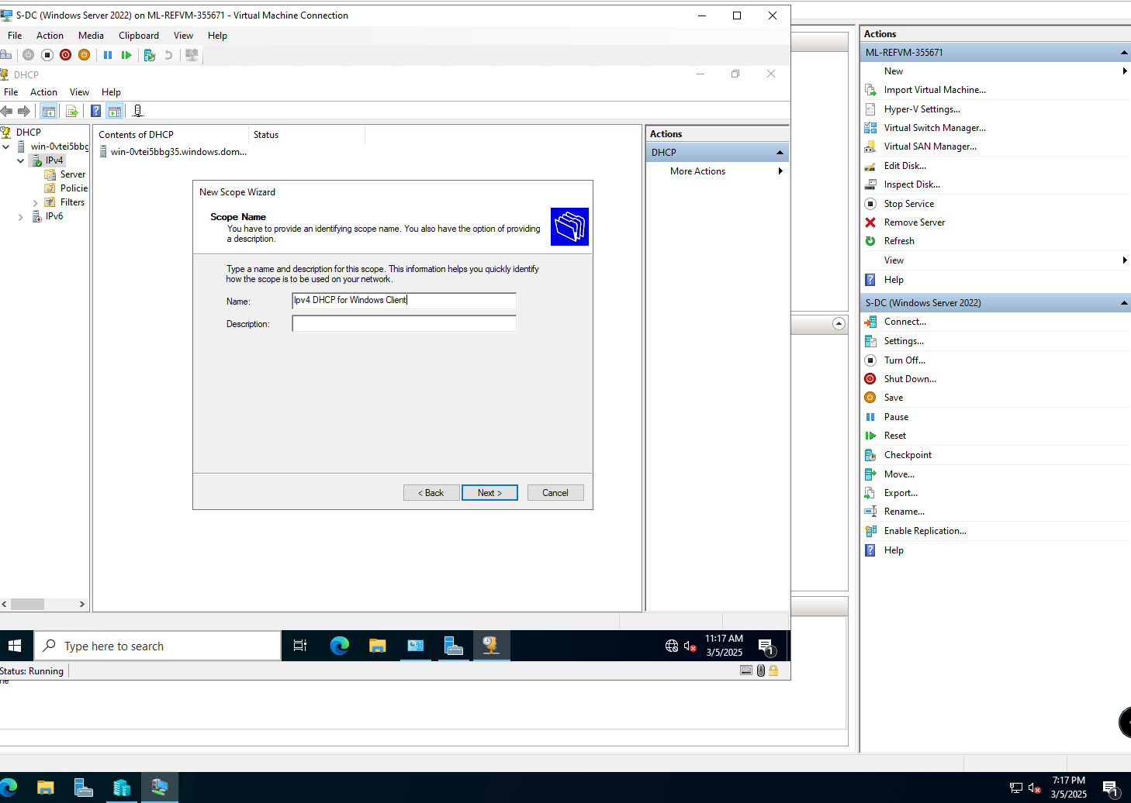
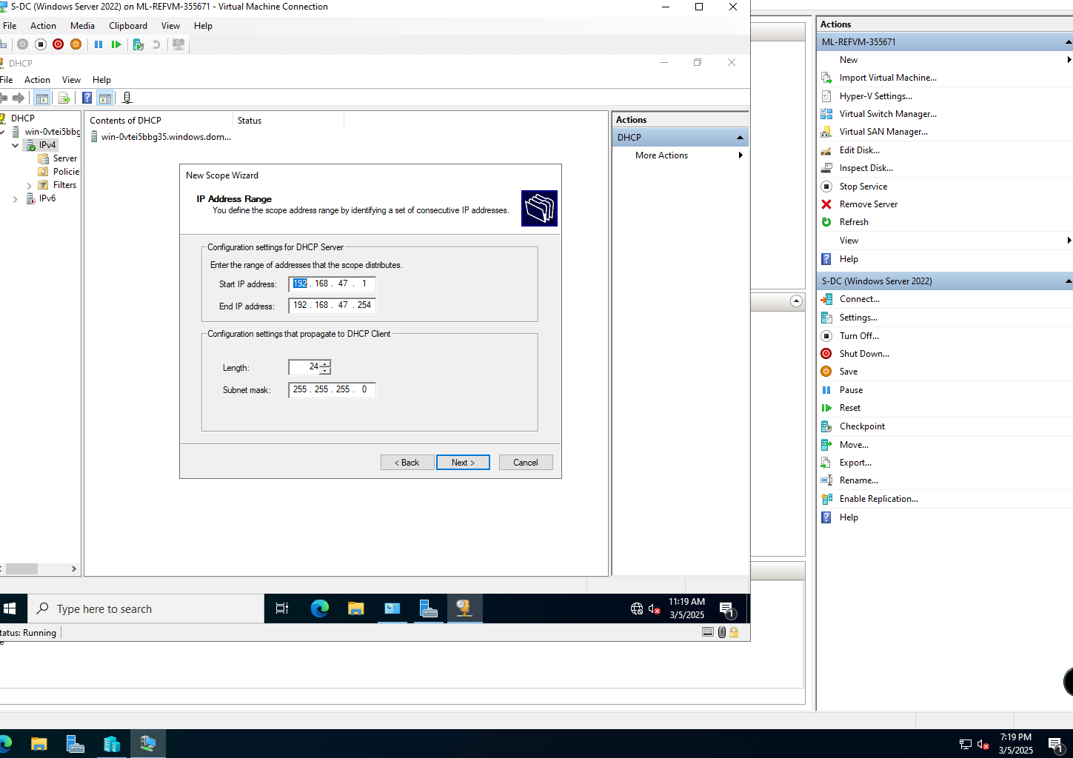
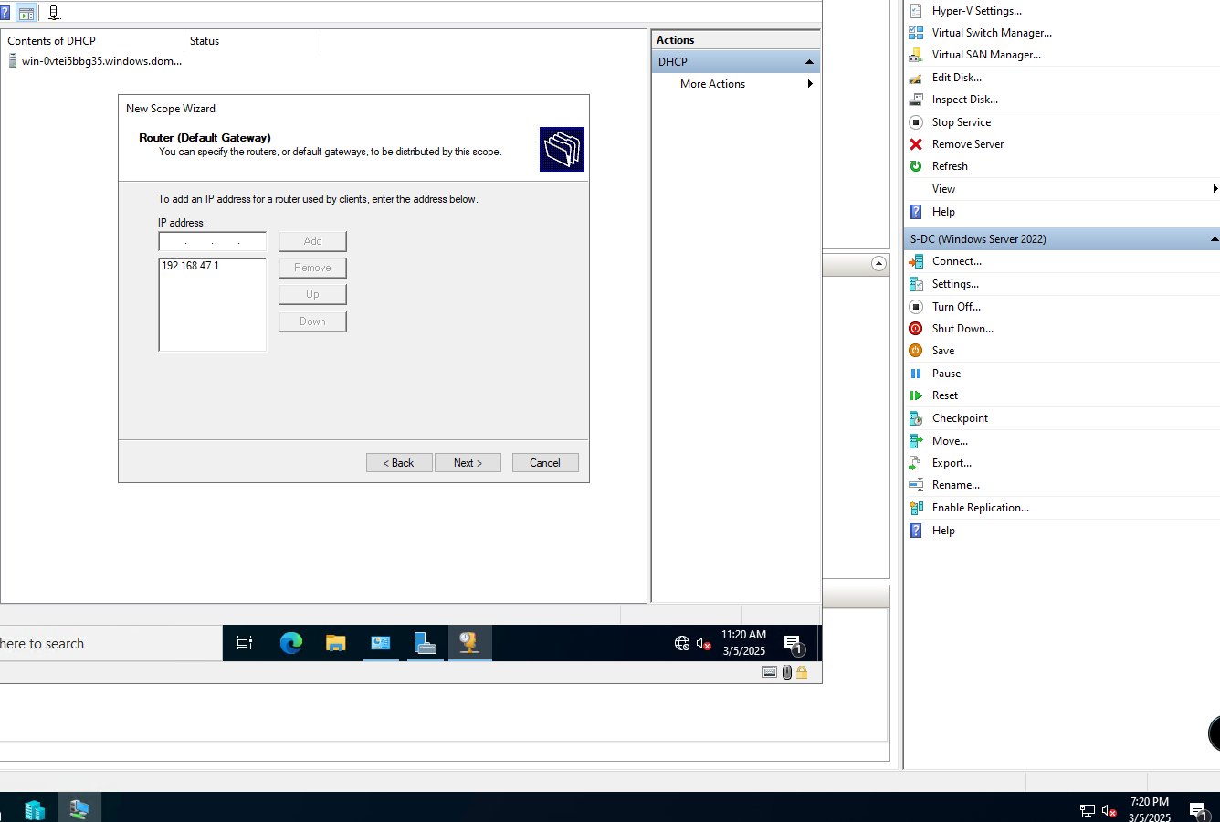
The ipv4 scope should now be set up, enabling my Windows 10 Client to obtain an IP from this DHCP server.

- WINDOWS CLIENT
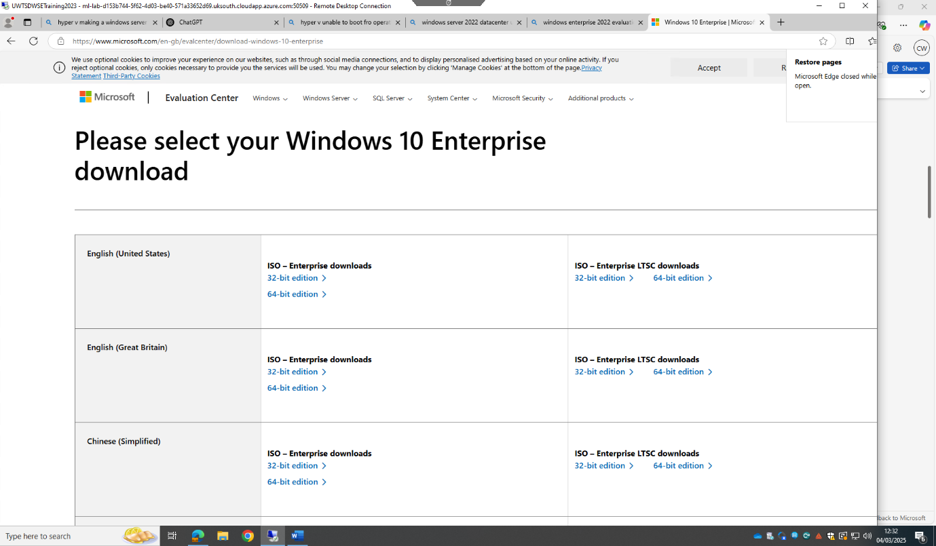

A lesson I learnt while setting up the windows client VM is that it takes a significant amount of storage to install Windows OS. I only allocated 10GB to the hard drive. I will be sure to allocate more going forward. The convenient part about hypervisors like this is I can just adjust the hard drive size. Screenshot below is proof it works - this is an automatically assigned address.
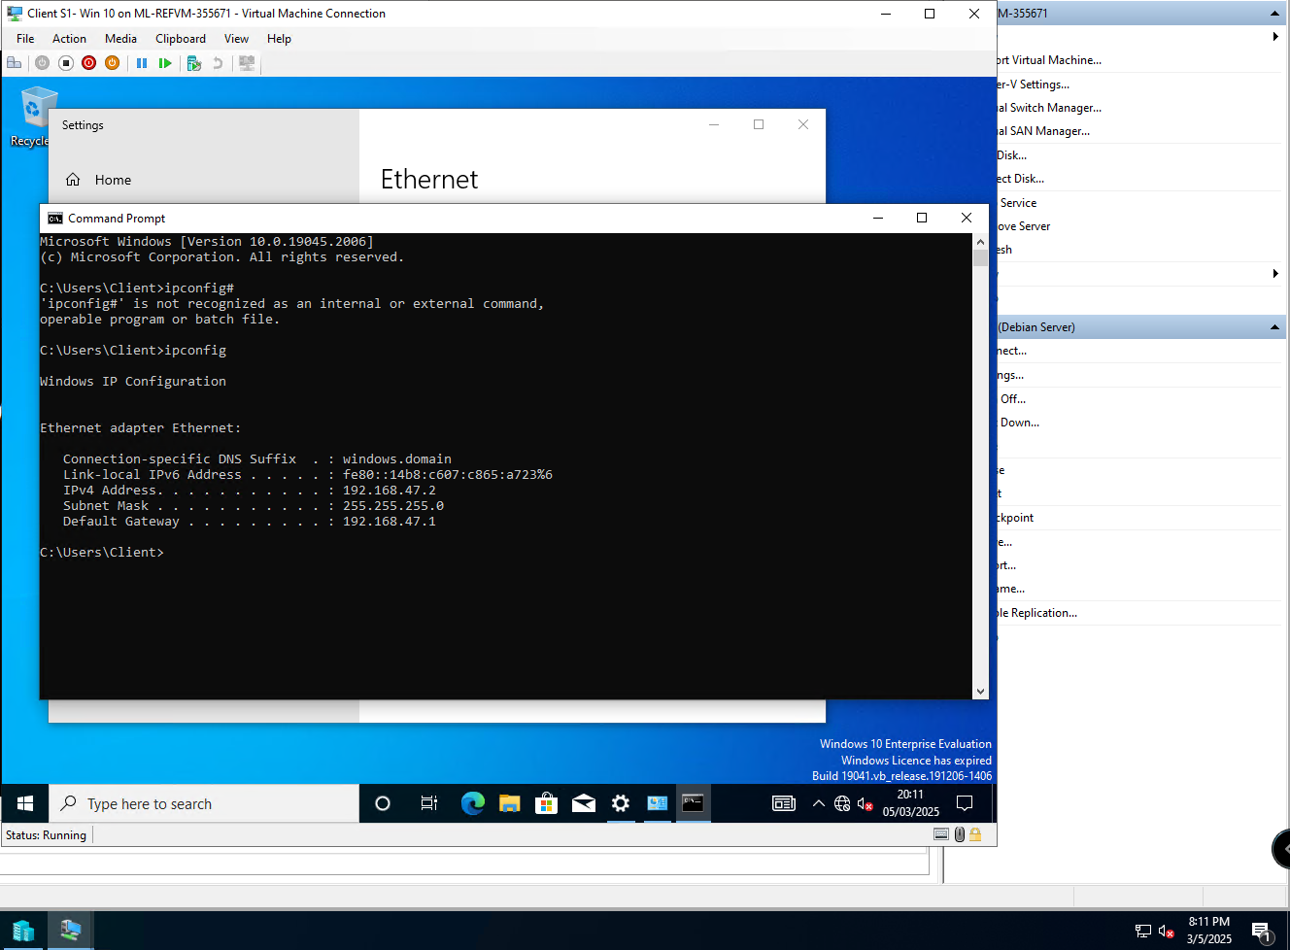

- LINUX SERVER AND CLIENT
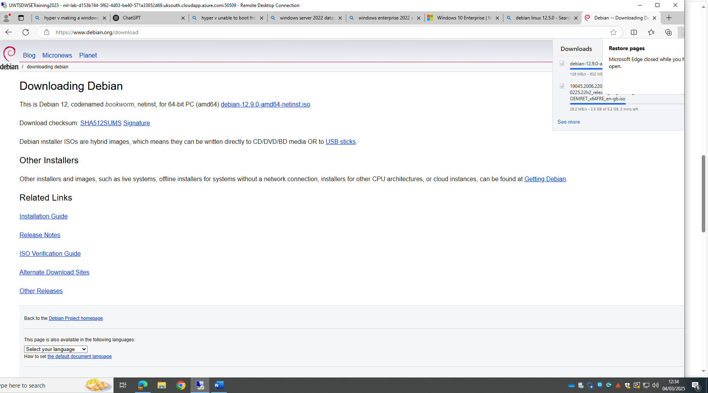

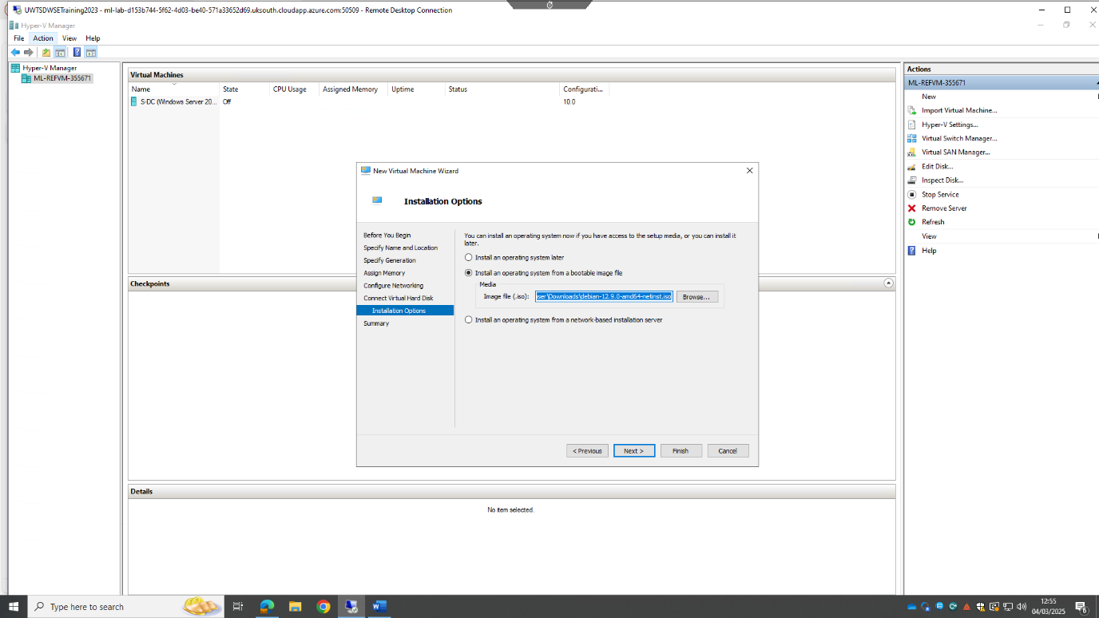
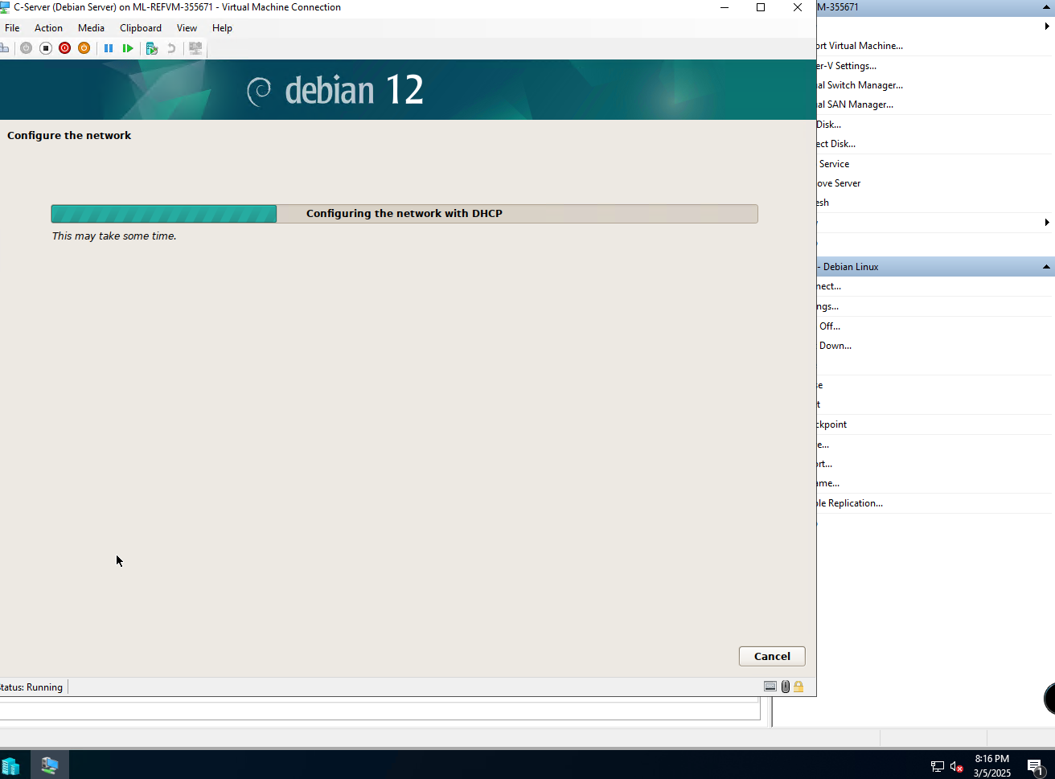

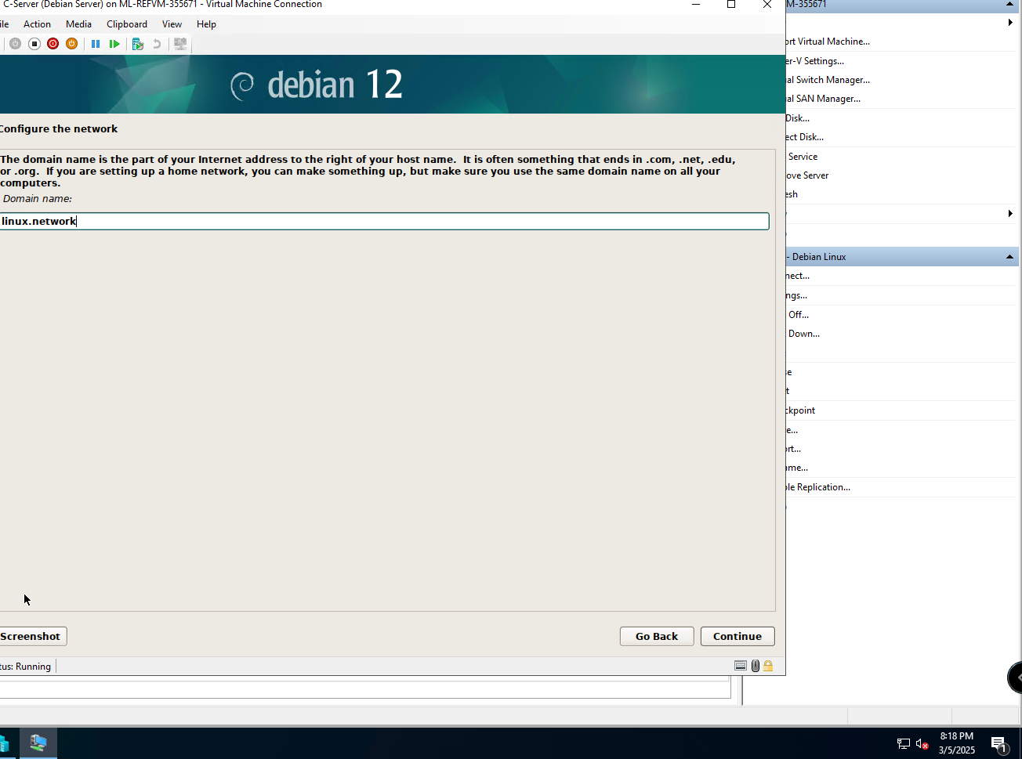
Linux details:
User: vboxuser
Password: changeme
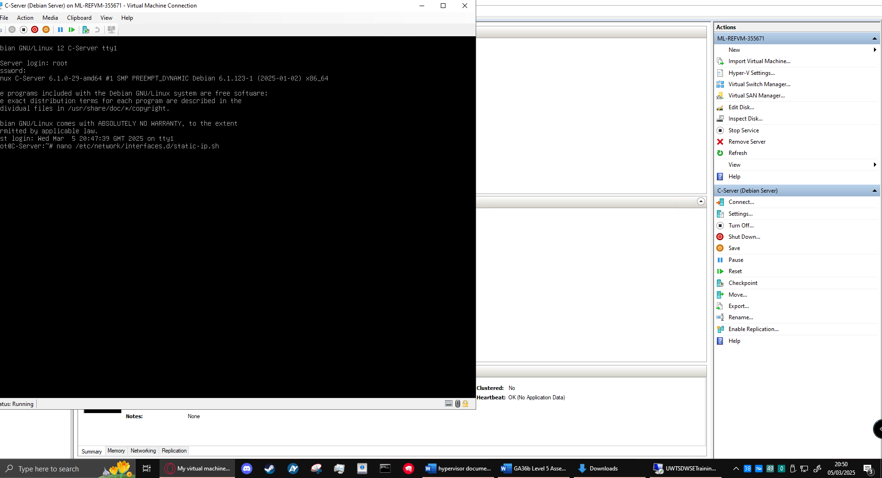
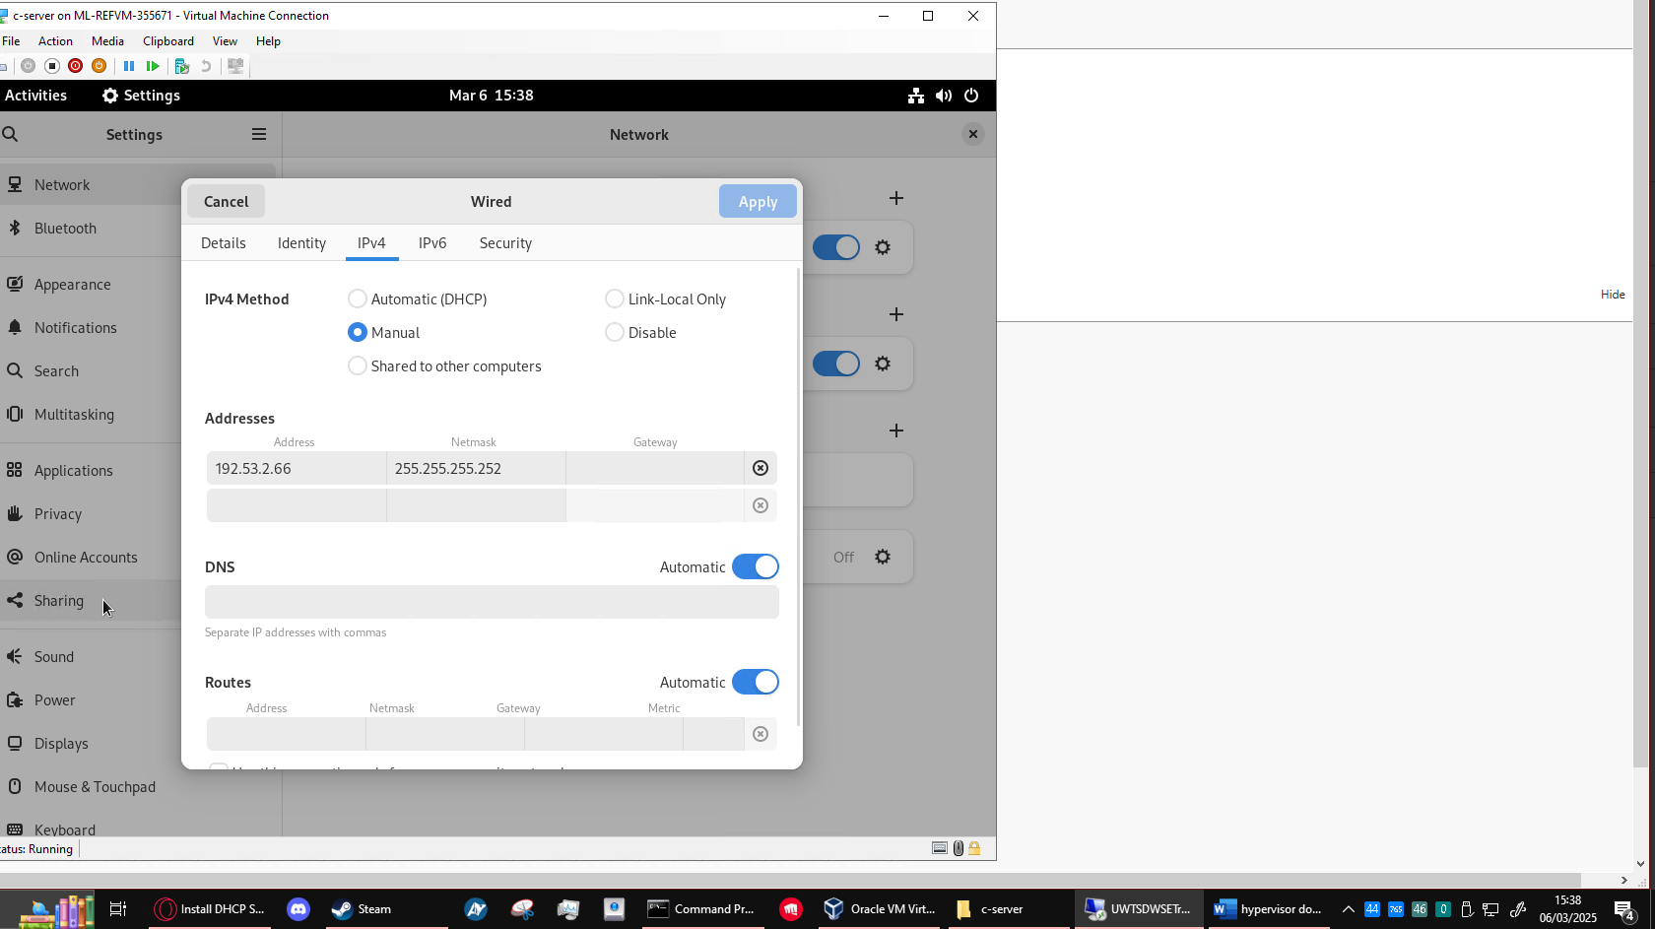
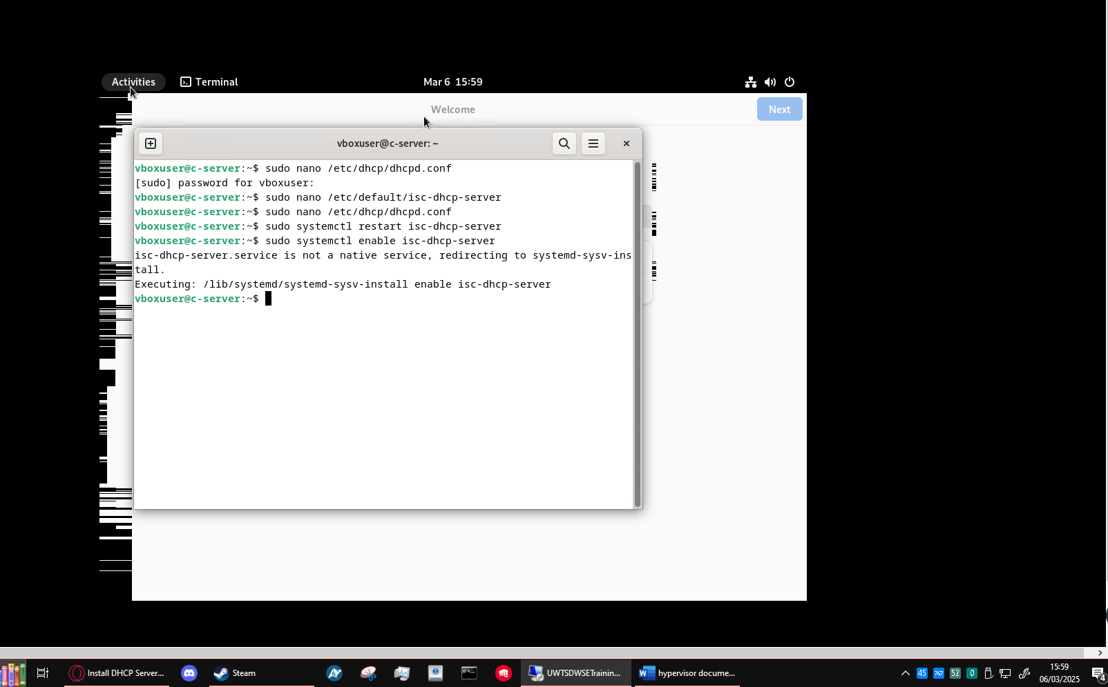
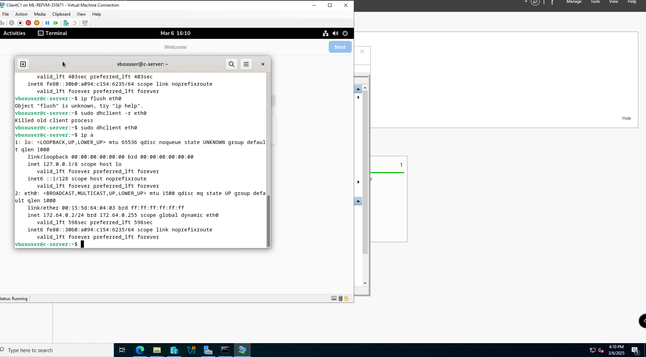
Above is dynamically assigned IP address on the Linux client.

- Ping attempts:
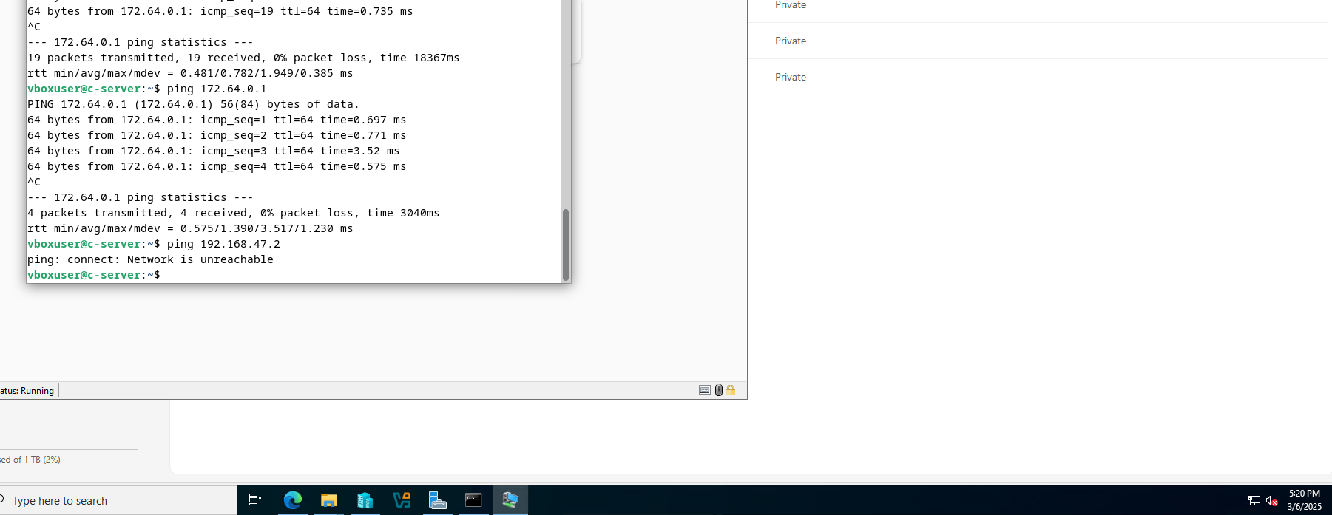
Pictured above: ping request to 172.64.0.1 (the Linux server) which succeeds within same network, and a second ping request to 192.168.47.2 (the Windows client) on the other network. Doesn’t work because there is no route.
Reverse is below, Windows Client to Windows server and Linux client with same results.
(This is what the brief asked for. Successful within the same network, unsuccessful within different networks)

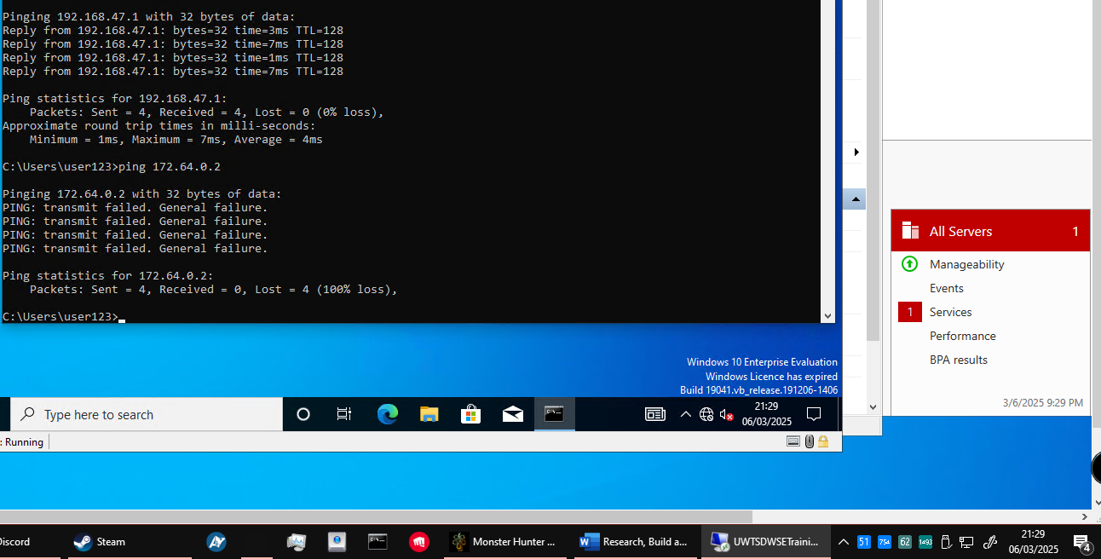

- Personal Reflection
Configuring the machines and DHCP for Windows was a quick, straightforward process (although the Windows takes a while to build itself) while there were so many complications with my Linux machines. I could not get either of them to have the internet access needed to download the graphical user interface or the DHCP package. I eventually managed to find a work around but it was complex and very time consuming, next time allowing myself more time to work out how to give them internet access will be necessary.

- Reference List

[1] robinharwood (2025). Hyper-V architecture. [online] Microsoft.com. Available at: https://learn.microsoft.com/en-us/windows-server/administration/performance-tuning/role/hyper-v-server/architecture [Accessed 2 Feb. 2025].
‌[2] Redhat.com. (2024). What is a hypervisor? [online] Available at: https://www.redhat.com/en/topics/virtualization/what-is-a-hypervisor [Accessed 2 Feb. 2025].
[3] https://chatgpt.com – used to consolidate sources on this topic for research purposes.
‌[4] https://www.ibm.com/think/insights/virtualization-benefits?utm_source=chatgpt.com (found using ChatGPT)
[5] https://circleci.com/blog/top-6-benefits-of-virtualization/?utm_source=chatgpt.com
(found using ChatGPT)
[6] How Does Data Travel on the Internet? - Networking Guides
This site is okay, the presentation is informal and a bit unclear, but the contents are good enough and I have enough of a solid understanding of networks that I can verify what I take from this site is correct.
[7] cloudflare.com/learning/network-layer/what-is-a-network-switch/
This site is good. It’s from Cloudflare, which is well known, and is trustworthy by my estimation.
[8] I used Microsoft Copilot’s AI to help me verify that I was not missing any steps here. I am quite sure that my demonstration/diagram is correct, but I deemed it worth checking anyway. I also used it occasionally for finding sources, as Copilot tends to pull sources I would not have found usually.
[9]Understanding IP Addresses: Importance and Functionality
[10] What is Subnetting, Benefits, and How does it Work?
[11] Classes of Routing Protocols - GeeksforGeeks- I’ve been referring from GeeksforGeeks for years now, it is quite possibly one of my favourite sites for researching networking concepts. They do only offer the fundamentals in this article, but in this instance, that is all that is needed.
[12] Types of Routing Protocols - The Ultimate Guide (The Essentials!) - I’ve never used this site before and am not really sure of their legitimacy- however- the site’s content seems to be clear and accurate. With some sense checking and cross referencing with other sources, I think it can be used.
[13] www.chatgpt.com – used to proofread and reinforce my ideas here as routing protocols are one of my weaker areas.
[14] https://www.digi.com/resources/documentation/Digidocs/90001477/concepts/c_dm_route_discovery.htm?TocPath=Networking%20methods%7CDelivery%20methods%7CDigiMesh%20networking%7C_____3
[15] https://www.geeksforgeeks.org/difference-between-static-and-dynamic-routing/
[16] https://azure.microsoft.com/en-us/resources/cloud-computing-dictionary/what-is-vpn
[17] https://learn.microsoft.com/en-us/windows-server/networking/technologies/dhcp/dhcp-top
[18] https://learn.microsoft.com/en-us/windows-server/identity/ad-ds/get-started/virtual-dc/active-directory-domain-services-overview
[19] What is a Certificate Authority? CA's Explained | DigiCert
[20] https://learn.microsoft.com/en-us/windows-server/virtualization/hyper-v/get-started/install-hyper-v?pivots=windows-server
[21] https://learn.microsoft.com/en-us/windows-server/virtualization/hyper-v/plan/should-i-create-a-generation-1-or-2-virtual-machine-in-hyper-v
[22] https://learn.microsoft.com/en-us/windows-server/networking/technologies/dhcp/quickstart-install-configure-dhcp-server?tabs=gui

