WORKSHEET 4 – TESTING (Arrays)

- Original code:
class Program

{
static void Main()
{
Console.WriteLine("Welcome to the Slot Machine!,SPIN TO WIN!"); //Welcome message displayed to screen

SpinReels();

Console.WriteLine("Thank you for playing"); //Thank you message displayed to screen
}

static void SpinReels()
{
Random random = new Random();

string[] symbols = { "Cherry", "Plum", "Orange", "Strawberry", "Pineapple" }; //Defining fruits for the slot machine reels

string reel1 = symbols[random.Next(symbols.Length)]; //Spin reel 1
string reel2 = symbols[random.Next(symbols.Length)]; //Spin reel 2
string reel3 = symbols[random.Next(symbols.Length)]; //Spin reel 3

Console.WriteLine($"Reel 1: {reel1}"); //Display result for reel 1
Console.WriteLine($"Reel 2: {reel2}"); //Display result for reel 2
Console.WriteLine($"Reel 3: {reel3}"); //Display result for reel 3

if (reel1 == reel2 && reel2 == reel3) //Checking for a win
{
Console.WriteLine("Congratulations! You Win!"); //Display message if you win
}
else
{
Console.WriteLine("Unlucky, Better luck next time."); //Display message if you lose
}
}
}

- Code Testing

For each test below, run your code and enter the values provided. Provide a screenshot of the programme output. Did the programme behave correctly or did it do something unexpected? Fill in a box for each test below.

Test the following values for your fruit machine:

- 4 4 4 (20 points)
- 1 3 2 (0 points)
- 5 5 3 (100 points)
- 5 2 5 (100 points)
- 1 5 5 (100 points)
- 5 5 5 (2000 points)

vii. Enter “N” when user is asked whether they wish to make another spin

Test: i. 444 (20 points)

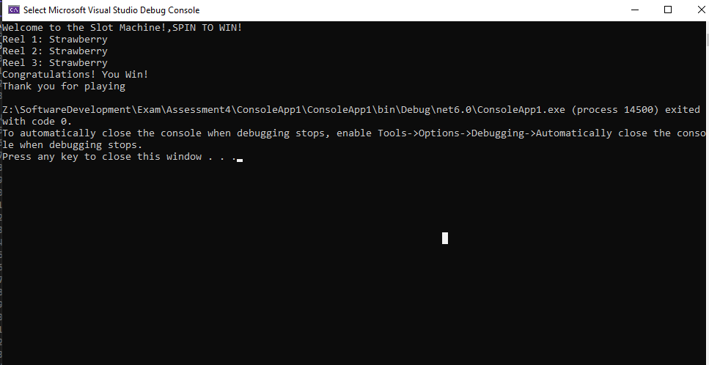
Result: Did the programme behave as expected ie syntactically and logically correct?
YES/NO (delete as appropriate)
If NO, what went wrong?
In my slot machine, I struggled to add points to each fruit. So when 3 of the same appear it displays a message saying “Congratulations! You Win!”

Test: ii. 1 3 2 (0 points)
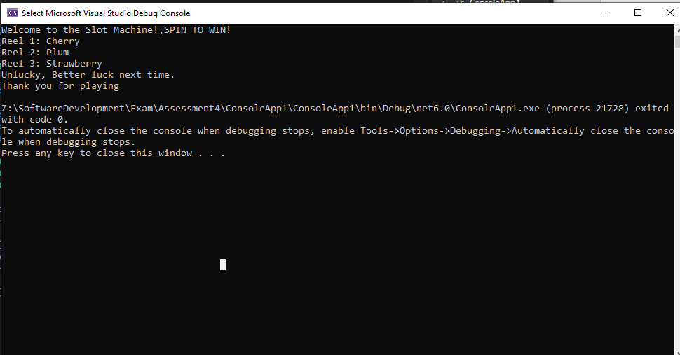
Result: Did the programme behave as expected ie syntactically and logically correct?
YES/NO (delete as appropriate)
If NO, what went wrong?
Yes, no score is shown for the loss.

Continue the rest of the tests below. (Copy and paste a box for each one)

Test: iii. 5 5 3 (100 points)
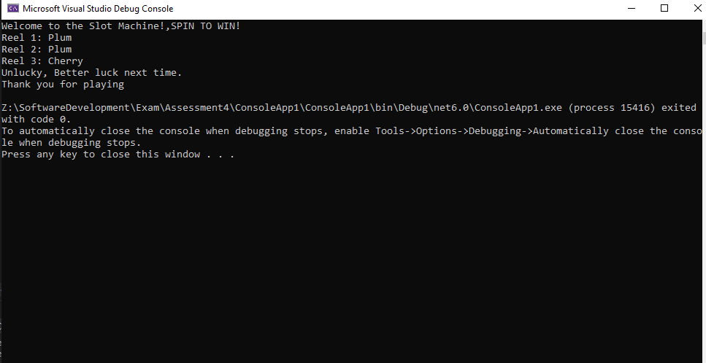
Result: Did the programme behave as expected ie syntactically and logically correct?
YES/NO (delete as appropriate)
If NO, what went wrong?
I struggled to add points to the corresponding fruit so it only randomly reels off 3 fruit and displays a message saying “Unlucky, Better luck next time.” Because not all the fruit that appeared are the same.

Test: iv. 5 2 5 (100 points)
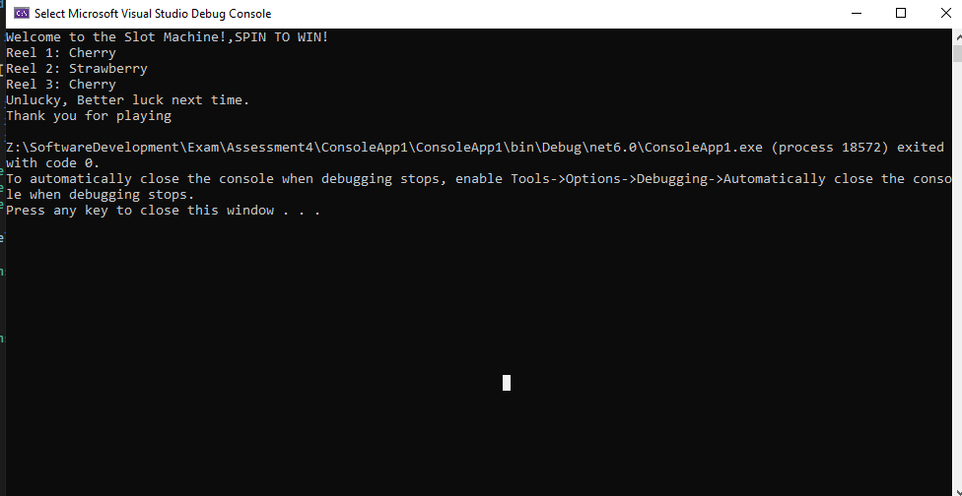
Result: Did the programme behave as expected ie syntactically and logically correct?
YES/NO (delete as appropriate)
If NO, what went wrong?
I struggled to add points to the corresponding fruit so it only randomly reels off 3 fruit and displays a message saying “Unlucky, Better luck next time.” Because not all the fruit that appeared are the same.

Test: v. 1 5 5 (100 points)
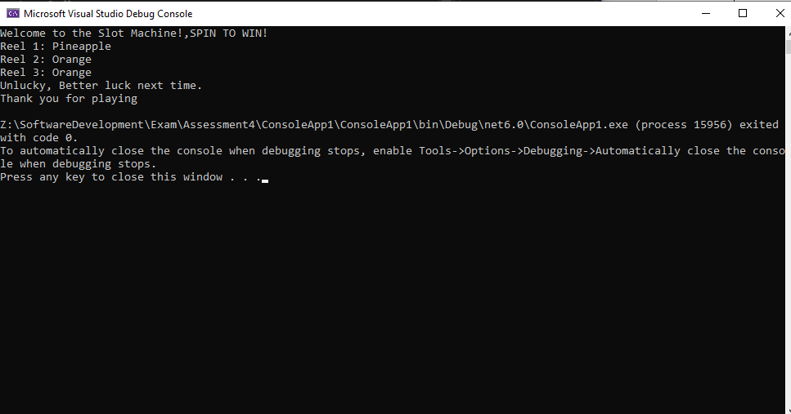
Result: Did the programme behave as expected ie syntactically and logically correct?
YES/NO (delete as appropriate)
If NO, what went wrong?
I struggled to add points to the corresponding fruit so it only randomly reels off 3 fruit and displays a message saying “Unlucky, Better luck next time.” Because not all the fruit that appeared are the same.

Test: vi. 5 5 5 (2000 points)
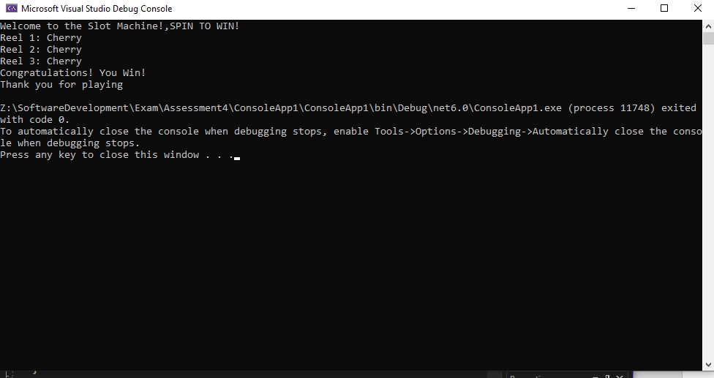
Result: Did the programme behave as expected ie syntactically and logically correct?
YES/NO (delete as appropriate)
If NO, what went wrong?
In my slot machine, I struggled to add points to each fruit. So when 3 of the same appear it displays a message saying “Congratulations! You Win!”

Any other tests you feel may be relevant, or reveal a strength or deficiency in your original code, please detail below:
Test:

Screenshot(s) of output:

Result: Did the programme behave as expected ie syntactically and logically correct?
YES/NO (delete as appropriate)
If NO, what went wrong?

- Consider the results of the above tests and revisit your code in order to solve any problems discovered at the testing phase. (Note: you may not be able to solve all of them, but solve as many as you can.)

Paste your revised code here:
class Program

{
static void Main()
{
Console.WriteLine("Welcome to the Slot Machine!,SPIN TO WIN!"); //Welcome message displayed to screen

SpinReels();

Console.WriteLine("Thank you for playing"); //Thank you message displayed to screen
}

static void SpinReels()
{
Random random = new Random();

string[] symbols = { "Cherry", "Plum", "Orange", "Strawberry", "Pineapple" }; //Defining fruits for the slot machine reels

string reel1 = symbols[random.Next(symbols.Length)]; //Spin reel 1
string reel2 = symbols[random.Next(symbols.Length)]; //Spin reel 2
string reel3 = symbols[random.Next(symbols.Length)]; //Spin reel 3

Console.WriteLine($"Reel 1: {reel1}"); //Display result for reel 1
Console.WriteLine($"Reel 2: {reel2}"); //Display result for reel 2
Console.WriteLine($"Reel 3: {reel3}"); //Display result for reel 3

if (reel1 == reel2 && reel2 == reel3) //Checking for a win
{
Console.WriteLine("Congratulations! You Win!"); //Display message if you win
}
else
{
Console.WriteLine("Unlucky, Better luck next time."); //Display message if you lose
}
}
}

