  - Construction Materials
  - ACBA4006

Prepared for Allan Nantel

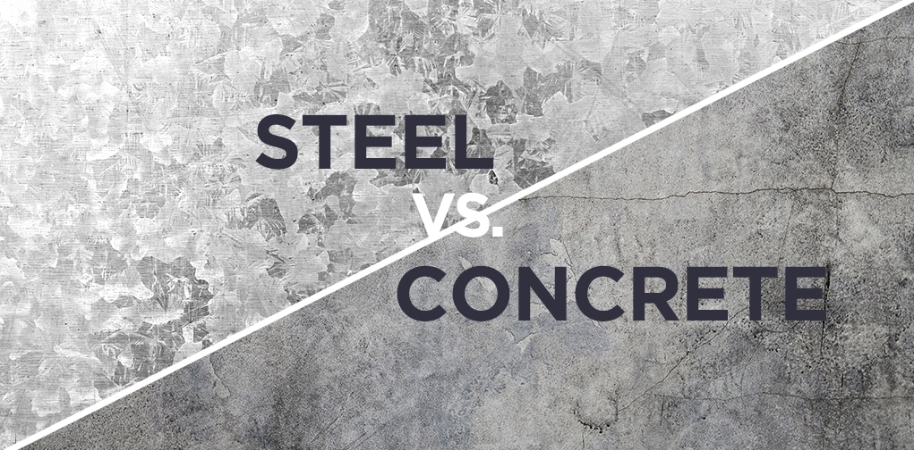


Created by Jonathan Langstone
Date Completed:
02 March 2021

Contents
1.0 Executive Summary 2
2.0 Terms of Reference 2
3.0 Procedure 2
4.0 Findings 2
4.1 Concrete Frame 3
4.1.1 Brief History of Concrete 5
4.2 Steel Frame 6
4.2.2 Brief History of Steel 8
4.3 Concrete Frame Case-study 9
4.3.1 The Burj Khalifa 9
4.3.2 Construction Method 10
4.4 Steel Frame Case-study 11
4.4.1 The Willis Tower (aka Sears Tower) 11
5.0 Conclusion 14
6.0 References 15

Figures
Figure 1 Pantheon, Rome (Ranogajec, n.d.) 5
Figure 2 The Burj Khalifa (Skyscraper.org, 2010) 8

Executive Summary
This report aims to examine two different types of construction material used to create commonly known building frames. These materials are Steel and Concrete. There are two different buildings with a concrete and steel frame used as case studies, which are analyzed to compare the strengths and weaknesses of the framing material. The report will also look at the climactic resistance, potential impact, environmental sustainability, methods of construction and production process of both materials.

Terms of Reference

  - The Principle Focus.

2.1.1 To compare the construction frame materials shown.
2.1.2 To Examine how they differ in strengths and weaknesses.
2.1.3 To evaluate why and where these materials would be best used for chosen construction framing materials.

  - The Report was constrained by the information given and researched and the need to complete it by the 2nd of March 2021.

3.0 Procedure
This section identifies the research sources used.

3.1 The research included secondary sources about Steel and concrete and their use as a framing material in constructing buildings from websites, Textbooks, magazines set out in the references and bibliography.

  - University notes also provided background to the research.

4.0 Findings

4.1 Concrete Frame
Concrete is the most used man-made product on planet earth.
Concrete is a composite material made up of four raw materials:
Water
“A chemical reaction is initiated when cement encounters water. This is known as hydration, and is responsible for the setting and hardening of cement.”
(Virdi, 2017)

Aggregates (Typically crushed Limestone)
The proportions of aggregate for are a particular mix depend on the part of the building where it is to be used.

Cement (predominantly Old Portland Cement)
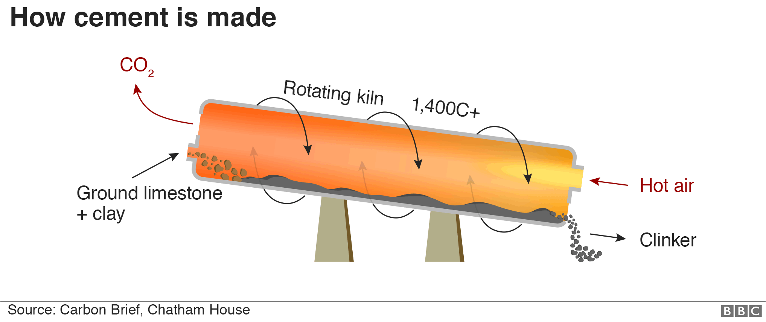
Cement is the binding material for the concrete. It allows it to cure and solidify. The cement process begins with the mining of limestone and clay in quarries. These huge blocks are crushed, ground, and mixed with other minerals. The mix is conveyed into a kiln at temperatures approaching 2000 degrees Celsius. This is transformed into small granules known a clinker. Clinker is mixed with gypsum to become cement. The figure below shows the cycle of production:
Figure 1 Cement production (Rodgers, 2018)
Sand (fine Aggregate)

Types of concrete

Durability
Concrete’s durability is ideal for large structures. concrete buildings can last up to 100 years or more when built properly and are sufficiently maintained.
Versatility
Other materials such as steel, insulation and admixtures can be added to the structure of concrete for added strength, insulation, and aesthetic attractiveness.
Fire Safety
Concrete does not burn. It has a high degree of resistance to fire and offers increased protection to buildings.
“In fire, concrete performs well – both as an engineered structure, and as a material in its own right. It has the highest fire resistance classification (class AI) under EN 13501-1:2007- A1:2009.”
(Fire Resistance, n.d.)
Workability
The concrete must be

Advantages of using Concrete:

Disadvantages:
Environmental impact
The process of making cement impacts the environment in a huge way. The process produces a huge amount of Carbon Dioxide. Also the extraction of lime stone by blasting produces dust, gas, noise and damage to the landscape (Virdi, 2017).

4.1.1 Brief History of Concrete
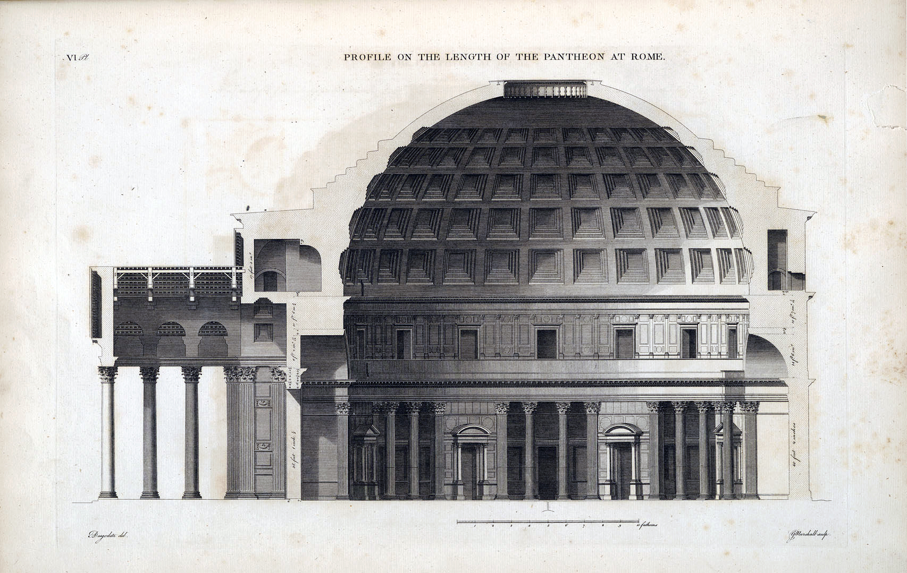
Concrete has been recorded in existence as long ago as 7000BC. Concrete comes from the Latin word ‘Concretus’. Concrete has been used to build structures for an estimated three thousand years. The Romans vastly developed the material, starting from 300BC to 476AD. In this time, they managed to enhance its potential by using different types of physical properties, which would later allow them to construct buildings such as the infamous 8th wonder of the world, also known as the Pantheon, situated in Rome, Italy. Which still stands today.

Figure 2 Pantheon, Rome (Ranogajec, n.d.)
A quote taken from decoding science describes how the Romans found the use of volcanic ash in a concrete mixture. This made it incredibly strong, even for modern-day standards:
“The Vesuvian components make Roman cement a superior cement that rivals modern standards. The ancient Romans, perhaps, stumbled upon the use of the Vesuvian component to the cement while quarrying for its components, clay, gypsum, and lime.”
(DceodedScience.org, 2021)

4.2 Steel Frame
“steel, the most important ferrous metal in building construction, is an alloy of iron and carbon” (G.D.Taylor, 2000). Steel is an alloy of iron and carbon containing less than 1%manganese and 2% Carbon and small amounts of silicon, phosphorus, sulphur and oxygen. Steel contains an iron concentration of 98 to 99% or more. Steel is one of the world's most important construction materials. It is used all over the globe, from cars to various construction products. A large portion of the world's steel is used to help reinforce concrete structures.
Steel frame construction is mainly used to build a high-rise, industrial, warehouse, and residential buildings.
Advantages:
- Very strong properties.
- Span large distances.
- Ease and speed of installation.
- Can be prefabricated and built off-site.
- resistant wind and earthquakes (Environmental consequences).
- Can Adapt to virtually any shape.
- Can have additional cladding with a wide variety of materials.
- Weighs less than concrete.
- Mostly off-site fabrication.
- Mass produced.
Disadvantages:
- Can corrode if exposed to the elements and rust over time.
- Steel is susceptible to fire and high temperatures.

Skill capabilities
Off-site prefabricated steel construction reduces the need for on-site labour as compared to the forming of concrete. Lowered labour reduces on-site risk and noise disruption to the surrounding community. Steel frame requires highly skilled workers as the tolerances for precise measurements can be very tight.
Sustainability
Steel frames reduce excess waste removal, and most structural steel can be reused and recycled. As steel is 100% recyclable.
Efficiency
Steel frames are usually built very close to a building’s specification, using 3D modelling and various new design technology. This will reduce the risk of mistakes made. This technology also ensures fast product construction and completion times.
Environmental Impact

4.2.2 Brief History of Steel
As early as 6,000 years ago, early civilizations have used iron ore found in meteorites to construct tools and weapons. Henry Bessemer the British inventor is universally credited with the invention of the very first technique to mass-produce steel in 1854. But steel was first used for the creation of expensive personal items like watches, swords, and scythes before being incorporated into architecture in the early 1800s. Iron and cast iron, the close relative of steel had been around for thousands of years, but steel came long after.
In 1890 the first steel-framed building was the Rand McNally, built in Chicago, Illinois, USA.
Rand, McNalley & Co built the first steel frame building in 1889, which had 10 stories. This sparked a new era for steel frame building and the emergence of skyscrapers.
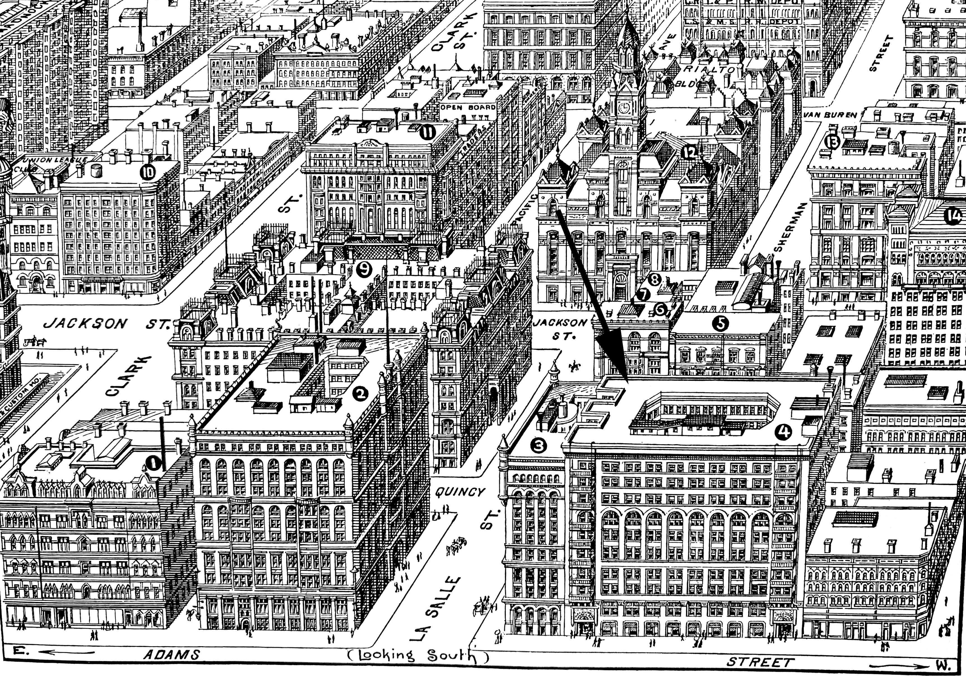
Figure 3 Randy McNalley Building (Randy McNally Buildings, 2020)

4.3 Concrete Frame Case-study

4.3.1 The Burj Khalifa
Figure 4 The Burj Khalifa (Skyscraper.org, 2010)
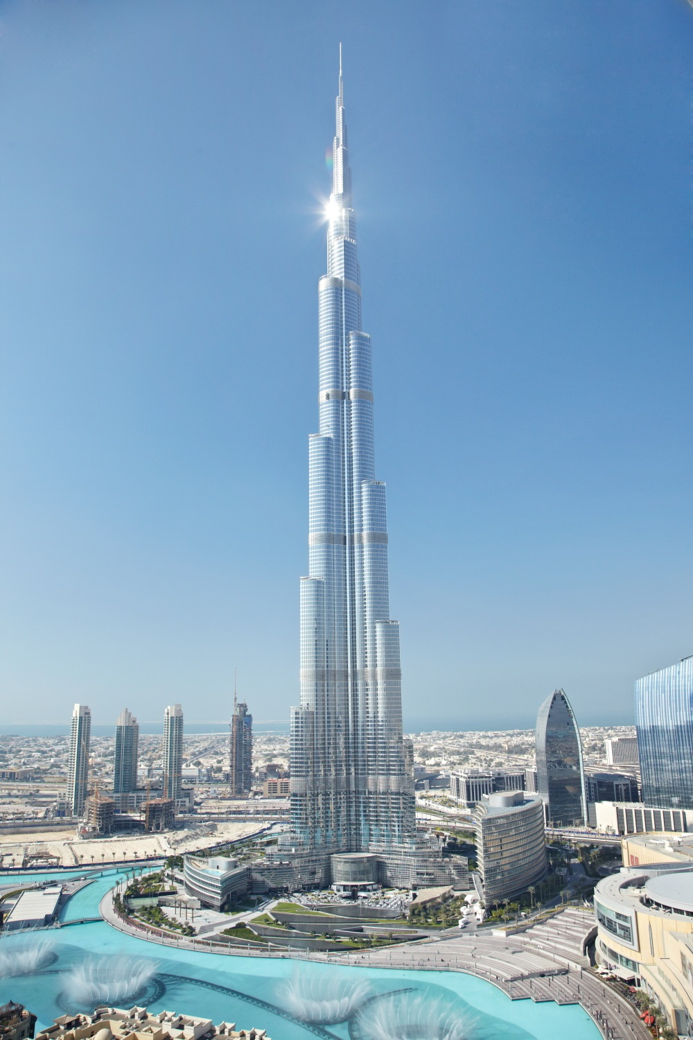
The Burj Khalifa is currently the tallest building in the world since its completed construction on 4th January 2010. The name is translated into “The Tower of Dubai” from Arabic.
Building facts
Location: Dubai, United Arab Emirates
Building Frame: Concrete
Cost: $1.5 Billion USD
Time to build: 4 years.
Principle designer: (SOM) Skidmore, Owings & Merrill.
Construction manager: David Bradford
Height: 828 Meters
No. of Floors: 160
Floor area: 460,000M squared.
Building Cladding: Triple glazed curtain walling system
Weight: 500,000 Tons in total, steel rebar used: 39,000 tons

4.3.2 Construction Method
Figure 5 Burj Khalifa Concrete Frame (Nasvik, 2008)
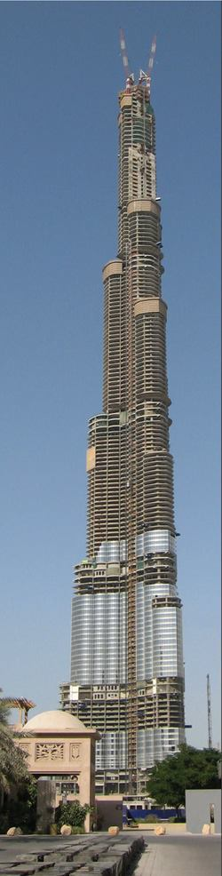
The engineers and designers at SOM produced an expensive design that would allow cutting-edge technology to achieve high performance in an extreme desert macroclimate. Here is a quote is taken from Concrete Construction magazine outlining the key structure of the building:
“Structurally reinforced concrete and self-consolidating concrete will give this super-tall building the strength it needs to withstand wind forces and the site's corrosive soil.”
(The Burj Dubai, 2007)
Foundation
The foundation had to reach great depths using 194 reinforced concrete friction piles, that were in turn connected to a reinforced concrete pad closer to the surface of the ground. The friction pile will help the structure stay secure in the sand throughout its life-cycle.
Reinforced Concre te Frame
The Concrete frame was designed to counteract the high-velocity winds that are found at high altitude. These winds can compromise the structural integrity of the building over time.
The building was built in the shape of a ‘Y’ from its foundation to the very top, the structure decreased in size and shape as it ascended to its top.
Here is a quote from SOM describing how the shape of the building helped adapt to the climate: “Wind vortexes can never sufficiently coalesce because the wind encounters a different building shape at each tier” (SOM, Burj Khalifa - Structural Engineering, n.d.).
The Concrete frame can be described as having a buttressed core. It was built very quickly and efficiently for its size compared to other projects around the world.
The floors
Cladding system There are incredible 24,000 windows on the building. The highest amount of any building in the world. Almost the entire outer surface of the building is cladded with thick triple glazed glass with durable aluminium frames to withstand the high-velocity winds.

4.4 Steel Frame Case-study
Figure 6 Willis Tower (Brooke, 2013)

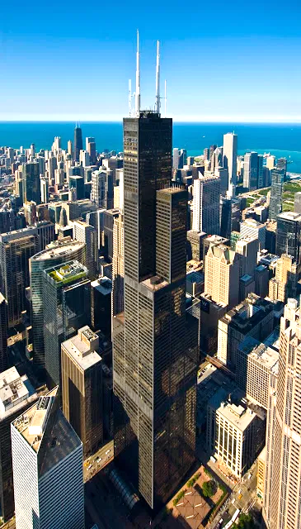
4.4.1 The Willis Tower (aka Sears Tower)

The Willis Tower is currently the 12th tallest building in the world. It originally held the top spot in the world rankings since its completion in 1973 to 1998. The highest skyscraper that uses only steel structure. Others use composite construction material (concrete and steel).
But currently the 2nd tallest building in the USA
Building facts
Location: Chicago, Illinois, USA
Building Frame: Steel
Cost: Estimated at $150 Million – $800million equivalent to today
Duration of build: 3 years
Principle designer: (SOM) Skidmore, Owings & Merrill.
Construction manager: Richard C. Halpern
Height: 442metres
No. of floors: 110-storeys
Floor area: M squared
Building Cladding: Black aluminium structure and bronze-tinted vision glass panels
Weight: Total weight: 222,500 tons, 76,000 tons of steel
4.4.2 Construction MethodSteel frame
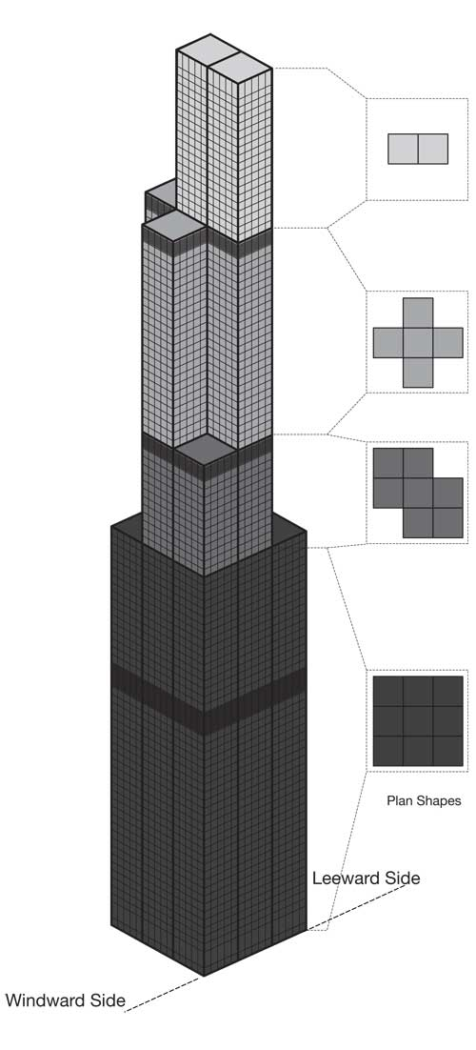
Chicago is well known for being called ‘the windy city’. The climate of the region endures hot summers and harsh winters which bring very strong winds. This led the engineer Fazlur Khan to invent a new system to allow this building to be built to a great height. That new idea was a ‘tube concept’. The tube concept system was different from the traditional form of steel frame because it brings the external columns closer together so that the columns would act as a wall on the perimeter of the building.
Figure 7 Willis Tower 'tube concept' (Major Works, n.d.)
At the base of the building, there is a series of 9 steel tubes for the frame, that bundled together, as you can see in the figure to the right. Due to the structure’s height-to-width ratio, a single framed tube (traditional way) is not adequate. But bundling the tubes does increase the strength as the building rises in height, they step around and minimize in number to create a shape that looks to have a staggering effect. This staggered effect is also used on the Burj Khalifa. But the Willis tower was the first of its kind to use this system. The staggered and step system helped withstand high winds at tall heights, which would normally cause a lot of harm to a traditionally built steel frame over a period. Here is a quote from the SOM website, the principal designers of the Willis tower, briefly describing the tube concept:
“The tubes are bundled together as a closed square below the first 50 stories. Above the first 50 stories, the tubes terminate at varying heights and create a multi-tiered form.”
(SOM, The Willis Tower, n.d.)
Prefabricated steel
The construction site was very small as it is in the center of busy downtown Chicago. This meant it was very difficult to store the steel on the site, ready for use. The solution was to have daily, continuous deliveries of prefabricated steel. This put a lot of pressure on the work force. But the columns and half of the girders were welded offsite in the factory to help speed up the construction times, which in turn helped ease the pressure.
As the project went on and the height of the building grew, the operation became more and more difficult as the temperatures and wind speeds rose. This then made construction speeds decrease.
Foundation
The building sits on reinforced concrete caissons (piles) that go down to bedrock. The caissons are tied together by a reinforced concrete mat. Compared to the Burj Khalifa, this location offered a bed rock for the loads to bare down on. Which will help maintain the structural integrity of the building for years to come.

5.0 Conclusion
Looking carefully at both case studies. There are many advantages to both designs.

6.0 References
Brooke. (2013). Willis Tower Chicago. Retrieved from brooklynberrydesigns.com: https://brooklynberrydesigns.com/willis-tower-chicago-skydeck/
DceodedScience.org. (2021). Decoded Science. Retrieved from Decoded science.org: https://decodedscience.org/roman-cement-genius-from-roman-artisans-and-engineers/#:~:text=The%20fly%20ash%20of%20Mount,%2C%20in%20truth%2C%20a%20science.
Fire Resistance. (n.d.). Retrieved from concretecentre.com: https://www.concretecentre.com/Performance-Sustainability/Fire-Resistance.aspx#:~:text=Concrete%20does%20not%20burn%20%E2%80%93%20it,fumes%20when%20affected%20by%20fire.&text=It%20is%20this%20slow%20rate,protect%20itself%20from%20fire%20damage.
G.D.Taylor. (2000). Materials in Construction: an Introduction. Longman.
Major Works. (n.d.). Retrieved from khan.princeton.edu: http://khan.princeton.edu/khanSears.html
Nasvik, J. (2008). the Burj Khalifa. Retrieved from concreteconstruction.net: https://www.concreteconstruction.net/projects/commercial-industrial/the-burj-dubai_o
Randy McNally Buildings. (2020). Retrieved from chicagology.com: https://chicagology.com/goldenage/goldenage006/
Ranogajec, D. P. (n.d.). The Pantheon. Retrieved from khanacademy.org: https://www.khanacademy.org/humanities/ancient-art-civilizations/roman/middle-empire/a/the-pantheon
Skyscraper.org. (2010). Sky Scraper Museum. Retrieved from skyscraper.org: https://skyscraper.org/exhibitions/worlds-tallest-building-burj-dubai/#construction
SOM. (n.d.). Burj Khalifa - Structural Engineering. Retrieved from www.som.com: https://www.som.com/projects/burj_khalifa__structural_engineering
SOM. (n.d.). The Willis Tower. Retrieved from https://www.som.com/projects/willis_tower_formerly_sears_tower: https://www.som.com/projects/willis_tower_formerly_sears_tower
The Burj Dubai. (2007). Retrieved from concreteconstruction.net: https://www.concreteconstruction.net/projects/the-burj-dubai_o

