Name: Naseem Khan
Student I.D: 1807432
Lecturer: Mark Gallagher-Read
Children, young people and Families
Module: BMHP5004

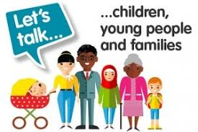

CONTENTS PAGE

Introduction…………………………………………………………….. Pg 3
What made Family B vulnerable…………………………………….. Pg 3,4
Professional Intervention…………………………………………….. Pg 4,
Models used in Health and Social Care……………………………. Pg 4,5
Recommendation……………………………………………………... Pg 5
Conclusion……………………………………………………………… Pg 6
References…………………………………………………………….. Pg 7
Appendices……………………………………………………………. Pg 8

INTRODUCTION
This assignment will look into the case study of Family B, it will focus on the Family structure, the agencies, and the risk factors within the family. It will look into how the Family was helped, what policies and procedures were followed under government legislation, and how the risk factors concerning the family were addressed. A serious case review will be looked into as well as common assessment frameworks. An evaluation around Family B will be discussed as to whether the family benefited from the project which was referred to them by the Youth Offending Team
What made family B vulnerable?
Family B had several risk factors namely, poverty, worklessness, homelessness, violence, parenting issues and behavioural issues around their teenage son.
Poverty is a huge risk factor as it leads to many problems within families. Family B consists of mother, partner, three teenage children and two primary school children, we can clearly see that it was a large family. Th Prime minister’s speech addressed at Toynbee Hall in 1999 pledged to eliminate child poverty as it is connected with poor child wellbeing and welfare. A child to be poor just because they are living in a large family is unjust (Bradshaw et al 2006).
There were issues around the worklessness around the mother’s partner. The Department for Education (2016) has noted that worklessness is a risk factor that effects families. it is common to find children and young people in workless households to have the following characteristics: -
Evidence suggests that parent worklessness has a negative impact in young people finding employment especially if they are simultaneously faced with other social economic disadvantages such as living in poverty and parents having a low education. (Ingrid, S., Barnes. M, Brown. V, Parsons. S, Ross, A. & Vignoles, A (2012).
There is an idea about worklessness that it may be a family inheritance, value and practice that encourages the unemployed to be dependent on the welfare system. (Shildrick, MacDonald, Furlong, Rodan, and Crow,2012,pg 5.)
Family B’s teenage son was a youth offender and had behavioural issues. Violence in families can lead to childhood trauma. Children who grow up in households where there is constant violence are more likely to have low I.Q, have low parent involvement, poor behaviour control, involvement with drugs, antisocial beliefs and attitudes, history of treatment for emotional problems, learning disorders, low achievement in school, involved with gangs and many other factors. (Centres for Disease Control and Prevention 2020).
Professional Intervention
A number of agencies were involved with family B, such as the Local Authority, education services, the police, the youth in need team, probation services , Neighbourhood services, a parenting support group, the antisocial behavioural team, CAMHS, connexions, job centre plus, homeless persons unit and the Kinara family resource centre. A social worker was also involved with Family B.
Local authorities have a role and duty to provide services for deprived families under U.K legislation (Nethercott 2017).
The social worker involved with the family had a duty to promote the strengths and the overall wellbeing of the family, and to safeguard the vulnerable children and adults within the household. The social workers acted as a guide and an advocate for the family wishing positive outcomes for Family B. The social worker was involved with all the agencies and made sure that the agencies were the right source of intervention to help the family (Social Work England U.K 2020).
CAMHS service was used to tackle the behavioural issue of the young boy in Family B. CAMHS would have supported the young boy with his violence or anger problems. NHS CAMHS services are all around the U.K ,nurses, therapists, support workers, psychologists and other professionals make up the CAMHS team (Young Minds 2020)
Models used in Health and Social Care.
The social model acts upon the field of disability and mental health, it underlines optimistic and revolutionary possibilities for children, families and communities. The social model particularly draws attention to the economic, environmental and cultural barriers endured by individuals with distinct levels of ability, but it has not been used to think about child protection which is conducted by risk and risk avoidance (Featherstone, B et al 2016).
Annex 1 looks at a common assessment framework that may have most likely been suitable for Family B as it addresses all the issues with the wider society not just within the family.
Lord Lamming made amendments to the Children’s Act 2004, the Children’s and Social Care Act 2017 then made further changes to the 2004 after the unfortunate murder of Victoria Climbie. Some of the Key changes made were,
- Local authorities to prepare to encourage joint action with key partners and local agencies, in order to improve the well-being of children in the local authority care.
- Agencies such as the local authority, the police and health services, to assure that when carrying out their work that they always examine the need to safeguard and to foster the child’s best interests at all times.
- The local authority, NHS Clinical Commissioning Groups and the Police, to establish the roles and duty to which are answerable for deciding how safeguarding agreements should work within their area.
Doctoral dissertation, University of Nottingham 2016 (The common Assessment Framework was introduced nationally following the death of Victoria Climbie, (Annex 2) it has been widely adopted in England over the past decade).
Recommendation
Family B did feel that they were helped by all agencies involved after the intervention of the project, they were re housed into a suitable family home. There was hope for the son in local authority care to be integrated back into the family home. The Greenwich project helped a handful of families, it’s a shame more families in the u.k cannot be helped sooner and to achieve a more positive outcome by the social care we have in place. Family B only got the help they clearly needed due to the project; local authorities should provide funding for such projects in order for families to achieve positive outcomes.

Conclusion
I worked with my work partner Carla Moseley, we created a Whatsapp group in order to plan who would be doing what. We worked very well together, we helped one another by giving ideas and by emailing articles/journals of relevance. I feel I was the team leader and assigned work to Carla that she was happy and comfortable to do. We utilised every opportunity to practice our presentation together, email, facetime and group room chat which was set up by our lecturer.

References
Bradshaw, J., Finch, N., Mayhew, E., Ritakallio, V. and Skinner, C.,(2006) ‘ Child poverty in large families’. Policy Press Bristol
Centres for disease control and prevention (2020). Risk and protective factors. Available:https://www.cdc.gov/violenceprevention/youthviolence/riskprotectivefactor.html. (Accessed: 27th June 2020).
Featherstone, B. Gupta, A. Morris, Warner, J (2016) ‘Let’s stop feeding the risk monster: Towards a social model of ‘child protection’, Families, Relationships and Societies. Vol X. Accessed:9th July 2020. Doi.org/10.1332/204674316X14552878034622
Ingrid, S., Barnes. M, Brown. V, Parsons. S, Ross, A. & Vignoles, A (2012) Intergenerational transmission of worklessness: Evidence from the Millennium Cohort and the Longitudinal Study of Young People In England. Institute of Education & National Centre for Social Research.
Lucas, S., (2016) Service users’ experiences of multi-agency practice in children’s social care: the Common Assessment Framework (Doctoral dissertation, University of Nottingham).
Nethercott, K. (2017) ‘The Common Assessment Framework form 9 years on: a creative process’, Child & Family Social Work, 22(2), pp.751-761. Accessed 1st July 2020. DOI.org/10.1111/cfs.12292
Shildrick, T.A., MacDonald, R., Furlong, A., Rodan, J. and Crow, R., (2012) Are ‘cultures of worklessness' passed down the generations? Cambridge Publishing Management Limited: Joseph Rowntree Foundation.
Social work England (2020). Professional Standards. Available at https://www.socialworkengland.org.uk/standards/professional-standards. (Accessed: 30th June 2020).
Young Minds (2020). What is CAMHS? Available at https://youngminds.org.uk/find-help/your-guide-to-support/guide-to-camhs/ (Accessed 8th July 2020).

Appendices
Appendix 1.

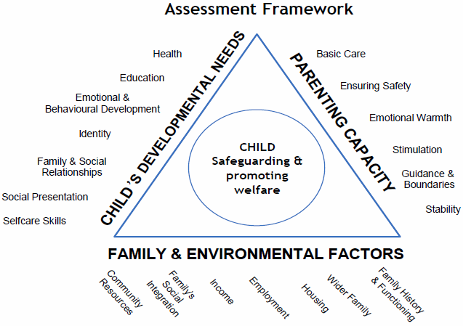

Appendix 2.
Victoria Climbie, a western African girl who was murdered by her aunt and her aunt’s boyfriend. Climbie’s death lead to a great public enquiry, significant changes were brought forward to the child protection policies in the U.K.
The most basic procedures to protect her failed to keep her safe. The factors identified to keep her safe were early involvement, disorganization, lack of sharing information and no one single person to take accountability.
Every child matters (2003) was introduced to make significant changes in children’s programmes to allow children, disregarding their background or their circumstances to have support required to achieve better outcomes in key areas such as being healthy, always to be safe, to enjoy and achieve to make a positive contribution in society and to achieve economic success.
CAF is commonly used where there are concerns with regards to how a child is progressing. If a professional service cannot address the needs of the child then it thought that CAF would intervene to identify and address the required needs.

