
Fan Courier Romania
Strategic Management of SMEs (BMSK6004_LON)
Student: Ionela Madalina Saiz 1605699
Lecturer: Rexon Nting

ABSTRACT
With the motive of determining the effective set of the decisions being taken in an organization, strategic management is termed as an important concept. The manager of an organization must have the in-detailed analysis of the internal and external factors which affects the overall working ability of an organization. This evaluation helps in taking the mist accurate decision as per the development of an organization. The implementation of SWOT and PESTEL analysis is done to regulate internal and external factors. Strategic management provides a way to deal with the competitive environment in an effective and developed way.
This report emphasizes the strategic management done over an organization named as FAN Courier Company. It is the leading courier service in Romania. It has been serving its facilities to the country since 2006. It is the reliable partner of all those who choose these services with the same passion and dedication over each delivery. The total distance travelled by the FAN couriers every night is evaluated to be 95.270km. It covers over 130 routes of the entire country. The company is ready to welcome the people who are interested and dedicated over the work. The report focuses on the evaluation done over the services and decisions taken by the managers of an organization.

Table of Contents
ABSTRACT 2
INTRODUCTION 4
CHAPTER 1 5
1.1 MISION, VISION, OBJECTIVES AND GOALS 5
CHAPTER 2 7
2.0 MICRO AND MACRO ANALYSIS OF AN ENVIRONMENT 7
2.1 MACRO ANALYSIS- PESTEL 7
2.2 MICRO ANALYSIS- PORTER’S FIVE FORCE MODEL 11
CHAPTER 3 13
3.0 CAPABILITY ANALYSIS OF FAN COURIER ROMANIA 13
3.1 VALUE CHAIN ANALYSIS 13
CHAPTER 4 15
4.1 SWOT ANALYSIS 15
4.2 STRATEGIC ANALYSIS FROM TOWS MATRIX 16
4.3 BOWMAN’S STRATEGIC CLOCK 16
4.4 ANSOFF MATRIX 17
CHAPTER 5 19
5.1 SAF EVALUATION 19
5.2 STAKEHOLDER MAPPING 20
CHAPTER 6 21
6.0 CONCLUSION 21
REFERENCES 22

INTRODUCTION
An organization named as FAN Courier Romania was founded in the year 1998. The founders of this organization are Adrian Mihai Neculai Michael and Felix Patrascanu. At present, the organization is ranked at the 12th position among the top 100 most enduring and famous brands of Romania. The organization has been also awarded as the winner of super brands and many other awards have been achieved by an organization.
The prizes won by an organization are observed due to the development of solid business strategy along with the constant investment and trust managed by an organization. The organization has been declared as the winner of Black Friday Hero award by Govnet in 2018. At present, it has been recognized as the winner of Superbrands in the 2019 competition. These achievements within an organization have been made possible by the accurate implementation of the business strategy as well as the strategic management.

CHAPTER 1

1.1 MISION, VISION, OBJECTIVES AND GOALS
    - MISSION STATEMENT OF FAN COURIER ROMANIA
The mission statement of the FAN Courier Romania is to bring the people closer together with the motive of delivering satisfactory services to the customers. The company aims to deliver the parcel with emotions along with providing the accurate and timely delivery of the parcel (GEORGESCU, 2017).
NEW MISSION STATEMENT
The new mission of an organization is to deliver the services which cover the full life cycle of the building. These need to be achieved by having a continuous improvement over the quality and to take the new initiatives over the changing trends and needs of the courier services.
    - VISION STATEMENT
The processing of the strategies and tasks has been maintained by the global vision of an organization. Before the way of experiencing ineffective and unsatisfactory delivery of the services, the organization has a vision to employee the passionate and dedicated employees who can deliver the satisfactory set of the courier services in an organization.
NEW VISION STATEMENT
The new vision of an organization is committed to upholding the principle as per the inception provided by a global vision. This has the aim to look over the varying expectations of customers as per the changes made in terms of the technological and environmental factors of an organization.
    - GOAL
The fundamental goal of an organization is to have become the most popular courier company in Romania. This includes threw accurate implementation of the services defined as per the project management team of the organization named as Global vision. The goal of an organization is to build up a healthy and Trustworthy relationship with the customers (GEORGESCU, 2017). With the motive of increasing the overall set of techniques and strategies within an organization, the number of job opportunities is also increased. The company focuses to hire the candidate having the dedication and passion to work within an organization.
PROPOSED GOALS
- To deploy the services as per the varying technology
- To hire dedicated and passionate employees
- To regulate over the Romanian postal services as per the varying trends
    - OBJECTIVE STATEMENT
The objective statements for FAN Courier Romania are:
- To make the shipping services easily available in international as well as the national level
- To increase the business over several localities without increasing the number of kilometres
- To deliver the services over the customers within the minimum time interval.
The determination of an objective statement explains that the financial condition, as well as the way of hiring the people, needs to be improved in an organization. This change helps in achieving the above-discussed aims and objectives of an organization. This would also help in improving the overall marketing position of an organization (Mihoc et al., 2016).
PROPOSED NEW OBJECTIVES
- To have the careful transferring of the packages over to the couriers and partners
- To deliver every single package with full care and passion
- To provide value-added services to the customers as per the implication of new trends and services.
- To invest in the IT sectors ad training sectors for having the skill set of the employees

CHAPTER 2

2.0 MICRO AND MACRO ANALYSIS OF AN ENVIRONMENT
Intending to deploy the proposed mission and vision statement, there finds the need for an organization to regulate the varying conditions of an environment before implementing a new strategy and procedure. In terms of having an in-depth analysis of an organizational environment, the external and internal condition of an organization has been regulated. It has been found that about 129 branches are established by an organization. This includes over 3900 vehicles that are ready for delivering the packages at the given interval of time (MUNTEANU, 2015).

2.1 MACRO ANALYSIS- PESTEL
2.1.1 POLITICAL FACTOR
In terms of regulating the impact of political factors over the working environment of an organization named as FAN Couriers Romania, the implementation of the new strategies are made to be more reliable and easy. In the Romania market, the country has stability over the political changes in the last few years. The development of new law based over the Romanian Courier and service forum association has been made with the way of providing the concept of direct marketing. Due to which the growth of FAN Courier Romania organization has been achieved (Siminica and Sichigea, 2018).
The country named as Romania has been dealing with the issue based over the terrorist effects. This has been affecting the import and export facilities provided by the FAN Courier Company negatively. The FAN Courier has a high level of stability due to the fact that Romania is the funding member of Black sea consortium for economic development.
The liberalization has been regulated over the trade and incentives regulation in Romania; this affects the working ability of the employees in the FAN Courier Company. The investors belonging to the resident or non-resident section has been given an equal number of opportunities to do marketing over the area of Romania. The standard VAT rate is observed to be 16% for the year 2018 in Romania market (Siminica and Sichigea, 2018).
The increase in several exports over the marketing environment of Romania is found to be increased in the past few years. Due to this, FAN Courier Company has a path for generating a high level of profit generation within the developing environment of Romania.
2.1.2 ECONOMIC FACTOR
The analysis of economic factors helps in dealing with the various services and policies over which the entire economy of the country is regulated. In terms of the FAN couriers Romania, the rate of inflation is observed to be high as per the easy accessing the supply of the resources. The overall domestic demand within the country has been increasing. The current account balance regulated over the financial structure of Romania is found to be increasing over the needs of the domestic (Bran et al., 2015). This affects the services being offered by FAN couriers.
Per IMF, the huge deficit over the account has been created by investments made in the industrial sector. Due to which the overall capacity of production in FAN Couriers is evaluated to be increasing. This generates a positive effect on the development phase of the FAN Courier Company.
The interest rate over the market of Romania has been rising at continuous rates. This helps in tightening the monetary policy. The rise in overall interest rates of Romania provides a new way of regulating the resources being utilized by FAN couriers.
The FDI policies in Romania have increased. This has helped the FAN Couriers to improve the overall business environment as per the aim of taking the benefits of increasing FDI policies (Hategan et al., 2019).
Due to the rapid growth and implication of beneficial technologies, the employment wages have been increased as per the increase in the marketing environment of Romania. This has provided the easy availability of the passionate and dedicated employees being hired in FAN Couriers. In terms of economic ratings, Romania is at low-risk with relation to investments.
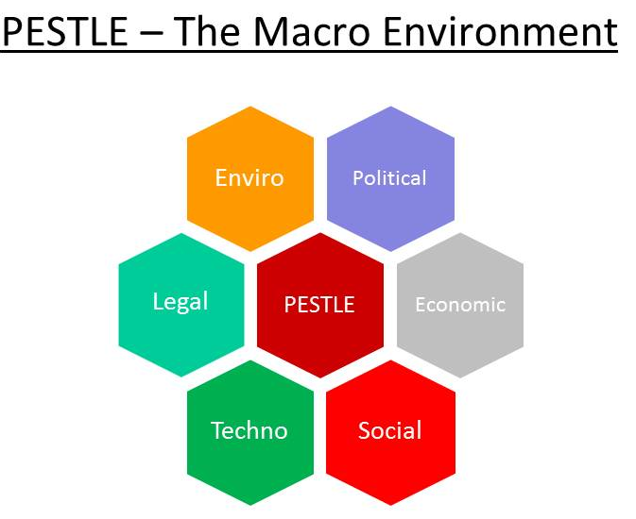
Figure 1: PESTEL Analysis
Source: (Hategan et al., 2019)
2.1.3. SOCIAL FACTOR
In terms of establishing the active and healthy working environment over the company, there finds the need to regulate the social factors which provide the level of job satisfaction and overall performance of an organization. The maximum number of people which makes the population of the country is named as Romanians. The most preferred language of Romania is the Romanian language. In terms of providing healthy interaction among the customers with that of the services being delivered by an organization, the employees of an organization as focused over the way of learning the Romanian language (Gabriel, 2015).
The country has an extremely high proportion of young adults due to the implication of ex-communist policies. This has been served advantageous for the entire business organization of FAN Couriers. The easy delivery and understanding of the services provided by FAN over its customers are understood.

2.1.4 TECHNOLOGICAL FACTOR
As per the increase over the technical factors over the existing working environment of an organization, the overall development of an organization varies. The implementation of technical factors is dependent on the population of Romania. According to the analysis done over Romania, it has been found that about 70% of Romanians are unaware of the basic computer skills and about 43.5% of people belonging to the urban region on the computer. Apart from this data, the overall market based on the IT sector is expected to grow in Eastern Europe. This impacts the technologies being utilized by the FAN Couriers over the aim of enhancing the services as per the rapid technologies (Constantin, 2015).
Supporting this, FAN Couriers have implemented the online payment system with security features. In order to make the customers aware of their package transfer, online tracking has been also introduced by an organization.
In addition to this FAN, courier supports the vehicles having high technical abilities. The entire data and information related to the address of sender and receiver have been stored over the online system of database management. This helps in providing the easy and fast accessing of the services provided by the company (Alexandra, 2016).
The working of an organization is dependent on the entire research and development system made by the members of an organization.
2.1.5 ENVIRONMENTAL FACTOR
In terms of being recognized as the courier company, the issues related to the increasing pollution needs to be executed. The FAN Courier Company has been focusing over the way of utilizing the types of vehicles for the delivery of packages causing less or no pollution over the environmental situations. Along with this, the organization has been also focusing on the development of policies and techniques which causes less harm to an environment. The company has been developing alternative solutions to be used instead of using the fuels and resources which are considered to an essential part for the entire processing of an organization (Alexandra, 2016).
The FAN Courier also utilizes the packaging material which is eco-friendly with the environment. This eliminates the usage of plastic wraps and materials to pack the provided material.
2.1.6 LEGAL FACTORS
As the FAN Courier is recognized as the popular and famous courier company of Romania, the stability over an organization has been achieved by the accurate implementation of policies and laws as per the defined procedures determined within an organization. The set of laws which are applied over the working environment of an organization includes the health and safety based acts, data protection act, environmental protection act and many other the acts have been determined as per the working ability of an organization as the set of the resources being implied over an organization (Leovaridis, 2015).
In terms of international factors, the variation done over policies and procedures of an organization affects the stability of an organization. In terms of dealing with this issues, there finds the need to have the strategic development of the procedures and policies as per the implementation of the strategic plan, This plan helps in overcoming the losses faced by an organization due to improper implication of legal laws.

2.2 MICRO ANALYSIS- PORTER’S FIVE FORCE MODEL
The regulation of microenvironment helps in assessing the powers of an organization. This can be achieved by developing healthy and effective relationships with others. The overall regulation of the micro factors also helps in increasing the overall efficiency and working of an organization.
The porter’s five forces model was provided by Michael Porter. This helps in regulating the variable competition and issues faced by an organization having the aim to expand the business in other areas of the world. This model helps in regulating the overall services and substitutes provided within the market. In Courier Company, the FAN couriers also face the issues of having a low level of profit generation as per the frequent changes made over the entire working structure an organization (Lechman, 2018).
The porter’s five force analysis over FAN Couriers is regulated as:
COMPETITION IN INDUSTRY
This component helps in evaluating the intensity of competition faced by the particular industry to fill the specific space of the marketing position as per the evaluation is done over the number of competitors. This helps in regulating the relative strength of an organization as per the varying working conditions. In terms of FAN Couriers, internal competition is regulated to be high. This is observed due to the low differentiation as the result of which competing environment is noticed by the company (Danciulescu, 2015). The level of intensive rivalry makes difficult for the competitors of FAN Couriers to increase the market shares.
In courier companies, the competition is majorly faced due to the presence of high internationally owned players. The low barrier over the entrance increases the rivalry within the company. It serves easy for the people to switch over the other courier services organization (Danciulescu, 2015).
POTENTIAL OF NEW ENTRANTS IN INDUSTRY
In the sector of regulating the potential over the new entrants, the FAN Couriers face the low barriers over the entrance of new organizations. In the courier industry, technology has determined the new platform or the way of establishing new and effective business models. Due to the sharing of such business models, the suppliers and customers of an organization end up with bringing the new trends and features within the industry. This provides the fact that new technologies have been applied by an organization with the fear of facing a new level of competition. This offers the way of using the interactive benchmarking rates over the existing services and products of an organization.
POWER OF SUPPLIERS
This component helps in determining the total number of resources being utilized in an organization. On being categorized as the courier company, the FAN courier involves the limited number of suppliers being made as per the demands and need to deliver the packages within the specified interval of time. Due to this fact, the number of suppliers over FAN couriers is less. This decreases the overall power of suppliers (Iovan, 2017). The suppliers regulated in terms of the courier industry form the mixture of the materials being supplied by the stationery industry in terms of providing the proper packaging of the packages needed to be delivered from source to the destination. The way of delivering these packages generates the need for being supplied with the effective number of vehicles causing less harm to the environment and maintains a safe and secure network for transferring the packages in good quality.
POWER OF BUYERS
The bargaining power of the buyers is categorized as the ability of buyers to deal with the minimum amount of the cost regulation as per the needs of services over the working structure of an organization. Due to the occurrence of minimum differentiation along with that of the low delivery costs, the bargaining powers of the buyers are regulated to be high concerning the courier company. The expectancy of the customers to have the faster and safe delivery of packages with increasing the level of transparency at the lower price increases the power of buyers (Iovan, 2017).
Apart from this, it has been regulated that the manufacturing and the delivery of product inappropriate way attract the number of customers over an organization but the varying costs over the delivery of a product by another organization increase the power of buyers within the courier companies.
THREAT OF NEW SUBSTITUTES
The organization is ranked at the 12th position among the top 100 most enduring and famous brands of Romania. The organization has been also awarded as the winner of super brands and many other awards have been achieved by an organization.
The prizes won by an organization are observed due to the development of solid business strategy along with the constant investment and trust managed by an organization. The organization has been declared as the winner of Black Friday Hero award by Govnet in 2018. At present, it has been recognized as the winner of Superbrands in the 2019 competition. Due to this achievement, the FAN Couriers faced the low threat of new substitutes. In terms of being recognized as the popular and satisfactory organization, the majority of people wishing to have the careful transportation of the package in local and international form prefer the FAN Couriers (Iosub et al., 2016).

CHAPTER 3

3.0 CAPABILITY ANALYSIS OF FAN COURIER ROMANIA
The process of analyzing the abilities of an organization has been regulated by implying the strategic capabilities based on the evaluation of the competitive position of an organization to perform in an effective way. The detailed analysis of this procedure helps in the determination of competitive strategies along with the opportunities which help in overcoming the threats and weakness of an organization.

3.1 VALUE CHAIN ANALYSIS
The implication of this model provides a way of generating strategies over the company to deal with the increasing level of competition. This model helps in the evaluation of information done in relation to the affix values along with the specified goals and objectives. This leads to the accomplishment of procedures and strategies as per the motive of satisfying the needs of customers. The way of satisfying the needs and demands of customers helps in regulating the strength and weakness of an organization (Iosub et al., 2016). This way of regulating the necessary information and data of an organization provides the improvement over the upper hand for having the equality among the rivals.
3.1.1 PRIMARY ACTIVITES
MARKET-RELATED
Inbound logistics
This includes the focus made over the logistic categories dealing with the transport, storage and delivery of the parcel and envelopes within FAN Couriers. This leads to providing the way for launching the new procedures and strategies over the working of an organization.
The ethical suppliers include the way of implementing the issues and laws based on the legal factors of an organization. These factors deal with the evaluation of factors based on the environmental and social factors.
The financial announcement focuses on the way of investing over the employees and the resources needed to be regulated over the working structure of an organization. This deals with the sustainable sourcing, energy efficiency and the ethical trade in an organization (Albastroiu et al., 2018).
Outbound logistics
This includes the evaluation and regulation of the sources which affects the overall working of an organization in external terms. This has been majorly focused over the way of transporting and delivering the services as per the demands of the customers. It also helps in the evaluation of additional procedures and resources which are found effective for the overall working structure of an organization.
This acts as the process of being concerned with the services and storage facilities provided over an organization. The FAN Couriers work with the motive of accomplishing the provided set of procedures by satisfying the needs and demands of the customers. It continues to regulate the investment done over the delivery services of an organization (Albastroiu et al., 2018).
Marketing and sales
This helps in dealing with the ways of making the customer aware of the facilities and services which are provided by the customers. This helps in increasing the focus over the ways of utilizing the technologies and innovation made over the existing technologies of an organization (Dabija and Grant, 2016). This has been evaluated in terms of having the multiple experiences of the customers having different things and envelopes to be transferred. In terms of dealing with this issues, the FAN Couriers provides differentiation of the parcel done on the basis of light and heavyweight materials.
Service
The basic services provided in an organization depends majorly over the transport and delivery of the services. The organization has been considered as the leader of the courier market in Romania. In such case, the guarantee of the quality of the services and tailoring of the procedures as per the needs and demands of customers act as the greatest opportunity for achieving the customer trust and loyalty within an organization (Dabija and Grant, 2016).

CHAPTER 4

4.1 SWOT ANALYSIS
Strengths
The standard has been maintained at the time of delivering the packages. This includes proper sorting, delivery and transport of envelopes and parcels in terms of regulating the conditions of roads. This acts as the way of attracting a large number of customers based on the services provided by an organization.
FAN Couriers have implemented the online payment system with security features. In order to make the customers aware of their package transfer, online tracking has been also introduced by an organization (Baba, 2015).
Weakness
The company faces the issue of having highly skilled workers. Due to this, the overall working of an organization has been decreased. The company fails to implement the effective set of HR policies and management due to which the company faces a tough level of competition (Lăzărescu, 2017)

OPPORTUNITIES
In terms of dealing with the services provided by FAN Couriers, the organization has been considered as the leader of the courier market in Romania. In such case, the guarantee of the quality of the services and tailoring of the procedures as per the needs and demands of customers act as the greatest opportunity for achieving the customer trust and loyalty within an organization (Lăzărescu, 2017).
In addition to this FAN, courier supports the vehicles having high technical abilities. The entire data and information related to the address of sender and receiver have been stored over the online system of database management. This helps in providing the easy and fast accessing of the services provided by the company. This increases the opportunities for generating a high level of profit generation within the company and by achieving a high level of customer satisfaction (Siminica et al., 2017).

THREATS
One of the major threats for the company is the sector to which the company belongs. In the sector of couriers business, there is a large number of small couriers available to transport the parcels and envelops at the given interval of time. This acts as the threat of decreasing the overall popularity of an organization. Another threat identified within the FAN Couriers includes the ineffective processing and planning of technologies based on the working ability of an organization. The improper availability of transport vehicles also affects the overall transport of parcels and envelops in an effective form (Siminica et al., 2017).

4.2 STRATEGIC ANALYSIS FROM TOWS MATRIX
In order to deal with the changing needs and policies of an organization, the basic strategy must be implied in FAN Couriers. This could be determined with the help of implementing competitive differentiation strategy. In this strategy, the value of the customers has been made different from that of its competitors (Siminica et al., 2017). This strategy focuses on the way analysis of customers having the will to pay a higher amount. The adaption of such a strategy helps in achieving the customer base along with the human services.
FAN Couriers utilizes different ways to deal with the marketing abilities. This adds the ways of improving the entire brand image of the company. Apart from this, the cost leadership strategies need to be operated over low costs as per the implication of technologies.
The strategic options which were preferred over the TOWS matrix are:
- An improvement over the level of customer satisfaction by improving the services
- The re-launch of the website of FAN Couriers could help in adding the new features
- The ways to venture over the international markets
- To improve the sustainability measures by incorporation of provided strategies (Mitreva et al., 2017)

4.3 BOWMAN’S STRATEGIC CLOCK
In terms of evaluating the lifecycle of the organization, the company has been able to achieve its popularity. This strategic model helps in linking the route for the company to face the barriers for firms and to apply the new set of methods for competing effectively with the upcoming barrier. The FAN Couriers is based over the way of implementing the services as per the needs and demands of the customers. In such a situation, there is no way to adapt the new strategies based over the provided business environment (Dan, 2016). This improves the ability to enhance the dependency level in an organization.
The hybrids act as an important factor for business growth. This includes the evaluation done based on developing the services with an accurate offering of prices. This helps in adding the quality delivery of the services (Dan, 2016).
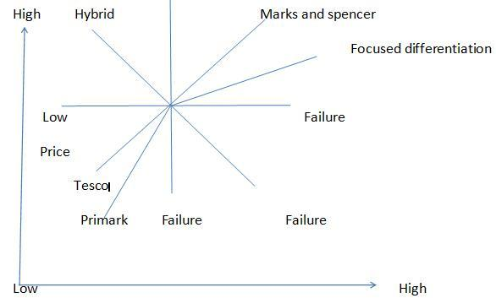
Figure 2: Strategic model
Source: (Dan, 2016)
The differentiation stage adds the value over the economic scales, this leads to the way of providing the branding strategies over the services provided by an organization.

4.4 ANSOFF MATRIX
The implication of such model helps in the regulation of strategies and procedures defined over the strategic development. This model provides a detailed understanding of the services being handled by the customers. In FAN Couriers, this matrix focuses over the way of regulating and maintaining the proper market share along with the present sale of the services. The organization has been delivering the parcels and envelopes by making the standard delivery of the services. This leads to the ways of promoting the brand image (Ciobanu and Stratulat, 2016).
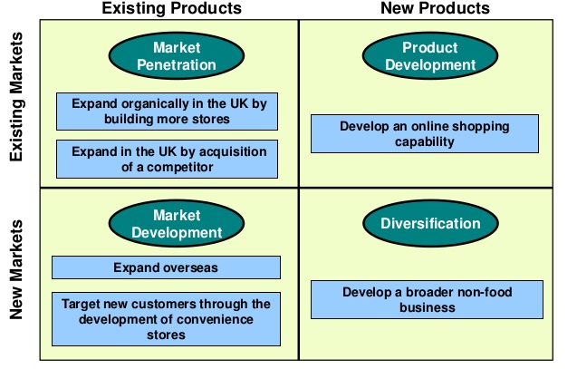
Figure 3: Ansoff Matrix
Source: (Ciobanu and Stratulat, 2016)
Along with this the market development strategy could provide support to improve the sales over the services in the new marketing environment. In terms of introducing the new services, product development strategy is needed.

CHAPTER 5

5.1 SAF EVALUATION
SUITABILITY
The overall working environment of an organization has strong values-based on the guiding procedures. This includes the variables defined over the employees, stakeholders and supply chain partners of an organization. The ways of adding innovative values help in the formulation of strategic management. This strategic model helps in linking the route for the company to face the barriers for firms and to apply the new set of methods for competing effectively with the upcoming barrier. The FAN Couriers is based over the way of implementing the services as per the needs and demands of the customers. In such a situation there is no way to adapt the new strategies based over the provided business environment. This improves the ability to enhance the dependency level in an organization.
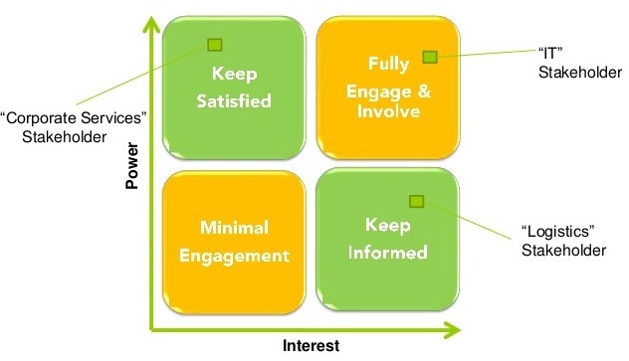
Figure 4: SAF Evaluation
Source: (Ciobanu and Stratulat, 2016)

ACCEPTABILITY
It is defined as the point in the business where a fixed set of risks are evaluated as per the type of strategy being implemented in an organization. The acceptance of new strategies depends on the way of adopting these strategies in a positive manner.
The stakeholder in such situation helps in maintaining the financial structure of an organization which affects the overall progress and development of an organization. The presence of stakeholders includes employees, customers and shareholders of an organization. This includes the expectations of stakeholders over the implementation of a new procedure or strategy (Ciobanu and Stratulat, 2016).

5.2 STAKEHOLDER MAPPING
The mapping of stakeholders in FAN Courier Romania is done as:
FEASIBILITY
The factor of determining the feasibility over the FAN Couriers is included due to strong financial conditions along with having the effective implementation of technologies. This includes the sufficient amount needed for the development and processing of human capital in an effective way.
This helps in focusing over the ways of improving sustainability in an organization needed to build up the required knowledge as per the proposed strategy. This provides the way to think over large perceptions as per the differentiation of strategies (Ciobanu and Stratulat, 2016).

CHAPTER 6

6.0 CONCLUSION
After conducting the entire report, the motive of conducting the strategic management over an organization named as FAN Couriers Romania has been accomplished. In terms of having the effective regulation of various strategies and procedures implied by an organization, the detailed study of various models has been done within this report.
In order to have the detailed analysis, the various tools have been applied over the working structure of FAN Courier Romania. These models are named as Porter’s Five Force Analysis, VRIO framework, value chain analysis model. Apart from these models, the strategic evaluation is done by implementing the Bowman’s Strategic Model and SAF evaluation model. This helps in regulating the entire business abilities and working strategies applied over an organization. It also helps in the accurate implementation of strategies as per the varying environment and culture of the business.

REFERENCES
Albastroiu, I., Vasiliu, C. and Dinu, V., 2018. CONSUMER PERSPECTIVE TOWARD DELIVERY AND RETURN POLICIES OF ONLINE STORES: AN EXPLORATORY RESEARCH FROM ROMANIA. Transformations in Business & Economics, 17(1).
Alexandra, I.D., 2016. Risk Management and Risk Psychology in Romanian SME’s. Manager, (22), pp.42-52.
Baba, M.C., 2015. Cost reduction analysis in online retail as compared to classic retail. Bulletin of the Transilvania University of Brasov. Economic Sciences. Series V, 8(1), p.141.
Bran, C., Militaru, G. and Ionescu, S., 2015, October. Cybermarketing, a key driver for the improvement of flexibility in the sales process of a company. In International Conference on Management and Industrial Engineering (No. 7, p. 91). Niculescu Publishing House.
Ciobanu, G. and Stratulat, O., 2016. ANALYSIS OF ROMANIAN COMPANIES'ACTIVITY IN THE CONTEXT OF BUILDING THE INFORMATIONAL SOCIETY IN ROMANIA. Quality-Access to Success, 17.
Constantin, C., 2015. An Assessment of Customer Behaviours Regarding the Romanian Postal Services.
Dabija, D.C. and Grant, D.B., 2016. Investigating shopping experience and fulfilment in omnichannel retailing: A proposed comparative study in Romania and UK of generation Y consumers. In Proceedings of the 21st Annual Logistics Research Network (LRN) Conference, University of Hull, September, e-proceedings.
Dan, P., 2016, July. Electronic commerce in Romania: History, overview and projections. In 2016 International Conference on Logistics, Informatics and Service Sciences (LISS) (pp. 1-6). IEEE.
Danciulescu, A.I., 2015. Risk Management and Risk Psychology in Romanian SME's. Manager, (22), p.42.
Gabriel, F.L., 2015. THE IMPACT OF PROMOTION CAMPAIGNS OVER THE COMPANIES IN THE CURRENT ECONOMIC CONTEXT. The Annals of'Constantin Brancusi'University of Targu-Jiu. Economy Series.
GEORGESCU, S.D., 2017. Study on strategic options for Romanian economic agents in post-crisis global economy: Policy options for the courier sector. Revista de Științe Politice. Revue des Sciences Politiques, (54), pp.70-89.
Hategan, C.D., Curea-Pitorac, R.I. and Hategan, V.P., 2019. The Romanian Family Businesses Philosophy for Performance and Sustainability. Sustainability, 11(6), p.1715.
Iosub, I., Ivanov, A. and Smedescu, D., 2016. Characteristics and Development of Social Media as a Marketing Communications Tool. Journal of Emerging Trends in Marketing and Management, 1(1), pp.339-345.
Iovan, S., 2017. Predictive analytics for transportation industry. Journal of Information Systems & Operations Management, p.58.
Lăzărescu, C., 2017. The Postal Market–a New Economic Challenge in the Context of Globalization. Journal of Humanistic and Social Studies, 8(1), pp.187-196.
Lechman, E., 2018. Born Poland, gone global: The case of successful Polish ICT company Aiton Caldwell 1. In Entrepreneurship in Central and Eastern Europe (pp. 112-126). Routledge.
Leovaridis, C., 2015. Workplace Innovations as Reflected in the Romanian Economic Press. Revista Română de Comunicare şi Relaţii Publice, 17(1), pp.101-119.
Mihoc, F., Wilkinson, T.J. and Hinnenkamp, C., 2016. What Sells in Romania: Performance or Relationships?. Journal of East-West Business, 22(2), pp.77-96.
Mitreva, E., Filiposki, O., Krivokapić, Z., Jovanovic, J. and Taskov, N., 2017. Leadership–dedication to the Quality Management System and customer focus in Macedonian companies.
MUNTEANU, A.R., 2015. Reviewing The Performance Of Organic E-Shops In Romania. In Proceedings of the INTERNATIONAL MANAGEMENT CONFERENCE (Vol. 9, No. 1, pp. 999-1008). Faculty of Management, Academy of Economic Studies, Bucharest, Romania.
Siminica, M. and Sichigea, M., 2018. Corporate Social Responsibility as a Voluntary Initiative but a Mandatory Non-financial Reporting Link Between the Social and Financial Performance of Romanian Companies. In Current Issues in Corporate Social Responsibility (pp. 77-96). Springer, Cham.
Siminica, M., Motoi, A.G. and Dumitru, A., 2017. Financial management as component of tactical management. Polish Journal of Management Studies, 15.

