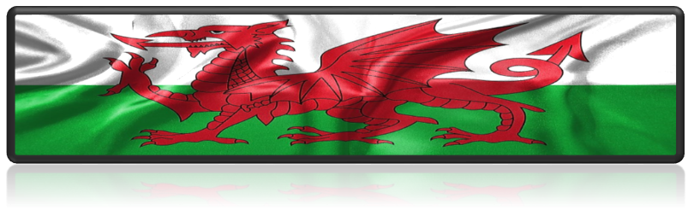
(worldatlas.com)

Lisa Thomas - 2223470
ECIE5004 - Portfolio

Celebrating Language and Culture- Belonging to Wales


(skyports.com)
  (Photoeverywhere.co.uk, 2025) (Freefoodphotos.com, 2019)

Contents

Rationale 3-6

Overview of activities 6-9

Evaluation 9-10

Appendices 11-12

References 13-16


(Wikimedia.org, 2024)
In July 2017, the Welsh Government published a strategy to promote the Welsh language, Cymraeg 2050: A million Welsh speakers (Llywodraeth Cymru, 2017). This is a long-term approach, and the education system is key to achieving this. The approach includes two main targets. These targets are to reach one million Welsh speakers by 2050, and the percentage of the population that speaks Welsh daily and can speak more than just a few words of Welsh, to increase from 10% (in 2013 to 2015) to 20% by 2050. Alongside these targets are three themes, increasing the number of Welsh speakers at the core of Cymraeg 2050, increasing the use of Welsh, and creating suitable conditions, infrastructure, and context where the Welsh language can thrive. Subsequently, in July 2021, the strategy’s second work programme was published, outlining their work from 2021 to 2026 (Welsh Government, 2024). The 2021 Census offering valuable data revealed that the most significant reduction in the percentage of Welsh speakers occurred within the 5 to 15-year-old age group (Welsh Government, 2022). However, many sources must be examined to see the entire picture. This is because the Census results are estimates that include some uncertainty from the statistical models used to account for non-response, as well as a minor effect as described in Statistical Closure Control (Office for National Statistics, 2021).
Furthermore, the COVID-19 pandemic profoundly impacted children’s ability and confidence to communicate in Welsh (GOV.WALES, 2020). The Welsh Government has analysed school data from the Welsh in Education Strategic Plans (WESPs) and has agreed to collaborate with all local authorities to recover lost ground (Gov.wales, 2022). The Welsh Government believes that the Welsh language belongs to everyone, as does the responsibility for its future. This links to the Well-being of Future Generations (Wales) Act 2015. The Well-being of Future Generations Act 2015 includes seven well-being goals for Wales (see Appendix 1). (Future Generations Commissioner for Wales, 2015). It aims to improve Wales’ social, economic, environmental, and cultural well-being of Wales leading the world in legislating for sustainable development. Wales has many challenges, such as climate change, poverty, poor health, and lack of jobs (GOV.WALES, 2020a).
The Welsh language is believed to have arrived in Britain around 600 BC, making it the oldest language in Britain (Brain, 2018). However, there have been many challenges to the preservation of the language. One of these threats was in 1536 when Henry VIII’s decision to pass the Act of Union between England and Wales brought Wales under England’s rule by prohibiting the use of Welsh in public administration and the legal system. This severely caused the Welsh language to suffer (Johnson, 2019). The Welsh language was banned, and its official status was removed (Maya-Martinez, 2022).
Furthermore, there was a cultural shift from Welsh to English. Welsh speakers were expected to communicate in English at work. Also, the education system suppressed the Welsh language from an early age. In the eighteenth century, there was a further challenge with the influx of English speakers due to the Industrial Revolution. This had a significant impact on the Welsh language, contributing to its decline both socially and economically. The nineteenth century was also a turbulent time for Wales, marked by riots believed to be linked to the Welsh language (Bbc.co.uk, 2014b). In 1846, a Welsh MP named William Williams, who represented Coventry, delivered a speech that led to a commission investigating the role of Welsh in education. This report came to be known as the Treachery of the Blue Books, named for the blue cover of the report and treachery from an ancient Arthurian myth regarding the Saxon invasion of Britain. The content of these books contained derogatory remarks about the morals of Welsh people (Bbc.co.uk, 2014a).
During the nineteenth and early twentieth centuries, Welsh was not part of the school curriculum. It was discouraged in schools, and children were forced to speak English. If they spoke Welsh, they were given a plaque called the ‘Welsh Not’. It was then passed on throughout the day to whoever next spoke Welsh (see Appendix 2). At the end of the day, the child who had the ‘Welsh Not’ would be punished (FelinFach, 2024).
In the twentieth century, it became recognised that Welsh language/speakers were being discriminated against. The Welsh Courts Act addressed the issue in 1942, requiring defendants and plaintiffs to be compelled to speak in English.
A common misconception about the Welsh language is that it is only spoken in rural areas. While it is more prevalent in West and North Wales, it is spoken in every county, with Cardiff having more Welsh speakers than any county except Gwynedd. Such misconceptions can harm the language’s future and create barriers for new learners, leading to the false belief that only white individuals or older generations speak Welsh and that the language is dying out. It is vital to promote the visibility of Welsh across all communities (Challenging Five Myths About Learning Welsh, 2022).
A significant piece of legislation, primarily based on the Hughes Parry Report, was introduced in 1967 after Plaid Cymru and the Welsh Language Society campaigned. This was to be the Welsh Language Act 1967. This legislation established that written and spoken Welsh should be equal to English in the courts (Brain, 2018). This was seen as a significant moment for recognising the Welsh language. The Welsh Language Board was created in 1993 under the Welsh Language Act 1993 and was allocated an annual grant of £1.3 million to promote and facilitate the use of the Welsh language. In 2012, the Welsh Language Board was abolished and replaced by the Welsh Language Service (GOV.UK, n.d.).
The New Curriculum for Wales (2022) strongly emphasises Welsh as a vital part of Welsh identity and culture. Welsh is not only taught as a subject but is also integrated across other learning areas (Welsh Government, 2020). Curriculum Cymreig is integrated into the New Curriculum for Wales, reflecting Wales’s cultural heritage and supporting bilingualism. Siarter Iaith is a Welsh language charter which provides a structured framework for schools to enhance their Welsh language provision (hwb.gov.wales, 2024). School A is committed to meeting the charter’s goals, demonstrating the commitment to fostering a Welsh language environment within the community (see Appendix 3). School A has a group of pupils, ‘Criw Cymraeg’ consisting of representatives from each year group who meet regularly to discuss progress and new initiatives. These pupils play a pivotal role as dedicated champions of the Welsh language, helping to create a thriving bilingual environment. Fostering an inclusive and collaborative environment involves a whole school approach (Pembroke, 2022a).
In March 2014, the Welsh Government commissioned Professor Graham Donaldson to conduct a comprehensive review of the curriculum and assessment frameworks used in schools across Wales (Dauncey, 2015). A review was conducted and many people, including children, thought the curriculum was outdated. There was a demand for a greater focus on life skills, personal confidence, basic skills, work skills, career advice, health, and well-being. Furthermore, children wanted their learning to be fun and more engaging. The report stated that the curriculum should have four purposes in Wales. These are ambitious, capable learners, ethical, informed citizens, enterprising, creative contributors, healthy, confident individuals (Donaldson, 2015).
Professor Cummins' (1979) theories on language acquisition have significantly impacted educational practices. He identifies two distinct types of language proficiency, Basic Interpersonal Communication Skills (BICS), which is everyday social language, and Cognitive Academic Language Proficiency (CALP), which focuses on proficiency in academic language (Colorín Colorado, 2019). This distinction helps educators better understand learners’ language abilities and set appropriate expectations for learning and communication in the classroom.
School A actively promotes the Welsh language through engaging activities and initiatives encouraging its use and preservation. Community events, educational resources, and cultural initiatives create an environment where the Welsh language thrives and is celebrated. Incidental Welsh is incorporated daily in the classroom through everyday experiences such as answering the register, check-ins, days of the week, the weather and asking to go to the toilet (see Appendix 4). The children absorb the language quickly by overhearing phrases in an unfocused way, adding an element of fun to their learning. This approach helps them expand their language skills and fosters a deeper connection to their home country (hwb.gov.wales, 2019).
Additionally, posters and signs are prominently displayed around the classroom as constant visual reminders. American-born linguist Chomsky (1957) developed the language acquisition theory (LAD) and posited that children possess an innate ability to learn languages (Grosjean, 2013). According to his theory, children’s brains are equipped with unique language-learning mechanisms from birth (Armstead, 2019).
Counting is an essential part of daily life for children. School A encourages children to practice their counting skills in Welsh, whether through engaging activities, games, or informal conversations. This helps them develop their numeracy skills but also strengthens their connection to their cultural heritage. Researchers have discovered that children who learn Welsh tend to perform better in mathematics than their English language peers. The reason for this is that the Welsh have adopted a modern number-naming system, which aligns more closely with the base-10 numeral system, whereas England still adopts the more traditional method (Clark, 2005).
Shwmae Day is a national celebration across Wales to promote the Welsh language. Schools participate in various activities to mark this occasion, allowing people to come together and connect. The main aim of Shwmae Day is to demonstrate that the Welsh language is accessible to everyone, whether they are native speakers, learners, or complete beginners. On this day, children are encouraged to wear Welsh colours to school, and the canteen serves traditional Welsh food. Also, prizes for the most spoken Welsh language are awarded, and other competitions are held throughout the school (Chandler, 2021).
School A celebrates the Eisteddfod by inviting families to a concert where children perform Welsh songs, including the Welsh national anthem, and recite Welsh poems (Bbc.co.uk, 2024). This event links to Article 30, which recognises the right to use your own language and celebrate your culture (UNICEF, 1989). Additionally, competitions are organised for children to participate in at home with their families. These may include creating Welsh-themed artwork using a medium of their choice, composing a Welsh poem, taking a photograph, or displaying their best handwriting (see Appendix 5). The winners of the competitions are announced during the St Davids Day celebrations (Pembroke, 2022b).
School A actively promotes the Welsh language through Meistroli, a language-learning tool explicitly developed for Pembrokeshire learners. Meistroli means to master and use real-life context and provides structured language learning materials across four levels of short activities. Each level contains ten communicative functions containing sets of flashcards. The children read the English phrase, vocalising the translation, then click the check button to verify the correct Welsh translation. It aims to enhance learners’ Welsh language skills and fosters a more structured and practical learning approach by reinforcing language retention. Designed for ease of use, Meistroli ensures access for all learners with differentiated content that is both fun and engaging. It promotes an interactive and immersive learning experience. It aligns with the Welsh language Curriculum, enabling children to become ambitious and capable learners. It also ties in with Curriculum Cymraeg (Gareth, Jones and Roderick, 2024). Learners control their learning journey, and the competitive component of competing against their peers from their class and other schools encourages them to engage with others, fostering motivation and empowerment (Meistroli.cymru, 2025).
Moreover, Meistroli is linked to MARS EARS sessions, which further support children in developing their Welsh language skills (MARS, 2025). Since using Meistroli it has received positive feedback from both children and staff. Staff report that it empowers them and children, fostering independence and enthusiasm for speaking Welsh. The self-assessment component allows children to progress at their own pace.
MARS EARS is a pedagogical cycle created by Conti and implemented at School A to support Welsh (Conti, 2021). It introduces new phrases, followed by using Drillio, an engaging drilling activity that is both quick and fun, with an emphasis on the accuracy of pronunciation (see Appendix 6). One of the earliest scientific explanations for language acquisition was provided by the American psychologist Skinner (1957). He posits that language learning results from habit formation through imitation, reinforcement, and conditioning. This theory emphasises the importance of repetition and practice to reinforce essential vocabulary and grammar structures (Sanako Blog, 2024). Another activity, called mosaic translation, involves presenting sentences in English that children must translate into Welsh by colouring the correct translation of each sentence in a different colour. The activity focuses on reading and retrieving. In addition to this, there is a listening gap-fill activity, where a paragraph written in Welsh contains gaps for the children to fill in. This activity reinforces listening, reading, and the consolidation of sentence patterns and vocabulary. The children can also play a Welsh version of Snakes and Ladders.
School A’s current priorities for the School Development Plan 2024-2025 include maintaining and enhancing at least 15% of school activities, both inside and outside the classroom, delivered in Welsh. Additionally, the school aims to continue improving overall standards across the school and increasing the amount of cross-curricular Welsh delivered (sites.google.com, n.d.). The aims outlined in the school's mission statement emphasise the importance of developing a strong Welsh ethos, encouraging pupils to take pride in using the Welsh language (sites.google.com, n.d.). Furthermore, the school seeks to promote ethically informed citizens who are ready to take their place in Wales and the global community. All staff and children are encouraged to use Welsh daily at school. School A seeks to enhance language usage and provide a relevant context for its teaching. Most teaching is through activities and games, as well as weekly diary writing sessions in Welsh in key stage 2. Staff encourage children to be proud of their Welsh heritage and to respect the cultural identity of all children in school (Welsh Language Development in the Foundation Phase, 2013). School A fully complies with The Education Wales Act 2013, which is designed to enhance educational outcomes effectively (Legislation.gov.uk, 2024).
Some reading sessions are delivered in Welsh, providing an immersive language experience for learners. This includes shared/individual reading. This approach allows children to enhance their reading skills while engaging with texts in a familiar cultural context. Each session focuses on developing fluency, comprehension, and critical thinking, tailored to the needs of the children (McGee, 2021). It also improves cognitive ability. Vygotsky’s sociocultural theory emphasises the importance of social interactions and cultural contexts as crucial factors in shaping language development (Moore, 2011). A meta-analysis of studies that examined the cognitive correlates of bilingualism was extracted with results indicating that bilingualism is reliably associated with several cognitive outcomes (Adesope et al., 2010).
Many people still believe that the Welsh language is an ancient tongue. However, a study published by the Royal Society suggests that, over time, the language is likely to flourish. If the number of Welsh speakers increases steadily in line with the government’s plan for the next few years, three-quarters of the nation will speak it proficiently by 2300 (Whole nation ‘could speak Welsh’ within 300 years, 2020). Migration and the influx of non-Welsh speakers moving to Wales are the biggest threats to preserving the Welsh language. In a rapidly evolving world, it is evident that technology is the key to progress. Children are increasingly engaged with iPads and laptops as tools for their learning. The Curriculum Cymraeg is enhanced by technology, providing learners with opportunities to discover and analyse information about the rich heritage of Wales, and enabling them to share their findings through various means of communication. This demonstrates the positive impact Meistroli has on children’s learning. With the continued use of Meistroli, children can develop their Welsh language further, supporting the Welsh government’s strategy for improving the Welsh language. To further enhance incidental Welsh language use in school A, it is essential to keep creating opportunities that foster natural language interactions. This could involve immersive language workshops and working with local partnerships. Being able to communicate in Welsh allows people to become global citizens and allows for increased employment opportunities (Sneddon, 2008). It is essential to educate parents as they may have had a negative experience of learning Welsh in school (Graham, 2017). Pavlov’s Classical conditioning shows that attitudes can change when associated with pleasant events (Bottaro, 2022).

Appendix 1 Appendix 2
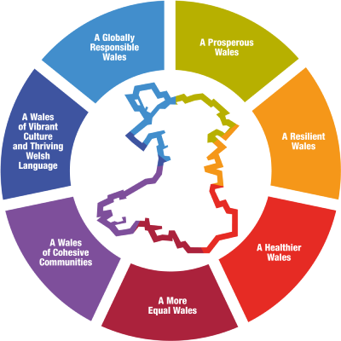(gov.wales) 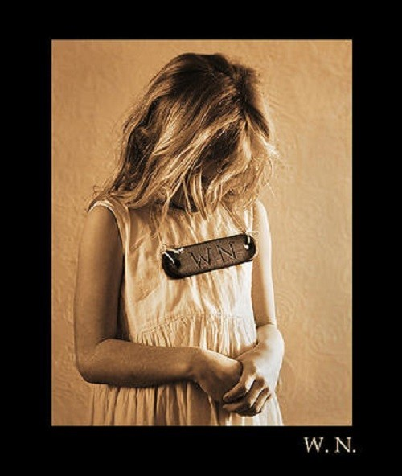
(wrexham.com)

Appendix 3
Appendix 4
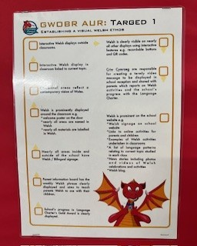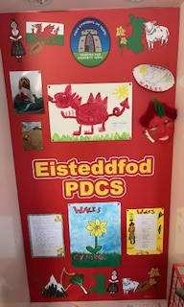
(Siarter Iaith, school A) (St. Davids Day, school A)

Appendix 5
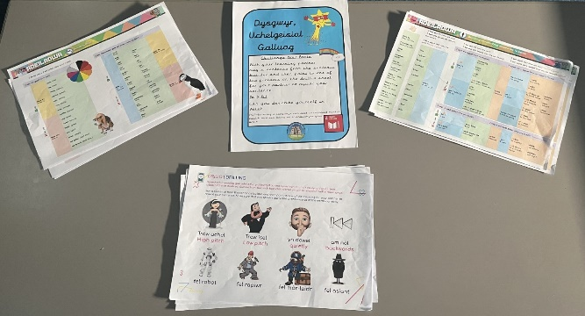
(drillio, school A)

Appendix 6

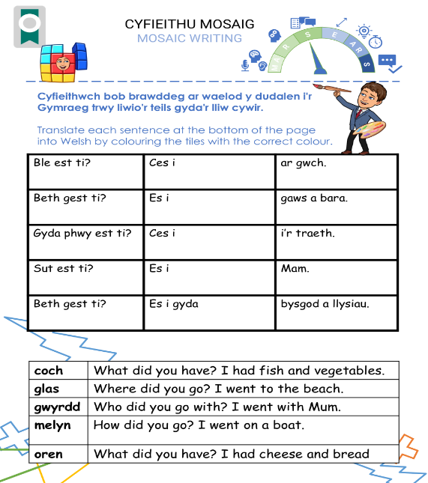
(sites.google.com)

Reference list
Adesope, O.O., Lavin, T., Thompson, T. and Ungerleider, C. (2010). A Systematic Review and Meta-Analysis of the Cognitive Correlates of Bilingualism. Review of Educational Research, 80(2), pp.207–245. doi:https://doi.org/10.3102/0034654310368803.
Armstead, K. (2019). Chomsky’s Language Acquisition Device: Definition & Explanation - Video & Lesson Transcript | Study.com. [online] Study.com. Available at: https://study.com/academy/lesson/chomskys-language-acquisition-device-definition-lesson-quiz.html [Accessed 31 Dec. 2024].
BBC Tiny Happy People. (2025). The myth of speech delay in bilingual toddlers: Top tips for speaking two languages to baby. [online] Available at: https://www.bbc.co.uk/tiny-happy-people/articles/zn73f4j [Accessed 5 Jan. 2025].
Bbc.co.uk. (2014a). BBC - Wales - History - Themes - Women - The Blue Books. [online] Available at: https://www.bbc.co.uk/wales/history/sites/themes/society/women_blue_books.shtml [Accessed 29 Dec. 2024].
Bbc.co.uk. (2014b). BBC Wales - History - Themes - The Rebecca Riots. [online] Available at: https://www.bbc.co.uk/wales/history/sites/themes/society/politics_rebecca_riots.shtml [Accessed 5 Jan. 2025].
Bbc.co.uk. (2024). St David’s Day 2019: Everything you need to know - CBBC Newsround. [online] Available at: https://www.bbc.co.uk/newsround/43240280 [Accessed 2 Jan. 2025].
Bottaro, A. (2022). Pavlov’s Theory of Classical Conditioning: What You Need To Know. [online] Verywell Health. Available at: https://www.verywellhealth.com/classical-conditioning-5218361 [Accessed 5 Jan. 2025].
Brain, J. (2018). The Welsh Language. [online] Historic UK. Available at: https://www.historic-uk.com/HistoryUK/HistoryofWales/Welsh-Language/ [Accessed 29 Dec. 2024].
Challenging 5 myths about learning Welsh. (2022). BBC Cymru Fyw. [online] 21 Oct. Available at: https://www.bbc.co.uk/cymrufyw/63351402 [Accessed 1 Jan. 2025].
Chandler, A. (2021). Schools gearing up for Shwmae Day. [online] The Pembrokeshire Herald. Available at: https://pembrokeshire-herald.com/69409/schools-gearing-up-for-shwmae-day/ [Accessed 2 Jan. 2025].
Clark, R. (2005). Children who learn Welsh ‘better at maths’. [online] Wales Online. Available at: https://www.walesonline.co.uk/news/wales-news/children-who-learn-welsh-better-2363323 [Accessed 31 Dec. 2024].
Colorín Colorado (2019). What are BICS and CALP? [online] Colorín Colorado. Available at: https://www.colorincolorado.org/faq/what-are-bics-and-calp [Accessed 5 Jan. 2025
Conti, G., Phd, MA, MA and PGCE (2021). Implementing MARS EARS in lessons and across the department – by Aurélie Lethuilier. [online] The Language Gym. Available at: https://gianfrancoconti.com/2021/02/12/implementing-mars-ears-in-lessons-and-across-the-department-by-aurelie-lethuilier/.
Dauncey, M. (2015). Donaldson Review: The ‘purposes’ and content of a Curriculum for Wales. [online] research.senedd.wales. Available at: https://research.senedd.wales/research-articles/donaldson-review-the-purposes-and-content-of-a-curriculum-for-wales/ [Accessed 30 Dec. 2024].
Donaldson, G. (2015). Successful Futures Looking at the Curriculum and Assessment Arrangements in Wales. [online] Available at: https://www.gov.wales/sites/default/files/publications/2018-03/succesful-futures-a-summary-of-professor-graham-donaldsons-report.pdf [Accessed 30 Dec. 2024].
FelinFach (2024). Welsh Not - A Form of Punishment. [online] FelinFach. Available at: https://www.felinfach.com/pages/welsh-not-welsh-knot?srsltid=AfmBOoodRVXI8aZ1CzB7oYaHkysiVCAOlC8DKp4iHLPrl_byP74i7eos [Accessed 29 Dec. 2024].
Future Generations Commissioner for Wales (2015). Well-being of Future Generations (Wales) Act 2015. [online] www.futuregenerations.wales. Available at: https://www.futuregenerations.wales/about-us/future-generations-act/ [Accessed 30 Dec. 2024].
Gareth, Jones, E. and Roderick, G. (2024). The Cwricwlwm Cymreig, history and the story of wales. [online] Available at: https://www.gov.wales/sites/default/files/publications/2018-11/the-cwricwlwm-cymreig-history-and-the-story-of-wales-final-report.pdf.
GOV.UK. (n.d.). Welsh language scheme. [online] Available at: https://www.gov.uk/government/organisations/office-of-the-public-guardian/about/welsh-language-scheme [Accessed 5 Jan. 2025].
GOV.WALES. (2020a). Cymraeg. It belongs to us all [HTML]. [online] Available at: https://www.gov.wales/cymraeg-it-belongs-to-us-all-html [Accessed 29 Dec. 2024].
GOV.WALES. (2020b). Written Statement: The effects of Covid-19 on Welsh language community groups – survey findings (10 December 2020) | GOV.WALES. [online] Available at: https://www.gov.wales/written-statement-effects-covid-19-welsh-language-community-groups-survey-findings [Accessed 29 Dec. 2024].
Gov.wales. (2022). Welsh in Education Strategic Plan (WESP). [online] Available at: https://www.carmarthenshire.gov.wales/council-services/education-schools/bilingual-education/welsh-in-education-strategic-plan-wesp/ [Accessed 29 Dec. 2024].
Graham, H. (2017). Teachers reveal the one thing parents can do to help their child at school. [online] ChronicleLive. Available at: https://www.chroniclelive.co.uk/news/north-east-news/bad-teenage-experiences-scare-parents-13827626 [Accessed 5 Jan. 2025].
Grosjean, F. (2013). Noam Chomsky on Bilingualism | Psychology Today United Kingdom. [online] www.psychologytoday.com. Available at: https://www.psychologytoday.com/gb/blog/life-bilingual/201305/noam-chomsky-bilingualism [Accessed 30 Dec. 2024].
hwb.gov.wales. (2019). Languages, Literacy and Communication: Designing your curriculum - Hwb. [online] Available at: https://hwb.gov.wales/curriculum-for-wales/languages-literacy-and-communication/designing-your-curriculum [Accessed 2 Jan. 2025].
hwb.gov.wales. (2024). Siarter Iaith - Hwb. [online] Available at: https://hwb.gov.wales/siarter-iaith [Accessed 2 Jan. 2025].
Johnson, B. (2019). Henry VIII, King of England and his six wives. [online] Historic UK. Available at: https://www.historic-uk.com/HistoryUK/HistoryofEngland/Henry-VIII [Accessed 29 Dec. 2024].
Legislation.gov.uk. (2024). School Standards and Organisation (Wales) Act 2013. [online] Available at: https://www.legislation.gov.uk/anaw/2013/1/contents [Accessed 5 Jan. 2025].
Llywodraeth Cymru (2017). Cymraeg 2050 A million Welsh speakers. [online] Available at: https://www.gov.wales/sites/default/files/publications/2018-12/cymraeg-2050-welsh-language-strategy.pdf [Accessed 30 Dec. 2024].
MARS, C. (2025). Y GROMLECH - CC2 + CC3 MARS EARS. [online] Google.com. Available at: https://sites.google.com/hwbcymru.net/ygromlech/cyfrwng-saesneg/cynllun-datblygiad-iaith/cc2-cc3-mars-ears [Accessed 2 Jan. 2025].
Maya-Martinez, M. (2022). Welsh language: A national treasure - Civil Service. [online] civilservice.blog.gov.uk. Available at: https://civilservice.blog.gov.uk/2022/07/19/welsh-language-a-national-treasure/ [Accessed 30 Dec. 2024].
McGee, C. (2021). The Benefits of Reading in a Foreign Language - A Thousand Lives - Medium. [online] Medium. Available at: https://medium.com/a-thousand-lives/the-benefits-of-reading-in-a-foreign-language-d5a994c68210 [Accessed 5 Jan. 2025].
Meistroli.cymru. (2025). Meistroli. [online] Available at: https://www.meistroli.cymru/ [Accessed 1 Jan. 2025].
Moore, M. (2011). Vygotsky’s Cognitive Development Theory. Encyclopedia of Child Behavior and Development, [online] 1(1), pp.1549–1550. doi:https://doi.org/10.1007/978-0-387-79061-9_3054.
Office for National Statistics (2021). Quality and methodology information (QMI) for Census 2021 - Office for National Statistics. [online] www.ons.gov.uk. Available at: https://www.ons.gov.uk/peoplepopulationandcommunity/populationandmigration/populationestimates/methodologies/qualityandmethodologyinformationqmiforcensus2021 [Accessed 29 Dec. 2024].
Pembroke (2022a). Pembroke Dock Community School - Cymraeg@PDCS. [online] Google.com. Available at: https://sites.google.com/hwbcymru.net/pdcsprimary/key-information/pupil-voice/cymraegpdcs [Accessed 5 Jan. 2025].
Pembroke (2022b). Pembroke Dock Community School - Eisteddfod. [online] Google.com. Available at: https://sites.google.com/hwbcymru.net/pdcsprimary/key-information/pupil-voice/cymraegpdcs/eisteddfod [Accessed 3 Jan. 2025].
Sanako Blog (2024). 8 leading theories in second language acquisition. [online] Sanako. Available at: https://sanako.com/8-leading-theories-in-second-language-acquisition [Accessed 3 Jan. 2025].
sites.google.com. (n.d.). Pembroke Dock Community School - About us. [online] Available at: https://sites.google.com/hwbcymru.net/pdcsprimary/about-us [Accessed 3 Jan. 2025].
sites.google.com. (n.d.). Pembroke Dock Community School - School Development Plan. [online] Available at: https://sites.google.com/hwbcymru.net/pdcsprimary/key-information/school-development-plan [Accessed 3 Jan. 2025].
Sneddon, R. (2008). English Teaching: Practice and Critique. [online] 7(2). Available at: https://files.eric.ed.gov/fulltext/EJ832209.pdf [Accessed 5 Jan. 2025].
UNICEF (1989). Our Rights. [online] Available at: https://www.unicef.org.uk/wp-content/uploads/2017/09/Our-rights_UNCRC.pdf [Accessed 2 Jan. 2025].
Welsh Government (2022). Welsh language in Wales (Census 2021). [online] GOV.WALES. Available at: https://www.gov.wales/welsh-language-wales-census-2021-html [Accessed 29 Dec. 2024].
Welsh Government (2024). Cymraeg 2050: Welsh language strategy action plan 2024 to 2025 [HTML] | GOV.WALES. [online] www.gov.wales. Available at: https://www.gov.wales/cymraeg-2050-welsh-language-strategy-action-plan-2024-2025-html [Accessed 29 Dec. 2024].
Welsh Government (2020). Developing a vision for curriculum design - Hwb. [online] hwb.gov.wales. Available at: https://hwb.gov.wales/curriculum-for-wales/designing-your-curriculum/developing-a-vision-for-curriculum-design/ [Accessed 2 Jan. 2025].
Welsh Language Development in the Foundation Phase. (2013). Available at: https://www.estyn.gov.wales/system/files/2020-07/Welsh%2520Language%2520Development%2520in%2520the%2520Foundation%2520Phase%2520-%2520January%25202013.pdf [Accessed 2 Jan. 2025].
Welsh language technology action plan. (2018). Available at: https://www.gov.wales/sites/default/files/publications/2018-12/welsh-language-technology-and-digital-media-action-plan.pdf [Accessed 4 Jan. 2025].
Whole nation ‘could speak Welsh’ within 300 years. (2020). BBC News. [online] 8 Jan. Available at: https://www.bbc.co.uk/news/uk-wales-51036598 [Accessed 4 Jan. 2025].

