DS 1 Template

My Screenshots/Photos

Screenshot/Photo 1
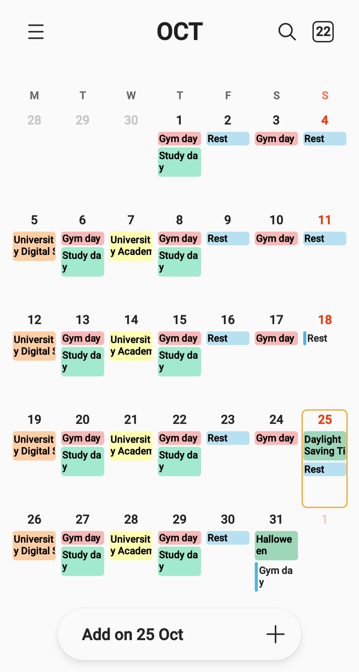
My first screenshot demonstrates how I use my phones calendar to best plan my routine. For instance, I colour code my Digital Skills class in orange, Academic Skills in yellow and my rest days in blue. This tool is incredibly useful for my studies because it helps prevent scheduling conflicts. Relying on this digital calendar has significantly improved my time management and boosted my confidence in balancing work alongside my studies.

Screenshot/Photo 2
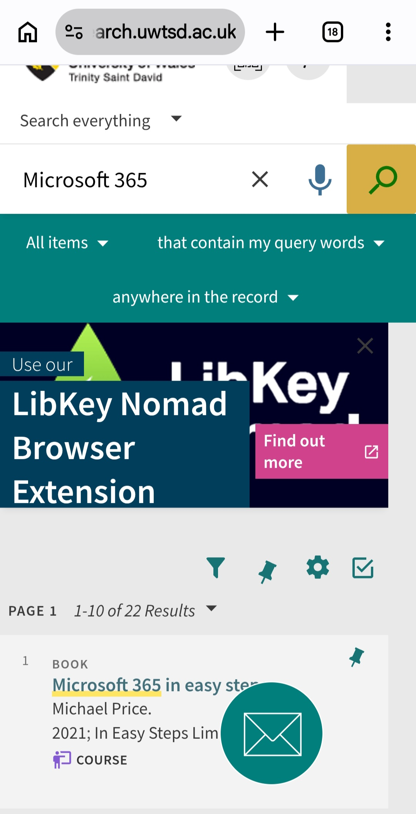
Screenshot number two shows me searching the university online library for academic resources. For example, I used the platforms search bar to narrow down the results and find a specific book that could help me improve my Microsoft 365 skills. Having access to this digital database is invaluable for my studies as it allows me to find credible, verified information any time I need it.

Screenshot/Photo 3
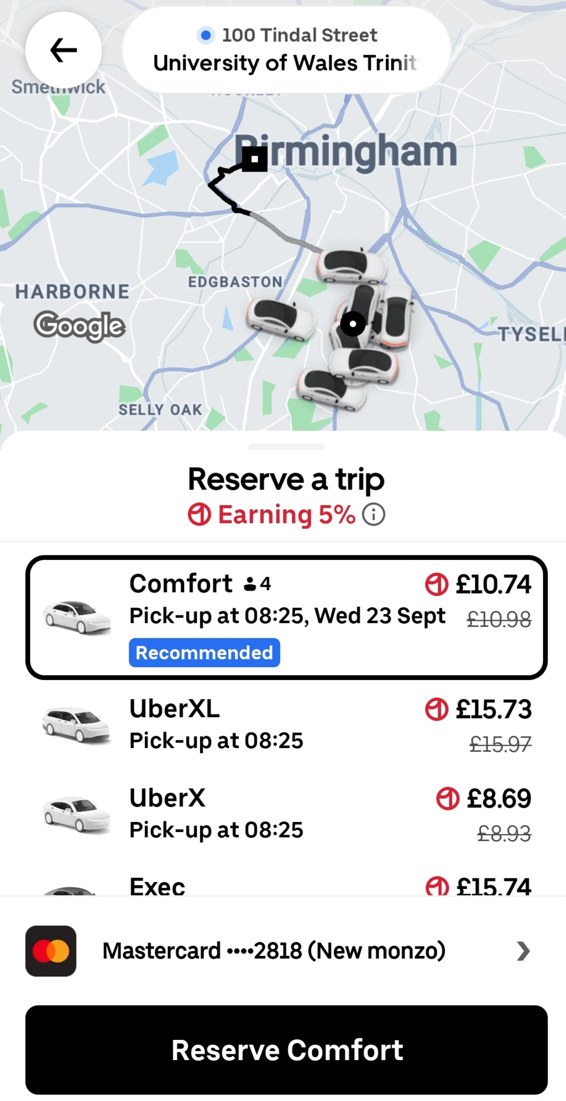
Screenshot number 3 is of the Uber app on my phone, which I use to plan my daily travel needs. For instance, I use the apps scheduling feature to prebook my trips to university to avoid unnecessary delays. Learning to use all the range of features of the app has allowed me to get the best prices and book different taxis to suit my needs at the time.

Screenshot/Photo 4
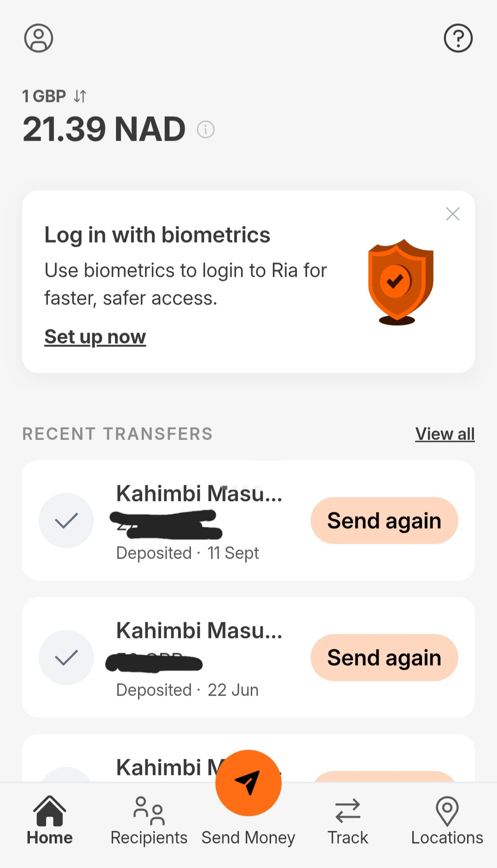
Screenshot number 4 displays my use of the Ria Money Transfer app to securely manage my international payments and to check live currency conversion rates. As an example, my partner lives in another country, I use the app to quickly transfer money abroad, avoiding the long delays of bank transfers. Successfully navigating digital financial apps has helped me feel confident in managing money transfers and understanding real time currency conversions on my mobile device.

Screenshot/Photo 5
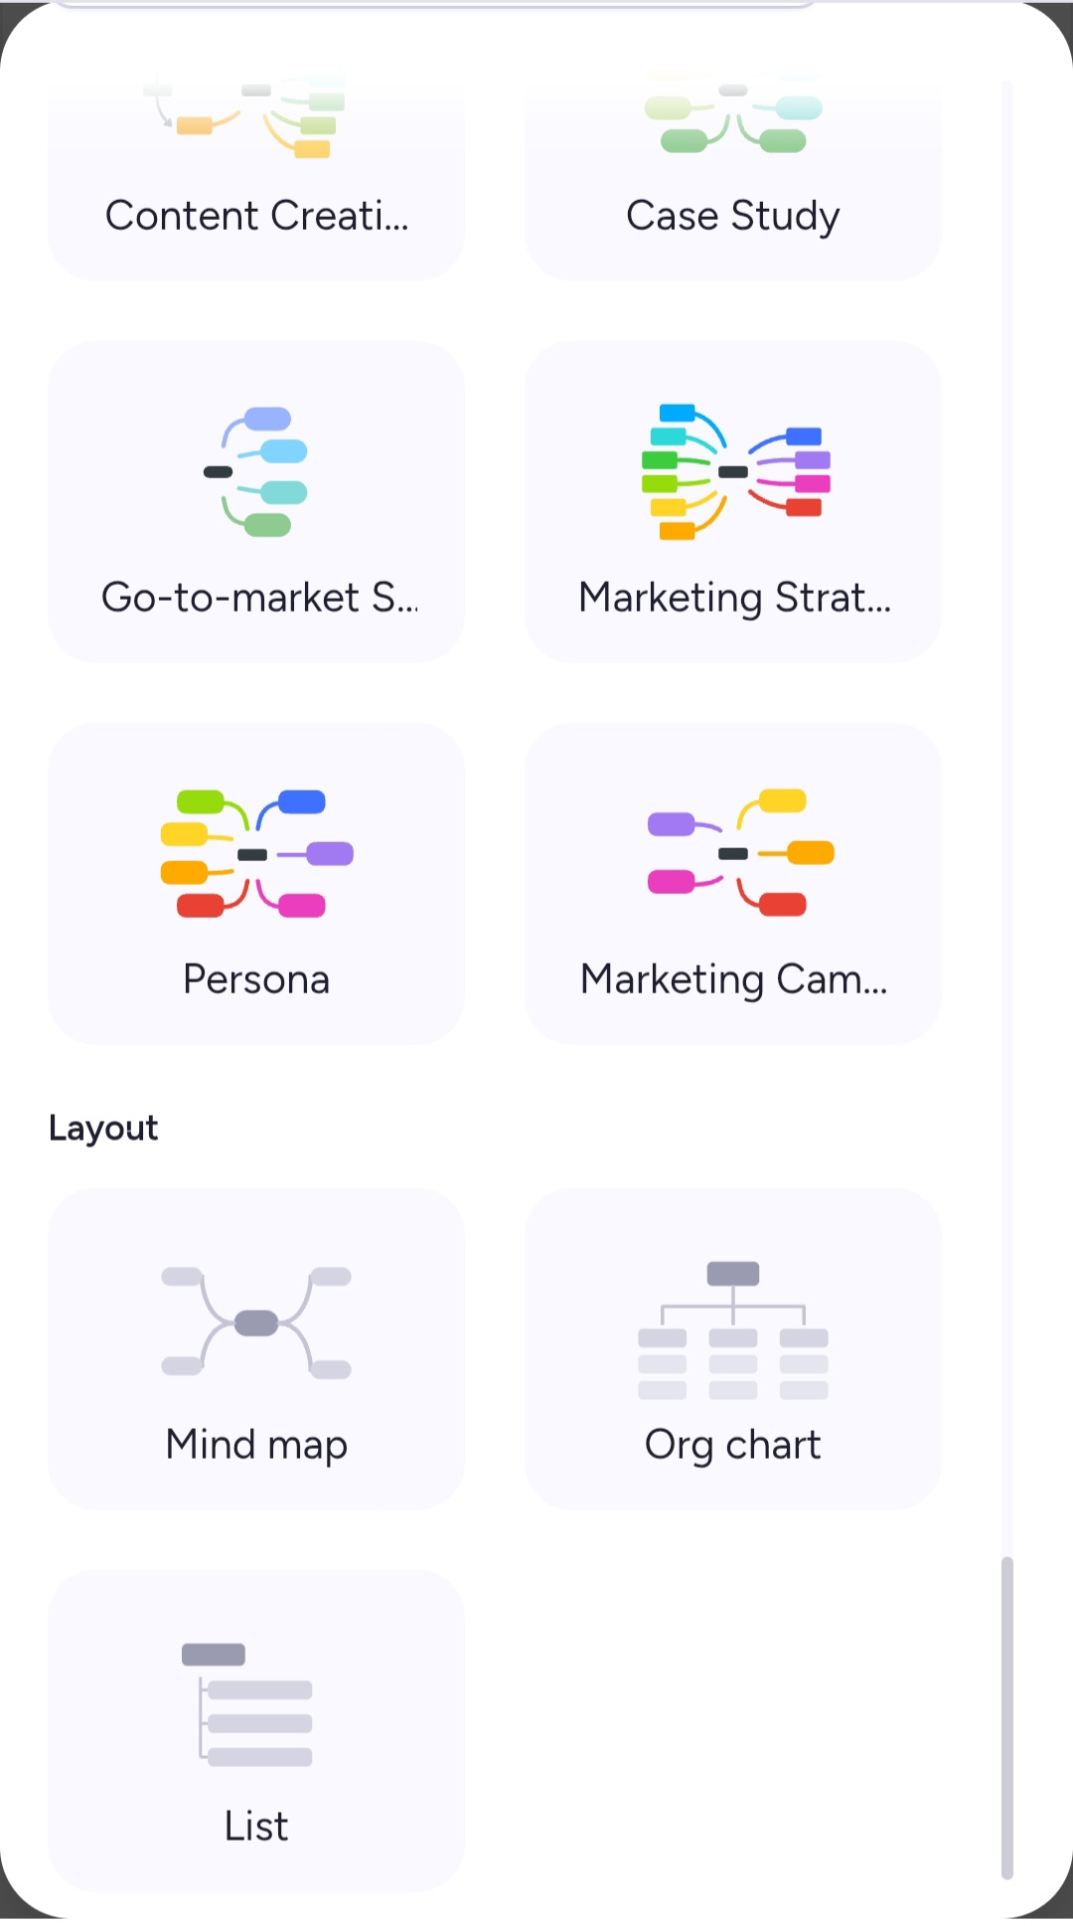
Screenshot number 5 shows how I use a digital tool called MindMeister to visually organise information for my projects. Specifically, I use these online templates to create mind maps that I can incorporate into my assessments when required. Integrating this tool into my studies has boosted the quality of the work I produce and enhanced my digital confidence.

Screenshot/Photo 6
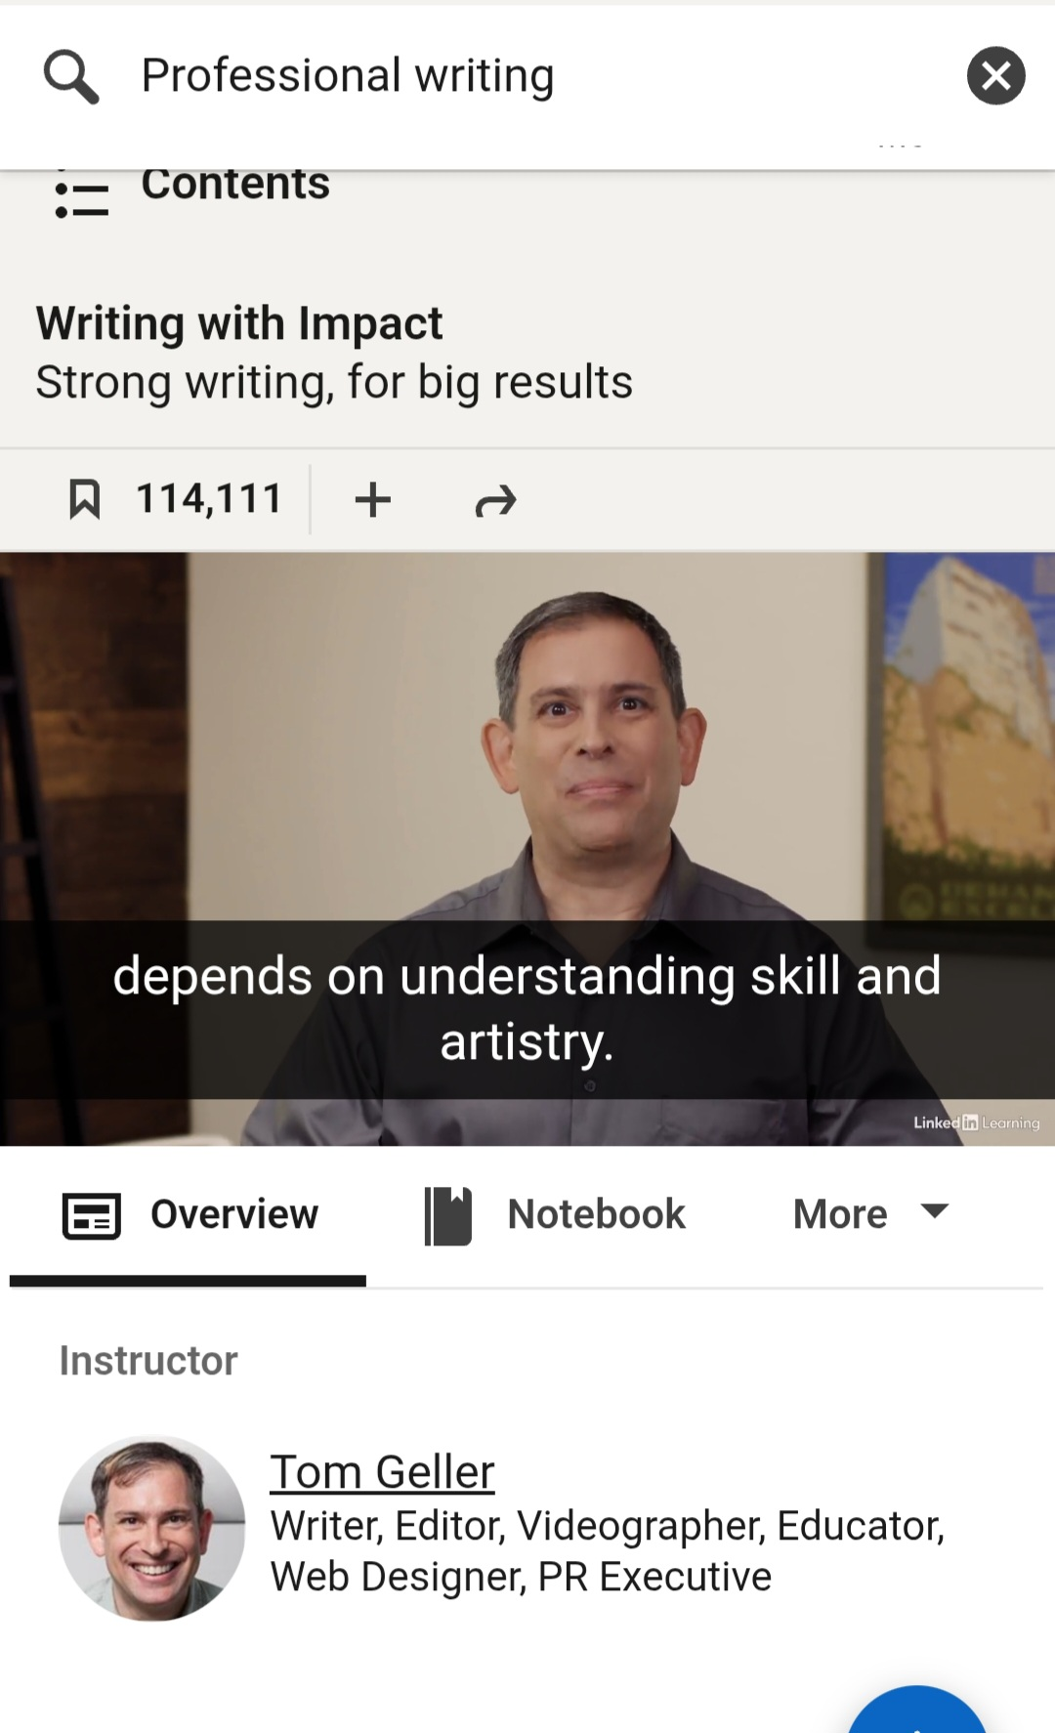
Screenshot number 6 highlights my use of LinkedIn Learning to supplement my regular university classes. For example, I am currently completing a video course focused on impactful writing to help refine my vocabulary and writing structure for upcoming assessments. Using online training platforms is incredibly useful for my education because it allows me to bridge the skills gaps I have identified, which will allow me to improve the quality of the work I produce.

My Short Reflection

I frequently use digital tools to support my education needs and keep my personal routine organised. To maintain this structure, I often use a variety of software such as library catalogues, visual tools like MindMeister and study tools like LinkedIn Learning. Utilizing these resources helps me to find credible sources of information and improve the visual standard of my coursework. However, because many online platforms require you to use complex privacy systems, I sometimes feel nervous about fully understanding how to keep myself safe online when doing tasks involving sensitive data, such as protecting my data while using publicly accessible internet connections.
Ultimately, I hope the digital skills module will help me build a stronger capability online and help establish safer practices. Specifically, I would like to gain a deeper understanding of how to use software like Microsoft Excel and PowerPoint by the end of the academic year. Developing these skills is important to me because most modern industries are integrating computer systems into their operations, meaning these skills are now more important than ever. Learning as many digital skills as possible will expand my career options after graduation.

