2219188@student.uwtsd.ac.uk
28/10/2024
Upgrading a control system to improve efficiency AND FUNCTIONALITY
Independent project (ACCA6020)
Tomos Hall
Potential supervisor: Dr Gary Jones / Dr Stephen Mosey
Table of Contents
Table of figures 2
Introduction 3
Literature review 6
Aims and objectives 7
Aims 7
Objectives 7
Project design 7
Program requirements 8
HMI, engineers screen, fault screen 9
Project analysis 10
Resources and planning 11
Bibliography 12
Appendix 1 Gantt chart 0
Gantt chart continued 0
Gantt chart Continued 0

Table of figures
Figure 1 - Burn-off oven diagram 1 [2] 3
Figure 2 - Burn-off oven diagram 2 [4] 4
Figure 3 - Control system for Burn-off oven 5
Figure 4 - HMI example [16] 6

Introduction
To rewind an electric motor, the old windings and insulation must be removed. Due to the varnish used in the winding process, removing the original copper and insulation can be a difficult task. To combat this problem, the stator is placed in a burn-off oven. This oven is used to breakdown the varnish as well as the original insulation. To achieve this without melting the copper coils or damaging the stator casing, the burn-off oven must regulate a specific environment. The oven must also manage the pollutants created in the process. Using an afterburner and water-cooling system, the oven eliminates pollutants, exhausting only carbon dioxide and water vapour [1]. This process is called pyrolysis [2].
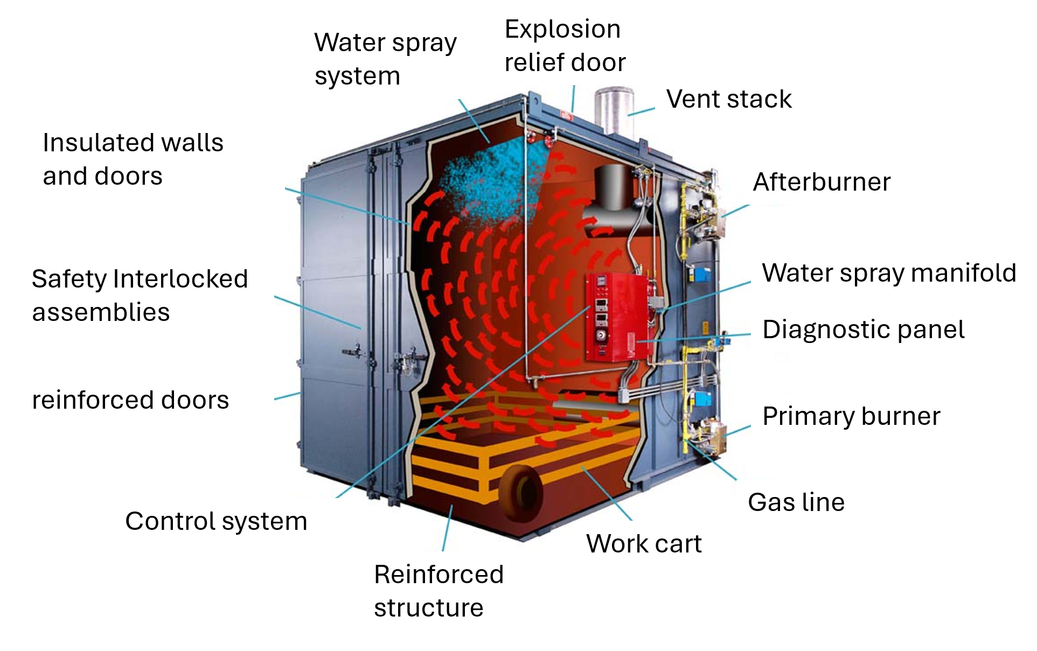
The burnout oven utilises two enclosed combustion chambers, allowing the motor area to be heated without administering direct flame to the work piece. The combustion chambers are fuelled by natural gas. Once the unwanted materials like varnish and insulation are broken down, the vapours they produce are burnt off by the after burners in second combustion chamber. To keep this process at a manageable rate, water jets are used to cool the furnace allowing time for the vapours to be burnt off. Once the process is complete, only carbon dioxide and water vapour are exhausted. The varnish and insulating materials are reduced to ash allowing the copper coils to be removed [1] [3]. Diagrams illustrating the Burn-off oven function can be see below in figures 1 and 2 [2] [4].
Figure 1 - Burn-off oven diagram 1 [2]

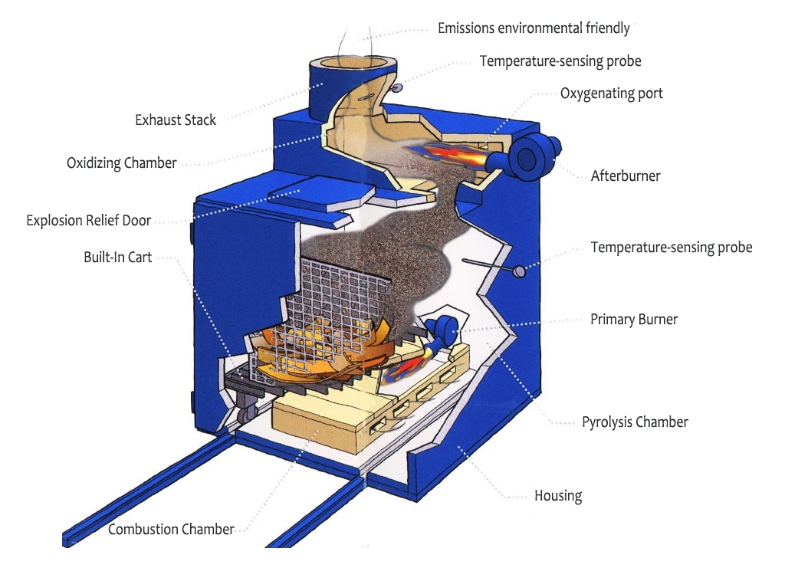
Figure 2 - Burn-off oven diagram 2 [4]
The burn-off oven used at Eriks Swansea was manufactured in 1999. It utilises an outdated control system made up of mechanical relays and timers as shown in figure 3.

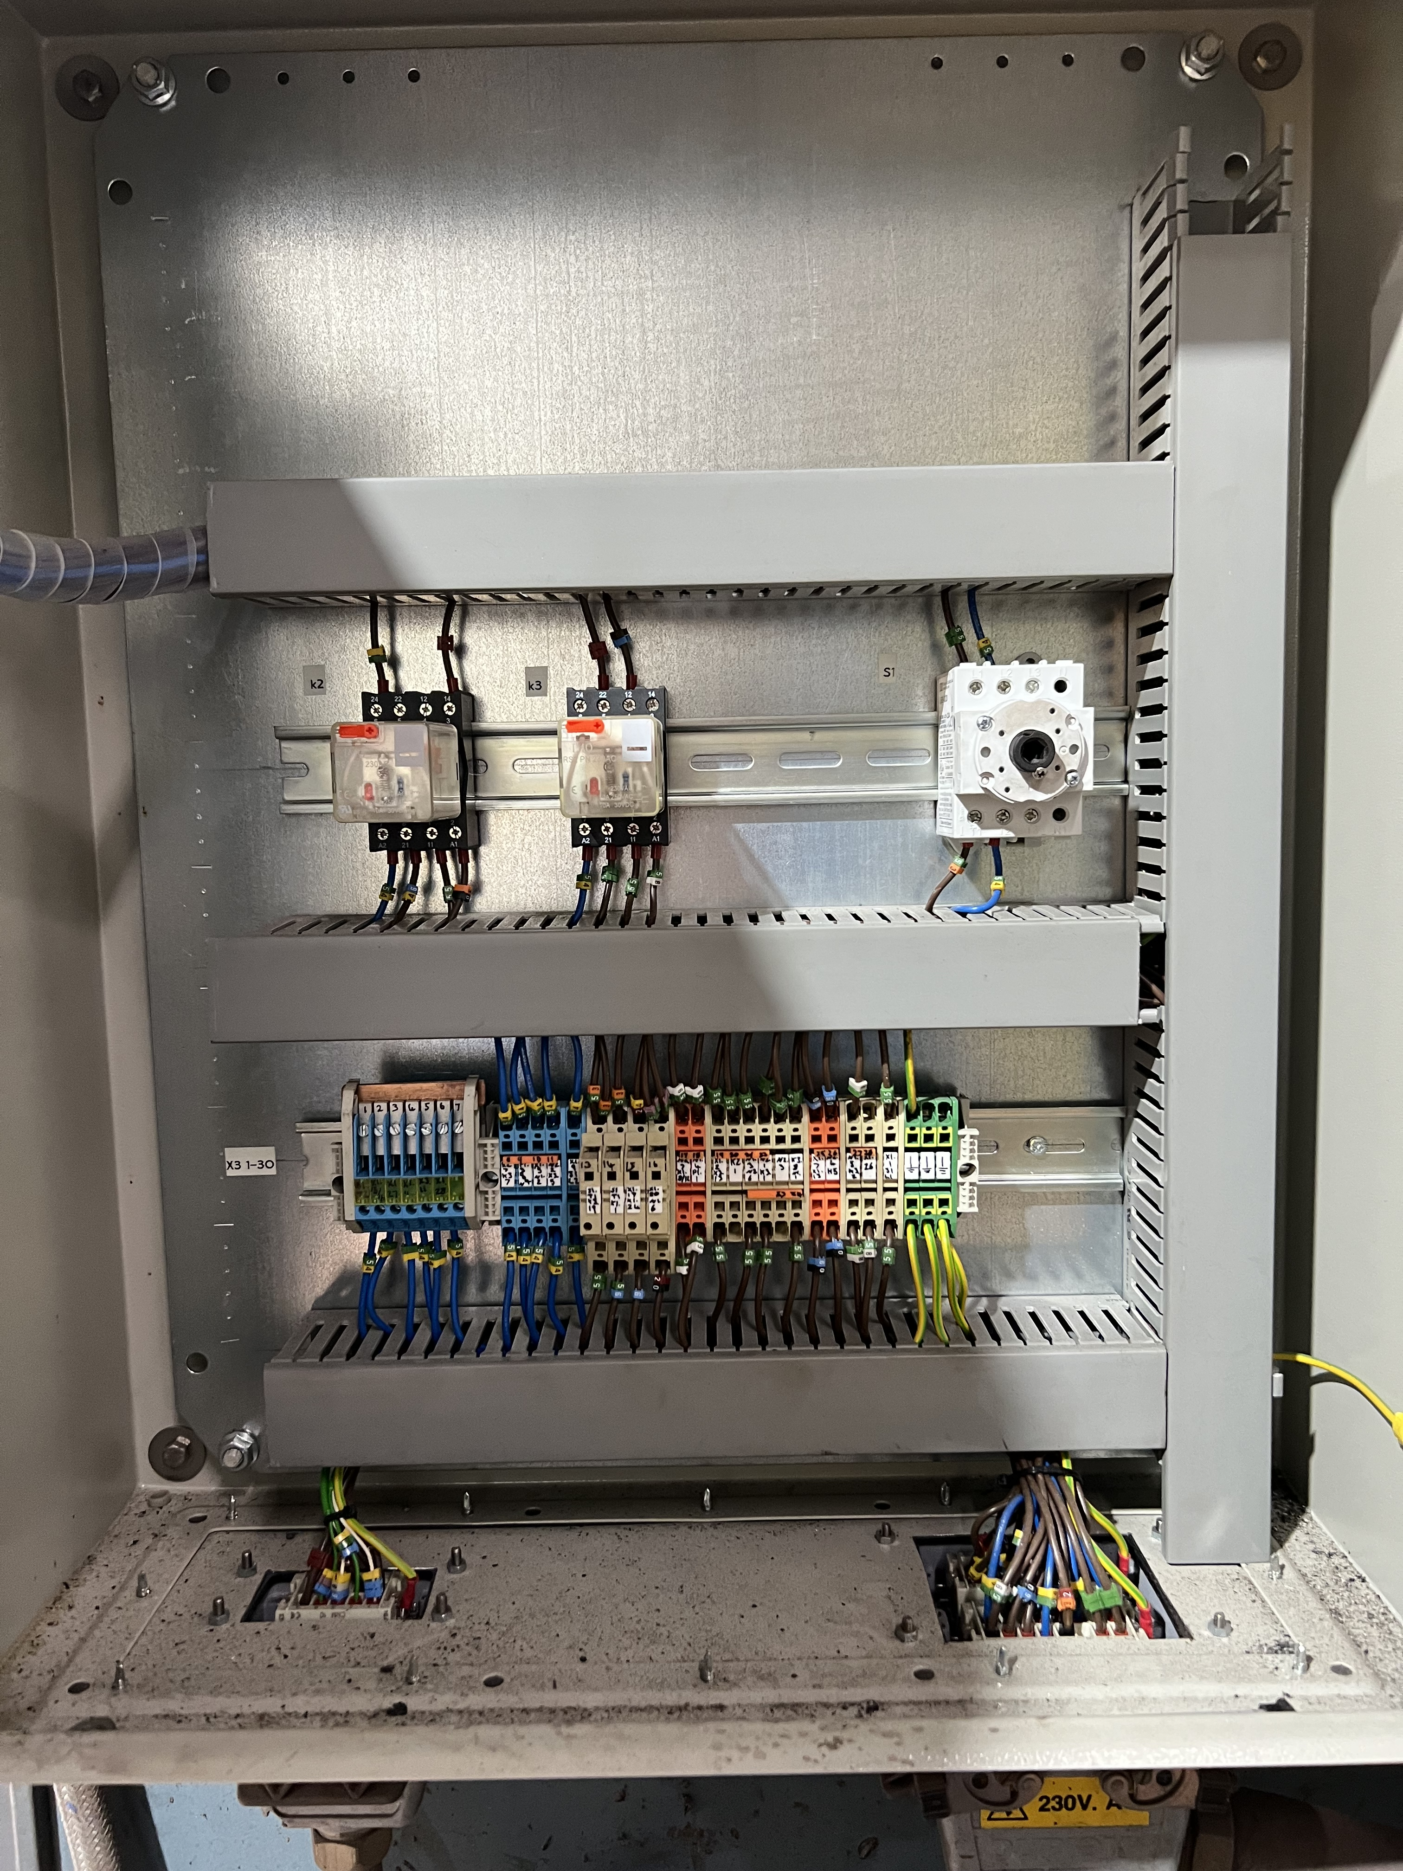

Figure 3 - Control system for Burn-off oven

Newer systems from manufacturers like Whitelegg, Rotary and Longworth, incorporate PLC systems rather than Relay control [5] [6] [7]. This allows the engineer more control over the conditions of the oven. It also allows for data-collection, allowing the engineer to determine the most efficient and cost-effective process to run. PLC implementation allows Whitelegg to offer full on-line support as any faults can be directly uploaded from anywhere in the world [7].
With the current system, the engineer has experienced problems with the oven’s operation. The afterburner is ignited first, climbing to 800°C. The main burner can only be ignited once the after burner is at 800°C. A problem can occur when the main chamber is first ignited as cold air is blown through the after burner, this lowers the temperature reading of the afterburner, tripping out the main burner. As the oven is often used overnight, this goes unnoticed leading to delays in the rewinding process. Additional control, offered by the PLC would allow this to be prevented [3].
Currently, only cast-iron stators can be cleaned using the Burn-off oven as the high temperatures would melt aluminium casings. By including a workpiece thermocouple, a PLC could prevent the workpiece from reaching melting point by turning off the burners or increasing the water jets. By retrofitting the oven with a PLC control system, Eriks will benefit from modern automation technology, improving safety, efficiency and control.

Literature review

Throughout industry, engineers are opting to retrofit machinery with modern control systems to increase efficiency and control capabilities [8]. This provides a more cost-effective solution to purchasing all new equipment. The upgraded machine offers the same flexibility and efficiency as a brand-new machine but at a much lower cost. This improves the lifespan of the equipment, creating a more sustainable workplace avoiding machine obsolescence [9]. In the proposed project, the burnout oven would become equipped with datalogging capabilities, a new technology only available by purchasing a new machine from the manufacturer [5] [7].
When upgrading machinery, PLCs are often the chosen method for control. All counters, timers and control components are contained within the PLC, producing a simpler wiring system compared to the relay control [10] [11]. As PLC programming follows the original relay ladder logic, upgrading to PLC would be a straightforward process [12, p. 1192] [13]. PLCs offer a higher reliability and decrease downtime. Faults are detected and flagged more effectively by the PLC, meaning faster repairs [14] [15].
Similar project focus on creating an easy-to-use HMI screen. A touch screen pad allows the engineer to easily interact with the system and to get visual feedback of the operation. An example of this can be seen in figure 4 from the International Journal of Mechanical Engineering and Technology [16].
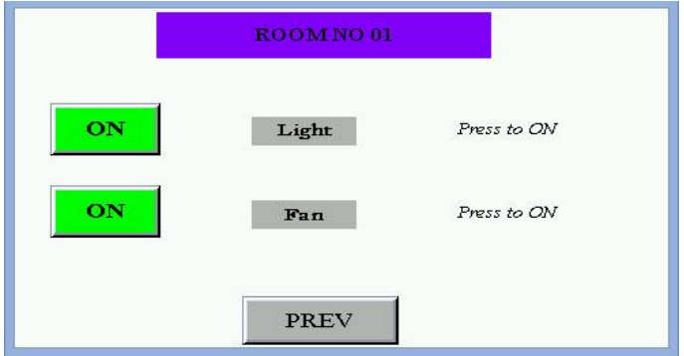
Figure 4 - HMI example [16]

Aims and objectives

Aims
- To design and build an upgraded control system for the workplace burn-off oven.

Objectives
- To analyse the original control system.
- To determine how operation can be upgraded.
- To design a PLC program capable of improving oven efficiency.
- To design an HMI, engineer’s and fault screen.
- To select and implement new hardware into the oven.
- To develop a datalogging system to allow the engineer to fine tune operating conditions.

The proposed project would create a new control system allowing the engineer more control over the burn-off procedure. Timings and temperature readings will be analysed allowing for more efficient use of the oven in the future. This will help cut down on energy costs as well as repair timeframes for customers. Upon completion, a software and hardware design will be submitted as well as a full report detailing the projects progression.

Project design
The finished project will produce an upgraded control system for the burn-off oven. A PLC will monitor and control the temperatures of the two combustion chambers, a thermocouple will be installed to be attached to the workpiece, allowing the program to closely monitor the temperature of the motor casing to avoid melting. The PLC will control the gas input as well as the water jets. Safety measures will be implemented to all features of the oven, including testing procedures to ensure functionality of each component before the oven is operated. This will include checking the door interlocks, testing operation of the water jets and the gas pressure. As mentioned, currently a fault occurs where the main chamber fan trips out the afterburner, this will be resolved in the upgraded program by implementing a delay in the system to allow the main chamber to reach temperature. Datalogging will be included allowing the engineer to review operations.

Program requirements
The completed program must complete the following operations:
- Check door interlock is closed
- Check pressure relief panels are present
- Check for input from temperature sensor
- Check water pressure
- Check gas pressure
- Check flow through water nozzle
- Engage door lock
- Ignite afterburner
- Turn on afterburner blower motor
- If afterburner is 800°C ignite main burner
- Allow main burner to reach set point (370°C)
- If afterburner temp drops below 800°C trip main burner (allow grace period for set up time)
- If temperature exceeds set point, spray water
- Run for set time
- Turn off burners
- Wait for temperature to drop to safe level
- Unlock door

HMI, engineers screen, fault screen
The HMI screen must have the following features:
- Program duration control
- Temperature of afterburner
- Temperature of main chamber
- Start button
- Stop button
- E-stop
- Timer countdown
- Afterburner on indicator
- Main burner on indicator
- Fault indicator
- Interlock indicator
- Workpiece temperature
The engineers screen must have the following features:
- Password protection
- Temperature setpoints for afterburner
- Temperature setpoint for main burner
- Data logged from previous cycles (temperature and time)
The fault screen must have the following features:
- Low water pressure indicator
- Low gas pressure indicator
- Pressure relief panel fault
- Door interlock fault
- No flow in nozzle
- No temperature reading
- Main burner fault
- Afterburner fault

Project analysis
The chosen project could have a positive effect on the environment. Having more control over the burn-off process could lower power consumption as well as cut down on gas usage by customizing a more efficient process. Utilising the PLC as a datalogger would allow this customization [17]. Improving the functionality of the burn-off oven allows for more motors to be stripped in a sustainable way. Without the burn-off oven, stators are stripped using propane torches. The emissions from this burning process are released into the atmosphere, having a negative effect on the environment. The burn off oven produces no harmful emissions as all contaminants are burned off in the afterburner. When rewinding a motor, the process is much quicker when using the oven compared to hand stripping. This may influence customers decisions when choosing between a new motor or a repair. Repairing the original motor is a more sustainable process as it prevents the manufacturing of a new motor. Repair is also preferred as it prevents the original motor being scrapped, producing more waste.
Implementing a PLC would allow the engineer to program in more safety features. As the oven uses gas and pressurised water, it could be a danger to the workshop in the event of a fault. Programming fail safes into the controller would make the workshop safer. To mitigate the risks of releasing flammable gas into the workshop, testing will be carried out using simulation software Factory IO before installing the new system.
Another risk of the project may be unforeseen delays which could prevent completion by the deadline. To mitigate this risk the scope of the project must be carefully planned, allowing time for errors or delays like delivery time on components or faults with software.
To ensure the proposed project is ethical, an ethics form was submitted through the university.

Resources and planning

Required resources:
- Computer for programming
- Programming software
- Simulation software (Factory IO)
- PLC
- HMI screen
- Various electrical components
- Access to wiring diagrams
- Access to original control system
- Permission to perform upgrade
To ensure the project is completed within the timeframe a Gantt chart was created (see appendix 1). The tasks are split into sections, illustrating milestones through the project. The Gantt chart allows the critical path to be determined for the order of project tasks. The Gantt chart will be subject to change as the project progresses. To record the progression of the project, a logbook has been started.

Bibliography

[1] | Pollution control products co., “Burn off oven process,” 22 10 2024. [Online]. Available: https://www.pcpconline.com/burn-off-oven-process.html. [Accessed 22 10 2024].
[2] | Pollution control products co., “PCPC burn off oven diagram,” Pollution control products co., 22 10 2024. [Online]. Available: https://www.pcpconline.com/burn-off-oven-diagram.html. [Accessed 22 10 2024].
[3] | S. Swallow, Interviewee, Meeting with manufacturer. [Interview]. 18 10 2024.
[4] | SNT, “Burn off oven,” SNT, 22 10 2024. [Online]. Available: https://www.thermal-cleaning-system.com/product/burn-off-oven/. [Accessed 22 10 2024].
[5] | Rotary Engineering, “Burn Off Oven,” Rotary Engineering, 22 10 2024. [Online]. Available: https://www.rotary.co.uk/equipment-details/burn-off-oven/. [Accessed 22 10 2024].
[6] | Longworth, “Burn-off ovens / Burnout ovens,” Longworth, 22 10 2024. [Online]. Available: https://www.bmlongworth.com/burn-off-ovens/. [Accessed 22 10 2024].
[7] | Whitelegg, “Burn-off ovens,” Whitelegg, 22 10 2024. [Online]. Available: http://www.whitelegg.com/products/electric-motor/electric-motor-rewind-and-repair/burn-off-ovens. [Accessed 22 10 2024].
[8] | M. Bryan, H. Mills, D. Rewitzer, B. Sedhwick, J. Little and H. Patterson, “Replacing aging relays: Challenges and keys to success,” NetaWorld, 23 02 2024. [Online]. Available: netaworldjournal.org/replacing-aging-relays-challenges-and-keys-to-success/. [Accessed 22 10 2024].
[9] | J. N. Kamau, “A Step-By-Step Approach to Retrofit and Automation of PCB Machines Using PLC,” Proceedings of the Sustainable Research and Innovation Conference, Kenya, 2018.
[10] | R. Sykora, “Moving up from hardwired relay logic,” 18 04 2012. [Online]. Available: https://www.controleng.com/articles/moving-up-from-hardwired-relay-logic/. [Accessed 22 10 2024].
[11] | R. gamboa, “Relays: Out with the old?,” Omron industrial automation, 10 08 2011. [Online]. Available: controldesign.com/control/plc-pacs/article/11368660/industrial-plcs-relays-out-with-the-old. [Accessed 22 10 2024].
[12] | E. R. Alphonsus and M. O. Abdullah, “A review on the applications of programmable logic controllers (PLCs),” Renewable and Sustainable Energy Reviews, vol. 60, pp. 1185-1205, 2016.
[13] | G. Prashant, “A case study: Idustrial automation using PLC,” IRE Journals, vol. 4, no. 4, pp. 52-55, 10 2020.
[14] | F. Onaifo, A. A. Okandeji, O. Folorunsho, U. E. Essien, A. O. Oyedeji and O. R. Aboade, “Comparison of the reliability of programmable logic controller and electromagnetic relay control in industrial production line,” Nigerian Journal of Technology, vol. 38, no. 4, pp. 1030-1035, 4 10 2019.
[15] | H. T. H. Thabet, I. S. Jameel and I. A. Hasan, “Rehabilitation of an old traditional elevator based on PLC techniques,” Wasit Journal of engineering Sciences, vol. 6, no. 3, pp. 76-89, 08 07 2018.
[16] | M. K. Gupta, P. K. Gupta, R. K. Giri and A. Gupta, “SMART ELECTRIC CONTROL SYSTEM USING PLC & HMI,” International Journal of Mechanical Engineering and Technology, vol. 9, no. 4, pp. 548-555, 04 2018.
[17] | A. D. Suleiman and I. G. Abdulhamid, “Programmable logic controller based electric oven temperature remote monitoring and control,” International journal of women in technical education and employment, vol. 5, no. 1, pp. 76-85, 07 2024.

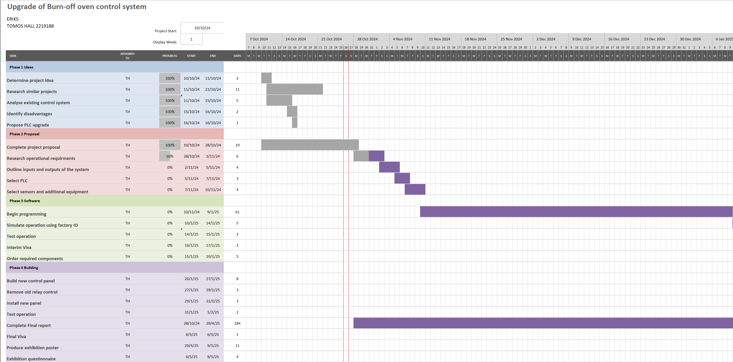
Appendix 1 Gantt chart

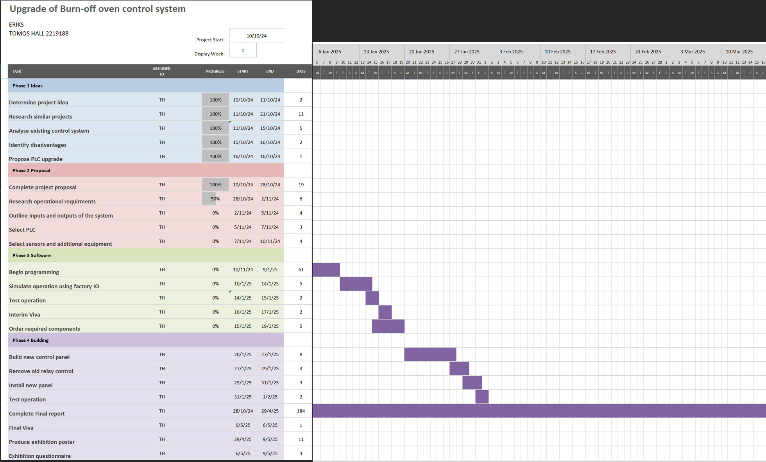
Gantt chart continued

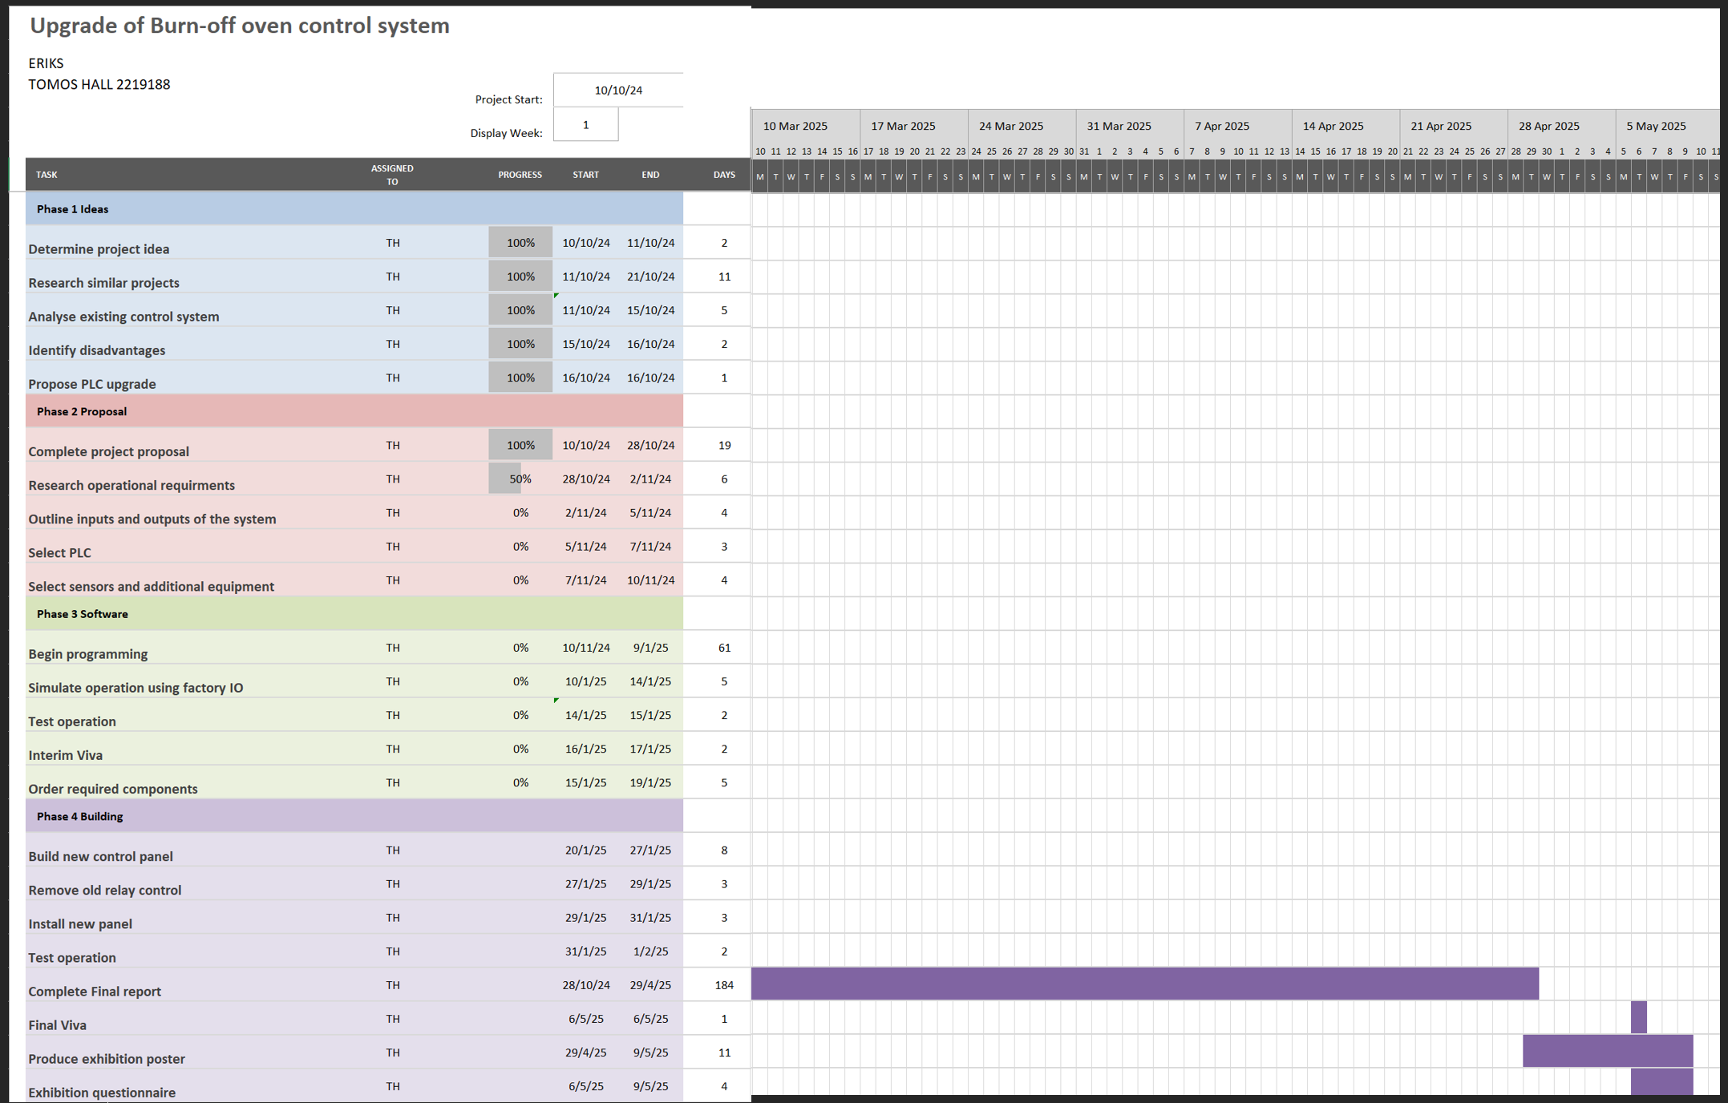
Gantt chart Continued

