

Postgraduate/Distance Learning
Assignment coversheet & feedback form

THIS SHEET MUST BE THE FIRST PAGE OF THE ASSIGNMENT YOU ARE SUBMITTING (DO NOT SEND AS A SEPARATE FILE)

For completion by the student:
Student Name: ANNE JAMES

Student University Email: 2005297@student.uwtsd.ac.uk
Module code: HPCA7015  Module title: FOUNDATIONS IN CULTURAL ASTRONOMY AND ASTROLOGY | Student ID number:  2005297 |  |  | Educational support needs:  No
Assignment title: Essay based on a Sky Journal

‘To think is to walk among clouds’. Discuss this statement From Alexandra Harris as it relates to your sky journal observations

Assignment due date: December 4th 2020
This assignment is for the 1^{st ☒} 2nd 3rd 4th 5th 6th module of the degree
I confirm that this is my original work and that I have adhered to the University policy on plagiarism.

Signed ……Anne James………………………………………………………
Email submission:if you are submitting this form via email, please tick this box □
(as a substitute for your signature) to confirm that you agree to the above declaration.
Assignment Mark
1st Marker’s Provisional mark
2nd Marker’s/Moderator’s provisional mark
External Examiner’s mark (if relevant)
Final Mark

NB. All marks are provisional until confirmed by the Final Examination Board.

For completion by Marker 1 :
Comments:

Marker’s signature: |  |  | Date:
For completion by Marker 2/Moderator:

Comments:

Marker’s Signature: |  | Date:
External Examiner’s comments (if relevant)

External Examiner’s Signature: |  | Date:

Essay based on a Sky Journal

‘To think is to walk among clouds’. Discuss this statement From Alexandra Harris as it relates to your sky journal observations

Word Count 2055

In this essay, I shall discuss the cultural commentator Alexandra Harris’s comment that ‘To think is to walk among clouds’, made in her book Weatherlands (Thames and Hudson, London 2016). My response will, in part, use my observations of the daytime sky from Sheffield, South Yorkshire, in November 2020. In addition to my observations, I shall refer to different sections of Harris’ book, as well as to the historian and mythographer Marina Warner’s article ‘Spirit visions: Faces in the clouds, or, Figuring the Impossible’ Raritan Volume 21 no 4, (Spring, 2002) pp 264-301. As well as these sources, I shall also include several other references which I have found relevant. The essay will also examine three themes of clouds as thought: cloud appearances, shapes and colours; clouds and other sky phenomena; and clouds and the landscape. My reflexive basis is as that of white woman in her sixties, of Welsh, Italian and German descent, who is interested in how ancient and early modern cultures viewed sky phenomena but has only theoretical knowledge and very limited experience of sky watching in any structured way.

Methodology

For seven consecutive days, I went into my garden at around two o’clock in the afternoon, looked to the North-North West and observed the sky for at least thirty minutes, sometimes longer. This began on Tuesday 10th November and ended on Monday 16th. During this period, I took some photographs both of the sky and the immediate landscape, recorded my thoughts in a notebook and also made some sketches.

Cloud appearances, shapes and colours

Clouds provide a physical paradigm of thought. As material entities, bodies of water vapour in the sky, they are constantly present and available to watch, study and examine. Yet their physical form varies from transparent to opaque, they move as the wind takes them, and they constantly change and mutate in form just as thoughts do. After a week of watching, my observations have thoroughly supported Harris’ statement. While she makes it in a section of her book concerned with Romantic literature and pictorial art, at an earlier point she mentions an ancient Christian legend that Adam’s thoughts were created from clouds, something which identifies human minds as changeable and less than divine. Warner, similarly, mentions that in Robert Kirk’s Secret Commonwealth of Elves, Fauns and Fairies, fairies are imagined to have bodies compared with ‘condensed cloud’. Both ideas, of cloud minds especially but also cloud bodies, often came to mind as I watched the sky.

The appearance of clouds can vary: at 2.20pm on November 15th, for example, I was struck by the way that they ‘shine at the edges’ yet ‘seethe’ inside. Their different shapes, constant movement, and often changeable colours, has led to their use in divination. For example, Mark Williams in his book Fiery Shapes describes a prediction made by the druid Cainnelsciath which was based on the differing colours of three clouds. As they reflect the sun above, they are edged or filled with light, although in Paradise Lost, John Milton wrote that light was created before the sun even came into existence, and

‘in a cloudy tabernacle
Sojourned the while.’

Clouds can also mislead or delude, as Marina Warner shows in referring to the Brocken Spectre, ‘the famed conjunction between clouds, sky, and shadows’ which projects a vast and frightening, yet completely artificial silhouette. Beyond this effect, she also examines the ways in which peoples’ thoughts can themselves become clouded, as their imagination projects such sacred or secular visions as the wartime ‘Angels of Mons’ onto natural phenomena or simply fashions images to provide a comforting meaning when there is none. The sight of the sun, partly hidden but shining through clouds, can inspire thoughts of glory or peace, and at 2.30pm on November 15th my observations included the fact that ‘a cloud with the sun at its centre seems to speak of godhead.’ Furthermore, a cloud, like a thought, can even be unsuitable for its time and place: Ovid shows how the cloud form Jupiter adopted to seduce Io during the day was far too dark, arousing Juno’s suspicions. Noting such a dark cloud at 2.30pm on November 16th, among others with ‘fluffy, ferny shapes’ I realised how deeply classical mythology is related to the sky and how it can condition the ways in which we relate to sky phenomena.

Again, on November 10^{th,} my first day of observation, I had noticed their ‘tattered’ look and that ‘no cloud is all one colour, light and dark move and separate, dark clouds move over light ones, with blocks, wisps and spider webs.’ A dramatic example of these cloud layers seen at 2.20pm on November 10th, is shown here. (Fig 1). In this kind of interaction, every different layer of colour reflects changes in light and colour, resembling alterations in thoughts and moods.

My observations and readings, taken together, give a clear indication that thoughts and clouds are very similar. To see clouds move and change is perhaps the closest possible representation of the process of thinking: the images and moods which they have created for myself and for others watching them demonstrate how easily this relationship evolves.

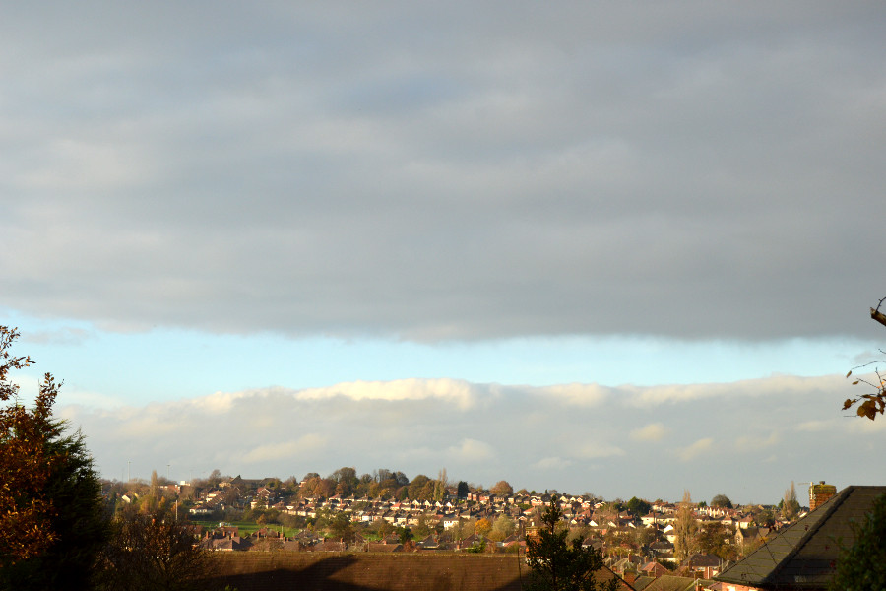
Figure 1: Cloud layers above the valley: view facing North-North West, November 10th 2020, 2.20 pm
Photo: Anne James
Clouds and other sky phenomena

Clouds and other sky phenomena

Clouds are positioned between earth and sky: for Aristotle, they were created in and occupied a specific level between the heavens and earth where air and water mixed. In this position they mediate light and warmth, just as thought processes convert ideas into a comprehensible form. Both may be intrusive: clouds can, more or less, obscure the day or night sky, frustrating astronomers or participants in rituals for which a clear sky is vital, while thoughts can overshadow and inhibit more constructive behaviour. In Joni Mitchell’s song ‘Both Sides Now’, for example, such mental clouds are destructive, impeding ‘so many things I could have done’. Yet clouds are also protective, bringing the comforts of rain and shade and hiding the fierce light of the sun. Importantly, just as thought processes can help shield a mind from traumatic memories, so clouds in history or mythology have been shown conceal sights or events, both good and bad, which would otherwise be beyond human ability to experience or process. In Matthew’s Gospel, the Apostles attending Christ’s Transfiguration had their eyes shielded by a ‘bright cloud’ from the sight of God, and heard only his voice. Livy, meanwhile, debated whether the death of Rome’s founder Romulus, supposedly snatched up to heaven in a thundercloud, was in fact a concealed murder by his rivals. At 2.15pm on November 13th, a particularly cold day, I noticed the vapour rise from my coffee cup, ‘dancing on the surface then seeming to fly away’ as especially dark clouds floated overhead. Comparing this lively movement with the clouds above, it turned my attention to the extent which they ‘block the heavens’ and mediate their light, while making me aware that the clouds themselves briefly seemed ominous.

There is also an interesting contrast between cloud and mist, a similar but generally thicker phenomenon which to Aristotle was ‘unproductive cloud’. Harris notes that the poet Keats, while unhappy when surrounded by it, considered that it mirrored the mind’s life. Yet it also valid to compare the experience of being encircled by mist with depression. Whereas clouds generally lie well above the ground over all but the highest hills, mist is far more pervasive, descending to ground level and obliterating any views. In the same way, depression invades the mind, fills it with desperation and restricts its capacity for thought. On Saturday 14th November at 2.05 pm my experience was that ‘unlike clouds, mist takes the view’.

A final but very visible sky phenomenon is artificial, an aircraft’s vapour trail. Like clouds, but far more regular in shape, this mainly comprises water vapour. With fewer aircraft flying in recent months, these trails have become more noticeable, and this example from November 12th at 3.25pm has almost the shocking visual effect of a comet. (Fig. 2) The different shapes reflect the categorisations of cloud shapes by the Eighteenth-century artist John Cozens. For Harris this is an artistic achievement, continued by such painters as Constable; for Warner, concerned with the scientific representation of natural and spiritual phenomena, it is more a matter of removing self-deception by rationalising nature, effectively a way of limiting and controlling thought.

Clouds, and the sky phenomena which they hid or revealed, have been important to cultures, mythologies, and belief systems throughout history. Seen every day, and in a position effectively midway between earth and sky, clouds have an important position as effective gatekeepers to the heavens. They have led people to prophesy, to explain the weather, and to make forecasts about their lives. As they have encouraged beliefs and ideas, so they have and continue to stimulate people to put thoughts into action.

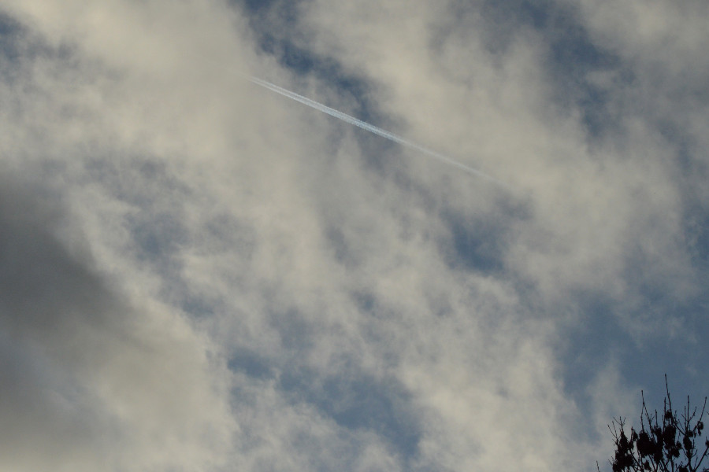
Figure 2: Vapour trail contrasted with clouds, November 12th 2020, 3.25pm Photo: Anne James

While clouds are only one of many types of sky phenomena, they have an important position effectively midway between earth and sky. They are seen every day

Clouds and the landscape

While clouds can mirror abstract thoughts, they may also enhance the more concrete ways in which people see and relate to the world around them. In art, their depiction often heightens the sensations caused by a real or imaginary landscape. Harris, for example, notes the different effects on the emotions caused by two paintings by the artist John Constable of Salisbury Cathedral, in which cloudscapes showing very different weather conditions appear.

In the same way, as clouds move over the landscape, the shadows they cast often remodel its appearance, just as changing thoughts can affect a mind. For example, my garden is on one side of a steep but heavily built-up valley, and on several occasions, I observed that the shading cast over them largely hid the buildings, showing instead the natural curve of the valley. A totally cloudy sky, like a sombre frame of mind, seems to shrink the landscape and can even deaden or inhibit sound: on several cloudy days during my observations, it even became noticeable that birds were less likely to appear. Even smaller natural features in a garden are affected and even enhanced as clouds pass over. On November 15th, for example, I observed that with a gap in the clouds ‘moss became almost fluorescent, likewise the last remaining leaves.’ At 2.15pm on November 10th a group of trees, lit then hidden by fast-moving clouds the sun, become far more noticeable like newly developed ideas (Fig. X). On November 14th, I noticed that ‘the clouds can reveal the sun which tells the time of day … the clouds speak to the landscape’.

While this interplay of light and shadow can only be the sort of ‘passing disturbance’ which for the sociologist Emile Durkheim would not be enough to constitute a religion, for Marina Warner clouds are ‘infused with divinity’ and even related to life after death. Their effects of light and shade on the land, though brief, can trigger spiritually-related thoughts and directly affect the way in which landscapes and natural features are perceived.

As clouds pass over a landscape, especially on a sunny day where plenty of light and shade are created, this can encourage new types of thought about the natural world and its appearance. This perception illustrates the interconnection between clouds and thoughts.

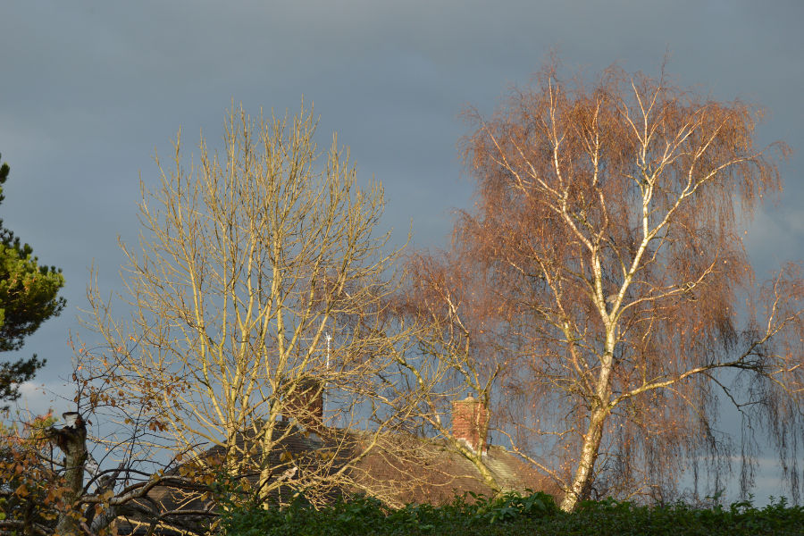
Figure 3: Trees highlighted against dark clouds: view facing North, 10th November 2020, 2.15pm
Photo: Anne James

Conclusion

Clouds and thoughts, as I have indicated throughout this essay, correspond and interplay in many ways. My own sky observations, exploration of the three themes above, and readings have regularly confirmed this fact. The appearance and movements of clouds strongly parallel, and stimulate, processes of abstract thought. In their relationship to other sky phenomena, clouds have a more concrete function, mediating between heaven and earth in the same way that thoughts direct ideas towards action. Finally, in relation to the landscape, they heighten the senses, and stimulate more otherworldly or spiritual reactions to the world. In each respect, to think is undeniably to walk with clouds.

BIBLIOGRAPHY

ARISTOTLE, Meteorologica, translated by H.D.P. Lee. Loeb Classical Library 397 (Cambridge,
MA: Harvard University Press, 1952)

The Bible, Authorised King James Version; edited with introduction and notes by
Robert Carroll and Stephen Prickett (Oxford: Oxford University Press, 1997),
Matthew 17.5

DURKHEIM, Emile, The Elemental Forms of Religious Life, translated and with an
introduction by Karen E. Fields, (New York, London: The Free Press, 1995)

HARRIS, Alexandra, Weatherland, Paperback edition, (London: Thames and Hudson, 2016)

LIVY, History of Rome Volume I, translated by B.O. Foster. Loeb Classical Library 114
(Cambridge, MA: Harvard University Press, 1919)

MILTON, John, The Major Works; edited with an introduction by Stephen Orgel and
Jonathan Goldberg, (Oxford: Oxford University Press, 2003)

MITCHELL, Joni, ‘Both Sides Now’, in Clouds (Hollywood: A & M Records, 1969)
http://youtube.com/watch?v=Pbn6aOAFfnM [accessed 2 December 2020]

OVID, Metamorphoses, translated by Frank Justus Miller. Loeb Classical Library 42
(Cambridge, MA: Harvard University Press, 1919)

WARNER, Marina, ‘Spirit visions: Faces in the clouds, or, Figuring the Impossible’
Raritan Volume 21 no 4, (Spring, 2002), pp. 264-301<https://search-proquest-com.ezproxy.uwtsd.ac.uk/scholarly-journals/spirit-visions-faces-clouds-figuring-invisible/docview/203879569/se-2?accountid=130472,> [accessed 9 November 2020]

WILLIAMS, Mark, Fiery Shapes: Celestial Portents and Astrology in Ireland and Wales 700–
1700, (Oxford: Oxford University Press, 2010)
<https://oxford.universitypressscholarship.com/view/10.1093/acprof:oso/9780199571840.001.0001/acprof-9780199571840> [Accessed 22 October 2020]

Alexandra Harris, Weatherland Paperback edition, (London, Thames and Hudson, 2016), p. 247.
Ibid, pp. 13, 14.
Marina Warner ‘Spirit visions: Faces in the clouds, or, Figuring the Impossible’ Raritan Volume 21 no 4, (Spring, 2002), p. 274.
Mark Williams, Fiery Shapes: Celestial Portents and Astrology in Ireland and Wales 70 –1700, (Oxford, Oxford University Press, 2010), p.44. <https://oxford.universitypressscholarship.com/view/10.1093/acprof:oso/9780199571840.001.0001/acprof-9780199571840> [Accessed 22 October 2020].
John Milton, The Major Works; edited with an introduction by Stephen Orgel and Jonathan Goldberg (Oxford, Oxford University Press, 2003) Paradise Lost, Book VII 247-9, p. 497.
Marina Warner ‘Spirit visions: Faces in the clouds, or, Figuring the Impossible’ Raritan Volume 21 no 4, (Spring, 2002) p. 277. <https://search-proquest-com.ezproxy.uwtsd.ac.uk/scholarly-journals/spirit-visions-faces-clouds-figuring-invisible/docview/203879569/se-2?accountid=130472,> [accessed 9 November 2020].
Ibid, pp. 268-9, 277.
Ovid, Metamorphoses, Book I, translated by Frank Justus Miller. Loeb Classical Library 42 (Cambridge, MA: Harvard University Press, 1919), 45.
Aristotle, Meteorologica, trans, by H.D.P. Lee (Cambridge, MA: Harvard University Press, 1952), 69.
Joni Mitchell, ‘Both Sides Now’, Clouds (A & M Records, Hollywood, 1969), http://youtube.com/watch?v=Pbn6aOAFfnM [accessed 2 December 2020].
The Bible, Authorised King James Version; edited with introduction and notes by Robert Carroll and Stephen Prickett (Oxford, Oxford University Press, 1997) New Testament, Matthew 17.5.
Livy, History of Rome Volume I, translated by B.O. Foster. Loeb Classical Library 114 (Cambridge, MA: Harvard University Press, 1919), 57-59.
Aristotle, Meteorologica, 71.
Harris, Weatherland, p. 246.
Ibid., pp. 240-1; 243-4; Warner, ‘Spirit visions’, p. 294.
Harris, Weatherland, pp. 245-6.
Emile Durkheim, The Elemental Forms of Religious Life, translated and with an introduction by Karen E. Fields (New York, London: The Free Press, 1995), p. 81; Warner, ‘Spirit Visions’, p. 269, 273.

