University of Wales Trinity Saint David School of Engineering
Part 2 of project soap box
Integrating project (M4X01506)
Rhodri, Calum, Gwydion, Jonathan, Aryan, Chris
28/4/19

Table of Contents
1 Introduction 2
2 Final CAD Design 3
3 Calculations on soap box 4
4 Summary 6
4.1 Suitability 6
4.2 Improvements 6

Table of figures

Figure 1-Final Soap box design 3
Figure 2-weight acting on soapbox 4

Introduction

This report is going to display the final group project design for a soapbox racer that falls within the criteria of Richards Castle soapbox derby. This report demonstrates the calculations carried out on the racer as well as the final CAD designs.
Group members:
- Rhodri Jenkins
- Gwydion Clement
- Calum McGowan Franklin
- Chris Herbert Salter
- Aryan Adibmehr
- Jonathan Pugh

This report includes the final chassis design created from the software solid works and also shows the different forces that are going to affect the design. The report looks at many factors during the project e.g. forces acting on the soap box, and the velocity and acceleration of the soap box expected on the track.

The report will also be investigating how and why the group changed the original design into the final design.
In addition to this report, the group has done a presentation through software power point to display each member’s role and tasks individuals had throughout the project as well as talking through why the decision was taken to decide on the final design of the soap box. At the end of the project the group evaluates the project and investigation and discuss what they would do differently assessing factors such as budget and time.

Final CAD Design

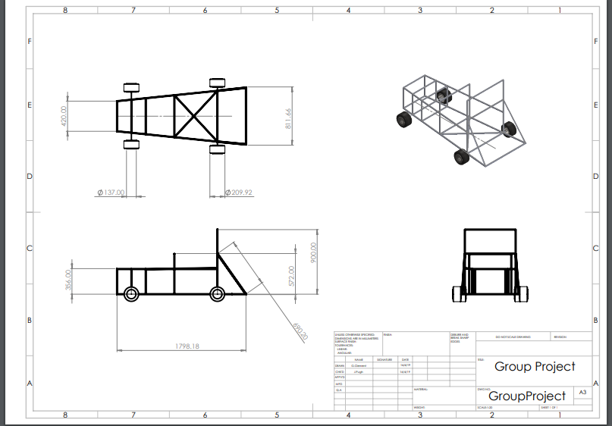
Figure 1-Final Soap box design
Throughout the design process the group had several obstacles that needed consideration in order to successfully implement the design of a soap box racer. These being; the strength and safety of the racer, the materials of the racer which weight and dimensions were considered and cost of the build.
A major consideration in the design was the frame as this would be the most highly scrutinised for safety as well as being the largest cost factor, the most time consuming and set the precedent for the rest of the build.
From preliminary designs the group already had a strong direction in what type of design was envisioned, this being a spaceframe design with a suitable roll cage in its most simple form.
The final design was not that far from the early drawings but following extensive research, considerations were made on fixing points, nodes and practical measures such as leg room and seatbelt attachment points to create a strong spaceframe design that was practical for its application.
The weight of the soapbox is 36.42kg which includes the wheels, brakes and chassis.

Calculations on soap box

This section of the report is going to show calculations of forces acting on the soap box.

By having basic calculations, we can work out the following:
- Force
- Kinetic energy
- Power
- Acceleration
- Rotational acceleration
- Radius of gyration
- Moment of inertia
- Torque

In accordance with the course information provided on the Richards Castle website. It is said that the course is 550m long, the launch ramp has an incline of 1 in 8 and expected speeds are that of 30-40mph. In addition to this information the weight of the soapbox could be approximated by using the supplier’s dimensions.

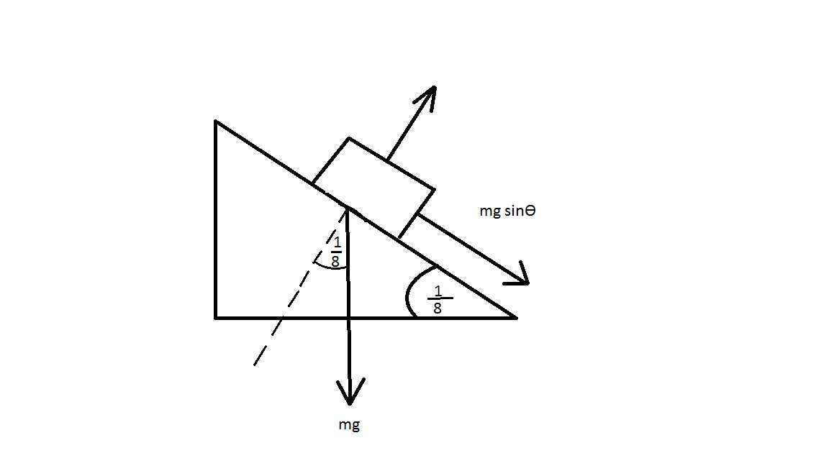
Figure 2-weight acting on soapbox
- 24.2kg- frame
- 9.42kg- flooring
- 2.8kg-wheels
- 82kg-driver
- Wheel diameter-0.30m
- Wheel weight-4kg

The overall weight including driver is approximately 118.42kg
$$118.42×9.81×\frac{1}{8}=Force$$
Force = 145.2N

Using an approx. at velocity taken at 56kph
$${56}/{3.6}=15.56\frac{m}{{ps}^{2}}=V$$
$$K.E=118.42×{15.56}^{2}$$

K.E = 14335.55J

By having velocity and force, you can now work out power
$$p=F.V$$
$$p=145.2×15.56$$
p=2259.47W

Having velocity and distance of the track, you can now work out acceleration
$$\frac{V^{2}-U^{2}}{2s}=a$$

$$\frac{{15.56}^{2}-0^{2}}{2×550}$$

a=0.22$m/{s^{2}}$

By having all these calculations, we can work out the rotary equations

$$\frac{a}{r}=x$$

$$1.47 {rad}/{s^{2}}=x$$

$$k^{2}=11.25×{10}^{-3}$$

$$I=mk^{2}$$

$$I=0.045kgm^{2}$$

By having this we can work out the torque
$$T=ix$$

$$T=0.045×1.47$$

T=0.066Nm

Summary

Suitability
Requirements of the project were to complete a successful example of a soap box racer that could be produced to compete in the Richards Castle soapbox derby following the guidelines given on the website. The car had to fit certain criteria to compete in the race such as a suitable roll cage, adequate brakes for safety concerns and limited dimensions for the chassis. we strived to create a soapbox that could be a competitor as well as complicit in the races, with this in mind we designed a steel spaceframe chassis mounted on 0.30m Monoblock wheels with a Pullman arm steering mechanism and hydraulic bicycle brakes.
Taking all of these components into consideration and with basic calculations of weight, dimensions and approximated speeds, it is calculated that the designed soapbox is not only suitable but could be a worthy competitor in Richards soap box derby.
A reoccurring obstacle in the design process was to keep weight down while keeping a rigid and strong frame all within a limited budget. This was hard to rectify without compromising strength, adding excess weight or overshooting a limited budget. This ruled out materials such carbon fibre and titanium, and due to the scrutiny of the race, strength could also not be compromised resulting in a heavier than optimal racer. However, as the racer was propelled by weight and gravity alone it was paramount to distribute the weight in a calculated manor in order to use the momentum of the racer to its advantage rather than hindrance.

Improvements
An obvious improvement would be to have an increased budget for the development and implementation of higher-grade components. This, along with a longer lead time, would allow for the manufacture of more precise components. Other improvements could benefit from coming up with a test design from a 3d printer and test to make sure the body can withstand the aerodynamics on a smaller scale.

