Student Name: Jay Johnson – Student ID: 1920319

Module code: (BMSW6103_BIRM)

Leading and implementing workplace change

Lecturer's name: Mrs. Zahida Khan

Contents
Introduction 3
Automation Implementation and change in the world of working 4
Automation advantages and disadvantages 6
Research and analysis of automation on society and job markets 9
Automation and implementation of the Lewin’s change model 12
Lewin change Model Implementation 13
Organisational conflict due to automation implementation 17
Maslow Hierarchy of needs 20
Recommendations 23
Conclusion 24
References 25

Introduction

For this report, research and all findings will be discussed relating to how changes have been implemented within the world of working due to automation and the impact this has had on society. According to (Barnhizer, 2016), 80 percent of the US work force have become increasingly concerned due to the risk of unemployment due to automation implementation and hold fears of this type of technology. The report will review what changes effect job security, job opportunities, redundancies, further training, and confidence within the working sectors. A critical evaluation will be conducted using the well-known Lewis change model and how this can be implemented due to worldwide workplace automation. The report will also critically discuss how various types of organisational structures may influence change management processes and what impact this has for the organisation and society at large. Finally, the report will summarise all findings with a recommendation and a conclusion based on research and evidence relating to automation and changes within the working sector.

Automation Implementation and change in the world of working

1
Automation is a practical and brilliant addition to human working society for its low carbon, low cost, and more productive measures through great innovation with less mistakes and less wastage through machine learning and reduced costs of human labour. However according to the report by the international research and advisory company, 2022 there have been forecasts that have been made for the future based on automation within western and eastern countries by the year 2040. The concerns of many people are that automation will replace human labour in the future due to providing organisations with more cost-effective and better managed processes, that is less expensive to run and creating a lower carbon footprint that meet Government guidelines. The report states but did not guarantee that five major Eastern and European countries, India, China, South Korea, Australia, Japan that includes Europe and north America will potentially face job losses of up to 247 million by 2040 due to emerging technology through automation. In this current digital age, organisations are looking at ways of saving capital and using emerging technology to become more productive whilst reducing their carbon footprint due to climate change and pressure from governmental bodies. Automation is being used in many areas of society such as car manufacturing with laser cutting and vehicle assembly, also within the medical field for internal imagery of patients and even specialized operations. According to (Diana Stegall, 2019), president elect of the American Society of Safety Professionals 2018 – 2019. The world is in rapid change due to new emerging technologies and increasing automation and predictive analytics, and being a safety professional, this is my responsibility to better understand new technologies that involve robots, drones, automated vehicles, and new AI systems that have the potential of changing traditional job functionality and expectations but can also contribute to organisational performance. Automation has the potential to change the landscape of a traditional working structure due to better productivity, lower required resources, and lower capital spending. Organisations that have been implementing emerging technologies mainly for automation uses, have noticed that productivity has increased, with less mistakes, waste, time training employees, managing staff whilst meeting Governmental expectations to reduce carbon emissions. According to the (IJCRT – International Journal of Creative research thoughts, 2017), Within the industrial industry of manufacturing, automation through robot use has demonstrated a much better production level of large product volumes within a short time compared to human productivity. Organisations exist to provide products and services that raise revenue and save on capital expenditure that would involve employee wages, resources, team training and support functions, large staff facilities etc. Implementing automation technology is a great choice for the organisation but have raised new challenges that organisations now face due to impact on employee job security and moral. This being the case, more interest and research has been shown within the area of emerging automation and impact to the world of working. According to (Nof, 2009), With Artificial Intelligence being used and becoming more complex in nature, the demand of using AI has been increasing due to the capabilities of responding and addressing complex issues without having the assistance of human resources and expertise within short periods of time. Organisations have strived to implement various structures of management that best serves all stakeholders in relationship terms but also revenue generation. Automation is a difficult problem to deal with due to ethical practice dealing with human capital and how moving forward with emerging technologies of automation may be more damaging to society with impact to organisational relationships, reputation, and trust. Below are a few examples of positives and negatives implementing automation technology.

Automation advantages and disadvantages

Based on the Covid-19 pandemic, organisations had to implement all resources they had available to continue with normal business functions. Basic day to day practices such as board room meetings, face to face contacts, document handling, launch room processes that involved the preparation of food but also human capital, and how they were to operate, such as two metres apart with designated spaces to stand, not to mention mask wearing and impact to societal moral. Many organisations were not able to deal with such a quick change in the macro environment that tied so many facets of normal life to the normal running of a business, and due to a requirement of quick utilisation of organisational change, many businesses fell as a result. This is a stark waring to even the biggest and most successful organisations, that change can come without warning. According to The Guardian 2020, M&S retail had closures of half of their clothing line rented space that had been impacted with reduced sales of over £600 million within a six-month period. In 2019 M&S’s clothing retail had turned over £1.55 billion compared to £917 million in 2020, with a loss of £107 million. These are profound amounts of money that many SMEs would not be able to contend with, hence closures and liquidations. According to (Yampolskiy, 2013), There has been much debate regarding AI automation on the global job market and economy with discussion from leading companies such as SpaceX and Tesla, advising that Governments over the next few years will be required to pay out UBI (Universal Basic Income), to cover many human professions that will be made redundant and irrelevant due to AI automation technologies. Therefore, the topic and implementation of automation has pros and cons. Below are a few examples of advantages and disadvantages of automation within the working world.

Advantages:
Improved working environment – Production process example
- Improved safety process
- Reduce or erase manual handling processes
- Reduce risk of repetitive processes that cause strains and injuries

Increased competitive opportunities
- Automation processes are better automated and easy to use
- Reduced human errors
- Consistent product quality
- Reduced product parts due to increased production speeds and reduction in the required resources

According to (Coeckelbergh, 2015). The law sector has implemented technology that has supported legislators to gain access easily and accurately to large numbers of legal documentation that take human employment far longer to source

No more organisational labour crisis
- Automation will not require maned labour and will produce consistent products that meet organisational quality control and production levels without complaint or mundane repetitive processes that human labour is required to fulfil.

Increased production capabilities
- Automation production can be set 24/7 without human intervention
- Automation does not require breaks, sick days, or paid holidays
- Automation can work faster and more accurately than human labour
- Automation will never get tired or hold emotional concerns
- Automation will not disagree with management changes, processes or desires.

Further training opportunities
- Employees are no longer required to perform mundane, displeasing, and mind-numbing tasks

Disadvantages:
Capital expenditure
- Automation programs and software is expensive and time consuming
- Risk of newer AI software and automotive technology after setup
- May require special mechanical engineering skills to maintain
- May require special software engineering skills to maintain

Employee and organisational impacts
- Automation replaces human labour
- Automation will not offer experience and knowledge transfer options to new staff
- A failure in the system can impact the whole production process.
- No intuition to act, fix or think on your feet
- Automation will not build on reputation or relationships
- No human charisma or leadership qualities to aspire to

Even though Automation poses more greater risk to human capital, organisation have seen increased revenues and easier management process emerge which would suggest that there is a change with emerging technologies, but also emerging management processes as human capital is becoming less to think about by management teams. According to (David, 2015), There will be over 80% of customer driven services that will be using Automation AI technology.

Research and analysis of automation on society and job markets

Automation has given organisations new powers, possibilities, and potential in many areas of society. People have become better connected with all news and events around the world and this has provided many new technological developments that have been of great help to front line and back-office services. For example, Police use sophisticated camaras that can read other vehicles and display quick reporting to the user, also how paramedics arrive at a patient’s house and use an iPad to gather and report data instead of paper and pen. The facts clearly reveal that automation provides excellent feedback from any part of the world, without any slowdown, but also offers increased productivity with no delays. It is reasonable to think moving forwards with the implementation of automation within most sectors is a positive adjustment in technological emerging times. However, though automation has many positives, where there is big change in society, there must be an impact that coincides with that change. The question is how big the impact will be on a societal level. On the positive, people have benefited from the mundane repetitive nature of some jobs through robotic implementation, and the use of emerging microchip implementation in computers that would not have been possible without robotics in place through automation. According to (Coeckelbergh, 2015). As there has been many improvements within the areas of software, mechanics, and intelligent sensor technology, one can expect further innovation within this area of growth. He also mentions that AI automation is expected to transform the business landscape and contribute to the growth of the economy. Automation has provided people with programs and systems that save time, money, and resources. But with the overuse of automation implementation, this leaves very little room for the people that used to conduct the duties of these job roles. Below in diagram 1 are examples of risks posed to various job sectors and education.

Diagram 1
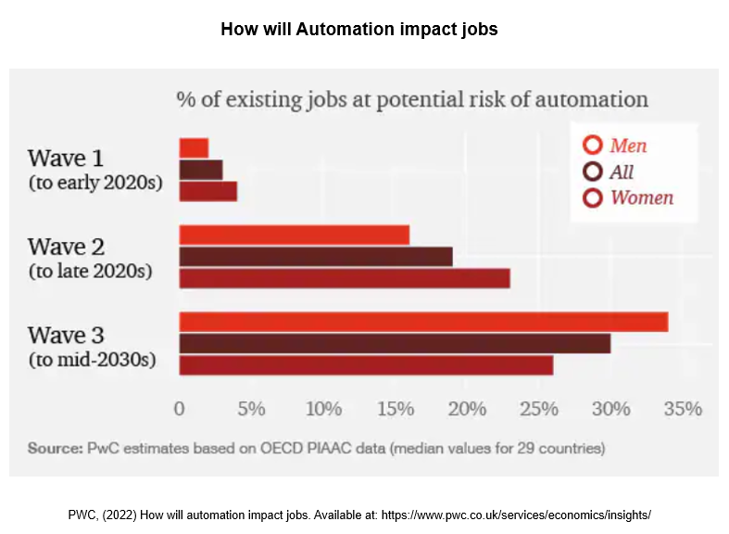

Based on the diagram 1 chart, wave one represents emerging technologies and automation implementation that is not considered significant threat to job security in the early 2020s. Paying attention to the mid-2020s in wave two, about 20% of women are more at risk due to the decline in office and administration duties due to automation of these roles. Men are less at risk due to conducting most of the manual labour duties, however in wave three job man’s security has been significantly impacted of up to 33% due to manual labour duties been taken over by automation. Based on the chart above, these number could also include the transport sector with the emergence of AI vehicles that are showing great potential now in the early 2020s. According to (Issa, Sun & Vasarhelyi, 2016). An analysis had been conducted in relation to the use of AI systems and concluded within deep learning techniques that utilizes AI networks and accounts for a value between 3.5 to 5.8 trillion dollars on an annual basis with a prediction that there will be further growth and advancements within the areas of AI automation. (Wang et al., 2011), points out that labour productivity is a key factor to growth and when reviewing the labour productivity in the US, this had declined from 2.4% to 0.5% within the years of 2010 and 2014. Below in diagram 2 displays automation impact within different job markets by 2030.

Diagram 2
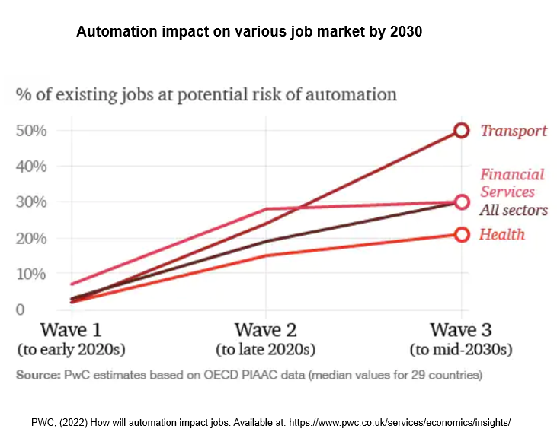

In diagram 2, the most at risk would be transport with financial services receiving an impact that’s in line with all other sectors of the job market excluding the health sectors.

Automation and implementation of the Lewin’s change model

There have been many changes within the macro space environment and other business sectors of work due to automation. Organisations have had to make rapid implementation of change management and plan how the organisation can stay sustainable and continue to build on revenues and stakeholder relationships. (Jämsä-Jounela, 2007), states that with increasing rapid technological advancements, this will provide people to identify matching jobs and inject more enthusiasm into the labouring sectors of working. The management teams will need to consider various factors that may affect human capital and moral of the organisation. In times of change, senior management will also need to consider strong members in their teams that have management and leadership qualities. Management should consider strong and supportive team members that are happy to support other colleagues with learning and adjustments to new systems and processes that may include automation. Also, these selected team members with leadership or management qualities will have to be diverse enough to take onboard and adjust to rapid change quickly whilst still able to support other colleagues to meet the desires of senior management. With automation becoming more in demand with further advancements to technologies, organisations may go through a change in management processes, procedures, and management structures, this will also depend on what organisation this is, and where in the world the organisation is situated, as western and eastern organisational philosophy are structured in different ways to each other with different methods of negotiation delivery. Automation has helped in many areas such as worldwide communication, negotiations, and financing, but there are drawbacks to consider before automation implementation. According to (Goodall, 2014), With the growth of the Internet of all things, this will encourage further development into smart homes and smart properties such as the implementation of Amazon Echo that have helped in setting the protocols and platforms that were previously known and confusing. There are models that can help management teams with a structured process of change management from, idea, to change and then to implementation of the required change. The first process of change is knowing why a change is required. Organisational change can be triggered for various reasons that can be internal or external, involve new products, services, or suppliers, and in this case of automation implementation, the organisation will be required to carry out an external analysis known as PESTEL analysis to gage changing factors outside of the organisation that may have an impact on the organisation, but PESTEL may also display advantages that the organisation may want to investigate or take advantage of. For this report, the Lewin change model will be used for the implementation of change and what the best steps are considering all factors that involve all stakeholders. Another model to consider for change management is the Maslow hierarchy of needs as this considers the safety, motivations, and growth of employees.

Lewin change Model Implementation

The Lewin’s change model is a well known and respected model of change management that follows three steps of change in an organisation. The first stage is the unfreezing of current processes or procedures to make room for new ones. The second step is moving forwards and implementing the change of management desires of new processes or procedures. The third step is re-freezing the new changes and processes in place as the new main functions of the organisation. According to (Beer & Nohria, 2000), The most difficult tasks organisational leadership face will be the implementation of planned organisational change with some authors suggesting that around two thirds of organisational initiatives tend to fail. Below in diagram 3 is a brief overview of the Lewin’s change model and the steps the model follows to implement organisational change.

Diagram 3
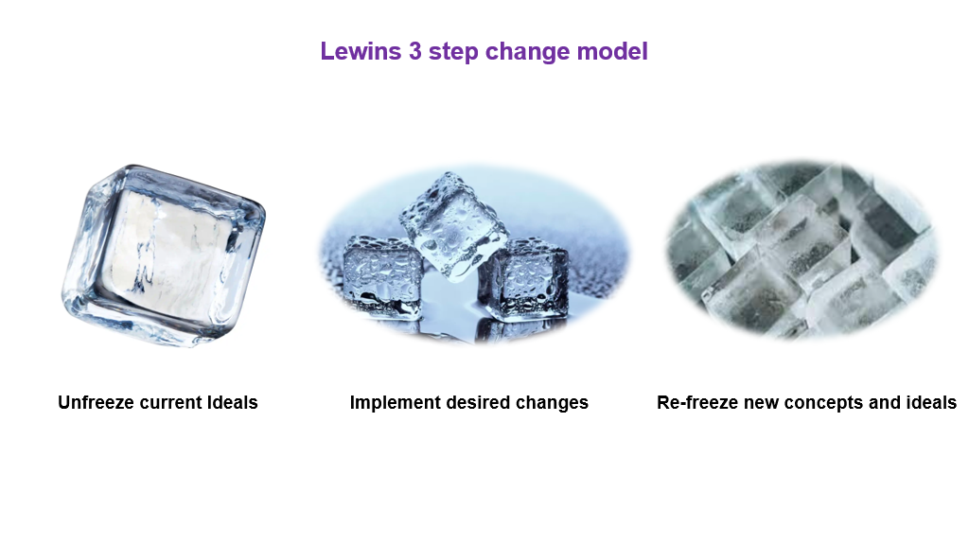

Lewin’s change concepts: Unfreezing
- Consider all current functions with strategical planning of desired organisational objectives in place.
- Consider leadership and management qualities in employees that can provide a clear and smoother training process of new working implementations to colleagues as part of the knowledge transfer process of change.
- Give clear instruction of work duties with supportive functions to employees
- Based on the organisations hierarchical structure, provide horizontal information shearing to team leaders and colleagues giving clear understanding of tasks and responsibilities across the organisation
- (Alvesson & Sveningsson, 2008), states, With the world changing at a rapid pace, organisations will need to implement change quickly for the development and survivability of the organisation
Lewin’s change concepts: Change
- Start to dismantle old mindsets and implement the new changes of processes, procedures, information flow, management structure, business structure etc.
- Experienced employees are to pass on training, processes, and information acquisition as part of the knowledge transfer process of change
- Consider charismatic and leadership qualities in employees to help with the smooth transition of change management throughout departments and teams
- Implement motivation incentives such as rewards, further training and promotion for long time employees and new enthusiastic employees.
- According to (Hakanson, 1993, Foss and Pedersen, 2002). Shearing of organisational resources is a fundamental component of sustainability, competition, and a dynamic economy.

The 7 C’s of change (Molloy and Whittington, 2005)

Within the process of change management, the 7 C’s of change management model should be applied due to key fundamental areas of the organisation that is considered. Below are the 7 C’s of change management that will give a better understanding of change management and a structed process to assist and guide senior management in the change process. According to (Luthans & Avolio, 2003), Authentic leadership is a process that considers both the positive psychological capabilities but also a highly developed organisational context, with results of greater self-awareness and positive behaviour that builds on self-development.

- Choosing a team - Management are required to select a team with key skills of organisational culture, organisational design, and management skills.
- Crafting a vision - Senior management are required to present a clear vision that is realistic and achievable.
- Connecting organisational change - Communicating organisational wide change utilising hard and soft management communication approaches
- Consulting stakeholders - Organisations are required to consult relevant stakeholders on required or desired information based on position and hierarchy.
- Communicating – It is best practice to communicate effectively by providing all employees with accurate and relevant up-to-date information on a regular basis
- Coping with change – implementing effective methods and mechanisms that support employees within the change process.
- Capturing learning – Organisations are required to acquire and disseminate the knowledge and experiences of employees on an internal and external basis.
- (Ambrosini and Bowman, 2001, Brown and Duguid, 1991), claim that organisations are not only reliant on a system of training, staffing, and managing systems as the organisation can pull on the knowledge of individual beliefs, skills experiences, abilities, and competencies.

Lewin’s change concepts: Re-freezing

- Once all activity planning and commitments of change have been established, the implementation of change is to be followed within the re-freezing stage.
- All organisational changes, activities, and events with effective communication must be successful for the re-freezing process to be implemented.
- All possible impacts of change that affect human capital and the organisation must have been identified before the refreezing process can commence.
- Consider employees with knowledge shearing capabilities that will support the management teams and colleagues with organisational change before, within and after the process of change has been implemented.
- According to (Kanter, Stein and Jick, 1992), Many organisations use different models of change management that help organisations stay in competition within the market such as the, Like positive model, The action research model and the Lewin’s change model.

John. P. Kotter had a very similar process of change management that was made up of eight steps to follow. Below is an example of the Kotter model of change and the processes Kotter believes should be followed to implement change within an organisation.

Figure 5
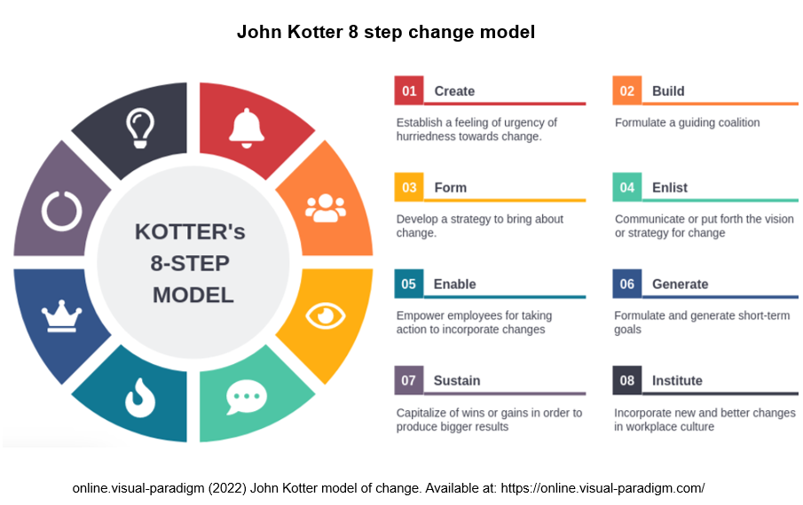

Organisational conflict due to automation implementation

Due to changes within an organisation, stakeholders may become uneased or demotivated with the duties they are assigned to. On the other hand, employees may become dismissive of management decisions and conflict may arise because of these changes. Automation has become more concerning to employees due to risk of job losses and AI automation replacing human capital. With automation becoming more common within big industries, it is best practice for any organisation to identify what type of conflict may or has risen, so to better gage and direct what actions are required to mitigate risk to all stakeholders and organisational reputation. Below are a few examples of organisational conflicts and how to understand them to make ethical and productive management decisions.

Changes within the organisation:
- Organisational restructuring
- Business mergers
- Overhaul of procedure and processes
- Contractual changes

Organisational culture differences:
- Employees hold different culture values.
- People’s behaviours and norms differ from said colleagues
- Employee communication breakdown due to misunderstanding
- Conflict due to different beliefs systems and being singled out
- Not enough diversity and understanding of other cultures and their background

Team dynamics are not aligned:
- A lack of understanding of different cultures may lead to disrespect of colleague either intentional or unintentionally.
- Language barriers may become concerning if colleagues do not support foreign employees with information and patience when communicating
- Favouritism of employees to only sit and work with desired colleagues, singling out other colleagues and missing development opportunities.

Employee Individual differences:
- Arguments and individual differences between one or more colleagues on a team
- Jealousy and patronising projections to other team colleagues.
- Laziness and not being a team player
- Mistakes that are made and not willing to accept colleague help or suggestions.
It is very important to support each other especially with major changes in society as according to (Strasser, et al 2014), Studies state that implementation of the automation wave could extend well into 2020s and impact on 30% of all job activities early to mid-2030’s.
Organisational conflict may arise in many ways but for this report the conflict is based on the implementation of automation and risk to human capital and other stakeholders. Based on the above research, one will need to consider what type of conflict may develop and how best to handle this conflict. There are several methods that can be used by managers and how best to use them based on the conflict. The first questions to raise will be what impact automation implementation had on individuals, teams, groups, and the overall organisation. How big of an impact automation had on all stakeholders, and what is the best method to use to maintain a smooth operating business that generates revenues with a motivated employment staff. Below are several methods that can be considered when weighing up different conflict management processes.

Approaches:
- Ignore
- Involve the team
- Involve a third party
- Confront directly
- Escalate / appeal the conflict to senior management

The advantage and disadvantage to ignoring conflict:
- An advantage could provide more cooling off time and try to preserve a harmonious environment
- The disadvantage of ignoring this conflict will be that things may become worse within the organisational environment.
With more use of automation within large sectors of business, the above management approaches will need to be considered and many of the above approaches will be implemented to make sure that the employees do not feel as though they do not have a voice and that management will consider their opinion and support their individual needs. Employees will also need to be kept up to date with changes within the organisation as the implementation of automation may present further training and job opportunities that become available. The organisation will need to make a strong effort to sell the vision and strategy to all appropriate stakeholders so to make changes of a positive venture and not a negative one. According to (Kotter’s Leading Change model 1995), there are key areas that must be considered to implement change. Below are example that senior management can use to bring about organisational change and consider all stakeholders involved.

- Establish a sense of urgency
- Create a coalition
- Develop a clear vision
- Shear the vision
- Empower people to clear obstacles
- Secure short-term wins
- Consolidate and keep moving
- Anchor the change

Maslow Hierarchy of needs

This report has reviewed automation implementation and what type of impact this will have on employees and other stakeholders. The report has demonstrated what type of impact automation has had in different business sectors and what forecasts have been predicted over the next decade. Based on studies conducted, automation is in fact a positive step in terms of meeting production levels and delivering on organisation delivery targets that are not always guaranteed with human capital due to factors such as human error, demotivation, conflicts, low team cohesion, sick days off, staff training etc. Machines do not complain, have sick days off, disagree with management and will not be affected by organisation change, thus meaning that managing conflicts of organisational change will be non-existent by implementing AI automation. By reviewing these facts there is evidently going to be an impact against organisational and revenue growth, or human interests, wants and concerns. There are models that can help organisations with understanding the motivations of there employment staff by utilizing the Maslow hierarchy of needs model. Organisations will be in a better position to understand employees needs and wants and try to balance how much automation should be used to generate revenues but also maintain a happy work force that is positive and motivated. According to (Shili, 2008), Organisational culture has been considered elusive based on a lack of a single culture definition that has been generally accepted throughout organisational literatures. With organisational change, one can expect change within the organisation culture due to these changes of new processes or procedures. Below in diagram 6 is the Maslow Hierarchy of needs.

Figure 6
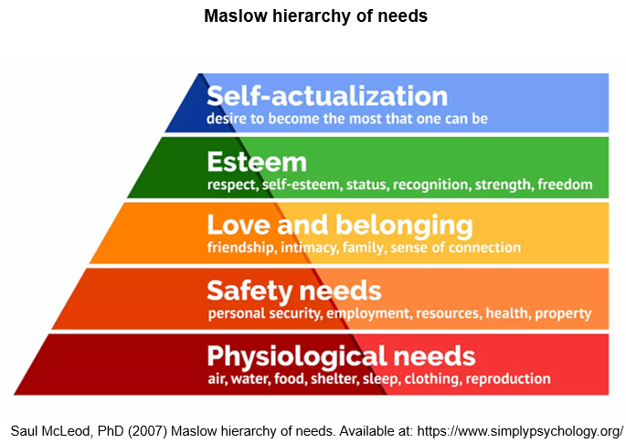

Below are a few explanations of how automation will impact employees using the Maslow hierarchy of needs model.

The concerns of employment staff will be based on one or more of these needs pointed out by the Maslow hierarchy of needs model. In the case of automation, risk of job losses will be among the top conflicts to employees and organisations. Departments such as HR & HRM can act as a supportive measure whilst going through organisational change due to HR representing the interests of the organisation and HRM representing the interests of human capital. According to (Storey, 1992), HRM includes administrative processes that can be associated with recruitment drives, selection, training, orientation, appraisal motivation and remuneration.

Physiological needs: Air, water, food, shelter, clothing, and reproduction
Automation can impact on job losses leading to loss of income and impacting on the physiological needs of employee’s basic necessities to survive, which encompasses the above needs discarding air. Money is required to pay for the above needs and without money, demotivation, stress, panic, and personal status will suffer.

Safety needs: Personal security, employment, resources, health, and property
If automation is heavily introduced with many job losses, this will severely impact the personal safety of employment staff due to the many commitments in their personal life. Stress will affect their health and wellbeing, personal security will be reduced due to not earning a wage and having to look for other work whilst creditors still require monthly payments to pay for rent, food, and energy commitments.

Love and belonging: Friendship, intimacy, Family, sense of connection
Automation will break team cohesion as robots do not have any human emotion and do not hold any interests that team colleagues and can learn from or aspire to. Robots do not have charisma for staff to feel inspired and will not give feedback on above and beyond work that staff have achieved. This coupled with job losses will place risk to employee relationships and friendships that have been built over time. Automation can only impact employee families due to a lack of income and will sever any employee connections that exist.

Esteem: Respect, self-esteem, status, recognition, strength, and freedom
Automation will replace incentives and rewards offered to employees, Organisation offer rewards and incentives to keep high moral and a motivated work force for revenue generation. With automation replacing the human workforce, employees will feel low in their self-esteem and disrespected due to newer and easier ways to produce the same goods. This demonstrates that employees are used until something new is implemented and then discarded. This will be the employee mind set when no recognition is provided.

Self-actualisation: Desire to become the most one can be
If automation can not provide new training or job openings, then there is no self-actualisation in that organisation, however, this is a very personal attribute of people, and one can push to become the best they can be regardless of their current situation regarding job opportunities.

Recommendations

Automation has its pros and cons regarding future tents; however, technology is becoming more advanced and will be utilised due to more cost productive capital spending and easier management systems being implemented. The subject is difficult to weigh up as from an organisational perspective, automation will save on time and capital sending in many business areas with automation implementation, but also provide sustained production levels without complaint, and if there were no risk to human capital, there is no argument as to what decision should be made. My recommendations regarding automation implementation would be to identify the areas automation is really required in and look at what impact automation will have on human capital, finances, and reputation before going ahead. Stakeholder interests is another key area to focus on regarding organisational desires and the needs and wants of employees, customers, shareholders etc. The needs around automation would have to suggest that all other options are not available to the organisation and no other choice was able to be made as the impact will make employees feel useless and non-desirable if they are not considered.

Conclusion

Based on all research and evidence that has been provided, I feel a little uneased regarding this topic. My reasons are that looking through the eyes of a employee of a company that is paid a wage, any threat to wellbeing or my personal life outside of the organisation is never a good sign due to family, children, mortgage, finance and so on. This becomes a question of what is valued more. The organisation or my wellbeing. My conclusion is that employees do not despise automation, they despise the impact automation will have against them directly, due to job security, with a mental burden of their job not being secure and be taken at any time and job losses. Automation is a great idea and tool but should be used wisely because if there is worry and impact now in the early 2020s, then how far will this go and when will it stop. According to (Mulhall, 2010), AI automation of rapid growth is not the overall threat, rather a preconditioning for productivity increases and job growth.

References

Alvesson, M. (2008) Sveningsson Changing organizational culture: Culture change. Work in progress Routledge. London, New York.

Ambrosini, V. (2001) “Bowman Tacit knowledge: Some suggestions for operationalization,” Journal of Management Studies, 38(6), pp. 811–829.

Barnhizer, D. (2016) “The future of work: Apps, artificial intelligence, automation and androids,” Artificial Intelligence, Automation and Androids, (289).

Beer, M. and Nohria, N. (2000) “Cracking the code of change,” Harvard business review, 78(3), pp. 133–41, 216.

Coeckelbergh, M. (2015) “The tragedy of the master: automation, vulnerability, and distance,” Ethics and information technology, 17(3), pp. 219–229. doi: 10.1007/s10676-015-9377-6.

David, H. J. J. O. E. P. (2015) “Why are there still so many jobs? The history and future of workplace automation,” Journal of economic perspectives, 29(3), pp. 3–30.

Goodall, N. J. (2014) “Ethical decision making during automated vehicle crashes,” Transportation Research Record, 2424(1), pp. 58–65.

Jämsä-Jounela, S. L. (2007) “Future trends in process automation,” IFAC Proceedings, 40, pp. 1–10.

Kanter, R. M. and Stein, B. A. (1992) Jick The challenge of organizational change The Free Press. New York.

Kotter, J. P. (1995) “Leading Change: Why Transformation Efforts Fail,” Harvard Business Review OnPoint, pp. 1–10.

Luthans, F. and Avolio, B. J. (2003) “Authentic leadership development,” in Cameron, K. S., Dutton, J. E., and Quinn, &. R. E. (eds.) Positive organizational scholarship: Foundations of a new discipline. San Francisco, CA: Berrett-Koehler, pp. 241–258.

Molloy, E. and Whittington, R. (2005) HR’s Role in Organising: Shaping Change. London: CIPD.

Mulhall, D. (2010) Our Molecular Future: How Nanotechnology, Robotics, Genetics and Artificial Intelligence Will Transfor M our World. Prometheus Books.

Nof, S. Y. (2009) “Automation: What it means to us around the world,” in Springer Handbook of Automation. Berlin, Heidelberg: Springer Berlin Heidelberg, pp. 13–52.

Shili, S. (2008) “Organizational culture,” International Journal of Business Management, 3, pp. 56–59.

Stegall, D., Cfps, A. and Sms, C. (2019) “Professional Safety,” Professional Safety, 64(10).

Storey, J. (1992) Developments in the management of human resources: An analytical review. London, England: Blackwell.

Strasser, T. et al. (2014) “A review of architectures and concepts for intelligence in future electric energy systems,” IEEE Transactions on Industrial Electronics, 62(4), pp. 2424–2438.

Yampolskiy, R. V. (2013) “Artificial intelligence safety engineering: Why machine ethics is a wrong approach,” in Studies in Applied Philosophy, Epistemology and Rational Ethics. Berlin, Heidelberg: Springer Berlin Heidelberg, pp. 389–396.

