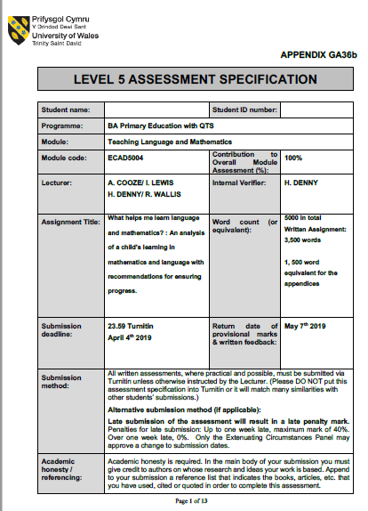
1700370
Within this assignment, I aim to analyse details of what helps children learn language and mathematics through looking at an individual’s work. Throughout Professional Teaching Experience (PTE), I undertook several observations in the classroom. The child I analysed in regard to language and mathematics and will discuss throughout is a girl aged six, placed in a class of twenty-two pupils. I will refer to this pupil as ‘Child A’. The pupil was of an ‘average attainment’ for a year two pupil. The school in which she is located, is average sized and situated in South Wales. Throughout my analysis, I shall see what can be done to ensure the child’s further development. My analysis is based on ‘The Mosaic Approach’, which places a high importance on the voice of child, indicating that children have a major input in their own analysis. Children are encouraged to be ‘creative in expressing their views and opinions’ (Clark, Moss, 2011, P.7). This is supported by Donaldson, in that one of his Four Purposes of the new curriculum were for children to be ‘enterprising, creative contributors’ (Donaldson, 2015, p.29).
Over five weeks, I used a range of methods such as observations, photographs, samples of the child’s work and interviews to analyse Child A. According to Clark and Moss (2011), ‘it is essential for a range method to be used that draw on the strong points of individuals.’ Having a range of methods can strengthen my analysis since both qualitative and quantitative methods are used. A variety of approaches is known as triangulation, providing me with reliable data. However, it could be argued that triangulation is not the only positive of using the Mosaic Approach and that collecting such a wide range of data can be known as ‘crystallisation’. Richardson and St Pierre (2005) describe it as a multi-dimensional way of looking at the world.
I shall be referring to the ‘A.S.K Model’ throughout, to support my analysis of how Child A best learns language and mathematics. According to Nottingham (2013), the model encompasses three areas: attitudes, skills and knowledge. Attitude refers to the child’s attitudes towards learning, skills refers to the skills needed for a child to gain knowledge in specific context and knowledge does not solely focus on subject specific knowledge, but on concepts, ideas, facts and figures. The research was carried out ethically due to gaining informed consent from both the child and the class teacher. Appendix 1 shows the signed consent form.
Donaldson proposes six areas of learning which aim to ‘prepare pupils at the school for the opportunities, responsibilities and experiences of later life.’ (Donaldson, 2015, p.22). However, Donaldson’s new curriculum is not yet in place in all schools. Currently in the Foundation Phase, there are seven statutory ‘Areas of Learning and Experience’, one being ‘Language, Literacy and Communication Skills’ (WAG, 2015, p.12). This is divided into three strands, Reading, Writing and Oracy. Alongside using the Framework on PTE, I incorporated language skills across a range of different lessons in a cross curricular manner through the Literacy and Numeracy Framework (LNF). A cross-curricular approach encouraged children to use their language skills in all areas of their education, though not taking away from their specific subject knowledge. Barnes (2015) confirms that by using a cross-curricular approach the uniqueness of subjects is not lessened. I aim to analyse Child A’s language skills in regard to Reading, Writing and Oracy and the LNF, whilst linking to the A.S.K Model. Due to the fact I did not teach a specific oracy lesson, I shall be incorporating elements into my writing analysis.

As a class, we read various stories. The first of which was ‘Mixed’, a story with a message about how we are equal. Reading stories with children appears to have benefits. It ‘has been linked with benefits to literacy in early childhood’ (Nunes, Bryant, 2004, p.213). The learning objective was to ‘write a letter about friendship’. During the lesson’s introduction, I read several statements such as ‘all colours are equal’, the questions were open-ended, with no correct answer. The children had to state whether they agreed, providing reasons to support their answer. Through observing Child A, it was clear that she was quiet in expressing her opinion in front of the class. According to the LNF, Year 2 children are expected to ‘express opinions, giving reasons and provide appropriate answers to questions’ (WAG, 2014). This links to the skills area of the A.S.K Model as she was able to express her opinion and give reasons, these are communicative skills. Class discussions can support children through relating to topics through real life experiences. This view is supported by (Daniels, 2005, p.295) as he states that posing questions allows children to ‘make connections between the text and their own life-experiences’. This was true of Child A as when stating her opinion to me, she expressed that if she was to be excluded, she would feel upset. Although Child A lacked confidence within the whole class environment, she showed an awareness of the importance of listening to the other children. Nottingham (2013) outlines the skills children need to become proficient learners, one of which is communicative skills. Child A also showed effective social skills as she ‘respected others’ viewpoints and acted appropriately in particular contexts’ (Nottingham, 2013, p.39).

‘Learning to write is an extraordinary feat and, as children become writers, we get glimpses of them at their most active, creative and imaginative’ (Graham, Kelly, 2010, pg.xiv). The following activity involved writing a letter, giving reasons why all the colours should have lived together in harmony, see appendix 2 for Child A’s letter. This related to the LNF writing skill of ‘follow and build upon a form modelled by a teacher’ (WAG, 2015). In Child A’s interview, she expressed how she learns language best when the teacher explains and models the task beforehand. See appendix 3, question 3. It is stated that a vital component of effective teaching is the ‘explicit modelling of processes so that students learn how to adapt and apply their knowledge’ (TES, 2015). By modelling the activity, Child A was able to apply knowledge that she had acquired in the discussion beforehand to her letter, adapting it accordingly to ensure it was suitable. Regarding the A.S.K model, Child A had a sound level of knowledge and several ideas that she used throughout. Although, perhaps Child A could have extended her sentences. Child A sometimes has difficulty spelling. See appendix 2 for spelling errors. When Child A asked how to spell a word, I encouraged her to sound out letters she could hear and to try by herself. This would help her to become an independent learner and avoid over reliance on the teacher. According to Graham and Kelly, ‘children will require a wide range of self-help and self-monitoring strategies in order to sustain their independence and avoid frustration and loss of confidence’ (Graham, Kelly, 2010, p.84). By encouraging Child A to attempt to spell independently, it allowed her to take a risk. If children are not encouraged to take control of their learning, they may be fearful of making mistakes. However, Child A was not afraid of making mistakes in her written work as she mentioned ‘next time I will do better’, see appendix 3, question 4. McLeod (2018) mentions how Piaget states that cognitive development stems from independent learning and that children construct their own understanding.

Reading
Within the classroom, there was a reading corner where the children were encouraged to read stories. See appendix 4. Whilst observing Child A, I frequently found her engaging in independent reading. Through interviewing her, she voiced how she felt ‘happy’ in this area as she got a chance to read quietly, see appendix 3 question 1. With reference to the A.S.K model’s attitude element, it was clear that Child A was positive and passionate concerning reading. The (Department for Education and Employment, 2001) mention that it is vital children are enthusiastic about lifelong learning. The fact that Child A was enthusiastic showed that she was comfortable in the classroom environment and had a sense of belonging. Maslow (1943) coined a hierarchy of needs, two of which being safety and belonging. These are crucial to reach the ‘top’ of the hierarchy, self-actualisation. Regarding reading, the children learnt Phonics through ‘Read-Write-Inc’ where the aim is to develop fluency in language to develop further skills. Each day the children practiced their speed sounds in order to read each grapheme correctly and confidently. Tann describes this as the phonic method, children must ‘tackle new words which are not in their sight vocabulary’ (Tann, 1991, p.112). Often children are confident when sounding out specific sounds (phonemes), but need practice matching the phoneme to its’ written representation (a grapheme). Child A was in the ‘middle’ ability Read Write Inc class, where the children focused on sounds like oa, ai and ire. Some sounds, Child A read with confidence. However, she was still unsure on others and needed more practice. Showing her sounds that she was unfamiliar with allowed her to be challenged. Paige et al. (2017) claim that it is vital to challenge children to develop their knowledge and skills further, otherwise no improvement will occur. When conversing with Child A in her interview, she expressed how she did not ‘feel sad’ when she made mistakes, see appendix 3, question 4. There was a display in the classroom concerning Dweck’s Growth Mindset. Dweck (2006) proposes a theory of mindset: fixed and growth mindsets. If children do not feel successful then they will give up, this is known as a fixed mindset. If children have a growth mindset then they accept a challenge and realise that they cannot always succeed.

Maths
‘Mathematics introduces children to concepts, skills and thinking strategies that are essential in everyday life and support learning across the curriculum’ (Haylock, 2010, p.12). The above quote conveys that mathematics is crucial in preparing children for real life. One of the Foundation Phase Areas of Learning is ‘Mathematical Development’ (WAG, 2015). This is in place from Reception to Year 2. Donaldson outlines the importance of mathematics in Wales stating that ‘a high level of numeracy and mathematical competence is important for the prosperity of the country’ (Donaldson, 2015, p.49). In a similar approach to language, I incorporated mathematics into other Areas of Learning in a cross curricular manner. The National Literacy and Numeracy Framework (LNF) helped me to embed mathematics as a cross curricular responsibility into all subjects. When analysing Child A regarding mathematics, I shall be referring to the Foundation Phase Framework, Donaldson’s Successful Futures and the LNF.
Overall, Child A enjoyed mathematics, as she mentioned it helps her to be smart. When asked how she best learns about mathematics, Child A mentioned that I helped her learn, along with Teacher A, Teacher B and her Mum at home. See appendix 5, question 3. Constructivist Vygotsky emphasised that knowledge and understanding are ‘constructed by the learner from their experiences’. (Pound, 2006, p.40). Child A was regularly in contact with mathematics, so therefore had experience both in school and in the home environment. Child A seemed to have a great sense of achievement from being able to sing the ‘two times table song in the morning’ in class due to practicing at home.
The first topic of mathematics that I undertook with the year two class was number bonds. Number bonds part of the ‘using number skills’ strand of the Foundation Phase Framework, under the ‘use number facts and relationships’ element (WAG, 2015). The year two requirement regarding number bonds was ‘to use mental recall of number bonds to 10, e.g. to derive 60+40 from 6+4’ (WAG, 2015). To introduce the topic, I presented a hanger with ten pegs on the bottom, as shown in appendix 6 and asked the children how I could use this to find all the possible ways of making the number ten. As a class, the children realised they could move one peg across each time, which would leave them with 9 + 1 at the start, then onto 8 + 2 and so on. This can be known as a systematic approach. The children were familiar with the term ‘systematic approach’ as Teacher A had introduced it prior to my placement. Child A stated in the interview that she ‘liked it when I used the pegs in the introduction because it helped her see the numbers as pegs’, see appendix 5 question 3. The pegs showed a visual representation of the numbers to ten which benefitted Child A. ‘Visual representations enable pupils to make connections between their own experience and mathematical concepts’ and ‘and therefore gain insight into these abstract mathematical ideas’ (Barmby et al. ,2012, p.7).
Child A undertook three activities regarding number bonds. These involved using Numicon, Cuisenaire rods and pairing number cards, see Appendix 7 for the lesson plan. These activities were all practical, with little writing involved. It is stated that ‘it is of little use if a child can correctly complete pages and pages of calculations but does not know how to get started when faced with an unfamiliar problem or a task presented in a practical rather than a written form’ (Pepperall et al., 2009, p. 1). Child A mentioned how more ‘practical’ lessons benefitted her as she stated ‘I get the work more when we use Numicon instead of writing’, see appendix 5, question 3. By using a range of concrete objects such as Cuisenaire to help children to understand the concept of number bonds, they are equipped with numerous representations. According to Cotton (2013), the best way to develop children’s skills is to equip them with as many representations as possible. This, in turn can help children with their communication and reasoning skills. When Child A was solving different number bond problems, I used questions to ask her how she was working out the answer, which she was able to do with confidence. Cotton goes on to mention how by asking children how they articulated their answer, the child must draw on their existing knowledge and recall their thinking process. When asked, Child A was confident explaining how she had coined a specific answer. In relation to the skills area of the A.S.K Model, she used thinking skills to identify the process of getting her answer. This also relates to the knowledge area of the model because she used her thought process to think about her mathematical knowledge that she had used to complete the task.
The children undertook a pair activity regarding adding one and two-digit numbers together. Child A worked efficiently in a pair, see appendix 8. This links to the skills area of the A.S.K model as she was using her social skills to interact with another member of the class. Working in partners allowed Child A to further develop her understanding of number bonds as they could share information that only they acquire, therefore learning from each other. Child A stated she finds working in pairs helpful as ‘sometimes I do not understand so we can work together and figure out the answers’, see appendix 5, question 3. This is in line with Vygotsky’s ‘Zone of Proximal Development’. This is ‘the gap between what children can do alone and what they can do with the help of someone more skilled or experienced, this can be an adult or a child’ (Pound, 2006, p.40).
Regarding adding and subtracting one and two-digit numbers, Child A seemed to have a sound understanding. However, she seemed to have misconceptions when undertaking a problem-solving activity. This is shown in appendix 9. For example, she had written the sum 4-56=60, when in fact it should have been 60-56=4. This was not a mistake but a misconception. ‘A mistake is defined as a wrong idea or a wrong action; a misconception is defined as a misunderstanding’ (Koshy et al., 2000). According to Hansen et al. (2005) the teacher needs to understand the cause of a child’s misconception in order to rectify it, this may involve going back to an earlier stage of the topic. In retrospect, looking at Child A’s answers, it is clear to see that she has mistaken subtracting for adding. It is unclear what the cause of this misconception was, possibly my explanation of the task could have been unclear or perhaps I did not show the children enough examples at the beginning of the task.
Regarding language, Child A is developing a growing sense of confidence in the subject, alongside a sense of interest, especially with reading. Hidi (1990) mentions that being interested in a subject can enhance learning, leading to improved performance. It is imperative that Child A’s enthusiasm continues to be encouraged to ensure future progress. Child A has shown enough strengths in Oracy, Reading and Writing. I shall be discussing how she can further progress regarding language. In relation to the Foundation Phase Outcomes, it appears Child A was primarily working at Level 4, however possessed a few skills found in Level 5. I have highlighted skills I felt Child A possessed or was working towards in appendix 10. During my time in the classroom, I did not cover all skills found in the criteria, so I have highlighted the skills that I had observed.
In relation to language, Child A used her knowledge of phonemes to help her write the written representation of words as graphemes. Child A was confident using this knowledge to spell out words such as consonant-vowel-consonant words but appeared to struggle when it came to spelling more difficult words. To help Child A progress with her spelling, she could practice more complex words at home, as she stated that she practices with her Mother at home already. According to Hornby (2011), parental involvement could improve children’s learning outcomes. Child A seemed to struggle with spelling words where the phoneme did not match with the grapheme. Reflecting on my personal pedagogy, I could have provided Child A with more support when she was undertaking written tasks. When she asked how to spell a word, I simply encouraged her to ‘have a go’ and sound out the letters that she could hear when saying it aloud. However, in hindsight I realise that this does not always work when the phoneme does not correspond with the grapheme. To help Child A progress onto the next Outcome, she may need a degree of scaffolding. ‘Learning needs to be built up slowly, starting with appropriate supports, which can then be systematically removed (TES, 2018). The Outcome 5 criteria mentions that children should be able to ‘extend their writing’ (WAG, 2015). To help Child A progress, she may have possibly needed more time to complete tasks in order for her to extend. She mentioned how she felt she often did not have enough time to complete her work, see appendix 3, question 4. On reflection, I realise I may have rushed the class to complete tasks on time. This may have placed unnecessary pressure on the children.
In relation to Child A’s confidence whilst sharing her opinion with the class orally, it could be suggested that perhaps less ‘formal’ activities such as acting out ‘real or make-believe roles using appropriate language’ (WAG, 2015, pg.53) would benefit her. (Holderness and Lalljee, 1998) maintain this view as they mention the importance of drama in improving oracy skills and state that drama can be a natural extension of children’s play. Perhaps this could be brought into the classroom in relation to continuous provision. As well as bringing the stories Child A loved to life, it could take the pressure off expressing her opinion as she would feel it was more make believe.
Although Child A seemed to enjoy language, she is also growing in confidence in relation to mathematics. Regarding the Foundation Phase Outcomes, I felt as though Child A possessed many of the skills found in the level 5 criteria. See Appendix 11. However, it is important to note that I cannot make a full judgement as I was in the school for a short period of time.
From my mathematical analysis of Child A, it is clear to see that a more hands-on approach suited her learning. She was keen on using concrete resources such as Numicon to assist her completion of tasks. Real-life representations are a useful tool for children. According to Bhagwanji, hands-on learning is a ‘natural outflow of the constructivist philosophy of education, in general and specifically in teaching mathematics’ (Korn, 2014, pg.10). It is important for Child A to continue to use concrete materials. However, to ensure her further progression onto the next outcome, perhaps a suggestion would be to develop her mental strategies. A requirement to reach the Level 6 Foundation Phase Outcome is for children to use ‘their preferred strategy including mental strategies’ (WAG, 2014, 56). There are benefits to using a mental approach to mathematics as they can help improve subject knowledge. Sometimes ‘mental maths’ can be confused with a pupils’ ability to complete sums quickly. However, ‘in its broadest sense, mental math also involves conceptual understanding and problem solving’ (Olsen, 2015, pg.544).

It could be mentioned that perhaps Child A could develop her mathematical language to further her development. When Child A was explaining her thought process when working out specific answers, her mathematical language was quite limited. This is supported by Anghileri (1995), who states that mathematical language can support numerical reasoning. She states that ‘children should be taught to understand the language of number and talk about their work’ (Anghileri, 1995, p.xv). Finally, in my analysis I mentioned that Child A had misconceptions regarding adding one and two-digit numbers. As a note on my professional practice, this could have been due to not explaining the activity clearly beforehand. According to the National Research Council (2001), effective teachers should give children a few explanations beforehand to link to their previous understanding. Regarding Child A’s future progress, I feel that in order to clear up any misconceptions, tasks need to be explained clearly with examples.

References
- Anghileri, J. (1995) Children’s Mathematical Thinking in the Primary Years. London. Create Publishing.
- Barmby, P et al. (2012) Developing the Use of Visual Representations in the Primary Classroom. Available at: https://www.nuffieldfoundation.org/sites/default/files/files/Developing%20the%20use%20of%20visual%20representations%20in%20the%20primary%20classroom%2013Jun13.pdf (Accessed on: 1st April 2019).
- Barnes, J. (2015) Cross Curricular Learning 3-14. London. SAGE Publications Ltd.
- Clark, A, Moss, P. (2011) Listening to Young Children: The Mosaic Approach 2nd Ed. London. NCB.
- Cotton, T. (2013) Understanding and Teaching Primary Mathematics 2nd Ed. Oxon. Routledge.
- Daniels, H. (2005) An Introduction to Vygotsky 2nd Ed. East Sussex. Routledge.
- Department for Education and Employment. (2001) Departmental Report. Available at: https://assets.publishing.service.gov.uk/government/uploads/system/uploads/attachment_data/file/250879/5102.pdf (Accessed: 29th March 2019).
- Donaldson, G. (2015) Successful Futures. Available at: https://gweddill.gov.wales/docs/dcells/publications/150225-successful-futures-en.pdf (Accessed: 28th March 2019).
- Dweck, C. (2006) Mindset. New York. Random House Publishing.
- Graham, J, Kelly, A. (2010) Writing Under Control 3rd Ed. Oxon. Routledge.
- Hansen et al. (2005) Children’s Errors in Mathematics. Exeter. Learning Matters Ltd.
- Haylock, D. (2010) Mathematics Explained for Primary Teachers 4th Ed. London. Sage Publications Ltd.
- Hidi, S. (1990). Interest and its contribution as a mental resource for learning. Review of Educational Research.
- Holderness, J, Lalljee, B. (1998) An Introduction to Oracy: Frameworks for Talk. London. Bloomsbury Publishing Ltd.
- Hornby, G. (2011). Parental Involvement in Childhood Education. Springer. London.
- Korn, J. (2014) Teaching Conceptual Understanding of Mathematics via a Hands-On Approach. Available at: https://pdfs.semanticscholar.org/aeaa/18adc2c21f652907c3072f700c46bb1ebf30.pdf (Accessed: 3rd April 2019).
- Koshy, V, Ernest, P, Casey, R. (2000) Mathematics for Primary Teachers. Oxon. Routledge.
- Maslow, A. (1943) A Theory of Human Motivation. Available at: https://books.google.co.uk/books?id=CkonDwAAQBAJ&printsec=frontcover&dq=maslow+motivation+theory&hl=en&sa=X&ved=0ahUKEwi-t9mS7qfhAhUYShUIHReMChAQ6AEIKjAA#v=onepage&q&f=false (Accessed 30th March 2019).
- McLeod, S. (2018) Jean Piaget’s Theory of Cognitive Development. Available at: https://www.simplypsychology.org/piaget.html (Accessed 1st April 2019).
- National Research Council. (2001) Educating Teachers of Science, Mathematics and Technology: New practices for the New Millennium. Washington. The National Academies Press.
- Nottingham, J. (2016) Challenging Learning 2nd Ed. Oxon. Routledge.
- Nunes, T, Bryant, P. (2004) Handbook of Children’s Literacy. The Netherlands. Kluwer Academic Publishers.
- Olsen, J. (2015). Five Keys for Teaching Mental Maths. Available at: mt2015-03-543a.pdf (Accessed: 2nd April 2019).
- Pepperall et al. (2009) Mathematics in the Primary Classroom 3rd Ed. Oxon. Routledge.
- Pound, L. (2006) How Children Learn. London. Practical Pre School Books, Ma Education Ltd.
- Richardson, L, St. Pierre, E. (2005) Writing: A Method of Enquiry. Thousand Oaks, CA. Sage Publishing.
- Tann, S. (1991) Developing Language in the Primary Classroom. London. Continuum International Publishing
- TES. (2015) How to Use Modelling Successfully in the Classroom. Available at: https://www.tes.com/news/how-use-modelling-successfully-classroom (Accessed: 1st April 2019).
- TES. (2018) How to Scaffold Learning in Three Steps. Available at: https://www.tes.com/news/how-scaffold-learning-three-steps (Accessed: 2nd April 2019)
- Welsh Government. (2014) Literacy and Numeracy Framework. Available at: https://learning.gov.wales/resources/browse-all/nlnf/framework?lang=en (Accessed: 30th March 2019).
- Welsh Government. (2015) Foundation Phase Framework. Available at: https://gov.wales/sites/default/files/publications/2018-02/foundation-phase-framework-revised-2015.pdf (Accessed: 30th March 2019).

Appendix 1- consent form
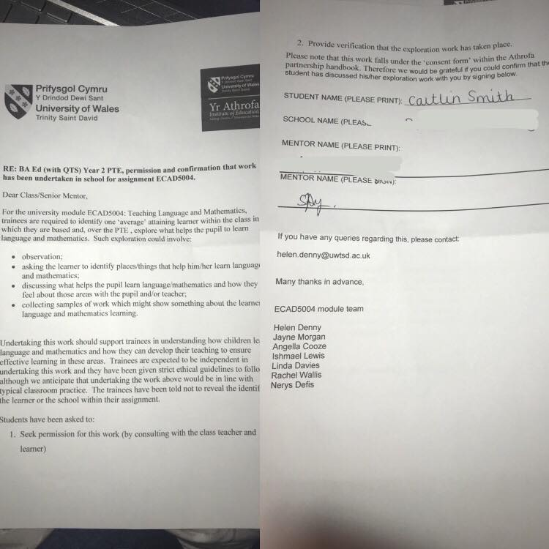
Appendix 2- Child A’s letter
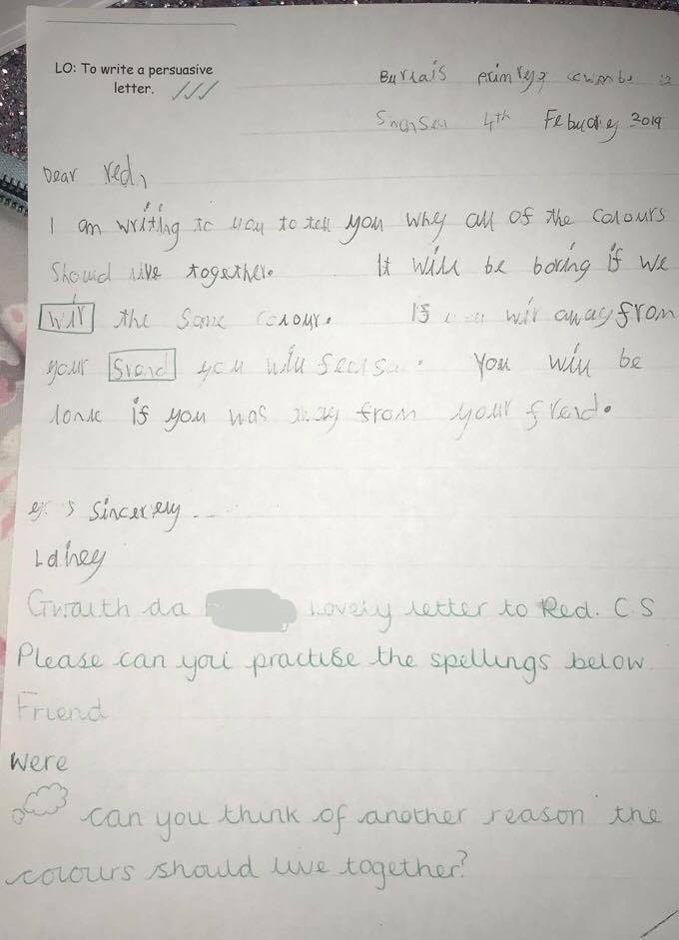
Appendix 3- Language interview with Child A
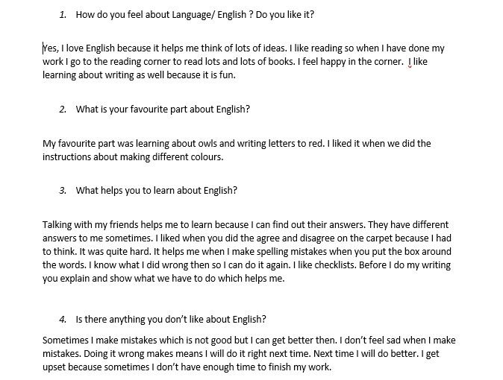

Appendix 4- Children’s reading corner
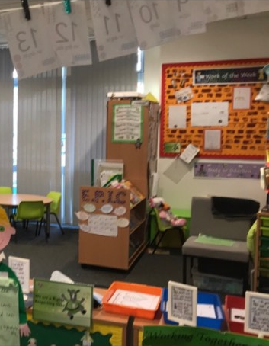
Appendix 5- Mathematics Interview with Child A
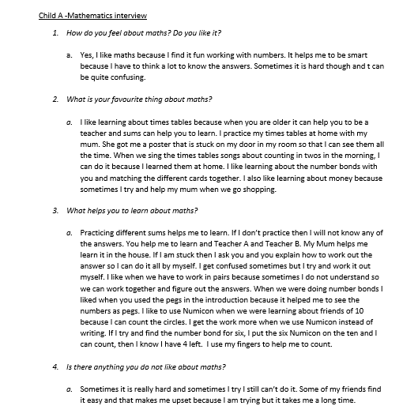

Appendix 6- Hanger and Pegs example
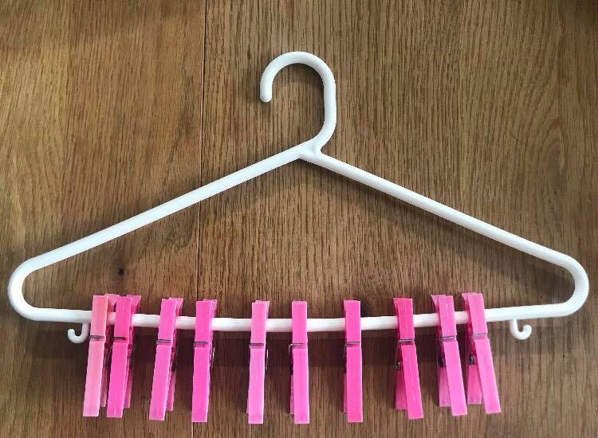
Appendix 7- Practical activities lesson plan
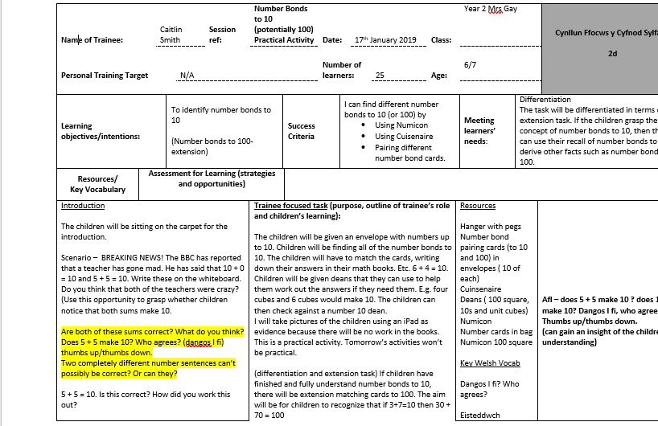
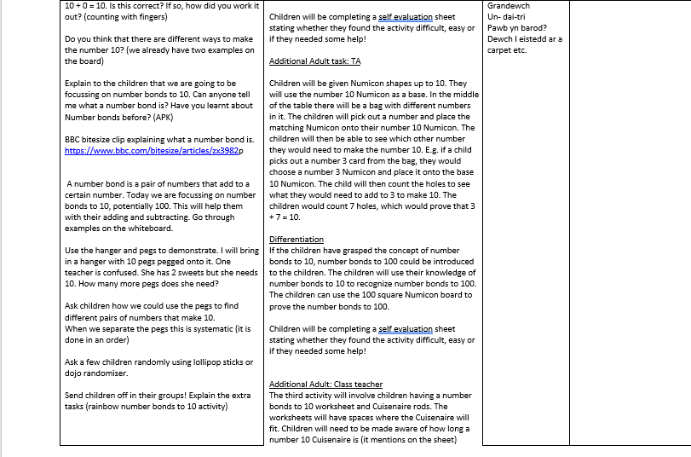
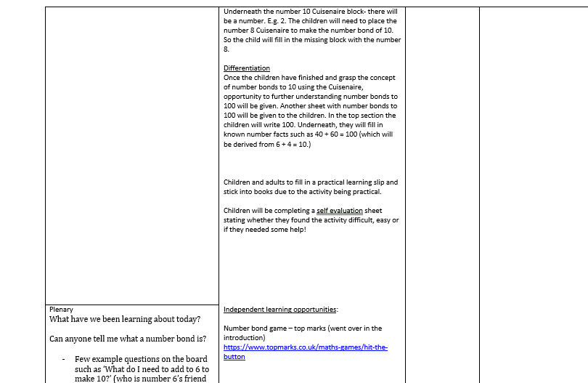
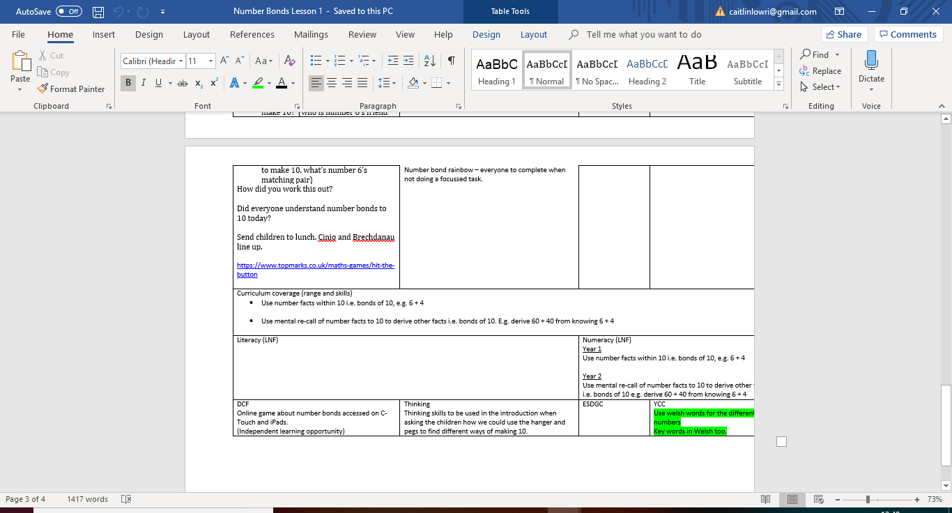
Appendix 8- Pairing activity
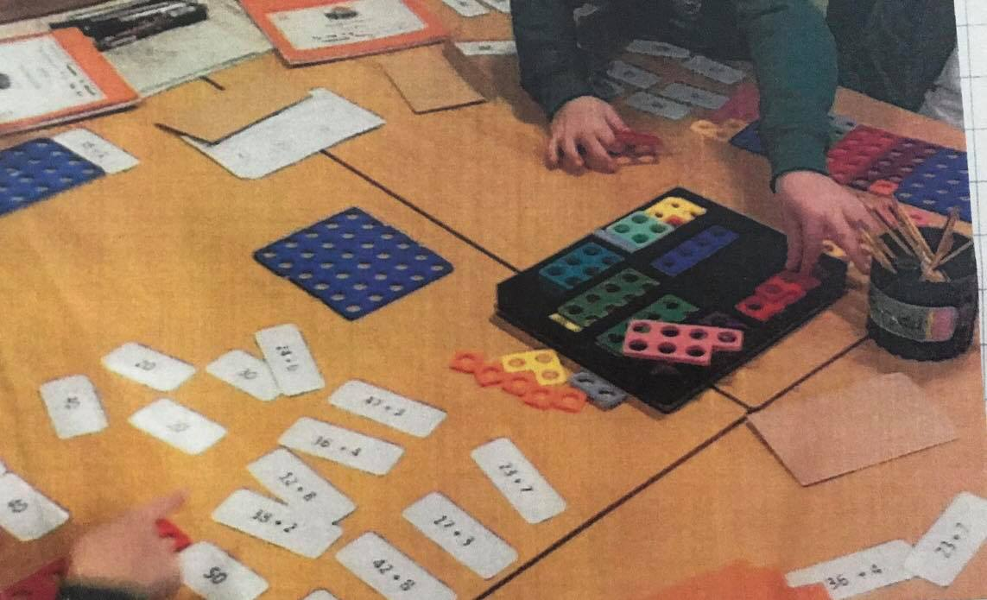
Appendix 9- Mathematical misconception
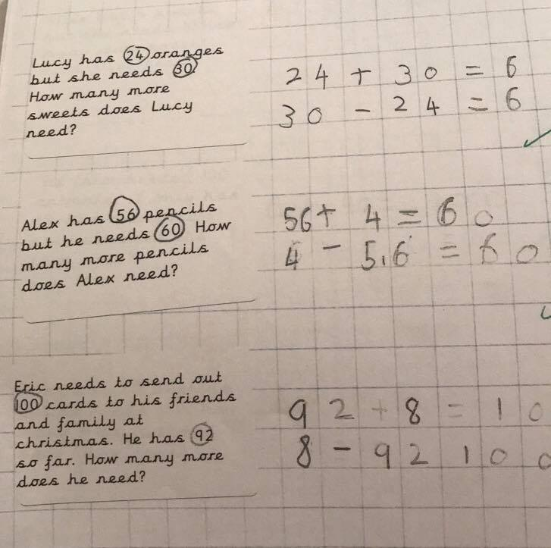
Appendix 10- Language Outcomes highlighted sheet
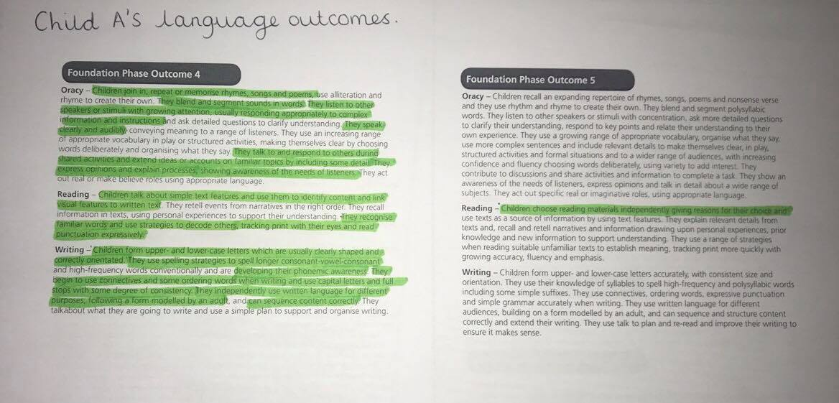
Appendix 11- Mathematical Outcomes highlighted sheet



