From "on-site scoring" to "separation of exams and grading", the influence of the reform of Chinese art examination on broadcasting and hosting major

Research objectives
1、Analyze the implementation effect of "separation of exams and grading"
·Assess the impact of online testing on performance and learning.
2、Discuss how technology can improve the fairness of art examination
· Consider how to reduce the regional inequality and improve the competition opportunity of examinees.
3、Assess the candidate's adaptability to the new test method
·Analysis of candidates' challenges and strategies in adapting to the online test format.
4、Get feedback from relevant educational institutions
·To collect views and suggestions from educational institutions and the industry on the separation of assessment.

CONTEXT:

1、Explanation of subjects and test terms：

· China Art Examination: The Unified entrance examination for art majors of ordinary colleges and universities, referred to as the Art college Entrance examination and Art examination, is the entrance examination for art majors of ordinary colleges and universities of the People's Republic of China. Selective Examination by regular high school graduates, secondary vocational school students or candidates with equivalent academic qualifications (Fujian Provincial Education Examination Institute, 2017).

Why is the art exam policy for 2024 released in 2023？The art exam often precedes the National unified entrance examination for colleges and universities, which will be held in June 2024, The art exam will begin in December 2023 and end around April 2024. While many policies say "Art exam for 2024", but in fact the release time is in 2023, "Art exam Policy for 2024" refers to students enrolled in September 2024, but these students need to take the exam in December 2023, and the policy needs to be promulgated before December 2023.

· Broadcasting and Hosting major: "Broadcasting and Hosting" is a relatively common major in Chinese universities, the main purpose of this major is to train radio and television announcers and hosts of different types of programs. Li (2023) points out that broadcasting and hosting art has now developed into an undergraduate major with Chinese characteristics.

At present, all provinces have unified the examination content. According to a document released by the Hunan Provincial Ministry of Education (2023), the exam will include three subjects: reading works, broadcasting news and commenting on topics. The score is based on 100 points, and the total score of broadcasting and hosting is 300 points.

·Briefly introduce why the art exam should be reformed:
The first， chaotic and diversified scoring standards. Second, unfair reports of cheating in exams (although many truths are covered up, according to Guo (2016) 's research, it is found that most art examinees know the existence of cheating).
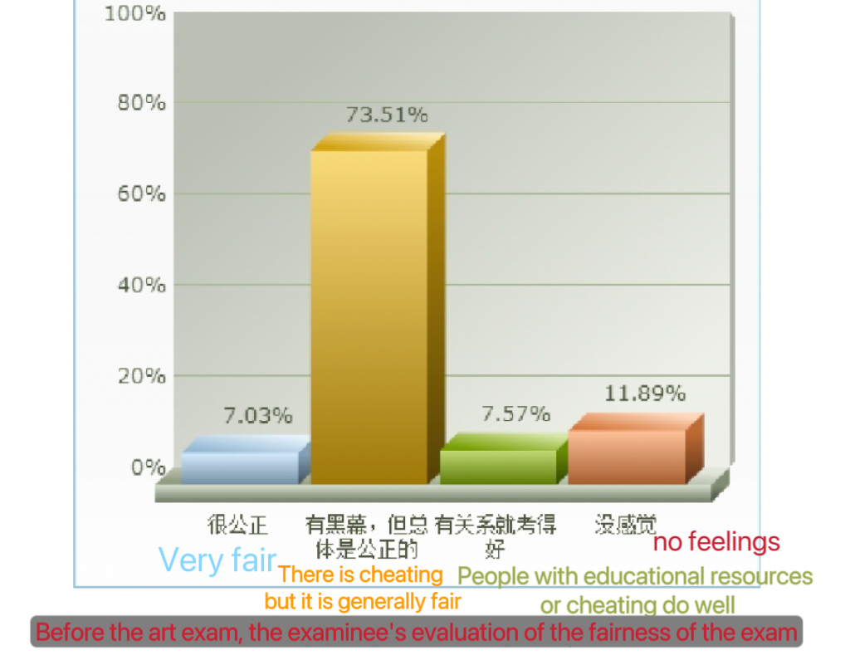
Therefore, the reform of the art examination is also the government's attempt to restore the public's confidence in the education sector and the education system, and to promote the fairness of the art examination through technological and institutional changes.

2、The timing of policy implementation：

Time 2021: 2021 The Ministry of Education of the People's Republic of China (MOE) has released a guideline on further strengthening and improving general institutions of higher learning.Guiding opinions on examination and enrollment of art majors.The policy emphasizes to promote the fairness and fairness of art examination, and changing the assessment method is a further measure of this policy to promote fairness.
There are generally two types of test organizers, one is the Ministry of Education of each province, and the other is the qualified school. The reform of the examination method focuses on the provincial examination organized by the provincial Ministry of Education. Prior to the Art exam in 2024, provincial-level examinations were conducted using on-site scoring.

Time 2023 : Hebei, Hunan, Jilin, and Guangdong and Yunnan provinces for the first time implemented "separation of exams and grading" in the art unified examination, and the broadcasting and hosting major was also included in the use of evaluation separation for assessment.
“The way of "separation of exams and grading" is adopted in the provincial unified examination of broadcasting and hosting”(Hunan Provincial Department of Education, 2023).
“Different from the on-site scoring methods of experts interviewed for the art unified examination in the past, this year, the city's art unified examination broadcast and host all subjects and music solfeggio subjects piloted the "separation of exams and grading" group test mode for the first time, and the test site recorded the candidates' audio and video materials using high-fidelity equipment. Expert judges do not appear at the test site, but score the performance of candidates by viewing audio and video after the test, so as to achieve unified test equipment conditions, unified test software, unified test process and unified scoring standards”（Tianjin Education News, 2023).

Time 2024/future
After the "separation of exams and grading" is piloted in some majors, more professional exams may be covered in the future.
According to a report by Feng（2024），Liaoning and Xinjiang have made it clear that from 2025, Liaoning will implement the assessment separation of performance (directing), broadcasting and hosting exams in the provincial unified examination, and gradually expand to the provincial unified examination of music and dance. The Jiangxi Provincial Department of Education mentioned in the pilot work plan of "separation of exams and grading" for the unified examination of art majors in Jiangxi Province's ordinary colleges and universities that the "separation of exams and grading" pilot will be carried out in 2025 for the interview classes that choose music, broadcasting and hosting, and will be expanded to all interview classes (including dance and choreographer) when conditions are mature.
According to a report published by Sohu.com user Dongjian Prosperity (2024), in the art exam of 2025, according to statistics, at least 14 provinces have adopted the system, covering many art majors such as music, broadcasting and hosting, dance, and performance.
I personally believe that more provinces will adopt the“separation of exams and grading ”in the future.

TEXT:

·On-site scoring definition: the test venue where the judges are located is relatively fixed, and the candidates are randomly assigned to different test venues. After the test is over, the judges score the candidates on-site, and the scores can not be changed.

·Definition of "Separation of exams and grading" :
"The specific implementation methods of" evaluation separation "are explained in the policy published by Fujian Province. Music (solfegge, vocal music, instrumental music) and broadcasting and hosting classes adopt the form of "separation of exams and grading", that is, candidates are first organized to record audio and video on the spot, and then judges are organized to score candidates' performance according to the recorded audio and video, and judges are not arranged on the test site "(Feng, 2024, para12).

In 2024 art exam, Hebei, Hunan, Jilin, and Guangdong and Yunnan provinces for the first time implemented "separation of exams and grading" in the art unified examination, and the broadcasting and hosting major was also included in the use of evaluation separation for assessment.
And adopt three random system, candidates randomly assigned, judges randomly selected, random formation of the examination room. Different from the former fixed examination room fixed teacher, the "separation of exams and grading" system sets more randomness to improve the specificity and fairness of the assessment.

Comparing the two systems, the main difference is whether the examinee meets the examiner (at the same time).

The consequence

1. Impact on candidates
- Stress during exams
The psychological pressure of the live exam is reduced. Video recording of some socially phobic students is more relaxed,because the model of marking on the spot is that a test room usually has about 10 teachers, and after the reform, there is only one technician.
- Fewer distractions during exams
There is an advantage for people who are not tall (recorded separately, without height comparison); Students are less likely to be influenced by the former and the latter during the test; Judges will not randomly ask questions to affect the status of candidates

-Higher professional skills and physical requirements
Without the interference of other factors, the examiner will focus more on the professional ability of the candidate.Because the video shooting will make people fat, so the candidates are required to have a slimmer body.

- The online test is different from the offline test.
The online ratings are transcribed by photography and recording equipment, and the auditory and visual ratings are somewhat different from the offline face-to-face ratings.

- More training costs
In order to be familiar with the examination process, the candidate's previous learning experience is required, and the candidate can only go to the training institution for pre-examination training; Such as: the shooting scope is limited; revealing personal information is regarded as cheating; after the end of the exam to say the end of the exam requirements, need to train in advance.

2、Impact on educational institutions
· Private training institutions:
-Re-equipment
Educational institutions need to adjust the curriculum according to the examination method.Introduction and use of new practice test equipment and techniques.
- Teachers with photogenic experience.
Require teachers with more on-camera experience to teach, and require highly professional teachers.

· Organizer:
- Purchase equipment and examiners training
Requires the cooperation of technical equipment and teachers: uses professional software and platforms to ensure the fairness and security of the examination.
- Enrollment quality
Because the online rating is affected by the technology of shooting and radio, the on-site rating can not intuitively feel the status of students, thus affecting the rating and enrollment quality.
- Reduce the likelihood of cheating on exams
Multi-supervision and multi-randomness reduce the chance of cheating.

3、Impact on government
The use of new technologies and software has increased the transparency of examinations, which has increased public confidence in the fairness of examinations and thus increased confidence in the government.

- Regional disparity
The separation of exams and grading system has only been implemented for one year, and according to a report published by Sohu.com User Insight (2024), statistics show that at least 14 provinces have adopted this system. Perhaps the implementation of the separation of exams and grading system will help to improve the fairness and science of the art examination, but it is not implemented nationwide at present, and the examination system and evaluation standards between the provinces that have been implemented and those that have not been implemented will affect the examination results of students.

5、Sum up

The change of the Separation of exams and grading system for students majoring in broadcasting and hosting will have less interference in the exam, but they will spend more time to learn the major, and adapt to the state in front of the camera puts higher requirements on the body and examination state of students.
For private training institutions, the new examination method has increased the requirements for teaching venues and teacher quality, they need to carry out innovation in technical equipment and teacher configuration, and test the institution's ability to interpret the new policy and professional adaptability, such as how to guide students to adapt to the new policy. For organizers, the cumbersome steps do reduce the risk of cheating, but they also cost a lot of money to train teachers and install new equipment.
At the same time, due to the short implementation time, the equipment and implementation methods in each region have not reached the national unity, which will still affect the scores of candidates。

Reference：
Insight into the prosperity (2024) Art examination reform: Five key points that candidates must know under the evaluation separation mode _ 艺考改革：考评分离模式下，考生必知的五大要点, Sohu.com. Available at: https://news.sohu.com/a/823602357_121956424 (Accessed: 10 November 2024).
Feng, Q. (2024)The reform of art examination has been fully implemented, and many provinces and cities will implement 'appraisal separation' in art examination in 2025. 艺考改革全面落地，多省市2025年艺考实行‘考评分离’, Sohu.com. Available at: https://www.sohu.com/a/822967281_114988?scm=1019.20001.0.0.0&spm=smpc.csrpage.news-list.1.1731250946371jQfj5B4 (Accessed: 10 November 2024).
Fujian Provincial Education Examination Institute (2017) Fujian: Notice on the provincial-level Unified Examination for the enrollment of art majors in general colleges and universities in 2017福建：关于做好2017年普通高校艺术类专业招生省级统一考试工作的通知, Chsi.com.cn. Available at: https://gaokao.chsi.com.cn/gkxx/zc/ss/201611/20161118/1568352335.html (Accessed: 10 November 2024).
The Ministry of Education of the People's Republic of China (MOE) (2021) The Guiding Opinions of the Ministry of Education on Further Strengthening and improving the Examination and Enrollment of Art majors in colleges and universities教育部关于进一步加强和改进普通高等学校艺术类专业考试招生工作的指导意见, www.moe.gov.cn. Available at: http://www.moe.gov.cn/srcsite/A15/moe_776/s3109/202109/t20210923_566071.html.
Hunan Provincial Department of Education (2023) Notice on the completion of the provincial Unified Examination for the enrollment of art majors in ordinary colleges and universities in 2024关于做好2024年普通高等学校招生艺术类专业全省统一考试工作的通知, Hunan.gov.cn. Available at: https://jyt.hunan.gov.cn/sjyt/hnsjyksy/web/ksyzkzx/202311/t20231110_32255491.html (Accessed: 12 November 2024).
http://www.moe.gov.cn/srcsite/A15/moe_776/s3109/202109/t20210923_566071.html.
Tianjin Education News (2023) The art examination in our city for the first time to carry out the ‘Testing and grading are separated’ 我市艺术类考试首次试点开展‘考评分离’, Tj.gov.cn. Available at: https://jy.tj.gov.cn/JYXW/TJJY/202312/t20231208_6476479.html (Accessed: 12 November 2024).

Picture link：
https://www.sohu.com/a/722921212_121124285

