c.420 BCE – The Temple of Athena Nike

“The temple of Athena Nike, a temple in the iconic order, tetrastyle, amphiprostyle, was constructed during the years between 427 and 424 B.C.” (YSMA, 2018).
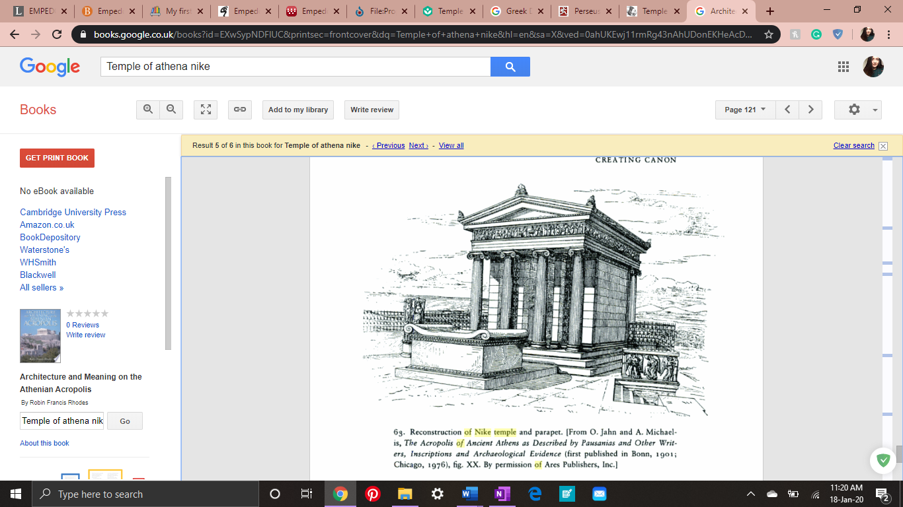
The reason for this temple’s construction is widely debated amongst scholars, however “The inscription indicates that a temple to victory was planned as a thank offering and commemoration to Athens leading role in Persian Wars” (Darling, 2004 p. 187).
Figure 1: Reconstruction of Athena Nike (Image from: (Robin Francis Rhodes, 1998, p.121)
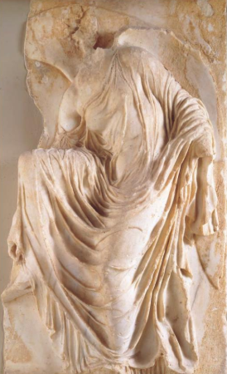
It is the smallest temple at the Acropolis and placed at the southwest corner, at the edge of a high cliff. “This was the spot most vulnerable to attack but also well placed for defense, was very appropriate for the worship of the goddess of victory” (Minollari, 2020).
The art style of the temple is another aspect that is debated, professor of art history and archaeology Kleiner argues that “Part of the frieze was devoted to the battle of Marathon – a human event” (Kleiner and Gardner, 2017). However, museum professional, and teacher Janson argues that “The participants are winged personification of victory rather than citizens of Athens (Horst Woldemar Janson and Janson, 2004, p.14)”
Figure 2: Nike adjusting her sandal, from the south side parapet of the temple of Athena Nike (Image from: (Kleiner and Gardner, 2017)

Bibliography
YSMA. (2018). Temple of Athena Nike - YSMA. [online] Available at: https://ysma.gr/en/monuments/temple_athena_nike/ [Accessed 18 Jan. 2020].
Darling, J.K. (2004). Architecture of Greece. Westport, Conn.: Greenwood Press, p.189.
Minollari, K. (2020). Temple of Athena Nike on the Athenian Acropolis (article) | Khan Academy. [online] Khan Academy. Available at: https://www.khanacademy.org/humanities/ancient-art-civilizations/greek-art/classical/a/temple-of-athena-nike [Accessed 18 Jan. 2020].
‌ Horst Woldemar Janson and Janson, A.F. (2004). History of art: The Western tradition. Vol. 1, [Prehistoric through gothic art]. Upper Saddle River: Pearson Prentice Hall, p.14.
Kleiner, F.S. and Gardner, H. (2017). Gardner’s art through the ages: The Western perspective. Volume I. Australia: Cengage Learning.
‌

‌

