Connor McGuinness
1803076

Vehicle Balance and Braking Report

Vehicle Systems
Kerry Tudor
M4X02198

Contents
Table of Contents
Contents 2
List of Figures 3
1.0 Introduction 4
2.0 Research 4
3.0 Results 6
4.0 Analysis 8
5.0 Conclusion 8

List of Figures
Table 1 : Front Loads against Longitudinal Acceleration 6
Table 2 : Rear Loads against Longitudinal Acceleration 6
Table 3 : Front Loads against Lateral Acceleration 6
Table 4 : Rear Loads against Lateral Acceleration 7
Table 5 : Front Loads against Velocity 7
Table 6 : Rear Loads against Velocity 7

1.0 Introduction

The purpose of this report is to compare and contrast different vehicle chassis and suspension types, the static loads for each corner of the vehicle will be calculated while the vehicle is undergoing a left-hand turn. To go along with these calculations, the aero load and the four corners of the car’s corner weights have been calculated with different longitudinal and lateral accelerations. The weight transfer from the left to right, and back to front is calculated and the same is done for varying the vehicle speed.

2.0 Research

There are a myriad of vehicle chassis and suspension systems that have evolved over the years and they keep on evolving as people try to revolutionise the motor industry. The Land Rover has a ladder chassis because of its two main integral parts, it has the frame which holds everything and it have its body which is attached, so if the body get damaged the internals and the chassis have reduced risk of being damage in an accident. This is good as it reduces risk of damage to the engine components and reduces rick of the frame bending while off road as the car has been designed. Chassis are constantly being revised because new industry standards and are being implemented to keep the driver safer in the event of an accident. Motorsport and road vehicle have different regulations due to the higher risk of accident with motorsport vehicles.
Series production, touring and sports cars have specific dimensions that they must follow while implementing a roll-cage for the vehicle, sports racing cars however are more lenient on the guidelines manufacturers and mechanics have to follow. There is a minimum height and specific material detailed.
Single seater racing cars have specific guidelines on dimensions and angle for the chassis. The material choices are also mentioned. While the main reason for the regulations is to keep the driver safer, road cars are typically using cheaper materials than motorsport cars because their intention is to be mass produced. Racing cars are built to be light weight, aerodynamic and structurally solid. More research is needed into materials to keep the chassis and main body of the vehicle as rigid and light weight as possible.
The Land Rover is a heavy and compact vehicle that is designed to be an off-road vehicle. Lighter suspension makes it a more comfortable ride for passengers, the soft suspension is less rigid which gives the vehicle a smoother ride over rough terrain, softer suspension is used in most road cars as well as it gives the driver a comfier experience. However, firm suspension is more rigid than soft suspension which leads to having a rougher ride, but it gives the vehicle a better handling around corners and higher traction which increases top speed and makes it easier to take corners at much higher speeds as the car is firmly planted. Racing cars also need a harsher suspension because of what the vehicle is doing, while this would not be a suitable for road cars as they need a lighter suspension system. Supercars and sports cars are not the only vehicles to use hard suspension, trucks use it as well but for a very different reason. This is so the truck can handle heavier loads and still maintain stability and handling while cornering. Without hard suspension for a truck, the rear would sag and cause damage to the vehicle’s axles.
Suspension is a critical part of a vehicle and no option is better than the other. It depends on what the vehicle is going to be doing, as stated above and how the drive will drive and treat their vehicle.
Anti-roll bars are a cheap but effective method of improving vehicle handling. An anti-roll bar is generally a metal beam on each of the vehicles axis’s, in the event of a corner, the ani-roll bar will reduce the roll of the vehicle by adding stability without affecting the spring rates for the suspension. This increase the handling of the vehicle by experiencing less suspension movement. This reduces unnecessary weight transfer to the outside tyres and increases the amount of work the inside tyres can perform. There are many advantages to anti-roll bars, but a disadvantage is linking the suspension together, this decreases the ability that suspension has to absorb small bumps in the road e.g speed bumps and potholes which inherently decreases tyre grip. The mounts used to secure the antiroll bar to the chassis often break due to stress and tension which impact the handling dramatically because the roll bar connected the suspension together, there is no longer that link to keep everything inline. If you wanted to reduce the roll the body experiences, there should be stiffer roll bars on either side of the vehicle or on both bars because this links the front and back because this links suspensions together. If you wanted to reduce understeer or increase oversteer, there should be stiffer rear bars to increase the grip the back tyres have, thus reducing understeer and increasing oversteer. The opposite is done to reduce oversteer and increase understeer. Anti-roll bars are widely used in road cars due to the nature of driving.

3.0 Results

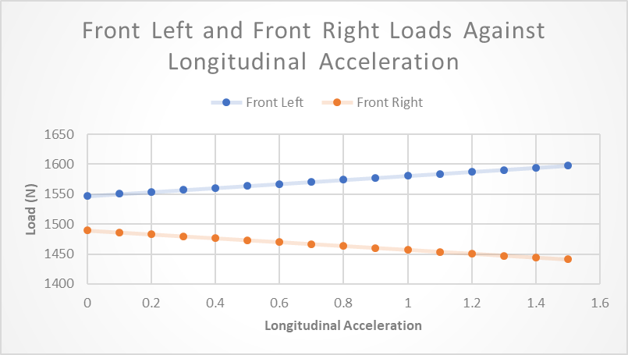

Table 1 : Front Loads against Longitudinal Acceleration
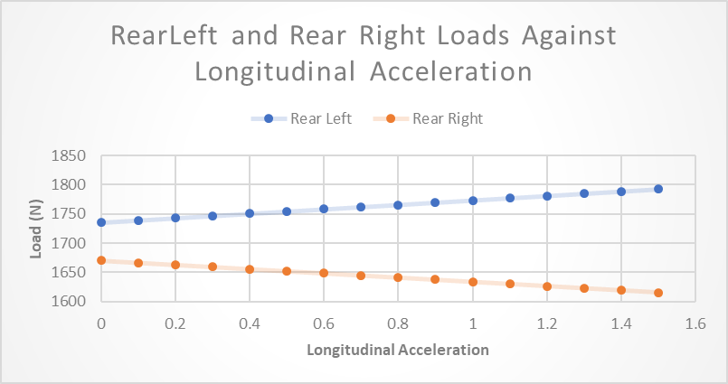

Table 2 : Rear Loads against Longitudinal Acceleration
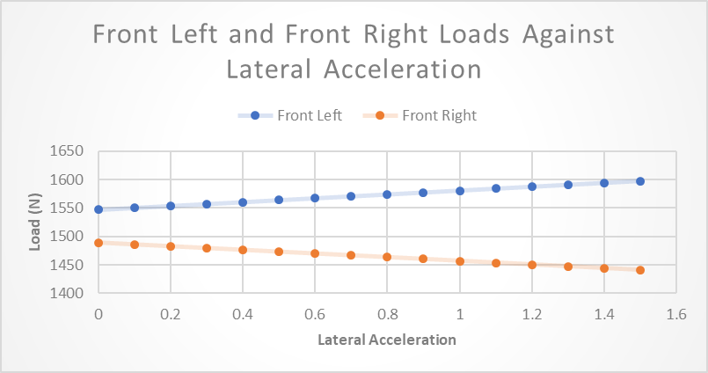

Table 3 : Front Loads against Lateral Acceleration
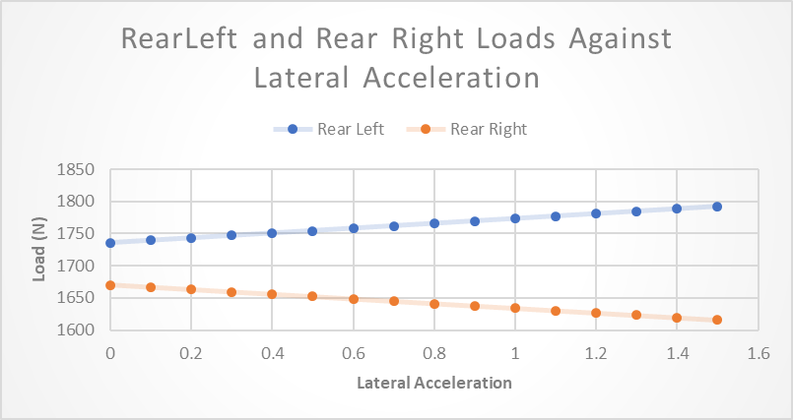

Table 4 : Rear Loads against Lateral Acceleration
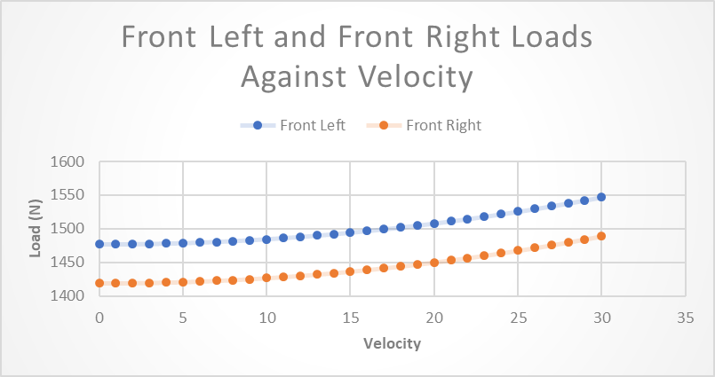

Table 5 : Front Loads against Velocity
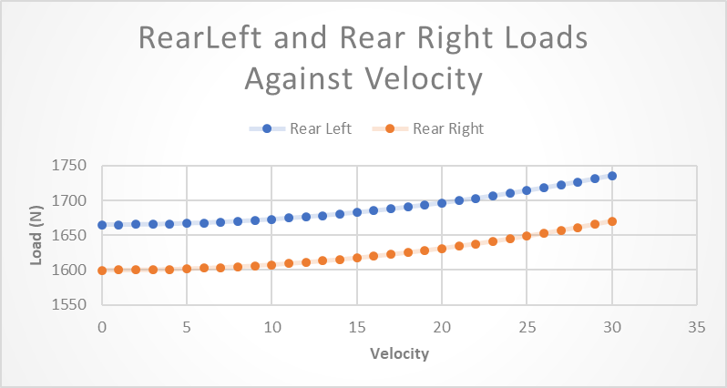

Table 6 : Rear Loads against Velocity

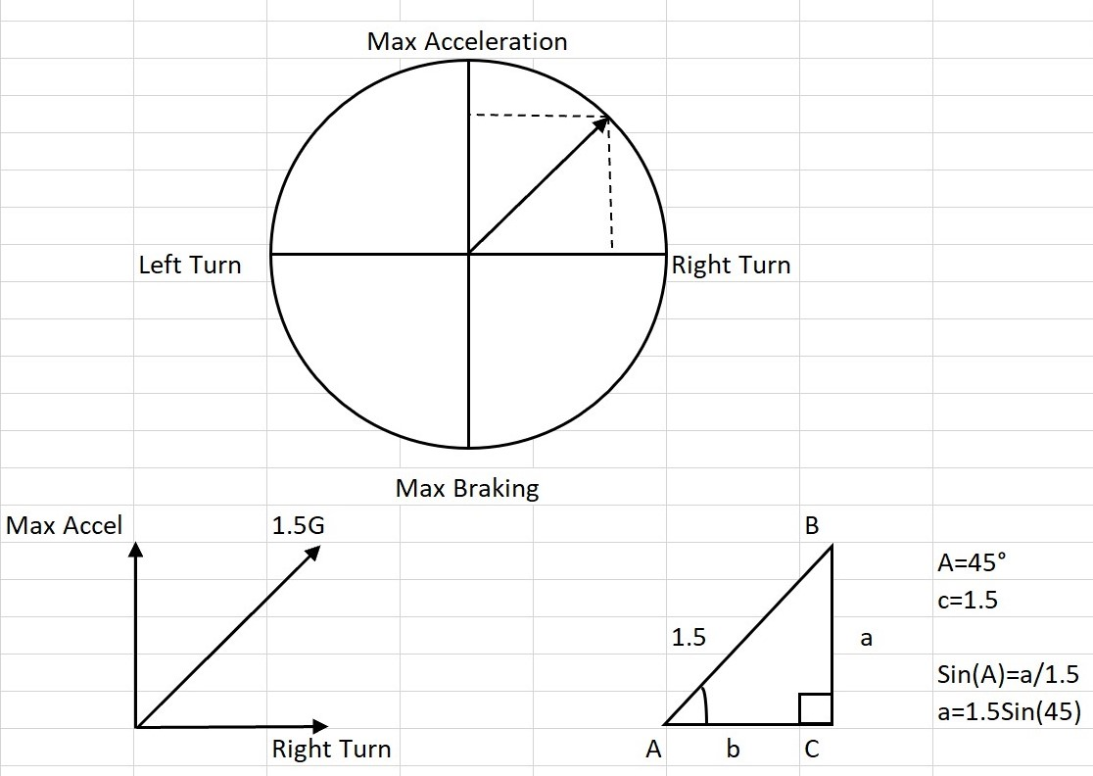

Table 7 : Traction Circle
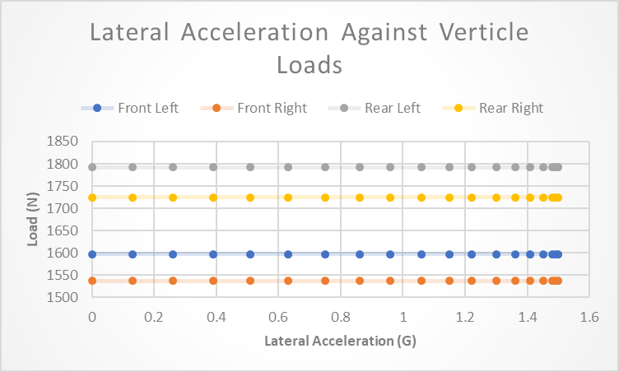

Table 8 : Lateral Acceleration against Loads
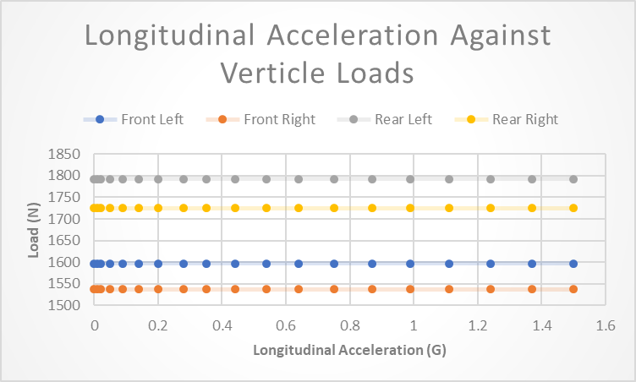
Table 9 : Longitudinal Acceleration against Loads

4.0 Analysis
The above graphs all share the same defining attributes, when the loads on the front and read left corners of the vehicle increase the loads on the front and rear right corners of the vehicle decrease. The Graph clearly states that the vehicle is undergoing a right-hand turn, this also shows that lateral and longitudinal accelerations are proportional to each other, along with the loads. The aerodynamic load is a negative value which means a downforce is acting on the vehicle, this is cause by the shape of the main body of the vehicle. At high speeds this increases the weight of the car proportional to the velocity at which it is travelling, which also increase the tyre grip because there is more load on the wheel, increasing the contact patch of the tyres. If a max of 1.5G in the longitudinal and lateral direction was to occur, there would be no tyre grip and the vehicle would lose all handling as the traction would be out of the traction circle as can be seen in the graph of the traction circle in the results part of this report. Increasing the average track wheelbase, the weight transfer and the unnecessary weight transfer and can also increase the possibility of the vehicle losing grip. The same situation is valid for increasing the centre of gravity height. Increasing the wheelbase of the vehicle decreases the weight transfer while also adding stability to the vehicle.

5.0 Conclusion
In conclusion,
Firstly, I think different suspension and chassis types can be used, but you use different types depending on the circumstances. As I have described in my research, the Land Rover has a ladder chassis and leaf spring suspension, this is because it is built for off-road. However, this could not be an efficient use on a McLaren P1 as it is a supercar and needs harder suspension to keep traction and a lighter chassis like the monocoque chassis as it is lighter and a is a full body chassis.
Secondly, anti-roll bars are widely used to increase the stability and tyre grip of vehicles as stated in my research above. The variety orientations to set up the anti-roll bar system and the cost of materials is an ingenious method of improving stability and grip to a vehicle while making to safer to drive.
Finally, from the graphical data, we can say that longitudinal and lateral acceleration is proportional to each other in this report. The weight transfer increases as the lateral/longitudinal acceleration increases, as one corner load increases, the other loads decrease meaning all side are proportional to each other and showing the vehicle is balanced.
6.0 References
1) picknbuy24.com. (2016) Firm Suspension versus Soft Suspension [online] Available at: https://www.picknbuy24.com/column_287.html
[Accessed 18 Mar 2020]
2) motorsportessentials.co.uk. (2017) Anti Roll Bars [online] Available at : https://motorsportessentials.co.uk/blogs/car-setup/test
[Accessed 18 Mar 2020]
3) balancemotorsport.co.uk. (2019) Anti-Roll Bars [online] Accessed at: https://balancemotorsport.co.uk/suspension/anti-roll-bars
[Accessed 18 Mar 2020]
4) Lecture Notes

