Developing a new Landscape for customer care at Crug Glas Country House

Kathryn Roberts 2114900
Strategic Management BMMB7013
Dr Jayne Griffith Parry

Contents

1. Contents Page 1
2. Executive Summary Page 2
3. Introduction Page 4
4. Main Findings Page 6
5. Conclusions Page 21
6. Recommendations Page 23
7. References Page 27
8. Appendices Page 34

Executive Summary

This report has been written to develop a new landscape for customer care at Crug Glas Country House, with the aim of “creatively reshaping the organisation’s strategic direction, discovering a new way forward for delivering innovative customer care ensuring future resilience and sustainable competitive advantage against a backdrop of a pandemic” (Parry, 2021). It has reviewed the business’ current strategic management as it currently stands, using both PESTLE and SWOT analysis and whilst reviewing customer care trends and strategies within this report to transmute current customer care at Crug Glas Country House. The Coronavirus pandemic has changed the face of customer service, altered demand and created an opportunity for Crug Glas to review its current standards. Change management has been considered alongside Lewin’s change model, ADKAR with measured goal points throughout the change process.

According to (Hayes, 2010, p. 3), most importantly is “translating the need for change into a desire for change. Organisational members may be reluctant to pursue change because they lack confidence in their own and others ability to make a difference”. The adaptations subsequent to Covid-19 are a clear illustration that Crug Glas are capable of effective change with government guidelines. This report will outline procedures in order to implement change effectively through technology, training and incentives in order to achieve the objective of reshaping Crug Glas’ customer care model.
Strategically, the current business model is defunct and redundant and an overhaul required. In order to create a new vision, steps must be taken. As requested by the owners, as the consultant for their business, with prior knowledge of working for Crug Glas Country House, my recommendations are to focus on employment and employee engagement, training, goals and incentives which puts the customer back at the centre of the business model alongside maximising space in the house to invest and gain on personal wellness, with it rebounding after stagnating during the Covid-19 pandemic (McKinsey & Company, 2021).

This report was compiled with prior knowledge of the business, extensive research and data from strategic management models, alongside examining how employee engagement is essential if you are to improve customer care. All with the goal of hyper personalisation in mind and utilising the current market trends to the business’ advantage. This report has not taken into consideration the farming aspect of the business.

Introduction

In March 2020 the Coronavirus changed businesses as we know it after the government ordered the immediate closure of establishments, hospitality among them (BBC, 2020). Lockdowns were imposed, employees placed on furlough, no gatherings were allowed and strict rules were put in place to ensure the safety of the nation. The impact of this is still felt throughout hospitality with customer service impacted and depersonalised, financial losses and an evolving virus and subsequent rules. Crug Glas was not unaffected. Weddings were cancelled and postponed, business interrupted, and Covid rules implemented. In this challenging environment, we need to put the needs of the guests first and analyse the business to see what strategies can be used to improve and revolutionise customer care under the current climate as requested by senior management.

The level of business interruption was unprecedented, with many businesses still under threat. According to (Ramuni, 2021) hospitality has been the hardest hit with consumer spending starting to increase in May of 2021, but still not to pre pandemic levels. Job vacancies in the industry are also high with Brexit considered as an additional factor (Euronews, 2021). £53.3bn is thought to be the annual loss of sales within hospitality in the last year with 42% of workers being “very concerned about their long term job security” with employers needing “to take great care to engage their teams, promote their wellbeing, and champion the sector once again as a great place to work and build a career” (UK Hospitality, 2021).

Reviewing the current climate, creating a sense of urgency in ensuring a sustainable business framework, a strategic analysis of the current business model, inclusive of reviewing customer care with reference to the pandemic is required. Indeed, (2016) claims ‘there are different approaches and frameworks for strategic management’ including, identification, analysis, formation, execution and evaluation. To implement this new strategy, the owners, general manager, accountants and consultant are to be involved alongside the team.

Prior to the pandemic, the weekly turnover at Crug Glas were on average in excess of £15,000, or £780,000 per annum with targets to reach £1million in turnover by 2025. Introducing Reinvention was part of the scheme to regenerate business and introduce new customers to the property, compliment event offerings and to offer additional attraction to customers. The Covid- 19 pandemic has resulted in a substantial loss, but thanks to the support of the government and loans, such as the Furlough scheme and grants made available, Crug Glas has not been made redundant. However, failure to review the current situation will most likely result in closure.

Main findings of strategic analysis and critical evaluation of the strategic options

Crug Glas is a country house, restaurant with rooms in Pembrokeshire. Set in 600 acres of land in St Davids, it offers breath taking views of unspoilt countryside and easy access to the area’s world-famous coast. This is Pembrokeshire accommodation at its finest. It’s where the warmth of home meets 5-star indulgence.
(Crug Glas, unknown)
Crug Glas Country House, an establishment renowned for its event venue, ‘The Cow Shed’ and the first choice as an eatery and 5 star hotel with a hair and beauty salon. Their mission statement, to be Wales's leading function establishment whilst continuing to offer a luxurious 5-star country house boutique hotel and restaurant, drawing guests from all over the world as well as locals who count it as one of the very best restaurants and places to eat in Pembrokeshire. Knowing the company, their values; warm Welsh welcome, create memorable moments, best foot forward, creativity in the way we do business and look after our community.

In order to consider a new strategy, a review of current trends, demands, climate and current business strategy needs to be reviewed. Reviewing the business and its current strategy by conducting a Pestle and Swot analysis gives a clear picture of the business’ current stance and what strategies will be required to be used in order to improve customer care. A Pestle analysis will examine six environmental areas that may affect the organisations and allow the business to be fully aware of their environment (AssistKD, 2018), whilst a swot analysis will help identify areas of the business that need overhauling, standardising, or improving.

Political
Rules and regulations are constantly evolving. The Coronavirus pandemic and the ever changing goal posts are an example of this. The threat of the virus is continuous, with levels of cases rising.
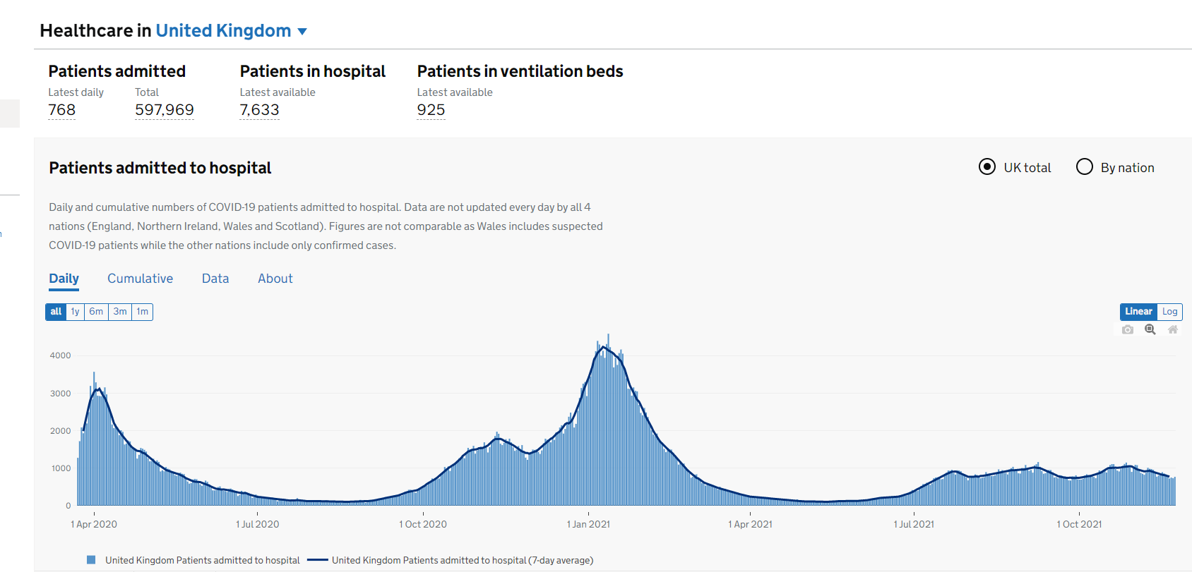
(Gov.UK, 2021)
Potential forced business closure needs to be considered and a plan in place. Brexit has also impacted business with a nationwide staff shortage, increase in food prices, lack of consumer confidence and staycations, Michael Radley (2021). Radley states that the industry “is facing a staffing crisis, just as businesses are trying to rebuild and recoup some of the money they have lost in the last year”. He also claims that staff failing to return after furlough and harsh migration laws have cost the hospitality sector 25% of their workforce. With all of that talent gone, seemingly overnight, how can the hospitality business bridge that gap? According to UK Hospitality (2021) “Businesses are having to limit their opening hours or even face total closure due to a lack of available employees” with “only 5% of businesses reported having no vacancies. 80% of respondents had front-of-house vacancies, 66% had chef jobs unfilled and 47% were in need of housekeepers.”

Economic
Not only have businesses and their owners have had to find innovative ways to ensure their organisations continue to be a going concern during the pandemic, they have also had to deal with the aftermath of the UK parting with the EU. The pandemic has left business weakened struggling to prepare and adapt to the prolonged consequences of Brexit (Tetlow and Thomas, 2020).

The impact of coronavirus and FTA Brexit on GDP in different sectors
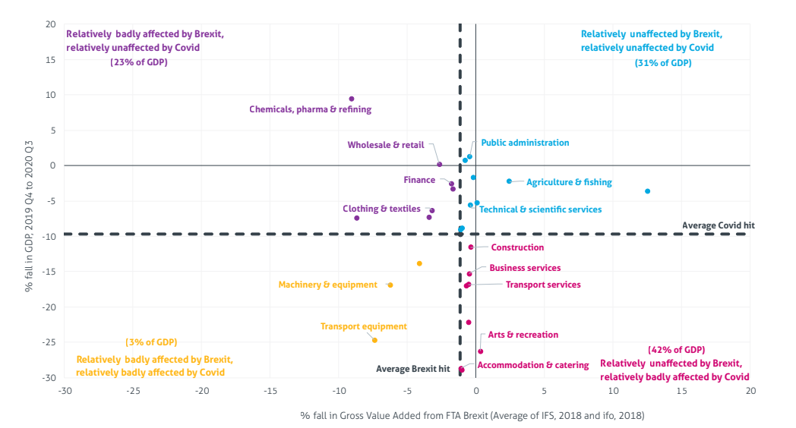
Source: Office for National Statistics, (Tetlow and Thomas, 2020)
This report is however outdated and does not take into consideration the impact of employees affected by Brexit both within the industry and outside of hospitality. With a nationwide shortage of HGV drivers (Office for National Statistics, 2021), based on prior experience within the business, getting the products to businesses is causing a problem along with the rise in costs. With 30% of the industries workers thought to be from Europe (Butler, 2021) and 300,000 hospitality workers having left their posts in hospitality (Office for National Statistics, 2020), it’s no wonder Crug Glas are struggling with recruitment and goods. Food prices are predicted to rise between 3-5% (Michael Radley, 2021) and reviewing current suppliers and recruitment practices ought to be paramount.

Social Environment
Reviewing current trends in the market to ensure future resilience of Crug Glas is equally important. With “Insta Worthy Décor” Sustainability and Staycations (Hospitality Titans, 2021) being the hospitality trends of 2021, what else needs to be considered? “Wellness is a holistic conversation, which involves six dimensions: emotional, occupational, physical, social, intellectual and spiritual.” (Cooks- Campbell, 2021). More than ever, consumers, thanks to Covid -19, are concerned and coveting long lasting wellness. McKinsey (2021) research shows that there are 6 wellness categories that consumers are most interested in, health, fitness, nutrition appearance, sleep and mindfulness. How can Crug Glas incorporate this?

Technological factors
Covid 19 has catapulted many business into the modern era by forcing their hand into the digital age. Paper was removed, and replaced with apps, check ins were done virtually and printing menu’s made a thing of the past. These methods revolutionised by companies such as Vamoos (Vamoos, 2021) and Hotel Perfect ‘Hotel Management Made Easy’ ( Hotel Perfect, 2021). How can Crug Glas improve? Excel is an outdated way to do business.

Legal
There are many laws and regulations that must be followed within the hospitality sector. Not only health and hygiene guidelines, but employment laws, sustainability guidelines, fire regulations and trade description acts. Reviewing the hotels procedures, Crug Glas must ensure compliance at all levels with legalities and regulations.

Environmental
We now more than ever need to look towards protecting our natural resources, protect our environment against climate change and pollution. Crug Glas already produce their own electricity and heat their water using wood burning boilers. Sustainability is much more than looking after the environment; “We can use sustainability at the forefront of our business models, to reflect on company culture and help the business plan long term” (Roberts, 2021).

SWOT
Strengths  Established  Popular  Location  Quick growth  Beauty Salon  Photogenic  Going concern | Weaknesses  Feedback inconsistent  Consistency  Sustainability – all things green  Mission statement and values  Communication  Technology  Knowledge  Fibre
Opportunities  Team strength – we have a combination of old and new teams member.  Sales  Rev par  Offers  Further collaboration  Loyalty programmes  Events  Restaurant | Threats  Covid – 19  Brexit  Current industry shortage for employees  Expansion of other near hotels  Premier Inn  Air BNB  Seasonality  Location

Reviewing Crug Glas’ business using SWOT demonstrates the potential the business has to improve and change. Combine this with the PESTLE analysis and we have common ground to review for choosing what to challenge, and strategically view to change.
Current climate and impact of covid on hospitality
“The initial shock of the COVID-19 pandemic forced organizations to adopt physical distancing, test their business continuity plans, and rapidly deploy work-from-home models, all while customers rushed to digital channels. This urgent response has now given way to a pervasive uncertainty about what lies ahead. One certainty, however, is that personalization will continue to be central to the customer experience” ( McKinsey, 2020).
With this in mind, developing a new customer care strategy is of the utmost importance with flexibility built in for the fluctuations in demands for dealing with the pandemic.

Hyper personalisation
In order to redefine Crug Glas’ customer care strategy, what are today’s catchphrases? Hyper personalisation “had become an integral part of exceptional customer experience – not just in e-commerce channels but in all customer interactions” (McKinsey 2021). Knowing how businesses have been forced to embrace technology, this idea seems key to combining the perfect customer care package in a digital world. According to McKinsey (2021) “Companies should make hyperpersonalization in customer care a top goal for 2025. This time frame reinforces the urgency while providing enough time for companies to achieve the goal”.
What do customers want? They want to feel special, they want to feel recognised, they want to feel that they are the centre of the universe (Vera, 2020). In order to achieve this in a customer facing context, the right offerings need to be available and employees trained in the art of personalised customer care with great attention to detail. Proactive, pre-emptive service. Technology will help with gathering data, the employees will offer this service. If the industry is not careful, “we will lose the empathy within hospitality and anybody can be automated but not a human. The future is not technology, the future is going to be human” (Monique Morrow, 2018). Technology plays a part, but cannot offer the human touch. Hyper personalisation in a world where we are currently de-personalised, with social distancing and masks, is going to reintroduce hospitality to hospitality.

Current trends
With health being the new wealth, ensuring trending amenities are available for guests will in itself enhance Crug Glas’ customer care platform. One of the 10 trends shaping the industry at present is “holistic health and wellbeing”, (EHL Insights, 2021). The Global Wellness Institute considers various types of wellness, including, mental, physical, workplace wellness, healthy eating, personal care and beauty and preventative and personalised public health with wellness, a large growing sector of the world’s economy, considered to be 5.6% of global economic output (Global Wellness Institute, Unknown). McKinsey & Company (2021) supports this, indicating that there are six dimensions to wellness; better health, fitness, nutrition, appearance, sleep and mindfulness and also claim that out guests want “more personalisation please”.
Wellness is here to stay as consumers across nations plan to increase their spending on personal health, appearance, fitness, and more. If the pandemic has taught us one thing, it’s that physical and mental health will remain a priority for millions of people across the globe for a long time to come. (McKinsey & Company, 2021)
Customer Care
Hospitality is known for being customer orientated, front facing and creating an environment for the guest experience. How can an industry like this improve and radicalise customer care? According to “The Best Service is No Service” (Price and Jaffe, 2008) there are seven principles for moving from basic to best service;
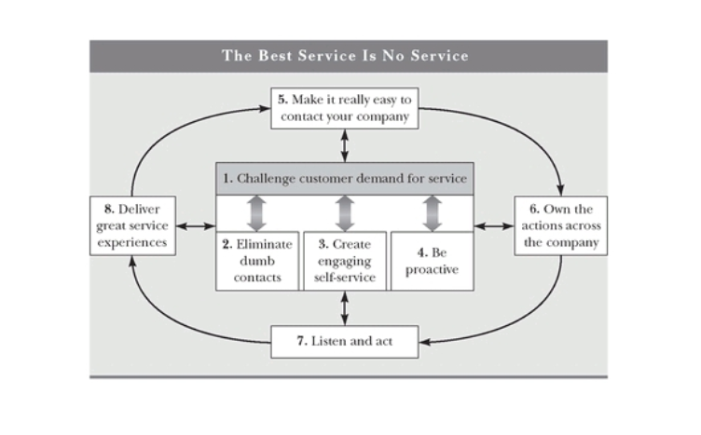
(Price and Jaffe, 2008, p. 29).
- Eliminate dumb contacts. Don’t handle contacts they shouldn’t need; in other words, reengineer them.
- Create engaging self-service, by which we mean with a very high success rate in the web or IVR self-service channel.
- Be proactive. If you know something’s wrong, tell your customers. If you need to send an alert, go do that before they have to contact you.
- Make it real easy to contact your company. Don’t hide behind web sites that have no 800 numbers and channels that don’t mix together. Just make it really easy to find out what’s really going on out there.
- Own the actions across the company. Very few customer service support issues are caused by customer service. They’re really caused by other groups. So figure out how to get the ownership back to them and work with them.
- Listen and act. There’s terrific information streaming all the time between customers and the service centre, so listen and act on that.
- Deliver great service experiences, taking a different approach, in terms of metrics and training and so forth, to deliver a great service experience because we’re never going to get rid of the service centre, the contact centre. We just want to reform what it does.
(Customer Think, 2008).

Reviewing their ideologies, getting the process right before the guests arrives is as imperative as offering hyper personalisation when they guests are in house. Utilising technology to minimise frustration, offering personalised service pre-emptively and proactively seeing to the guest when in situ.

Crug Glas should challenge the customer demand for service – (Price and Jaffe, 2008 p.8-9). “ The standard across most service operations is to report and track how quickly things were done, not how well they were done or how often, or why they needed to be done at all” (Price and Jaffe, 2008, p. 7-8). Challenge the status quo, if the customers are contacting Crug Glas, find out why and see if the situation can be resolved elsewhere. Do they even need to contact us at all? “Apple are genius at this”. (TED, 2017). They make buying seamless and remove obstacles to make buying simple. Empower your customers and your team to ensure service is seamless. By creating engaging self-service, putting customers in control and integrating channels, businesses would finally be helping correct self-service, making it not only an option, but a “key strategic imperative” (Price and Jaffe, 2008, p.68).

Finally, a review of the current engagement of employees was conducted. A survey was completed by the employees and results compiled. They show that the team feel disengaged and powerless and frustrated with archaic systems. The general consensus was that they enjoy working for the business but are frustrated with the systems in place and a lack of trust. This was alongside a feeling of management verses the team. Employee engagement is integral when it comes to providing excellent customer care and creating a sustainable business model. An engaged employee is driven to help their organisation succeed by directing their best efforts towards their work. They believe in the organisation, and they will work to make sure that the organisation succeeds. (Peters, 2021). Employees who are engaged are more likely to be productive, produce better service and have innovative ideas (Cipd, 2021).

Changing Strategy and Implementing Change
Implementing change in the workplace can be challenging. Hemerling (2021), claims there are 5 ways to lead in an area of change and you need to put people first.
- Inspire through purpose
- Instil a culture of continuous learning
- Go all in
- Give people what they need to succeed
- Demonstrate directive yet Inclusive leadership
The DeBoer Fellowship, (2020)
Putting people first, at the heart of your change management, getting them immersed, allowing inclusivity, parity and tools, you will have the potential for successful change management. Leaders often wait until the last moment, as a result everything happens in crisis mode, or given the urgency they just focus on short term goal which doesn’t give much hope for the future (Hemerling, 2016). This is reactive management at its worst. Hemerling (2016) claims that by putting people first with a clear road map, milestones accountability and inclusive leadership will give you the results you desire and diminish the resistance to change.

According to Zook & Allen (2011), assuming we review our business strategy, base it on the same ethics, amend it, success should follow; “Using the same but different”. Chan and Mauborgne (2009) argue that if the strategy is not aligned with customers, ethics and requirements it cannot be successful, we need to work with our competitors and suppliers and not against. When considering employees who will be implementing the change, Hemerling’s (2016, p 163) arguments are compelling, and Hayes (2010) confirms that leadership styles are an important factor with mutual trust and respect for team members key to successful change management.

In order to engage the team members in the change process, they must also be involved in the planning stage. Historically, employees deal with the day to day aspects of running a business, so know what will work and what may not fit. It is key to have their involvement form the start. This will not only reduce the likelihood of resistance to change, but will also allow for realistic ideas to be implemented along with ideas that will genuinely work strategically within the business. Bennah (2021), states that in order to create the right environment for change a business must, encourage the right attitude, develop a culture that is based on creativity and innovation, provide appropriate rewards and recognition, encourage flexibility, foster employee involvement along with empowering employees.

Adkar’s model posits a similar framework. Created by Jeffery Hiatt, the ADKAR model change “helps facilitate change on an individual level, since change is often less about the changes themselves and more about peoples reaction to them” (Lucid Content Team, unknown). Reviewing alternative options, they all agree that getting agreement for the need to change is crucial for the success of implementation. The Adkar model clearly demonstrates the steps to implement successful change.
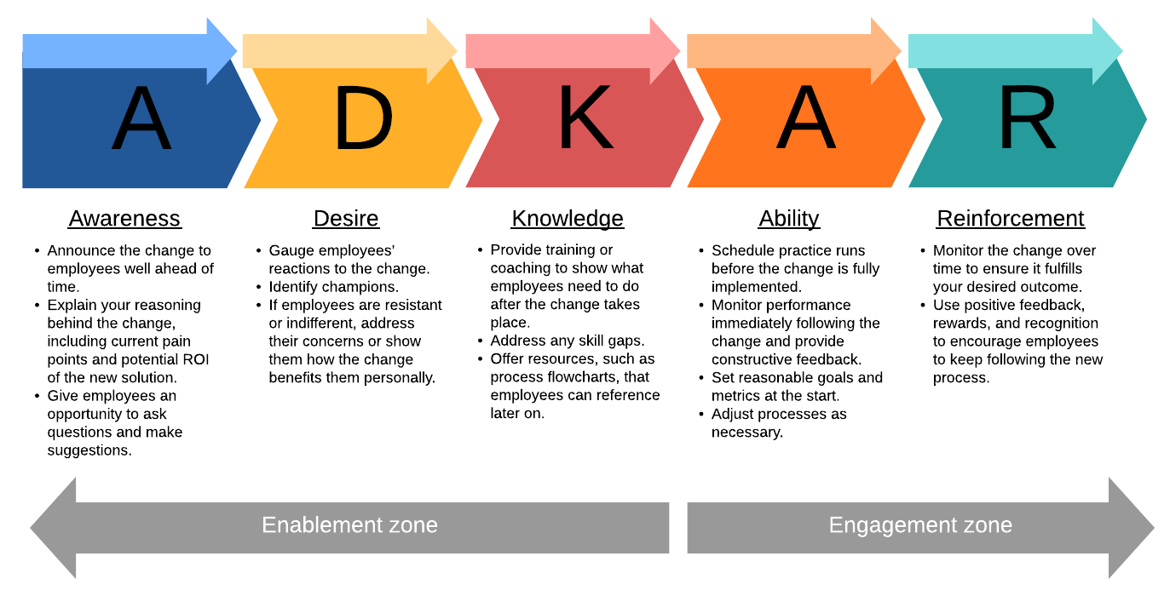
(Adkar model. Bing images (2021))
Lewin developed a change management model in the 1940’s and it is still relevant today due to its straightforward and effective structure.
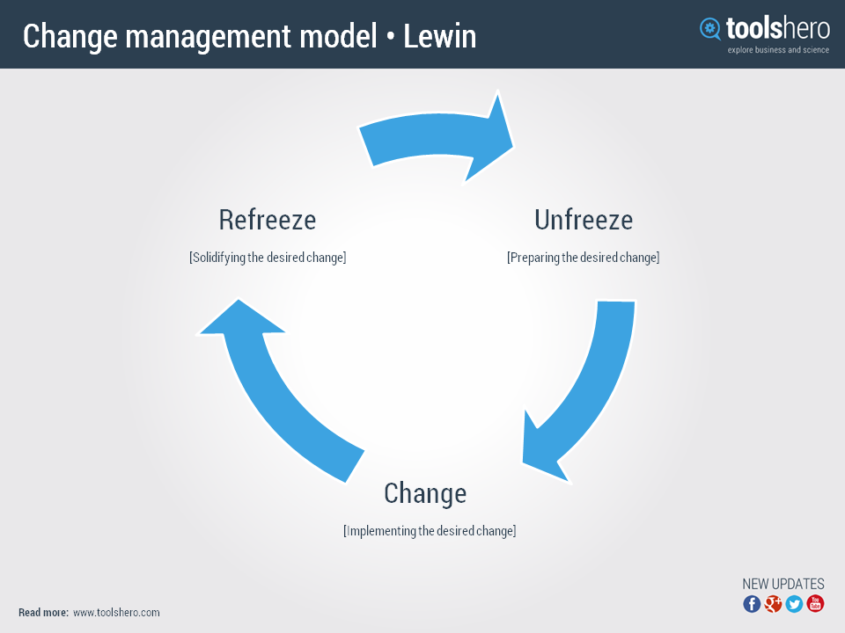
(Change Management model- Lewin. Bing Images (2021))

This strategic framework, can be used repeatedly in conjunction with alternate ideas and frameworks to ensure change is positive and reinforced. Hayes (2010, p29) claims “the need to unfreeze is not limited to transformation full change. Even when the change is relatively small incremental change, there may still be resistance from ‘local’ organisational members and other stakeholders”. In other words, this framework can be used to re balance, refocus or to make minor changes and adjustments within the business strategy whether on a small or large scale.

Measuring Change
Reviewing, managing and implementing change is futile without reviewing the consequences. Have the changes been successful? Are they working? Have they been implemented correctly? What are the reactions and subsequent consequences on the business; has it caused a ripple effect? According to Prosci “The first category of measurement is organisational performance” (Prosci, unknown). He continues that it is important to monitor metrics inclusive of Key Performance Indicators (KPI’s), performance improvements and deliveries. Reviewing Prosci’s Adkar model, performance should be monitored immediately (Kotter, unknown). In order to review success, or failure, basic KPI’s within the industry should be measured alongside reviewing guest feedback, TripAdvisor scores and the bottom line, profit. These should be compared historically. These KPI’s are a well known measurement used within the industry.

Conclusion
Hemerling (2021) states that changes can be challenging. Aligning vision, believing in people, having the right equipment and inclusivity are all way to navigate the sea of change effectively when implementing a new strategy in business. The current staffing crisis means that the hospitality industry will now more than ever need to consider staff retention (Future Shock, 2021) as a way to do business. UK Hospitality also explain how employees “prioritise close communication, supportive teams, training and clear career progression, and these factors could be at least as important as pay and perks in the second half of 2021” (UK Hospitality, 2021).

Modern trends such as health and wellbeing, should be considered alongside change management strategies to ensure a smooth transition with hyper personalisation as the ultimate goal for the business. This should be achieved through implementing training, coaching, engaging the team, introducing technology, reviewing procedures currently in place and challenging current business practices that are outdated and superfluous as seen in the pestle and swot analysis. As Price and Jaffe exclaim, “anticipate the customer needs” (p.101), “ Listen for Free” (p. 235) and “ make it fast and simple for the customer” (p.266). Your customers are you free consultants, provide proactive and pre-emptive service, break down barriers and “asses who really drives service interactions” (p.277).

In order to implement strategic change the use of a strategic change model should be used. The use of both the Adkar and Lewin model should be considered to help review the changes. The owners, general manager and employees should all be involved in reviewing the change and ensuring it is followed through. Using Hemerling’s vision should ensure a smooth transition along with reviewing KPI’s and guest feedback both when offering hyper personalisation and online reviews.

Recommendations
Crug Glas Country House has been a successful business since 1992. Reviewing the current customer care and business strategy, current demands, lifestyles, business trends and change management, customer care strategies such as the best service is no service and hyper personalisation, I have some recommendations for developing a new customer care landscape at Crug Glas Country House. Using the Swot and Pestle analysis and finding repeating opportunities is how I have come to the conclusions for these recommendations.

Employee Engagement
The first solution I suggest is simple; look after your team and engage your employees. It all starts with the right hire, training and investing time in the team for constant improvement. This change will need to be implemented by the owners and general manager. It will not be costly but time will need to be invested. With the current climate of Brexit and Covid-19, hospitality has been hardest hit and it is no longer acceptable not to look after our employees. In return, they will look after your guests. As Dostik (TEDx, 2017) suggests, we should be thinking just as much about our employees as our guests. Remove pinpoints, empower, feedback and give the employees a chance to grow and develop whilst also improving the customer experience.

Health and Wellbeing
With health and wellbeing being one of the biggest trends, Crug Glas should think about how they can utilise their property to help realize this. The function room is largely empty when there are no weddings. I suggest offering the room to yoga instructors, retreats operators, group workout classes all in the name of health and wellbeing. Utilising the space above the salon (Reinvention) for holistic treatments will also entice guests, both ones that stay in the house and ones who just want and require treatment. Not only is the health and wellbeing of our guests important but so is that of our colleagues. We need now more than ever consider the health and wellbeing of everyone. Having these offers will encourage customers to choose Crug Glas, but also looking after the team through these wellbeing offerings will be evident. This aspect should be frequently reviewed as to whether the business can delve further into this, nutrition, sleeping trends and therapies are to be considered. The company already attracts people to the country side, attracting business through clean fresh country air, nutritious meals and treatments will be beneficial to the business.

Hyper personalisation
Every member of the team in Crug Glas will be trained on how and what hyper personalisation is specifically with reference to how to offer his type of service in person and at different guest points during their experience. Prior to this, the owner and general manager will implement and review ‘The best Service is no Service’ and eliminate any processes that are counter intuitive and that make service and work not seamless for both the guests and the team. Everything that should be done is what is best for the guest. Eliminating barriers, easing back of house tasks, engaging employees will all make this new customer care offer flawless and enjoyable.

Technology
With customer care being the ultimate reason for this report and for why the business is successful, implementing hyper personalisation through training and development of the team is high priority. Although steps have been made to move forward in latter years, a holistic property management software required for the business to support employee engagement and hyper personalisation. There are many affordable pieces of cloud based offers on the market.

Strategic Management
Finally; The mission and vision statement for Crug Glas is outdated. Although many aspects are still useful, with change and growth must come a new vision. A team meeting to review the current visions and team decisions on redirection with the recommendations in this report should be considered. A rework of the current mission and values, to include ideas from all employees to effectively manage change adding more emphasis on the team, such as ‘we believe in people’.

Reviewing and measuring results
Recommendations for implementing the change are to use both Lewin and Adkar’s models. Lewin’s is simple to use on a daily basis, when offering feedback to an employee for example, whilst Adkar can be reviewed monthly to see how the business is moving along. Making sure time is planned to in to take stock and using figures to see how the business is moving forward. Employees should have monthly meetings to ensure they are still on target to achieve the new business care model and if there are difficulties, these can reviewed before they become a real barrier to offering hyper personalisation. “Organisational learning involves enhancing the collective ability to act more effectively” (Hayes, 2010), whilst measuring and reviewing the business changes holistically, individually, verbally, digitally and financially, Crug Glas can see if the recommendations have indeed been successful.

References
- AssistKD, (2018). What is PESTLE Analysis [video]. Available at: https://www.bing.com/videos/search?q=pestle+analysis&docid=608000952194909486&mid=D4BF7A9DCBE1EC7BE68BD4BF7A9DCBE1EC7BE68B&view=detail&FORM=VIRE (Accessed 29 November 2021).
- BBC News. (2020) ‘Coronavirus: UK pubs and restaurants told to shut to fight virus’ BBC News [video]. Available at: https://youtu.be/CgBU_XWPZBY (Accessed 29 November 2021).
- Butler, S. (2021) 'Quite a challenge: UK restaurants and pubs face staffing crisis after Brexit’, The Guardian, 1st May. Available at: https://www.theguardian.com/business/2021/may/01/uk-restaurants-pubs-brexit-staff-covid (Accessed: 02 December 2021).
- Crug Glas (Unknown) About Crug Glas. Available at: Crug Glas Country House B&B Restaurant With Rooms, Pembrokeshire (crug-glas.co.uk) ( Accessed:31 October 2021).
- Clover Infotech. (2021). Hyper-personalization and its benefits. Available at: https://www.bing.com/videos/search?q=hyper+personalization+in+hospitality&ru=%2fvideos%2fsearch%3fq%3dhyper%2520personalization%2520in%2520hospitality%26qs%3dn%26form%3dQBVDMH%26sp%3d-1%26pq%3dhyper%2520personalization%2520in%2520hospitality%26sc%3d0-36%26sk%3d%26cvid%3d5A95B1210CE4486FB30249608D591D9A&view=detail&mid=372EAC092555AFCAAECB372EAC092555AFCAAECB&rvsmid=B0DBBFAD0282AFA91297B0DBBFAD0282AFA91297&FORM=VDMCNR (Accessed 29 November 2021).
- Euronews. (2021). Britain's kitchen nightmare: Staff shortages across hospitality sector blamed on Brexit [video]. Available at: https://youtu.be/2O8hrWndyTo (Accessed 12 November 2021).
- Gov.UK (2021) Healthcare in United Kingdom. Available at: Healthcare in the UK | Coronavirus in the UK (data.gov.uk) (Accessed. 28 November 2021).
- Korosh, F. (2020) The Impact of Brexit on Hotel Industry Available at: https://www.hospitalitynet.org/opinion/4096893.html (Accessed: 01December 2021).
- Kotter (unknown) The 8 step process for leading change. Available at: The 8-Step Process for Leading Change | Dr. John Kotter (kotterinc.com) (Accessed: 18 November 2021).
- Customer Think (2008) The Best Service is no Serivce. Available at: The Best Service Is No Service | CustomerThink (Accessed: 29 November 2021).
- Bennah, G (2021) Creating an environment for change. UWTSD.
- Cooks-Campbell, A. ( 2021) 22 new wellness trends that should be on your radar. Available at : 22 new wellness trends that should be on your radar (betterup.com) (Accessed: 06 December 2021).
- EHL Insights (2021). 2022 Top Hospitality Industry Trends. Available at: 2022 Top Hospitality Industry Trends (ehl.edu) ( Accessed: 07 December 2021)
- Global Wellness Institute (unknown). Wellness Definitions. Available at Wellness Definitions - Global Wellness Institute (Accessed 07 December 2021).
- Hayes, J. (2010) The Theory and Practice of Change Management. Third Edition edn. Palgrave Macmillan.
- Hotel Perfect (2021). Hotel Management Made Easy. Available at Hotel Management Software | Hotel Software in the UK (hotelperfect.co.uk) (Accessed: 06 December 2021).
- Hospitality Titans (2021) Top 2021 Hospitality Trends. Available at: Top 2021 Hospitality Trends – Hospitality Titans (Accessed: 06 December 2021).
- Indeed Editorial Team (2021) Strategic Management: Definition, Purpose and Example. Available at: https://www.indeed.com/career-advice/career-development/what-is-strategic-management ( Accessed 11 October 2021).
- Jefferies, N. (2021) The impacts of EU exit and coronavirus (COVID-19) on UK trade in services. Available at: The impacts of EU exit and the coronavirus on UK trade in goods - Office for National Statistics (ons.gov.uk). (Accessed: 02 December 2021).
- Kim, W,C and Maugborgne, R. (2009) ‘Harvard Business Review’. How Strategy Shapes Structure, pp 73- 80.
- Lahari, R. (2021) Coronavirus and its impact on UK hospitality: January 2020 to June 2021. Available at: https://www.ons.gov.uk/businessindustryandtrade/business/activitysizeandlocation/articles/coronavirusanditsimpactonukhospitality/january2020tojune2021. (Accessed: 28 November 2021).
- Lucid Content Team (2021) 7 Fundamental Change Management Model. Available at: 7 Fundamental Change Management Models | Lucidchart Blog ( Accessed: 11 October 2021).
- McKinsey & Company, (2021) Feeling good: The Future of the $1.5 trillion wellness market. Available at The future of the $1.5 trillion wellness market | McKinsey (Accessed: 06.12.2021).
- McKinsey. (2020) The Care of one. Hyperpersonalizaition of customer care. McKinsey.
- McKinsey & Company, (2021) What will the wellness market look like in 2030? [video]. Available at: The wellness industry: Trends and predictions | The Next Normal | McKinsey & Company (Accessed: 06 December 2021).
- Office for National Statistics (2021). Hospitality businesses are most likely to be struggling to fill vacancies. Available at: https://www.ons.gov.uk/employmentandlabourmarket/peopleinwork/employmentandemployeetypes/articles/hospitalitybusinessesaremostlikelytobestrugglingtofillvacancies/2021-09-16 ( Accessed: 03.12.2021).
- Peters, R (2021) Employee Engagement. UWTSD.
- Price, B and Jaffe, D (2008) The Best Service is No Service. San Francisco: Jossey - Bass.
- Prosci (unknown). Metrics for Measuring Change Management. Available at Metrics for Measuring Change Management (prosci.com) (Accessed: 09 December 2021).
- Radley, M. (2021) The impact of Brexit on the UK hospitality industry and what businesses can do. Available at: https://trailapp.com/blog/impact-brexit-hospitality (Accessed 01 December 2021).
- Roberts, K (2021) Why hospitality businesses are unlikely to survive unless they embrace sustainable practices. UWTSD.
- Sap customer Experience (2020) What does hyper-personalisation look like? [video]. Available at: What does hyper-personalization look like? - YouTube ( Accessed: 29 November 2021).
- Strategic Management Insight (2021) McKinsey 7S Model: The 7S Framework explained. Available at: McKinsey 7S Model: The 7S Framework Explained - SM Insight (strategicmanagementinsight.com) (Accessed18 November 2021).
- The DeBoer Fellowship, (2020) Five Ways to Lead in an Era of Constant Change. Available at: Five Ways to Lead in an Era of Constant Change, Jim Hemerling [TED] - DeBoer Fellowship (Accessed 29 November 2021).
- Tetlow, G and Pope, T. (2020) Brexit and coronavirus. Economic impacts and policy response. Institute for Government. Available at: https://www.instituteforgovernment.org.uk/sites/default/files/publications/brexit-coronavirus-economic-impact.pdfhttps://www.instituteforgovernment.org.uk/sites/default/files/publications/brexit-coronavirus-economic-impact.pdf (Accessed: 02 December 2021).
- TEDx. (2016) 5 Ways to lead in an era of constant change. Available at: Jim Hemerling: 5 ways to lead in an era of constant change | TED Talk [video]. (Accessed: 29 November 2021).
- TEDx. (2017) Why we need to treat our employees as thoughtfully as our customers [video]. Available at: https://www.bing.com/videos/search?q=diana+dosik+ted+talk&view=detail&mid=F6355E63696796C94AB2F6355E63696796C94AB2&FORM=VIRE (Accessed 28 November 2021).
- TEDx. (2016), 5 ways to lead in an era of constant change [video]. Available at: Jim Hemerling: 5 ways to lead in an era of constant change | TED Talk [video] (Accessed 29 November 2021).
- TEDx. (2018) Return Hospitality Back to Humanity, Please! [video]. Available at: Monique Morrow: Return Hospitality Back to Humanity, Please! | TED Talk (Accessed: 01 December 2021).
- Tetlow, G and Stojanvic, A (2018) Understanding the economic impact of Brexit. Available at: https://www.instituteforgovernment.org.uk/sites/default/files/publications/brexit-coronavirus-economic-impact.pdfhttps://www.instituteforgovernment.org.uk/sites/default/files/publications/brexit-coronavirus-economic-impact.pdf ( Accessed: 01 December 2021).
- UK Hospitality, (2021) Future Shock Issue Eight - Survival to Revival. Available at: https://www.ukhospitality.org.uk/page/FutureShock-IssueEight (Accessed: 01 December 2021).
- Unknown, (2021) Adkar Change Management Model. Available at: https://d2slcw3kip6qmk.cloudfront.net/marketing/blog/2019Q3/adkar-model/adkar-change-model-overview.png (Accessed: 29 November 2021).
- Vamoos ( 2021) The guest app that adds wow. Available at: For Hotels Villas | Vamoos ( Accessed 06 December 2021).
- Vera, R. (2020) Trends of the New Normal: Hyper Personalization [video]. Available at: Trends of the New Normal: Hyper Personalization - YouTube (Accessed: 29 November 2021).
- Zook, A and Allen, J. (2011) ‘Harvard Business Review’ The Great Repeated Business Model. pp 1 – 9.

Appendices

Appendix 1
Crug Glas Country House is a Georgian building with farmland. It was mentioned in the Black Book of St Davids in the 12th century as part of the catalogue of manors, estates and farms in North Pembrokeshire. It is still ran as a farm today with beef and arable, but the focus is now much more on events and hospitality. The joint owners run both businesses which include the farm, events, bed and breakfast (B&B) and restaurant, both very active in their roles as host and chef with their sons running the day to day side running of the farm and a general manager to oversee the hospitality side.

Prior to becoming a B&B and restaurant, the owners ran it as farm and it was only when their children left home did their vision for the house change. They modernised the building whilst maintaining its Georgian charm. They converted many of the rooms to be en-suite and altered the top floor, originally the servants quarters, into a large and contemporary suite with panoramic views over Pembrokeshire. Pemebrokeshire is evident in every room with Melin Tregwynt throws, cushions and local materials used for the renovations. Two of the outbuildings were converted into suites, one with a 4 poster bed made from a tree from the grounds which is guarantees a warm reception from guests.

In 2015 converted their old, unused stone milking parlour into an aptly named events destination: ‘The Cow Shed’. Their first wedding for 300 people was a success and it did not stop there. With an average of 27 weddings a year, countless afternoon teas and host of the ‘Tour of Pembrokeshire’, it’s no surprise that The Cow Shed has truly seen Crug Glas go from a B&B to well established events venue overnight. Business quadrupled and the footfall tenfold. With such a rapid expansion comes it’s own problem; how to keep momentum whilst ensuring consistency, a large team of flexible workers and constantly challenging the way that at they do business.

Luxury and boutique are two words that are frequently used to describe Crug Glas, looking at their reviews and knowing how popular they are as a restaurant to celebrate special occasions. Their food is locally soured and the owner loves to cook, with her style being French cuisine meets British cuisine, all a la carte with a healthy dose of Welsh heritage thrown into the mix. Their food will serve you well whether you are hiking Pembrokeshire’s world renowned coastal path, celebrating or having an indulgent weekend in the countryside.

The Cow Shed can cater for up to 300 people, seated for an event. The food will not disappoint. With the kitchen brigade and a team of skilled servers, events run smoothly with nooks and crannies in the building to make it feel homely. Customizable to the guests desire, no two events look the same. The venue is exclusive to the guests for the duration and the menu bespoke.

Reinvention was introduced to Crug Glas in 2019. Their vision; to work with Pembrokeshire’s leading wedding venue and to reinvent themselves as not only hairstylist, but make up artists. This collaboration has worked well and is ideal for weddings and for bringing additional revenue and guests to the hotel combining afternoon tea with a new hair style. A truly decadent experience.
Crug Glas truly had a vision during a difficult time for the agricultural industry and used their personal skills to catapult the farm into hospitality. Their vision and entrepreneurship strong. They have successfully created a business with a great reputation, but there are areas for improvement as recommended in the report.
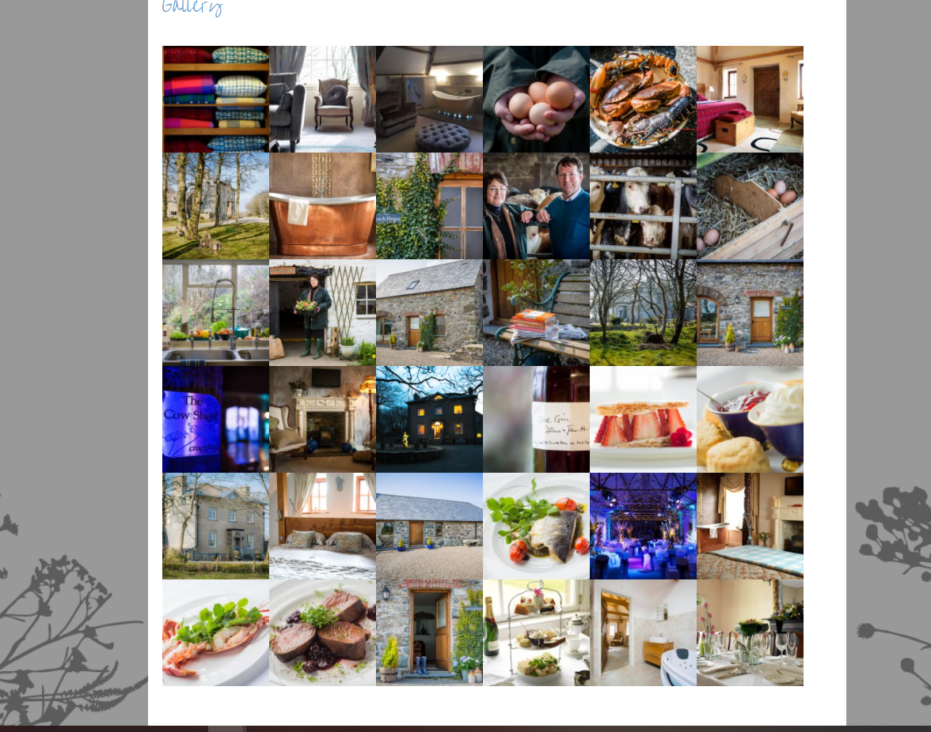
(Crug Glas, unknown)
Appendix 2
With an average score of 4.5 on TripAdvisor, there seemingly not much improvement that can be made.
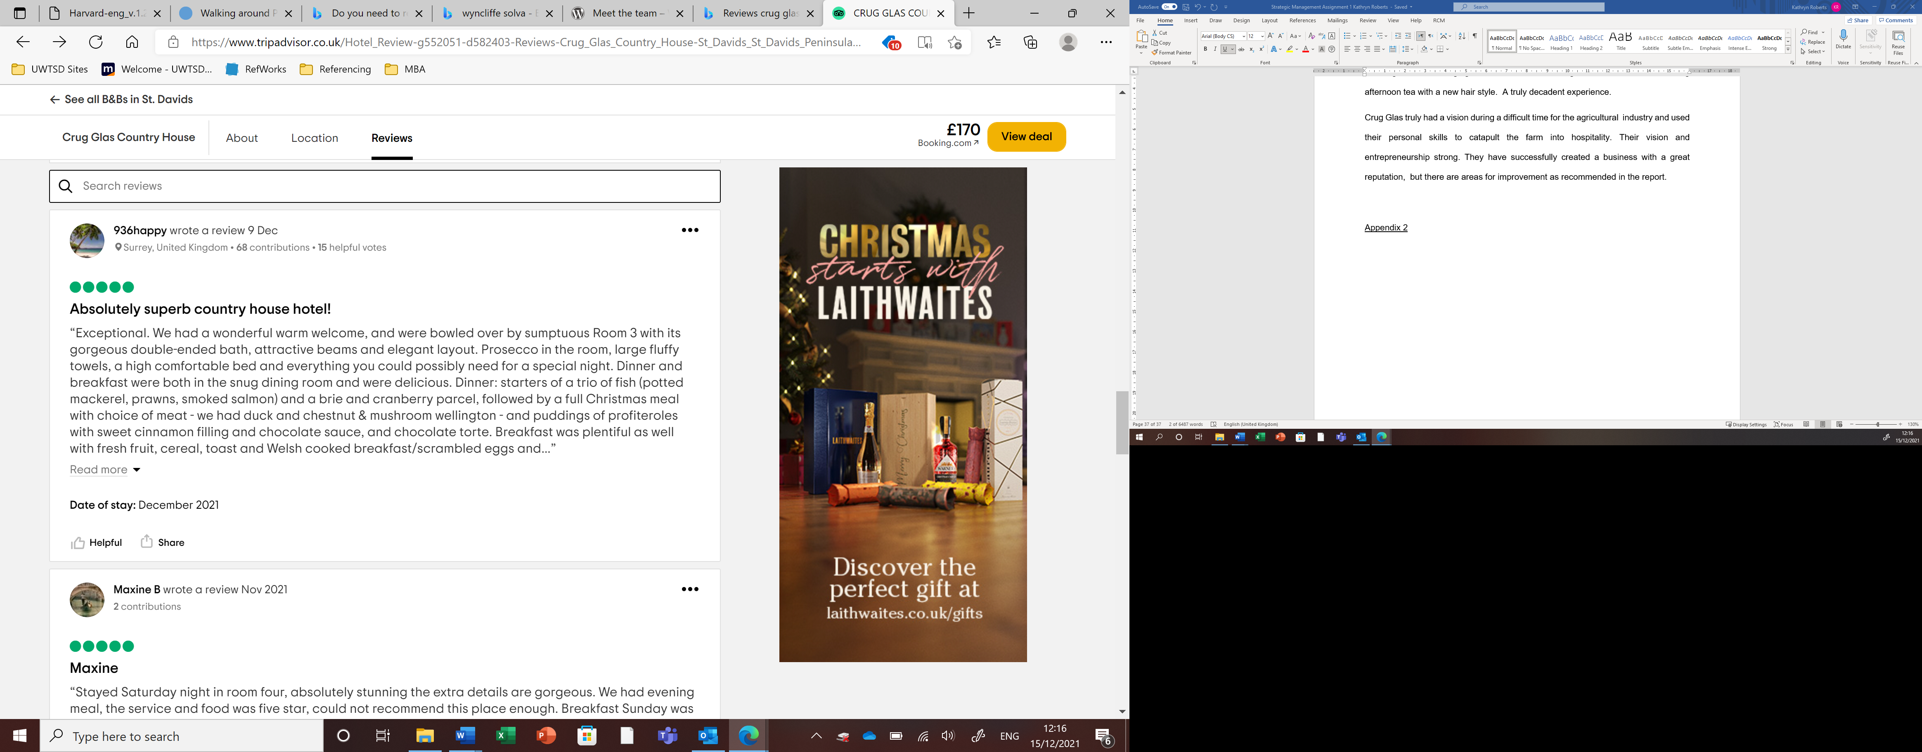
(TripAdvisor, 2021)
However, with a little research, it’s their service that lets them down with a lack of attention to detail and personalisation.
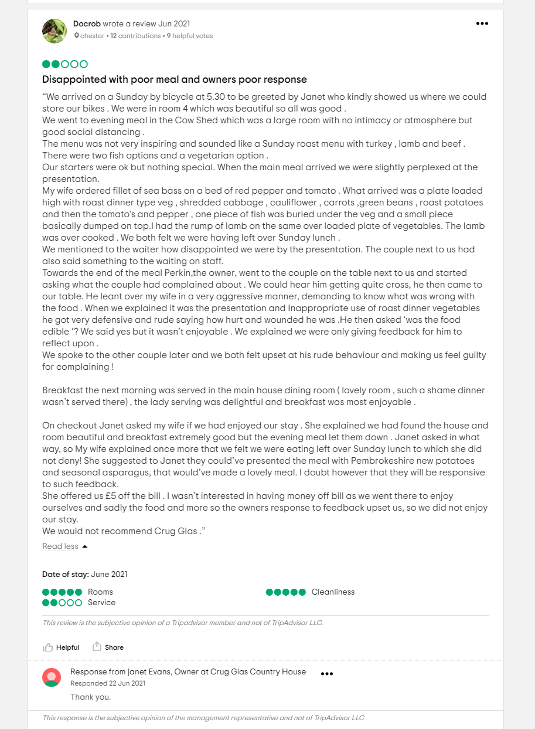
(TripAdvisor, 2021)
Appendix 3
The best service is no service was a great book reminding us of the frustrations customers deal with every day. Emotive and factual stories of frustrating policies and procedures in place which may agitate the guest before they even stay. We live in a world full of technology and where booking on line should be straightforward and easy with all of the questions a customer asks us available for them at the touch of a button. Sadly, this is not the case for many businesses. This book is, in my opinion, instrumental in aiding both the guest and the business in offering seamless service. Consideration needs to be taken from the guest’s point of view on how to offer ‘no service’; in other words, being able to book online or find out information seamlessly without clicking link after link to no avail, or worse, telephone options. If they cannot find the answer online and choose to call, the number for the business should be accessible and answered with minimal fuss. They key is to not needing the guest to call in the first place unless of course this is how the guests wishes to conduct their business. In which case, make it seamless. Creating the right and simple digital package alleviates the pressure for the team, allowing for them to relocate their workload to being hospitable (Price and Jaffe, 2008).

Appendix 4
Health and wellbeing as a trend and a lifestyle should be considered in all businesses. With lives being dramatically altered thanks to The Coronavirus Pandemic, health has never been so considered, whether it is fitness, immune boosting juices or sleep studies, our health and wellbeing has never been so critical.
- The future of the $1.5 trillion wellness market | McKinsey

- Microsoft PowerPoint - DH Well-being Poster - FINAL.pptx (publishing.service.gov.uk)
- GWI_Europe_WellnessEconomyMonitor2018.pdf (globalwellnessinstitute.org)

