Research in Context
Analyse the work or illustrators and, particularly, author illustrators who tackle difficult, sensitive and sometimes shocking themes.

Student number: 2314630
Course: BA(Hons) Illustration
Tutor: Delyth Lloyd-Evans
Word count: 2,648

In children’s literature, tackling themes such as loss, identity and grief requires a delicate balance of narrative and visual elements. Author illustrators particularly bring unique perspectives to these sensitive topics, by unifying textual and visual storytelling, allowing young readers to process sensitive subjects in a deep and meaningful way. By exploring these complex themes that are often avoided within other contexts, these author illustrators create these books to help their readers develop emotional awareness and resilience from a young age. This essay will examine three children’s books, these books are The Barnabus Project by the Fan brothers, The Heart and the Bottle by Oliver Jeffers, and The Memory Tree by Britta Teckentrup. Each of these books cover sensitive themes through the interplay of text and illustration.

By examining these children’s books through the lens of child development theories, visual analysis, and colour psychology, this essay will demonstrate how these works foster resilience, empathy and emotional growth in young readers. This essay will also discuss the interaction between text and image within children’s literature, as well as the social context of addressing sensitive themes.

Within children’s literature, illustrations are central to storytelling, working hand in hand with the written word of the book. Theo Van Leeuwen and Carey Jewitt, in their Handbook of Visual Analysis, argues that “images are more than simple decorations; they’re conduits of information, shaping perception as much as words” (van Leeuwen & Jewitt, 2001). Illustrators use visual cues such as colour, composition and symbolism to create an emotional landscape that draws in young readers and enhances their understanding of the theme within the story.

The first book this essay examines is The Barnabus Project (2020) by the Fan Brothers. Terry and Eric Fan, are known for creating beautifully illustrated children’s books that blend whimsy, wonder and heartfelt storytelling. Their works often feature imaginative worlds, thoughtful characters, and themes of friendship, self discovery, and resilience. They use intricate , dreamlike illustrations to bring their narratives to life, often combining surreal elements with a touch of nostalgia.

The Barnabus Project is a compelling picture book that explores multiple sensitive themes such as, individuality, rejection, and freedom. This book is set within a dystopian underground laboratory where so called ‘imperfect' creatures are imprisoned. The story follows Barnabus, a half mouse, half elephant hybrid, as he leads a courageous escape from this laboratory. This book is a symbol of societal pressures to conform, celebrating the strength of embracing imperfections and individuality. The Fan Brothers' intricate illustrations and nuanced storytelling make The Barnabus Project a vital contribution to children’s literature.

The Fan Brothers' illustrations within The Barnabus Project serve as a visual narrative that compliments the text. The underground laboratory in dark greys and greens, with looming machinery and rows upon rows of glass jars full of these ‘failed' projects, whivh evokes an oppressive atmosphere. In contrast, Barnabus is drawn with soft, rounded features, making him appear approachable and vulnerable. As Theo and Carey Jewitt discuss within The Handbook of Visual Analysis, “visual elements communicate underlying ideologies” (Van Leeuwen and Jewitt 2001). The rigid, mechanical lines of the laboratory represent conformity and control, while the organic shapes of each of the creatures symbolize individuality and life.



One striking image within the book shows Barnabus trapped within a glass jar, with his wide eyes reflecting both curiosity and despair. The jars transparency allows the reader to see his physical form but also emphasizes his confinement, which is a powerful metaphor for being hidden and misunderstood. This aligns with Nicholas Tuckers observation in The Child and the Book that visual storytelling allows young readers to “read between the lines of the text” (Tucker, 1981). Children can empathize with Barnabus's plight, even if they lack the vocabulary to articulate such feelings.
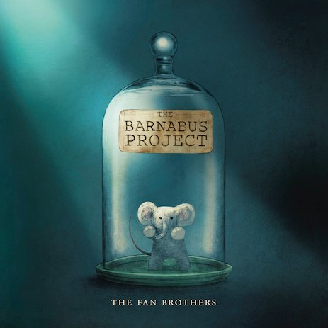

From a psychological perspective, The Barnabus Project resonates deeply with theories of child development. Baldwin states the importance of social and emotional learning in shaping a child’s personality. He argues that children develop resilience by navigating challenges, particularly those involving rejection and exclusion (Baldwin,1967). Barnabus's journey reflects this, as he transforms from a passive victim to an active leader. His courage to challenge the status quo mirrors a child’s growing ability to assert themselves in a world that often demands conformity.

David Fontanas insights in Personality and Education further illuminates Barnabus's development. Fontana highlights the role of storytelling with helping children process complex emotions. He notes that “narratives offer children a safe space to explore fears and anxieties” (Fontana, 1981). Barnbus's escape provides a hopeful resolution that reinforces the value of persistance and collective effort. This is particularly significant for children struggling to process feelings of inadequacy or exclusion, as it offers them a model of empowerment.

An important aspect of illustrations within children’s books is the use of colour. Angela Wrights book, The Beginners Guide to Colour Psychology, provides a framework for understanding the emotional impact of the Fan Brothers' use of colour. The illustrations of the laboratory are dominated by dull greys and greens, which are associated with feelings of stagnation and control. These colours create a sense of unease, reflecting the oppressive nature of the environment that Barnabus and his friends are stuck in.

In contrast, the creatures are depicted in warm, lively hues, symbolising their vitality and uniqueness, the visual distinction underscores the books’ central theme of individuality even in the face of systematic suppression. The climax of the story, where Barnabus and his friends reach the surface, is full of bright, natural colours such as vivid blues and greens within the sky and the trees. Wright explains that these sort of colours create feelings of freedom and renewal , reinforcing the emotional release of the characters liberation.

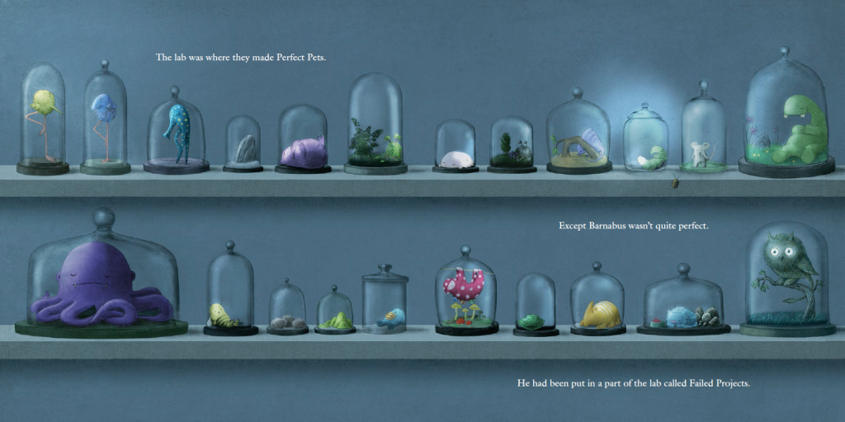

Nicholas Tuckers work highlights the unique capacity of picture books that address complex themes in an accessible manner. He argues that children’s literature often introduces “challenging ideas within the safe confines of a fictional narrative” (tucker, 1981). The Barnabus Project exemplifies this by using a dystopian setting as a metaphor for societal pressures. The creatures’ rejection as “failed projects” which mirror the real-world experience of children who my feel out of place or judged for their differences.

The collaboration between text and illustration allows for a multi-layered narrative, as suggested by Van Leeuwen and Jewitt. The Fan Brothers' use of visual contrast such as the cold, industrial setting verses the warm, organic designs of the creatures, creates a dynamic interplay that enhances comprehension and emotional engagement.

In summary, the Fan Brothers tackle sensitive and sometimes shocking themes with a remarkable amount of sensitivity and depth. Their illustrations, create a vivid narrative space where the tensions between individuality and conformity are noticeable. By drawing on insights from child psychology, the story aligns with theories or emotional development and resilience, offering young readers a framework to process feelings of rejection and acceptance.
The second book this essay examines is The Heart and the Bottle by Oliver Jeffers. This book is a poignant exploration of grief and emotional resilience, told through its powerful combination of text and illustration. This picture book follows the journey of a young girl who, after losing a loved one, isolates herself emotionally by metaphorically locking her heart in a bottle. While the story presents a universal message about loss and recovery, its brilliance lies in Jeffers’ ability to address such a complex and sensitive theme in a way that resonates with children and adults alike. Through the interplay of art and narrative, Jeffers not only introduces the abstract concept of gried but also provides a visual and emotional framework for processing it.

Jeffers’ approach to illustration is deceptively simple, using minimalistic linework, gentle watercolours, and whimsical details. This technique serves two purposes, it appeals to a young audience while also leaving room for interpretation. According to Theo Van Leeuwen and Carey Jewitt’s Handbook of Visual Analysis, the sparse composition allows the audience to focus on the core emotional elements, avoiding distractions and enhancing narrative impact.

For example, in one of the books pivotal scenes, the girl is depicted holding the heavy bottle that encases her heart. The exaggerated size of the bottle contrasts with her small frame, emphasising the burden of suppressed emotions. The lack of a detailed background within this scene underscores her isolation. As Nicholas Tucker explains in The Child and the Book, illustrations within children’s literature often simplify reality to make abstract ideas more accessible. Jeffers used this technique masterfully, translating grief into a tangible object – a bottle – that children can comprehend.

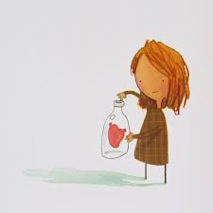

The visual juxtaposition of light, free flowing lines with the weightiness of the bottle mirrors the internal conflict between the girl’s innocence and her emotional numbness. This interplay between simplicity and weight aligns with Angela Wright’s observations in The Beginners Guide to Colour Psychology, which suggests that visual metaphors evoke strong emotional reactions, even in young readers.

Jeffers employs colour strategically to signify emotional shifts. The earlier scenes, characterised by warm yellows and greens, symbolises the girls curiosity and connection to the world. However, after the loss of her loved one, the palette changes to subdued greys and blues, reflecting her isolation and sadness. Angela Wright emphasises in her work on colour psychology that cool tones like blue often evoke a feeling of calm but can also signify the feeling of being detached. This international use of a muted colour palette amplifies the emotional weight of the story without overwhelming its audience.

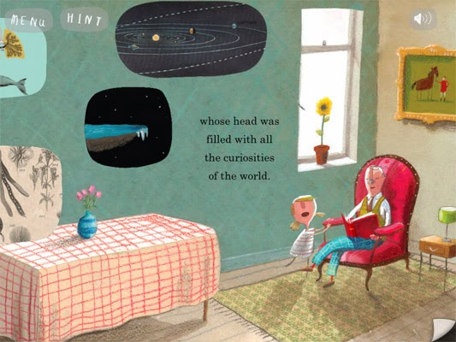
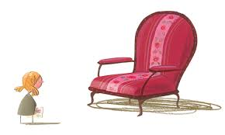

A notable contrast occurs within the final pages, where the girl retrieves her heart from the bottle. The gradual return of warm hues signifies hope and healing. The blossoming colours mirror her emotional reconnection with the world, reinforcing David Fontana’s theory in Personality and Education that children process emotional growth through sensory experiences, including visual stimuli.

From a psychological perspective, The Heart and the Bottle aligns with A. L. Baldwin’s theories of child development, particularly the concept of how children navigate complex emotions. Jeffers crafts a narrative that acknowledges the young audiences capacity to experience grief without simplifying or dismissing it. By personifying the girls heart and emotional withdrawal as a physical act of locking her heart within the bottle, he provides a relatable metaphor for emotional self-protection.

This approach also reflects David Fontana’s insights into the importance of storytelling within emotional education. By externalising the girls emotions through visual metaphors, Jeffers creates a safe space for children to be able to project and process their own feelings. The books resolution offers reassurance, suggesting that healing is possible when one confronts and shares their emotions.

In Jeffers’ work, the recurring motif of the bottle dominates the composition, drawing attention to the girls emotional state. The bottles positioning, often between the girl and the vibrant world around her, illustrates the barrier she has constructed. The visual representation of isolation reinforces the narratives emotional depth, making the abstract concept of grief accessible to the young audience. Additionally, Jeffers’ use of negative space emphasises loneliness. Scenes where the girl is surrounded by blank, white backgrounds highlight her detachment from her once colourful world. This interplay between colour and absence emphasises the emotions behind the illustrations.

Oliver Jeffers’ The Heart and the Bottle exemplifies how author illustrators can address sensitive themes with empathy. Through his use of minimalistic illustrations, strategic colour choices, and visual metaphors, Jeffers creates a narrative that not only resonates but also fosters understanding of grief and healing in children. Jeffers’ work underscores the power of picture books as tools for emotional education. As Nicholas Tucker aptly states in The Child and the Book, “children’s books often do more than entertain, they teach, they comfort and offer insight into the human experience”. Jeffers achieves all of this and more, providing young readers with a profound exploration of loss and recovery.

The final book this essay will analyse is The Memory Tree by Britta Teckentrup. This book addresses the sensitive theme of death and grief through a gentle narrative and emotional illustrations. The story centres on the death of a beloved fox and the memories his friends share as they come to terms with their loss. Teckentrup’s work is an example of how author illustrators use visual and textual storytelling to help children process complex emotions. By combing delicate imagery and a thoughtful narrative, she makes the difficult subject of loss accessible to a young audience.

Teckentrup’s illustrative approach employs a blend of digital techniques and hand-drawn textures to create warm, layered images. Her illustrations avoid sharp lines and harsh contrasts, which according to Angela Wright’s The Beginner’s Guide to Colour Psychology, fosters feelings of safety and comfort. The muted palette of browns, greens and soft yellows mirrors the natural world, grounding children in familiar environments during emotional turmoil. This also aligns with David Fontana’s Personality and Education, which emphasises the importance of maintaining psychological stability for children during times of change.

One pivotal illustration within the book, depicts Fox’s friends gathering under a tree, their expressions conveying a mix of sadness and warmth. The visual composition is structured to direct the readers eyes from Fox’s resting place to the growing tree that symbolises continuity and renewal. The tree branches stretch outward, embodying the shared memories of the characters. According to Theo Van Leeuwen and Carey Jewitt in Handbook of Visual Analysis, such directional cues within illustrations guide emotional interpretation, helping young readers connect the narrative to the concept of life after loss. The use of soft lighting around the tree reinforces feelings of hope and acceptance, which are key emotions that help balance the story’s theme of grief.

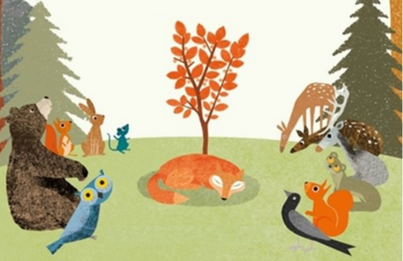

The colour palette used with the illustrations is integral to emotional resonance. Angela Wright identifies earth tones as Stabilising, evoking feelings of security. The transition within the illustrations, from muted tones during Fox’s passing to brighter, golden hues as the tree flourishes, mirrors the emotional journey of grief to remembrance. This visual progression helps children associate loss with positive transformation rather than despair.

Through the combination of emotive illustrations, a compassionate narrative, and the strategic use of colour, Britta Teckentrup’s The Memory tree provides an accessible way for children to explore the difficult topic of grief. By engaging with theories from Baldwin, Fontana, van Leeuwen, Jewitt, and Wright, we see how this book uses visual and textual elements to foster an emotional understanding. Teckentrup’s sensitive approach exemplifies how picture books can guide children through complex emotions, offering comfort and insight during challenging times.

In conclusion, the works of author illustrators such as The Memory Tree by Britta Teckentrup, The Barnabus Project by the Fan Brothers, and The Heart and the Bottle by Oliver Jeffers demonstrate the power of storytelling to address sensitive and sometimes shocking themes with grace, empathy, and creativity. These creators use carefully crafted visuals and narratives to explore complex topics such as grief, loss, belonging, and emotional vulnerability, making them accessible to young audiences.

In the Memory Tree, Teckentrup gently guides readers through the concept of death and remembrance. Through soft, natural imagery and a tender story, she creates a comforting space to reflect on loss, emphasising the beauty of memories and the cycle of life. Similarly, The Barnabus Project tackles themes of rejection, identity, and belonging, presenting an emotional yet hopeful tale about overcoming adversity. The Fan Brothers’ detailed illustrations bring to life a hidden world that mirrors real life struggles for acceptance, fostering resilience and empathy, Finally, Jeffers’ The Heart and the Bottle explores the profound impact of grief and emotional detachment. His minimalist art style and poignant narrative allows readers to engage deeply with themes of love, loss, and healing, offering a message of rediscovery and hope.

These works highlight the unique ability that these author illustrators have to be able to tackle difficult subjects in a way that resonates across multiple age groups. Through their sensitive storytelling and moving illustrations, they provide tools for understanding, discussing, and processing emotions, making challenging themes approachable and meaning for readers.

Reference list:

Baldwin, A.L. (1967) Theories of Child Development. New York: Wiley.
Fontana, D. (1981) Personality and Education. London, Routledge.
Tucker, N. (1981) The Child and the Book: A Psychological and Literary Exploration. Cambridge, Cambridge University Press.
Van Leeuwen, T. and Jewitt, C. (2001) The Handbook of Visual Analysis. London, SAGE Publications.
Wright, A. (1995) The Beginners Guide to Colour Psychology. London, Kyle Cathie Limited.
Teckentrup, B. (2014) The Memory Tree. London: Orchard Books.
Fan Brothers (2020) The Barnabus Project. Canada: Random House of Canada
Jeffers, O. (2010) The Heart and the Bottle. New York: HarperCollins Children’s Books.

