[4]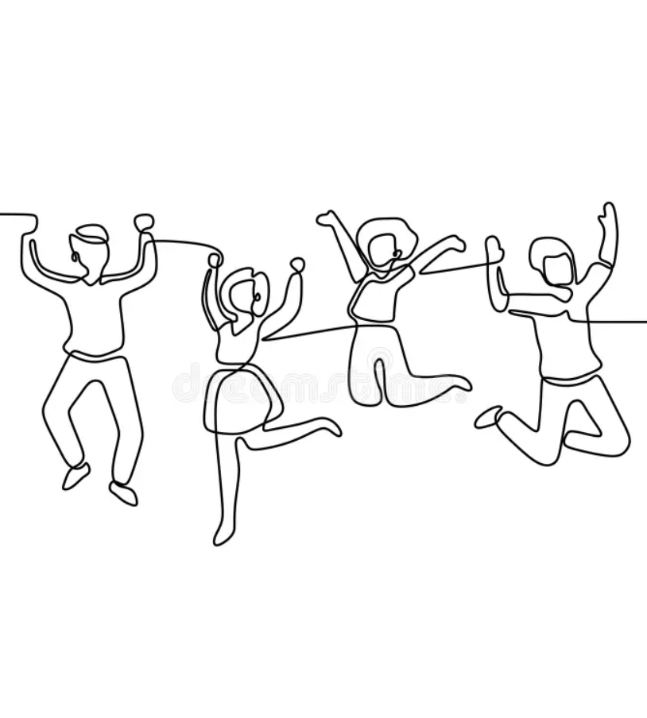  Work Based Group Project  ACDA5022 | Abstract  This report examines the soft skills exhibited by a five-person design team, particularly focusing on the role of the Technical Research and Design (TR&D) engineer in communication and collaboration. The study follows the team as they develop a solution through a structured case study, analysing interactions, decision-making, progress tracking, and conflict resolution practices. The report begins by outlining the initial team setup, including the establishment of expectations, communication platforms, and project tracking tools. It highlights how the team collectively translated stakeholder demands into formalized specification requirements, demonstrating the TR&D engineer’s influence in refining technical language and managing disagreements. Key design deliverables are explored, detailing the integration of critical features into a pre-selected Commercial Off The Shelf (COTS) drone. The TR&D engineer played a pivotal role in collaborating with manufacturing engineers to ensure seamless integration, while also conducting trade-off analyses on component selection. The study further investigates design selection methodologies, including Pugh matrices and justification documents, to assess proposed solutions. Despite the absence of a dedicated test and evaluation engineer, trial proposals were developed collaboratively to inform safety considerations. The report also examines the TR&D engineer’s interactions with manufacturing, disposal, and safety teams to ensure compliance with technical and operational constraints. Finally, reflections on team communication highlight the benefits of a compact, well-structured team. The balance between independent work and structured check-ins facilitated efficient progress while maintaining alignment with overall project goals.  Rebecca Dingwall (2217521)

Table of Contents
1 Report Introduction 3
1.1 Group working introduction 3
2 Customer requirements 3
3 Design deliverables 4
4 Analyses of design trade off and design selection 5
5 Trial proposals 5
6 Key Interactions 6
7 Reflections 7
Conclusion 8
Bibliography 9

Figure 1 Presentation slide detailing COTS conformity 4
Figure 2 Trials proposal Presentation slide 5
Figure 3 Group presentation feedback 7

1 Report Introduction
This report covers the soft skills exhibited by a team of 5 people, mainly focusing on the Technical Research and Design (TR&D) engineer and their input and communication with the team. The report follows how the design team worked through a case study. The team produced and delivered an OME solution to a problem presented to them, working through as the task developed. It covers the interactions and communications within the team, progress, decision making and conflict resolution practices used.

Group working introduction
During the first team meeting, expectations from each team member were established, how each individual likes to work for example, face to face or online etc. There was a mutual understanding between every team member, set out during expectations that much of the work up until QFD phase 2 needed everyone’s contributions, and to be completed by a specified date.

During this meeting, a group was set up on Microsoft Teams (MS Teams) including all team members and documents with shared access to work on together. A design book containing the work and a project tracker book containing meeting dates, agendas, work done, action tracker and meeting minutes. On the MS Teams group, every member shared both their personal and work contact details and availability. One of the team members then shared a group meeting request on MS Teams to invite everyone to a weekly call. This weekly call was used to check progress in the times we couldn’t meet face to face.

2 Customer requirements
The group collectively looked at the customer requirements and agreed that the ‘stakeholder demands’ needed to be translated into specification requirements. For example:
- ‘military/Operational Command: Requires a device capable of neutralizing the target communications centre while minimizing collateral damage.’
Was translated to:
- The system should be designed so that its effect is limited to the target room and does not impact adjacent rooms.
- The system may be designed so that injuries to occupants are minimised.
- The system shall include safeguards to prevent accidental initiation during its lifecycle
During this time the TR&D engineer requested a language review for the wording being used in the requirement set. They requested a team member to look what their employer used in requirement sets. This was the first time there was some opposition from some members of the team stemming from conflicting information found online, regarding the legal language that should be used. The TR&D engineer suggested that it was important to move on with the time frame, but to note on the requirement set clearly stating the intention when using specified wording. Everyone was happy or agreed to disagree and move on with the task. It would have been beneficial to have a team member with a legal and contractual based discipline.

3 Design deliverables
Some of the feature importances coming from QFD phase 2 outlined critical design features needed for the product to operate effectively, this starting place was used for the design engineer to further develop specifics of the design.
This included dimensions and integration onto the pre-selected Commercial Off The Shelf (COTS) drone [1].
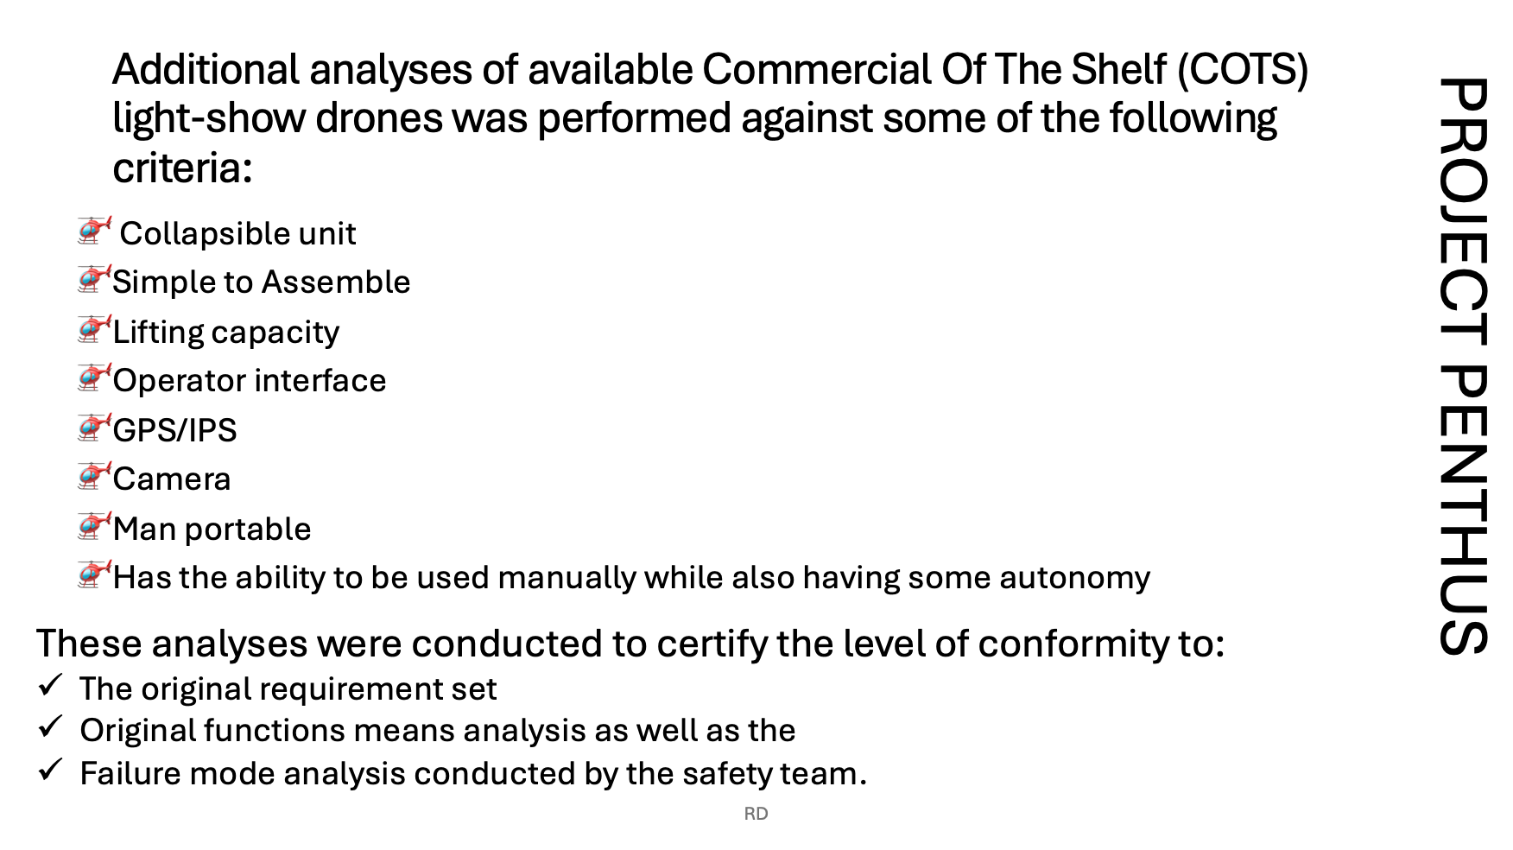
The TR&D engineer ensured a robust requirement set was produced to gather information of conformity to both the original requirement set, and the function means analysis that had been performed.
Figure 1 Presentation slide detailing COTS conformity

The design engineer worked with the drone manufacturer [1] to ensure seamless physical integration onto the platform. They also highlighted the following during design as critical features to ensure the product aligns with both the requirements and the effective operability of the design:

- Safe arming mechanism design- robust in safe mode while able to function every time when initiated.
- Overall dimensions of munition
- Overall weight of munition
- Overall charge dimensions/volume
- Overall weight of munition is within the lifting capacity of the COTS drone.

4 Analyses of design trade off and design selection
Some details in section 3 were discussed with the manufacturing engineer. It was identified that there was a requirement for a change of explosive, due to the dimensions of the charge size. The original RDX/Wax option would be difficult and result in a dramatic increase of cost. PE8 was a cheaper option. The NEQ was reduced due to the stretch requirement, of incapacitate room occupants over delivering a charge with effects incompatible with life.
The TR&D engineer further developed the concept designs from the original into two concepts, covering more detail while still adhering to the original group choice and met with the manufacturing engineer online to perform analysis on the designs. A justification document was produced that linked to the system Pugh matrix within the design book. The TR&D engineer presented to the team during the weekly meeting to present their work and collect feedback from the rest of the team, if they disagreed with any choices or if they needed anything explained in more detail, the TR&D engineer and manufacturing lead shared the research conducted into the PE8 [2].

5 Trial proposals
This team of 5, didn’t consist of a test and evaluation engineer, the TR&D engineer and safety worked together and proposed a set of trials they would expect to see. These consisted of:

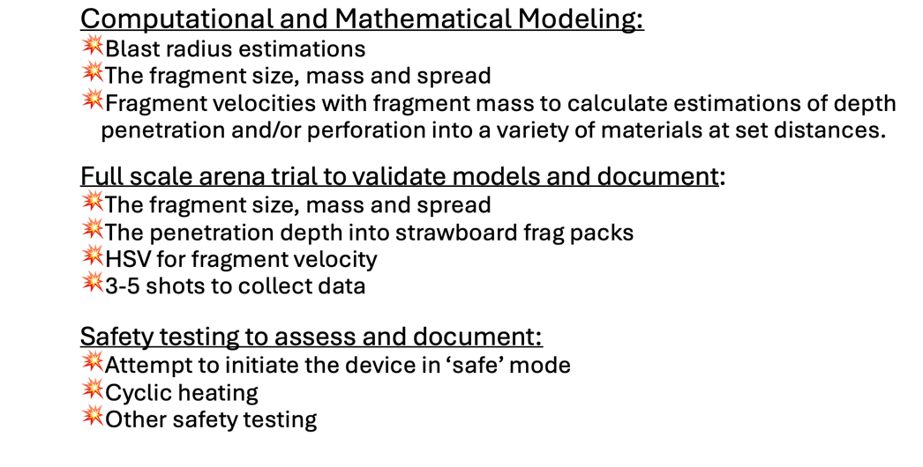
Figure 2 Trials proposal Presentation slide

Much of the data collected from these trials would inform safety and breakdown in their roles within the team.

6 Key Interactions
Manufacturing - Key elements emerging from QFD4 for the manufacturing lead was the charge size and Dimensions. Some other critical design features in terms of the overall design as mentioned in section 4.

Disposal- The disposal engineer required the NEQ from the TR&D engineer and manufacturing lead, as well as needing all the trials data, projection hazard of fragments etc of the munition.

Safety Team – Discussion and in-depth explanation on points of human interaction, justification and compatibility groups. A more through explanation of the safe arming mechanism that was designed for the device how it works, why conventional means of ‘safe arming’ couldn’t be used for the device.

7 Reflections
The author felt the team communicated well throughout the process; the group consisted of 5 people of varying ages and disciplines. The team was intended to have 7 members, however, the 5 worked well as no one was fighting to be heard. The early expression of expectations, and whole group collaborative work being completed by the specified date, team members were able to continue with their own tasks for their roles at individual paces. The author felt this was beneficial to the whole team due to not having to rely on someone to complete some work before their own progress could be made. The team continued check-ins on the weekly calls to share progress, track changes and gather feedback. It worked well to share contact details early in the process giving team members the opportunity to speak to individuals when required for tasks that only require one or two team members without having to wait for the weekly catch up, or to redirect the attention away from the weekly agenda and onto a task.

Any disagreements or conflicts were resolved quickly and calmly. No negatives to identify about team communications and working. The author felt the project and group work was enjoyable; the team members were a good group of people to work with and all took feedback and/or criticism well. Anytime there was a group discussion, and one team member disagreed, they were happy with a ‘majority ruling’ on the most part.
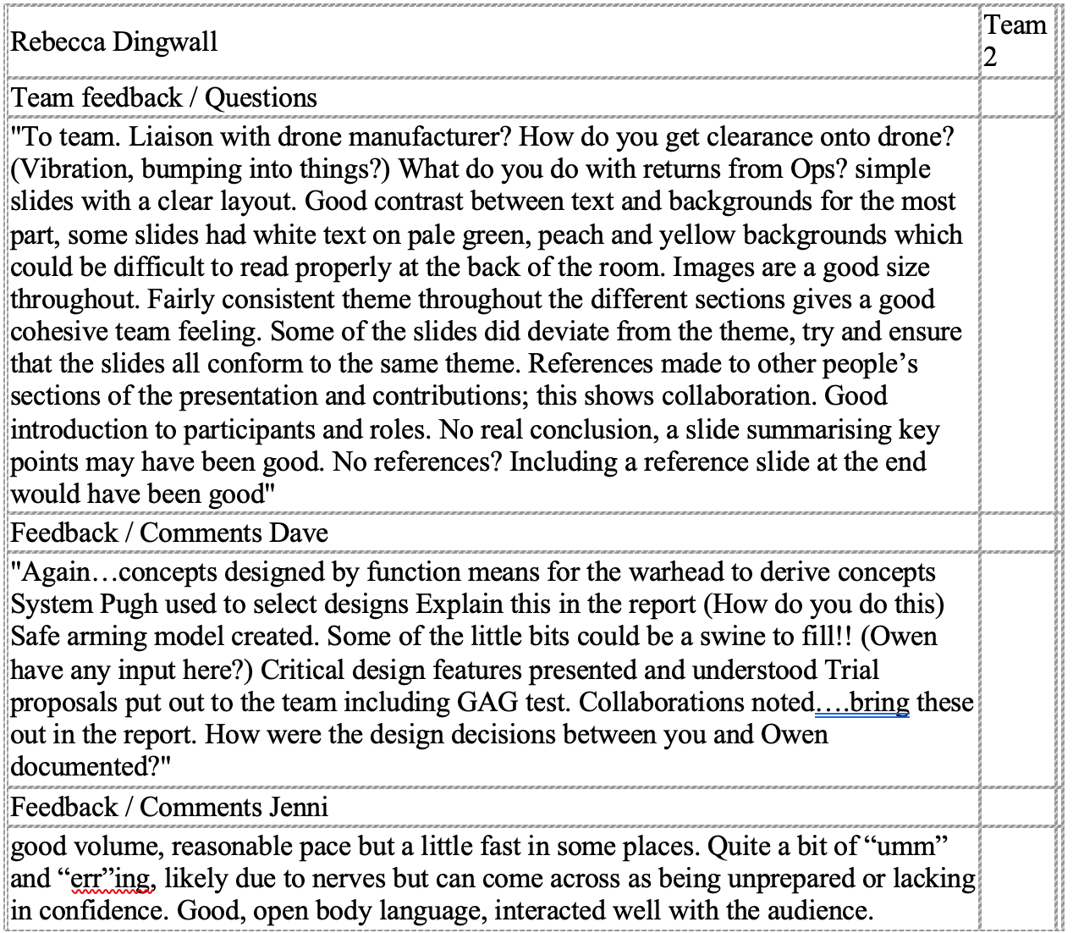
Figure 3 Group presentation feedback
It can be seen in figure 3, the feedback collected from the customer and principal project manager that there were some elements covered in the design that were not mentioned in the presentation but had been finalised prior to the presentation. There is room for improvement in slide presentation, and information communicated. To address this issue moving forwards, a request sent to the customer and principal project manager asking for key areas they would like to be covered could be beneficial.
TR&D engineer has reflected on their presentation skills and has booked onto a training course [3] to address:
- Confidence and how to apply techniques to control nervousness when presenting.
- Structuring and delivery of content for greater impact.
- Learn best practices for using visual aids to support and enhance their message.
- Audience engagement strategies to maintain interest and interaction.

Conclusion
The project was well executed and the team worked well to get the work completed. During the project work the team kept in contact and managed their time well, the presentation was mostly cohesive and within the allotted time and team members presented their areas well with open body language.
The efforts put in by the team in the beginning voicing their own expectations worked well. More practice of the presentation to a group of peers to collect feedback on missing or under-explained elements could be useful in the future.

Bibliography

[1] | DRONE Swarm, “Drone Light Shows – New, Unseen and Cutting Edge,” DRONE Swarm, [Online]. Available: https://www.droneswarm.co.uk/drone-light-display/. [Accessed 02 2025].
[2] | Chemring Energetics UK, “PLASTIC EXPLOSIVE (PE8),” 04 2022. [Online]. Available: https://www.chemring.com/~/media/Files/C/Chemring-V3/documents/energetics/heds/pe8-apr22.pdf. [Accessed 03 2025].
[3] | GTG, “Presentation Skills: Deliver with Impact,” GTG, 2023. [Online]. Available: https://gtg.co.uk/courses/presentation-skills-deliver-with-impact/. [Accessed 05 2025].
[4] | dreamstime , [Online]. Available: https://www.dreamstime.com/illustration/one-woman-group-men.html.

