

Student name: | Mohammed Jahangir Alam | Student ID number: | 2430566
Programme: | Certificate of Higher Education Skills for the Workplace (Health & Social Care)
Module: | Introduction to Health and Social Care
Module code: | LCHS4003 | Internal Verifier: | Dr Patronella Ganza
Assignment Title: | Portfolio – Two Tasks | Submission deadline: | 17th Nov 2025

Table of Contents

Task 1 3
Task 2 7
References 9

Task 1: Poster
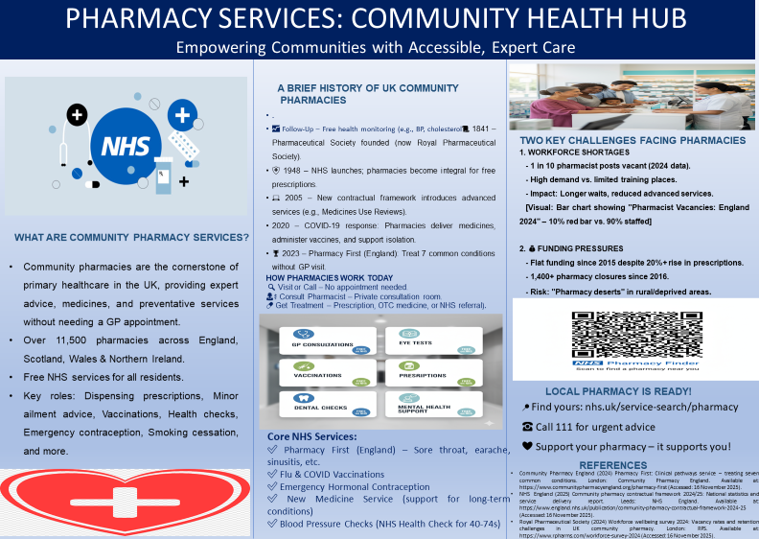

Poster Description:

Community Pharmacy as a Healthcare Cornerstone.
The most available and most often used pillars of primary healthcare within the complex framework of the United Kingdom (NHS) are community pharmacies. Instead of being nothing more than a simple retail pharmacy of drugs, they are active healthcare centres offering specialised guidance, dispensing the necessary medication, and offering a slowly expanding range of health preventive measures, which could be delivered without the need to appoint a GP in advance. Having network linkages of more than 11,500 pharmacies smoothly interlinked regionally in England, Scotland, Wales and Northern Ireland, this system makes it possible to access free and professional NHS support by virtually all the residents, with only a few more steps to create that connection (NHS UK, 2025).
The modern pharmacy roles have increased manifold since they earlier had a traditional-based role of dispensing prescriptions. Although the correct and safe provision of drugs prescribed by the doctor is still considered a fundamental, but extremely important operation, the professional knowledge of a pharmacist is now used in a broad range of interventions for population health. Patients will be able to consult confidentially about minor conditions such as coughs, colds, and skin rashes and will not clog the GP surgeries and A&E departments. They are also the core projects of national vaccination campaigns, which serve flu and coronavirus vaccinations and essential health examinations, including the monitoring of blood pressure, which may be significant in the early diagnosis of heart problems. Moreover, pharmacies are the on-the-ground troops in the community health efforts, providing systematic guidance in quitting smoking, making emergency hormonal birth control free, and controlling substance abuse programmes. This change in the transactions model to the relational services model makes the community pharmacy an irreplaceable initial point of contact for health and wellbeing.
A History of Adaptation: History and Current Workflow
The development of this strategic position is based on a lengthy past of professionalisation and integration. Formal standards on education and practice were created in 1841 after the establishment of the Pharmaceutical Society (which became Royal in 1842), making it a unified profession whose primary aim was to keep the people safe. The groundbreaking change came in 1948 when the NHS was launched and made pharmacies part of the publicly funded healthcare system, offering free prescriptions and securing their position on the high street (Community Pharmacy England 2024). A new contractual framework of community pharmacy in England and Wales that took place in 2005 marked a turning point, as it left behind dispensing and introduced all sorts of "Advanced Services" such as Medicines Use Reviews (MURs). This formalised the pharmacist as a clinical consultant to maximise patient outcomes provided by systematic medicine optimisation.
The 2020 COVID-19 pandemic was a vivid point of challenge of this resilience: pharmacies were open, with men as one of the few sources of regular public access. They valiantly had a supply of medicines to those who were protecting, made themselves primary locations where life-saving vaccinations were given, and gave a composed and informed air to the entire population in reference to widespread panic. The service gives pharmacists the ability to clinically evaluate and provide prescription-only treatment to seven common conditions (such as sinus and sore throat, earache) to patients facing no GP referral, a parameter of one of the most substantial decentralisations of care in NHS history (Royal Pharmaceutical Society, 2024).
This model of patient flow corresponds to the present-day patient experience. It starts by making a visit to the local pharmacy without making an appointment or calling. This is followed by a confidential consultation with the qualified pharmacist, which usually occurs in a private consultation room, so as to be confidential. The result is quick and efficient: the patient can get a prescription, a suitable over-the-counter medication, or a smooth referral to another NHS service in case it is necessary to offer more specialised treatment to the patient.
The Growing Core NHS Service Portfolio
The range of services which are provided under the umbrella of the NHS is extensive and specialised to handle the proactive management of the health conditions of the people. The flagship programme in England is Pharmacy First, which directly treats common conditions and saves millions of GP appointments. DFS services have been scaled massively, and pharmacies have become one of the main and convenient points on the list of annual flu and COVID-19 boosters. Emergency Hormonal Contraception provision guarantees access to emergency reproductive healthcare in a timely and confidential manner.
The New Medicine Service is priceless to those who are caring about long-term cases. The pharmacist also consults with patients to ensure their understanding, compliance, and side effects when a medication is administered, and it is appropriate in terms of asthma or diabetes. And follow-up consultations can greatly enhance treatment effectiveness. Preventative care is also enhanced by the NHS Blood Pressure Checks and the broader NHS Health Check of patients between 40-74 years old to prevent the development of heart disease, stroke, kidney disease and dementia.

Managing an Emergent Kindred Crossroads: Pressures and Challenges
Although community pharmacies have demonstrated their value and increased role, in the UK, they are going through a time of deep crisis, which is jeopardising their survival and the quality of service delivery potential.
WORKFORCE SHORTAGES: The industry is currently struggling with a shortage of skilled personnel. Recent statistics of 2024 show that about ten per cent of pharmacist posts are vacant. This imbalance has been fuelled by high demand for their skills both in the NHS, in general practice and industry, with several pre-registration training opportunities being very few. The effect is direct and direct on the patient. Headlong patients get to wait longer to have their prescriptions and advice followed, the remaining staff experience stress and burnout, and the ability to give the highly sophisticated services that the NHS is attempting to offer is diminished (PSNC, 2024).
FUNDING PRESSURES: This is perhaps the farthest out of existence threat, financial. Funding cash allocation to community pharmacy has been successfully frozen since 2015 due to the COVID-19 lockdown, although the amount of prescription output dispensed by the community pharmacy has increased more than 20% since then. This is a major real-terms reduction, compelling the pharmacies to accomplish considerably more using significantly less. The result has been a surge of store closures; more than 1,400 pharmacies have been closed since 2016. This poses a threatening impact of what has come to be known as pharmacy deserts, where communities, especially rural or socio-economically disadvantaged, are losing their nearest source of healthcare, thereby exacerbating health disparity among the most vulnerable groups.

References
- Community Pharmacy England (2024). Pharmacy First: Clinical pathways service – treating seven common conditions. London: Community Pharmacy England. Available at: https://www.communitypharmacyengland.org/pharmacy-first (Accessed: 16 November 2025).
- NHS UK (2025). Community pharmacy contractual framework 2024/25: National statistics and service delivery report. Leeds: NHS England. Available at: https://www.england.nhs.uk/publication/community-pharmacy-contractual-framework-2024-25 (Accessed: 16 November 2025).
- PSNC (Pharmaceutical Services Negotiating Committee) (2024). Funding and closure analysis: Community pharmacy in England 2015–2024. London: PSNC. Available at: https://psnc.org.uk/funding-closure-report-2024 (Accessed: 16 November 2025)
- Royal Pharmaceutical Society (2024). Workforce wellbeing survey 2024: Vacancy rates and retention challenges in UK community pharmacy. London: RPS. Available at: https://www.rpharms.com/workforce-survey-2024 (Accessed: 16 November 2025).

Task 2:
Origins of the National Health Service (NHS)
The National Health Service (NHS) was formed on 5 July 1948, and it was a product of the blending of wartime solidarity, pre-war welfare reforms and political pragmatism. Its intellectual and social roots date back to before World War II, but became solid during the war. In 1942, Liberal economist William Beveridge wrote the Beveridge Report, which was found to have five giants (Want, Disease, Ignorance, Squalor, and Idleness) interfering with the reconstruction of the post-war period. Disease requires a health service, which is comprehensive and free to the user and is funded through taxes and National Insurance. This appealed to people weary of rationing, air bombing and partially voluntary hospitals (Timmins, N. 2017).
The fragments of the system, Pre-NHS Britain Pre-NHS Britain had a fragmented system, with municipal hospitals serving the poor, voluntary (charity) hospitals serving the insured or the affluent and private GPs charging fees. The 1911 Act of National Insurance only included employed men in GP care; the rest of the population, which includes women, children and the unemployed, had to depend on charity or do without. The intervention during wartime by the state intervention through Emergency Medical Service (EMS) proved the efficiency of central coordination: Hospitals were unified, experts were redirected, and care was standardised. This infrastructure was developed by the 1944 White Paper (Coalition Government) and 1946 National Health Service Act (Labour, Aneurin Bevan as Health Minister) (Timmins, N. 2017).
The tripartite model of Bevan, comprising hospitals, executive councils (GPs/dentists) and local authority services, was a compromise. In order to establish equity, he nationalised the 2,700 voluntary and municipal hospitals; however, he still permitted GPs to remain independent contractors to gain the support of the BMA. Its main tenets were universality (covering all), comprehensiveness (treating all the requirements), and equity (free at point-of-delivery). Investment through general taxation shunned means-testing and differentiated the NHS with Bismarckian insurance systems.

Current Structure and Functioning
The NHS today is run as four devolved systems (England, Scotland, Wales, Northern Ireland), the largest and most marketised part of which is England. In England, the primary care and specialised services are commissioned by NHS England (NHSE); the local providers are organised through 42 Integrated Care Systems (ICSs, since 2022). There are NHS trusts (acute, mental health, ambulance) and foundation trusts that provide care in the secondary category. Primary care is provided through -6,800 GP practices (independent contractors) with GMS/PMS contracts. Community pharmacy, dentistry and optometry are also contracted (Webster, C. 2021).
This is mainly (80 out of 100) tax-funded (primarily with National Insurance and patient fees (prescriptions in England, dental/optical)). The 2022 Health and Care Act is forcing ICSs to embed health and social care, but social care is continuing to be means-tested and local-authority-funded, and this introduces a permanent fault line.
Functioning strengths: The NHS is still enjoying high levels of equity and clinical quality akin to that of any nation operating on a lower per-capita basis (~PS3,800 vs USA ~12,000). Survival and amenable mortality measures in cancer lie in the middle of the first-income countries. These digital initiatives include the NHS App (used by 35 million people), electronic health records that can coordinate (Webster, C. 2021).
Critical weaknesses: There is an imbalance between supply and demand. Backlog After the COVID (over 7.6 million elective waits, England, Oct 2025): A&E 4-hour target, No more than 60%. Pay suppression (real-terms reduction 2010-2022) and Brexit staff flow of EU personnel leads to workforce shortages of 90,000 nurse vacancies and 10% pharmacist vacancies ( King’s Fund, 2025).
Increase in GP consultations 15% (2019-2024): decreasing numbers of practices. Growth in funding (3.3 per cent annual average in real terms, 2010-2024) lags with European rivals (Germany 4.5 per cent). Privatisation is encroaching through the outsourcing (e.g. Virgin Care, Operose Health) owning the chains of GPs, and the PFI debts (PS80 billion capital liability). Devolution cuts standards: Scotland scrapped prescription charges: England kept them (PS9.65/item, exemptions ~90%) ( King’s Fund, 2025).
The NHS represents the Beveridge dream but has been stretched by demographic challenges (ageing population, multimorbidity), labour imbalances and a lack of investment in preventive/primary care. Supply Structural integration through ICSs is a prospect, but lacking reform of social care and long-term allocation of funds, equity risks are eroded.

References
King’s Fund (2025). The NHS at 77: Performance, funding and reform under the 2022 Health and Care Act. London: The King’s Fund. Available at: https://www.kingsfund.org.uk/publications/nhs-77 (Accessed: 16 November 2025).
Timmins, N. (2017). The five giants: A biography of the welfare state. 3rd edn. London: William Collins.
Webster, C. (2021). The National Health Service: A political history. 3rd edn. Oxford: Oxford University Press.

