Interest in micro adventure has grown because of the COVID-19 pandemic, highlighting questions over the future direction of the adventure industry. I consider the impact of the pandemic on adventure activities. I will look at the current social goals of connecting with nature, slowing down and efforts towards sustainability and the role of microadventure in promoting these. Finally, I point out the need for a change of mindset in the adventure industry if it is to succeed with microadventure.
Adventure generally includes a challenge and something unusual or exciting, making it the opposite to daily life (Beames and Mackie and Atencio, 2019) which can be dull and uneventful (Mortlock, 2004). Adventure involves an element of uncertainty (Beames and Mackie and Atencio, 2019) and a battle of emotions (Mortlock, 2004), that requires physical and metal skills to overcome in demanding environments (Beames and Mackie and Atencio, 2019), which is enjoyable and beneficial (Hodgson and Berry, 2011). After the COVID-19 pandemic traditional adventure approaches have had to change, and microadventures have become a popular way of pursuing adventure through UK lockdowns (Goodnow and Mackenzie, 2020).
Humphreys (2014, pp.14) defines microadventure as:
“an adventure that is close to home: cheap, simple, short, and yet very effective. It still captures the essence of big adventures, the challenge, the fun, the escapism, the learning experience and the excitement. All these things remain.”
Adventure can be had all around us (Humphreys, 2014) we just need to explore where we live (Watchow and Brown, 2011) to find it. Motivations for taking part in adventure include: an escape from daily life, a lack of boundaries (Goodnow and Mackenzie, 2020), excitement from risk, feeling special, a sense of belonging, sensory pleasure, a sense of identity, health improvements, a sense of connection to nature, and a sense of flow (Beames and Mackie and Atencio, 2019). Fulfilling these needs and motivations throughout the restrictions of the COVID-19 pandemic have been a challenge (Quay, 2020).
During the beginning of the COVID-19 pandemic in the UK we couldn't travel and were told to stay at home (Gov.uk, 2020). The idea of traveling seeming unethical (Goodnow and Mackenzie, 2020). Some restrictions on travel continue now (Welsh government, 2022) and the future seems unclear. Many adventurers felt restricted in their access to the outdoors (Quay, 2020), while practitioners lost jobs, businesses (Save outdoor education, 2021) and their ease of close contact (Quay, 2020). These adventurers may have found it hard to find satisfying adventure in their local areas after the grand adventures they were used to. There were also restrictions placed on adventurous activities as they could place pressure on health services (Gov. UK, 2020), further limiting traditional forms of adventure.
The spread of COVID-19 and the restrictions have required global travel to change (Goodnow and Mackenzie, 2020). There have also been social restrictions limiting our interaction with other people and there was need to isolate ourselves (Gov.uk, 2020), creating mental health problems from the feelings of isolation and restrictions on people actions (Ham, 2020). The pressure on people’s mental health led to many seeking refuge in finding their nearby nature, often in creative ways, highlighting our desperate need for nature as we found beauty in it (Goodnow and Mackenzie, 2020). Mental illness has also been linked to a nature deficit disorder. This highlights that all should have access to nature and adventure as a matter of priority. Traditional adventure has been unaffordable for some, and others have perceived it as something outside of their ability and social circles (Goodnow and Mackenzie, 2020). Money shouldn’t be a factor preventing individuals from going on adventures and microadventures fulfils that need (Humphreys, 2014).
Microadventures can be as simple as stepping outside our front door and having a look at the different thing that you can see (Humphreys, 2014). This makes us aware of all the little things, and people that may change over time as we continue to look over time. In this way microadventures can promote a sense of place in the rediscovery of our local nature and can promote attachment to local place (Goodnow and Mackenzie, 2020). This attachment can help us to see the damage to our local ecology and the effects of climate change (Watchow and Brown, 2011). This connection is likely to encourage people to care (Humphreys, 2014) which may prompt them to do something to help. However, this connection with place could have mental health implications as we see the damage around us (Sheffield and Lumber, 2019). Sense of place encourages us to explore like a child, to build relationships and understand the local culture which all helps us to learn to belong (Watchow and Brown, 2011). There are social and psychological benefits to connection with nature that improve our well-being (Goodnow and Brown, 2020).
Heritage travel can be linked to the idea of sense of place involving travelling slowly through an environment and learning about the history and culture of the place, teaching us to live well in the places we are in (Henderson, 2010). This slow-moving travel is likely to be human powered, having little to no environmental impact, making it a suitable direction for the future of adventure (Goodnow and Mackenzie, 2020). Heritage travel encompasses simplicity and could become part of microadventures as they can take place in the places we live. For example, instead of getting the train back from work we could set time aside to walk the route to experience the places we normally speed through (Humphreys, 2014). Microadventures can act as a tool as they have over the pandemic to reconnect us to the places around us.
The pandemic created space for economic growth to take a back seat and for things to be rethought, acting as an accelerant to changing ideas (Goodnow and Mackenzie, 2020). People have reprioritised, appreciating the intrinsic value of our surroundings, the little things in life, and the need to slow down (Goodnow and Mackenzie, 2020). However, there were concerns that this would not last when restrictions were lifted (Quay, 2020) which sadly in my opinion seems to be playing out. Financial challenges facing traditional forms of adventure continue with tighter budgets leading to a lack of disposable income for many and government funding cuts (Goodnow and Mackenzie, 2020). Given this financial pressure to traditional adventure, microadventures can act as a hope for the future, encouraging future adventure interest (Watchow and Brown, 2011) through their simplicity and low cost which remove barriers (Humphreys, 2014). While affordable and accessible nature can be seen as positive for societies, for practitioners it could be seen as a negative by a decrease in demand for guided adventure, placing further financial strain on the industry. This is a challenge to the industry to change its mindset and embrace microadventure, which I believe is where the future lies.
The three Pillars of sustainability are: Social, economic, and environmental (Purvis and Mao, 2018). These pillars highlight problems with traditional adventure with; environmental justice, social justice and economic challenges being areas that have caused criticism for traditional forms of adventure (Goodnow and Mackenzie, 2020). Climate change and the use of fossil fuels is something that can't be solved quickly (Goodnow and Mackenzie, 2020) and is a continued concern with traditional adventure. In contrast microadventure can support the three pillars of sustainability with limited carbon emissions, limited economic leakage while promoting the local economy, and limited social disruption (Goodnow and Mackenzie, 2020). For example, a keen paddler may choose to go to one of the largest rivers in the world or instead decide to follow their closest river from source to the sea (Humphreys, 2014).
There are concerns in the UK over the increased use of typical adventure areas posing a threat to the local communities as was seen following the first UK lockdown (Goodnow and Mackenzie, 2020). During the pandemic pressure was put on rural communities as people flocked to UK adventure destinations, stretching the health care and rescue services, making even domestic adventure appear unethical (Goodnow and Mackenzie, 2020). However, through the lockdowns adventure organisations such as Canoe Wales have issued guidance to their members through emails (Browning, 2020, Dickson, 2022) indicating that more traditional adventurers may have been responsible, unlike those who found adventure for the first time through the pandemic. Adventure in nature should be used to encourage moral decision making and ethical development (Stonehouse, 2010), which microadventures in our local area may help us to apply to our daily lives. Adventure ethics should: keep species and other people safe, protect endangered species and environments, and keep participants safe (Nigtingale, 2010). Travelling to remote and untouched places is unlikely to achieve all of these. There is however also a question over how well some microadventures can adhere to this as demonstrated in the flocking to remote places.
The Benefits of traditional adventure include Character building (Hodgson and Berry, 2011), personal transformation, self-confidence, self-esteem, well-being, intrinsic motivation, resilience, and an eco-centric perspective (Goodnow and Mackenzie, 2020). However, these benefits such as character development take time to build and may be difficult to achieve over only one expedition and may only last over the course of the expedition (Stonehouse, 2010, Beames, 2010). Using Microadventures could create the space for regular interaction over a longer period. Adventure can act as a removal from daily life (Bell, 2010) that can create a new focus (Beames and Mackie and Atencio, 2019), raising self-awareness (Allison and Von Wald, 2010) to develop our understanding (Mortlock, 2004). This could be lost through Microadventures done so close to home. However, there is evidence to suggests microadventure still maintains benefits of traditional adventure (Goodnow and Mackenzie, 2020).
Microadventures offer a more accessible option to traditional adventure, making adventure more available (Goodnow and Mackenzie, 2020) to all in comparison to more traditional forms of adventure that struggle to be inclusive, (Beames and Mackie and Atencio, 2019) often due to lack of funds (Beames and Alison, 2010). We shouldn’t have to live in beautiful wilderness to have our own personal adventures (Humphreys, 2014). The nature of staying close to home and using simple equipment makes microadventures more affordable (Goodnow and Mackenzie, 2020, Watchow and Brown, 2011). Microadventures are also something that it is possible to do on your own without specialist equipment or experience (Watchow and Brown, 2011). Traditional adventure can create a separation from daily life which can make it seem like the real world is outside of where we are (Watchow and Brown, 2011) but microadventures encourages us to make adventure part of our everyday lives.
Microadventure can be seen as a short-term adventure (Goodnow and Mackenzie, 2020) which could put some people off the idea as it doesn’t seem like some big challenge. This requires a change in mindset to look for the challenge where we are. Microadventure does involve the spirit of adventure (Humphreys, 2014) and a shorter time frame makes it more accessible to the time poor (Goodnow and Mackenzie, 2020) as it can fit around an individual’s working day (Beames and Mackie and Atencio, 2019). There is excitement in the unknown (Watchow and Brown, 2011) which is potentially why traditional adventure is seen as more attractive. However, we can find the unknown even in the surroundings we see every day if we look for it. For example, I discovered a new footpath that I don’t remember seeing before on a walk I went on regularly.
Goodnow and Mackenzie (2020) make suggestions for the need to improve investment in nature particularly in deprived communities to increase the occurrence of interaction with nature and shift our attitudes to embrace domestic travel (Goodnow and Mackenzie, 2020). Perhaps microadventure seems like an idealistic hope for the adventure industry which may be reluctant to accept and promote it as it could be seen to demean our existing skillsets and so threaten our jobs. However, if the industry is prepared to change and incorporate nature experience into adventure it could provide a new field of adventure, with lower running costs not being reliant on a specialist activity centre. Government funding may be more likely to go into nature spaces and groups promoting sustainability. I think that Microadventures can be a preferred approach to future adventure although I believe it will need a change in mindset within the profession, along with investment in local nature spaces, which the pandemic may have created the demand for.

Word count: 2058

Reference list
- Alison, P. and Von Wald, K. (2010) ‘Choices values, and untidy processes: Personal, social and health education on educational expeditions’, in Beames, S (ed) Understanding educational expeditions. Rotterdam: Sense Publishers
- Beames, S. (2010) ‘Interactionism and expeditions’, in Beames, S (ed) Understanding educational expeditions. Rotterdam: Sense Publishers
- Beames, S. and Allison, P. (2010) ‘Current issues on educational expeditions’, in Beames, S (ed) Understanding educational expeditions. Rotterdam: Sense Publishers
- Beames, S. and Mackie, C. and Atencio, M. (2019) Adventure and society. Cham: Springer international publishing
- Bell, B. (2010) ‘The expedition and rites of passage’, in Beames, S (ed) Understanding educational expeditions. Rotterdam: Sense Publishers
- Brownings, J. (2020) Email Robson, B, 6th July
- Dickson, A. (2022) Email Robson, B, 14th January
- Goodnow, J. and Mackenzie, S. H. (2020) ‘Adventure in the age of COVID-19: Embracing Microadventures and Locavism in a Post-pandemic world’ Leisure sciences, 7(3), pp.1-8. DOI: 10.1080/01490400.2020.1773984
- Gov. UK (2020) Staying at home and away from others (Social distancing). Available at: https://www.gov.uk/government/publications/full-guidance-on-staying-at-home-and-away-from-others/full-guidance-on-staying-at-home-and-away-from-others (Accessed: 12 February 2022)
- Ham, C. (2020) ‘The challenges facing the NHS in England in 2021’ BMJ: British medical journal, 371, pp.1-2. DOI:10.1136/bmj.m4973
- Henderson, B. (2010) ‘Understanding heritage travel: Story, place and technology’, in Beames, S (ed) Understanding educational expeditions. Rotterdam: Sense Publishers
- Humphreys, A. (2014) Microadventures: Local discoveries for great escapes. London: Harper Collins publishers
- Hodgson, C. and Berry, M. (2011) Adventure education: An introduction. New york: Routledge
- Mortlock, C. (2004) The adventure alternative. Cumbria: Cicerone press police square
- Mortlock, C. (2009) The spirit of adventure. Kendal: Outdoor integrity publishing limited
- Nightingale, A. (2010) ‘Ethics for expeditions’, in Beames, S (ed) Understanding educational expeditions. Rotterdam: Sense Publishers
- Purvis, B. and Mao, Y. and Robinson, D. (2018) ‘Three pillars of sustainability: in search of conceptual origins’ Sustainability science, 14(3), pp.681-695
- Quay, J. et al. (2020) ‘What future/s for outdoor and environmental education in a world that has contended with COVID-19?’ Journal of outdoor and environmental education 23(2020), pp.93-117
- Sheffield, D. and Luber, R. (2019) ‘friend of foe: Salutogenic possibilities of the natural environment’ in Donnelly, A. A. and Macintyre, T. E. Physical activity in natural settings: green and blue exercise. Abingdon: Routledge
- Stonehouse, P. (2010) ‘Virtue ethics and expeditions’, in Beames, S (ed) Understanding educational expeditions. Rotterdam: Sense Publishers
- Watchow, B. and Brown, M. (2011) A pedagogy of place: outdoor education for a changing world. Clayton: Monash university publishing
- Welsh government (2022) Rules for international travel to and from Wales: Coronavirus. Available at: https://gov.wales/rules-international-travel-and-wales-coronavirus (Accessed: 12 February 2022)

Appendices
Browning, 2020
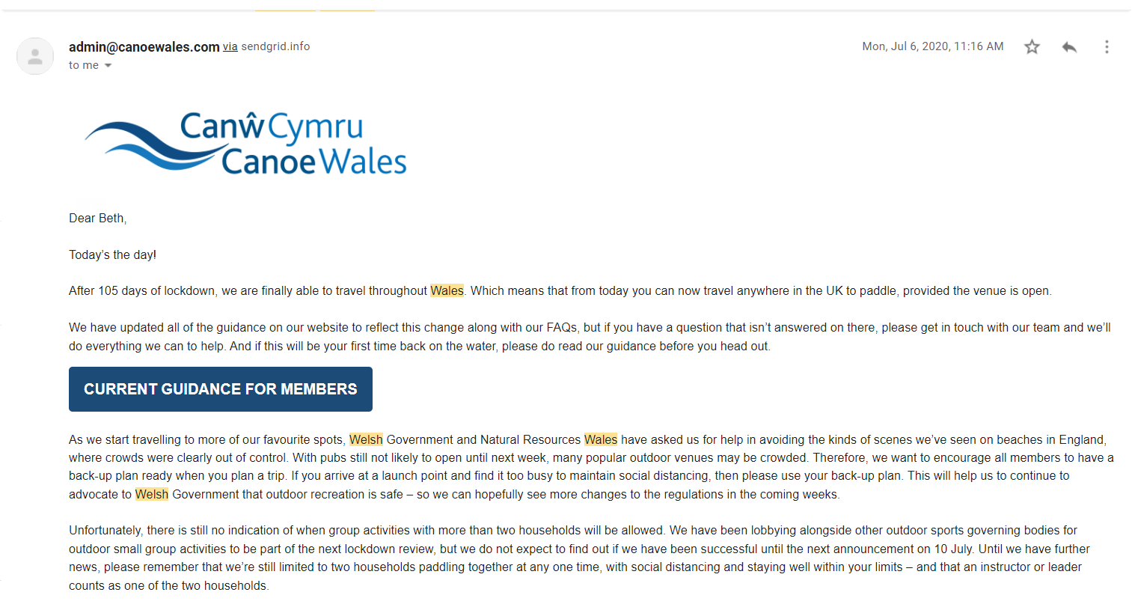
Dickson, 2020


