Carry out a research project and write up a study report exploring The Serial Position Effect.
Psych Lab ECPS4007

Olivia Lovell

Carry out a research project and write up a study report exploring The Serial Position Effect.
Abstract
This report aims to conduct a study looking at the serial position and primacy recency effects in relation to memory recall. Participants were shown a list of words, which they were then asked to recall by writing them down on paper. From the results produced by recording the number of times each word was recalled successfully, a serial position curve was generally observed. This is because the participants remembered the first few words and last few words more readily than the words in the middle of the sequence. This supports the primacy recency effect, where the first few words are stored in long-term memory and more easily recalled, as well as the last few words being recalled the most easily due to being stored in short-term memory. As such, the position of each word in the sequence influenced its likelihood of being remembered and successfully recalled by participants.

Introduction
The primacy recency effect is an observed finding showing that people tend to remember more of the beginning and end of events rather than the middle. For example, when shown a series of words, those at the beginning and end of said list would be recalled the most (Wiswede, Rüsseler and Münte, 2007). This is due to the first few words being transferred into a person’s long-term memory; therefore, they are more likely to be recalled (Tulving and Craik, 2000). Furthermore, the words at the end of the list are likely to enter a person’s short-term memory and are therefore more readily recalled (e.g., Atkinson and Shiffrin, 1968). According to Rundus (1971), the first few words in the list are more likely to be rehearsed and therefore remembered. Additionally, research has shown that the effects of primacy are less prominent than the recency effect, as words shown last are most often remembered (Baddeley, 2000). This is linked with the serial position effect, which describes the likelihood of a word being recalled according to its place within the list. This is usually represented in studies by a serial position curve, which forms a U shape. This curve is still observed even among participants with cognitive impairments (Weitzner and Calamia, 2020). Further observations indicate that delays between viewing the words and having to recall them reduces the recency effect (e.g., Howard and Kahanna, 1999). This is because the words move away from the short-term memory during the delay, meaning that these words are less likely to be recalled in this scenario compared to the first few words, which have still entered the long-term memory.
The aim of this study is to observe the serial position effect in the results of participants completing a memory recall task. A list of words will be shown to participants, who will then be asked to recall as many as possible.
Hypothesis: participants’ results will create a U shaped serial position curve in accordance with the serial position effect and primacy recency effect.

Method
Participants
Ten participants were selected from the University of Wales Trinity Saint David for the study. Out of these participants, eight provided their age and gender. The ages of participants ranged from 19-31 (mean of 23.25), with five reported females and three reported males.
Design
For the independent variable in the study, the words selected were randomised into an order that would remain the same for each participant. By using the same order of words throughout the study, the position of each word could be observed with the intention of creating a serial position curve. The recorded response from each participant would include each word they successfully recalled, which would then be totalled for each word in the sequence.
Materials
For the experiment, fourteen words were selected from the Toronto Word Pool. These words were selected for having similar concreteness scores and were randomised into an order by writing each word on a small piece of paper and selecting them from a paper cup. These words were then implemented into the Superlab program in the randomised order. Each word was presented on its own for 1500 milliseconds, followed by an interstimulus interval (blank screen) and focus cross (cross placed in centre of screen) each for 500 milliseconds. The words and cross were all set to font size 72 so that each participant would be able to clearly see each word. An instructions page was placed before the words appeared to give the participant a brief overview of what they were about to see. This was also explained to participants upon arrival, as they were all first given an information sheet and consent form (see appendix). A blank sheet of paper was placed by the participant with a pen so that they could write down the words they remembered after they were all shown. Participants were also given a debrief form to keep after completing the task.
Procedure
When each participant arrived, they were greeted by the researcher and taken into the laboratory. Here, the researcher would sit them down in front of the computer with the Superlab program and allow the participant to read through the information sheet on the desk. If they were happy to continue, the participant would be prompted to sign a consent form. After reading the instructions on the computer screen, participants could begin the program and view the words that had been selected. After the words had been shown, the screen would prompt the participant to write down the words they could remember on the paper provided. This was then collected by the researcher, who would then give the participant a debrief form explaining the full purpose of the study. Finally, the participant would be thanked for their time and be allowed to leave the laboratory.

Results
Once all the data were collected from participants, the total number of recollections for each word were tallied. Any words that participants had misspelled or repeated were excluded from the tally. From the graph below, the number of times each word was successfully recalled is shown. As expected, the primacy effect can be observed from the graph, as the first few words in the list had a higher number of recalls compared to the middle of the list. Additionally, the last two words in the list had a higher recall rate, with the last word being recalled by all participants. The tenth word in the sequence, ‘unlikely’, was incorrectly implemented into the Superlab program, therefore creating an anomaly (word was supposed to be ‘unlike’). As a result of this, the expected U-shaped serial position curve was not observed, as shown in the second graph below. Despite this, the results still follow the overall serial position trend, as the primacy recency effect was still observed. Overall, the hypothesis can still be accepted.
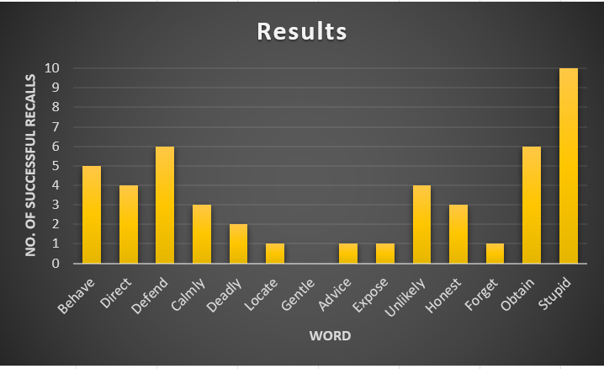

Discussion
The hypothesis of the study was that a U-shaped serial position curve would be observed from the results of participants in accordance with the serial position and primacy recency effects. From the results obtained from the study, the general serial position trend was observed, therefore confirming the hypothesis. An anomaly was observed as the tenth word in the sequence was input incorrectly into the program, resulting in a higher recall rate than expected.
Previous material suggests that the words at the beginning of the sequence are more likely to be remembered in comparison to the words in the middle of the sequence. This is due to the primacy effects, where the first few words are stored in the participant’s long-term memory and are therefore more readily recalled than words in the middle of the sequence (Tulving and Craik, 2000). Similarly, the words at the end of the sequence are most likely to be recalled by participants as a result of the recency effect. This is where the last few words are committed to short-term memory and can therefore be more easily recalled than the words in the middle of the sequence (Atkinson and Shiffrin, 1968). This effect is more prominently observed compared to the primacy effect, as the words at the end of the sequence are often the most recalled (Baddeley, 2000).
If this study was to be conducted again, it would be interesting to observe if resolving the anomalous word in the sequence would influence the results. Additionally, the number of words selected could be increased to observe the consistency of the serial position effect – if the number of words has an impact on the serial position curve expected to appear.
Conclusion
Overall, the effects of primacy recency and the serial position curve was observed from the results gathered from participants. Despite an anomaly in the study, the trend of the graph still indicated that the hypothesised effects had occurred. In accordance with the primacy recency effect, participants were able to recall the words at the beginning and end of the sequence compared to the words in the middle. This created a rough serial position curve from the recorded results.

References
Friendly, M., Franklin, P. E., Hoffman, D., Rubin, D. C. (1982). The Toronto Word Pool: Norms for imagery, concreteness, orthographic variables, and grammatical usage for 1,080 words. Behavior Research Methods & Instrumentation, 14 (4), 375-399.
Murphy, D. H., Friedman, M. C., Castel, A. D. (2022). Metacognitive control, serial position effects, and effective transfer to self-paced study. Memory and cognition, 50 (1), 144-159.
Osth, A. F., Farrell, S., Hollyoak, K. J. (2019). Using response time distributions and race models to characterise primacy and recency effects in free recall initiation. America Psychological association psychological review, 126 (4), 578-609.
Weitzner, D. S., Calamia, M., Yeates, K. O. (2020). Serial position effects on list learning tasks in mild cognitive impairment and Alzheimer’s disease. Neuropsychology, 34 (4), 467-478.
Wiswede, D., Rüsseler, J., Münte, T. F. (2007). Serial position effects in free memory recall – An ERP-study. Biological psychology, 75 (2), 185-193.

Appendix
Appendix 1
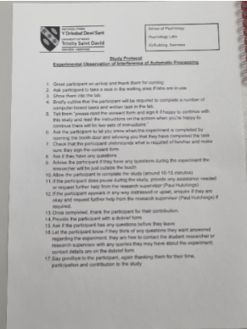
Appendix 2

Appendix 3
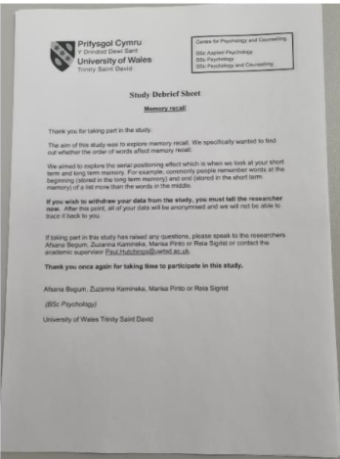
Appendix 4
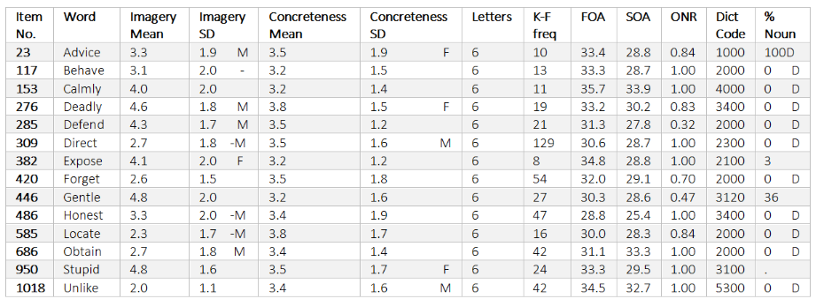
Appendix 5


