

University of Wales Trinity Saint David
Systems Engineering ACDA5021

Ordnance, Munitions and Explosives (Beng)
Academic Year 2023- 2028

Joseph Compton
Taguchi Analysis

Supervisor: Dave Holley
April 2026

This thesis is submitted in partial fulfilment of the requirements for the degree of Ordnance, Munitions and Explosives (Beng)
(NB. Remove if the degree award is based solely on examination of the thesis)

© UWTSD 2025. All rights reserved. No part of this publication may be reproduced without the written permission of the copyright owner.

Contents
1. Objective 3
2. Method and apparatus 3
3. Experimental data 4
4. Interpretation of results 4
4.1 Main Effects Analysis 4
4.2 Interaction Effects 6
4.3 Identification of Key Control Factors 7
4.4 Prediction of optimal configuration 7
4.5 Validation of Results 8
5. Conclusion 8
6. Reflection 8
References 10

Table of Figures
Figure 1 - Array Populated 4
Figure 2 - Effect of Pull-back distance on horizontol range 5
Figure 3 - Effect of Front position on horizontal range 5
Figure 4 - Anchor Position effect 5
Figure 5 - Stop position effect 6
Figure 6 - Operator effect 6
Figure 7 - AB Interaction 6
Figure 8 - BC Interaction 7

Table of Tables
Table 1 - Summary of results 4

Objective
This experiment focused on using the Taguchi Design of Experiment (DOE) methodology to determine the key factors impacting the efficiency of a mechanical catapult. The main performance measure used is the horizontal distance covered by the launched projectile.
The research is aimed at establishing which parameters have the most significant impact on the performance of the system, checking the possible interactions between these parameters and finding the optimal setup for maximising distance. A second purpose was to test and validate the optimal set of parameters in an additional experiment. This method is further explained [1] stating “The experimental design proposed by Taguchi involves using orthogonal arrays to organize the parameters affecting the process and the levels at which they should be varies. Instead of having to test all possible combinations like the factorial design, the Taguchi method tests pairs of combinations. This allows for the collection of the necessary data to determine which factors most affect product quality with a minimum amount of experimentation, thus saving time and resources.”

Method and apparatus
A small mechanical catapult was used in the experiment for launching the projectile in repeatable conditions. The horizontal distance travelled by the projectile was measured and considered the response variable in each trial.
Five primary control factors were selected:
- Band front position
- Band anchor position
- Stop position
- Pull back distance
- Operator
In addition to the main effects, two interaction terms were considered:
- AB interaction (Band front x Band anchor)
- BC interaction (Band anchor x Stop position)
An L8 orthogonal array was used to structure the experiment that could analyse the effects of seven factors (interactions included) at two levels in just eight runs. This method guarantees equal consideration for all factors while significantly decreasing the number of runs compared to a factorial design.
Each experimental configuration was conducted based on the orthogonal array (see Fig. 1). Tests were conducted by setting up the catapult according to the outlined conditions. The distance travelled by the projectile was measured during each trial. All experiments were conducted under safe firing procedures.
After the first experiment, more validation tests were carried out using specific factor combinations to confirm the predicted optimal performance.
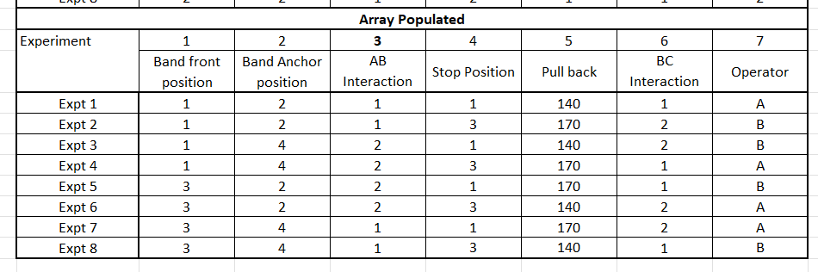
Figure 1 - Array Populated

Experimental data
The results obtained from the eight experimental trials are summarised below:
Table 1 - Summary of results
Experiment | Average Range
1 | 100.33
2 | 192.67
3 | 86.33
4 | 145.67
5 | 110.0
6 | 39.67
7 | 99.67
8 | 36.33

The data shows a wide variation in results depending on control factor setup, indicating they have a significant influence on the output.
In order to interpret the results, main effects graphs were generated for each variable. The graphs show the average response at each level and allow for direct comparison of factor influence.
The additional validation trials were performed using selected configurations, including both predicted optimal and intermediate conditions.

Interpretation of results

Main Effects Analysis
The Taguchi method identifies the major controlling factors by comparing the average performance of each level of a specific independent variable. The slope of each of the main effect plots indicates the effect of that particular independent variable.
Pull back distance was shown to have the strongest impact on the results obtained. An increase in the pull back distance from 140mm to 170mm resulted in a considerable improvement in average distance (see figure 2) This is because a greater pull back increases stored elastic potential energy, leading to higher launch velocity. These claims are further supported by [1] stating “the extension of the elastic band is directly proportional to the distance travelled by the object”

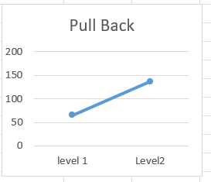
Figure 2 - Effect of Pull-back distance on horizontol range
The band front position also showed strong effect (figure 3). Level 1 produced a significantly greater range than level 2, which suggests the geometry of the band attachment influences the efficiency of energy transfer to the projectile.
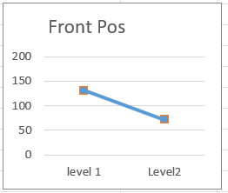
Figure 3 - Effect of Front position on horizontal range
The band anchor position showed a moderate influence (Figure 4), with Level 1 generally outperforming Level 2. This means that each end of the elastic system influences the efficiency of the whole system. As the elastic band applies force through its attachment to the arm and system components, influencing how energy is distributed between the mechanism and projectile [2].
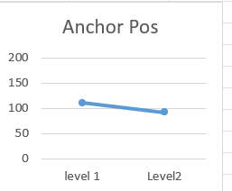
Figure 4 - Anchor Position effect
The stop position had a small but noticeable influence (figure 5). This factor controls the release angle, which directly affects the projectile trajectory and therefore range.
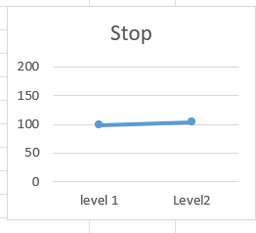Figure 5 - Stop position effect
The operator had the least impact (Figure 6), although a slight variation was observed between operators A and B. While human factors introduce some variability, they are less significant than mechanical parameters.
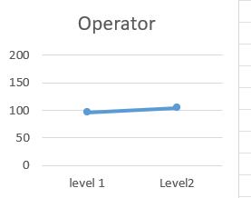
Figure 6 - Operator effect

Interaction Effects
Interactions were analysed based on columns AB and BC of the orthogonal array.
The interaction effect AB (Figure 7) turned out to be relatively insignificant, implying that the effect of the band front position to some extent depends on the band anchor position. However, the magnitude of this interaction was relatively small compared to the main effects.
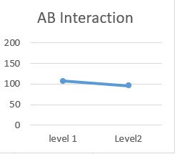
Figure 7 - AB Interaction
Similarly, the BC interaction (Figure 8) showed a minor influence, suggesting a weak dependency between band anchor position and stop position.
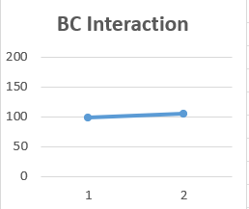
Figure 8 - BC Interaction
Overall, interaction effects were present but not dominant, meaning the system behaviour is largely governed by individual factor contributions.

Identification of Key Control Factors
Based on the magnitude of the observed effects, the factors can be ranked in order of importance:
- Pull-back distance
- Band front position
- Band anchor position
- Stop Position
- Operator
This ranking indicates that energy input (Pull-back) and elastic configuration (Band positions) are the primary drivers of performers.

Prediction of optimal configuration
Using Taguchi optimisation principles, the best configuration can be worked out by selecting the level of each factor that produces the highest average response:
- Band front position – Level 1
- Band anchor position – Level 1
- Stop position – Level 2
- Pull back – 170mm
- Operator – B
This combination represents the predicted optimal scenario for maximising the range of the projectile.

Validation of Results
The validation experiments confirmed the expected trends. The highest average range 220.33 occurred in the following combination of settings:
- Front position – 1
- Pull-back – 170mm
The result is very close to the theoretical best setup configuration and therefore validating the reliability of the Taguchi approach.
A mid-point test where the pull back was 155mm produced an average range of around 140mm, which is very close to the predicted value of 140.25mm. This shows a very positive link between the experiment results and the predicted results, proving the model can predict system behaviour quite accurately.

Conclusion
In this case, Taguchi design was applied successfully to determine the performance of the mechanical catapult and to determine the major control parameters affecting the projectile range.
From the results, it can be observed that:
- The pull-back distance is the major factor, determining the amount of energy input into the system
- Band positioning significantly affects how efficiently energy is transferred
- There are interaction effects but thet are not as important as the main effects.
The application of orthogonal arrays was found useful in reducing the number of experiments needed.
The predicted optimal solution provided validity of the Taguchi approach in system optimisation is effective and useful.
Overall, the experiment demonstrated the value of using such approaches in engineering applications, particularly when dealing with multiple interacting variables.

Reflection
The experiment provided an insight to the advantages of the Taguchi method in reducing the complexity of an experiment while still maintaining the key analytical purposes.
A strength of the experiment was how it clearly identifies the dominant factors particularly the pull-back distance which aligned with expectations. The graphs also provide an intuitive understanding of system behaviour.
However there were some limitations to the experiment for example there was only one measurement used which was the distance which introduces some uncertainty and variability although repeating each trial three times and producing averages did increase reliability. Also further improvements like an automated release mechanism completely eliminates operator variability and human error and more precise measuring techniques could be used.
Despite these limitations the experiment successfully demonstrated the effectiveness of the Taguchi method and provided valuable insight into the factors governing catapult performance.

References
[1]S. Fraley, J. Zalewski, M. Oom, and B. Terrien, “14.1: Design of Experiments via Taguchi Methods - Orthogonal Arrays,” Engineering LibreTexts, May 19, 2020. https://eng.libretexts.org/Bookshelves/Industrial_and_Systems_Engineering/Chemical_Process_Dynamics_and_Controls_(Woolf)/14%3A_Design_of_Experiments/14.01%3A_Design_of_Experiments_via_Taguchi_Methods_-_Orthogonal_Arrays
[2] P. Menon, “Catapult effect of the extension of the elastic band on the distance travelled by the object it releases - Pranav Girish Menon,” May 18, 2023. https://www.researchgate.net/publication/389875071_Catapult_effect_of_the_extension_of_the_elastic_band_on_the_distance_travelled_by_the_object_it_releases_-_Pranav_Girish_Menon
[3] Ingridscience.ca. (2026). Catapult from tin can / poster tube | ingridscience.ca. [online] Available at: https://www.ingridscience.ca/node/458 [Accessed 19 Apr. 2026].

‌

