
Changemakers: Creativity and Value Creation (BMHP5014_LON)

Assessment 1: Online portfolio-artefacts
Student: Raluca Roman
Student no. 2113735
Lecturer: Dr Eleni Koutsogeorgou

Introduction
The purpose of my report is to bring awareness and support for individuals suffering with Dementia and their loved ones. Most often family becomes the main care giver for patient, and they really struggle with the unknown about how the future will be and how bad it will get to the end of life. Working in care sector for several years, I have learned that no everyone can provide care for Dementia patients, you must be strong minded and not get too affected by the changes that will occur.
To work in a care environment, you have initially to complete certain trainings that will bring a lot of information about mental health and dementia particularly. Also, after you start working you could experience a shock as the changes that dementia cause in individuals seem so unfair and unjustified but after a while you should get used to it.
I have decided to create a blog for me to explain what signs and changes we can encounter in dementia patients. At the beginning the signs are mild and easy to hide but as the condition progress becomes more obvious and much harder to overcome. For patients this can be confusing and frightening but these feelings are experienced by families as well since they are not sure about how the future will look like.
It is heartbreaking to make the decision to put your loved one in a care home, but at this point families tried as much as they could to support them, and it is not working. I have used a mind map with 7 steps to explain the stages of Dementia progress and how it affects our functional and cognitive abilities. As we all know there is no cure for Dementia, but we also do not know how fast is progressing depending on individual to individual.

Dementia awareness. Support information for families.

The purpose of my blog today is to offer more information for families having their loved ones suffering with dementia. I have worked in the care sector for 6 years. I have realized that it is so confusing and challenging for families to offer their loved one's support. They want what is best for their loved ones but sometimes they do not know where to reach for help.
What is dementia? How people develop dementia?
Alzheimer’s disease is a progressive neurologic disorder that causes the brain to shrink and the brain cell to die. Dementia is a general term for impaired ability to remember recent events, daily activities and it also interferes with decision making and affects our mental capacity. (Greensleeves Care, 2020)
The most common type of dementia is Alzheimer diseases, and it is mostly affecting older adults but is not a general part of aging.
Recent studies show that for those over 65 years old in UK there is an estimated 900.000 people living with dementia in 2021 and projected to reach 1 million by 2025 and 1.5 million by 2040. (Alzheimer's Society, 2021)
Below is a list of symptoms that could be a sign of dementia and you could use it to look for signs of dementia in your loved ones. At the beginning they are just small difficulties that we do not experience daily but as the conditions develop, symptoms get worse.
- Memory losses
- Attention
- Difficulties communicating and expressing
- Reasoning, judgment and taking decisions
- Change in vision and seeing things that are not here
Other signs of dementia may include:
- Getting lost in the neighborhood, not being able to remember how to get home
- Not remembering the name of familiar items in your home or the use of it
- Forgetting names of friends, loved ones
- Forgetting recent events
It is especially important for dementia patient to continue living their life as much as they can considering the impairment they are struggling with. Family and friends are the first ones that can support an individual suffering with dementia. There are diverse ways to support individuals in their everyday life such as:
- Remember that they are still your family or friend, this illness might change them but they ‘come back’ for shorter period.
- Include them in all the conversations as much as they will enjoy
- Always ask for their opinion do not just assume what they want or what they need
- Offer them support because they might not feel comfortable enough to ask for it.
- Try to understand what means for them to live with this medical condition.
- Remember they still can do the same activities with a bit of support
Most often people with dementia tend to isolate themselves from the society, they become depressed, low mood, finding it difficult to communicate with others. They need to be supported to enjoy their hobbies and interest as much as possible. You can support them by including them in social activities and events, have the patients to engage in a conversation with them and try to engage them in an activity you know that they enjoy. (greensleeves.org.uk)
Suffering with dementia can make communication exceedingly difficult and cause a lot of frustration for the patient. Having the patience to sit and listen to what they have to say would make them feel included and still useful to society. As dementia progresses communication can become very reduced as they find it difficult to express what they think, and the words come out in a wrong way. Patience, is they key when trying to communicate with dementia patients, give them time and always ask for their opinion.

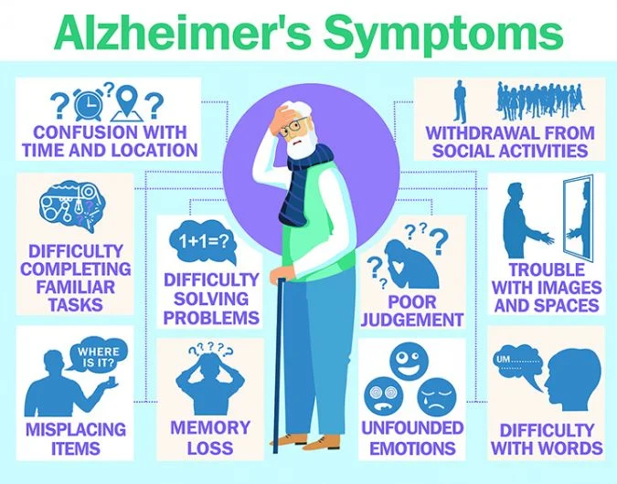
Picture 1 (Urgentteam.com, 2021)
The families can get support from different organizations specialized in dementia awareness and could meet up with other families or persons suffering with dementia. Exchange experiences, get emotional support and awareness about the way the diseases develop. It is particularly important for families to be aware of how this condition affects their loved ones and how bad it will get.
The following organizations provide support and counseling for families and individuals suffering with dementia.
https://www.dementiauk.org/get-support/
https://www.alzheimers.org.uk/find-support-near-you
Living with Dementia is extremely hard for patients and the ones caring for them, getting as much information as possible could reduce the shock of the initial diagnose and work together to support the patient in the best feasible way. Uk offers a lot of support for patients and their families compared to other countries, although there is space for improvement, society has been educated to support rather than judge.
My blog today will end with a big virtual hug for you my readers and hopefully the information provided will help when it comes to supporting loved ones or even elderly persons struggling in shops or post offices. You should keep in mind that a smile could change someone's day, choose to do good every day little by little.

Dementia Progress in 7 steps

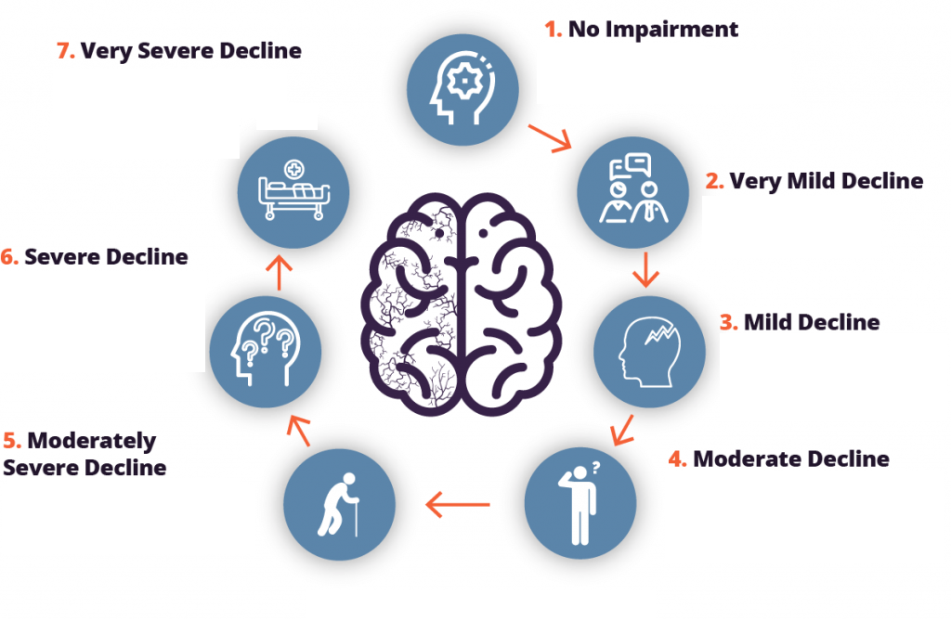

Picture 2 (Dr. Barry Reisberg of New York University, 2020)

One of the most prevalent and deadly conditions affecting the senior population, dementia is a global public health concern. The impairment of memory, logic, communication, and daily functioning is progressive although frequently gradual in this illness. These symptoms can be brought on by a variety of conditions that damage brain tissue and alter its chemical and structural makeup. (nhs.uk)
A timely diagnosis of dementia can still be helpful, especially for younger patients and their families, as they can be offered a variety of supportive or therapeutic interventions, educate themselves about the condition, and plan for their future financial and care needs, which may help. Currently, there are no treatments that are curative for dementia.
There is not a quick, accurate test available right now to spot dementia in its earliest stages. There are currently no diagnostic tools that are sufficiently developed for use in dementia screening.
It is not possible to distinguish dementia from other disorders using a gold standard. Caretakers' capacity to discern one dementia condition from another is limited by the many dementia disorders' imprecise definitions.
There are many ways (scales and indices) to gauge how severe different dementia symptoms, like cognitive decline, functional decline, and behavioral alterations, are. It is more challenging to judge the effectiveness of certain care and treatment modalities because most methods have not undergone adequate examination.
Family, friends, and caregivers (knowledgeable informants/collateral sources) can offer helpful information to support a diagnosis.
The step for a diagnosis for dementia starts with acknowledging the early signs of dementia.
- No Impairment, this stage can be classified as normal functioning stage as there are no obvious changes in the patient abilities. The patient has not experienced any obvious signs and at this stage there is no medication required.
- Very mild decline, at this stage patients experience occasionally lapses of memories such as forgetting some names, forgetting where they placed an object or even how to usually do activities like making tea or putting the kettle on. Still at this stage, medication is not required.
- Mild decline, patient tend to experience a mild decline in their memory function, it becomes obvious for people living with them. At this stage Alzheimer disease can be diagnosed.
- Moderate decline, patients experience problems with thinking and reasoning as these issues become more obvious and disturbing. Obvious signs of Alzheimer are seen. Communication can become difficult and frustrating for patients.
- Moderately severe decline, at this stage individuals start to become socially withdrawn, showing obvious changes in personality and behavior. They may also experience significant confusion and become agitated. At this stage assistance is required with day-to-day activities.
- Severe decline, at this stage patients require constant supervision day and night as they start to wander, they can become anxious and have trouble with sleeping. They do not have the ability to distinguish day and night anymore and at this point medication might be prescribed. Patients can also experience incontinence and they are not able to manage it on their own.
- Very severe decline this could be considered the last stage. At this point patient lose their ability to communicate or respond to environment, reduced mobility, and locomotion. Substantial risk of developing medical complication that could result in death. 24hour assistance is required, set an advance decision about the way they want to spend their last days and the treatment they would like to have. This must be completed while still having mental capacity together with LPA.
(AlzheimersDisease.net, 2019)

Conclusion
Dementia is a degenerative disease that eventually affects a person’s ability to live independently. Although people with dementia frequently display behaviours that are difficult for informal and formal caregivers to control, the actions are brought on by brain deterioration and are not deliberate. Unmet needs may be the root of challenging behaviours, which can also serve as a form of communication. The caregiver may be able to identify the underlying need and discover ways to reduce the troublesome behaviour by closely examining what happens right before and after an incident. (www.atrainceu.com, n.d.)
Compassion and the knowledge that people with dementia can still enjoy life should be shown to them. Restrictions that are physical or chemical should only be employed as a final resort. The foundations of customised care, physical and chemical constraints, have a wide range of effective substitutes.

References
(2016). Help and support for people living with a dementia. [online] Available at: https://www.nidirect.gov.uk/articles/help-and-support-people-living-dementia.
Dementia UK. (n.d.). Call 0800 888 6678 for support and advice for carers and people with dementia. [online] Available at: https://www.dementiauk.org/get-support/.
AlzheimersDisease.net. (2019). Reisberg’s Seven Stages of Alzheimer’s Disease. [online] Available at: https://alzheimersdisease.net/reisbergs-stages.
Alzheimer’s Society. (2019). Find support near you. [online] Available at: https://www.alzheimers.org.uk/find-support-near-you.
Alzheimer's Society (2021). How many people have dementia in the UK? | Alzheimer’s Society. [online] www.alzheimers.org.uk. Available at: https://www.alzheimers.org.uk/blog/how-many-people-have-dementia-uk.
Fisher Center for Alzheimer’s Research Foundation. (2014). Clinical Stages of Alzheimer’s. [online] Available at: http://www.alzinfo.org/understand-alzheimers/clinical-stages-of-alzheimers/ [Accessed 14 Dec. 2022].
‌ Greensleeves Care. (2020). What is dementia? | Symptoms, causes and diagnosis | Factsheet. [online] Available at: https://www.greensleeves.org.uk/what-is-dementia/.
Greensleeves Care. (2020). Social isolation and dementia. [online] Available at: https://www.greensleeves.org.uk/social-isolation-and-dementia [Accessed 13 Dec. 2022].
Urgentteam.com. (2021). [online] Available at: https://www.urgentteam.com/wp-content/uploads/2020/02/alzheimers_symptoms_graphic_shutterstock_1401618854-1024x803.jpg.
www.atrainceu.com. (n.d.). 10. Conclusion | ATrain Education. [online] Available at: https://www.atrainceu.com/content/10-conclusion-0.
‌

‌

‌

‌

