

LOCATION: Swansea | LLEOLIAD: abertawe
LEVEL 5 | LEFEL 5
EXAMINATION PERIOD | CYFNOD ARHOLIADAU
MARCH 2019 | MAWRTH 2019

MODULE CODE: ACCB5002
ROUTING AND SWITCHING CONCEPTS PRACTICAL
TIME: 3 HOURS

Student Name : ______________________
Student ID : ______________________
Date : ______________________

This is an individual practical lab-test, held under examination conditions. You will be assigned 3 Routers, 2 Switches and two PCs; you should configure these devices based on the following specifications.

This paper is marked out of 100.

TOPOLOGY DIAGRAM

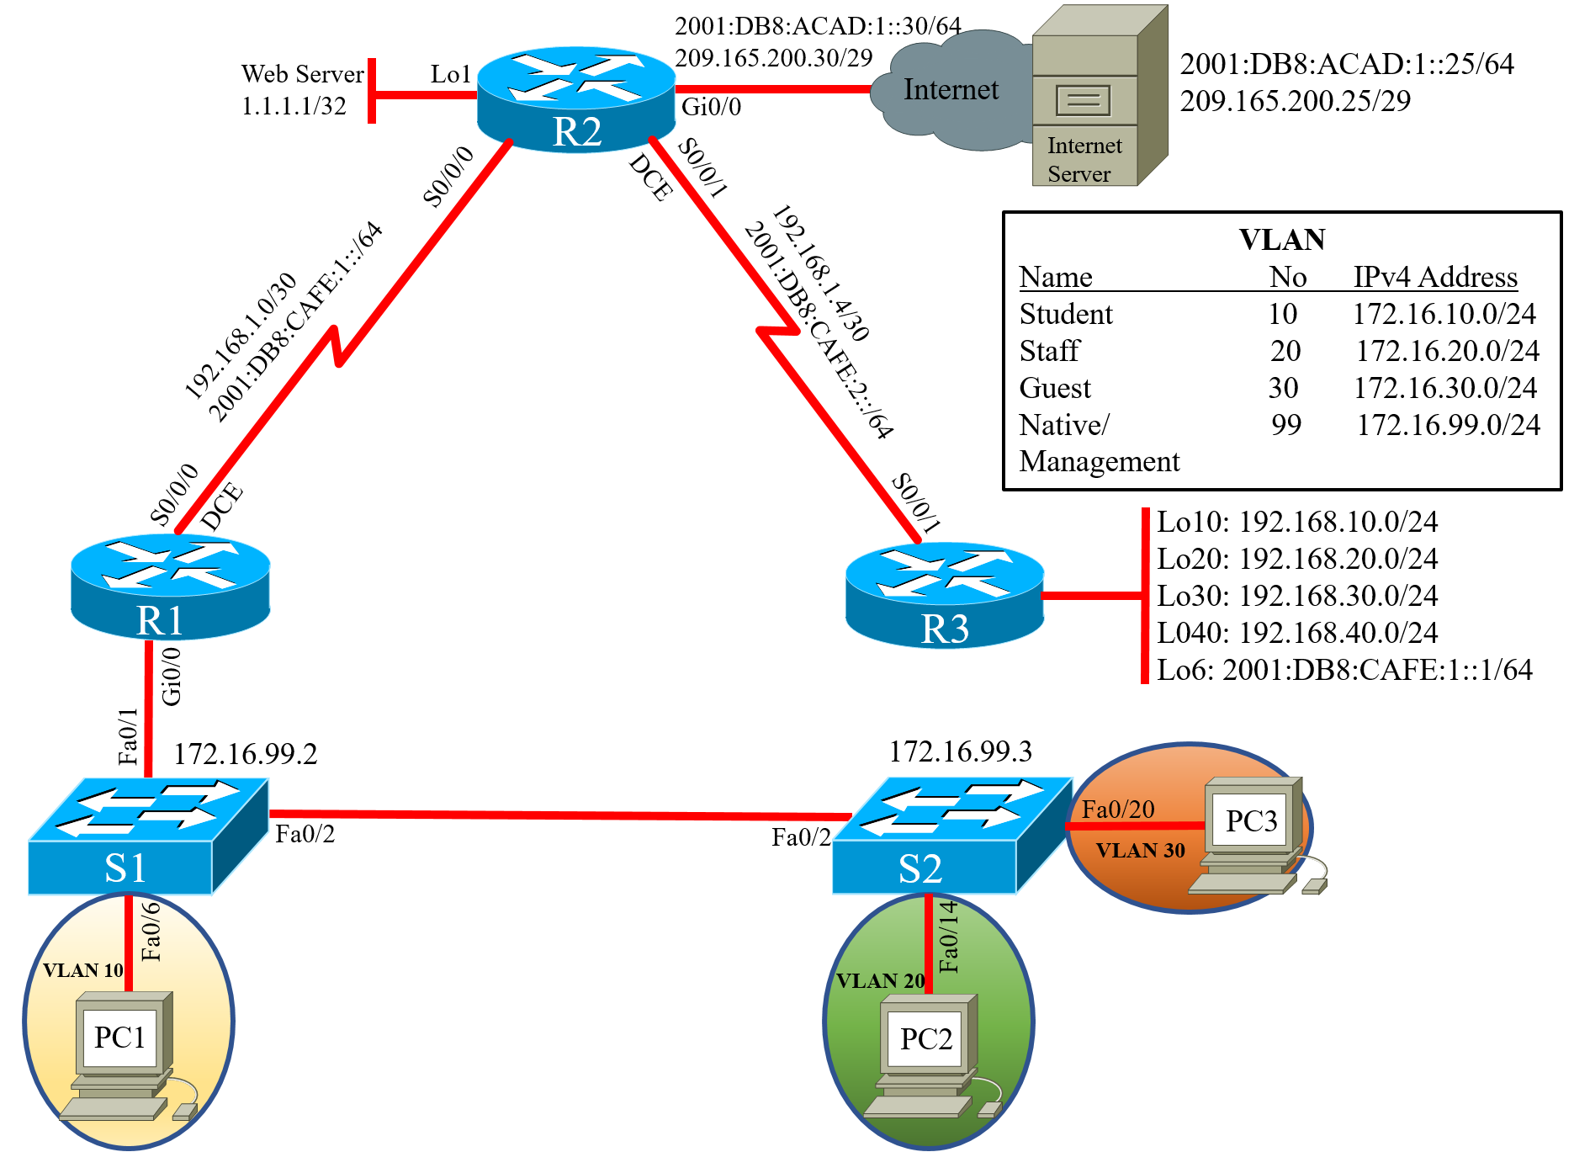

Task 1: IP addressing scheme (5 marks)

Device | Interface | IP Address | Subnet Mask | IPv6 Address
R1 | Ge0/0
R1 | Ge0/0.10
R1 | Ge0/0.20
R1 | Ge0/0.30
R1 | Ge0/0.99
R1 | S0/0/0
 |  |  |  | Link-local:
R2 | S0/0/0
 |  |  |  | Link-local:
R2 | S0/0/1
 |  |  |  | Link-local:
R2 | Ge0/0
 |  |  |  | Link-local:
R2 | Lo1
R3 | S0/0/1
 |  |  |  | Link-local:
R3 | Lo10
R3 | Lo20
R3 | Lo30
R3 | Lo40
R3 | Lo6
S1 | VLAN99
S2 | VLAN99
Internet Server
 |  |  |  | Link-local:

Task 2: Network Connection (5 Marks)

Physically cable the network as shown in the topology diagram.

Task 3: Configure the basic configuration (10 Marks)

            - Configure all devices with hostname
            - Disable DNS lookup
            - Configure all devices with interfaces as shown in the topology.
            - Configure Internet PC with IPv4 and IPv6 address.

Task 4: Configure Routers and Switches (65 marks)

1. Configure OSPFv2 on all routers and advertise networks shown in the topology.
2. Configure IPv6 static route with exit interface on all routers.
3. On R2, configure IPV4 and IPv6 default route out Gi0/0.
4. Propagate default route in to OSPF
5. On S1 and S2, configure VLANs
6. Assign the IPv4 address to Management VLAN 99 on S1 and S2.
7. Assign default gateway on switches
8. On S1, force trunking on Fa0/1 and Fa0/2. Use VLAN99 as the Native VLAN
9. on S2, force trunking on Fa0/2. Use VLAN99 as the Native VLAN.
10. On S1, assign Fa0/6 to VLAN10 and on S2, assign Fa0/14 to VLAN20 and Fa0/20 to VLAN30.
11. On both switches, shutdown all unused ports.
12. Configure Router-on-Stick inter-VLAN routing.
13. On all Routers, configure all Loopback and Ethernet interfaces as passive.
14. Configure R1 as the DHCP server for VLANs 10, 20 and 30. Reserve first 10 IP addresses for static configurations.

VLAN10: Name: Student  DNS-Server: 1.1.1.1  Domain-Name: SoAC.com  Set the default gateway | VLAN 20: Name: Staff  DNS-Server: 1.1.1.1  Domain-Name: SoAC.com  Set the default gateway. | VLAN30: Name: Guest  DNS-Server: 1.1.1.1  Domain-Name: SoAC.com  Set the default gateway

15. Create a local database with 1 user account: username: webuser, password: soac1234, privilege: 15.
16. On R2, configure a static NAT to the Web Server. Assign the inside and outside interface for static NAT.
17. Configure the dynamic NAT. Allow VLAN 10 and 20 networks on R1 to be translated.
18. Define the pool of usable public IP addresses, 209.165.200.26 to 209.165.200.29.
19. Define the dynamic NAT translation.

Task 5: Verify connectivity (15 marks)

After configuring each host computer, record the host network settings with the ipconfig /all command.

Host PC-1 Network Configuration
Description
Physical Address
IP Address
Subnet Mask
Default Gateway

Host PC-2 Network Configuration
Description
Physical Address
IP Address
Subnet Mask
Default Gateway

Host PC-3 Network Configuration
Description
Physical Address
IP Address
Subnet Mask
Default Gateway

Verify PC-1 can ping PC-2 and PC-3. Is it successful? __________________

Use a Web browser on the Internet PC to access the Web Server (209.165.200.29). Login with Username: webuser and password: soac1234.
Is the Web server accessible? _____________________________

Submission Requirement
On each device the following outputs should be copied on to a text file. The file name should be as Surname_SNo_routername.txt

Show running-configuration
Show ip interface brief
Show ip route
Show vlan

All documentation for your solution should be submitted electronically on Moodle.
It is your responsibility that you copy all the outputs and files correctly.

