Buisness plan
Module name - Managing enterprise
Tutor- Melanie Squire
Student name Ayasha khatun
Student numbere -1712713
Date 02/07/2023
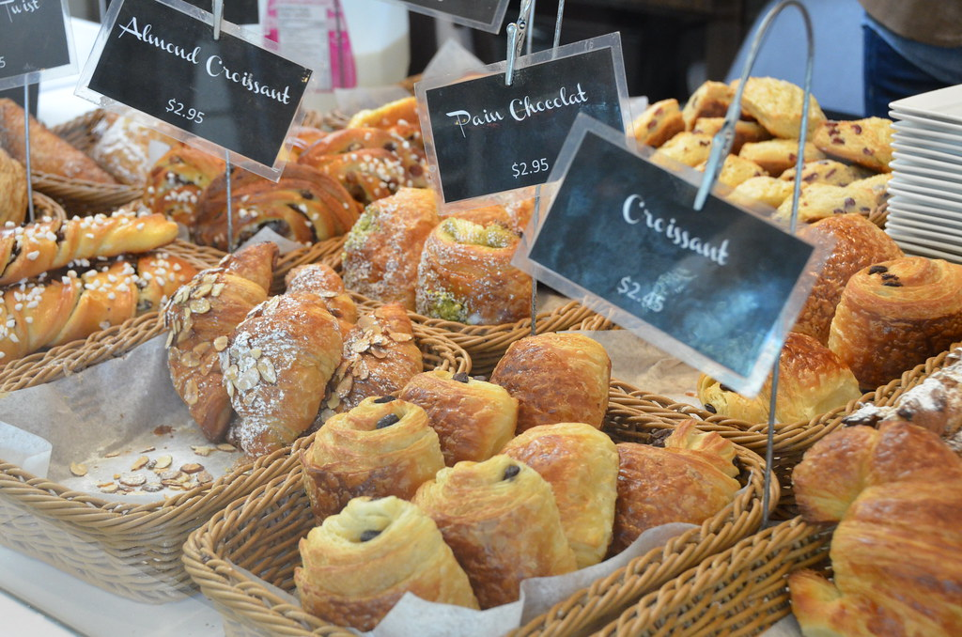

Contents page
Introduction page 3
Description/overview page 4
Legal status page 5
Misson statement page 6
Aims and objectives page 6
Human resources page 7
Location page 8
Market research page 8
Marketing ideas and strategy page 9/10
12-month Cash flow forecast page 12
SWOT analysis page 13
SWOT Conversion strategy page 14
Conclusion page 15
Refences page 15

Introduction
This report will focus on the bakery sector. The bakery industry has been around for many centturies and has played a huge role in proving customers with authentic and different recipes each time.

Description /overview
We are proud to say that will open up our new busness that is pastry shop. The new bekery shop will offer a variety of pastries to choose from . this includes the classic bristish pastries, flavors from around the world this includes african, indian and the classic british.

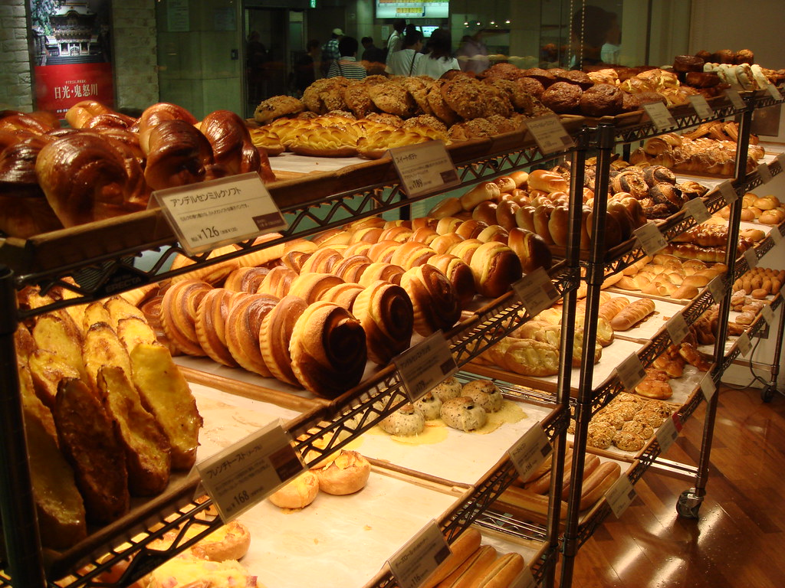

Legal status
My legal status is that I plan to be a sole trader. There will be pressure due to all falling on one pesson. However its not impossble with hard work and dedication. The reason I chose to be my own boss is due to the fact that I have experinced parteneship business and it was not the easiest. A new buisness can be succesful with the correct training and understanding for the respective buisness. (Beresford and Mark, 2005)



Mission statement
For startup businesses or old businesses there can be a lot of catchy lines to promote.
Our missions is to bring our customers unique pastries simple yet delicious.
Aims
- An aim is necessary in every field u come across whether it is for work, education or to be you own boss. To go one step ahead one must have the vision of the future and that is an Aim. ‘Businesses have an aim and objective they can be financial and non-financial.’ (BBC Bitesize,2023)
Our aim is that we want to have the best product and reputation in the market.
Objectives
It is vital for businesses to have a defined objective, to be locally famous is a success. (Nur,2020) We have thought of several objectives for out pastry shop these are:
- To have a grand opening by cutting the ribbon, on a Saturday (2023)
- To be a well-known pastry shop in Cardiff.
- To make a profit of 4000 a month (2023)
- To save 80% off the profit end of each month (2023)
- Hold a ribbon cutting ceremony to create a buzz. (2023)
- To have the business established by October (2023)

Human resources

Initially, my sister and I will run business together. If the business does well within the first 12 months, we will hire two other experienced individuals to help us around the business to ensure that everything runs smoothly. (Garavan, 2016)
These employees will receive training upon getting hired. Their roles will be to bake the food items, send and response to business emails, and count the money from the tills at the end of the day.


This Photo by Unknown Author is licensed under CC BY

Location
It is ideal to think of a location for your business where is it safe and suitable for consumers. Our chosen location is in Grangetown at the heart of Cardiff. This location is suitable for a fresh start up business. There are many advantages that are linked with this area. New pastry shop will be a short distance away from the town centre. However, we also have the famous bay. We are hoping for the best as we usually have tourist in Cardiff for concerts and games. (Foods, 2019)
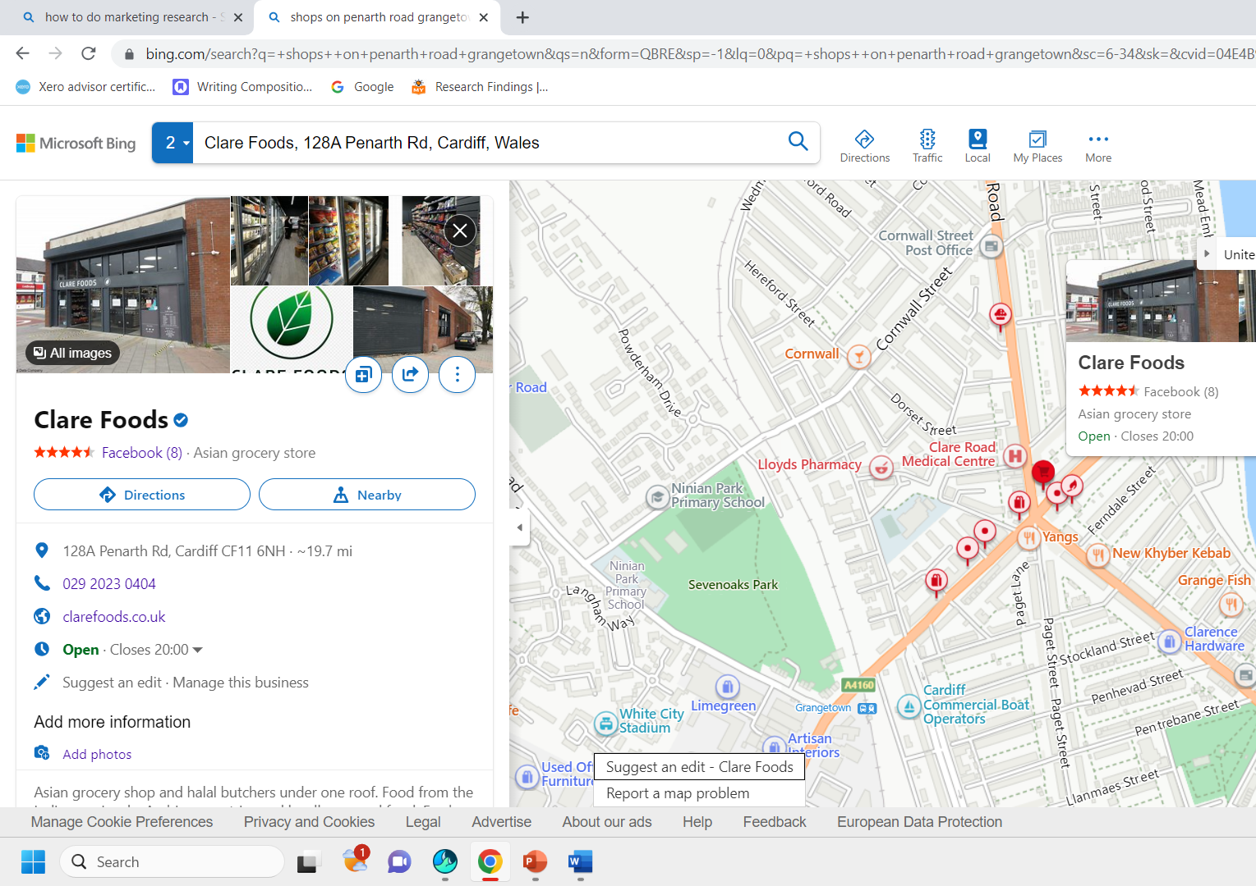

Market research
Before beginning any type of work it is vital do do background reaserch. Prior to this buisness we looked at the back backdrop we instantly knew this was not going to be a easy one and did a brainstorm. From our research we found out that it doesn’t matter how old or young you are. An scrumcious pastry shoul always be on the menu. Our target audience are people from all age groups, we conducted an anonymous online survey and asked various questions, the questionnaire has helped us immensely to know the likes and dislikes our customers therefore we plan to do more surveys once the pastry shop is up and running as it will give us a great insight for the needs of our customers. However, we also done a survey at the local parks and asked them to fill in a quick questionnaire, once it was completed, we gathered all the information and decided to go ahead will the plan. To get a detailed overview we decided to open a pop-up stall for one day at the local park funfair. We had dived deeper to weigh out the pros and cons, this means just like any other business the bakery industry also has trends. People's choice and taste buds change with seasons. Additionally, in a market which has a segment of consumers, quality store brands can be an instrument for retailers to generate. (Corstjens, 2016).

Market research and ideas
When planning a startup business as a sole trader or partnership is good to know how the market works. All the ideas and suggestions can be daunting but helpful at the same time. According to (Matkó et al., 2014) It is particularly important to perform market research for a company in any other segment. What is marketing research? (1996).

We have decided how we want to advertise for our new business and the main methods are:
- To post leaflets door to door
- To hand out business cards
- To post on social media this includes Facebook, Instagram, and twitter.
- To Have a website on google
- We will collaborate with other companies on Instagram.
- Flyers to be distributed.
- We will collaborate with influencers.

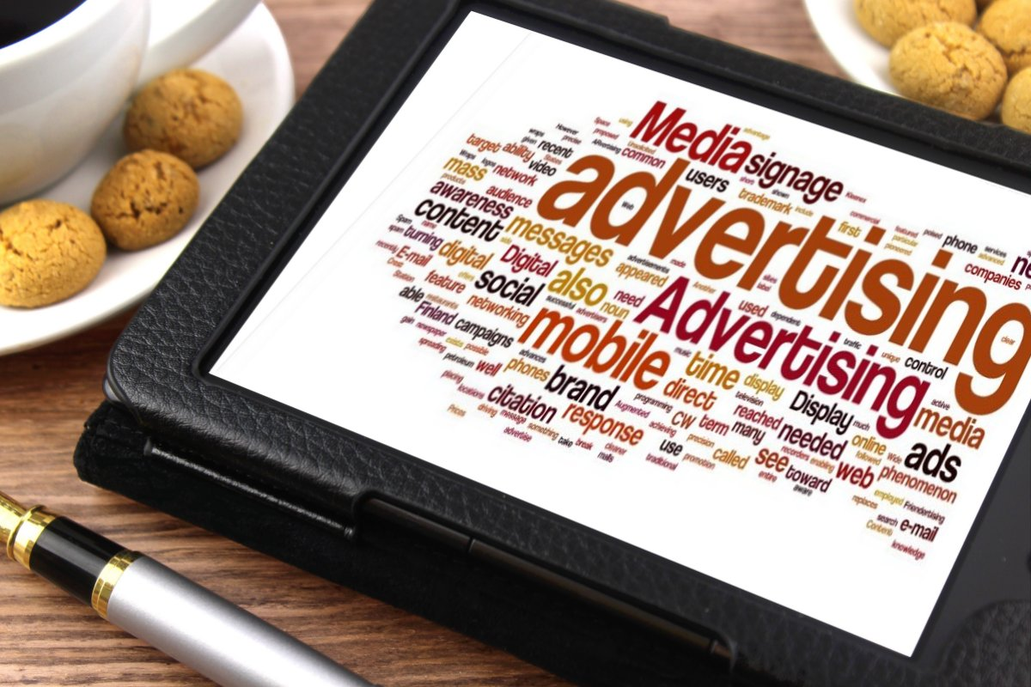

Financial resources
Without adequate funds or investments, it can be exceedingly difficult to open any business. Therefore, to avoid disappointments it is ideal to have your finances in place, spare savings is a life saver for many of us.
To open the business, we have decided to borrow a loan from the bank, we intend to borrow from friends and family. The amount that is needed is £50.000 altogether, this amount will allow us to decorate, buy new equipment and of course keep the business up and running for raw materials petrol, bills, and wages. However, if extra finance is required, we will invest some of our savings. There is not anything better than making your business go big. Haag, A.B. (2013).



12-month Cash flow forecast
Cash flow is a clever technique to keep track of your income and expenses. (Givoly, Hayn and Reuven Lehavy, 2009)
 | 1 | 2 | 3 | 4 | 5 | 6 | 7 | 8 | 9 | 10 | 11 | 12 | Total
Income
Sales | 3000 | 2000 | 4000 | 5000 | 4000 | 4000 | 5000 | 4000 | 4000 | 4000 | 3000 | 2000
Loans | 50.000
Investment
Total | 53.000 | 6000 | 5000 | 7000 | 8000 | 5000 | 4000 | 4000 | 5000 | 4000 | 4000 | 4000 | 83.000
Expenditure
Wages | 500 | 500 | 500 | 500 | 500 | 500 | 500 | 500 | 500 | 500 | 600 | 600
Drawings
Rent | 800 | 800 | 800 | 1000 | 1000 | 1000 | 1000 | 1000 | 1000 | 100 | 1000 | 1000
Utilities | 2000 | 2000 | 2100 | 2200 | 2100 | 2000 | 2000 | 2000 | 1900 | 1900 | 2000 | 2000
Phone | 50 | 50 | 50 | 50 | 50 | 50 | 50 | 50 | 50 | 50 | 50 | 50
Loans
Raw materials | 1000 | 900 | 900 | 1000 | 900 | 800 | 900 | 900 | 800 | 900 | 900 | 800
N  INO | 100 | 100 | 100 | 100 | 100 | 100 | 100 | 100 | 100 | 100 | 100 | 100
Adverts | 80 | 80 | 80 | 70 | 50 | 40 | 40 | 40 | 40 | 40 | 40 | 40
Petrol | 150 | 140 | 140 | 150 | 155 | 145 | 140 | 140 | 140 | 140 | 140 | 140
Pensions | 100 | 100 | 100 | 100 | 100 | 100 | 100 | 100 | 100 | 100 | 100 | 100
Insurances | 40 | 40 | 40 | 40 | 40 | 40 | 40 | 40 | 40 | 40 | 40 | 40
Capital spends
Total | 7020 | 5910 | 5910 | 7220 | 6210 | 5775 | 5870 | 5870 | 6670 | 3870 | 4970 | 5870 | 71.165
Net cash flow | 45.980 | -3910 | -3910 | -4220 | -4210 | -3775 | -2870 | -2670 | -2970 | --870 | -2970 | -1870
Opening balance |  | 45.980 | 42.070 | 38.160 | 38.940 | 29.730 | 25.955 | 23.085 | 20.215 | 17.545 | 166.75 | 13.705
Closing balance |  | 42.070 | 38.160 | 33.940 | 29.730 | 25.955 | 230.85 | 20.215 | 17.545 | 16.675 | 13.705 | 11.835

Swot Analysis

1.Be my own boss without relying on anyone.  2.We will offer a prominent level of customer service.  3.Can attract customers from my unique business name.  4.Safe location  5.Quality products | Weaknesses  1.Invest extra hours  2.Finishing off other assignments whilst running a business  3.There are multiple restaurants in the same area.  4.It can become difficult to focus, due to the fast trend in the market.  5.Tight staff can affect the business
Opportunities  1.Online orders for events  2.Collaborate with other companies.  2.It will be in a busy area of Cardiff.  3.Advertise as much as we can  4.Potential for better marketing with our own app  5.We will cater to pop up shops and stalls | Threats  1.Lack of experience within the bakery sector.  2.Difficult to keep up with the trends in the market.  3.Too much pressure as a fresh start up business.  4.Parking restrictions  5. Will technology change  6. Rising cost of ingredients

SWOT Conversion strategy
According to Madecraft, Belfiore, J. and Madecraft$$FMadecraft (2021
) You may have solid plans in place, but when the unexpected strikes you may be forced be pivot and re-evaluate your options
(Bbc.co.uk, 2023) ‘By putting your firm under the magnifying glass in such a fashion, you may find the way to grow your company or increase your earnings may vary’.
My biggest threat is that I will work as a sole trader which means all my tax and debts will solely be on me alone. I can turn that into an opportunity by working hard and paying it off with the profits I make.
My biggest weakness is that I do not have much experience for the bakery industry I can turn that into an opportunity by undertaking up a professional training course. This will allow me to gain the experience and confidence that I need.
We are living in turbulent times due to unforeseen circumstances business decision has become more unpredictable than ever Wilson, P. and Bates, S. (2003)

Conclusion
In conclusion this report has covered the main topics of our pastry shop. This includes the breakdown of the legal status, financial overview, location, and market research. Consumers want more which mean we will need to keep up with the fast trends.

Refences
Ash, E. (2015) Insights and strategies. Taking ideas into business reality. Melbourne, Victoria: Seven Dimensions.
‌BBC Bitesize. (2023). What are aims and objectives in business? - Business aims and objectives - OCR - GCSE Business Revision - OCR - BBC Bitesize. [online] Available at: https://www.bbc.co.uk/bitesize/guides/zr2bvk7/revision/1 [Accessed 10 Jun. 2023].
BbcBBC NEWS | Business | What it pays to be a business SWOT. [online] Available at: http://news.bbc.co.uk/1/hi/business/4634107.stm [Accessed 11 Jun. 2023].
Beresford, R., and Mark (2005). Professionalization of the business start-up process. [online] 14(6), pp.337–347. doi:https://doi.org/10.1002/jsc.734.
Corstjens, M. (2016). Building Store Loyalty through Store Brands - Marcel Corstjens, Rajiv Lal, 2000. [online] Journal of Marketing Research. Available at: https://journals.sagepub.com/doi/abs/10.1509/jmkr.37.3.281.18781 [Accessed 1 Jul. 2023].
Demir, G. (2015). Boutique pastry management as a rising services marketing practice and a comprehensive survey of boutique pastries in İstanbul. Isikun.edu.tr. [e] doi:https://hdl.handle.net/11729/986.
Foods, C. (2019). Clare Foods · 128A Penarth Rd, Cardiff CF11 6NH. [online] Clare Foods · 128A Penarth Rd, Cardiff CF11 6NH. Available at: https://www.google.co.uk/maps/place/Clare+Foods/@51.4704735,-
Fidalgo, A. and Miranda, J. (2023). Innovation in the Commercial System of the Small Bakery Industry. [online] pp.261–275. doi:https://doi.org/10.1007/978-3-031-25027-9_16.
Garavan, T.N. (2016). A Strategic Perspective on Human Resource Development - Thomas N. Garavan, 2007. [online] Advances in Developing Human Resources. Available at: https://journals.sagepub.com/doi/abs/10.1177/1523422306294492 [Accessed 3 Jul. 2023].
Givoly, D., Hayn, C. and Reuven Lehavy (2009). The Quality of Analysts’ Cash Flow Forecasts. [online] 84(6), pp.1877–1911. doi:https://doi.org/10.2308/accr.2009.84.6.1877.
Haag, A.B. (2013). Writing a Successful Business Plan. Workplace Health & Safety, [online] 61(1), pp.19–29. doi:https://doi.org/10.1177/216507991306100104.
‌Harvard Business Review (2022). A Plan Is Not a Strategy. YouTube. Available at: https://www.youtube.com/watch?v=iuYlGRnC7J8 [Accessed 11 Jun. 2023].
Madecraft, Belfiore, J. and Madecraft$$FMadecraft (2021) Conducting a SWOT Analysis. Carpenteria, CA: linkedin.com.
Givoly, D., Hayn, C. and Reuven Lehavy (2009). The Quality of Analysts’ Cash Flow Forecasts. [online] 84(6), pp.1877–1911. doi:https://doi.org/10.2308/accr.2009.84.6.1877.
Nur, N. (2020). Smiling Orchid Bakery & Cake / Nik Nur Farahani Nasharudin - UiTM Institutional Repository. Uitm.edu.my. [online] doi:https://ir.uitm.edu.my/id/eprint/59129/1/59129.pdf.
‌What is marketing research? (1996). London, England: TV Choice. Matkó, A., Eszter Szűcs, Tamás Takács and S. T. S. Kovács (2014). Examining the significance of market research in the case
Wilson, P. and Bates, S. (2003) The essential guide to managing small business growth. Chichester; Wiley.

