Mobile Application Development II
  - Lecture 1 Lab Tutorial Exercise

The Traditional “Hello World”, Extended!

Objectives
In programing, it is typical for the first programming exercise to shout out a Hello to the world. In keeping with tradition, our first Android App will do just that, but also say “Bore Da” or anything you prefer, and also in your preferred other language.

Exercise 1: Creating the Hello World App
- Launch Android Studio
- Click on the Start a new Android Studio project link.
- In the following screen, you need to configure the app
  - Application name: Hello World (or whatever you prefer). This is the name of the application shown in the Google Play Store, the title bar and other places.
  - Company Domain: Recall that your application code is compiled into a package (APK). Android Studio uses the company domain to form the name of the package that will be used for your app.
For example, if your app name is “My First App” and you specify a company domain of “ka.madII.com”, Android Studio will derive the package name: com.madii.ka.myfirstapp.
So you may want to use something to reflect yourself (name or initials e.g. ka) and the course or your company name if applicable (e.g. madII). See example below.
Company Domain: ka.madii.com
  - Project Location: select a location to save your app work
Important!
- Android Studio is fussy and does not like:
  - “Funny” characters in folder or file names. The entire location should not have spaces or other special characters (use underscores or hyphens instead).
  - Long file paths for the application builds (when it compiles the app to run it). Try and save as close to a root directory as possible. If you do not understand or you still get errors, ask me.
- If you want to organise your files and you end up saving to a long file path folder, you can configure a different location for the build outputs. Ask me.
  - Click Next
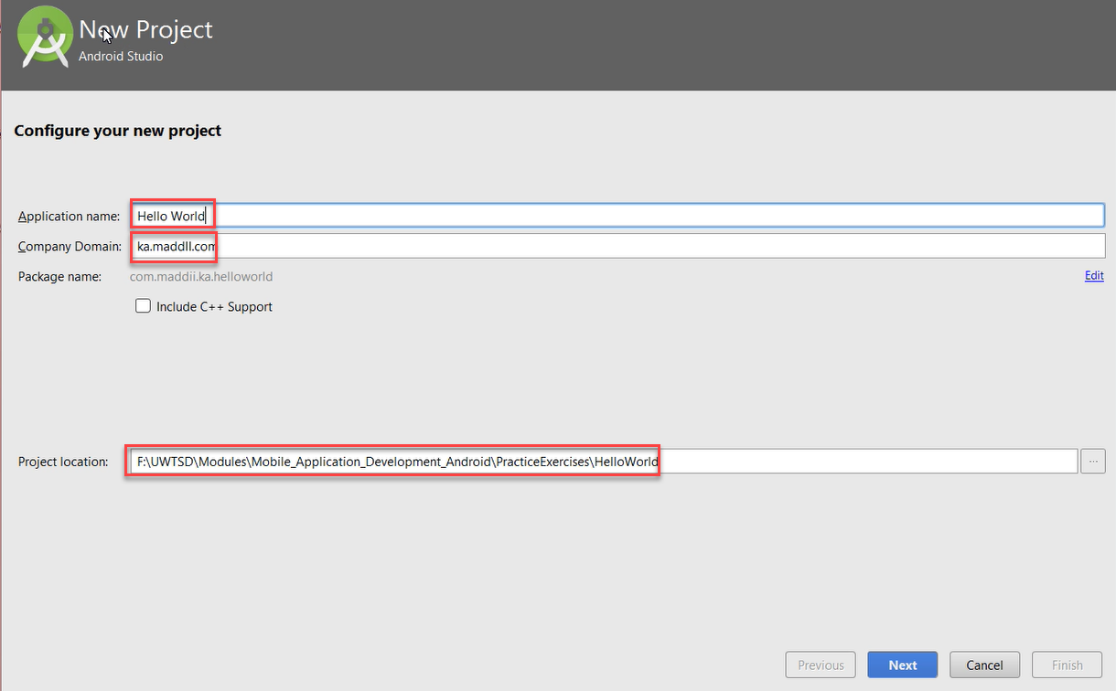

- The following screen asks you to specify the target API level/version. Accept the defaults on this page.
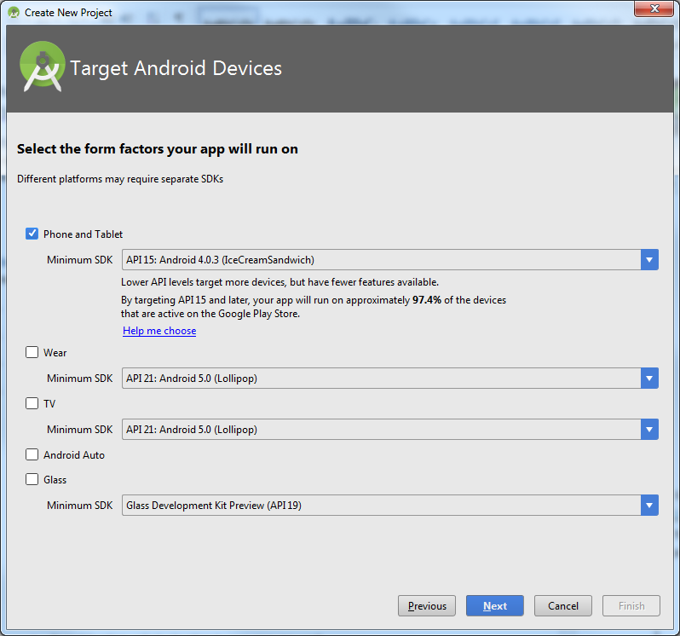
- The next step prompts you to add an activity to your project.
  - An activity is a single, defined thing that your user can do.
  - Select the Empty Activity and click Next.
- Next you need to configure the Activity.
  - Activity Name: the name of the class that will contain your Java code.
  - Layout Name: the XML file that will describe the User Interface (UI) layout.
  - Leave the defaults (or change if you wish) and click Finish.
- Be patient as Android Studio builds your app. If prompted to configure the proxy, you can use the following settings:
  - Host name: 193.62.88.55
  - Port number: 3128
- Hopefully, you have a screen similar to the following:
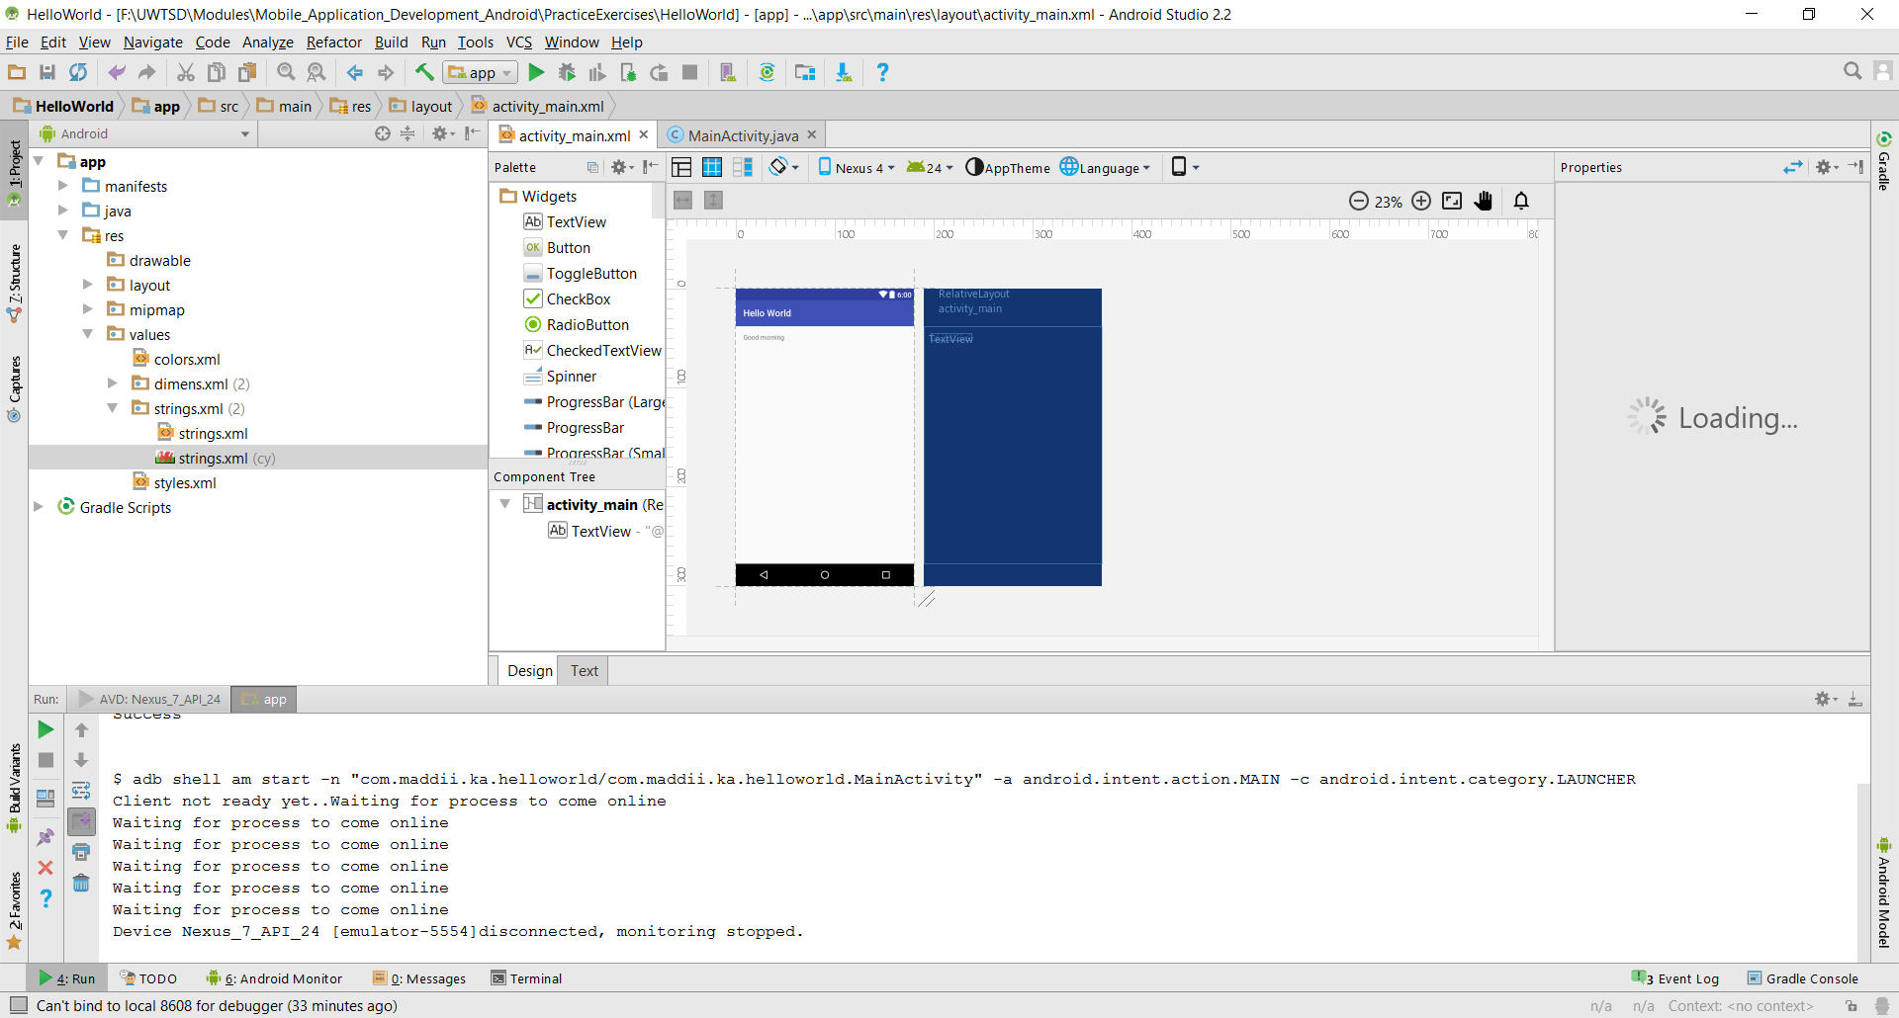

Exercise 2: Running the App in the Android Emulator
To run an app in an emulator, you need to set up an Android Virtual Device (AVD) first.

Creating an Android Virtual Device (AVD)
- From within Android Studio, go to Tools Android AVD Manager
- If you already have a device configured, you can skip this step, otherwise click the Create Virtual Device button.
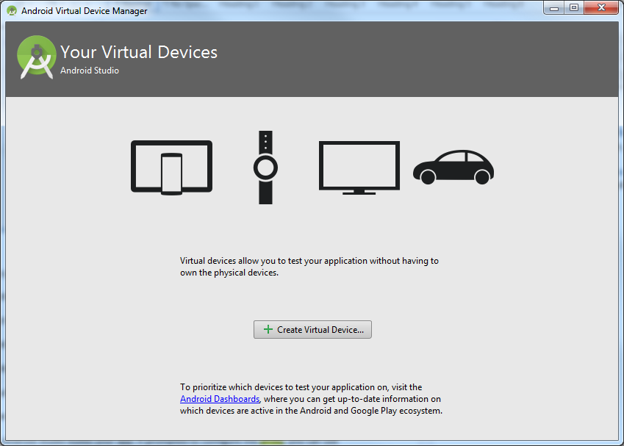
- Choose a device that your AVD will emulate.
- On the next screen, you select a system image. The system image gives you an installed version of the Android operating system. You can also choose what type of CPU. Make your selection as you wish and click Next.
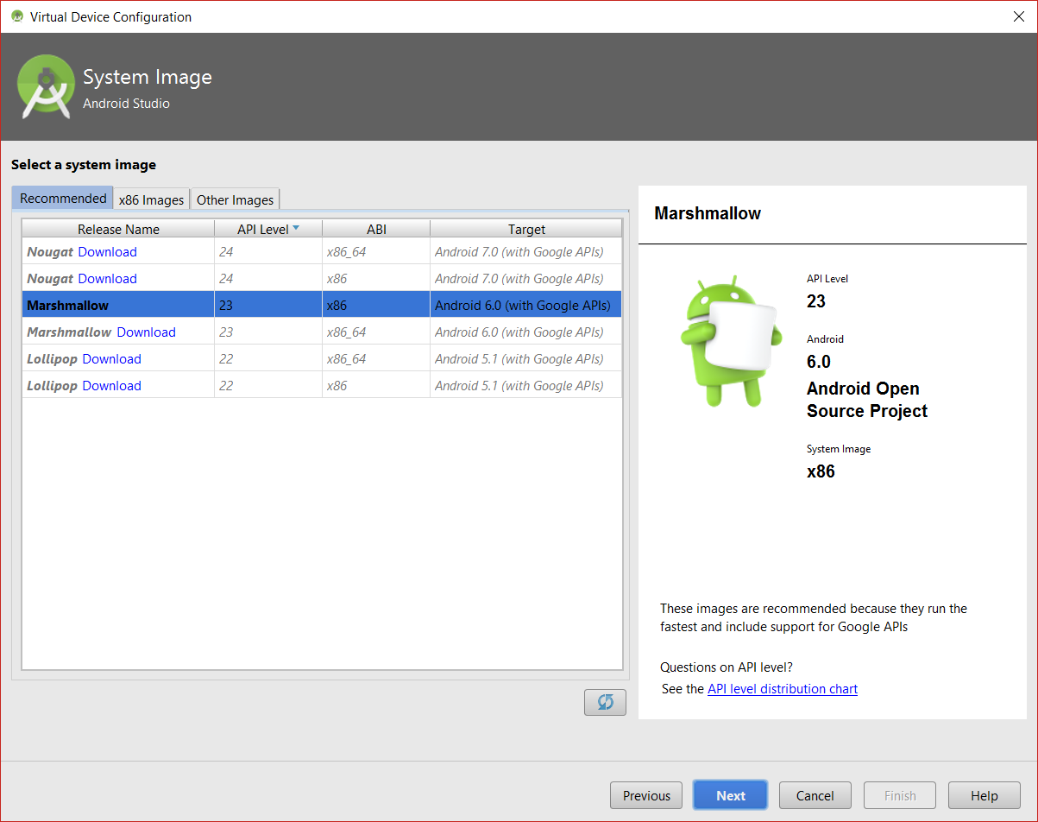
- Click the Finish button on the next screen and the AVD Manager will create your configured AVD.
- When done, you can either minimise or close the AVD Manager.

Running the App in the Emulator
- Return to your project in Android Studio.
- You can either run your app using the Run Run ‘app’ menu option or use the green play button to run your app.
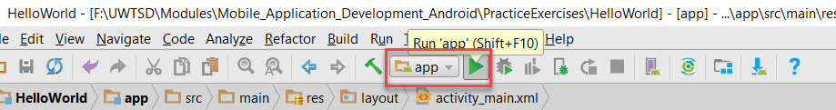
- You may get some warning about HAXM (Hardware Acceleration Execution Manager) not being installed (install this). Be patient, the emulator may take a while to start and that is an understatement! It’s a good time to go for a coffee.
- You may also get and error message saying “Android Emulator is incompatible with Hyper-V”. If you do click the link to turn it off. Unfortunately, doing this requires a system restart.
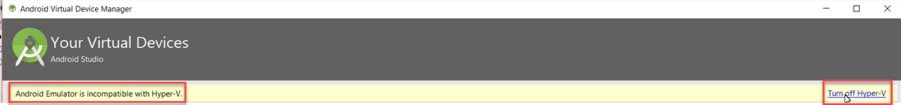
- Hopefully, it eventually loads and you have something similar to the image on the next page.

Exercise 3: “Refining” the App
At the moment, the app displays the static text “Hello World”. In this exercise, you will make it display the contents of a string value, whose content can be changed dynamically.

Creating a String Resource
- At the moment, the TextView component on the layout file is displaying the fixed string as shown below.
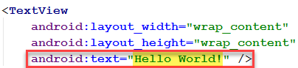
- We need to change this, so that it references a string resource whose value can be changed dynamically instead.
- Resources are stored in XML files.
- In the project window, navigate to res values. This folder should contain a file called strings.xml. Open it.
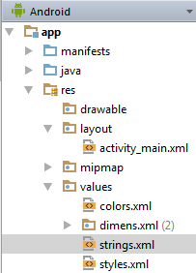
- Add a new string resource as shown, replacing the highlighted text with whatever text you want to display instead:
- Save your changes.

Updating the Layout File
- Next, you need to change the appearance of the app by changing the text that is displayed from the static text to use the string resource instead.
- Go to the layout, activity_main.xml (or whatever you called it) file. If you are in design view (showing the phone view and not the code view), click on the Text tab at the bottom to show the code view.
- Locate the TextView element on the page and change the value of the android:text attribute as follows (this will define a reference to a string resource whose value can be changed):
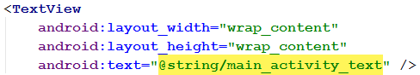
- Save your changes and try running your app.
- Has the text changed?

Localisation
String resources are good for localisation i.e. providing alternatives that adapt to meet language, cultural, etc. requirements.
- Right click on the res folder in the project view window and select New Android resource directory.
- You should get a popup window similar to the folder. You will configure localisation to support the Welsh language. Select the options as shown and hit OK when done:
  - Available quantifiers: Locale
  - Language: cy: Welsh (Any Region) – of course you can use another language if you prefer
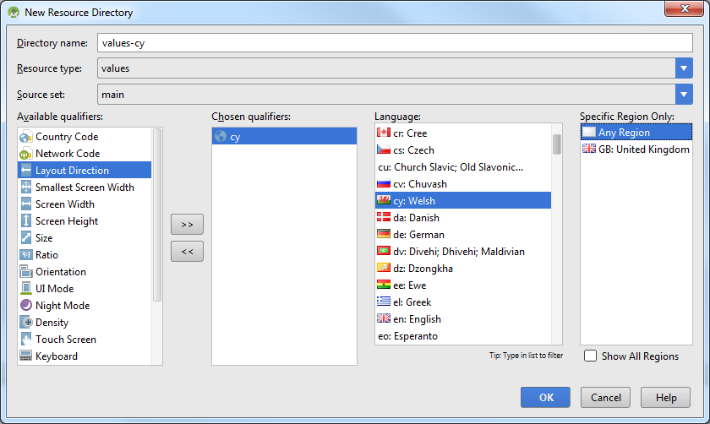
- Next, right-click on the res\values folder and select New Values resource file
- Specify the following:
  - File name: strings (this should be the same name as the other strings file)
  - Available quantifiers: Locale
  - Language: cy: Welsh (Any Region) – selecting this will automatically update the Directory name to the localisation folder created in the last step.
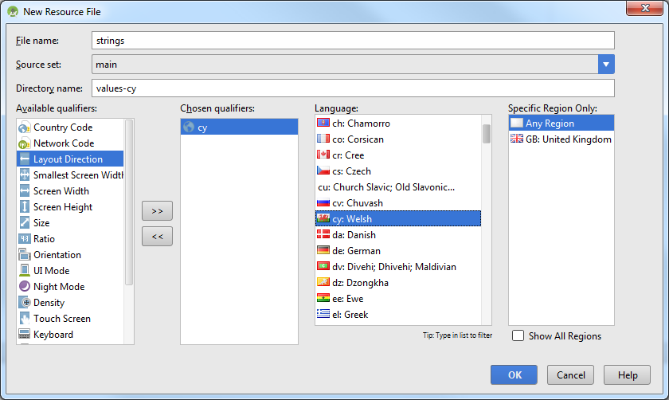
- A new strings.xml should have been created and should be displayed in the editor.
- Update the file to include the Welsh translation (or your chosen language) of the text added in step 5 – use Google translate if needed. See example below:
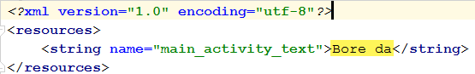
- Save your changes.

Changing the Current Localisation on your Device
- Go to Apps on the Emulator Device and look for Custom Locale, set this to cy – Cymraeg (if not there, set manually).
- Now return to Android Studio and run your app. Did it work? It should have.
- When done, you can set it back to en-GB or whatever you prefer.
- That’s all for today

