Starbucks – Premier Roaster and Retailer of Specialty Coffee
Strategic Management and Sustainability
Samuel Rees (P147950)
P147950

TABLE OF CONTENTS

1. Executive Summary…..…………………………………………………….
2. Introduction…...……………………………………………………………...
2.1 Report Remit………………………………………………….
2.2 Background of the organisation………………………….
2.3 Definition of major concepts……………………………..
2.3.1 Competitive Strategy………………………..
2.3.2 Porter’s Generic Strategies………………..
3. Main body……………………………………………………………………..
3.1 Brand Recognition………………………….……………….
3.2 Social Trends…………………………………………………
3.3 CSR…………………………………………….………………
3.4 Advantages…………………………………...………………
3.5 Disadvantages……………………………….………………
4. Conclusion……………………………………………………………………
4.1 Recommendations…………………………………………
5. References……………………………………………………………………

1. Executive Summary
The purpose of this report is to define strategy and why it is important to take into consideration when planning for the future. The strategies implemented by Starbucks will be outlined and evaluated to conclude why they do, or do not work well. Recommendations will be made based on the information in the main body of the report.
The research carried out in this report suggested that the differentiation strategy was applied to Starbucks’ operations because of targeting a broad market with a unique take on a coffee house. The differentiation strategy is an idea used in Porter’s Generic Strategies to target a large market with a unique product or service.
Starbucks created uniqueness by having new products introduced by their R&D team a regular interval with exceptional quality that is not matched by any competitor, and adapting to the growing social phenomenon of mobile phones by creating mobile applications to order and pay for products in advance.
Starbucks created advantages for themselves by having the best quality products and materials, creating a consumer perception of the highest quality, and attempting to make all raw materials fairly sourced by reliable farmers and suppliers.
To avoid decreased profits or market share Starbucks must account for the impact of BREXIT’s trade implications, rising inflation in the U.K and consumer social class distribution.

2. Introduction
Starbucks, an organisation that specialise in quality hot beverages and snacks for consumers at a premium price. With an annual revenue of $21.3 billion in 2016 (Starbucks, 2016. C) they occupy a large portion of the coffee market. In comparison, the nearest competitor, Costa, generated revenue of $1.8 billion in 2015 (Statista, 2016. A). In the U.S. coffee market at the end of 2016, Starbucks secured a sizeable share of 39.8% (Statista, 2016. A).
2.1 Report Remit
The objective of this report is to identify the competitive strategy in place for Starbucks to enable the organisation to maintain and increase market share. A critical evaluation of these strategies will outline the influence they have on the operations of the business.
2.2 Background of the organisation
Founders Jerry Baldwin, Zev Siegl and Gordon Bowker opened the first Starbucks coffeehouse in Seattle’s Pike Place Market in 1971. (Starbucks, 2017. A). The name ‘Starbucks’ was derived from the character ‘Starbuck’ in the 1851 classic novel Moby-Dick. A customer named Howard Schultz was very enthusiastic about the coffee they produced, and in 1981 he joined the organisation. Furthermore he believed the experience of an Italian coffeehouse would be well suited to the U.S. and took a break from Starbucks to create his own vision coffeehouse ‘Giornale’, and later bought Starbucks to carry on the vision he had of a community feeling coffeehouse (Starbucks, 2017. B). As of May 2017 Starbucks employ a total of 240,000 employees and are headquartered in Seattle, Washington (Forbes, 2017).
2.3 Definitions of major concepts
2.3.1 Competitive Strategy
Porter’s definition of competitive strategy states ‘Competitive strategy is about being different. It means deliberately choosing a different set of activities to deliver a unique mix of value’ (Porter, 1998, p. 60). Chandler, a leading business history professor previously at Harvard has a more sequential view of strategy with an emphasis on flow. ‘The determination of the basic long-term goals and objectives of an enterprise, and the adoption of courses of action and the allocation of resources necessary for carrying out these goals.’ (Chandler, 1963, p.13). Porter puts emphasis on the importance of variety and uniqueness in strategy. Alternatively, Chandler seems to suggest future planning and preparation are the important aspect of strategy, not even mentioning uniqueness as Porter emphasized. Both however have an implied concept of the long term which acknowledges the importance of having a plan in place, being adaptive, flexible and focused on the end-goal. In essence, strategy is the plan to create business value, have long term goals and the means in place to achieve these goals.
Deeper in the concept of strategy lies three basic levels. Corporate-level strategy is the overall goals and visions of the organisation on a global scale. ‘Corporate-level strategy is concerned with the overall scope of an organisation and how value is added to the constituent business of the organisational whole.’ (Johnson et al., 2010, p.7).The corporate level directly deals with market segmentation around the globe, resource management throughout the organisation’s different sectors, and the diversity of the business in terms of the variety of markets currently entered.
Business-level strategy defines how each strategic business unit should be behaving in their respective markets. ‘How the various businesses included in the corporate strategy should compete in their particular markets’ (Johnson et al., 2010, p.7). A strategic business unit (SBU) is a sector of business that has a unique and clearly specified market. This level is responsible for monitoring the market to keep an eye on competitors’ behaviour, adapting to the situations put forward in the market, pricing strategies, distribution, and innovation.
Operational strategies is the final level in the various strategy concepts in which the overall efficiency and delivery of the business-level and corporate-level strategy. Operations will monitor and evaluate the resource, people and process usage in order to get the most efficiency from the business. ‘Concerned with how the component parts of an organisation deliver effectively the corporate and business-level strategies in terms of resources, processes and people.’ (Johnson et al., 2010, p.7).
2.3.2 Porter’s Generic Strategies
To grasp an understanding of the strategies in place at Starbucks, Porter’s Generic Strategies will be used to contrast the different strategies in place. The theory defines four different methods of marketing which come under if the market is large, or niche, and if the advantage of the product is the value or the uniqueness.
See figure 1 overleaf.
The competitive advantage is essentially why the product/service being offered is superior to alternatives, in terms of value, benefits or quality. On the other axis, displays the attributes of the market entered. The broad market represents products that are a necessity such as basic nutrition, and commonly purchased items such as clothing, and household items.
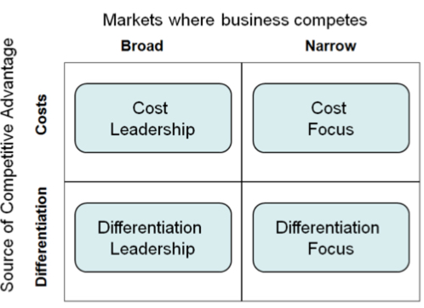

Figure 1 – Diagram of Porter’s Generic Strategies. Source: Porter, 1980.
The relationship betwixt the two axis’ defines which strategy is being used or should be being used.
Cost leadership places hard focus on maintaining the lowest cost in the market, and to not be undercut by competitors. This has a large emphasis on to produce in large quantities to enable good use of economies of scale. ‘To achieve overall cost leadership in an industry through… aggressive construction of efficient-scale facilities, vigorous pursuit of cost reduction tight cost and overhead control..’ (Porter, 1980, p. 35).
Differentiation supposes that variety is king. Creating a product/service that is unique in a niche market comes under the differentiation focus strategy. Whereas a broader market with a unique product falls into the differentiation leadership classification. (Porter, 1980, p. 37). Differentiating the product or service, thus creating something that is perceived as unique.
The focus section covers both cost focus and differentiation focus, as Porter classified them both under focus. ‘The entire focus strategy is built around serving a particular target very well and each functional policy is developed with this in mind.’ (Porter, 1980, p. 38).
Porter has identified that it is not always possible to fall into a category and hence has the ‘Stuck in the middle’ category. Porter (2008) indicates that falling into this category is a competitive issue and is in poor position. Businesses in this position will fail to compete with competitors that are using a specific strategy in the theory.

3. Main body
With a total of 37,000 stores at the end of 2016 (Starbucks, 2016, B) it is clear that they operate in a broad market; in North America, the market is valued at $21,997 million (Marketline, 2017. B). Starbucks’ products are of a high quality and the premium price tag to coincide with that. This suggests the differentiation leadership strategy due to being focused on quality in a large market; the quality bringing the source of competitive advantage. In the Swansea branch of Starbucks, the 20oz (Venti) Latte costs £2.95, whereas in the Swansea branch of Costa the 20oz (Massimo) costs 10% less at £2.65. The cost of the products varies in different geographical segmentations for both coffee vendors to accompany the relevant social classes present. Starbucks make a large portion of their intake from consumers that want a relatively fast and convenient warm drink and a snack. This is where the differentiation comes into play because the nearest rival, Costa has a worldwide total of 3500 stores (Marketline, 2017, A) in comparison to the 37,000 Starbucks has. To be in such a large variety of locations in all major cities worldwide is a huge convenience for Starbucks’ customers giving the business a huge competitive advantage over Costa. Consumers in cities are often work in business which can incurs business trips globally, thus having their favourite coffee provider widely available will allow them to purchase the products in all major and some minor locations.
3.1 Brand Recognition
A huge part of what makes Starbucks successful in their differentiation leadership strategy is the brand image/consumer’s perception of the brand. The logo is a huge influence on consumers because brand recognition is one of the most important parts of consumer psychology. Seeing a recognisable logo gives consumers a sense of trust because they have seen others using the product, have had the product previously, or because it is a big business they know it will likely ensure good quality. In figure 2 overleaf, the logo has become more simplistic to make it easier to recall the logo; if it was more complex as the previous logos show, it would take more memory to recognise and remember the logo. The siren in the logo is quite distinct over other competitors; and itself has a deeper meaning. In Greek mythology the siren lures sailors with their enchanting music and voice; having the siren in the logo subconsciously lures consumers to the brand from being a seductress and also quite hypnotic looking. The green colour suggests nature to the consumer subconsciously from the relation of green and nature, and the store design is often black which projects quality; thus making an image of quality nature produce to consumers. To summarise, the logo is a big part of what gives Starbucks its competitive advantage.
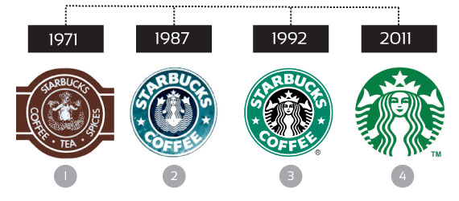

Figure 2 - Starbucks’ logo evolution. Source: Starbucks.

3.2 Social Trends
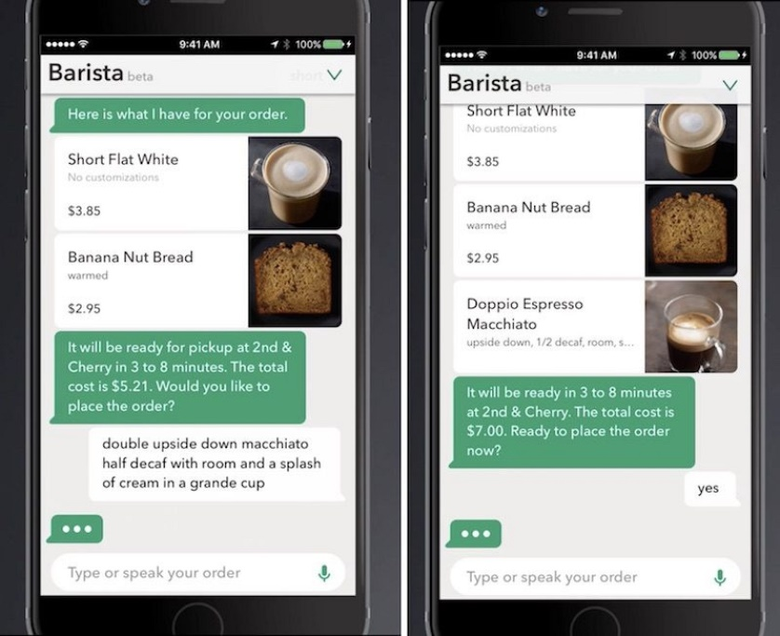
With new social changes and trends making an appearance this decade with mobile phones Starbucks are maintaining advantage over competitors by taking this opportunity and making it their own. Everywhere you see millennia’s, and even some generation Y using their phones constantly. With 4.23 billion mobile phone users worldwide in 2014 and over 5 billion users predicted by 2019 (Statista, 2015) the mobile device is becoming more prevalent. To coincide with this Starbucks designed the ‘My Starbucks Barista’ application.

Figure 3 – ‘My Starbucks’ Barista’ application. Source: Starbucks.
Making its original appearance on the iOS store, it has now subsequently appeared on the Android market place. Users can place orders via messages or with voice command to AI, which is then forwarded to the relevant Starbucks branch. With the ‘largest mobile ecosystem’ Starbucks have 8 million customers using the application, which equates to 1 in 3 paying via the application (Starbucks, 2016. A.).
3.3 CSR
Although Starbucks’ products are clearly high in quality which is a competitive advantage, an issue with sourcing the raw materials could damage the company image, or cast light on the CSR (Corporate social responsibility) in the sense that it does not seem to be important to the business. A lot of raw materials used in popular food such as coffee beans, cocoa have ‘fair-trade’ certification which can be a huge persuasion to ethically upright consumers. Starbucks created their own equivalent of this called ‘C.A.F.E Practices Programme’ (Starbucks, 2016. D) which claims to provide fair pay to the farmers of their product. Whether or not this is actually the case is unclear, and what raises more suspicion is that a very small selection of their products do in fact have ‘fair-trade’ certification, but not all. Their own initiative of fair pay is clearing not having success, and casts doubt on why they conform to ‘fair-trade’ for a confined selection of products, perhaps suggesting they are in fact not paying a fair rate for their raw materials.
A great initiative is their ‘Re-use your cup and get rewarded’ scheme. In an effort to reduce waste by recycling cups, Starbucks introduced this system which discounts any drink by 25p or they sell a £1 reusable tumbler . In 2014, ‘Earthsleeve’ was introduced which uses 100% recycled materials that save ‘the equivalent of three million sleeves per month (Starbucks, 2017, C). According to research carried out by the global information and data measurement company, Nielson Holdings ‘55% of global online consumers across 60 countries say they are willing to pay more for product and services provided by companies that are committed to positive social and environmental impact’ (Nielsen, 2014). Thus highlighting the important of having a good corporate image, and well managed CSR.
3.4 Advantages of the Differentiation Strategy
A unique product is a bonus to any strategy, whether the product is good quality or not is a follow-on from that. Meaning being unique is not good enough if the product does not meet a high enough standard to be appealing to consumers. Starbucks have hit the nail on the head with their products; the quality is distinguished amongst the coffee industry which is clearly shown in the global market share (Statista, 2016. A). This has created great brand perception to which allows near extortionate prices to be charged with losing only minimal levels of customers; a mark-up of around 80% claims various sources: Marketwatch, Telegraph, and CoffeeMakerUSA. The exact figure is unknown but you can assume at least a 70% mark-up. The sales figure could be improved with possible budget options for the lower social classes. In the UK, the average annual income is roughly £23,556 (Gov, 2017. A) placing the large majority of British citizens into the lower social classes. Targeting this particular segment would likely increase sales, but could damage the brand perception as the best coffee on the street. Being so well regarded it might be a blunder to taint it with a budget variety; since there is little to no true substitute for Starbucks creating less competition and increasing market share, resulting in the greater profit.
3.5 Disadvantages
The bedrock to this particular differentiation strategy definition places huge emphasis on being the best quality with the premium price to correspond with that which cuts out a large amount of the population due to social class, with the low average income of the UK and many other countries many consumers are not a target for Starbucks making them a missed opportunity, potentially. In the political world, BREXIT has hit hard on Starbucks, or so they claim to be the cause. In the first quarter of 2017 Starbucks issued a report which is no longer publically available that shows pre-tax profits in the UK have fallen 61% (BBC, 2017). Since this is only stage 1 of BREXIT, the income from the British sector of Starbucks is likely to take another hit when trade regulations become abolished and new ones in place as the UK will no longer have access to the European Union’s trade system; new tariffs, and deals will have to be made which likely will increase importation costs of products and materials. Therefore resulting in lower profit margins if selling price is not changed; having another knock on effect of lower disposable income for consumers which could lower sales of Starbucks. Currently in the UK inflation is at 2.8% (GOV, 2017. B) which is higher than the Bank of England’s target of 2%. Inflation lowers the value of money unless interest rates are higher which can result in lower disposable income for consumers as prices are higher. This will inevitably mean increasing the price of Starbuck’s products to match the inflation, which again can lower sales due to lack of disposable income.

4. Conclusion
Starbucks have had immense success using the differentiation strategy with annual profits of $21.3 billion in 2016 (Starbucks, 2016. C) and a U.S market share of 39.8% (Statista, 2016. A). The perception of top class quality from consumers has allowed the premium price tag and mark up to be successful.
They have introduced new varieties of coffee regularly to maintain the uniqueness, kept quality control to perfection and have found the sweet spot for the selling price to keep a high market share while maintaining high profits.
Starbucks must keep a close eye on the political world in the UK to be ready to adapt for any new importation regulations/tariffs when BREXIT hits in full force.
4.1 Recommendations
Starbucks should keep improving their recycling and general CSR by getting more of their products fair trade certified to encourage morally upright consumers to purchase their produce.
Keep introducing new products by expanding the R&D carried out by the organisation.

5. References

BBC, 2017. Starbucks says Brexit vote hit UK profits. [Online].
Available at: http://www.bbc.co.uk/news/business-39586848
[Accessed 11 November 2017].

Chandler, A.D., (1962). Strategy and Structure: Chapters in the History of American Enterprise. MIT Press, p. 13.

Forbes, 2017. Global 2000: Top Regarded Companies. [Online].
Available at: https://www.forbes.com/companies/starbucks/
[Accessed 10 November 2017].

Gov, 2017. A. Annual Survey. [Online].
Available at: https://www.ons.gov.uk/employmentandlabourmarket/peopleinwork/earningsandworkinghours/bulletins/annualsurveyofhoursandearnings/2017provisionaland2016revisedresults#average-earnings
[Accessed 11 November 2017].

Gov, 2017. B. Economy – Inflation. [Online].
Available at: https://www.ons.gov.uk/economy/inflationandpriceindices
[Accessed 11 November 2017].

Johnson, G, Scholes, K and Whittington, (2010), R, Exploring Corporate Strategy, p. 7.

Marketline, (2017). A. Costa Limited. [Online]
Available at: Marketline Advantage Database.
[Accessed 5 November 2017].

Marketline, (2017). B. North America - Hot Drinks Profile. [Online]
Available at: Marketline Advantage Database.
[Accessed 4 November 2017].

Nielsen, (2014). Global Consumers. [Online].
Available at: http://www.nielsen.com/us/en/press-room/2014/global-consumers-are-willing-to-put-their-money-where-their-heart-is.html
[Accessed 10 November 2017].

Porter, M.E., (1980). Competitive Strategy. Techniques for Analyzing Industries and Competitors, p. 35-38.

Porter, M.E., (1998). What is strategy, Harvard Business Review, November- December, p. 60.

Porter, M. E., (2008). Competitive Strategy: Techniques for Analyzing Industries and Competitors. New York: Free Press, 1980.

Starbucks, 2016. A. 10 Big Announcements. [Online].
Available at: https://news.starbucks.com/news/10-announcements-starbucks-investor-day-2016
[Accessed 2 November 2017].

Starbucks, 2016. B. Investor Day 2016. [Online].
Available at: https://news.starbucks.com/news/investor-day-2016-press-release
[Accessed 10 November 2017].

Starbucks, 2016. C. Starbucks Reports Record Q4. [Online].
Available at: https://news.starbucks.com/news/q4-fy16-earnings
[Accessed 8 November 2017].

Starbucks, 2016. D. Our Coffee. [Online].
Available at: https://www.starbucks.co.uk/responsibility/sourcing/coffee
[Accessed 11 November 2017].

Starbucks, 2017. A. Company Information. [Online].
Available at: https://www.starbucks.com/about-us/company-information
[Accessed 28 October 2017].

Starbucks, 2017. B. Company Timeline. [Online].
Available at: https://www.starbucks.com/about-us/company-information/starbucks-company-timeline
[Accessed 28 October 2017].

Starbucks, 2017. C. Responsibility - Environment. [Online].
Available at: https://www.starbucks.co.uk/responsibility/environment/recycling
[Accessed 10 November 2017].

Statista, 2015. Number of Mobile Phone Users Worldwide. [Online].
Available at: https://www.statista.com/statistics/274774/forecast-of-mobile-phone-users-worldwide/
[Accessed 4 November 2017].

Statista, 2016. A. Market Share of the Leading Coffee Chains. [Online].
Available at: https://www.statista.com/statistics/250166/market-share-of-major-us-coffee-shops/
[Accessed 31 October 2017].

Statista, 2016. B. Starbucks Statistics & Facts. [Online].
Available at: https://www.statista.com/topics/1246/starbucks/
[Accessed 30 October 2017].

