

ACDA5004

Managing a Hardware/Software Project Integrated with Enterprise and Innovation Group Project

By
Rebecca Ryall
1705433


Table of Contents
Table of Figures 2
what E-ceipts is about 3
what’s included 3
Constraints 4
Timescale 4
Budget 4
Methods we have used to keep cost low 4
Authority 4
Resources 5
Gantt Chart 6
Activity Network 8
References 10

Table of Figures
Figure 1 Gantt Chart Table[4] 6
Figure 2 Gantt Chart TimeLine[4] 6
Figure 3 Gantt Chart TimeLine[4] 7
Figure 4 Gantt Chart TimeLine[4] 7
Figure 5 Network Diagram[5] 8
Figure 6 Network Diagram[5] 8
Figure 7 Network Diagram[5] 9
Figure 8 Network Diagram[5] 9

Project initiation Document (PID)
E-ceipts (receipt and banking application)

what E-ceipts is about
E-ceipts is a basically making receipts digital the idea is to one day integrate are application with banking apps but until we are able to get the banks on board we will be using our own website and mobile phone application to store all the digital receipt’s, in the future we are hoping to one day do away with all paper receipts and help customers and businesses keep track of all payment in what store they were purchased on the date and time. And store them in order of what shop then by the date making it easier and faster to find each receipt the website and app will both contain a search bar to help narrow down your search when looking for individual receipt then ordering them by date for either to return items or to just stay on top of your finance as well as to help the environment with using less paper.

what’s included
E-ceipts will have their own stand aloud application but hopefully it will be integrated into many banking applications. There will also be a website where you can login and look through all the receipts from the last 7 years as it will be the same as banks with holding your data up to 7 years but this is an option you can remove receipt you no longer need or just leave then it up to you. This will also be the same as the app as you will be login into a secure server where all the recipe will be stored. The app will make this easier as you can scan in receipts.
What’s Not
Well there not many things that E-ceipts do not include other than a store as this will not need a shop to run this business as it can all be done online.

Constraints

Timescale
Due to some data protection with the banks and there security the timescale of integrating the applications within banking applications there could be some time before any progress on this section but as we have decide to have a stand aloud application and website for now we are on track to reaching are January and March deadline we have set.

Budget
The budget is reasonable low due to renting servers and having the produce we online and available to be download to customers person or business’s devices the set budget is £100.

Methods we have used to keep cost low
How the idea is able be run on a low budget, because we have reached and found ways to lower cost by saving money on various hardware needed for the project by renting servers as its cheaper and more cost effective to rent servers to handle the website and all to hold all of the data rather then the cost of storing and maintaining our own server as we would need to rent a place to house the units as well as keep them cool and have a generator to power the unit if lost of power to prevent loss of data.

Authority

- As we are a privately-owned working within financial sector our group has control over the project and has ultimate authority of the implementation of how this project is run and resources that will and won’t be used.
- The group is structured with the project leader idea and project manager being James Dunhill, he will be overseeing the project and delegates what is necessary to be completed throughout the project and Harry Byrne’s role is market research, he will be contacting banks and will continue to look into market research as the project continues. Conner Osborne is in charge of planning and production, he will be looking into companies of which who will be supplying the server for us to rent from for this project. Aida Lamer is taking on the role of business, she will be looking into legal classification of our privately-owned organization as we will be working within the financial sector for our business start-up. I myself will be taking the role of Team-Working and Management, I will be keeping the team organized within the time scale and managing individual members to make sure they are completing their assigned section of the project within good time but still leaving space for human error and unexpected delays.
- Throughout this project the group will be taking on additional roles such as; myself and Harry Byne will be programming and testing the application, Connor Osborne will also be creating the website and James Dunhill will be creating the infrastructure of the initial layout. All group members will be working on the final design of the website and the final design of the application, the group will also be looking into meeting with multiple banks but hoping to work with newly-formed online banks as their structure would be more flexible to integrate with our business project and also to check to see which type of banks are more interested.

Resources
The equipment we will be using and need throughout the construction of this business project will include numerus variations of software and a limited amount of hardware.
The software that will be used to create and display the application will be done on Unity[1] and then the scripts will be written in C# using visual studios[2].
To create the website it will be coded in Notepad++ [3] as we felt through Conner Osborne’s research that instead of having an online website builder create the website for us, We chose not to use a website builder because we would be limited on the changes as well as restricted on the ability to expand on it once it has been generated by the website builder. Because Notepad++ is adaptable we can make minor changes easily and quickly at any time as well as expand the website if needed later down the line.
The hardware that we will be using will be a rented server as the cost of running our own was costly and unnecessary and buying our own would be difficult to store where as it would be more reliable and cost-effective to rent as they’re cheaper and the cost to maintain the server is included.

Gantt Chart
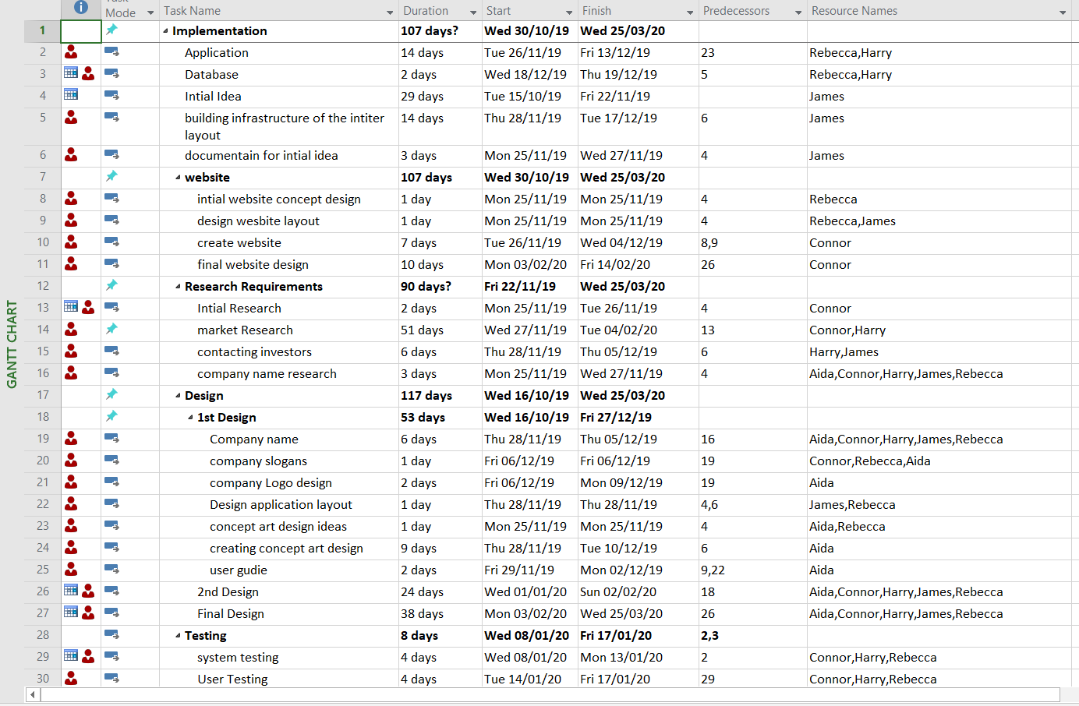
Figure 1 Gantt Chart Table[4]

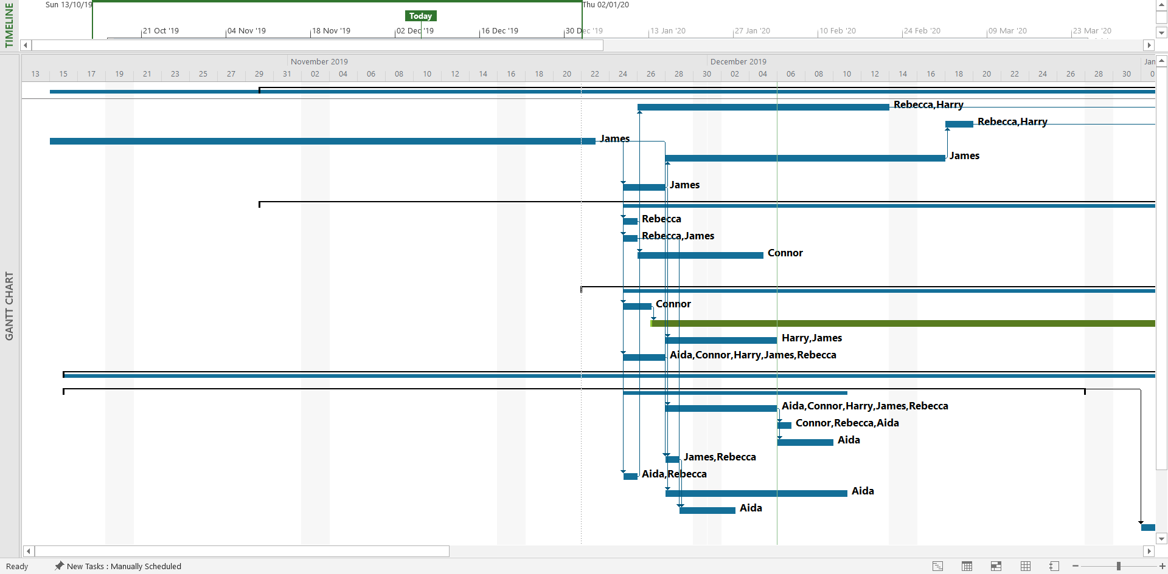
Figure 2 Gantt Chart TimeLine[4]
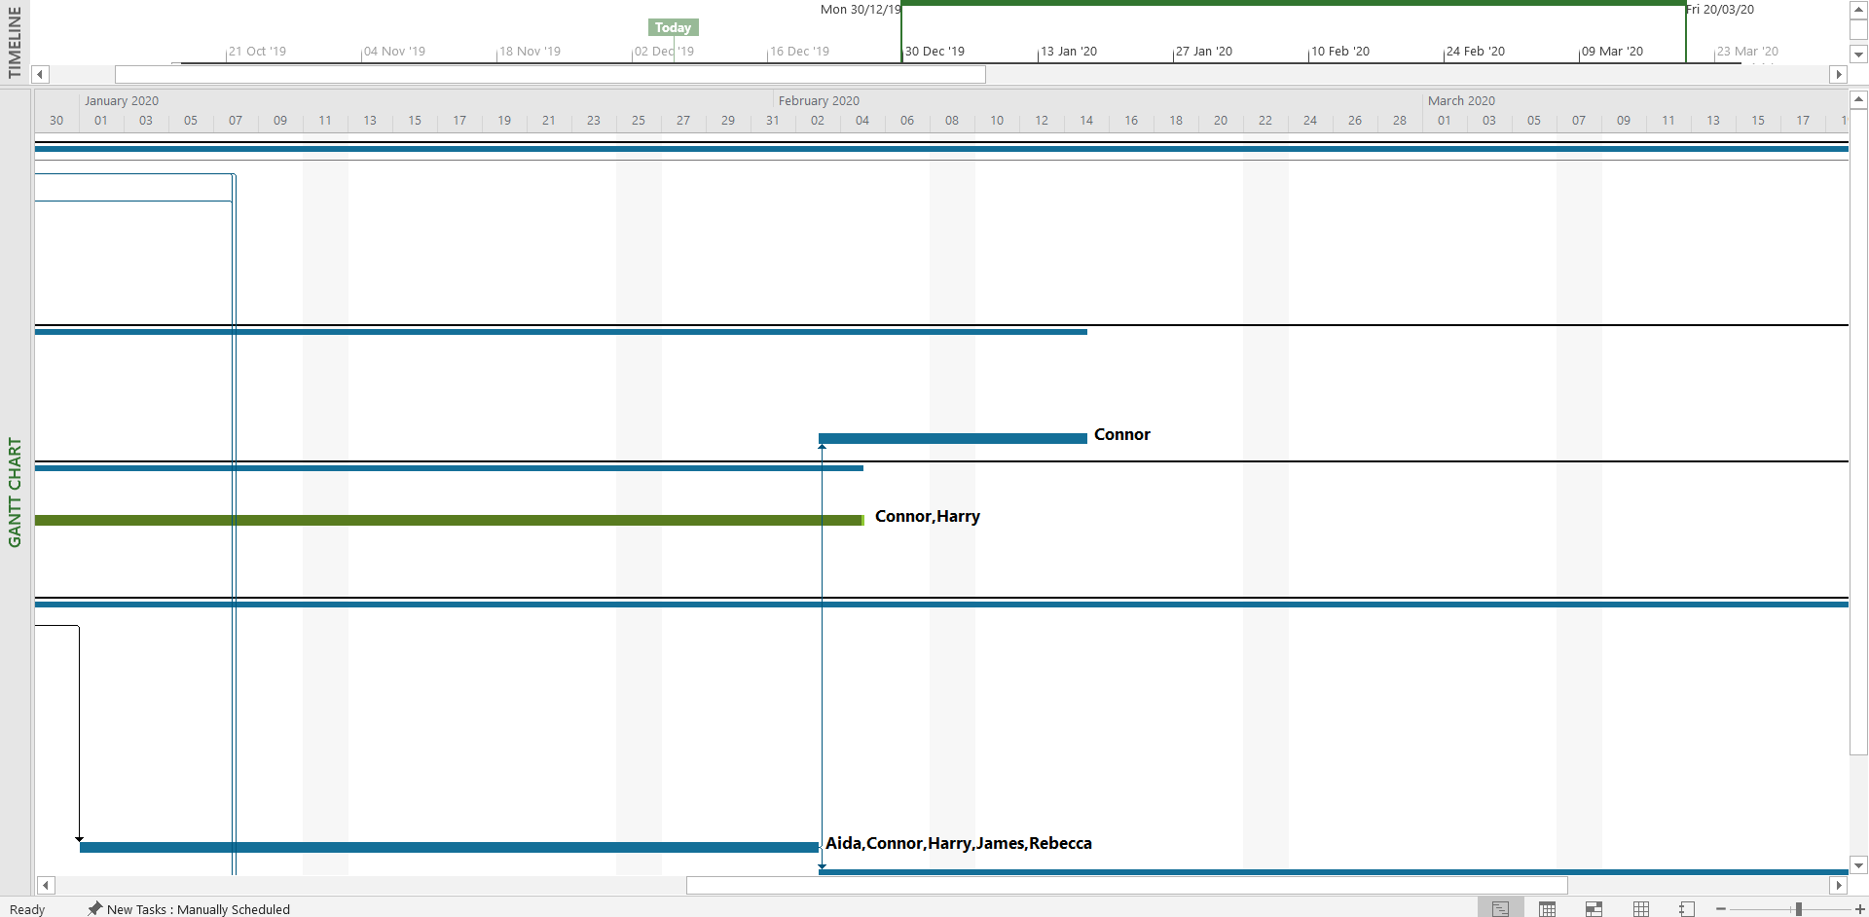
Figure 3 Gantt Chart TimeLine[4]
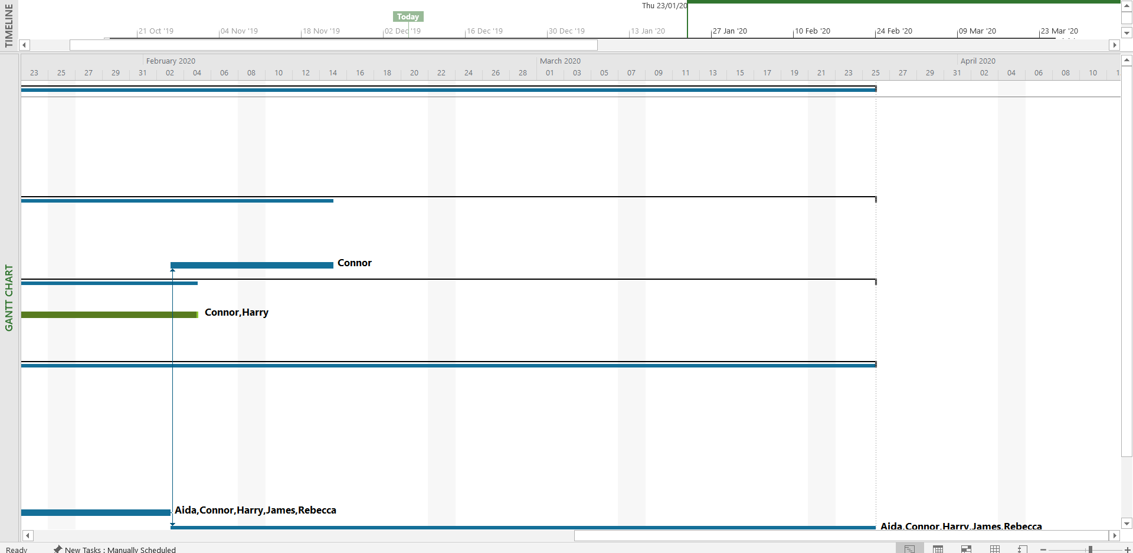
Figure 4 Gantt Chart TimeLine[4]

Activity Network

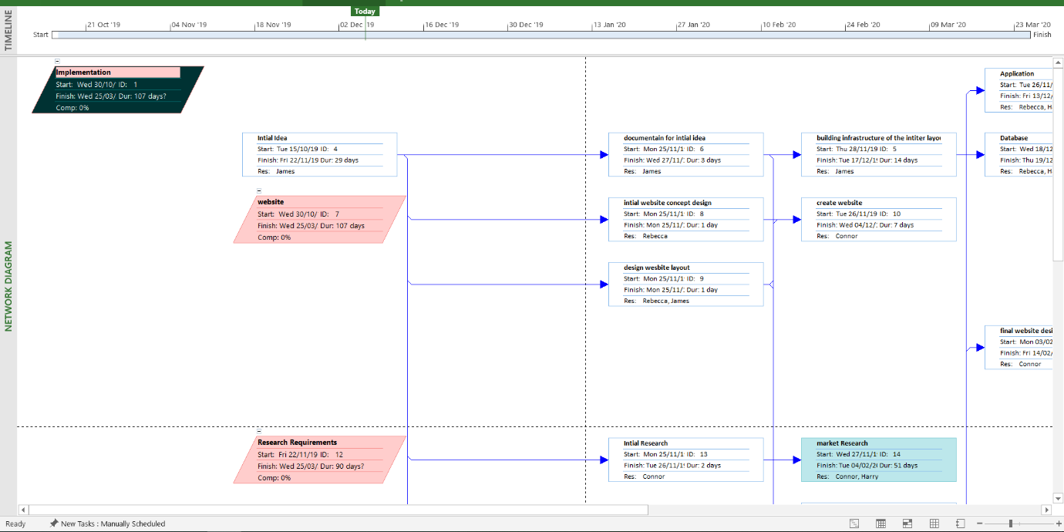
Figure 5 Network Diagram[5]

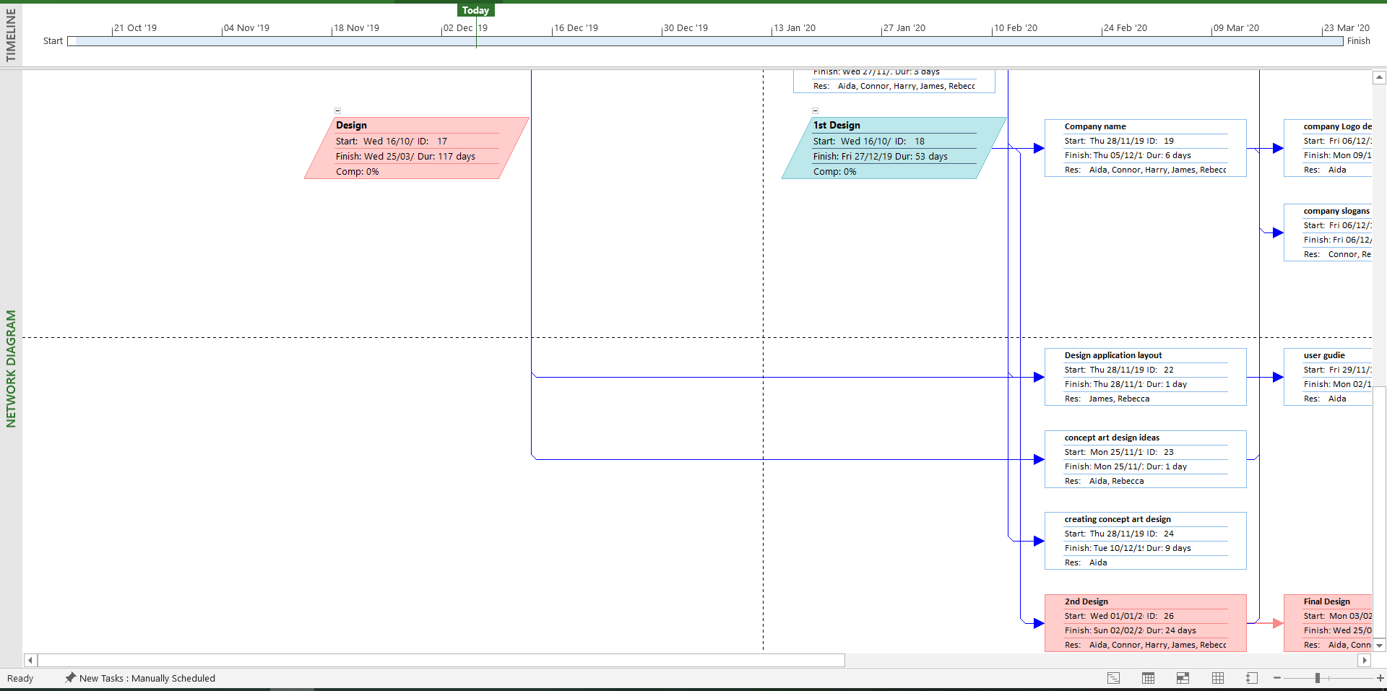
Figure 6 Network Diagram[5]
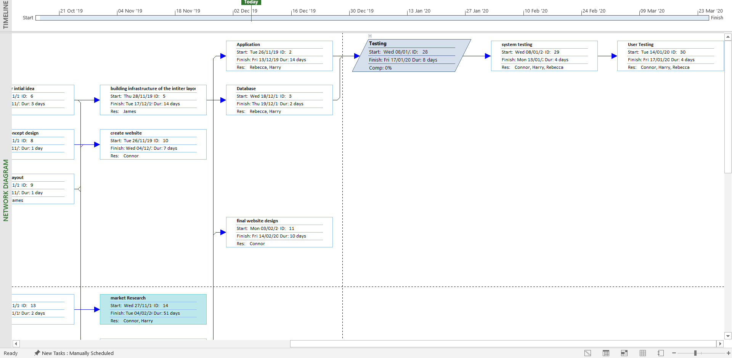
Figure 7 Network Diagram[5]
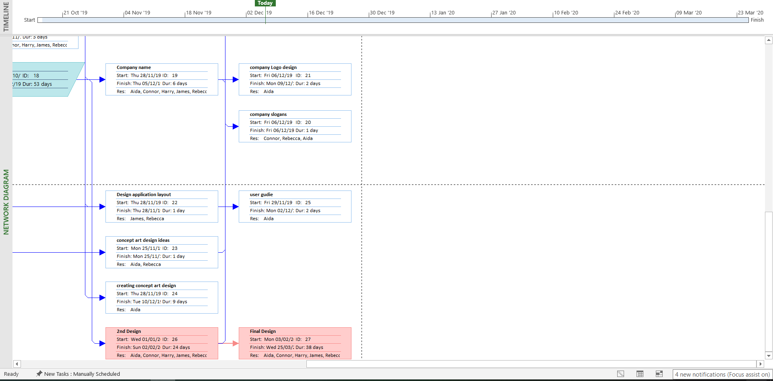
Figure 8 Network Diagram[5]

References

[1] ‘Unity Real-Time Development Platform | 3D, 2D VR & AR Visualizations’. [Online]. Available: https://unity.com/. [Accessed: 06-Dec-2019].
[2] ‘Visual Studio IDE, Code Editor, Azure DevOps, & App Center - Visual Studio’. [Online]. Available: https://visualstudio.microsoft.com/. [Accessed: 06-Dec-2019].
[3] ‘Downloads | Notepad++’. [Online]. Available: https://notepad-plus-plus.org/downloads/. [Accessed: 06-Dec-2019].
[4] ‘Gantt Charts - Project Management Tools from MindTools.com’. [Online]. Available: https://www.mindtools.com/pages/article/newPPM_03.htm. [Accessed: 03-Dec-2019].
[5] ‘Microsoft Project Reviews: Pricing & Software Features 2019 - Financesonline.com’. [Online]. Available: https://reviews.financesonline.com/p/microsoft-project/. [Accessed: 30-Nov-2019].

