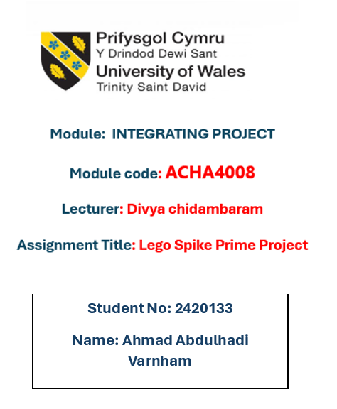

Table of Contents
- Introduction
1.1 Overview of LEGO SPIKE
1.2 The Significance of Robotics
  - 1.2a Educational Benefits of Robotics
  - 1.2b Robotics and Technological Innovation
  - 1.2c Robotics Across Different Academic Fields
1.3 Understanding the Problem
1.4 My Role in This Project
- Team Collaboration
2.1 Importance of Working in a Group
  - 2.1a Transferable Skills Gained from Teamwork
  - 2.1b Key Lessons from This Project
2.2 Team Responsibilities
2.3 Why Our Team Structure Was Effective
2.4 How We Stayed Organized and Coordinated
2.5 Areas for Improvement
- Research and Background Study
3.1 Relevant Sources & Academic Studies on Robotics
3.2 Common Tools and Methods in Robotics Projects
3.3 Analysis of Key Components:
  - 3.3a Hardware Used in Robotics
  - 3.3b Software and Coding Platforms for Robotics
  - 3.3c Structural Design and Mechanical Concepts
- Problem-Solving Approach
4.1 Introduction to the Problem-Solving Process
4.2a Step-by-Step Plan of Action
4.2b Visual Representation (Flowchart)
4.2c My Strategy for Maze Navigation
- Programming and Implementation
5.1a Initial Code for Maze Navigation
5.1b Adjustments and Changes Made
5.2 Finalized Code and Improvements
5.3 Evaluating the Effectiveness of the Code
- Project Evaluation and Outcomes
6.1 Project Breakdown into Phases
6.2 Evaluating Success at Each Stage
6.3 Final Results and Analysis
6.4 Reflection on the Project Experience
6.5 Final Thoughts and Key Takeaways
- References
1. Introduction
This report documents my experience working on an in-class robotics project using LEGO SPIKE Prime. My team was responsible for designing and programming a robot to follow a coloured line, avoid obstacles, and navigate a maze using sensors. The report explains the importance of robotics, the challenges faced, and the lessons learned during the project.
1.1 Overview of LEGO SPIKE
LEGO SPIKE Prime is an educational robotics kit designed to teach students coding, problem-solving, and engineering concepts. It consists of a programmable hub, sensors, and motors that allow users to build and program robots. The system uses block-based coding, making it beginner-friendly while also allowing for advanced programming [1].
1.2 The Importance of Robotics
Robotics is a growing field that contributes to education, industry, and research. It helps students develop critical thinking, problem-solving, and teamwork skills. Robotics also prepares students for STEM (Science, Technology, Engineering, and Mathematics) careers by providing hands-on experience [2].
1.2a Educational Benefits of Robotics
Robotics improves learning by making it interactive and practical. It helps students apply theory to real-world applications, improving their understanding of coding and mechanical systems. It also promotes collaboration as students work in teams to solve problems [3].
1.2b Robotics and Technological Innovation
Robotics is a key part of modern technology. It is used in automation, artificial intelligence, and smart devices. Learning robotics helps students understand how these technologies work and prepares them for future advancements [4].
1.2c Robotics in Different Fields
Robotics is used in many industries, including:
- Medicine – Robots assist in surgeries and medical procedures.
- Space Exploration – Robots explore areas that are dangerous for humans.
- Entertainment – Robotics is used in movies, gaming, and animation.
Since robotics is used in multiple industries, learning robotics can open many career opportunities [5].
1.3 Understanding the Problem
The main challenge of this project was to design and program a robot that could:
- Follow a coloured line.
- Move around a box.
- Navigate a maze using sensors.
These tasks required precise programming and testing to ensure success.
1.4 My Role in the Project
My main responsibility was programming the robot to navigate the maze. At first, I struggled with getting the movements right, but through testing and improvements, I managed to make the robot complete the maze successfully.
On the assessment day, one of my teammates was absent, so I also had to modify the line-following code. Despite arriving late, I quickly adjusted the turning angles, and the robot worked. However, the line-following task was unsuccessful.
Through this project, I improved my coding skills, teamwork, and problem-solving abilities.

2. Team Collaboration
2.1 Importance of Working in a Group
Working in a team is essential for tackling complex tasks efficiently. It allows team members to contribute their strengths, support each other, and share responsibilities to achieve a common goal.
2.1a Transferable Skills Gained from Teamwork
This project helped me develop important skills such as communication, problem-solving, and adaptability. Learning how to coordinate tasks and assist teammates when needed are valuable skills that can be applied in both academic and professional settings.
2.1b Key Lessons from This Project
One of the main lessons I learned was the importance of flexibility. Unexpected issues, such as a teammate’s absence, required quick thinking and adjustments to the plan. I also realized how crucial it is to test and refine work continuously to ensure success.
2.2 Team Responsibilities
Our group had three members: Alin, Hossam, and myself. Each of us had a specific role:
- Alin worked on the coding for line-following.
- I programmed the robot to navigate the maze.
- Hossam worked on designing the robot to make sure it was the right size and balanced.
- All of us worked together on journaling our thoughts and documenting our progress.
2.3 Why Our Team Structure Was Effective
Our team structure worked well because we divided responsibilities based on our strengths. Having clear roles helped us stay focused while also allowing room for collaboration when someone needed help. Our ability to step in for each other when necessary also ensured that we stayed on track.
2.4 How We Stayed Organized and Coordinated
To stay organized and work efficiently, we did the following:
- Held weekly meetings to check our progress and discuss any issues.
- Shared all files and updates using Google Drive so everyone had access to the latest work.
- Helped each other when someone got stuck or needed feedback.
- Tested the robot after every major change to ensure it was working correctly.
2.5 Areas for Improvement
While our teamwork was effective, there are always ways to improve. One thing we could have done better was managing unexpected situations. When Alin was absent on the assessment day, I had to rewrite part of the line-following code, which could have been avoided if we had a backup plan in place. In the future, setting up contingency plans for each role would help prevent last-minute disruptions.
Additionally, while our communication was good, we could have made it even better by documenting our coding progress in more detail. This would have made it easier for any team member to step in if needed. Overall, despite these challenges, we worked well together, and I learned a lot about both technical problem-solving and effective teamwork.
3. Research and Background Study
3.1 Relevant Sources & Academic Studies on Robotics
Researching robotics helped us understand best practices and techniques for designing and programming our robot. We referred to academic articles, online tutorials, and official LEGO SPIKE documentation to guide our work.
3.2 Common Tools and Methods in Robotics Projects
Robotics projects often involve hardware components such as sensors and motors, combined with software for programming movement and decision-making. Testing and iterative development are key methods used to refine a robot’s performance.
3.3 Analysis of Key Components
3.3a Hardware Used in Robotics
For this project, we used LEGO SPIKE Prime hardware, including motors for movement and sensors for detecting colours and navigating obstacles.
3.3b Software and Coding Platforms for Robotics
We used LEGO SPIKE’s block-based coding environment to program the robot. This platform allowed us to create commands for movement, sensor input processing, and decision-making.
3.3c Structural Design and Mechanical Concepts
The robot’s design needed to be stable and balanced to ensure smooth movement. We considered factors like weight distribution and wheel placement to optimize performance in both the line-following and maze navigation tasks.
4. Problem-Solving Approach
4.1 Introduction to the Problem-Solving Process
In this project, problem-solving was key to ensuring our robot could complete the required tasks efficiently. We followed a structured approach: identifying the challenges, brainstorming possible solutions, testing different methods, and refining our work based on the results. This process helped us improve our robot’s performance and overcome obstacles during development.
4.2a Step-by-Step Plan of Action
To tackle the challenges, our team followed these steps:
- Understanding the Task – We broke down the assessment into specific requirements: line following, avoiding a box, and maze navigation.
- Assigning Responsibilities – Each member focused on a different aspect: line-following code, maze navigation, and robot design.
- Research and Testing – We explored different programming techniques and sensor functions to improve accuracy.
- Iterative Improvement – We tested the robot frequently and made adjustments based on the results.
- Final Adjustments – On the assessment day, last-minute code tweaks were needed to ensure everything worked smoothly.
4.2b Visual Representation (Flowchart)

4.2c My Strategy for Maze Navigation
My task was to program the robot to navigate through the maze. Initially, I faced difficulties in getting the robot to turn accurately and detect walls correctly. To solve this:
- I started with basic movement commands, testing small sections of the maze first.
- I refined the code by adjusting turning angles and sensor sensitivity.
- I used trial and error, analysing how the robot behaved and tweaking the program accordingly.
- On the assessment day, I made final adjustments to the turning degrees, which improved accuracy and allowed the robot to complete the maze successfully.
This structured approach helped me enhance my coding skills and develop a better understanding of robotics problem-solving.
5. Programming and Implementation
5.1a Initial Code for Maze Navigation
At the beginning of the project, I programmed the robot to navigate the maze using the push button sensor. The logic was simple:
- If the push button was pressed (meaning the robot hit a wall), it would pause, reverse by 3 cm, and turn 265 degrees.
- This was placed inside a forever loop, so the robot would continue following this pattern throughout the maze.
While this approach worked in some cases, I noticed issues:
- In some sections of the maze, the robot needed to turn differently, but my fixed 265-degree turn was not always the best option.
- The push button sensor made the robot too long, which sometimes caused it to get stuck.
- My teammate Hossam suggested switching to a distance sensor for better accuracy.
5.1b Adjustments and Changes Made
After testing, I decided to replace the push button sensor with a distance sensor. This allowed the robot to detect walls before reaching them, making navigation smoother. The main changes I made included:
- Setting the movement speed to 25% for better control.
- Programming the robot to move forward until the distance sensor (positioned at F) detected a wall exactly 5 cm away.
- Once detected, the robot would stop, reverse by 0.5 cm, and prepare to turn.
- Using the set acceleration block (slow) to ensure smooth turns.
- Making the robot turn 267 degrees using motor A when turning one way.
- If the robot needed to turn the other way, I used motor C instead of motor A because turning with motor A in that direction caused it to move backward and crash into the wall.
- Programming the robot to stop at the red colour to indicate the end of the maze. (see Figure5.1b.1 for code)

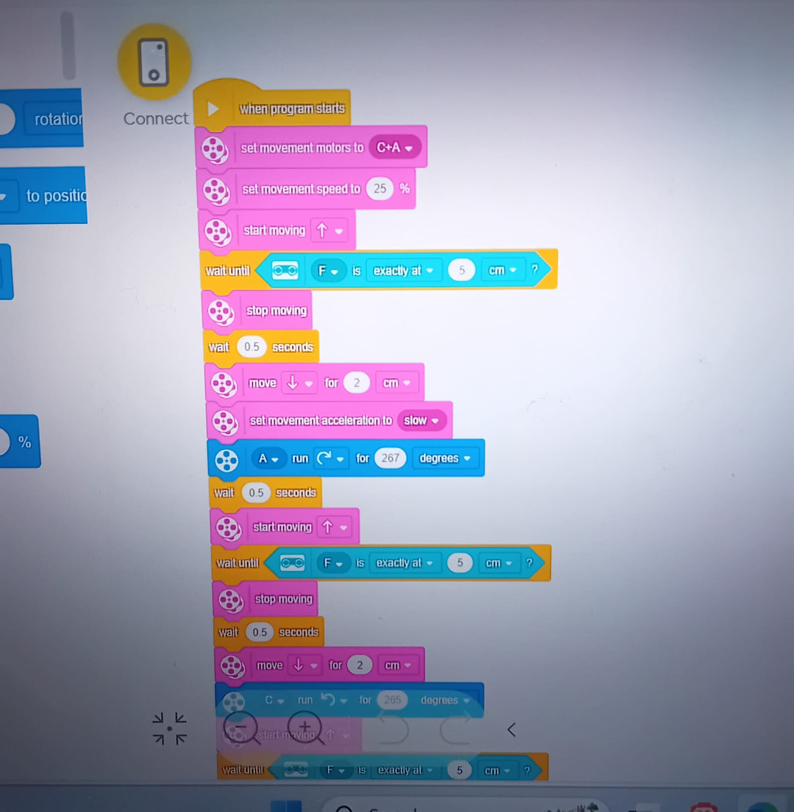
Figure5.1b.1
5.2 Finalized Code and Improvements
The final version of my code made the robot navigate the maze much more effectively. The distance sensor helped it detect walls before crashing, reducing errors and unnecessary adjustments. The controlled turning also prevented it from veering off course or reversing too much.
5.3 Evaluating the Effectiveness of the Code
By switching to the distance sensor and refining the turning mechanism, I was able to make the robot complete the maze more smoothly. The improvements helped in:
- Reducing errors caused by the push button sensor.
- Making the movements more controlled, preventing crashes.
- Allowing better turns by adjusting the motor used for each direction.
- Stopping accurately at the final destination (red colour).
Overall, the new code worked much better than my original approach, and the robot successfully completed the maze during the assessment.
6. Project Evaluation and Outcomes
6.1 Project Breakdown into Phases
The project was completed in several key phases:
- Planning and Research – Understanding the assessment task and assigning responsibilities among teammates.
- Initial Development – Designing the robot structure and writing the first versions of the line-following and maze navigation code.
- Testing and Debugging – Running tests, identifying issues, and making adjustments to improve accuracy.
- Final Implementation – Refining the robot’s movement, switching from a push button sensor to a distance sensor, and testing the final code.
- Assessment Day Execution – Making last-minute changes, troubleshooting unexpected problems, and successfully completing the assessment.
6.2 Evaluating Success at Each Stage
- Early development – Some challenges arose, such as difficulties with the push button sensor and turning angles, but initial testing helped identify these issues.
- Midway through the project – Switching to a distance sensor improved performance significantly, and weekly meetings helped keep the team on track.
- Final stage – The robot successfully navigated the maze, but the line-following task was unsuccessful.
6.3 Final Results and Analysis
The final robot was able to:
Navigate around the box as required.
Complete the maze using the distance sensor.
Fail to complete the line-following task due to issues in the coding.
Although the maze navigation was successful, the line-following did not work as expected, possibly due to errors in the sensor input or last-minute adjustments to the code. If given more time, I would have tested and refined the line-following logic further.
6.4 Reflection on the Project Experience
This project was a great learning experience. At the beginning, I struggled with getting the robot to navigate the maze properly, but through testing and adjustments, I improved my understanding of sensor-based movement and coding logic. I also had to step in last-minute to modify the line-following code when my teammate was absent. Unfortunately, despite my efforts, the line-following code did not work on assessment day, which was a setback but also a learning opportunity.
6.5 Final Thoughts and Key Takeaways
Some key takeaways from this project include:
- Trial and error is essential – Testing small changes made a big difference in improving accuracy.
- Teamwork matters – Even though we had different roles, working together helped solve challenges more efficiently.
- Flexibility is important – Unexpected situations, like my teammate’s absence, required quick thinking and problem-solving.
- Failure is part of learning – While the maze navigation worked well, the line-following failure showed me that early testing and backup plans are important.
- Robotics is hands-on learning – This project helped bridge the gap between theory and real-world application.
Overall, this project helped me develop my coding skills, problem-solving abilities, and teamwork—all valuable for future projects. While not everything was successful, it was still a valuable experience that taught me resilience and adaptability.

7. References

[1] LEGO Education, “LEGO SPIKE Prime Kit Documentation,” 2023. [Online]. Available: https://www.legoeducation.com.
[2] S. Papert, Mindstorms: Children, Computers, and Powerful Ideas, New York, NY, USA: Basic Books, 1980.
[3] M. Resnick, Lifelong Kindergarten: Cultivating Creativity through Projects, Passion, Peers, and Play, Cambridge, MA, USA: MIT Press, 2017.
[4] R. A. Brooks, Flesh and Machines: How Robots Will Change Us, New York, NY, USA: Vintage, 2002.
[5] G. A. Bekey, Autonomous Robots: From Biological Inspiration to Implementation and Control, Cambridge, MA, USA: MIT Press, 2005.

