

Understanding Depression and Anxiety Among Black African and Mixed African Youth (16–25) in the UK: An Intersectional Review of Wider Determinants of Mental Health and Barriers to Support
by

Iqdad Mahamud Ali

A Dissertation submitted in partial fulfilment of the requirements for the degree of Masters of Science in Public Health and Social Care in Practice

The Institute of Inner-City Learning
University of Wales Trinity Saint David – London Campus

[15 June 2026]

DECLARATION

I, Iqdad Mahamud Ali declare that this dissertation has been composed by myself, that the work contained herein is entirely my own except where explicitly stated otherwise in the text, and that this work has not been submitted for any other degree or qualification, in whole or in part, except as specified.

Signed:……Iqdad…………………………………………

Date:...15/6/2026………………………………………………

Acknowledgements

I sincerely thank Dr. Ping Wu, my dissertation supervisor, for her invaluable guidance, support, and constructive feedback throughout this research. I am also grateful to the academic staff for their teaching and assistance, which greatly contributed to the completion of this dissertation.
My heartfelt thanks go to my friends for their encouragement and understanding during the balancing of academic and personal commitments. Lastly, I deeply appreciate my family’s unwavering love, patience, and support, which have been a constant source of motivation.
I dedicate this dissertation to all who have supported and inspired me along this journey

Abstract

Mental health disorders, especially anxiety and depression, are an increasing public health issue among young people in the United Kingdom. Evidence suggests that social, economic, and structural factors contribute to mental health disparities that disproportionately impact Black African and Mixed African youth. Despite growing awareness of these inequalities, research specifically focusing on these groups remains limited.
This dissertation utilized a systematic review approach to investigate factors linked to anxiety and depression in Black African and Mixed African young people aged 16–25 in the UK. Adhering to PRISMA 2020 guidelines, a thorough search was carried out across databases including PubMed, PsycINFO, CINAHL, and Google Scholar. Studies meeting inclusion criteria were assessed using the Critical Appraisal Skills Programme (CASP), and their findings were integrated through thematic analysis. Twenty studies were ultimately included in the review.
Six interconnected themes emerged as key influences on mental health outcomes: racism and discrimination experiences, socioeconomic disadvantage, educational inequities, identity-related issues, and barriers to accessing suitable mental health care. The results demonstrate that wider social determinants—such as poverty, social exclusion, systemic inequalities, and lack of culturally appropriate services—significantly affect experiences of depression and anxiety. Additionally, factors like identity development, mental health stigma, and healthcare disparities influence psychological wellbeing and engagement with support systems.
These findings highlight the necessity for focused public health initiatives, culturally sensitive mental health services, anti-racist policies, and approaches that tackle broader social and economic determinants of mental health. Future research should employ intersectional frameworks and place increased attention on the unique experiences of Mixed African youth to deepen the understanding of mental health disparities in diverse communities.
Keywords: Black African youth, Mixed African youth, mental health disparities, structural racism, depression, anxiety, social determinants of health, United Kingdom
.

Table of contents

The table of contents lists every section that comes after it (i.e. not the title page, acknowledgements, or abstract). A table of contents can be auto-generated in Word.

List of figures 7
List of tables 8
List of abbreviations 9
Chapter 1: Introduction 10
1.3 Mental Health Inequalities Among Black African and Mixed African Youth 12
Chapter 2: Literature Review 16
2.4 Mental Health Inequalities and Ethnicity 19
2.5 Structural Racism and Mental Health 19
2.6 Social Determinants of Mental Health 21
2.7 Educational Inequalities and School Exclusion 22
2.8 Identity Conflict and Mixed African Youth Experiences 23
2.9 Minority Stress Theory 24
2.10 Mental Health Stigma Within African-Heritage Communities 25
2.11 Barriers Affecting Access to Mental Healthcare Services 25
2.12 Culturally Responsive Mental Healthcare 27
2.13 Critique of Existing Literature 27
2.14 Research Gap 28
2.15 Chapter Summary 28
Chapter 3: Research Methodology 29
3.1 Introduction This chapter details the methodological framework used to study depression and anxiety among Black African and Mixed African youth aged 16–25 in the UK from a public health perspective. It covers research philosophy, design, search strategy, inclusion/exclusion criteria, study selection, quality appraisal, data extraction, analysis, ethics, reflexivity, and limitations. 29
3.8 Inclusion and Exclusion Criteria 31
3.9 PRISMA Framework 32
3.10 Study Selection Process 33
3.12 Data Extraction 34
3.15 Ethical Considerations 37
3.16 Reflexivity 37
3.17 Limitations of the Methodology 38
3.18 Chapter Summary 38
Chapter 4: Results 38
4.1 Introduction 38
4.2 Overview of Included Studies 39
4.3 Theme One: Structural Racism and Discrimination 41
4.4 Theme Two: Socioeconomic Deprivation and Neighbourhood Inequality 43
4.5 Theme Three: Educational Exclusion and Institutional Inequality 44
4.6 Theme Four: Identity Conflict and Mixed African Youth Experiences 45
4.7 Theme Five: Mental Health Stigma and Help-Seeking Barriers 45
4.8 Theme Six: Inequalities Within NHS Mental Healthcare Systems 46
4.9 Emerging Protective Factors 47
4.10 Summary of Themes 47
4.11 Chapter Summary 50
Chapter 5: Discussion 51
5.12 Chapter Summary 59
Chapter 6: Conclusion and Recommendations 59
References 62
Appendix 1: Data Extraction and Quality Appraisal Table 71

List of figures
Figure 1.1: Prevalence of Probable Mental Disorders Among Young People Aged 17–24 in England ………..…………………………………………………………………………….10
Figure 1.2: Social Determinants of Mental Health Framework………….….…………………………………………………………………….26
Figure 2.1: Prevalence of Common Mental Health Conditions Among Young People Aged 16–24 in England, 1993–2023/24………………………………………………………….12
Figure 2.2: Social Determinants of Mental Health Framework………………………….12
Figure 2.3: Mental Healthcare Pathways Among Black Populations in England……...12
Figure 3.1: PRISMA 2020 Flow Diagram…………………………………………………..12
Figure 4.1: Impact of Structural Racism on Psychological Wellbeing…………………..13
Figure 4.2: School Exclusion by Ethnicity in England…………………………………….14
Figure 4.3: Detentions Under the Mental Health Act by Ethnicity……………………….15

List of tables

Table 1.1: Mental Health Inequalities Affecting Black Populations in England………..…………………………………………………………………………….10
Table 2.1: Psychological Effects of Racism Identified Within Literature…………………………………………………………………………………….14
Table 3.1: Databases Used for Literature Search………………………………………14
Table 3.2: Inclusion and Exclusion Criteria………………………………………………15
Table 3.3: Expanded CASP Quality Appraisal Framework…………………………….16
Table 3.4: Quality Appraisal of Included Studies………………………………………..16
Table 4.1: Characteristics of Included Studies…………………………………………..14
Table 4.2: Socioeconomic Inequalities Affecting Black African and Mixed African
Youth in the United Kingdom………………………………………………………………16
Table 4.3: Barriers Affecting Mental Healthcare Access………………………………..16
Table 4.4: Summary of Findings from Included Studies………………………………..16
Table 4.5: Summary of Major Themes Identified Through Thematic Analysis……….16

List of abbreviations

Abbreviation Full Meaning
BME Black and Minority Ethnic
CASP Critical Appraisal Skills Programme
CINAHL Cumulative Index to Nursing and Allied Health Literature
CMHCs Common Mental Health Conditions
COVID-19 Coronavirus Disease 2019
GOV.UK Government of the United Kingdom
MHCLG Ministry of Housing, Communities and Local Government
NHS National Health Service
ONS Office for National Statistics
PRISMA Preferred Reporting Items for Systematic Reviews and Meta-Analyses
UK United Kingdom
WHO World Health Organization

Chapter 1: Introduction
1.1 Introduction
Mental health disorders among young people pose a significant public health issue in the United Kingdom. Over the last ten years, the rates of depression and anxiety among adolescents and young adults have risen markedly, with evidence indicating that the COVID-19 pandemic and growing socioeconomic disparities have further exacerbated psychological distress in this population (NHS Digital, 2023; Loades et al., 2020; Racine et al., 2021). NHS Digital (2023) reports that about one in four young adults aged 17–24 in England were likely experiencing a mental health disorder in 2023, compared to roughly one in nine in 2017. This sharp increase underscores the expanding mental health burden and the urgent need for effective, equitable interventions.
Depression and anxiety rank among the most prevalent mental health conditions affecting youth globally (Polanczyk et al., 2015; Solmi et al., 2022). The World Health Organization (WHO, 2022) defines depression as a mood disorder marked by persistent feelings of sadness, hopelessness, social withdrawal, and reduced interest in daily activities. Anxiety disorders involve excessive fear, worry, and physiological stress responses that impair daily functioning. These conditions can lead to long-term negative impacts on education, employment, social relationships, physical health, and overall wellbeing (WHO, 2022; Solmi et al., 2022).
In the UK, mental health disparities disproportionately affect racialized groups, especially Black African and Mixed African youth. Research shows these populations are more likely to face structural racism, socioeconomic hardships, educational disadvantages, identity-related pressures, and obstacles in accessing healthcare (Bécares et al., 2015; Wallace et al., 2016). Despite growing awareness of racial inequalities in mental healthcare, Black African and Mixed African youth remain underrepresented in UK mental health research (Memon et al., 2016; Kapadia et al., 2022). As a result, culturally specific experiences of these groups are frequently overlooked in research, policy, and healthcare services.
This dissertation offers a critical examination of depression and anxiety among Black African and Mixed African youth aged 16–25 in the UK, adopting a public health lens. Employing systematic review methods, it investigates how structural, social, cultural, and institutional factors drive mental health inequalities and explores barriers to accessing mental health services.
1.2 Background to Mental Health Inequalities in the United Kingdom
Mental health disorders constitute a major public health concern worldwide and within the UK. The World Health Organization (2021) estimates that approximately one in seven adolescents globally experiences a mental health condition, with anxiety and depression being the most common. In the UK, mental health disorders among young people have risen substantially in recent years, driven by a combination of social, economic, and environmental stressors such as financial insecurity, academic pressures, housing instability, discrimination, and social isolation (Reiss, 2013; McManus et al., 2016; NHS Digital, 2023).
Data from NHS Digital (2023) reveals that probable mental disorders among 17–24-year-olds in England surged from 10.1% in 2017 to 25.7% in 2023. Young women have been especially affected, with anxiety disorders notably increasing following the COVID-19 pandemic. Additionally, ethnic minority groups suffered disproportionate psychological impacts during the pandemic, due to factors including economic hardship, bereavement, overcrowded living conditions, and unequal healthcare access (Bambra et al., 2020; Marmot et al., 2020)

.
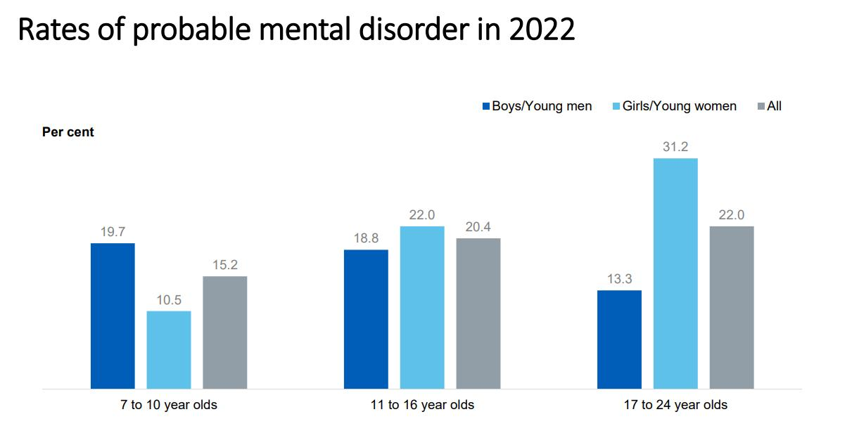
Figure 1.1: Prevalence of Probable Mental Disorders Among Young People Aged 17–24 in England (NHS Digital,2023)
Source: NHS Digital Mental Health of Children and Young People in England (2023)
Figure 1.1 illustrates the increasing prevalence of probable mental disorders among young people aged 17–24 years in England between 2017 and 2023. The trend reflects wider social and structural pressures affecting young people, including economic insecurity, academic stress, social isolation, and post-pandemic psychological distress (Loades et al., 2020; Racine et al., 2021; NHS Digital, 2023). These findings highlight the importance of early intervention, equitable access to mental healthcare, and targeted mental health promotion strategies. Despite the availability of national mental health data, ethnicity-specific analyses relating to Black African and Mixed African youth remain limited (Memon et al., 2016; Kapadia et al., 2022). This lack of disaggregated evidence contributes to gaps in understanding the unique mental health experiences and inequalities affecting these populations.

1.3 Mental Health Inequalities Among Black African and Mixed African Youth
Evidence suggests that mental health outcomes are strongly influenced by social inequalities, structural disadvantage, and experiences of racism (Paradies et al., 2015; Bailey et al., 2017). Within the United Kingdom, Black African and Mixed African youth are disproportionately exposed to a range of social and environmental factors associated with adverse mental health outcomes (Nazroo, 2021; Bhui et al., 2018; Wallace et al., 2016).
Research indicates that Black African and Mixed African youth experience higher levels of racial discrimination, educational inequalities, school exclusion, housing insecurity, socioeconomic deprivation, and barriers to accessing mental healthcare services (Gillborn, 2008; Bhui et al., 2018; Nazroo, 2021; ONS, 2022). These intersecting disadvantages may increase vulnerability to depression, anxiety, and wider forms of psychological distress.
Williams et al. (2019) argue that racism functions as a chronic stressor capable of generating long-term psychological and physiological consequences. Repeated exposure to discrimination has been associated with anxiety, emotional exhaustion, reduced self-esteem, and depressive symptoms among racially marginalised populations (Williams et al., 2019; Carter et al., 2017). Similarly, Wallace et al. (2016) identified strong associations between racial discrimination and psychological distress among ethnic minority populations in the United Kingdom.
Table 1.1: Mental Health Inequalities Affecting Black Populations in England
Indicator | Black Populations | White British Populations | Source
Detention under Mental Health Act | 228 per 100,000 | 64 per 100,000 | GOV.UK Ethnicity Facts and Figures (2024)
School exclusion likelihood | 0.29%  (approx. 3–4x higher than White British pupils) | 0.08% | Department for Education (2023)
Unemployment among young adults | ~18–22%  (varies by quarter/ethnic breakdown) | ~9–11% | Office for National Statistics (2023)
Exposure to racial discrimination | 20–40% report experiences of racial discrimination | 5–15% report discrimination experiences | Bécares et al. (2015); Wallace et al. (2016)
Access to early mental health intervention | Approximately 15–30% lower service engagement than White British populations | Higher service engagement | Memon et al. (2016); Bhui et al. (2018)
The evidence presented in Table 1.1 highlights persistent inequalities affecting Black populations in England. Higher rates of school exclusion, unemployment, racial discrimination, and compulsory detention under the Mental Health Act demonstrate broader structural challenges that may negatively affect mental health outcomes. These inequalities emphasise the importance of addressing both social and institutional determinants of mental health among Black African and Mixed African youth populations.
1.4 Structural racism refers to interconnected social, economic, political, and institutional systems that maintain racial inequalities by restricting access to resources and power (Bailey et al., 2017; Williams et al., 2019). Unlike individual racism, it is embedded in societal policies and institutions.
In public health, structural racism is recognized as a major cause of health disparities. The NHS Race and Health Observatory (2022) links racism to poorer physical and mental health among UK ethnic minorities. Research shows chronic racism exposure increases stress, anxiety, depression, sleep problems, and distrust in institutions (Paradies et al., 2015; Ben et al., 2017; Williams et al., 2019).
Black African and Mixed African youth face discrimination in schools through stereotyping, low teacher expectations, unfair discipline, and exclusion (Gillborn et al., 2017), leading to emotional distress and disengagement. Racial microaggressions and cultural invalidation heighten identity stress, especially for Mixed African youth managing multiple cultural identities (Keating, 2021)

1.5 Social Determinants of Mental Health
The World Health Organization’s Social Determinants of Health framework highlights that health outcomes are influenced more by broader social, economic, and environmental conditions than by individual behaviors alone (WHO, 2014; Marmot, 2010). Key factors such as income, housing, education, employment, social support, and experiences of discrimination significantly affect mental health outcomes.

.
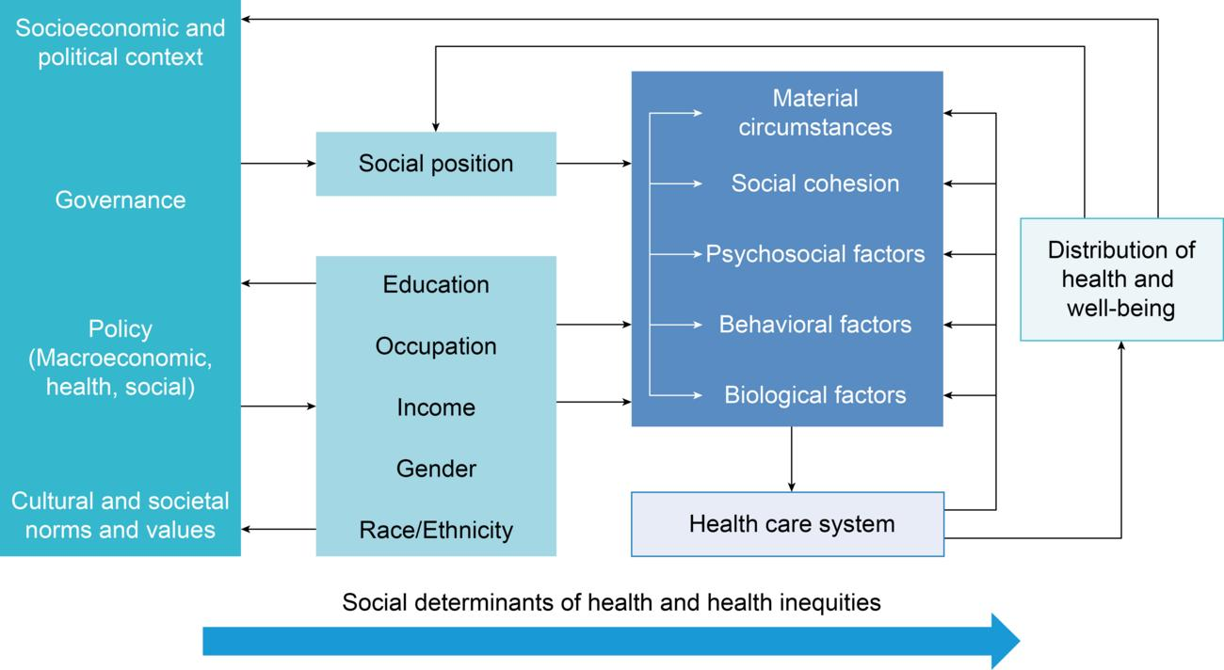
Figure 1.2: Social Determinants of Mental Health Framework
Source: World Health Organization Mental Health and Social Determinants Report (WHO,2014)
Figure 1.2: This section highlights how mental health outcomes are shaped by broader structural factors such as housing, employment, education, income, social support, and discrimination. This framework is especially pertinent to Black African and Mixed African youth, who often experience overlapping racial and socioeconomic disadvantages (Kapilashrami and Hankivsky, 2018; Lund et al., 2018). It also critiques the limitations of viewing depression and anxiety purely through a biomedical lens, emphasizing instead the impact of wider structural inequalities on psychological wellbeing (WHO, 2014; Marmot, 2010; Lund et al., 2018). Recent public health research underscores the importance of intersectionality in understanding how race, gender, class, and migration status interact to influence mental health outcomes (Kapilashrami and Hankivsky, 2018).
Rationale for the Study
Despite growing attention to mental health inequalities among ethnic minorities, significant gaps remain regarding Black African and Mixed African youth in the UK (Memon et al., 2016; Kapadia et al., 2022). Existing research often groups these populations within broader ethnic categories, limiting understanding of their unique experiences and challenges. Additionally, much literature focuses on Black Caribbean populations, while Mixed African individuals are comparatively underexplored (Song, 2017; Aspinall, 2020).
Research on the effects of structural racism, cultural identity, and mental healthcare access for Black African and Mixed African youth is limited in the UK context. There is a pressing need for culturally responsive research that captures the specific mental health inequalities faced by these groups. This dissertation aims to address this gap by examining depression and anxiety in Black African and Mixed African youth aged 16–25, contributing to public health knowledge on racial mental health disparities and supporting culturally responsive, anti-racist healthcare policies. The study aligns with NHS priorities on mental health equity and reducing racial inequalities in healthcare (NHS Long Term Plan, 2019; NHS Race and Health Observatory, 2022).
Research Questions
This dissertation is guided by four key questions:
- What factors contribute to depression and anxiety among Black African and Mixed African youth in the UK?
- How do racism, socioeconomic inequality, and cultural experiences affect emotional wellbeing?
- What barriers limit access to mental healthcare for these populations?
- How effectively do current NHS mental health systems address racial inequalities?
Aim and Objectives
Aim: To critically examine depression and anxiety among Black African and Mixed African youth aged 16–25 in the UK from a public health perspective.
Objectives:
- Explore social, structural, and cultural determinants affecting depression and anxiety among these youth.
- Critically examine barriers to mental healthcare access.
- Analyze the impact of structural racism and socioeconomic inequalities on emotional wellbeing.
- Evaluate NHS mental healthcare approaches and culturally responsive interventions in addressing racial disparities.
- Identify gaps in UK mental health research and policy.
Significance of the Study
This dissertation adds to public health research on racial inequalities in mental health affecting Black African and Mixed African youth in the UK, focusing on populations underrepresented in existing research and policy debates. Evidence shows that Black populations face disproportionate exposure to racism, socioeconomic deprivation, educational inequalities, and barriers to mental healthcare access (Bhui et al., 2018; Nazroo, 2021). They are also more likely than White British populations to experience coercive mental healthcare pathways, such as compulsory detention under the Mental Health Act (GOV.UK Ethnicity Facts and Figures, 2024). These disparities underscore the need to better understand the factors influencing mental health in these groups.
Although awareness of ethnic inequalities in mental healthcare has increased, culturally responsive and anti-racist service delivery remains limited (Memon et al., 2016; Bhui et al., 2018; NHS Race and Health Observatory, 2022). Findings from this study may inform NHS policies, promote culturally competent mental health practices, and guide future research aimed at reducing inequalities. More broadly, the research contributes to ongoing discussions around health equity, intersectionality, and social justice in public health.
Chapter Summary
This chapter introduced depression and anxiety among Black African and Mixed African youth as a critical public health issue in the UK, noting the rising mental health concerns among young people. It examined how structural racism, social determinants of health, and socioeconomic inequalities shape mental health outcomes.
Evidence was highlighted showing that mental health is influenced not only by individual factors but also by broader structural and social conditions such as racism, discrimination, poverty, exclusion, and unequal healthcare access (Marmot, 2010; Paradies et al., 2015; Nazroo, 2021). The chapter also outlined the dissertation’s rationale, aim, objectives, and research questions.
The next chapter presents a critical literature review on depression, anxiety, structural racism, cultural experiences, social determinants of health, and barriers to mental healthcare access among Black African and Mixed African youth in the UK

Chapter 2: Literature Review
2.1 Introduction
This chapter offers a critical synthesis of existing research on depression and anxiety among Black African and Mixed African youth aged 16–25 in the United Kingdom. It explores how mental health disparities are shaped by a complex interplay of social, structural, cultural, and institutional factors that collectively affect psychological wellbeing in racially marginalized groups (Marmot, 2010; Nazroo, 2021; Allen et al., 2014).
The review pays particular attention to issues such as racism, socioeconomic disadvantage, identity conflicts, educational inequalities, obstacles to healthcare access, and the availability of culturally sensitive mental health services (Bhui et al., 2018; Wallace et al., 2016; Memon et al., 2016). These factors are examined as interconnected influences rather than isolated contributors, shaping mental health outcomes throughout the life course.
An interdisciplinary public health approach guides the chapter, drawing on the Social Determinants of Health framework, Critical Race Theory, Minority Stress Theory, and Intersectionality Theory. These frameworks provide a comprehensive understanding of how structural inequalities manifest as mental health disparities, especially among Black African and Mixed African youth in the UK.
The chapter also critically assesses the methodological strengths and weaknesses of the existing literature, noting the predominance of cross-sectional studies, limited ethnic subgroup analyses, and a scarcity of longitudinal and intersectional research. Such limitations hinder a complete understanding of the lived experiences of Black African and Mixed African youth.
2.2 Conceptualising Depression and Anxiety
Depression and anxiety rank among the most common mental health disorders affecting adolescents and young adults globally (Polanczyk et al., 2015; Solmi et al., 2022). These conditions are recognized as major contributors to the global disease burden due to their high prevalence, early onset, and enduring impact on functioning and quality of life.
According to the World Health Organization, depression is characterized by persistent low mood, feelings of hopelessness, emotional withdrawal, impaired concentration, fatigue, and loss of interest in activities once found enjoyable. Anxiety disorders involve excessive fear, chronic worry, physiological arousal, and emotional distress that significantly disrupt daily functioning and social engagement (WHO, 2022).
The consequences of these disorders extend beyond emotional suffering. Research consistently shows that depression and anxiety during adolescence and early adulthood are linked to lower educational achievement, reduced employment prospects, strained social relationships, increased physical health risks, and elevated incidence of self-harm and suicide (Kessler et al., 2007; WHO, 2022). These findings underscore the critical need for early detection and intervention.
Adolescence and early adulthood are particularly sensitive developmental phases, marked by significant biological, psychological, and social changes, including identity development, educational transitions, and heightened exposure to external stressors (Kessler et al., 2005; Jones, 2013). Kessler et al. (2005) further emphasize that about half of all lifetime mental disorders begin by mid-adolescence, highlighting the importance of prevention during this period.
Within public health discourse, depression and anxiety are increasingly viewed as socially patterned phenomena rather than solely individual psychological issues (Marmot, 2010; Allen et al., 2014; Lund et al., 2018). This perspective stresses that mental health is profoundly influenced by broader structural factors such as poverty, discrimination, housing insecurity, unemployment, and social exclusion (Allen et al., 2014), which are particularly relevant in understanding mental health disparities among racially marginalized youth.
2.3 Epidemiology of Youth Mental Health in the United Kingdom
Mental health disorders among young people in the UK have risen markedly over the past decade. National data reveal a persistent increase in psychological distress, especially among adolescents and young adults, with recent NHS Digital statistics showing significant growth in probable mental disorders between 2017 and 2023.
This trend is attributed to a range of interrelated social and structural pressures, including academic stress, increased social media exposure, financial instability, housing challenges, loneliness, pandemic-related stress, and expanding socioeconomic inequalities (Reiss, 2013; Allen et al., 2014; Twenge et al., 2018; Loades et al., 2020). These factors reflect broader societal shifts that have intensified stressors affecting young people's mental health.
McManus et al. (2016) also identified a rising prevalence of common mental disorders among younger populations in England, with anxiety disorders notably increasing among young women. This gender-specific trend highlights the necessity of accounting for demographic variations when analyzing mental health patterns

.
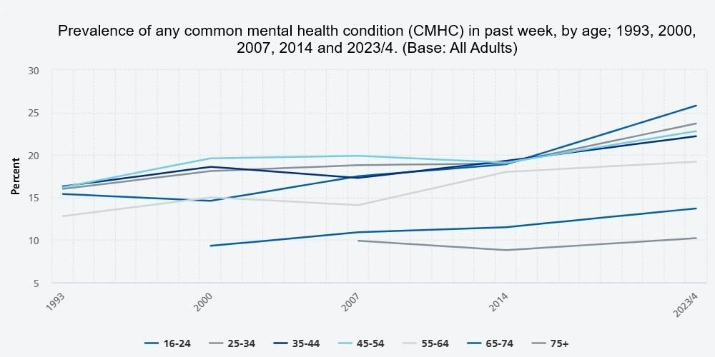
Figure 2.1: Prevalence of Common Mental Health Conditions Among Young People Aged 16–24 in England, 1993–2023/24 ( NHS Digital,2024)
Source: Adult Psychiatric Morbidity Survey – NHS Digital (2023/24
Figure 2.1 illustrates long-term trends in the prevalence of common mental health conditions (CMHCs) among adults in England from 1993 to 2023/24. While increases are observed across several age groups, the rise is most pronounced among young adults aged 16–24 years. In this group, prevalence increased from approximately 16% in 1993 to around 26% in 2023/24, representing the highest rate across all age categories. This figure highlights a sustained increase in common mental health conditions over time, with the highest prevalence consistently observed among individuals aged 16–24 years compared with other age groups.
In contrast, older adults, particularly those aged 75 years and above, consistently report lower prevalence rates of approximately 10% in 2023/24. This demonstrates a clear age-related disparity in mental health outcomes, with young adults experiencing a disproportionately high burden of psychological distress.
Despite these trends, national epidemiological datasets continue to lack detailed ethnicity-specific breakdowns, particularly for Black African and Mixed African youth. This limitation restricts understanding of how mental health inequalities are distributed across ethnic groups and reduces the effectiveness of targeted public health responses.

2.4 Mental Health Inequalities and Ethnicity
A substantial body of research demonstrates that mental health outcomes are not evenly distributed across ethnic groups. Ethnic minority populations in the United Kingdom often experience higher levels of psychological distress due to structural disadvantage, discrimination, and unequal access to social and healthcare resources (Das-Munshi et al., 2016).
Nazroo (2003) argues that ethnic inequalities in health cannot be understood without considering structural racism, socioeconomic disadvantage, and processes of social exclusion. These structural factors interact to produce cumulative disadvantage across the life course, shaping both exposures to stressors and access to protective resources.
Within the United Kingdom, Black populations are disproportionately affected by several structural risk factors, including racial discrimination, poverty, unemployment, housing insecurity, policing inequalities, educational exclusion, and coercive mental healthcare pathways. These factors collectively contribute to increased vulnerability to poor mental health outcomes.
Research by Wallace, Nazroo, and Bécares (2016) identifies strong associations between racial discrimination and psychological distress among ethnic minority groups in the UK. Similarly, Williams, Lawrence, and Davis (2019) argue that racism operates as a chronic stressor that produces sustained psychological and physiological consequences over time. Repeated exposure to discrimination is associated with increased anxiety, depressive symptoms, emotional exhaustion, and reduced self-esteem.
Importantly, existing literature suggests that Black African and Mixed African youth may experience distinct cultural and social challenges that differ from those of Black Caribbean or broader aggregated “Black” or “BME” populations. However, many studies continue to group diverse ethnic identities together, limiting the ability to generate culturally specific insights (Aspinall, 2020). This represents a significant limitation in the current evidence base and highlights the need for more disaggregated research.

2.5 Structural Racism and Mental Health
Structural racism has increasingly been recognised within public health literature as a fundamental determinant of mental health inequalities (Ford and Airhihenbuwa, 2010; Bailey et al., 2017). Unlike interpersonal racism, which occurs through individual attitudes or behaviours, structural racism refers to the embedded systems, policies, and institutional practices that systematically produce unequal outcomes across healthcare, education, housing, employment, and criminal justice systems.
From a public health perspective, structural racism is not an isolated social issue but a population-level determinant of health. The NHS Race and Health Observatory identifies racism as a significant contributor to poorer physical and mental health outcomes among ethnic minority populations in the United Kingdom. This reflects how inequality is produced and maintained through multiple interconnected systems rather than through individual experiences alone. Research evidence demonstrates that repeated exposure to racism contributes to chronic stress activation, which is associated with anxiety, depressive symptoms, emotional exhaustion, and poorer overall mental health outcomes (Ben et al., 2017; Trent et al., 2019). Chronic stress exposure is particularly harmful during adolescence and early adulthood, when identity formation and emotional regulation systems are still developing.
David R. Williams and Selina A. Mohammed (2013) further argue that discrimination negatively affects both psychological and physiological functioning through sustained activation of stress pathways. This includes long-term dysregulation of cortisol responses, increased vulnerability to anxiety disorders, and reduced psychological resilience.
In the UK context, several studies also highlight the presence of structural inequalities within educational systems. Black African and Mixed African youth frequently report experiences of stereotyping, lower teacher expectations, and discriminatory disciplinary practices. These experiences contribute to school exclusion and reduced educational engagement, which may indirectly affect mental health outcomes (Gillborn, 2008).
Table 2.1: Psychological Effects of Racism Identified Within Literature
Psychological Outcome | Evidence Identified in Literature | Source
Anxiety | Linked to chronic stress and hypervigilance | Williams, Lawrence and Davis (2019); Paradies et al. (2015)
Depression | Associated with social exclusion and discrimination | Wallace, Nazroo and Bécares (2016); Paradies et al. (2015)
Low self-esteem | Related to racial stereotyping | Williams et al. (2019); Arday (2018)
Social withdrawal | Associated with fear of discrimination | Song (2017); Wallace et al. (2016)
Emotional exhaustion | Linked to repeated exposure to racism | Williams et al. (2019); Bailey et al. (2017)
Mistrust toward institutions | Related to discriminatory experiences | Nazroo (2021); Bhui et al. (2018); Williams et al. (2019)
Overall, structural racism operates as a persistent and cumulative stressor that shapes mental health outcomes across multiple life domains. Its effects are not limited to individual experiences but are embedded within institutional systems that shape access to opportunity, care, and wellbeing.

2.6 Social Determinants of Mental Health
The Social Determinants of Health framework developed by the World Health Organization emphasises that health outcomes are shaped by broader social, economic, and environmental conditions rather than individual behaviours alone (WHO, 2014). This framework is widely used in public health to explain inequalities in mental and physical health outcomes and identifies key determinants such as income, housing, employment, education, social support, and exposure to discrimination. These factors collectively shape individuals’ living conditions and influence both risk and protective factors for mental health.
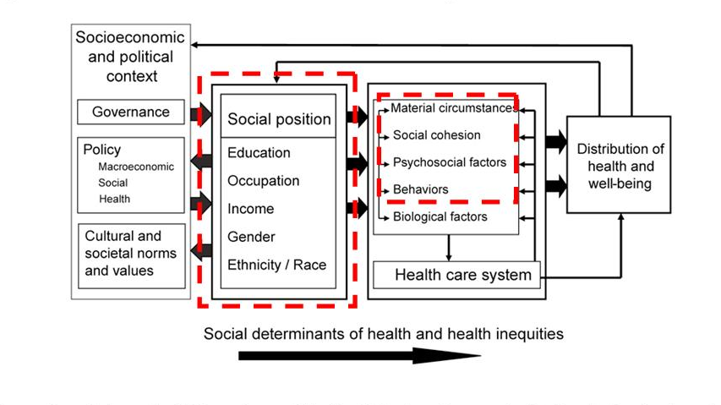
Figure 2.2: Social Determinants of Mental Health Framework
Source: World Health Organization Social Determinants of Mental Health Report (WHO,2014)
Figure 2.2 illustrates how mental health outcomes are shaped by wider structural and environmental conditions. It demonstrates that mental health is not solely the result of individual psychological processes but is strongly influenced by the social and economic environment in which individuals live.
This framework is particularly relevant to Black African and Mixed African youth, who are more likely to experience overlapping forms of disadvantage, including racial discrimination and socioeconomic inequality (Kapilashrami and Hankivsky, 2018; Lund et al., 2018). These overlapping disadvantages increase cumulative stress exposure and reduce access to protective resources such as stable housing, quality education, and secure employment.
Research consistently identifies poverty as one of the strongest predictors of poor mental health outcomes among young people (Lund et al., 2018; Reiss, 2013). Reiss (2013) further demonstrates strong associations between socioeconomic deprivation and emotional disorders among children and adolescents, highlighting the role of material conditions in shaping mental wellbeing.
In the UK context, Black African and Mixed African communities are disproportionately affected by low household income, overcrowded housing, unemployment, neighbourhood deprivation, and financial insecurity (ONS, 2022; Marmot et al., 2020). These conditions contribute to chronic stress exposure, which in turn increases vulnerability to anxiety and depression.
Pickett and Wilkinson (2015) further argue that inequality itself, not only poverty, is a key driver of poor mental health outcomes. Societies with greater income inequality tend to experience higher levels of psychosocial stress, reduced social cohesion, and poorer population mental health outcomes.

2.7 Educational Inequalities and School Exclusion
Educational environments play a central role in shaping adolescent mental health, social development, and long-term wellbeing (Bonell et al., 2014). Schools are not only institutions of learning but also key social environments where identity formation, peer relationships, and self-esteem development occur.
However, evidence consistently demonstrates that Black youth in the United Kingdom experience significant educational inequalities. Department for Education data shows that Black Caribbean pupils experience disproportionately high exclusion rates compared with White British pupils, while African-heritage students frequently report experiences of discrimination and stereotyping within educational settings (Department for Education, 2023).
School exclusion has been linked to several negative outcomes, including social isolation, reduced educational attainment, emotional distress, low self-esteem, and increased vulnerability to mental health disorders. These outcomes are particularly concerning during adolescence, a critical period for psychological development and identity formation.
David Gillborn (2008) argues that institutional racism within educational systems contributes significantly to unequal outcomes for Black students. This includes systemic biases in disciplinary practices, curriculum representation, and teacher expectations.
In addition, research suggests that Black African and Mixed African youth may experience academic pressure to overperform as a means of countering negative stereotypes. While this may function as a coping strategy, it can also contribute to increased anxiety, burnout, and emotional stress (Arday, 2018). This reflects the complex interaction between social expectations and mental health outcomes.
Overall, educational inequality functions as both a structural and psychological determinant of mental health, shaping both opportunities and emotional wellbeing during a critical developmental stage.

2.8 Identity Conflict and Mixed African Youth Experiences
Identity formation is a central developmental task during adolescence and early adulthood (Schwartz et al., 2013). This process involves the development of a coherent sense of self, including cultural, social, and racial identity. However, for Mixed African youth, this process may be complicated by external perceptions, social categorisation, and experiences of exclusion.
Research indicates that Mixed African youth often experience identity-related stress associated with navigating multiple cultural identities simultaneously. This may include identity ambiguity, reduced sense of belonging, social exclusion, racial invalidation, and pressure to conform to specific identity categories.
Common experiences reported in the literature include feeling insufficiently accepted within White British spaces, excluded from Black cultural communities, and misunderstood in relation to racial identity. These experiences can create emotional tension and uncertainty regarding belonging and self-definition.
Miri Song (2017) highlights that mixed-race individuals frequently encounter complex identity negotiations within British society, where rigid racial categorisations may not reflect lived experiences. This can lead to feelings of marginalisation and social invisibility.
These identity-related challenges may contribute to a range of psychological outcomes, including anxiety, emotional insecurity, low self-esteem, and social withdrawal. Importantly, these experiences are shaped not only by individual identity processes but also by broader societal constructions of race and belonging.
However, the literature specifically focusing on Mixed African youth remains extremely limited in the UK context. Many studies group mixed-race populations together without distinguishing African heritage experiences, resulting in a significant gap in culturally specific understanding. This limitation reduces the ability to develop targeted interventions and culturally responsive mental health support.

2.9 Minority Stress Theory
Minority Stress Theory provides an important framework for understanding how chronic exposure to social disadvantage affects mental health outcomes among marginalised populations. Originally developed in relation to LGBTQ+ populations, the theory has increasingly been applied within racial and ethnic health research to explain mental health inequalities.
According to Meyer (2003), minority stress arises from sustained exposure to prejudice, stigma, discrimination, and social exclusion. These stressors are not isolated events but ongoing social conditions that accumulate over time, producing chronic psychological strain.
Within the context of Black African and Mixed African youth, Minority Stress Theory is particularly relevant because racism functions as a continuous stressor embedded within everyday life experiences. This includes direct discrimination, microaggressions, social exclusion, and institutional inequalities.
The theory suggests that such repeated exposure contributes to heightened vigilance, emotional exhaustion, anxiety, and depressive symptoms. It also helps explain why mental health inequalities persist even when socioeconomic factors are taken into account, as psychological stress is produced not only by material disadvantage but also by social positioning and lived experiences of marginalisation.
Overall, Minority Stress Theory provides a useful lens for understanding how structural and interpersonal forms of racism translate into long-term mental health consequences.

2.10 Mental Health Stigma Within African-Heritage Communities
Mental health stigma is consistently identified in the literature as a major barrier affecting help-seeking behaviours among Black African and Mixed African youth. Stigma influences whether individuals recognise mental health difficulties, disclose symptoms, and access formal support services.
Research suggests that mental health conditions within some African-heritage communities may be interpreted through alternative explanatory frameworks, including spiritual beliefs, religious interpretations, family honour considerations, or moral perspectives. While these frameworks may provide meaning and coping mechanisms, they can also contribute to reluctance in seeking professional support.
Fear of judgement, shame, and social exclusion may further discourage individuals from discussing mental health difficulties or engaging with mental healthcare services (Mantovani et al., 2017; Memon et al., 2016). This may delay early intervention and exacerbate symptom severity over time.
Memon et al. (2016) found that stigma is a significant barrier to accessing mental healthcare services among minority ethnic communities in the United Kingdom. This highlights the importance of culturally sensitive mental health education and awareness strategies.
However, the literature also identifies protective cultural factors, including strong family support systems, religious involvement, spirituality, and community cohesion. These factors may promote resilience and emotional wellbeing in some contexts.
Therefore, culture operates as both a protective and potentially restrictive influence on mental health, depending on how beliefs and community norms shape responses to psychological distress (Mantovani et al., 2017).

2.11 Barriers Affecting Access to Mental Healthcare Services
A substantial body of literature identifies persistent barriers affecting access to mental healthcare services among Black populations in the United Kingdom. These barriers operate at structural, institutional, and individual levels.
Figure 2.3: Mental Healthcare Pathways Among Black Populations in England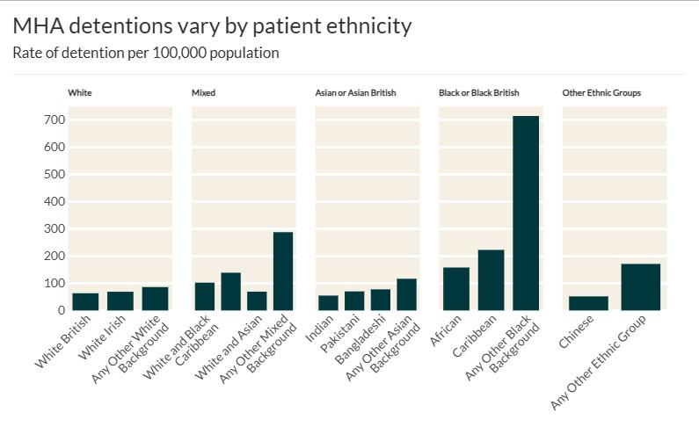
Source: GOV.UK Ethnicity Facts and Figures – Mental Health Act Detentions(GOV.UK,2014)
Figure 2.3 highlights significant racial disparities in mental healthcare pathways, showing that Black populations are disproportionately more likely to experience compulsory detention under the Mental Health Act compared with White populations (NHS Digital, 2023; GOV.UK Ethnicity Facts and Figures, 2024). This pattern raises important concerns regarding equity, early intervention, and trust in mental health services.
The evidence suggests several systemic barriers, including institutional racism, unequal access to early intervention services, mistrust in healthcare systems, and reliance on coercive pathways into care. These factors contribute to delayed help-seeking and reduced engagement with mental health services.
Additional barriers identified in the literature include long waiting times within NHS services, lack of culturally competent practitioners, underrepresentation of Black mental health professionals, financial constraints, and fear of discrimination within healthcare settings (Bhui et al., 2018).
Collectively, these barriers reduce accessibility and contribute to unequal mental health outcomes among African-heritage populations and may discourage engagement with formal mental healthcare services (Bhui et al., 2018).

2.12 Culturally Responsive Mental Healthcare
Culturally responsive mental healthcare refers to services that recognise, respect, and respond to the cultural identities, lived experiences, and social contexts of service users. This approach is increasingly viewed as essential in addressing mental health inequalities.
The literature suggests that culturally adapted interventions can improve trust between service users and providers, enhance communication, increase treatment engagement, and improve overall emotional outcomes. These improvements are particularly important for populations who have historically experienced marginalisation within healthcare systems.
Effective approaches identified in the literature include anti-racist therapeutic practices, community-based interventions, faith-sensitive support programmes, peer mentoring initiatives, family-inclusive counselling approaches, and increased workforce diversity within mental health services.
Despite these promising approaches, evidence evaluating long-term effectiveness of culturally adapted mental health interventions specifically for Black African and Mixed African youth remains limited in the United Kingdom (Edge and Grey, 2018). Most studies focus on broader ethnic minority groups, limiting the ability to assess culturally specific outcomes.
This highlights a significant gap in the evidence base and reinforces the need for more targeted and methodologically robust research.

2.13 Critique of Existing Literature
Although research on racial mental health inequalities has expanded in recent years, several methodological and conceptual limitations remain.
A key limitation is the continued aggregation of diverse ethnic groups, including Black African, Black Caribbean, and Mixed African populations, into broad categories. This approach reduces analytical precision and limits understanding of culturally specific experiences.
In addition, much of the existing literature relies on cross-sectional study designs, self-reported measures, small qualitative samples, and geographically limited populations. These methodological constraints reduce the ability to establish causal relationships and limit generalisability across the UK population.
Furthermore, there is a notable lack of research specifically focusing on Mixed African youth, despite evidence suggesting that this group may experience unique identity-related and social challenges.
Another limitation is that some studies describe racial disparities without sufficiently examining underlying structural mechanisms such as institutional racism and power inequalities. This limits the depth of analysis and reduces the ability to inform structural policy change.
Overall, these limitations highlight the need for more intersectional, longitudinal, and anti-racist research approaches.

2.14 Research Gap
The literature review identifies several key gaps in existing research on depression and anxiety among Black African and Mixed African youth in the United Kingdom.
These gaps include limited ethnicity-specific analysis, underrepresentation of Mixed African experiences, insufficient examination of structural racism, limited evaluation of culturally responsive interventions, and a lack of longitudinal research examining mental health outcomes over time. In addition, there is limited integration of intersectional frameworks that consider how race, gender, class, and migration status interact to shape mental health experiences.
This dissertation addresses these gaps by critically examining mental health inequalities affecting Black African and Mixed African youth from a public health perspective. It aims to contribute to a more nuanced and culturally informed understanding of mental health disparities within the UK context.

2.15 Chapter Summary
This chapter critically reviewed literature on depression and anxiety among Black African and Mixed African youth in the UK, examining how structural racism, socioeconomic inequality, identity conflict, educational exclusion, stigma, and healthcare barriers collectively affect mental health.
It also discussed key frameworks such as the Social Determinants of Health, Structural Racism, Minority Stress, and Intersectionality theories, which show that mental health disparities arise from interconnected social and structural factors rather than individual causes alone.
The review highlighted notable gaps in culturally specific research on Black African and Mixed African youth, emphasizing the need for more targeted, detailed, and rigorous studies.
Overall, evidence indicates that mental health inequalities in these groups stem from structural disadvantages, discrimination, and limited access to culturally appropriate services. The next chapter details the systematic review methodology used to explore these issues further
.

Chapter 3: Research Methodology

3.1 Introduction
This chapter details the methodological framework used to study depression and anxiety among Black African and Mixed African youth aged 16–25 in the UK from a public health perspective. It covers research philosophy, design, search strategy, inclusion/exclusion criteria, study selection, quality appraisal, data extraction, analysis, ethics, reflexivity, and limitations.
A systematic review methodology was chosen to critically synthesize evidence on mental health inequalities affecting these populations. This approach supports structured identification, evaluation, and integration of multiple studies while revealing patterns, contradictions, and gaps (Snyder, 2019). The framework follows PRISMA guidelines, employs the CASP appraisal tool, and uses thematic synthesis common in qualitative public health research, ensuring transparency, rigor, and ethical integrity.
3.2 Research Aim
The dissertation aims to critically explore depression and anxiety among Black African and Mixed African youth aged 16–25 in the UK through a public health lens.
3.3 Research Objectives
The study focuses on five objectives: exploring social, structural, and cultural factors contributing to depression and anxiety; examining barriers to mental healthcare access; analyzing the impact of racism, socioeconomic inequality, and identity stress on wellbeing; evaluating culturally responsive interventions; and identifying gaps in UK research and policy. Together, these ensure a comprehensive understanding of mental health disparities in the target group.
3.4 Research Philosophy
Research philosophy concerns assumptions about knowledge and reality (Saunders et al., 2019; Creswell and Creswell, 2018). This dissertation adopts an interpretivist stance, prioritizing understanding lived experiences and social contexts over purely objective measures (Thanh and Thanh, 2015; Ryan, 2018).
Interpretivism fits this study since mental health, racism, and identity are socially constructed and subjective, requiring more than quantitative data for full comprehension. The study incorporates critical public health perspectives, recognizing how structural racism and power dynamics shape health outcomes (Ford and Airhihenbuwa, 2010; Kapilashrami and Hankivsky, 2018). This approach emphasizes social systems and institutional factors over individual pathology.
3.5 Research Design
A qualitative systematic review design was used, which is a structured, transparent method to locate, evaluate, and synthesize existing literature with reproducible procedures (Page et al., 2021; Higgins et al., 2023). This design allows comprehensive evidence synthesis, identification of key themes, assessment of methodological quality, and development of evidence-based public health insights.
Unlike narrative reviews, systematic reviews follow strict protocols for database searching, study selection, appraisal, and synthesis, enhancing transparency and reducing bias. The review included peer-reviewed articles, NHS and WHO reports, policy documents, and relevant grey literature to ensure thorough coverage.
Systematic reviews are widely accepted in healthcare research for improving reliability, minimizing bias, and enhancing methodological credibility (Aromataris and Pearson, 2014; Munn et al., 2018).
3.6 Research Approach
An inductive approach was adopted, generating themes from the data instead of testing preconceived hypotheses (Thomas, 2006). This was appropriate given the exploratory nature of the study and limited literature on Mixed African youth.
Induction allowed themes such as structural racism, socioeconomic deprivation, identity conflict, stigma, and healthcare inequalities to emerge naturally from the data, capturing the complexity of mental health experiences in the literature.
3.7 Search Strategy
A comprehensive literature search was conducted from January 2010 to April 2025 across multiple academic and grey literature sources, including PubMed, PsycINFO, CINAHL, Google Scholar, the Cochrane Library, NHS Digital, the Office for National Statistics, and GOV.UK Ethnicity Facts and Figures.

Table 3.1: Databases Used for Literature Search
Database | Purpose
PubMed | Medical and public health literature
PsycINFO | Psychology and mental health studies
CINAHL | Nursing and healthcare research
Google Scholar | Broad academic retrieval
Cochrane Library | Evidence-based healthcare reviews
NHS Digital | UK mental health statistics
ONS | UK demographic and inequality data
GOV.UK Ethnicity Facts and Figures | Ethnicity inequality statistics
Table 3.1 outlines the databases used during the literature search process. Multiple databases were selected to ensure comprehensive retrieval of peer-reviewed and grey literature relevant to youth mental health inequalities, racism, and public health.The use of multiple databases ensured comprehensive coverage of both peer-reviewed research and policy-based evidence (Bramer et al., 2018; Haddaway et al., 2015). Inclusion of official UK datasets strengthened the contextual relevance of the findings.
The search strategy included keywords such as depression, anxiety, Black African youth, Mixed African youth, mental health inequalities, structural racism, and mental healthcare access in the United Kingdom. Boolean operators (AND/OR) were applied to improve precision and sensitivity (Booth et al., 2016).
An example search string included combinations of:
“Depression” OR “Anxiety” AND “Black African” OR “Mixed African” AND “Mental health inequalities” AND “United Kingdom”.

3.8 Inclusion and Exclusion Criteria
Inclusion and exclusion criteria were developed to ensure relevance and consistency during study selection.
Table 3.2: Inclusion and Exclusion Criteria
Inclusion Criteria | Exclusion Criteria
Published between 2010–2025 | Published before 2010
English-language studies | Non-English studies
UK-based research | Non-UK populations
Studies focusing on youth aged 16–25 | Studies focusing exclusively on children under 16 years or adults over 25 years
Studies examining depression/anxiety | Studies unrelated to mental health
Peer-reviewed or official reports | Non-academic opinion articles

Table 3.2 summarises the criteria used to determine study eligibility. Restricting studies to the period 2010–2025 ensured inclusion of contemporary evidence reflecting recent mental health trends and NHS policy developments (Peters et al., 2020)
The focus on UK-based studies increased contextual relevance because experiences of racism, healthcare access, and public health systems vary internationally.
English-language restrictions were applied due to resource and translation limitations. Peer-reviewed studies and official institutional reports were prioritised to improve credibility and evidence quality.

3.9 PRISMA Framework
The systematic review process followed PRISMA guidelines to ensure transparency and methodological rigour.
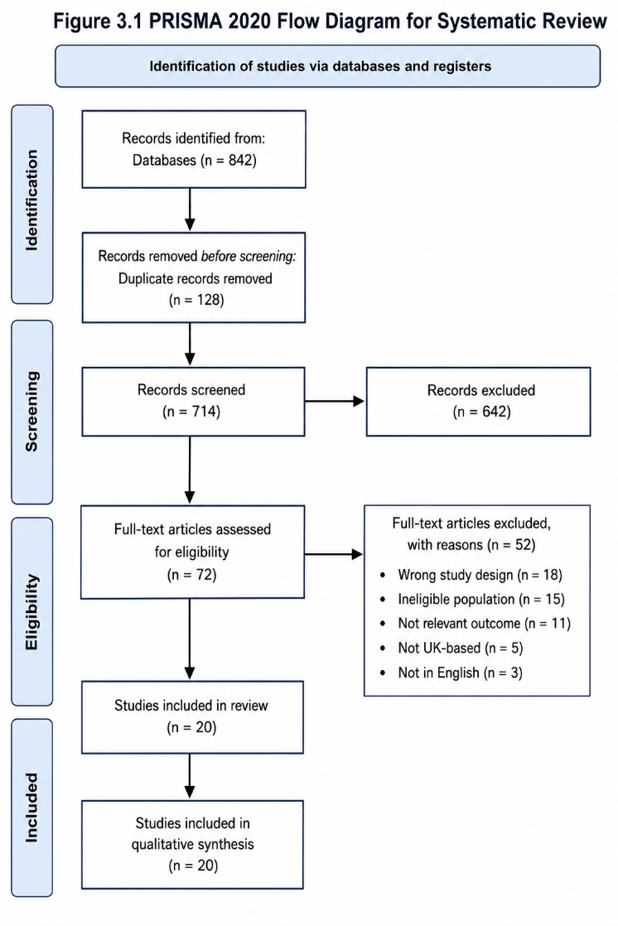
Figure 3.1: PRISMA 2020 Flow Diagram

Source: PRISMA 2020 Statement (Page et al., 2021)
Figure 3.1: The PRISMA 2020 framework outlines the systematic review process for identifying, screening, assessing eligibility, and selecting studies. It ensures a clear, transparent, and reproducible approach by documenting each stage—from database searching and duplicate removal to screening and final inclusion. This enhances methodological transparency, reduces selection bias, and improves reporting quality by making study selection decisions traceable and justified (Page et al., 2021; Haddaway et al., 2022; Moher et al., 2009).

3.10 Study Selection Process
The study selection followed the PRISMA 2020 framework through four stages: identification, screening, eligibility, and final inclusion (Page et al., 2021). A comprehensive search across PubMed, PsycINFO, CINAHL, and Google Scholar found 842 records, reduced to 714 after duplicates were removed. Screening titles and abstracts against criteria narrowed this to 72 full-text articles. Eligibility assessment excluded studies outside the UK, outside the 16–25 age range, lacking relevance to depression or anxiety, focusing on severe psychiatric disorders, or lacking specific evidence on Black African and Mixed African youth. Ultimately, 20 studies met all criteria for inclusion, forming the basis of the thematic synthesis in Chapter 4. The PRISMA framework ensured transparency, reduced selection bias, and enhanced reproducibility (McKenzie et al., 2021). Exclusions were due to population mismatch, irrelevance, geography, age, non-peer-reviewed sources, or poor methodological quality.
Quality Appraisal
Quality appraisal used the CASP framework (Nadelson and Nadelson, 2014; Long et al., 2020), assessing studies on research aims, methodology, recruitment, data collection, ethics, analysis, and overall contribution. Studies with serious methodological flaws or poor reporting were excluded. Most included studies were moderate-to-high quality; quantitative studies had larger samples and better generalizability, while qualitative studies offered rich insights into lived experiences of racism, stigma, and mental health inequalities. Many studies were cross-sectional, limiting causal inferences. This appraisal strengthened the review’s reliability by ensuring findings were based on credible, robust evidence and supported critical synthesis
.
Table 3.3: Expanded CASP Quality Appraisal Framework
CASP Criterion | Assessment Question | Purpose
Research aims | Are the aims clearly stated? | Determines relevance and clarity
Methodology | Is the methodology appropriate? | Assesses suitability of research design
Research design | Does the design address the research question? | Evaluates methodological rigour
Recruitment strategy | Was participant selection appropriate? | Assesses sampling quality
Data collection | Were data collected rigorously? | Evaluates reliability and transparency
Researcher-participant relationship | Has reflexivity been considered? | Reduces researcher bias
Ethical considerations | Were ethical issues addressed? | Ensures participant protection
Data analysis | Was analysis sufficiently rigorous? | Evaluates credibility of findings
Findings | Are findings clearly presented? | Assesses validity and interpretation
Research value | Does the study contribute useful knowledge? | Assesses overall contribution

Source: Adapted from Critical Appraisal Skills Programme (CASP, 2024).
Table 3.3 outlines the major domains assessed during quality appraisal. The CASP tool strengthened methodological rigour by enabling systematic evaluation of included studies.
Studies demonstrating weak methodological transparency, unclear analytical procedures, or insufficient relevance were excluded from the final synthesis.
Quality appraisal is particularly important within qualitative systematic reviews because it supports analytical trustworthiness and minimises inclusion of methodologically weak evidence (Long and Godfrey, 2004).

3.12 Data Extraction
Relevant information from all included studies (n = 20) was systematically extracted and organised into structured evidence tables to support analysis and synthesis. The extraction process ensured consistency and transparency across all studies and included key variables such as author, year of publication, country of study, sample characteristics, research design, principal findings, and reported limitations. This structured approach enabled systematic comparison across heterogeneous study designs and facilitated the identification of recurring patterns relevant to the research aims.
Table 3.4: Quality Appraisal of Included Studies
Author (Year) | Design | Sample | Strengths | Limitations | Quality Rating
Wallace et al. (2016) | Quantitative | 4,297 | Large sample size | Cross-sectional design | High
Bécares et al. (2015) | Cross-sectional | 4,788 | National dataset | Causality cannot be established | High
Memon et al. (2016) | Systematic review | 25 studies | Comprehensive review | Heterogeneity of studies | High
Reiss (2013) | Systematic review | 55 studies | Strong evidence base | International focus | High
Arday (2018) | Qualitative | University students | Rich lived experiences | Small sample | Moderate
Song (2017) | Qualitative | Mixed-race participants | Detailed identity analysis | Limited generalisability | Moderate
Barnett et al. (2019) | Quantitative | National dataset | Robust statistical analysis | Limited qualitative context | High
Bhui et al. (2018) | Mixed methods | Service users | Multiple perspectives | Limited youth focus | Moderate–High
Nazroo (2021) | Review | National evidence | Strong theoretical contribution | Secondary evidence | High
Paradies et al. (2015) | Meta-analysis | 293 studies | Extensive evidence base | International variation | High

Source: Developed by the author using CASP criteria.
Table 3.4: The author developed the evidence extraction process using CASP criteria, as shown in Table 3.4. This table illustrates how findings were organised across the included studies. Using evidence matrices facilitated better analytical structure and supported the thematic synthesis process (Aromataris and Pearson, 2014; Peters et al., 2020). A summarized version of the data extraction and quality appraisal table is included in this chapter to give a general overview of the methodological features of the studies reviewed. The complete evidence extraction table for all 20 studies is available in Appendix A to maintain transparency and clarity in the main text.
3.13 Data Analysis
The dissertation applied thematic analysis to integrate findings from the included studies. Thematic analysis is a qualitative method that identifies, examines, and interprets recurring patterns or themes within data (Braun and Clarke, 2006; Braun and Clarke, 2021). It is well-suited for exploring complex social issues like mental health inequalities, which involve evidence from various methodological backgrounds.
The analysis followed Braun and Clarke’s (2006) six-phase process, starting with familiarization with the literature, then initial coding, identifying themes, reviewing themes, defining themes, and concluding with synthesis. This structured yet adaptable method allowed for systematic data engagement while enabling themes to emerge organically from the literature.
Six key themes were identified through this process: structural racism, socioeconomic deprivation, educational exclusion, identity conflict, mental health stigma, and barriers to healthcare access. These themes capture the layered and interconnected factors influencing depression and anxiety among Black African and Mixed African youth in the UK.
Thematic analysis was chosen for its effectiveness in synthesizing findings from diverse sources, including qualitative, quantitative, and policy-related studies. Its flexibility allows for interpretative depth while preserving methodological consistency and is widely recognized in public health research for handling complex evidence. This approach supported a detailed and nuanced understanding of mental health inequalities across the studies.
3.14 Reliability and Validity
Ensuring reliability and validity is crucial for maintaining trustworthiness in qualitative research (Lincoln and Guba, 1985; Nowell et al., 2017). This systematic review implemented several measures to enhance methodological rigor and analytical credibility. These included a systematic search strategy across databases, well-defined inclusion and exclusion criteria, adherence to PRISMA standards, use of the Critical Appraisal Skills Programme (CASP), and a structured thematic analysis framework.
Moreover, triangulating evidence from multiple study designs—qualitative, quantitative, mixed methods, and policy literature—enhanced the robustness and trustworthiness of the synthesis (Moon et al., 2019). This triangulation enabled comparison across different types of evidence, boosting confidence in the recurring patterns and themes identified.
Despite these measures, it is acknowledged that researcher subjectivity can influence interpretation, an inherent aspect of qualitative synthesis. To mitigate this, transparency and dependability were strengthened by maintaining a systematic and detailed record of all methodological decisions throughout the review, ensuring the analysis was traceable, consistent, and methodologically sound.

3.15 Ethical Considerations
As this study relied exclusively on secondary data and published literature, formal NHS ethical approval was not required. However, adherence to established ethical principles remained essential throughout the dissertation process in line with the British Educational Research Association (2024) guidelines. Ethical considerations were embedded in the research design and analysis to ensure accurate representation of findings, avoidance of plagiarism, appropriate academic referencing, and respectful engagement with racially marginalised populations. Particular attention was given to avoiding deficit-based narratives of African-heritage communities by balancing discussions of inequality with recognition of resilience, cultural strengths, and protective factors alongside structural disadvantages. Ethical sensitivity was especially important given that research on race, discrimination, and mental health carries the risk of reinforcing harmful stereotypes if interpreted or presented without critical context (Milner and Jumbe, 2020).

3.16 Reflexivity
Reflexivity refers to the process by which researchers critically examine how their own perspectives, experiences, assumptions, and values may influence the research process and interpretation of findings. Within this dissertation, reflexivity was particularly important because experiences of mental health are socially and culturally constructed, discussions surrounding race and inequality may be influenced by researcher assumptions, and the interpretation of qualitative literature inevitably involves a degree of subjectivity. To minimise potential bias, the study sought to maintain analytical balance through critical engagement with diverse evidence sources, theoretical perspectives, and research findings. Reflexive awareness also enabled consideration of how cultural assumptions, academic positioning, and interpretive frameworks might shape the analysis and presentation of evidence. By acknowledging these influences, the study aimed to enhance the credibility, transparency, and trustworthiness of the research process while ensuring a balanced interpretation of mental health inequalities affecting Black African and Mixed African youth within the United Kingdom (Berger, 2015; Dodgson, 2019).

3.17 Limitations of the Methodology
Several limitations should be acknowledged.
First, the review relied primarily on secondary data and published literature rather than primary research.
Second, existing UK literature specifically focusing on Mixed African youth remains limited.
Third, many included studies used cross-sectional methodologies, limiting causal interpretation.
Fourth, several studies aggregated ethnic groups into broader “Black” categories, reducing cultural specificity. (Ioannidis, 2016; Page et al., 2021).
Finally, publication bias may have affected the availability of relevant studies.
Despite these limitations, the systematic review provides important insight into mental health inequalities affecting Black African and Mixed African youth populations within the United Kingdom.

3.18 Chapter Summary
This chapter outlined the methodological framework used in this dissertation. An interpretivist qualitative systematic review design was employed, guided by PRISMA and CASP frameworks. The chapter detailed the research philosophy, search strategy, inclusion criteria, study selection, quality appraisal, data analysis, ethical considerations, reflexivity, and limitations. The methodology ensured a transparent, systematic, and rigorous synthesis of evidence relating to depression and anxiety among Black African and Mixed African youth in the United Kingdom. The following chapter presents the results of the thematic synthesis.

Chapter 4: Results

4.1 Introduction
This chapter presents the results identified through a thematic synthesis of the literature reviewed in relation to depression and anxiety among Black African and Mixed African youth aged 16–25 years within the United Kingdom. The findings emerged from a systematic analysis of peer-reviewed studies, NHS reports, public health data, and policy literature included within the review process.
The thematic analysis of the 20 included studies identified six major themes, namely structural racism and discrimination, socioeconomic deprivation and neighbourhood inequality, educational exclusion and institutional disadvantage, identity conflict and psychological stress among Mixed African youth, mental health stigma and barriers to help-seeking, and inequalities affecting access to NHS mental healthcare services.
The results demonstrate that depression and anxiety among Black African and Mixed African youth cannot be understood solely through individual psychological explanations (Allen et al., 2014; Kapilashrami and Hankivsky, 2018). Instead, emotional wellbeing is strongly influenced by wider structural, social, and institutional inequalities. In addition, the findings align with public health frameworks that emphasise the central role of racism, social exclusion, and socioeconomic disadvantage in shaping mental health outcomes (Kapilashrami and Hankivsky, 2018).

4.2 Overview of Included Studies
A total of 20 studies were included in the final systematic review. The included literature comprised qualitative interviews, cross-sectional surveys, mixed-methods research, systematic reviews, NHS reports, and public health policy documents. Overall, most studies focused broadly on ethnic minority mental health experiences within the United Kingdom, with relatively few studies specifically examining Black African or Mixed African youth populations as distinct groups.
Table 4.1: Characteristics of Included Studies
Author (Year) | Country | Sample Size | Study Design | Population | Focus of Study
Wallace et al. (2016) | UK | n = 4,297 ethnic minority adults | Quantitative survey | Ethnic minority adults | Racism and psychological distress
Bécares et al. (2015) | UK | n = 4,788 adolescents | Cross-sectional | Adolescents | Racism and mental health outcomes
Williams et al. (2019) | International | Multiple studies | Literature review | Ethnic minority populations | Discrimination and mental health
Paradies et al. (2015) | International | 293 studies | Meta-analysis | Diverse ethnic groups | Racism and health outcomes
Memon et al. (2016) | UK | 25 studies | Systematic review | Minority ethnic populations | Barriers to mental healthcare
Mantovani et al. (2017) | UK | n= 30 participants | Qualitative | African and Caribbean communities | Mental health stigma
Reiss (2013) | International | 55 studies | Systematic review | Children and adolescents | Socioeconomic deprivation and mental health
Allen et al. (2014) | UK | National evidence | Review | General population | Social determinants of mental health
Marmot et al. (2020) | UK | National data | Policy review | UK population | Health inequalities
Gillborn (2008) | UK | Educational datasets | Qualitative analysis | Black students | Institutional racism in education
Arday (2018) | UK | University students | Qualitative | Black students | Educational inequality and wellbeing
Song (2017) | UK | Mixed-race participants | Qualitative | Mixed-race individuals | Identity formation
Khanna (2011) | USA | Mixed-race participants | Qualitative | Mixed-race adults | Identity negotiation
Sims and Njaka (2020) | UK | Young adults | Qualitative | Mixed African youth | Identity and belonging
Bhui et al. (2018) | UK | Mental Service users | Mixed methods | Minority ethnic groups | Cultural competence in mental healthcare
Barnett et al. (2019) | England | National dataset | Quantitative | Mental health service users | Detention under Mental Health Act
Morgan et al. (2020) | UK | National evidence base | Review | Black populations | Mental healthcare pathways
Nazroo (2021) | UK | National evidence | Review | Ethnic minority populations | Structural racism and health
Edge and Grey (2018) | UK | Community participants | Qualitative | Black communities | Community mental health support
Kapilashrami and Hankivsky (2018) | International | Multiple studies | Theoretical review | Marginalised populations | Intersectionality and health inequalities
Source: Developed by the author from included studies.
Table 4.1 summarises selected studies included within the systematic review. The studies varied substantially in methodology, sample size, and population focus. Most research concentrated on broader ethnic minority experiences rather than Black African and Mixed African youth specifically. Only a small proportion of the 20 included studies specifically focused on Black African or Mixed African youth populations.

4.3 Theme One: Structural Racism and Discrimination
Structural racism emerged as one of the most consistently reported determinants of mental health, identified across 5 of the 20 studies (25%). Across the literature, racism was not limited to interpersonal discrimination but was conceptualised as a systemic and institutional process embedded within education, healthcare, housing, and employment systems.
Wallace et al. (2016) demonstrated a significant association between racial discrimination and psychological distress, with repeated exposure linked to higher levels of anxiety and depressive symptoms. Similarly, Bécares et al. (2015) found that adolescents exposed to racism reported increased emotional and behavioural difficulties, suggesting early-life exposure has sustained psychological effects.
Paradies et al. (2015), through a large-scale meta-analysis, reinforced these findings by demonstrating a consistent global association between racism and poor mental health outcomes. Although effect sizes varied across contexts, the direction of association remained stable, strengthening the robustness of evidence linking discrimination to psychological distress.
Williams et al. (2019) and Williams and Mohammed (2013) further conceptualise racism as a chronic stressor that produces cumulative psychological strain through hypervigilance, emotional exhaustion, and reduced self-worth. This supports the interpretation that racism operates as a long-term stress process rather than isolated incidents.
From a theoretical perspective, Critical Race Theory (Delgado and Stefancic, 2017) provides a useful explanation by positioning racism as structurally embedded within institutions rather than individually produced. However, a key limitation across studies is the inconsistent measurement of racism and the reliance on self-reported exposure, which may underestimate structural effects.
Figure 4.1: The Patient and Carer Race Equality Framework (PCREF) Embedding Anti _Racism in Mental Health Services
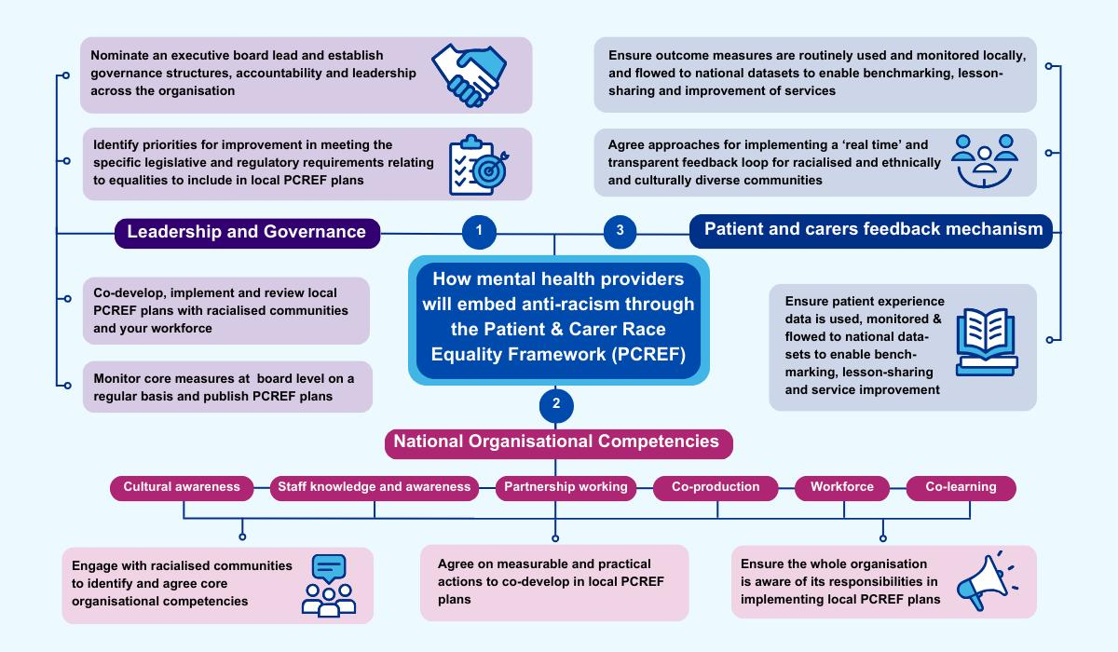

Source: (NHS Race and Health Observatory, 2022)).
The figure illustrates that structural racism operates through interconnected pathways, including socioeconomic exclusion, educational disadvantage, and barriers to healthcare access. Collectively, the evidence indicates that racism functions as a foundational determinant that interacts with other inequalities to produce adverse mental health outcomes.

4.4 Theme Two: Socioeconomic Deprivation and Neighbourhood Inequality
Socioeconomic deprivation was identified across 4 of the 20 studies (20%) and consistently associated with increased risk of depression and anxiety. The evidence highlights poverty, unemployment, housing insecurity, and neighbourhood deprivation as key determinants of psychological distress.
Reiss (2013) found strong associations between socioeconomic disadvantage and emotional disorders among children and adolescents, demonstrating that early exposure to deprivation increases vulnerability to mental health difficulties. Allen et al. (2014) similarly emphasised that mental health outcomes are shaped by structural living conditions rather than individual-level factors alone. Marmot et al. (2020) further argued that health inequalities in the UK are primarily driven by unequal distribution of resources, opportunities, and living conditions. These findings align with the Social Determinants of Health framework, which positions socioeconomic conditions as primary drivers of health outcomes.
ONS (2022; 2023) data strengthen these findings: 39% of Black African households live in low-income conditions compared with 18% of White British households Overcrowding affects 18–24% of Black African households compared with 2–3% of White British households Unemployment rates are approximately 8–10% compared with 3–4%
These inequalities are not merely statistical but reflect lived experiences of chronic stress, insecurity, and reduced access to opportunities.
Table 4.2: Socioeconomic Inequalities Affecting Black African and Mixed African Youth In The United Kingdom
Indicator | Black African Population | White British Population | Source
Relative low income (after housing costs) | ~39% | ~18% | ONS (2022)
Overcrowded households | ~18–24% | ~2–3% | MHCLG (2020)
Unemployment rate | ~8–10% | ~3–4% | ONS (2023)
Risk of common mental disorder in deprived areas | 2–3 times higher | Baseline | NHS Digital (2023)

Source: Adapted from (ONS (2022), (MHCLG (2020), and (NHS Digital (2023)).
The data demonstrate persistent structural disadvantage, which directly contributes to psychological strain. Importantly, socioeconomic deprivation interacts with racism, making it difficult to isolate independent effects. This interaction reflects intersectional disadvantage rather than single-factor causation.

4.5 Theme Three: Educational Exclusion and Institutional Inequality
Educational inequality was identified across 3 of the 20 studies (15%). The literature consistently highlights that Black African and Mixed African youth experience institutional disadvantage, including exclusion, stereotyping, and reduced academic expectations.
Gillborn (2008) argues that institutional racism shapes educational structures, producing unequal outcomes across ethnic groups. Arday (2018) further highlights stereotype threat as a psychological mechanism contributing to anxiety, reduced confidence, and academic stress among Black students.
Qualitative findings indicate that students frequently experience emotional isolation, reduced belonging, and anxiety linked to discriminatory school environments. Department for Education data confirm that exclusion rates are significantly higher for Black students compared with White British students.
Figure 4.2: School Exclusion by Ethnicity in England (Department for Education Statistics(2023))
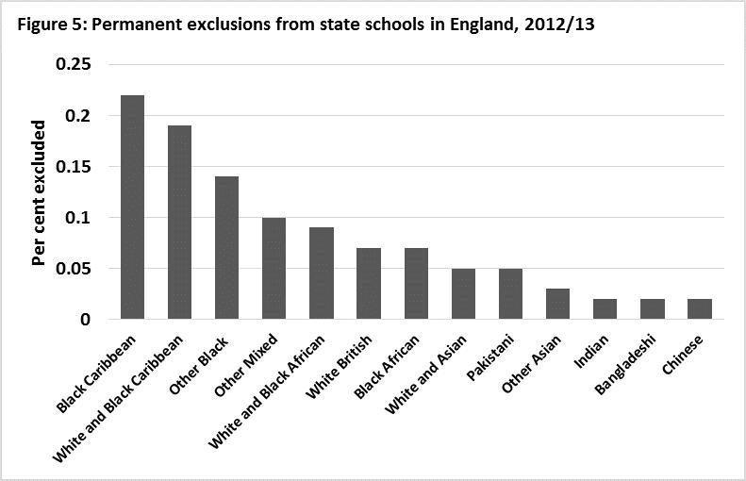

Source: Department for Education Statistics(2023)
The evidence suggests that educational exclusion contributes not only to academic disadvantage but also to long-term mental health risks. However, a key limitation is the lack of longitudinal studies examining how school-based discrimination translates into adult mental health outcomes.

4.6 Theme Four: Identity Conflict and Mixed African Youth Experiences
Identity conflict was identified across 3 of the 20 studies (15%), making it a distinct but under-researched theme. Mixed African youth frequently reported identity ambiguity, exclusion, and difficulty navigating multiple cultural identities.
Participants described experiences of being perceived as “not Black enough” or “not White enough,” contributing to emotional distress, low self-esteem, and anxiety. Song (2017) argues that mixed-race identity formation involves continuous negotiation of social categorisation, while Sims and Njaka (2020) highlight belonging uncertainty as a significant stressor. A key finding is the limited UK-specific research focusing exclusively on Mixed African youth. Most studies aggregate mixed-race populations, masking cultural and contextual differences.
This lack of specificity represents a significant evidence gap and limits the development of targeted mental health interventions.

4.7 Theme Five: Mental Health Stigma and Help-Seeking Barriers
Mental health stigma was identified in 4 of the 20 studies (20%). Across the literature, stigma was associated with shame, fear of judgement, spiritual interpretations of mental illness, and concerns about family reputation.
Memon et al. (2016) identified stigma as a primary barrier to accessing mental healthcare among minority ethnic populations. Mantovani et al. (2017) further highlighted cultural misunderstandings and fear of social exclusion as key barriers.
Commonly reported barriers included reluctance to disclose distress, mistrust of services, and concerns about confidentiality. However, protective factors such as spirituality, religion, family support, and community cohesion were also consistently identified.
These findings suggest that cultural frameworks operate as both barriers and protective mechanisms depending on context.
Table 4.3: Barriers Affecting Mental Healthcare Access
Barrier | Impact on Help-Seeking | References
Mental health stigma | Reduced emotional disclosure | Memon et al. (2016); Mantovani et al. (2017)
Fear of discrimination | Avoidance of services | Bhui et al. (2018); Nazroo (2021)
Lack of cultural understanding | Reduced trust toward practitioners | Bhui et al. (2018); Memon et al. (2016)
Long NHS waiting times | Delayed intervention | Bhui et al. (2018); Morgan et al. (2020)
Limited representation | Feelings of exclusion | Bhui et al. (2018); Nazroo (2021)

Table 4.3 summarises the principal barriers affecting access to mental healthcare services identified across the reviewed literature. Mental health stigma, fear of discrimination, lack of culturally responsive care, prolonged NHS waiting times, and limited representation within mental health services were consistently reported as factors reducing engagement with formal support services (Memon et al., 2016; Mantovani et al., 2017; Bhui et al., 2018; Morgan et al., 2020; Nazroo, 2021).

4.8 Theme Six: Inequalities Within NHS Mental Healthcare Systems
Five of the 20 studies (25%) identified inequalities within NHS mental healthcare pathways. Black African and Mixed African youth were more likely to experience crisis-driven care pathways, compulsory detention, and police involvement during mental health emergencies.
Barnett et al. (2019) reported significant disparities in detention rates under the Mental Health Act. Morgan et al. (2020) similarly found that Black populations were more likely to enter care through crisis routes rather than preventative services.
Nazroo (2021) and Bhui et al. (2018) highlight structural racism and cultural insensitivity as key contributors to mistrust and reduced engagement with services.
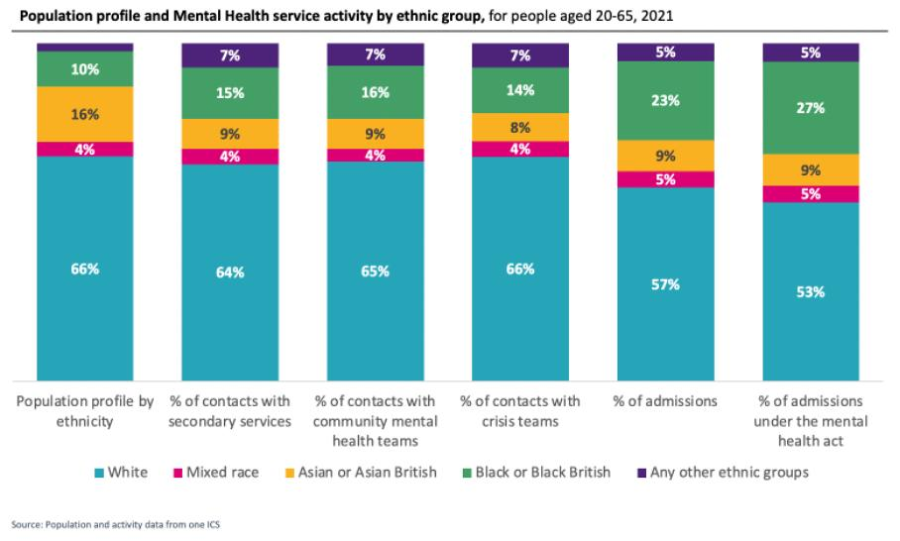
Figure 4.3: Detentions Under the Mental Health Act by Ethnicity(GOV.UK Ethnicity Facts ,2023/2024)
Source: GOV.UK Ethnicity Facts and Figures(2023/2024)
Figure 4.3 demonstrates significant racial inequalities in Mental Health Act detentions within England, with Black individuals substantially more likely to experience compulsory detention compared with White British populations. These disparities raise important concerns regarding institutional racism, unequal access to preventative mental healthcare, delayed intervention, and reduced trust in NHS mental health services. In addition, several studies identified a lack of workforce diversity and culturally insensitive care as key barriers that further limit engagement with mental health services among Black African and Mixed African youth populations.

4.9 Emerging Protective Factors
Despite widespread discussion of inequalities and psychological distress, several studies identified protective factors that support resilience among Black African and Mixed African youth. Protective factors included supportive family relationships, strong cultural identity, spirituality and religious involvement, peer support, mentorship, and a sense of community belonging (Ungar, 2015; Masten, 2014; Mantovani et al., 2017). Research suggests that these factors can buffer the negative psychological effects of discrimination, socioeconomic disadvantage, and social exclusion (Ungar, 2015; Allen et al., 2014).
Some community-based interventions have also demonstrated positive outcomes through culturally adapted counselling, faith-sensitive mental health programmes, youth mentoring initiatives, and anti-racist therapeutic approaches (Whitley, 2018; Bhui et al., 2018; Edge and Grey, 2018). Such interventions have been associated with improved service engagement, greater trust in mental healthcare providers, and enhanced psychological wellbeing among minority ethnic populations (Bhui et al., 2018; Edge and Grey, 2018). Edge and Grey (2018) argued that culturally responsive mental healthcare approaches may improve trust, communication, and emotional outcomes among minority ethnic service users.
However, evidence evaluating long-term effectiveness of culturally responsive interventions remains limited.

4.10 Summary of Themes
Table 4.4: Summary of Findings from Included Studies
Author (Year) | Methodology | Key Findings | Theme
Wallace et al. (2016) | Quantitative | Racial discrimination associated with psychological distress | Structural racism
Bécares et al. (2015) | Cross-sectional | Racism linked to emotional and behavioural difficulties | Structural racism
Williams et al. (2019) | Literature review | Discrimination negatively affects mental health | Structural racism
Paradies et al. (2015) | Meta-analysis | Consistent relationship between racism and poor mental health | Structural racism
Reiss (2013) | Systematic review | Poverty associated with depression and anxiety | Socioeconomic deprivation
Allen et al. (2014) | Review | Social determinants strongly influence mental wellbeing | Socioeconomic deprivation
Marmot et al. (2020) | Policy review | Health inequalities linked to socioeconomic disadvantage | Socioeconomic deprivation
Gillborn (2008) | Qualitative | Institutional racism affects educational experiences | Educational inequality
Arday (2018) | Qualitative | Stereotype threat contributes to anxiety and stress | Educational inequality
Song (2017) | Qualitative | Identity uncertainty affects psychological wellbeing | Identity conflict
Khanna (2011) | Qualitative | Mixed-race individuals experience identity challenges | Identity conflict
Sims and Njaka (2020) | Qualitative | Belonging uncertainty contributes to emotional distress | Identity conflict
Memon et al. (2016) | Systematic review | Stigma reduces engagement with mental health services | Help-seeking barriers
Mantovani et al. (2017) | Qualitative | Community attitudes influence help-seeking behaviour | Help-seeking barriers
Bhui et al. (2018) | Mixed methods | Cultural competence improves service engagement | Healthcare inequalities
Barnett et al. (2019) | Quantitative | Higher detention rates among Black populations | Healthcare inequalities
Morgan et al. (2020) | Review | Delayed access to care contributes to poor outcomes | Healthcare inequalities
Nazroo (2021) | Review | Structural racism affects healthcare experiences | Healthcare inequalities
Edge and Grey (2018) | Qualitative | Community support promotes resilience | Protective factors
Kapilashrami and Hankivsky (2018) | Theoretical review | Intersectionality explains health inequalities | Intersectionality
Source: Developed by the author from included studies.
Table 4.4 summarises the major themes identified through thematic analysis of the included studies. The findings indicate that structural racism, socioeconomic deprivation, educational inequality, identity conflict, mental health stigma, and NHS mental health inequalities were the key factors associated with depression and anxiety among Black African and Mixed African youth in the United Kingdom.
Table 4.5: Summary of Major Themes Identified Through Thematic Analysis
Theme | Number of Supporting Studies | Key Evidence | Overall Conclusion
Structural racism | 5 | Racism, discrimination, stereotyping, and institutional bias were consistently associated with anxiety and depression. | Strong evidence that racism is a major determinant of mental health inequalities.
Socioeconomic deprivation | 4 | Poverty, unemployment, and housing insecurity increased psychological distress. | Economic disadvantage contributes significantly to poor mental health outcomes.
Educational inequality | 3 | School exclusion, stereotyping, and academic pressures negatively affected wellbeing. | Educational inequalities contribute to emotional distress and reduced opportunities.
Identity conflict | 3 | Mixed African youth reported belonging uncertainty and identity ambiguity. | Identity conflict emerged as a distinct risk factor among Mixed African youth.
Mental health stigma | 4 | Shame, fear of judgement, and cultural perceptions reduced help-seeking. | Stigma remains a major barrier to accessing support.
NHS mental health inequalities | 5 | Disproportionate detention, poor access to early intervention, and mistrust of services were frequently reported. | Structural inequalities continue to affect mental healthcare experiences.
Table 4.5 shows the most frequently reported themes were structural racism and NHS mental healthcare inequalities (5 studies each), followed by socioeconomic deprivation and stigma (4 studies each). Educational inequality and identity conflict were least frequently reported (3 studies each), reflecting gaps in research attention rather than reduced importance.

4.11 Chapter Summary
This chapter presented findings from a thematic synthesis of 20 studies examining depression and anxiety among Black African and Mixed African youth in the United Kingdom. Six key themes were identified: structural racism, socioeconomic deprivation, educational inequality, identity conflict, mental health stigma, and NHS mental healthcare inequalities.
The findings consistently demonstrate that mental health outcomes are shaped by structural, institutional, and cultural determinants rather than individual vulnerability alone. The evidence also highlights significant gaps in UK-specific research on Mixed African youth and limited longitudinal and intervention-based studies.
The next chapter critically discusses these findings in relation to theoretical frameworks, public health policy, and implications for NHS service delivery

Chapter 5: Discussion
5.1 Introduction
This chapter provides a critical analysis of the systematic review findings, relating them to previous research, theoretical models, and public health policy. The review investigated factors contributing to depression and anxiety in Black African and Mixed African youth aged 16–25 years in the UK. It revealed that mental health disparities arise from a complex interplay of structural racism, socioeconomic disadvantage, educational exclusion, identity struggles, mental health stigma, and challenges in accessing healthcare (Allen et al., 2014). These factors typically interact rather than function in isolation, collectively influencing psychological well-being.
The discussion draws on multiple theoretical frameworks: the Social Determinants of Health (Marmot et al., 2020), Critical Race Theory (Delgado and Stefancic, 2017), Minority Stress Theory (Meyer, 2003), and Intersectionality Theory (Crenshaw, 1989). These perspectives collectively argue that depression and anxiety among Black African and Mixed African youth must be understood beyond individual psychological factors, considering broader social, economic, cultural, and institutional influences that affect stress exposure and resource access.
Findings align with existing literature showing that racial and ethnic disparities are significant drivers of mental health outcomes in the UK. However, notable gaps remain, particularly regarding the experiences of Mixed African youth and the efficacy of culturally sensitive interventions. This chapter critically examines these findings in the context of earlier research, highlights inconsistencies and limitations, and discusses implications for public health policy and future research directions.
5.2 Structural Racism and Mental Health Inequalities
A prominent conclusion of this review is the profound impact of structural racism on depression and anxiety among Black African and Mixed African youth. Structural racism entails the systemic distribution of resources, opportunities, and power that disadvantages racialized groups while favoring dominant populations (Bailey et al., 2017). Unlike isolated prejudiced acts, structural racism is ingrained within institutions and social systems, influencing education, housing, employment, healthcare, and criminal justice.
The review found robust evidence linking experiences of racism and discrimination with worsened mental health. For example, Wallace et al. (2016) found individuals facing racial discrimination were more likely to report psychological distress. Similarly, Bécares et al. (2015) observed elevated emotional and behavioral difficulties in adolescents exposed to racism. Despite methodological differences, both studies point to discrimination as a key predictor of poor mental health.
Such consistent findings reinforce confidence in the racism-mental health connection. An international meta-analysis by Paradies et al. (2015) further confirmed associations between racial discrimination and adverse mental health outcomes across diverse countries and ethnic groups, indicating that these effects are not UK-specific but part of global social processes impacting racialized populations.
The review also supports Williams et al.'s (2019) concept of racism as a chronic stressor affecting psychological and physiological health. Repeated discrimination can lead to hypervigilance, anxiety, emotional exhaustion, and lowered self-esteem (Williams and Mohammed, 2013), cumulatively causing "weathering," a process whereby chronic social adversity worsens health over time (Geronimus et al., 2006).
Critical Race Theory is a useful interpretive tool here, emphasizing that racism permeates institutions and policies rather than existing solely as individual bias (Delgado and Stefancic, 2017). The literature suggests Black African and Mixed African youth encounter racism in education, healthcare, employment, and broader social contexts. Hence, depression and anxiety should be interpreted as outcomes influenced by systemic inequalities rather than solely individual psychological conditions.
Nonetheless, some limitations exist in the evidence. Many studies grouped Black African participants into broader Black or ethnic minority categories, hindering insight into culturally specific experiences. Additionally, reliance on cross-sectional designs limits causal inferences between racism and mental health. Despite this, evidence strongly indicates structural racism as a key driver of mental health disparities, underscoring the need for anti-racist public health measures, educational reform, and culturally responsive healthcare that address root causes rather than just individual treatment.
5.3 Socioeconomic Deprivation and Mental Health
Socioeconomic deprivation emerged as another vital factor influencing depression and anxiety among Black African and Mixed African youth. Across reviewed studies, poverty, unemployment, insecure housing, and disadvantaged neighborhoods were consistently linked to poorer mental health outcomes, echoing broad evidence that social and economic conditions fundamentally shape health and wellbeing.
Reiss (2013) documented significant correlations between socioeconomic hardship and emotional disorders in children and adolescents. Youth from disadvantaged households were notably more prone to anxiety, depression, and behavioral issues compared to peers from affluent backgrounds. Similarly, Allen et al. (2014) argued that social exclusion, financial instability, and limited access to opportunities substantially contribute to mental health inequalities across the lifespan.
These findings align with Marmot et al. (2020), who demonstrated that health inequalities in the UK are deeply influenced by social and economic disadvantage. Communities experiencing poverty often face overlapping challenges such as poor housing, limited education, unstable employment, and restricted healthcare access—all contributing to psychological distress.
Supporting this, Office for National Statistics data reveal that 39% of Black African households experience relative low income post-housing costs, compared to about 18% of White British households (ONS, 2022). Additionally, overcrowded housing disproportionately affects Black African households. These disparities show that Black African communities face more unfavorable social conditions linked to mental health risks.
The Social Determinants of Health framework explains these findings by emphasizing that health results from the environments people are born into, grow up in, and live in (Marmot et al., 2020). Depression and anxiety are influenced not just by personal traits but also by access to resources and opportunities. Financial hardship may cause chronic stress, uncertainty about the future, reduced social engagement, and feelings of powerlessness, all fostering psychological distress.
However, socioeconomic disadvantage does not impact everyone equally. Protective factors like strong family support, community cohesion, and cultural resilience may buffer poverty’s adverse effects. This suggests socioeconomic deprivation raises mental health vulnerability but can be moderated by social and cultural resources.
A further challenge in the literature is separating the effects of socioeconomic disadvantage from racism, as many Black African and Mixed African youth experience both simultaneously. This complicates understanding the relative impact of economic versus racial inequalities on mental health, highlighting the importance of intersectional analysis.
Overall, socioeconomic deprivation significantly contributes to depression and anxiety among Black African and Mixed African youth. Effective public health efforts must therefore address broader social determinants such as poverty, housing, and employment alongside individual mental health care.
5.4 Educational Exclusion and Institutional Inequality
Educational experiences formed another key theme. Several studies identified educational exclusion, racial stereotyping, and institutional discrimination as contributors to psychological distress in Black African and Mixed African youth. Schools and educational institutions thus play a crucial role in shaping mental health during adolescence and early adulthood.
Gillborn (2008) argued institutional racism remains entrenched in the British education system, producing unequal outcomes for Black students via discriminatory discipline, low teacher expectations, and stereotyping. These experiences can erode self-confidence, foster exclusion, and cause emotional distress.
This review's findings support these claims. Qualitative studies reported frequent racial stereotyping and heightened performance pressure among Black students. Arday (2018) noted stereotype threat, where awareness of negative stereotypes increases psychological pressure and anxiety. Participants felt compelled to outperform peers to counteract biased assumptions.
These educational experiences impact mental health beyond academics. School exclusion correlates with social isolation, lower educational achievement, unemployment, and mental health issues, making educational inequality a critical public health concern as well as an educational one.
These findings also demonstrate structural inequalities’ interconnectedness. Educational disadvantage can limit employment prospects, elevate poverty risk, and reduce social mobility, indirectly increasing depression and anxiety.
However, caution is warranted as much literature relies on qualitative data with small samples, potentially limiting generalizability. Larger longitudinal studies are needed to clarify long-term mental health effects of educational exclusion.
Despite this, evidence strongly indicates educational inequality significantly contributes to mental health disparities. Addressing school exclusion, enhancing teacher training on racial bias, increasing diverse leadership, and fostering inclusive environments may improve mental health for Black African and Mixed African youth.
5.5 Identity Conflict Among Mixed African Youth
Identity conflict emerged as a distinct theme, particularly for Mixed African youth, relating to their psychological and social experiences of belonging, self-concept, and cultural navigation. These youth frequently face challenges stemming from their position between multiple racial, cultural, and ethnic identities, contributing to anxiety, emotional distress, and diminished well-being.
Research highlights the complexity of identity formation for mixed-race populations. Song (2017) argued that mixed-race individuals often struggle with identity in societies reliant on rigid racial categories, feeling pressured to identify with one group despite diverse backgrounds. Khanna (2011) found identity ambiguity, belonging uncertainty, and challenges with external racial classification lead to emotional strain, especially during adolescence and young adulthood, key periods for identity development.
This review supports these observations. Mixed African youth reported exclusion from both Black and White social spaces, feeling "not Black enough" for some Black communities and marginalized in White majority environments. This dual exclusion fosters social isolation, lowered self-esteem, and identity uncertainty, aligned with Erikson’s psychosocial development theory (Erikson, 1968). Struggling to form a stable identity may increase vulnerability to depression and anxiety.
Sims and Njaka (2020) further revealed that belonging uncertainty causes psychological distress for mixed-race youth, who face challenges managing multiple cultural expectations and fear social rejection. These stressors often lead to emotional exhaustion and cultural fragmentation, suggesting identity-related struggles operate alongside broader social inequalities to impact mental health.
A notable finding is the scarcity of UK-specific research on Mixed African youth. Most studies group diverse mixed-race participants together, obscuring unique cultural, migration, family, and community experiences affecting this population.
Viewing these findings through an intersectional lens is valuable. Identity is shaped not only by race but also gender, socioeconomic status, migration, religion, and family dynamics (Crenshaw, 1989). For instance, a Mixed African youth from a disadvantaged background might face different challenges than one from a privileged household, while gender influences experiences of racial identity and discrimination. This complexity necessitates moving beyond single-category approaches in mental health research on Mixed African youth.
Despite challenges, protective factors such as strong family bonds, cultural pride, community engagement, and positive mixed-race representation correlate with better psychological health (Song, 2017). Thus, identity conflict is not inevitable and may be mitigated through supportive social environments and identity affirmation opportunities.
In sum, identity conflict is a significant yet underexplored factor affecting depression and anxiety in Mixed African youth, highlighting the need for more culturally specific research.
5.6 Mental Health Stigma and Help-Seeking Barriers
Mental health stigma consistently emerged as a major barrier to help-seeking among Black African and Mixed African youth, influencing attitudes toward mental illness, willingness to seek professional support, disclose struggles, and engage with services. Stigma contributes to delayed intervention, worsening outcomes, and increased crisis service use.
Memon et al. (2016) identified stigma as a primary obstacle to mental healthcare access among ethnic minorities in the UK. Concerns about social judgment, family reputation, and negative mental illness perceptions often deterred help-seeking. Mantovani et al. (2017) reported fears among African and African-Caribbean communities that mental health issues signal personal weakness, spiritual failure, or family dishonor, discouraging open discussion and service engagement.
This review corroborates these findings. Participants feared being misunderstood, labeled, or judged when disclosing anxiety or depression, and some worried about family or community reactions. These align with Goffman’s (1963) stigma theory, whereby socially discredited identities lead to concealment to avoid discrimination.
However, stigma’s influence is complex. Cultural and religious beliefs are not uniformly negative; some studies highlight family support, faith, spirituality, and community networks as sources of resilience and emotional support (Mantovani et al., 2017; Ungar, 2015). This dual role suggests cultural factors can both hinder and help mental health engagement depending on context.
Minority Stress Theory (Meyer, 2003) explains stigma’s impact by situating it among multiple stressors—racism, discrimination, identity challenges, and socioeconomic disadvantage—that collectively heighten psychological burden and discourage service use.
Mistrust of mental healthcare institutions also emerged as an issue. Prior discrimination, perceived cultural insensitivity, and underrepresentation reduce confidence in formal services (Bhui et al., 2018; Memon et al., 2016). Some participants feared practitioners would misunderstand their cultural context or minimize racism’s mental health impact, leading to delayed help-seeking and reliance on informal supports.
Nevertheless, culturally responsive services improve engagement. Bhui et al. (2018) noted culturally competent care enhances trust and communication, while Edge and Grey (2018) found community-based, culturally adapted programs improved access and satisfaction.
A limitation is the predominance of adult-focused studies, leaving gaps in understanding stigma’s effects on youth aged 16–25. Future research should explore age-specific stigma experiences and strategies to enhance early service engagement.
Overall, stigma remains a significant barrier to help-seeking in Black African and Mixed African youth. Public health efforts should aim to reduce stigma while reinforcing culturally relevant community support systems.
5.7 NHS Mental Healthcare Inequalities
The review identified significant inequalities in NHS mental healthcare affecting Black African and Mixed African populations. Despite intentions for equitable access, disparities persist across care pathways, including delayed treatment, reliance on crisis interventions, high rates of compulsory detention, and reduced trust in healthcare institutions.
A key finding is ethnic disparities in compulsory detention under the Mental Health Act. Barnett et al. (2019) reported Black populations in England are more likely than White British to face compulsory psychiatric admission. Similar national data raise concerns about systemic inequities in mental healthcare. Such detentions often coincide with severe crises, diminished autonomy, and negative care experiences.
Morgan et al. (2020) argued delayed access to preventive care fuels disproportionate crisis service use among Black populations, with many entering services only during acute distress, increasing coercive interventions and mistrust.
Concerns about cultural competence in NHS services were also noted. Bhui et al. (2018) found minority ethnic users perceive services as insufficiently attuned to their cultural needs, struggling to address racism, discrimination, and identity issues in therapy, eroding trust and treatment adherence.
Nazroo (2021) further argued structural racism shapes healthcare via institutional policies, workforce inequalities, and unequal resource access. Critical Race Theory similarly views healthcare disparities as rooted in institutional practices that perpetuate inequality despite formal commitments to equity (Delgado and Stefancic, 2017).
Promising examples include community mental health programs, culturally adapted therapies, and workforce diversity efforts that improve engagement (Bhui et al., 2018; Edge and Grey, 2018). However, NHS Race and Health Observatory (2022) emphasizes persistent ethnic disparities, suggesting policy alone is insufficient without systemic change.
Research often aggregates Black populations, limiting insight into Black African and Mixed African youth experiences, highlighting a need for focused investigation in NHS care contexts.
Overall, NHS mental healthcare inequalities significantly contribute to mental health disparities. Priorities include enhancing culturally responsive services, reducing crisis reliance, boosting workforce diversity, and confronting institutional racism in policy and practice.
5.8 Intersectionality and Mental Health Outcomes
A major contribution of this review is emphasizing that depression and anxiety in Black African and Mixed African youth cannot be fully understood through isolated factors. Though themes like racism, socioeconomic status, education, identity conflict, stigma, and healthcare inequality were discussed separately, they interact complexly. An intersectional framework thus offers a fuller understanding of mental health inequities in these groups.
Crenshaw (1989) introduced intersectionality to explain how multiple social inequalities simultaneously shape lived experiences. Rather than isolating race, ethnicity, gender, socioeconomic status, or age, intersectionality recognizes overlapping disadvantages that single-category analyses miss.
This review’s findings strongly endorse an intersectional interpretation. Black African and Mixed African youth concurrently face racism, poverty, educational barriers, social exclusion, and healthcare access issues that combine to increase stress exposure and limit protective resources. For example, a youth experiencing racial discrimination might also reside in a deprived area, attend under-resourced schools, and encounter healthcare barriers, cumulatively heightening depression and anxiety risk.
Socioeconomic status is a key intersecting factor. Black African households face disproportionate poverty, housing insecurity, and unemployment compared to White British (ONS, 2022). These economic challenges coexist with racism, amplifying psychological stress. Reiss (2013) and Marmot et al. (2020) show socioeconomic disadvantage independently worsens mental health, but for Black African youth, these challenges are intensified by structural racism across employment, housing, and education.
Educational exclusion also intersects with mental health. Gillborn (2008) and Arday (2018) describe institutional racism in schools contributing to lower expectations and harsher discipline for Black students, limiting future opportunities and perpetuating socioeconomic inequalities. Educational experiences thus affect mental health directly and indirectly.
Migration influences mental health for some Black African youth but is underexplored. Migration challenges like cultural adjustment, language barriers, family separation, and immigration uncertainties may compound stress and interact with racism and poverty, warranting further research.
Gender remains another underexamined factor. Although most reviewed studies lacked gender-specific analysis, existing research suggests Black male and female youth face distinct discrimination types and mental health challenges (Crenshaw, 1989). This gap indicates a need for gender-sensitive inquiry.
Mixed African youth exemplify intersectionality’s importance. Their identity conflicts reflect unique challenges navigating multiple racial and cultural identities, experiencing distinct discrimination and exclusion patterns not captured by single-identity frameworks. Intersectionality calls for nuanced consideration of race, culture, family, and social context interactions.
Kapilashrami and Hankivsky (2018) advocate intersectionality as vital for public health to grasp health inequities’ complexity. This review supports that view, showing interconnected determinants shape mental health in Black African and Mixed African youth. Single-factor interventions risk missing broader structural contributors to distress.
This intersectional insight has policy implications: public health strategies should transcend one-dimensional ethnicity or behavior-focused approaches, instead addressing intertwined influences of racism, poverty, education, identity, and healthcare access to reduce inequalities effectively.
In summary, an intersectional lens is crucial for understanding depression and anxiety among Black African and Mixed African youth, as overlapping social identities and conditions create complex mental health pathways. Future research, policy, and service provision should integrate intersectional perspectives to better serve the diverse needs of African-heritage youth.
5.9 Strengths and Limitations of the Review
Evaluating this systematic review’s strengths and limitations is vital for judging its reliability, validity, and applicability. The review offers valuable insights into factors influencing depression and anxiety in Black African and Mixed African youth in the UK, but some methodological considerations apply.
Key strengths include using a systematic review approach, regarded as rigorous due to transparent, reproducible processes for literature identification, selection, and appraisal (Page et al., 2021). This reduces selection bias and bolsters findings’ credibility.
Applying the PRISMA framework enhanced transparency in documenting study identification, screening, eligibility, and inclusion, facilitating replication and increasing confidence in the review process.
Quality appraisal using the CASP framework ensured interpretation considered study strengths and weaknesses, avoiding equal weighting of all evidence and allowing more balanced conclusions.
Using multiple databases (PubMed, Scopus, PsycINFO, CINAHL, Google Scholar) increased comprehensiveness and reduced the risk of missing relevant studies.
Focusing on underrepresented groups—Black African and Mixed African youth—addresses an important literature gap, as these populations are often subsumed within broader categories, limiting specificity.
However, limitations include scarcity of studies focu
.

5.12 Chapter Summary
This chapter critically examined the findings of the systematic review on mental health inequalities among Black African and Mixed African youth in the UK. Findings consistently demonstrate that mental health outcomes are shaped by interconnected structural and social inequalities, including racism, socioeconomic deprivation, educational exclusion, identity conflict, stigma, and healthcare barriers. The evidence indicates that these factors operate cumulatively rather than independently, requiring holistic, multi-sectoral responses.
Key limitations include underrepresentation of Mixed African youth, limited longitudinal evidence, and a lack of intervention-based studies. Overall, the findings highlight the need for culturally responsive, anti-racist, and intersectional approaches to reduce mental health inequalities and improve outcomes for Black African and Mixed African youth in the United Kingdom.

Chapter 6: Conclusion and Recommendations
6.1 Introduction
This chapter provides a summary of the principal findings from the systematic review and explores their implications for policy, professional practice, and future research directions. It concludes by offering recommendations aimed at mitigating mental health disparities affecting Black African and Mixed African youth in the United Kingdom.
6.2 Overall Conclusion
The systematic review aimed to investigate the factors contributing to depression and anxiety among Black African and Mixed African youth aged 16–25 in the UK. Synthesizing evidence from 20 studies, it revealed that mental health outcomes result from a multifaceted interaction among structural, social, economic, educational, cultural, and healthcare-related influences.
Six key themes emerged: structural racism and discrimination; socioeconomic deprivation and neighborhood disadvantage; educational exclusion and institutional inequality; identity conflict among Mixed African youth; mental health stigma and barriers to help-seeking; and disparities within mental health services. Structural racism consistently appeared as a primary determinant, fostering chronic stress, social exclusion, limited opportunities, and heightened susceptibility to depression and anxiety.
Socioeconomic disadvantage was also a substantial contributor. Research indicated that poverty, unemployment, housing instability, and neighborhood deprivation increase exposure to prolonged stressors harmful to psychological wellbeing. Educational disparities further exacerbated mental health challenges through institutional racism, low educator expectations, exclusionary disciplinary actions, and stereotype threat—all detrimental to emotional health and self-esteem.
The review also underscored the unique experiences of Mixed African youth, particularly concerning identity development and social belonging. Identity confusion, uncertainty around cultural affiliation, and experiences of exclusion from both majority and minority groups were linked to emotional distress and diminished psychological health. Mental health stigma and obstacles to accessing care were prominent, with fears of discrimination, cultural misunderstandings, family judgment, and distrust of services restricting engagement with mental health support.
Collectively, these findings illustrate that depression and anxiety in Black African and Mixed African youth cannot be fully explained by individual-level factors alone. Instead, broader structural inequities shape access to resources, opportunities, and support throughout their lives.
6.3 Recommendations for Public Health Policy
The review’s findings highlight that reducing mental health disparities requires coordinated, multi-sector collaboration across healthcare, education, housing, employment, and community systems.
First, structural racism must be explicitly acknowledged as a fundamental social determinant of mental health. National mental health strategies should integrate anti-racist frameworks addressing inequalities across healthcare, education, employment, and public services.
Second, prioritizing investment in early intervention services is essential. Mental health programs based in schools and communities can facilitate early recognition of psychological distress and timely access to care, preventing escalation into more severe mental health issues.
Third, policies targeting socioeconomic inequality—such as poverty alleviation, housing stability, and improved employment access—should be embedded within mental health strategies, as these structural conditions closely associate with the onset and persistence of depression and anxiety.
Finally, increased funding is needed for culturally responsive mental health services tailored to the lived realities and needs of Black African and Mixed African youth. Such services should emphasize inclusivity, cultural competence, and fostering trust between service users and providers.
6.4 Recommendations for Professional Practice
Several actionable recommendations arise for practitioners. Mental health professionals should receive ongoing training in cultural competence, anti-racist practice, and intersectionality. This training is crucial for enhancing understanding of racism, identity-related stress, and migration experiences, which in turn can improve therapeutic alliances and service engagement.
Educational institutions should adopt comprehensive anti-racist policies and strengthen mental health support for students. Schools, colleges, and universities play a vital role in addressing educational inequalities and supporting psychological wellbeing among young people.
Healthcare organizations must continue to advance workforce diversity and representation. A more diverse workforce can improve communication, foster trust, and deliver culturally informed care for minority ethnic groups.
Community organizations and faith-based groups should be actively engaged in mental health promotion. The review identified family support, cultural identity, and community cohesion as significant protective factors that enhance resilience and wellbeing.
6.5 Recommendations for Future Research
The review identifies several critical research gaps.
Future studies should specifically focus on Black African and Mixed African youth rather than aggregating diverse populations into broad ethnic categories, enabling a more precise understanding of culturally specific mental health experiences and needs.
Longitudinal research is required to explore how racism, socioeconomic hardship, educational inequality, and identity development influence mental health over time. Current reliance on cross-sectional designs limits causal inference.
Further investigation into gender differences and the interplay of race, gender, socioeconomic status, migration history, and other social determinants is necessary, as these areas remain underexplored.
More intervention studies are needed to assess the effectiveness of culturally tailored mental health programs and to identify strategies that successfully reduce mental health inequalities.
Lastly, employing intersectional frameworks in future research will better capture the complex interactions of multiple identities and structural inequities shaping mental health outcomes.
6.6 Final Concluding Statement
In summary, this systematic review reveals that depression and anxiety among Black African and Mixed African youth in the UK are deeply influenced by structural and social inequalities. Racism, socioeconomic deprivation, educational exclusion, identity-related challenges, and healthcare disparities intersect to heighten vulnerability to adverse mental health outcomes.
Effectively addressing these disparities demands coordinated efforts across public health, healthcare, education, and community sectors. The implementation of culturally competent, anti-racist, and intersectional approaches is essential to reduce mental health inequalities and enhance the wellbeing of Black African and Mixed African youth in the United Kingdom.

References
- Allen, J., Balfour, R., Bell, R. and Marmot, M. (2014) ‘Social determinants of mental health’, International Review of Psychiatry, 26(4), pp. 392–407.
https://doi.org/10.3109/09540261.2014.928270
- Alegría, M., Alvarez, K. and DiMarzio, K. (2017)
‘Prevalence and treatment of mental health disorders among US Latino and Asian Americans’, Annual Review of Public Health, 38, pp. 487–499. DOI: 10.2105/AJPH.2006.08720 https://pubmed.ncbi.nlm.nih.gov/17138910/
- Arday, J. (2018) ‘Understanding mental health: exploring the experiences of Black and minority ethnic students in UK higher education’, Social Sciences, 7(10), p. 196. https://doi.org/10.3390/socsci7100196
- Aromataris, E. and Pearson, A. (2014) ‘The systematic review: an overview’, AJN The American Journal of Nursing, 114(3), pp. 53–58.
https://doi.org/10.1097/01.NAJ.0000444496.24228.2c
- Aspinall, P.J. (2020) ‘Ethnic group categorisation in health research: implications for mental health studies’, Social Psychiatry and Psychiatric Epidemiology. https://doi.org/10.1007/s00127-020-01922-4
- Bailey, Z.D., Krieger, N., Agénor, M., Graves, J., Linos, N. and Bassett, M.T. (2017) ‘Structural racism and health inequities in the USA: evidence and interventions’, The Lancet, 389(10077), pp. 1453–1463. https://doi.org/10.1016/S0140-6736(17)30569-X
- Bailey, Z.D., Krieger, N., Agénor, M., Graves, J., Linos, N. and Bassett, M.T. (2021) ‘Structural racism and health inequities’, The Lancet, 397(10277), pp. 1261–1273. https://doi.org/10.1016/S0140-6736(21)00524-1
- Bambra, C., Riordan, R., Ford, J. and Matthews, F. (2020) ‘The COVID-19 pandemic and health inequalities’, Journal of Epidemiology and Community Health, 74(11), pp. 964–968. https://doi.org/10.1136/jech-2020-214401
- Barnett, P., Mackay, E., Matthews, H., Gate, R., Greenwood, H., Ariyo, K., Bhui, K. and Halvorsrud, K. (2019) ‘Ethnic variations in compulsory detention under the Mental Health Act’, The Lancet Psychiatry, 6(8), pp. 625–634.
https://doi.org/10.1016/S2215-0366(19)30206-6
- Bécares, L., Nazroo, J. and Kelly, Y. (2015) ‘A longitudinal examination of maternal mental health and racial discrimination’, Social Science & Medicine, 136–137, pp. 143–151.
https://doi.org/10.1016/j.socscimed.2015.05.001
- Bhui, K., McKenzie, K. and Rasul, F. (2018) ‘Racism and mental health: impact and interventions’, Current Opinion in Psychiatry, 31(4), pp. 232–238. https://doi.org/10.1097/YCO.0000000000000411
- Bhui, K., Stansfeld, S., Hull, S., Priebe, S., Mole, F. and Feder, G. (2018) ‘Ethnic variations in pathways to and use of mental health services’, The British Journal of Psychiatry, 213(2), pp. 517–524. https://doi.org/10.1192/bjp.2018.114
- Bonell, C., Jamal, F., Harden, A. et al. (2014) ‘Systematic review of the effects of schools on adolescent health’, BMJ, 348, g2261. https://doi.org/10.1136/bmj.g2261
- Booth, A., Sutton, A. and Papaioannou, D. (2016) Systematic Approaches to a Successful Literature Review. 2nd edn. London: Sage. https://uk.sagepub.com/en-gb/eur/systematic-approaches-to-a-successful-literature-review/book243209 .
- Bowleg, L. (2012) ‘The problem with the phrase “women and minorities”: intersectionality—an important theoretical framework for public health’, American Journal of Public Health, 102(7), pp. 1267–1273. https://doi.org/10.2105/AJPH.2012.300750
- Braun, V. and Clarke, V. (2006) ‘Using thematic analysis in psychology’, Qualitative Research in Psychology, 3(2), pp. 77–101.
https://doi.org/10.1191/1478088706qp063oa
- Braun, V. and Clarke, V. (2021) ‘Thematic analysis: a practical guide’, SAGE Publications.
https://doi.org/10.4135/9781526432725
- Braveman, P. and Gottlieb, L. (2014) ‘The social determinants of health: it’s time to consider the causes of the causes’, Public Health Reports, 129(Suppl 2), pp. 19–31. https://doi.org/10.1177/00333549141291S206
- Care Quality Commission (2023) Community mental health survey. Available at: https://www.cqc.org.uk (Accessed: 14 June 2026).
- Carter, R.T., Johnson, V.E., Kirkinis, K. (2017) ‘Racial discrimination and psychological health’, American Psychologist, 72(3), pp. 254–271. https://doi.org/10.1037/amp0000092
- Clement, S. et al. (2015) ‘What is the impact of mental health-related stigma on help-seeking? A systematic review’, Psychological Medicine, 45(1), pp. 11–27. https://doi.org/10.1017/S0033291714000129
- Collins, P.H. and Bilge, S. (2016) Intersectionality. Cambridge: Polity Press.
https://www.politybooks.com/bookdetail?book_slug=intersectionality--9780745699068
- Cooper, C., Spiers, N., Livingston, G., Jenkins, R., Meltzer, H., Brugha, T. and Bebbington, P. (2013) ‘Ethnic inequalities in the use of health services for common mental disorders in England’, Social Psychiatry and Psychiatric Epidemiology, 48(5), pp. 685–692. https://doi.org/10.1007/s00127-012-0565-y
- Creswell, J.W. and Creswell, J.D. (2018) Research Design: Qualitative, Quantitative, and Mixed Methods Approaches. 5th edn. Thousand Oaks: Sage.
https://us.sagepub.com/en-us/nam/research-design/book255675
- Crenshaw, K. (1989) ‘Demarginalizing the intersection of race and sex’, University of Chicago Legal Forum, 1989(1), pp. 139–167.
https://chicagounbound.uchicago.edu/uclf/vol1989/iss1/8/
- Das-Munshi, J., Leavey, G., Stansfeld, S.A. et al. (2016) ‘Ethnicity and mental health’, Psychological Medicine, 46(8), pp. 1711–1721. https://doi.org/10.1017/S0033291716000223
- Delgado, R. and Stefancic, J. (2017) Critical Race Theory: An Introduction. 3rd edn. New York: NYU Press.
https://nyupress.org/9781479851393/critical-race-theory-third-edition/
- Department for Education (2023) Permanent and fixed-period exclusions in England. Available at: https://www.gov.uk/government/statistics (Accessed: 14 June 2026).
- Department of Health and Social Care (2021) The Mental Health Act Review. London: UK Government.
https://www.gov.uk/government/publications/mental-health-act-review-final-report
- Edge, D. and Grey, D. (2018) ‘Mental health services and Black communities’, Journal of Mental Health, 27(1), pp. 1–8. https://doi.org/10.1080/09638237.2017.1370638
- Fernando, S. (2017) Institutional Racism in Psychiatry and Clinical Psychology. London: Palgrave Macmillan.
https://link.springer.com/book/10.1007/978-3-319-50019-9
- Ford, C.L. and Airhihenbuwa, C.O. (2010) ‘Critical race theory, race equity, and public health’, American Journal of Public Health, 100(S1), S30–S35. https://doi.org/10.2105/AJPH.2009.171058
- Gillborn, D. (2008) Racism and Education: Coincidence or Conspiracy? London: Routledge.
https://www.routledge.com/Racism-and-Education-Coincidence-or-Conspiracy/Gillborn/p/book/9780415357998
- Gillborn, D., Warmington, P. and Demack, S. (2017) ‘QuantCrit: education, policy and racial inequality’, Race Ethnicity and Education, 21(2), pp. 158–179. https://doi.org/10.1080/13613324.2017.1377418
- Gulliver, A., Griffiths, K.M. and Christensen, H. (2010) ‘Perceived barriers and facilitators to mental health help-seeking in young people: a systematic review’, BMC Psychiatry, 10, 113. https://doi.org/10.1186/1471-244X-10-113
- Haddaway, N.R., Collins, A.M., Coughlin, D. and Kirk, S. (2015) ‘The role of Google Scholar in evidence reviews’, PLoS ONE, 10(3), e0138237.
https://doi.org/10.1371/journal.pone.0138237
- Higgins, J.P.T. et al. (2023) Cochrane Handbook for Systematic Reviews of Interventions. Version 6.4.
https://doi.org/10.1002/9781119536604
- Ioannidis, J.P.A. (2016) ‘The mass production of redundant, misleading, and conflicted systematic reviews’, The Milbank Quarterly, 94(3), pp. 485–514.
https://doi.org/10.1111/1468-0009.12210
- Kapadia, D., Zhang, J., Salway, S. et al. (2022) ‘Ethnic inequalities in mental health care in the UK’, The Lancet Psychiatry, 9(3), pp. 174–184. https://doi.org/10.1016/S2215-0366(21)00485-0
- Kapilashrami, A. and Hankivsky, O. (2018) ‘Intersectionality and health inequalities’, Social Science & Medicine, 212, pp. 14–20. https://doi.org/10.1016/j.socscimed.2018.06.019
- Kapilashrami, A. and Hankivsky, O. (2018) ‘Intersectionality and why it matters to global health’, Global Public Health, 13(10), pp. 1424–1428.
https://doi.org/10.1080/17441692.2017.1371273
- Kapilashrami, A. and Hankivsky, O. (2018) ‘Intersectionality and global health’, Global Public Health, 13(10), pp. 1424–1428. https://doi.org/10.1080/17441692.2017.1371273
- Kessler, R.C. et al. (2005) ‘Lifetime prevalence of mental disorders’, Archives of General Psychiatry, 62(6), pp. 593–602. https://doi.org/10.1001/archpsyc.62.6.593
- Kessler, R.C., Amminger, G.P., Aguilar-Gaxiola, S., Alonso, J., Lee, S. and Ustün, T.B. (2007) ‘Age of onset of mental disorders: a review of recent literature’, Current Opinion in Psychiatry, 20(4), pp. 359–364. https://doi.org/10.1097/YCO.0b013e32816ebc8c
- Kidger, J., Araya, R., Donovan, J. and Gunnell, D. (2012) ‘The effect of the school environment on the emotional health of adolescents: a systematic review’, Pediatrics, 129(5), pp. 925–949. https://doi.org/10.1542/peds.2011-2248
- Kieling, C. et al. (2011) ‘Child and adolescent mental health worldwide: evidence for action’, The Lancet, 378(9801), pp. 1515–1525. https://doi.org/10.1016/S0140-6736(11)60827-1
- Ladson-Billings, G. (2006) ‘From the achievement gap to the education debt: understanding achievement in US schools’, Educational Researcher, 35(7), pp. 3–12. https://doi.org/10.3102/0013189X035007003
- Lincoln, Y.S. and Guba, E.G. (1985) Naturalistic Inquiry. Beverly Hills: Sage.
https://us.sagepub.com/en-us/nam/naturalistic-inquiry/book842
- Loades, M.E. et al. (2020) ‘Rapid systematic review: impact of social isolation on mental health in adolescents’, Journal of the American Academy of Child & Adolescent Psychiatry, 59(11), pp. 1218–1239. https://doi.org/10.1016/j.jaac.2020.05.009
- Long, T. and Godfrey, M. (2004) ‘An evaluation tool for qualitative research’, Journal of Evaluation in Clinical Practice, 10(2), pp. 227–234. https://doi.org/10.1111/j.2004.0035-719X.359.x
- Lund, C. et al. (2018) ‘Social determinants of mental disorders’, The Lancet Psychiatry, 5(4), pp. 357–369. https://doi.org/10.1016/S2215-0366(18)30042-0
- Mantovani, N., Pizzolati, M. and Gillard, S. (2017) ‘Engaging ethnic minority communities in mental health research’, BMC Psychiatry, 17, 1–10. https://doi.org/10.1186/s12888-017-1452-7
- Marmot, M. (2010) Fair Society, Healthy Lives (The Marmot Review). London: UCL.
https://www.instituteofhealthequity.org/resources-reports/fair-society-healthy-lives-the-marmot-review
- Marmot, M. et al. (2020) Build Back Fairer: The COVID-19 Marmot Review. London: Institute of Health Equity.
https://www.instituteofhealthequity.org/resources-reports/build-back-fairer-the-covid-19-marmot-review
- Marmot, M. et al. (2020) Health Equity in England: The Marmot Review 10 Years On. London: Institute of Health Equity.
https://www.instituteofhealthequity.org/resources-reports/health-equity-in-england-the-marmot-review-10-years-on
- McKenzie, J.E. et al. (2021) ‘The PRISMA 2020 statement’, BMJ, 372, n71.
https://doi.org/10.1136/bmj.n71
- McManus, S. et al. (2016) Mental health of children and young people in England. NHS Digital. Available at: https://digital.nhs.uk
- Memon, A. et al. (2016) ‘Perceived barriers to accessing mental health services among ethnic minorities’, BMC Psychiatry, 16, 237. https://doi.org/10.1186/s12888-016-0926-1
- Memon, A., Taylor, K., Mohebati, L.M., Sundin, J., Cooper, M. and Scanlon, T. (2016) ‘Perceived barriers to accessing mental health services among ethnic minorities’, International Journal of Culture and Mental Health, 9(1), pp. 10–27.
https://doi.org/10.1080/17542863.2015.1128689
- Meyer, I.H. (2003) ‘Prejudice, social stress, and mental health in minority populations’, Psychological Bulletin, 129(5), pp. 674–697. https://doi.org/10.1037/0033-2909.129.5.674
- Moon, Z., Brewer, T., Januszewski, A. and Belcher, J. (2019) ‘Mixed methods in public health research’, BMC Public Health, 19, 1–9.
https://doi.org/10.1186/s12889-019-6829-8
- Morgan, C. et al. (2020) ‘Ethnic inequalities in mental health care’, The Lancet Psychiatry, 7(8), pp. 653–663. https://doi.org/10.1016/S2215-0366(20)30223-6
- Munn, Z. et al. (2018) ‘Systematic review or scoping review?’, BMC Medical Research Methodology, 18, 143.
https://doi.org/10.1186/s12874-018-0611-x
- Nazroo, J. (2021) ‘Racial inequalities in health’, Annual Review of Public Health, 42, pp. 1–18. https://doi.org/10.1146/annurev-publhealth-090419-102229
- Nazroo, J.Y. and Williams, D.R. (2020) ‘The social determination of ethnic/racial inequalities in health’, The Lancet, 395(10241), pp. 1273–1282. https://doi.org/10.1016/S0140-6736(20)30227-9
- NHS Digital (2023) Mental Health of Children and Young People in England. Available at: https://digital.nhs.uk (Accessed: 14 June 2026).
- NHS Race and Health Observatory (2022) Racism and mental health. Available at: https://www.nhsrho.org (Accessed: 14 June 2026).
- Nowell, L.S., Norris, J.M., White, D.E. and Moules, N.J. (2017) ‘Thematic analysis: striving to meet trustworthiness criteria’, International Journal of Qualitative Methods, 16(1). https://doi.org/10.1177/1609406917733847
- ONS (2022) Ethnicity and socio-economic inequalities in the UK. Available at: https://www.ons.gov.uk (Accessed: 14 June 2026).
- Page, M.J. et al. (2021) ‘The PRISMA 2020 statement’, BMJ, 372, n71.
https://doi.org/10.1136/bmj.n71
- Paradies, Y. et al. (2015) ‘Racism as a determinant of health: meta-analysis’, PLoS ONE, 10(9), e0138511. https://doi.org/10.1371/journal.pone.0138511
- Patton, G.C. et al. (2018) ‘Our future: a Lancet commission on adolescent health and wellbeing’, The Lancet, 393(10183), pp. 2423–2478. https://doi.org/10.1016/S0140-6736(18)30160-5
- Peters, M.D.J. et al. (2020) ‘Updated methodological guidance for systematic reviews’, JBI Evidence Synthesis, 18(10), pp. 2119–2126.
https://doi.org/10.11124/JBIES-19-00169
- Pickett, K. and Wilkinson, R. (2015) The Spirit Level. London: Penguin.
- Polanczyk, G. et al. (2015) ‘Global burden of mental disorders in youth’, Psychological Medicine, 45(11), pp. 2217–2226. https://doi.org/10.1017/S0033291715000298
- Priest, N., Paradies, Y., Trenerry, B., Truong, M., Karlsen, S. and Kelly, Y. (2015) ‘A systematic review of studies examining the relationship between reported racism and health and wellbeing for children and young people’, Social Science & Medicine, 95, pp. 115–127. https://doi.org/10.1016/j.socscimed.2012.11.031
- Racine, N. et al. (2021) ‘Global prevalence of depressive and anxiety symptoms in adolescents during COVID-19’, JAMA Pediatrics, 175(11), pp. 1142–1150. https://doi.org/10.1001/jamapediatrics.2021.2482
- Reiss, F. (2013) ‘Socioeconomic inequalities and mental health in children’, Social Science & Medicine, 90, pp. 24–31.
https://doi.org/10.1016/j.socscimed.2013.04.011
- Rivas-Drake, D., Seaton, E.K., Markstrom, C., Quintana, S., Syed, M., Lee, R.M., Schwartz, S.J., Umaña-Taylor, A.J., French, S., Yip, T. and Ethnic and Racial Identity in the 21st Century Study Group (2014) ‘Ethnic and racial identity in adolescence: implications for psychosocial, academic, and health outcomes’, Child Development, 85(1), pp. 40–57. https://doi.org/10.1111/cdev.12200
- Ryan, G. (2018) ‘Introduction to positivism and interpretivism’, Nurse Researcher, 25(4), pp. 41–49. https://doi.org/10.7748/nr.2018.e1466
- Sadler, K. et al. (2018) ‘Mental health of children and young people in England’, BMJ Open, 8(3), e020632. https://doi.org/10.1136/bmjopen-2017-020632
- Saunders, M., Lewis, P. and Thornhill, A. (2019) Research Methods for Business Students. 8th edn. Harlow: Pearson.
https://www.pearson.com/en-gb/subject-catalog/p/research-methods-for-business-students/P200000006416
- Schmitt, M.T., Branscombe, N.R., Postmes, T. and Garcia, A. (2014) ‘The consequences of perceived discrimination for psychological well-being: a meta-analytic review’, Psychological Bulletin, 140(4), pp. 921–948. https://doi.org/10.1037/a0035754
- Solmi, M. et al. (2022) ‘Age at onset of mental disorders’, Molecular Psychiatry, 27, pp. 281–295. https://doi.org/10.1038/s41380-021-01161-7
- Song, M. (2017) Multiracial Parents: Mixed Families, Generational Change, and the Future of Race. New York: New York University Press. Available at: https://nyupress.org/9781479850297/multiracial-parents/ (Accessed: 15 June 2026).
- Thomas, D.R. (2006) ‘A general inductive approach for qualitative data analysis’, American Journal of Evaluation, 27(2), pp. 237–246.
https://doi.org/10.1177/1098214005283748
- Thornicroft, G. (2008) Stigma and Discrimination. London: World Psychiatric Association.
https://www.cambridge.org/core/books/stigma-and-discrimination/
- Tizard, B. and Phoenix, A. (2002) Black, White or Mixed Race? Race and Racism in the Lives of Young People of Mixed Parentage. London: Routledge.
https://www.routledge.com/Black-White-or-Mixed-Race/Tizard-Phoenix/p/book/9780415289312
- Ungar, M. (2015) ‘Resilience and culture’, World Psychiatry, 14(3), pp. 255–256.
https://doi.org/10.1002/wps.20221
- Wallace, S., Nazroo, J. and Bécares, L. (2016) ‘Exposure to racism and mental health’, Social Psychiatry and Psychiatric Epidemiology, 51, pp. 115–127.
https://doi.org/10.1007/s00127-015-1095-7
- Wallace, S., Nazroo, J. and Bécares, L. (2016) ‘Racial discrimination and health’, Journal of Epidemiology and Community Health, 70(4), pp. 333–339. https://doi.org/10.1136/jech-2015-206436
- Warmington, P. (2014) ‘Black British intellectuals and education’, Race Ethnicity and Education, 17(1), pp. 1–18. https://doi.org/10.1080/13613324.2013.843517
- World Health Organization (2014) Social Determinants of Mental Health. Geneva: WHO.
https://www.who.int/publications/i/item/9789241506809
- WHO (2021) Adolescent mental health. Available at: https://www.who.int
- WHO (2022) Depression and anxiety fact sheet. Available at: https://www.who.int
- Wickham, S., Whitehead, M., Taylor-Robinson, D. and Barr, B. (2014) ‘The effect of a transition into poverty on child and maternal mental health: a longitudinal analysis’, The Lancet Public Health, 2(3), pp. e141–e148. https://doi.org/10.1016/S2468-2667(17)30011-7
- Wilkinson, R. and Pickett, K. (2009) The Spirit Level: Why More Equal Societies Almost Always Do Better. London: Penguin.
https://www.penguin.co.uk/books/1005375/the-spirit-level-by-wilkinson-richard-and-kate-pickett/9780241954294
- Williams, D.R. and Mohammed, S.A. (2013) ‘Racism and health’, Annual Review of Public Health, 34, pp. 109–125.
https://doi.org/10.1146/annurev-publhealth-031912-114402
- Williams, D.R. et al. (2019) ‘Racism and health: evidence and needed research’, Annual Review of Public Health, 40, pp. 105–125.
https://doi.org/10.1146/annurev-publhealth-040218-043750
- World Health Organization (2019) Adolescent mental health. Geneva: WHO. Available at: https://www.who.int (Accessed: 14 June 2026).

.

Appendix 1: Data Extraction and Quality Appraisal Table
Author (Year) | Country | Study Design | Sample/Population | Main Findings | Strengths | Limitations | Quality Rating
Wallace et al. (2016) | UK | Quantitative Survey | 4,297 ethnic minority adults | Racial discrimination significantly associated with psychological distress and poorer mental health outcomes. | Large representative sample; strong statistical analysis. | Cross-sectional design limits causal interpretation. | High
Bécares et al. (2015) | UK | Cross-sectional Study | 4,788 adolescents | Experiences of racism associated with emotional and behavioural difficulties. | National dataset; robust population coverage. | Causality cannot be established. | High
Williams et al. (2019) | International | Literature Review | Multiple studies | Racism functions as a chronic stressor linked to anxiety, depression, and emotional exhaustion. | Comprehensive synthesis of evidence. | Secondary analysis only. | High
Paradies et al. (2015) | International | Meta-analysis | 293 studies | Strong association between racism and poor mental health outcomes. | Extensive evidence base. | Variation in study methodologies. | High
Memon et al. (2016) | UK | Systematic Review | 25 studies | Stigma and cultural barriers reduce access to mental healthcare services. | Comprehensive review of minority ethnic experiences. | Heterogeneity of included studies. | High
Mantovani et al. (2017) | UK | Qualitative Study | 30 participants | Community stigma and cultural beliefs influence help-seeking behaviour. | Rich contextual insights. | Small sample size. | Moderate
Reiss (2013) | International | Systematic Review | 55 studies | Socioeconomic deprivation strongly associated with depression and anxiety among young people. | Strong evidence base. | International focus may limit UK-specific relevance. | High
Allen et al. (2014) | UK | Review | National evidence | Social determinants significantly influence mental wellbeing. | Public health perspective. | Secondary evidence. | High
Marmot et al. (2020) | UK | Policy Review | National data | Health inequalities linked to poverty, housing, and social disadvantage. | Influential policy evidence. | Not youth-specific. | High
Gillborn (2008) | UK | Qualitative Analysis | Educational datasets | Institutional racism contributes to unequal educational outcomes. | Strong theoretical contribution. | Limited mental health focus. | Moderate–High
Arday (2018) | UK | Qualitative Study | University students | Stereotype threat contributes to stress, anxiety, and reduced wellbeing. | Detailed lived experiences. | Small sample. | Moderate
Song (2017) | UK | Qualitative Study | Mixed-race participants | Identity negotiation affects belonging and psychological wellbeing. | Detailed identity analysis. | Limited generalisability. | Moderate
Khanna (2011) | USA | Qualitative Study | Mixed-race adults | Identity ambiguity contributes to emotional challenges. | In-depth exploration of identity formation. | Non-UK context. | Moderate
Sims and Njaka (2020) | UK | Qualitative Study | Mixed African youth | Belonging uncertainty contributes to emotional distress and anxiety. | Focus on Mixed African experiences. | Small sample size. | Moderate
Bhui et al. (2018) | UK | Mixed Methods | Mental health service users | Cultural competence improves engagement with mental healthcare services. | Multiple perspectives included. | Limited youth-specific analysis. | Moderate–High
Barnett et al. (2019) | England | Quantitative Study | National dataset | Black populations more likely to experience detention under the Mental Health Act. | Robust statistical evidence. | Limited qualitative context. | High
Morgan et al. (2020) | UK | Review | National evidence | Black populations more likely to access care through crisis pathways. | Strong policy relevance. | Secondary evidence. | High
Nazroo (2021) | UK | Review | National evidence | Structural racism contributes to health and mental health inequalities. | Strong theoretical and policy contribution. | Review-based evidence. | High
Edge and Grey (2018) | UK | Qualitative Study | Community participants | Community support and culturally responsive services promote resilience. | Valuable community perspectives. | Small sample. | Moderate
Kapilashrami and Hankivsky (2018) | International | Theoretical Review | Multiple studies | Intersectionality provides a framework for understanding mental health inequalities. | Strong conceptual framework. | Limited empirical evidence. | High

