BA (Hons) International Hotel Management
Module title: Hotel Placement – Managing Food and Beverage Operations
Module code: BMIH6002
Mohammed Ali Haider 2013121
Module Lead: Jessica Newport BA (Hons), MBA
Declaration
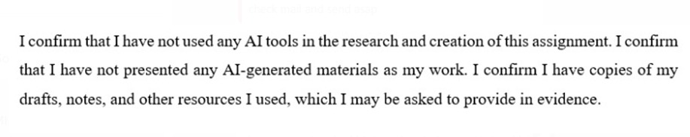

Table of Contents
1 Introduction 3
2 Main Body 3
2.1 Food & Beverage Operations Theory Background 3
2.2 Comparison: Theory vs Practice at Maldron Hotel 4
2.2.1 Application of SOPs and Service Sequence in Practice 4
2.2.2 SERVQUAL: Comparing Expected vs Actual Service Quality 4
2.3 Teamwork and Coordination in the Bar Area 5
2.4 Reflecting on the Skills and Professional Learning. 5
2.4.1 Description 5
2.4.2 Feeling 6
2.4.3 Evaluation 6
2.4.4 Analysis 6
2.4.5 Conclusion 6
2.4.6 Action Plan 6
2.5 Suggested Improvements 7
3 Conclusion 7
4 References 8
5 Appendix 10

Introduction
I was placed in the Maldron Hotel, where I served in the Food and Beverage (F&B) department, primarily in the restaurant. The restaurant also assists in guest functions and room service when there is a lot of traffic. The reason why the F&B department is essential is that it is directly related to the experience of the guests and the overall reputation of the hotel (Anon, 2010).
There were various rather essential staff members with whom I worked during my placement. The day-to-day floor activities and the leadership of the staff team were under the responsibility of Ken, David, and Rhys, who was the Restaurant Supervisor. David was the Restaurant Operations Manager, who was in charge of scheduling, performance, and quality control. Bellary and John were employees of the restaurant and bar that were promoting both food and beverage service..

Main Body

Food & Beverage Operations Theory Background
Hotel restaurants have a set of Standard Operating Procedures (SOPs) that provide consistency and quality in service delivery to guests. SOPs determine the service sequence and typically involve: welcoming and greeting the guest, seating, taking orders, delivering food and beverages, assessing guest satisfaction, clearing tables, payment, and thanking the guest (Budiman, 2024). These measures help form a smooth flow of service and ensure that every guest gets like standards in spite of changes in staff (Johnston et al., 2012). This theory is directly related to my experience during my placement as the consistency of the restaurant service was guided by SOPs. The mentioned sources are applicable because they describe the basis of functional discipline and service flow that I witnessed in practice.
Another key concern in hospitality is quality of service. The model explains five service quality dimensions such as reliability, assurance, empathy, and tangibles (Walker, 2021). Where these dimensions are not impressed, there is a service quality gap. The connection of theory with practice made me understand the importance of these dimensions in operating in real time. Consistency is paramount because customers of a hotel need to receive the same level of service every time they visit. This type of consistency is founded on teamwork, communication, training, and supervision within the food and beverage team (Rutherford and O’Fallon, 2007).

Comparison: Theory vs Practice at Maldron Hotel

Application of SOPs and Service Sequence in Practice
The restaurant had many guests registered, particularly during the peak hours of the day, 7:30 am to 9:00 am. The staff members followed the most basic service model: they greeted the guests, seated them at the table, and served them in a brief period of time (Odekerken-Schroder et al., 2022). Practically, this showed the application of the SOP theory, what was done to keep the flow, when the most difficult moments arose, and why teamwork and coordination were needed to support the quality of the services. This was the theoretical meaning of speed and efficiency during peak times and reflected the action of teamwork and time management.
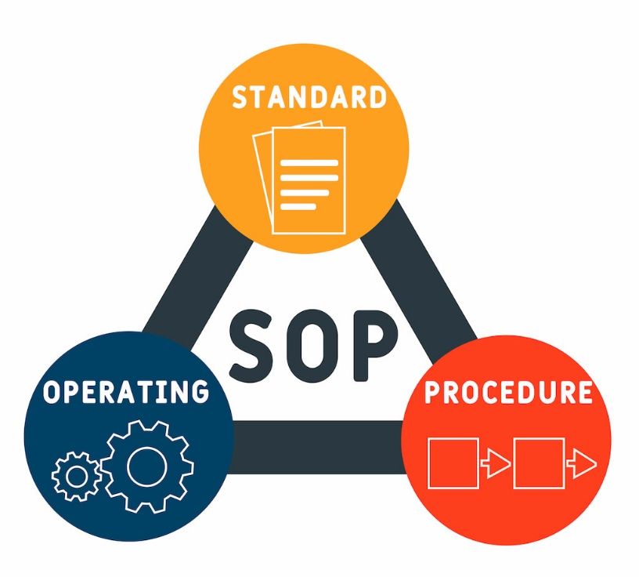
Figure 1application of SOPs
Source: (Provost, 2022)

SERVQUAL: Comparing Expected vs Actual Service Quality
The idea of reliability as the SERVQUAL model implies is that it is necessary to offer precise and consistent service (Shi and Shang, 2020). In actual practice the breakfast was not delivered when full blast on and the table cleared in an instant always. This comparison demonstrates the applicability of the SERVQUAL framework: it describes the gap between the expected (ideal) and the real (actual) service I observed. This made me critically examine service gaps and reflect how they might be minimized. This created waiting time, and at a certain stage, it led to dissatisfaction among the guests in the form of the difference between expected and received service (Ayodeji and Rjoub, 2021).
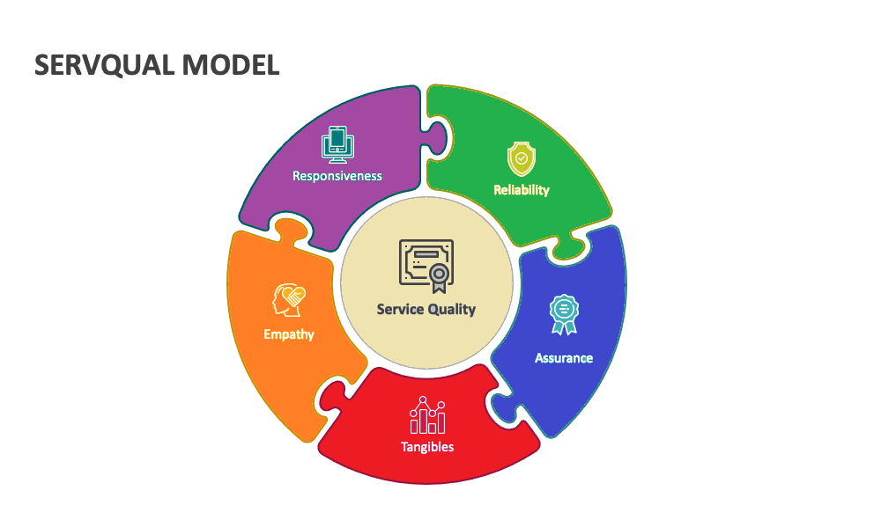
Figure 2 SERVQUAL Model
Source: (batheories, 2023)

Teamwork and Coordination in the Bar Area
I had seen more informal and yet efficient communication in the bar. One was an employee who served drinks, and another cleared or served tables. Teamwork in the Maldron Hotel was more organised and deliberate than in my Level 4 placement. In the past, I was primarily witnessing individual work patterns only, but here I observed how teamwork and delegation augmented work efficiency, why task division was important, and what the effect was on guest satisfaction. This kind of separation of roles helped in the efficient working process and demonstrated how teamwork and easy distribution of responsibilities can become useful towards the smooth running of things.

Reflecting on the Skills and Professional Learning.

Description
During my time in the placement, I served breakfast and dinner most of the time at the restaurant. In this instance, as an illustration, when I was on a certain hectic breakfast shift (8:00 9:00 am), I had three tables in total, which were taking orders, refilling coffee, and clearing in time. This practical experience showed how knowledge of multitasking and sequencing in theory became practice in actual sense.

Feeling
Initially, I was nervous since I feared that I would commit mistakes. I desired to serve guests politely and adequately, yet the pressure hindered my ability to be organised. I also did not know how to approach tasks best when I had numerous tasks demanding my attention.

Evaluation
This was a challenging scenario as well as helpful in developing me. The good side was that he managed to learn how to multitask and treat the guests politely and calmly (Hagg,2013). The bad one was that I was stressed initially and did not have a powerful approach to prioritising things.

Analysis
This experience has made me realise that service work is not always in line with the organised sequence that is outlined in theory. Speed, communication, and teamwork are what real service is about. Ken, David, and Rhys also led the team with calm and clear leadership that made them focus, and this emphasised the role of leadership style in determining the quality of the service.

Conclusion
I also discovered that professional behaviour in hospitality involves the use of patience, confidence, and clear communication. Errors may occur, and the reaction of the staff influences the experience of the guests (Grewal et al., 2020).

Action Plan
Table 1 Action Plan Table
Skill to Improve | Steps I Will Take | Support / Resources Needed | Timeline | Expected Outcome
Time management during busy service | Practise prioritising tasks and planning actions before peak times | Guidance from supervisors and continued practice on shift | Ongoing throughout future placements | Work faster and more confidently without feeling stressed
Communication with guests | Use polite and clear language when taking requests and handling concerns | Observe how experienced staff interact with guests and learn phrases | 2–4 weeks of regular practice | More confident guest interaction and improved service quality
Team coordination | Check in regularly with colleagues and share workload during rush periods | Continued teamwork experience and supervisor feedback | Ongoing | Stronger teamwork skills and better support for colleagues

Suggested Improvements
To enhance uniformity in service delivery, the restaurant would really benefit from brief refresher training on dealing with peak periods. A more open communication in cases of high traffic, including the designation of specific roles at the start of each shift, can be used to enhance the working process. The confusion during peak times would also be abated by introducing a better system of table allocation. The described changes have the potential to bridge the service quality gap outlined in the SERVQUAL model (Walker, 2021).

Conclusion
This position was beneficial in that I was able to relate theory as taught in the Food and Beverage Operations with practice in the hotel. I saw how the series of services and the SOPs worked in fulfilling the guests, but I also learnt how real-life problems, such as time constraints and staffing, affected service delivery. The collaboration with Ken, David, and Rhys and the restaurant team taught me the significance of working as a team, communicating, and making decisions amicably.

References
Anon. (2010) A good practice guide for placement and other work-based learning opportunities in higher education. Good Practice for Placements Guides, Volume 2, 52(4). doi: 10.1108/et.2010.00452dab.013.
Hagg, E. (2013) Internship guide: work placements step by step. The Hague: Eleven International Publishing.
Johnston, R., Clark, G. and Shulver, M. (2012) Service operations management: improving service delivery. 5th edn. London: Pearson.
Rutherford, D.G. and O’Fallon, M.J. (eds.) (2007) Hotel management and operations. 4th edn. Hoboken, NJ: John Wiley.
Walker, J.R. (2021) Introduction to hospitality. 8th edn. Global edition. Harlow: Pearson Education.
Budiman, B. (2024). ‘Application of Room Service SOP by Waiters and Waitresses in …’, Jurnal Manajemen Pelayanan Hotel, 8(2), pp.192-206. doi: 10.37484/jmph.070130.
Odekerken-Schröder, G., Mennens, K., Steins, M. and Mahr, D. (2022). ‘The service triad: an empirical study of service robots, customers and frontline employees’, Journal of Service Management, 33(2), pp. 246–292. doi: 10.1108/JOSM-10-2020-0372.
Provost, J. (2022). What Are the Different Types of SOP and Their Benefits? Great Lakes Advisory, a Key Performance Integrators Company. [online] Great Lakes Advisory, a Key Performance Integrators Company. Available at: https://greatlakesadvisory.com/blog/what-are-the-different-types-of-sop-and-their-benefits/ [Accessed 6 Nov. 2025].
Shi, Z. and Shang, H. (2020). A Review on Quality of Service and SERVQUAL Model. Lecture notes in computer science, [online] pp.188–204. doi:https://doi.org/10.1007/978-3-030-50341-3_15.
Ayodeji, Y. and Rjoub, H. (2021). ‘Investigation into waiting time, self-service technology, and customer loyalty: The mediating role of waiting time in satisfaction’, Human Factors and Ergonomics in Manufacturing & Service Industries, 31(5), pp. 487-500. doi: 10.1002/hfm.20867.
batheories (2023). SERVQUAL Model of Service Quality Explained. [online] BA Theories (Business Administration & Management). Available at: https://www.batheories.com/servqual-model/ [Accessed 6 Nov. 2025].
Mandić, D., Panić, A. and Čičin Šain, M. (2023). Automated service delivery in hotels: balancing efficiency and human interaction for optimal guest satisfaction. Conference proceedings : ICEMIT, [online] pp.167–174. doi:https://doi.org/10.46793/icemit23.137m.
Grewal, D., Mirja Kroschke, Mende, M., Roggeveen, A.L. and Scott, M.L. (2020). Frontline Cyborgs at Your Service: How Human Enhancement Technologies Affect Customer Experiences in Retail, Sales, and Service Settings. Journal of Interactive Marketing, [online] 51(1), pp.9–25. doi:https://doi.org/10.1016/j.intmar.2020.03.001.

Appendix
Table 2 Learning Objectives for the Placement
No. | Learning Objective | Explanation of What I Intended to Achieve
1 | Develop confidence in delivering professional food and beverage service using SOPs and service sequence. | I wanted to be able to follow the correct service process consistently during different service periods.
2 | Improve time management and the ability to multitask during high-pressure service periods. | I aimed to manage several tables and tasks without becoming stressed or confused.
3 | Strengthen communication and teamwork skills when coordinating with colleagues and supervisors. | I wanted to be able to ask for help, share tasks, and support others effectively during service.
4 | Build confidence in interacting with guests and managing guest expectations professionally. | My goal was to develop a calm and polite service approach, even when guests were demanding or service was busy.
5 | Apply theoretical concepts (SOPs, SERVQUAL, teamwork and leadership theories) to real-life workplace practice. | I aimed to connect what I learned in university with actual operational situations in the hotel.

Discussion on Achievement of learning Objectives
Goal 1 Develop confidence in delivering service using SOPs.
Achieved
I also used the service sequence, particularly at the time of breaking of breakfast and dinner. Despite the difficult times at peaks, I got to know how to adhere to greeting, seating, serving, and clearing procedures. The mentoring and observation of practiced staff members provided by the supervisors also assisted me to comprehend how SOPs are consistent.
Goal 2 To become a better time manager and multitasker.
Partially Achieved.
Initially, I was overwhelmed with numerous tables and work done simultaneously. Nevertheless, in the course of the placement, I became more confident and learnt how to be prioritisation based on urgency. I also require more practice to be able to perform under pressure, with a lower level of stress, which is why time management is a part of my action plan.
Goal 3 Enhance skills in communication and teamwork.
Achieved.
I also communicated with team members actively regarding the situation at the table and shared responsibilities. Teamwork was also well synchronized in the bar area particularly and this helped me to appreciate the importance of role division in enhancing efficiency. I also got to know how to seek help freely, which enhanced the process of work and lowered stress.
Goal 4 Develop confidence with interacting with the guests.
Achieved.
Initially, I was very anxious around guests but by experience, I was able to be more steady in keeping a polite conversation, ask and respond to demands, and address delays in service calmly. I also noticed the way older employees treated guests and I emulated this pattern.
Goal 5 Practice hospitality theory.
Achieved.
I could correlate the theoretical models that I observed in the work environment like SOPs and SERVQUAL. Indicatively, SERVQUAL allowed me to appreciate why the variations between the service expectations and service delivery led to dissatisfaction among guests at the peak seasons. Learning these theories helped me to have a deeper reflection and enhanced my professional awareness.

