Virtual Learning Environment (VLE)
And its impact on student’s learning
Andrei Viorel Ilie Minof
Module : Digital Skills and Research Methods
Student ID : 2132997
Lecturer Name : Ejiro Esohwode
Module : BMSW4003
Abstract
This research project's fundamental objective is to acquire data that may be useful in understanding the connections between VLE usage and student learning performance in higher education as well as to assess the influence of VLE on students learning. Furthermore, educators and specialists encounter difficulties that can be resolved by the findings of this research in order to better understand students and create teaching tactics that suit their learning preferences.

Table of Contents
1.0 Introduction 4
1.1 Background 4
1.2 Rationale 4
1.3 Research Object 4
1.4 Research Questions 4
2.0 Literature review 5
2.1 VLE use in Education 5
2.2 Challenges in VLE adoption 5
3.0 Methodology 6
3.1 Research Approach: qualitative and quantitative 6
3.2 Data collection: Primary/ Secondary 6
3.3 Data collection process 6
3.4 Data Sampling and size 6
3.5 Ethical consideration 7
4.0 Data analysis 7
4.1 Primary data analysis 7
4.2 Secondary data analysis 12
4.3 Summary of the findings 12
5.0 Conclusion and recommendation 13
Recommendations 13
References 14
Appendices 15

1.0 Introduction

1.1 Background
The “Virtual learning environment” (VLE) is a process of imparting knowledge to students with the use of online or digital platforms. With the educational field becoming more digital day by day the creation of VLE aims to provide a customized learning environment for students to mitigate learning needs. The widespread usage of VLE in education across various fields often serves to deliver instructional materials and communicate more effectively; however, its restricted accessibility also presents significant learning challenges (Lacka, Wong and Haddoud, 2021).
Therefore, the main goal of this research project is to gather indicators that may aid in comprehending the relationships involving VLE usage and student performance in learning in higher education as well as to gauge the impact of VLE on learners. Moreover, in order to better understand students and develop teaching strategies that suit their learning preferences; educators and experts face challenges that can be addressed by the conclusion drawn in this research.

1.2 Rationale
The impact of VLE on students learning experiences is a topic of debate as we enter the age of digitization. The use of the internet and other digital tools that aid in academic communication is gaining traction and is expected to be a vastly acceptable practice in the near future but its efficacy is still under question among many scholars (Torres Martín et al, 2021). Thus, this report aims to find the key aspects of how a Virtual learning environment impacts the performance and learning outcomes of students.

1.3 Research Object
- To gauge if the use of VLE in educational institutions beneficial for student learning
- To understand the key challenges faced by students in using VLE for learning
- To assess the future trend of VLE use in education and its impact on students.

1.4 Research Questions
- What are the learning challenges faced by students while learning using VLE?
- What positive impacts does VLE have on students learning if implemented in educational institutions?
- How will VLE use in education shape future learning practices in students?

2.0 Literature review

2.1 VLE use in Education
"Virtual learning environments (VLEs)" are frequently used in academia in a variety of contexts, typically to disseminate teaching opportunities and facilitate communication. According to Lacka, Wong and Haddoud (2021), empirical evidence suggests that using a "Virtual Learning Environment (VLE)" improves student achievement, stimulates independent learning, as well as increases students' enthusiasm for learning. As opined by Torres Martín et al (2021) and Herrador-Alcaide, Hernández-Solís and Sanguino Galván (2019), "VLE" is an electronic programming framework designed to support knowledge acquisition and instruction through the use of devices and workouts (Torres Martín et al, 2021). Students using a VLE can also be given a "task" to complete in classroom or at their individual pace. According to Lacka and Wong, 2021, they can participate in concurrent or non-concurrent chats to help promote their learning. As opined by Hamid et al (2018), the use of VLE encourages logical thought and independent reasoning while enhancing student reflection and aiding self-development in learning (Herrador-Alcaide, Hernández-Solís and Sanguino Galván, 2019).
However, as argued by Odrekhivskyy et al (2019), many experts share the opinion that electronic assistance ignores the social interaction and in-person cooperation that take place in traditional classroom teaching. Nevertheless, the VLE group participants expressed dissatisfaction with the instructional process (Lacka, Wong and Haddoud, 2021). Likewise, VLEs are frequently seen as an important component of institutional strategies; nevertheless, delivery is still unable to properly match this (Lacka and Wong, 2021). Effectiveness, educational objectives, and growing adaptation are among the sources of influence (Hamid et al, 2018). However, despite the fact that their full capacity for distant learning is widely anticipated, availability difficulties are now unsuccessfully taken into account (Odrekhivskyy et al, 2019).

2.2 Challenges in VLE adoption
According to Dung (2020), implementing VLEs presents difficulties for instructors and students, including scheduling (time-management) problems, mother tongue language preferences, a lack of assistance, as well as poor internet connectivity. There are relatively few issues with adopting VLE in schools, especially for teaching and learning (Dung, 2020). According to Boulton, Kent and Williams (2018), there is a low degree of staff and student participation. There is frequently little to no time allocated for employee training, and there is much less help for students as a consequence (Boulton, Kent and Williams, 2018). Therefore, as opined by Hamutoglu et al (2018), the sector as a whole has not yet fully created the mature support network infrastructure required.
As opined by Chaim et al (2018), among the issues faced by teachers, particularly older instructors, is the task of embracing new pedagogical innovations or learning management systems (LMS) introduced by higher education. An overwhelming number of senior teachers found it challenging to embrace this technological breakthrough and the modifications made to include ICT in their instruction (Hamutoglu et al, 2018). As argued by Hamutoglu et al (2020), educators feel that there was not a long history of teaching languages and that they lacked expertise in giving pupils ownership of their own learning through hands-on real-life engagement (Chaim et al, 2018). Predetermined elements of fear and peril also accompany this change. Educators are hesitant to change because many doubt their ability to implement the new techniques (Hamutoglu et al, 2020).

3.0 Methodology

3.1 Research Approach: qualitative and quantitative
Primary data gained through the survey will be the foundation of the Quantitative used to evaluate findings through the use of Excel graphs. Moreover, as the investigation also used scholarly research journals and articles, information gathered from there will serve as the Qualitative data that will be used to iterate key findings on how VLE impacts students' learning process (Pandey and Pandey, 2021).

3.2 Data collection: Primary/ Secondary
Primary data will be gathered through a questionnaire survey [refer to appendices 1]. This questionnaire has been carefully curated to understand important criticalities in the use of VLE to gauge participants' viewpoints. Additionally, by delving into scientific journals and articles, Secondary data will be gathered to address the key aspects of the topic.

3.3 Data collection process
Data will be collected via a survey questionnaire that mentions questions relevant to the topic of VLE use and will be provided to students learning in the university to gain their perspective. Moreover, the survey is based on the Likert Scale to get detailed answers from the respondents. After physically meeting and selecting the participants through the Random probability method the questionnaire would be sent to them via email (Pandey and Pandey, 2021). The first 50 replies would serve as the foundation of primary data being used in this investigation.

3.4 Data Sampling and size
50 participants would be used to collect primary data, who are students studying in the university. Moreover, the questionnaire would be sent to more than 50 individuals as it is expected not everyone would revert back. Therefore, the first 50 replies to the questionnaire would be used to further the research.

3.5 Ethical consideration
All consent of ethical consideration would be done to keep the participant's information confidential and their voluntary participation would be taken. No harm would be done and respect for data and participants would be done to further the research and safeguard participants' wellbeing (Pandey and Pandey, 2021).

4.0 Data analysis

4.1 Primary data analysis
Question 1
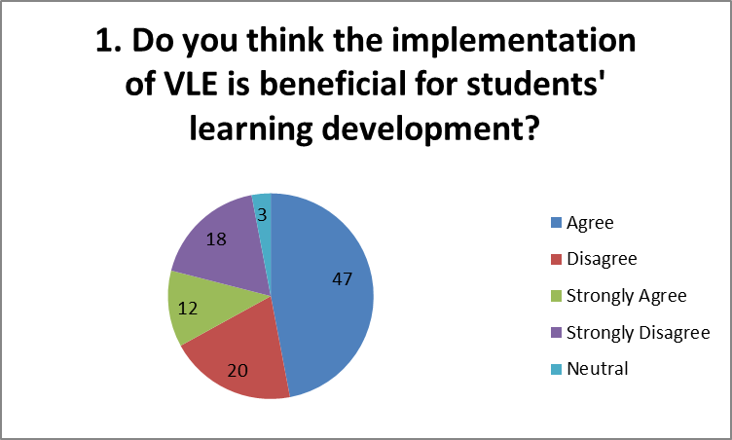
- According to the participants it can be seen that the majority believe it can be used as a tool to develop learning in students in the dynamic learning ecosystem that is becoming more digital day by day. Moreover, the participants believe that the correct use of VLE can enhance learning outcomes in students.

Question 2
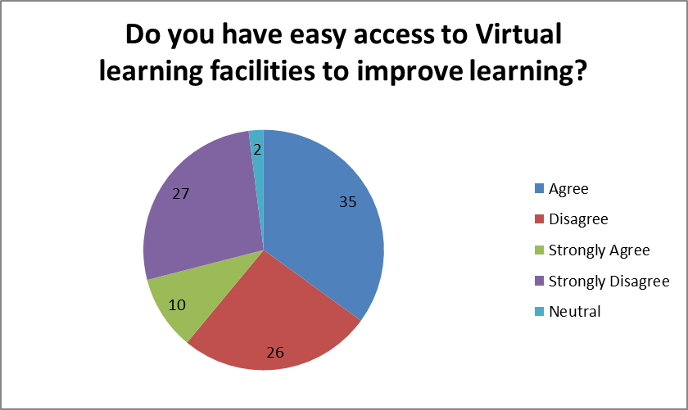
- Agree and disagree notions are quite equitable and show that accessibility to VLE most in internet access and digital proficiency is a key challenge faced by many in the use of VLE capabilities.
Question 3
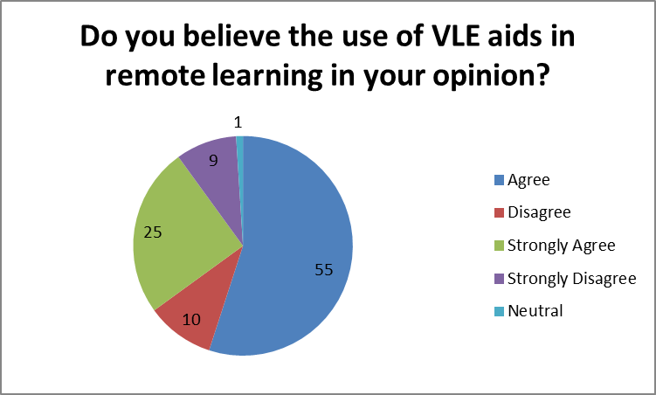
- The use of VLE is seen to be the most useful while delving into remote learning. Different tools in the VLE help in distant communication at a very rapid pace aiding geographic constraints.

Question 4
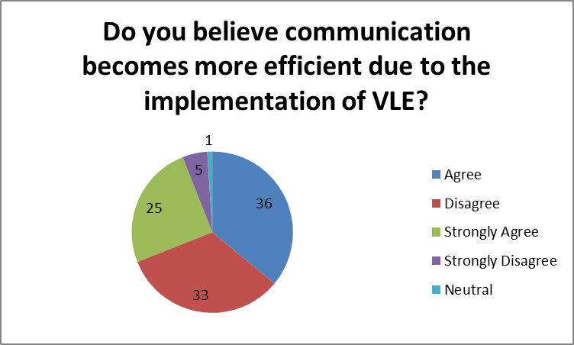
- It can be seen that though at times of distance communication VLE is appreciated but viewed in its entirety encompassing all types of communication needed for robust learning; communication through VLE is seen to have shortcomings.

Question 5
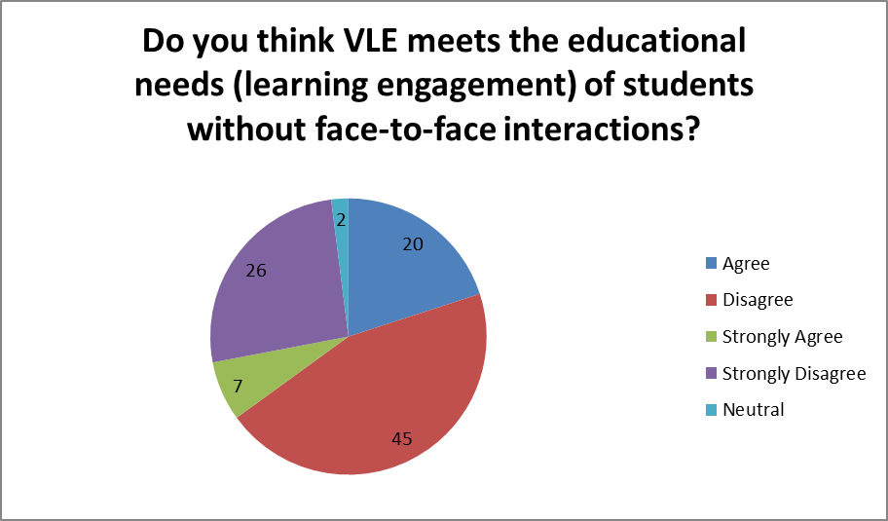
- The majority of the participants think that the benefits gained through physical interactions cannot be mitigated at the same level by the use of VLE. They believe face-to-face communication has its own communication benefits that VLE cannot provide.

Question 6
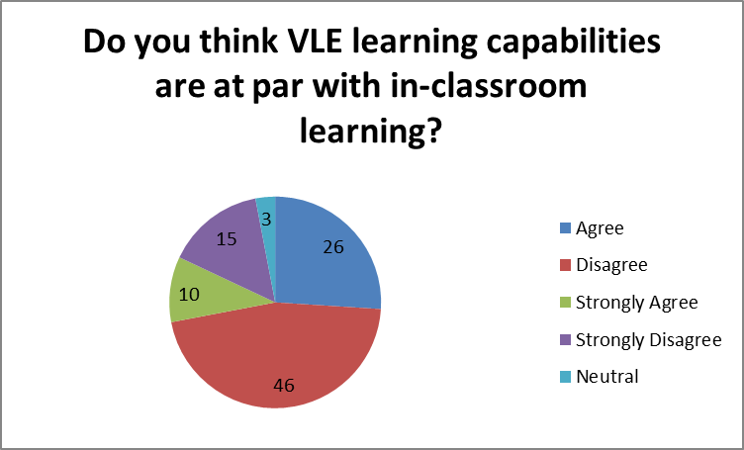
- The majority of the respondents in the survey believe that VLE provided a different kind of learning compared to in-class learning and one cannot be substituted with the other. Moreover, the absence of physical interaction that fosters a sense of nonverbal information exchange rendering communication easy and prompt is seen as the main impeding factor.
Question 7
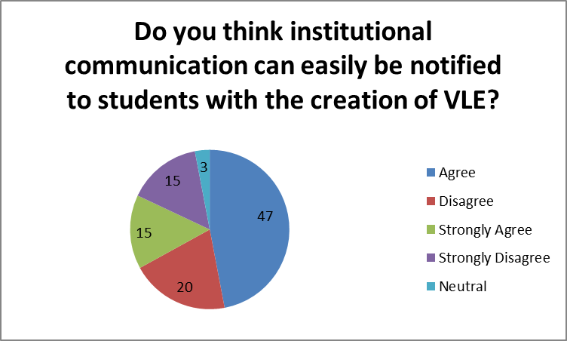
- It can be seen that the majority of the respondents believe it is easier for them to gain access to institutional information as VLE works as a one-point portal and can be used as a correspondence tool that can be accessed by students from anywhere if required.

Question 8
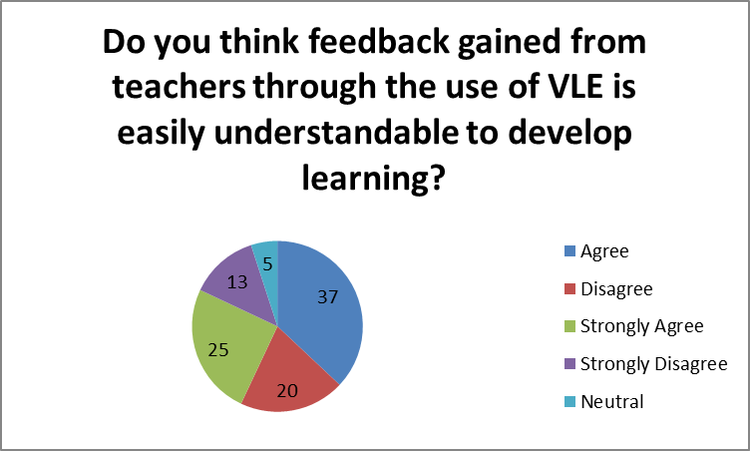
- Due to the lack of physical interaction VLE learning may foster the notion of alienation that is evident from the responses of the participants given above.

Question 9
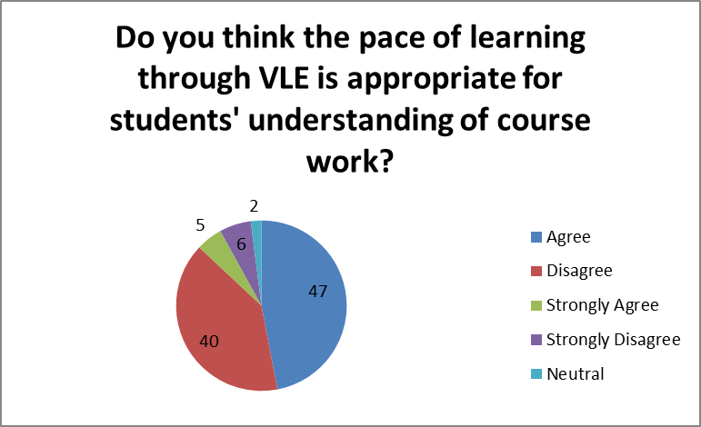
- The pacing of VLE learning and its acceptance by students is at par. This indicates though some like the pacing others do not feel it is not customised enough to suit the individual needs of students.

Question 10
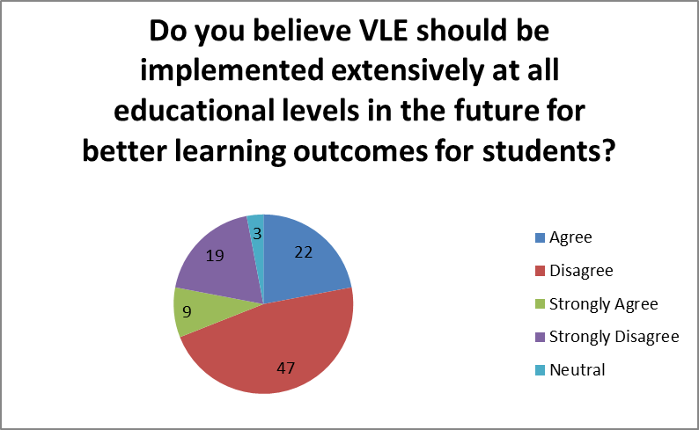
- The implementation of VLE is not seen as a good practice as the majority of the participants believe that it may hinder learning due to the absence of physical engagement. Moreover, the learners think that by using VLE learning may have gaps or could culminate in misunderstanding, thus hindering learning in students.

4.2 Secondary data analysis
The main difficulty in implementing VLEs causes issues for both teachers and students, including time-management issues, native language linguistic biases, a lack of guidance and inadequate internet access. Furthermore, this transition is also accompanied by predetermined aspects of dread and danger and because many of them are unsure of their capacity to execute the new strategies, educators are reluctant to change. The challenge of integrating new pedagogical innovations without impeding student learning is another challenge faced by teachers, especially older ones.

4.3 Summary of the findings
- VLE use is seen to perform best for dissimilating key communications but not for robust learning outcomes.
- Physical engagement and the productivity gained from classroom learning cannot be substituted by the use of VLE.
- The pace of learning by using VLE cannot be customized for individual needs culminating in non-adherence in a few scenarios.
- Mostly due to linguistic challenges the student may not be able to comprehend feedback gained from teachers, culminating in learning challenges in students.

5.0 Conclusion and recommendation
Through the analysis of the data it can be concluded that the positive impact of VLE use can be seen in 3 significant areas - a) long-distance communication b) remote learning capabilities and c) efficient communication between participants. Whereas, in other areas such as extensive use in future; learning comprehension; and bridging the gap between the classroom and online learning; VLE is not preferred. Moreover, participants believe both learning have their unique traits (advantages and shortcomings) and one cannot be substituted with the other.

Recommendations
- Face-to-face learning in the classroom must be used in unison with VLE to profess better learning performance in students.
- Institutionalized communication and key notices by teachers should use VLE to make the students aware due to its easy accessibility.
- Technological prowess is not always present so students must be educated on how to properly use VLE for learning.
- Video conferencing must be heavily used while teachers delve into VLE teaching as it would stop the student from feeling alienated and will help bridge the gap between VLE use and learning through physical engagement.

References
Boulton, C.A., Kent, C. and Williams, H.T., 2018. Virtual learning environment engagement and learning outcomes at a ‘bricks-and-mortar’university. Computers & Education, 126, pp.129-142.
Chaim, O., Muschard, B., Cazarini, E. and Rozenfeld, H., 2018. Insertion of sustainability performance indicators in an industry 4.0 virtual learning environment. Procedia Manufacturing, 21, pp.446-453.
Dung, D.T.H., 2020. The advantages and disadvantages of virtual learning. IOSR Journal of Research & Method in Education, 10(3), pp.45-48.
Hamid, Z., Peng, C.F., Shaharom, M.S.N., Ter, T.C. and Raman, K., 2018. The concept and use of the virtual learning environment in teaching: a literature review. International journal of academic research in business and social sciences, 8(6), pp.1293-1301.
Hamutoglu, N.B., Gemikonakli, O., Duman, I., Kirksekiz, A. and Kiyici, M., 2020. Evaluating students experiences using a virtual learning environment: satisfaction and preferences. Educational Technology Research and Development, 68(1), pp.437-462.
Hamutoglu, N.B., Gemikonakli, O., Savasci, M. and Gultekin, G.S., 2018. Development of a scale to evaluate virtual learning environment satisfaction. International Journal of Assessment Tools in Education, 5(2), pp.201-222.
Herrador-Alcaide, T.C., Hernández-Solís, M. and Sanguino Galván, R., 2019. Feelings of satisfaction in mature students of financial accounting in a virtual learning environment: an experience of measurement in higher education. International Journal of Educational Technology in Higher Education, 16(1), pp.1-19.
Lacka, E. and Wong, T.C., 2021. Examining the impact of digital technologies on students’ higher education outcomes: the case of the virtual learning environment and social media. Studies in Higher Education, 46(8), pp.1621-1634.
Lacka, E., Wong, T.C. and Haddoud, M.Y., 2021. Can digital technologies improve students' efficiency? Exploring the role of Virtual Learning Environment and Social Media use in Higher Education. Computers & Education, 163, p.104099.
Odrekhivskyy, M., Pasichnyk, V., Rzheuskyi, A., Andrunyk, V., Nazaruk, M., Kunanets, O. and Tabachyshyn, D., 2019. Problems of the Intelligent Virtual Learning Environment Development. In MoMLeT (pp. 359-369).
Pandey, P. and Pandey, M.M., 2021. Research methodology tools and techniques. Bridge Center.
Torres Martín, C., Acal, C., El Homrani, M. and Mingorance Estrada, Á.C., 2021. Impact on the virtual learning environment due to COVID-19. Sustainability, 13(2), p.582.

Appendices
Appendix: 1
Survey Questionnaire
- Do you think the implementation of VLE is beneficial for students learning development?
- Do you have easy access to Virtual learning facilities to improve learning?
- Do you believe the use of VLE aids in remote learning in your opinion?
- Do you believe communication becomes more efficient due to the implementation of VLE?
- Do you think VLE meets the educational needs (learning engagement) of students without face-to-face interactions?
- Do you think VLE learning capabilities are at par with in-classroom learning?
- Do you think institutional communication can easily be notified to students with the creation of VLE?
- Do you think feedback gained from teachers through the use of VLE is easily understandable to develop learning?
- Do you think the pace of learning through VLE is appropriate for students' understanding of course work?
- Do you believe VLE should be implemented extensively at all educational levels in the future for better learning outcomes for students?

