Student Name: Golam Ahmed
Student ID: 1817762
Module code: BMSW 5106
Assignment Section: Knowledge and Information Management of Tesco
Lecturer’s Name: Vajira Balasuriya

Table of Contents
Introduction 4
Background of company 4
Main body 5
Why are information systems being essential for Tesco? 5
What are the information systems implemented by Tesco and describe the input, Processing, and output of such a system? 7
3. Discuss Tesco’s potential knowledge management challenges and offer Recommendations to strengthen their knowledge management practices from the Knowledge acquisition-retention-transfer perspectives. 10
Recommendations 11
Develop a framework for establishing a knowledge management culture 12
Discuss how the overall approach adopted by Tesco incorporates Porter’s generic competitive strategy and in what ways the use of IS/IT has enabled Tesco to achieve a competitive advantage? 13
How would Tesco implement enterprise resource planning (ERP) systems (explain both benefits and challenges of having ERP systems with example/s)? 14
Conclusion 15
References 17

Executive summary
Information management system is very crucial for managing the workplace activities. The involvement of technology and management system improves the report is conducted with the context of Tesco. PLC. its information management system and knowledge management system. There are multiple systems of management has been implemented in the organisation which aims to improve the overall efficiency and manages a large amount of data regarding customers attributes, sales patterns, and historic records. The Integrated management system has been implemented such as, TPS, and ESS for effective decision-making process. Furthermore, the organisation implemented the loop system of input, process, and output system. The organisational management system is based on the technology and innovation. As the organisation is the largest retailing store in the UK, and has served a large number of customers on daily basis. Therefore, the organisation has been implemented the information system and knowledge management system. The knowledge management system is very essential for managing the resources of the organisation. As the knowledge is the valuable asset for the organisation. There are multiple challenges to manage the mega organisation for knowledge management. The recommendations for strengthening the knowledge management. the ERP system has been discussed with the context of Tesco. PLC.

Knowledge and Information Management Skills for the Workplace- A case study of Tesco

Introduction
In this era of globalised world, the influence of the technology is obvious in every field. Therefore, the use of integrated information system is very common to manage the data. Therefore, it can be seen that any business organisation would be successful when there would be appropriate management system of organisational and financial data. From the business environment, many organisations have been a shuffling in workflow procedures and processes regarding the accuracy and reliability. The accurate information is mandatory in the real world regarding business practices, as the business organisational are based on internet of things. The influence of the technology is very impactful which develop the need to innovate an accurate information system. This kind of information system would be helpful to get the data quickly on demand. Therefore, the effective information system helps the top management to make the better decision regarding situation.
The change in business practices along with the requirement and preferences of customers influence the organisation to make the new practices by incorporating the technology. Therefore, the implementation of information is very beneficial to control and monitored the business practices.

Background of company
Jack Cohen had established the Tesco in 1919, by using the demob money after leaving the Royal Flying Corporation. The organisation had initiated as grocery store in the East End of London. From the last two decades, Tesco is considered as the largest retailing store in England and third in entire world by revenue. The Tesco earned £56.5 billion from its sales, and exceptional and other items of £2,959 million. There are multiple operational activities of the Tesco regarding its businesses, and therefore, there are multiple subsidiaries of the Tesco such as Tesco Bank, Tesco Extra, and Tesco Metro, superstores, which serves a large range of customers across the UK. The main strategy of the organisation is to focus on the customers’ needs and provide the best value of product and services. Therefore, the company adds non – food products and intangible services to its long list of its products. Hence, the expansion of business make it successful. The effective information system would help the top management to make effective decision.
Therefore, this report is based on the information management system with the context of Tesco. PLC. It aims to provide the analysis about the information system regarding Tesco. PLC.

Main body

Why are information systems being essential for Tesco?
Computer framework can clearly offer assistance organization within the handling of information into precise, well-presented, up-to-date, and cost-effective data. However, weather that data is additionally brief, important, convenient, and total will generally depends on the capabilities of the individuals included in its preparing and choice.

Information systems are the foundation of operational activities for any organisation to make the decision according to past, present and future data. The data includes customer’s preferences, sales, financial data, data about inventories, and other essential information. Before the implementation of technology, it was hard for the mega organisation to gather, store, organise and utilise a big data and information. Therefore, the innovation process in management helps the organisation to manage the large data and utilise them according to their needs. Furthermore, the information system is based on mechanism to make sure that the information would be readily available to the managers when they require. In addition to this, the entire management system would be designed according to organisational processes. With the context of the Tesco, the organisation has 6,809 stores in Asian, European, and British countries. There are 423,092 employees in the organisation and it is operating its business activities in 13 countries. The organisation serves over 79 million shopping trips every week. Therefore, the organisation has big data regarding customers, sales, and finance. It would be hard for organisation to manage this kind of data without any appropriate information system. Therefore, for running such a large system, it is essential for managers to use appropriate information system. From the secondary research, it has been found that the managers at Tesco use the various information tools to monitor, manage and efficiently run the entire business departments. The information system enables them to assess the past, present, and future information. On the other hand, Tesco use the financial statement of expenses through information systems, and it assist them to make final decision. As there are 423,092 employees working in Tesco, and it is essential to know the how many hours the employees worked that ultimately affects the organisational goal. Furthermore, information management system does not only describe the sales and employees data, but it is also necessary to find out the customer preferences. In this era, the trend behind the customer preferences and choices is hanging constantly. Hence, the information system assist them to know the customers requirement associated with products and services. Concerning with the customers preferences, the Tesco used the effective strategic system for pricing analysis and loyalty scheme. The organisation had launched the Club card which had 700, 00 members across the Ireland, which had received the €200m in voucher. Concerning with the sales, merchandise, buying behaviour, stock optimisation, policies, and the organisation needs the appropriate system. In 1998, the organisation installed the G.O.L.D system, which was based to manage the physical stock flows of the warehouse. In addition to this, the information system of G.O.L.D. It would consider the different attributes of the quality control system such as monitor the stock level, the quality of goods, and stock location and the functionality of warehouse (TESCO, 2020).
As Tesco has expanded its business practices across the globe, and it required the more system of information such as IoT, and its advantages. To ensure the customers services and Tesco provides the flexibility to them by launching the website. In 2000, the company launched its website that provide accessibility to the organisation as well as customers. However, the company had implemented the internet of things since 1994. Through the online grocery shopping, the Irish online shopping has been increased by 21 percent to £ 57.1 million (Samantara & Sharma, 2014).

What are the information systems implemented by Tesco and describe the input, Processing, and output of such a system?
The information system is based on the organisational environment. The figure below depicts the input, process and output system of the organisation with the association of the control and feedback. Concerning with the Tesco. PLC. There are multiple information system are working and they are based on the input, processes, output systems and they are working in the closed system. Finance, revenue, HRM, data and information and other resources of the organisation is considered as the input of the organisation. Furthermore, the development of new product, manufacture, distribution, sales, and the service provision in banking and other stores are acted as the processes of the organisation. On the other hand, physical products, including food and grocery, clothing, etc. are outputs of the Tesco (Tesco. PLC, 2020).
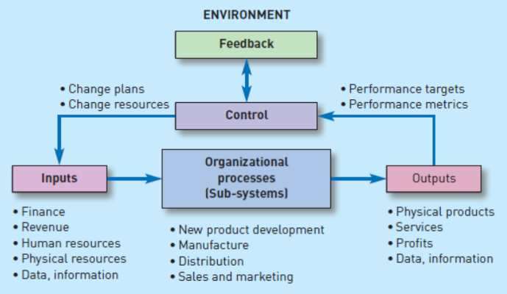
Figure 1information system
Furthermore, there are multiple information systems are implementing in the organisation, which helps to support the entire information system of the organisation and assist the managers to make any decision. With the context of the Tesco. PLC. TPS and ESS
TPS (Transaction processing system) and ESS Executive support systems are widely used and helps the managers to make the decisions. The both system are essential for the organisation (TESCO , 2019).
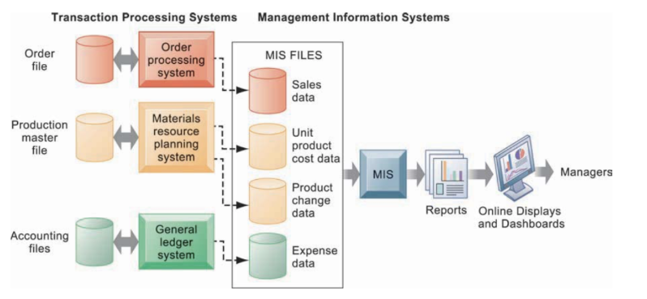
Figure 2 TPS system
. In addition to this, SAP and ORACLE have used for performing TPS and ESS (TESCO, 2015)
With the context TPS, it is considered as the computerised information system which have been implemented to manage the large data of daily transaction. In the system of large organisation, there is large amount of data is gathered regarding payrolls and inventories. TPS system helps to reduce the time duration for processing the information as compared to manual transaction process.
Hence, TPS is used to manage the large operational data. The transaction process in MIS includes the product cost, product change information, and expenditure data, which would be develop in the form of reports. These reports would assist the managers and save the time (Franjo, et al., 2013). The working capacity is increased due to smooth information system of TPS. ESS (Executive support system), as the name suggest that ESS is based on the software system which helps the executives for identify the effective ways to make decision at the executive level.
Concerning with TESCO.PLC. The support system manages the work according to the external environment. There are multiple tools of communication in the organisation including graphics has used. The decision can be tracked by using the cause and effect relationship in this system. EPS support system helps the organisation by providing the information about the situational analyse that may affect the decision and helps to take better decision-making process. However, ESS is relied on the other systems MIS, and TPS. Therefore, Tesco has implemented the ESS for enhancing the decision making, and other operational activities of the organisation such as cash flow activities, revenue making, closing and opening inventories etc (TESCO, 2015).
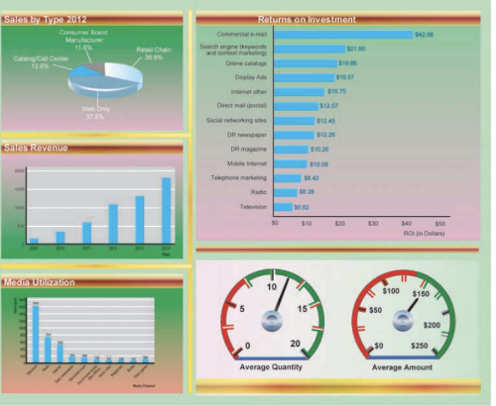
Figure 3 ESS system

3. Discuss Tesco’s potential knowledge management challenges and offer Recommendations to strengthen their knowledge management practices from the Knowledge acquisition-retention-transfer perspectives.
Knowledge management is conserved as the intangible, systematic business strategy that chooses segregate, stores, manage, packages and communicate the information that would be essential to the business of the organisation. In addition to tis, it ultimately improves the overall employee’s efficiency and corporate competitiveness. From the researches, it has been seen that many business organisation have implemented the knowledge economy by adopting the new methods and structures for the information by developing the new roles for managers. The term knowledge workers is defined as the individual which roles is revolve around, developing, utilising, sharing and implementing the knowledge (Rubenstein-Montano, et al., 2001). For instance, the work of knowledge engineer is merely focused on explaining the knowledge from experts that can be shared with others within the organisation.
With the context of Tesco. PLC, it has been found that the organisation has a large number of employees as it has been discussed earlier. The large number create the challenge for managing the knowledge across the organisation. Therefore, the knowledge management is very important process. As knowledge management is based on the multiple subjects such as acquiring knowledge, developing knowledge, sharing and utilising knowledge, and learning is an important step (Samantara & Sharma, 2014).
In the first segment of acquiring knowledge, the ensuring the authentic knowledge for all business practice and availability for managers and staff put the challenge for the organisation. As the organisation is based on innovation and technology which create the core competence for the organisation. Secondly, while developing the knowledge inside and outside of the organisation, the development process of innovation would create the challenges for the organisation to manage the confidentiality of the knowledge.
Sharing and utilising the knowledge is another important part of the knowledge management, it would be hard for the organisational managers to manage the appropriate information about the organisation. For instance, the knowledge about the company policies and procedures would be shared across the organisation. As Tesco is the corporate organisation, and its corporate culture would influence the managers to share the information among the employees (Rubenstein-Montano, et al., 2001). Whereas, the knowledge about the confidential information would not be shared with every person within the organisation. In the end, learning is the continuous process, the organisation implement the trading and development programme to train their staff and ensure that they would be able to learn and apply the knowledge. For ensuring, the learning about knowledge managed put the challenge for the management regarding knowledge management. Furthermore, the protection of organisational knowledge is as much necessary for the organisation. The knowledge is taken as asset, which create the value and it mandatory to protect it from the harm, as well as distributed for necessary people (TESCO, 2015).

Recommendations
As it has been discussed, the challenges associated with knowledge management within Tesco. There are some recommendation, which helps to strength the process of knowledge management for the organisation;
- The organisation should implement the easy process for finding the information and processing the information, what they are looking for.
- The organisation should encourage and motivate the people for sharing and using the information. The sharing between the authentic information for business practices develop the trust within employees as well organisation, and it would improve the efficiency (Holtshouse, 2013).
- For learning process of the organisation, the organisation should implement the training while updating the technology for development and implementation of knowledge management.
- The inter and intra collaboration in department is essential for effective team working for achieving the organisational goal. Therefore, the organisation should ensure as well as supports the inter collaboration.
- Reward system, which is a based on the knowledge contribution, is very necessary for the participation of employees and customers (Dalkir, 2017).

Develop a framework for establishing a knowledge management culture
With the context of knowledge management culture and its practices, there are multiple factors. Concerning the Tesco, the organisation is based on the innovation and technology. The DIKW model is based on the components that moves in hierarchal manner moving from data, to information, knowledge and wisdom. These components are associated with the decision and actions of the managers and top management. In the organisational management system, the innovation, and knowledge management is essential process. By implementing DIKW model, the information can be flow from hierarchal manner; the theatrical system is implemented in the organisational structure, which is suitable for the organisation to manage the data, information, knowledge and wisdom. The decision making process can be done along with knowledge management framework for innovation, implementation of policies and other processes.
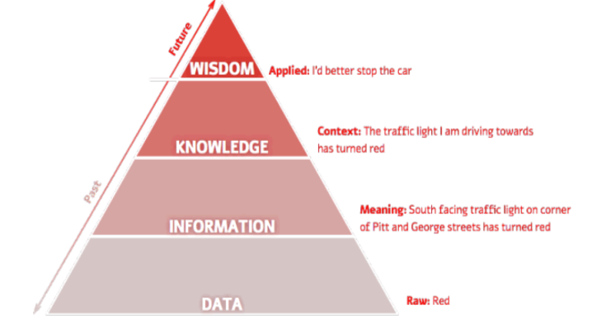
Figure 4 DIKW framework for knowledge management

Discuss how the overall approach adopted by Tesco incorporates Porter’s generic competitive strategy and in what ways the use of IS/IT has enabled Tesco to achieve a competitive advantage?
The porter’s generic strategies are very widely used framework for the any business organisation, which help to find out the potential niche for the organisation in which the organisation would stand among rivalry industries, and the organisation would gain competitive advantage for the organisation.
The porter’s generic strategy is based on the four segment such as Cost leadership, differentiation, cost focus, and differentiation focus. With the context of the Tesco, Tesco used the cost leadership and differentiation marketing strategy regarding the market need.
In the cost leadership, the organisation provides the best prices for its potential customers as compared to market rate, which increase the overall sales and it, ultimately increase the market share of the company. Hence, the company targets a large number of the customer. Concerning, Tesco has cost leadership, the organisation provides the best pricing strategy to have the largest market share of 42.7 % in the Supermarket stores. The cost leadership can be achieved by incorporating the different processes of the business strategies for the organisation while incorporating the IT, and MIS systems of the organisation (TESCO , 2019).
Furthermore, the organisation has used the differentiation strategy to stand strong among the rivalry industries. Hence, the implementation of the differentiation strategy is the secondary generic strategy, which ensure the Tesco to increase the customer by offering the effective and unique services and products. The features of products and services attract the customers and fulfil their requirement by improving the overall organisational services. Therefore, Tesco’s strategic aims of implementing the differentiation strategy is based on innovation and IT system of the organisation. For instance, Tesco has expanded its product line and services due to the customer concerns for differentiation processes within the industry. As Tesco has a large number of customers and it would be in millions per day. Therefore, it would be hard for the organisation to manage a large number of customers. Therefore, the organisation has implemented the information and technology system to implement to manage them. For instance, the company launched the club card for managing the big data regarding customers (TESCO, 2015).
As the company implement the differentiation strategy associated with the IT system and cost leadership, which ultimately enhance the customer base. The company is investing a large amount on innovation, technology, marketing and advertisement, which differentiate the organisation. For instance, the recent investment on innovation is robot delivery, and use of the IoT and online system. Recently, Tesco online sales have been increased by double due to COVID-19 circumstances. The panic situation enhanced the grocery sales, and the company use the online system to deliver the products to their customers at their doorstep. On the other hand, the organisation use the robots for delivery purpose, which provide the distinct position of Tesco. Robot delivery is the first ever initiate in supermarket of the UK. The robot delivery is based on the IoT system, which improves the customer experiences and organisational performances.

How would Tesco implement enterprise resource planning (ERP) systems (explain both benefits and challenges of having ERP systems with example/s)?
Tesco. PLC is the largest retailing store in the UK, which implements the ERP system to manage their business processes including the inventories, supply chain management, product lines and monitoring the stock and other activities. There are multiple benefits of using the ERP system in the Tesco. the first of all, the ERP system is used for procurement planning process, in which the organisational manager find out and determine the product that would be need to acquire. However, the quantity, quality ad product description can be done by using the ERP system (Jagoda, et al., 2017).
Furthermore, the ERP system is widely used for the source searching and it can be specified for identify the supplier regarding the acquired sources. On the other hand, tendering is an essential process for offering, negotiation with the key suppliers of the organisation. The supplier’s bids, offers and other proposals can be identified through the system for selecting the best vendor. The Oracle powers Tesco’s ERP system. Tesco has a large number of the customers, which require different items. The ERP system enable the Tesco to attain the low inventory levels by reducing the cost as well as achieve the greater value index. The management of inventory level should be maintained through ERP system, which assist to reduce the distribution over transportation and logistics control (Chou Huey-Wen, 2014).
Human resource management is another application of ERP system of the organisation, it helps to manage the human resource of the organisation by evaluating the performances of the employees, and it helps to protect the social workers by continuously monitoring of the business. ERP is used as an application, which helps to guide the team working of staff regarding their interpersonal skills. It helps to utilise their skills, on the other hand, the application of the system manages the accounts, pay rolls, deposits.
Logistics and distribution is another example of the application of ERP system, it helps to manage the raw material, products, and flow of goods and it smooth the physical flow of goods from raw material to the consumer end. Therefore, Tesco distribution centre is the main entity, which ensure the provision of very goods from the warehouses to the display store on the time. As it has been seen that Tesco has the primary and secondary distribution stores. In the primary store, which is known as the warehouse, the organisation has responsible to take the stock from supplier to the warehouse. Furthermore, in the secondary distribution area, the organisation store the products from warehouse to the main store. To manage the millions of the products according to the customers needs and required and provide it on the time is very crucial of customer value. However, entire system helps to manage the logistics and manage its flow (TESCO, 2015).

Conclusion
Knowledge management and business information is very crucial to manage the workplace activities in the organisation, which includes the HRM, staffing and managing the product line. The case study of Tesco has been selected to analyse the role of MIS system for managing the knowledge and other processes of the organisation. From this report, it has been concluded that the information system plays a very crucial role to manage the organisational activities. As information, system is very essential for managing the organisation. The closed loop information system along with its components input, output, and processes has been discussed. Furthermore, the organisation has implemented the integrated information management system, TPS and ESS has been implemented which assist the manager to make the decision making process. The potential challenges regarding the knowledge management process, and the recommendation has been given to improve the knowledge management process. The DIKW model for knowledge management has been implemented according to the organisational structure and culture. The porter’s generic competitive strategy has been discussed which elaborate the cost leadership, and differentiation strategy with the association of IT and innovation technology. The ERP system has been discussed according to organisational structure.

References
BBC, 2020. Tesco profits surge as online orders double. [Online]
[Accessed 2021].
Butler, S., 2015. Tesco suppliers say retailer worst at following grocery code of practice. [Online]
Available at: https://www.theguardian.com/business/2015/jun/22/tesco-suppliers-say-retailer-worst-at-following-grocery-code-of-practice
[Accessed March 2020].
Chou Huey-Wen, L. Y.-H. L. H.-S. C. H.-H. C. S.-B., 2014. Knowledge sharing and ERP system usage in post-implementation stage. Computers in Human Behavior, Volume 33, pp. 16-22.
Dalkir, K., 2017. Knowledge management in theory and practice. s.l.:MIT Press.
Franjo, B., Cingula, D. & Primorac, D., 2013. INFORMATION SYSTEM SUPPORT FOR DECISION MAKING IN PUBLIC ADMINISTRATION. Economic and Social Development, p. 922.
Hislop, D., Bosua, R. & Helms, R., 2018. Knowledge management in organizations: A critical introduction. s.l.: Oxford University Press.
Holtshouse, D. K., 2013. Information technology for knowledge management.. s.l.:Springer Science & Business Media.
Jagoda, Kalinga & Samaranayake, P., 2017. An integrated framework for ERP system Implementation.. nternational Journal of Accounting & Information Management, 25(1), pp. 91-109.
Kilic, Selcuk, H., Zaim, S. & Delen., D., 2014. Development of a hybrid methodology for ERP system selection: The case of Turkish Airlines.. Decision Support Systems, Volume 66, pp. 82-92.
Lindner, F. & Wald, A., 2011. Success factors of knowledge management in temporary organizations. International Journal of project management, 29(7), pp. 877-888.
López-Nicolás, C. & Meroño-Cerdán, Á. L., 2011. Strategic knowledge management, innovation and performance. International journal of information management, 31(6), pp. 502-509.
Lucio, R., 2019. Tesco shoppers enjoy grocery delivery via robots. [Online]
[Accessed 2021].
Nwankpa, Joseph & Roumani, Y., 2014. Understanding the link between organizational learning capability and ERP system usage: An empirical examination. Computers in Human Behavior, Volume 33, pp. 224-234.
Rubenstein-Montano, et al., 2001. A systems thinking framework for knowledge management. Decision support systems, 31(1), pp. 5-16.
Samantara, R. & Sharma, N., 2014. Talent Management at Tesco HSC—A Case Study. Management and Labour Studies, 39(4), pp. 477-485.
TESCO , 2019. Tesco: Annual Report and Financial Statements 2019, s.l.: Tesco. PLC.
Tesco. PLC, 2020. Tesco to simplify operational structures. [Online]
[Accessed 2021].
TESCO, 2015. Annual Report 2015, s.l.: TESCO.PLC.
TESCO, 2020. Tesco offer hundreds of exclusive deals for Clubcard customers. [Online]
[Accessed 2021].
Tescoinfo, 2014. Tesco Management System. [Online]
[Accessed 2021].

