Name: Ana Maria Acsinte
Student number: 2232423
E-portfolio report
Learning in the Digital Era – BMPL4007/BMPS4009
Table of Contents
Introduction 2
Task 1 – Written summary 3
Task 2 – Mind map 5
Task 3 – Presentation 6
Introduction 6
Overview of personal identity 7
Role of beliefs, values and place in personal identity 7
Ways of becoming a good team player 8
Conclusion 9
Task 4 – Reflection 10
Conclusion 11
Reference list 12

Introduction
The e portfolio report act as evidence of learning. With the help of this report, it becomes possible to demonstrate the foundational skills required to become a healthy and resilient independence learner. It focuses on undertaking various practices to promote the principles of learning ability. However, the use of technology has helped enhancing the learning experience of the individual learners in their field of discipline.

Task 1 – Written summary
Overview of the topic of “Preparing for Higher Education”: Higher education is considered to be one of the most essential aspects in the learning and development process of an individual. Hence the major focus of the individuals should be put forward to focus on preparing themselves for higher education (Freeman, et al., 2023). There are a large number of tips which should be followed by the students in order to ensure that they get their desired grades in higher education and develop a lot of knowledge from their higher studies. The first most essential tip for the purpose of preparing for higher education is to ensure preparing for the academic subjects in a strong way. This ensures learning all the topics and revising all the subject matters effectively. The second most essential tip for the purpose of preparing for higher education is to develop right habits and get into those right habits. This habits basically include the habit of preparing a time table of all the activities and then following the time table in order to complete the topics related to the subjects easily. The third most essential tip for preparing for higher education is to explore the potential interest (Gabriel, 2023). An individual learner should determine the area of interest in order to select that particular area for the studies and for developing a career in that selective area of interest. The fourth essential tip for preparing for higher education is to select the right university for the achievement of the career objectives. Selection of a right university for continuing higher education plays a very essential role in gaining success in the future career path.
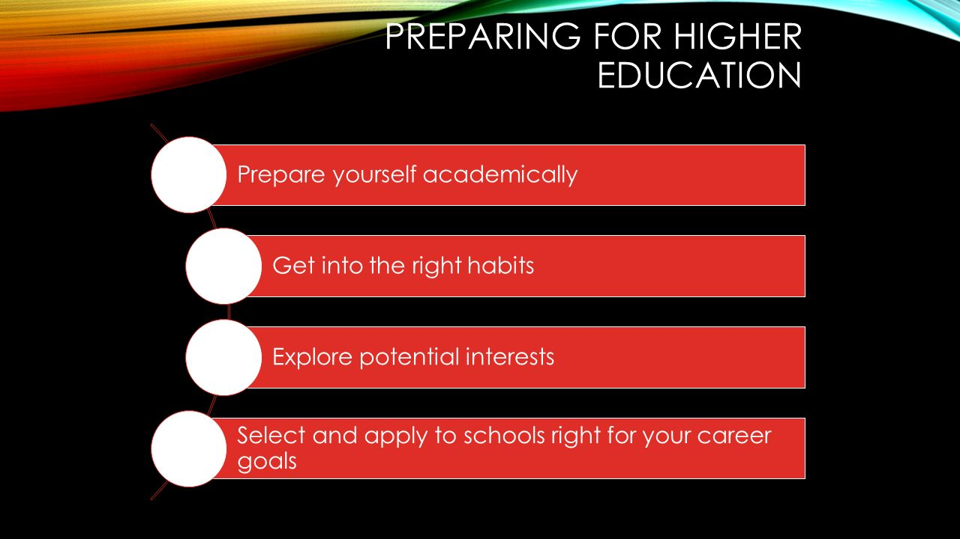
Figure 1:Preparing for Higher Education
Source: (Neumann, et al., 2023)
Significance and benefits of Higher education: There are a large number of benefits which can be gained by the learners by completing higher education successfully. Higher education ensures fulfilling the demand of the job market easily. It is evident that completing higher education develops a lot of new thinking and knowledge within the individuals regarding the society. A proper connection and communication can be established through the presence of higher Education (Orishev and Achilov, 2023). It focuses on undertaking various practices to promote the principles of learning ability.

Task 2 – Mind map
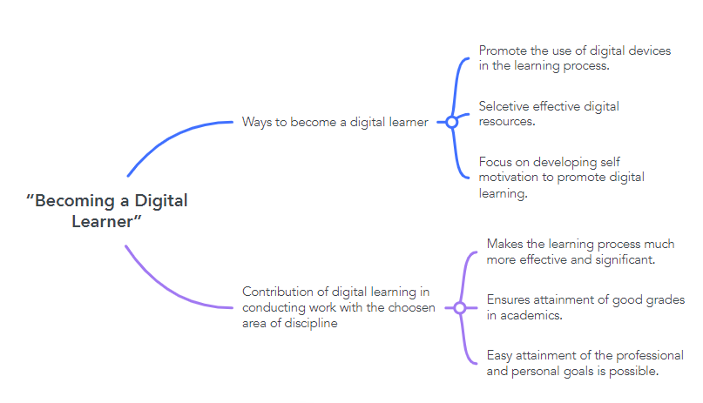
Figure 2:Mind Map
Source: Self-created
A proper mind map has been prepared in relation to the selected topic of “Becoming a Digital Learner”. The two essential segments which have been target comprises of determination of the ways to become a digital learner and contribution of digital learning in conducting work with the chosen area of discipline (Freeman, et al., 2023). Some of the ways to become a digital learner are provided as follows. The first essential way to become a digital learner is to promote the use of digital devices in the learning process. The second essential way to become a digital learner is to select an effective digital resource. The third essential way to become a digital learner is to focus on developing self-motivation to promote digital learning (Neumann, et al., 2023). On the other hand, an effective idea about the contribution of digital learning in conducting work with the chosen area of discipline are provided as follows. The first major contribution is the fact that it makes the learning process much more effective and significant. The second major contribution is the fact that it ensures attainment of good grades in academics. The third major contribution is the fact that it ensures easy attainment of the professional and personal goals is possible (Orishev and Achilov, 2023).

Task 3 – Presentation
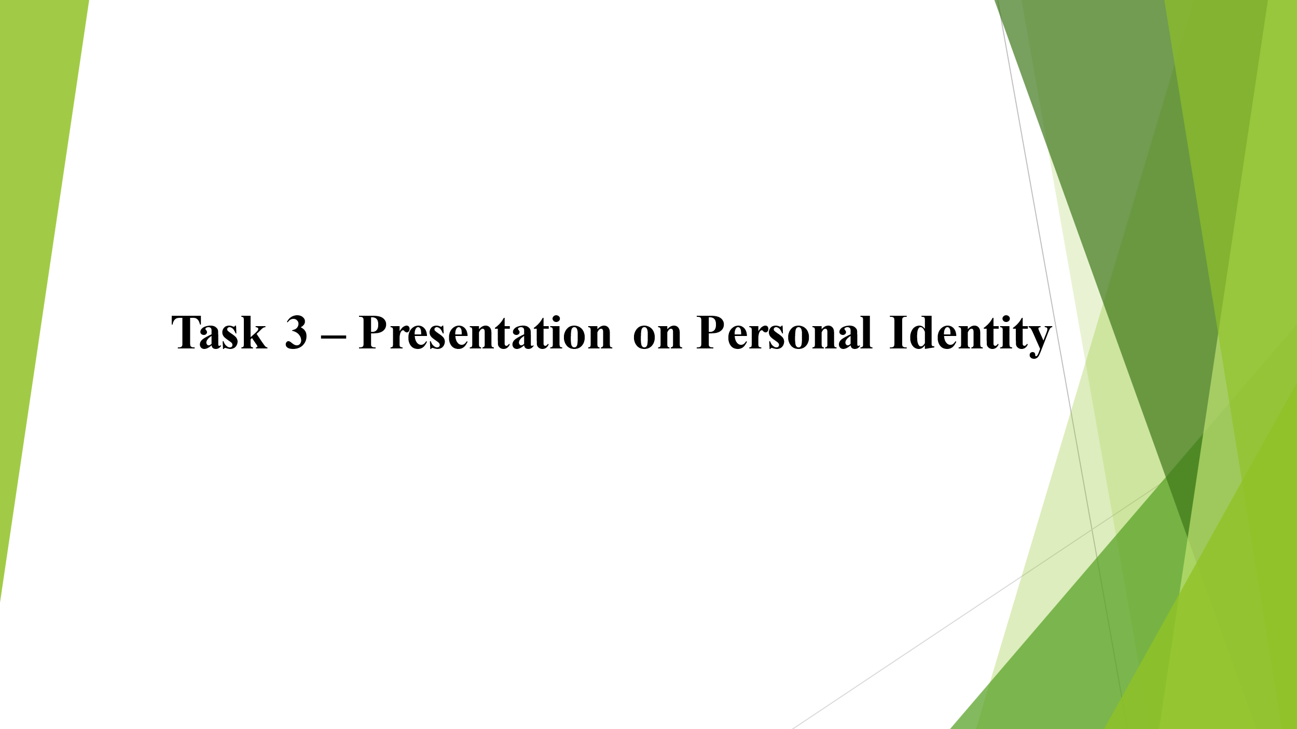

Introduction
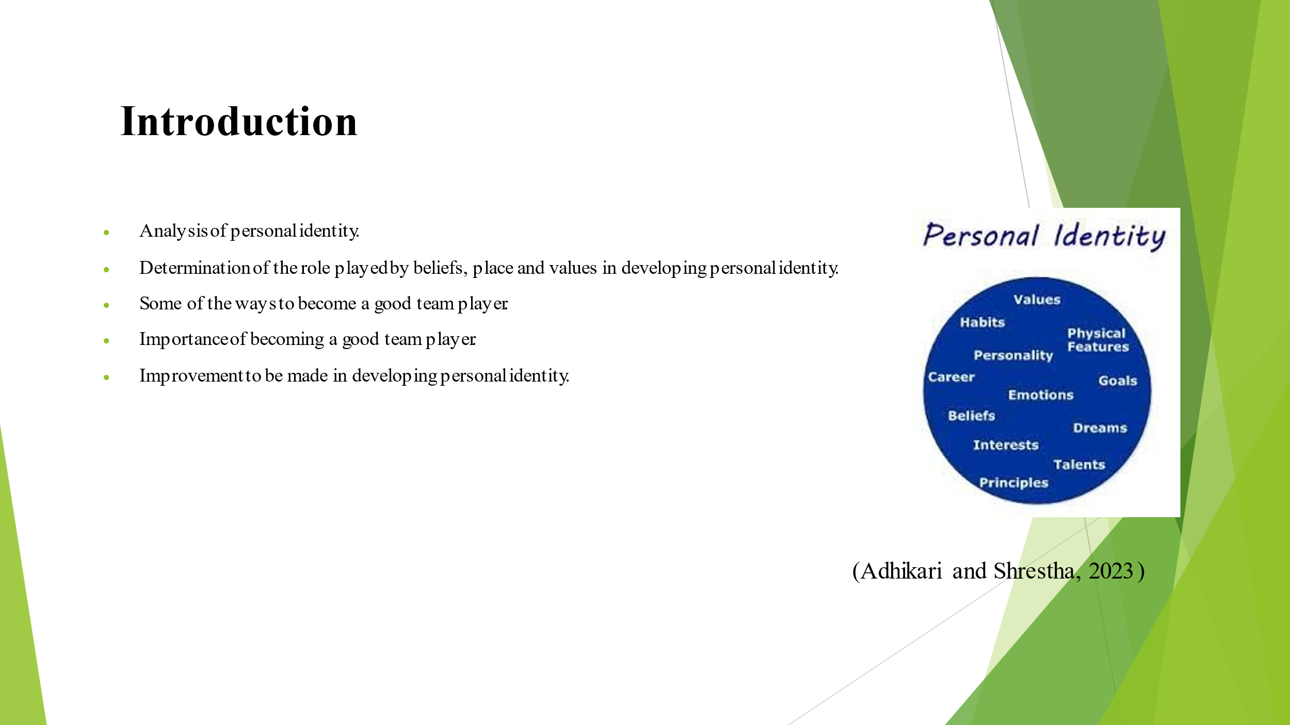The presentation comprises of analysis of personal identity, determination of the role played by beliefs, place and values in developing personal identity and the ways to become a good team player.

Overview of personal identity
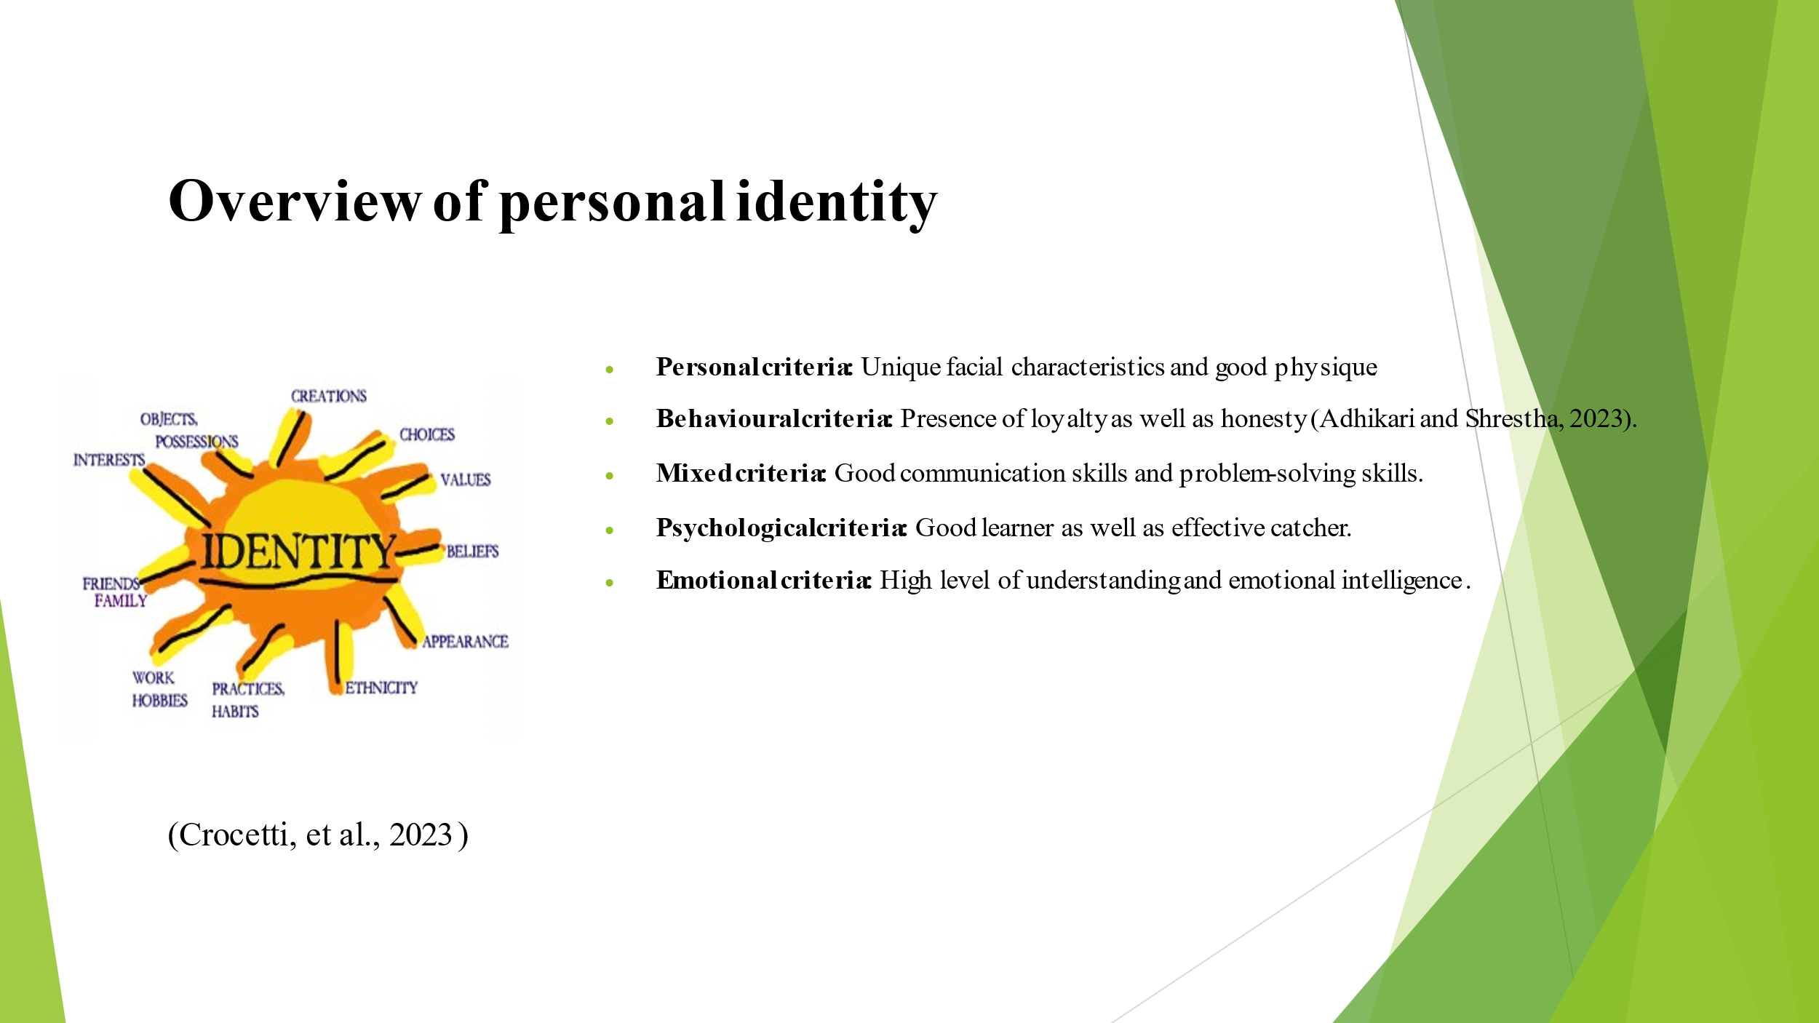An effective overview of personal identity comprises of unique facial characteristics and good physique, presence of loyalty as well as honesty, good communication skills and problem-solving skills, good learner as well as effective catcher, high level of understanding and emotional intelligence.

Role of beliefs, values and place in personal identity
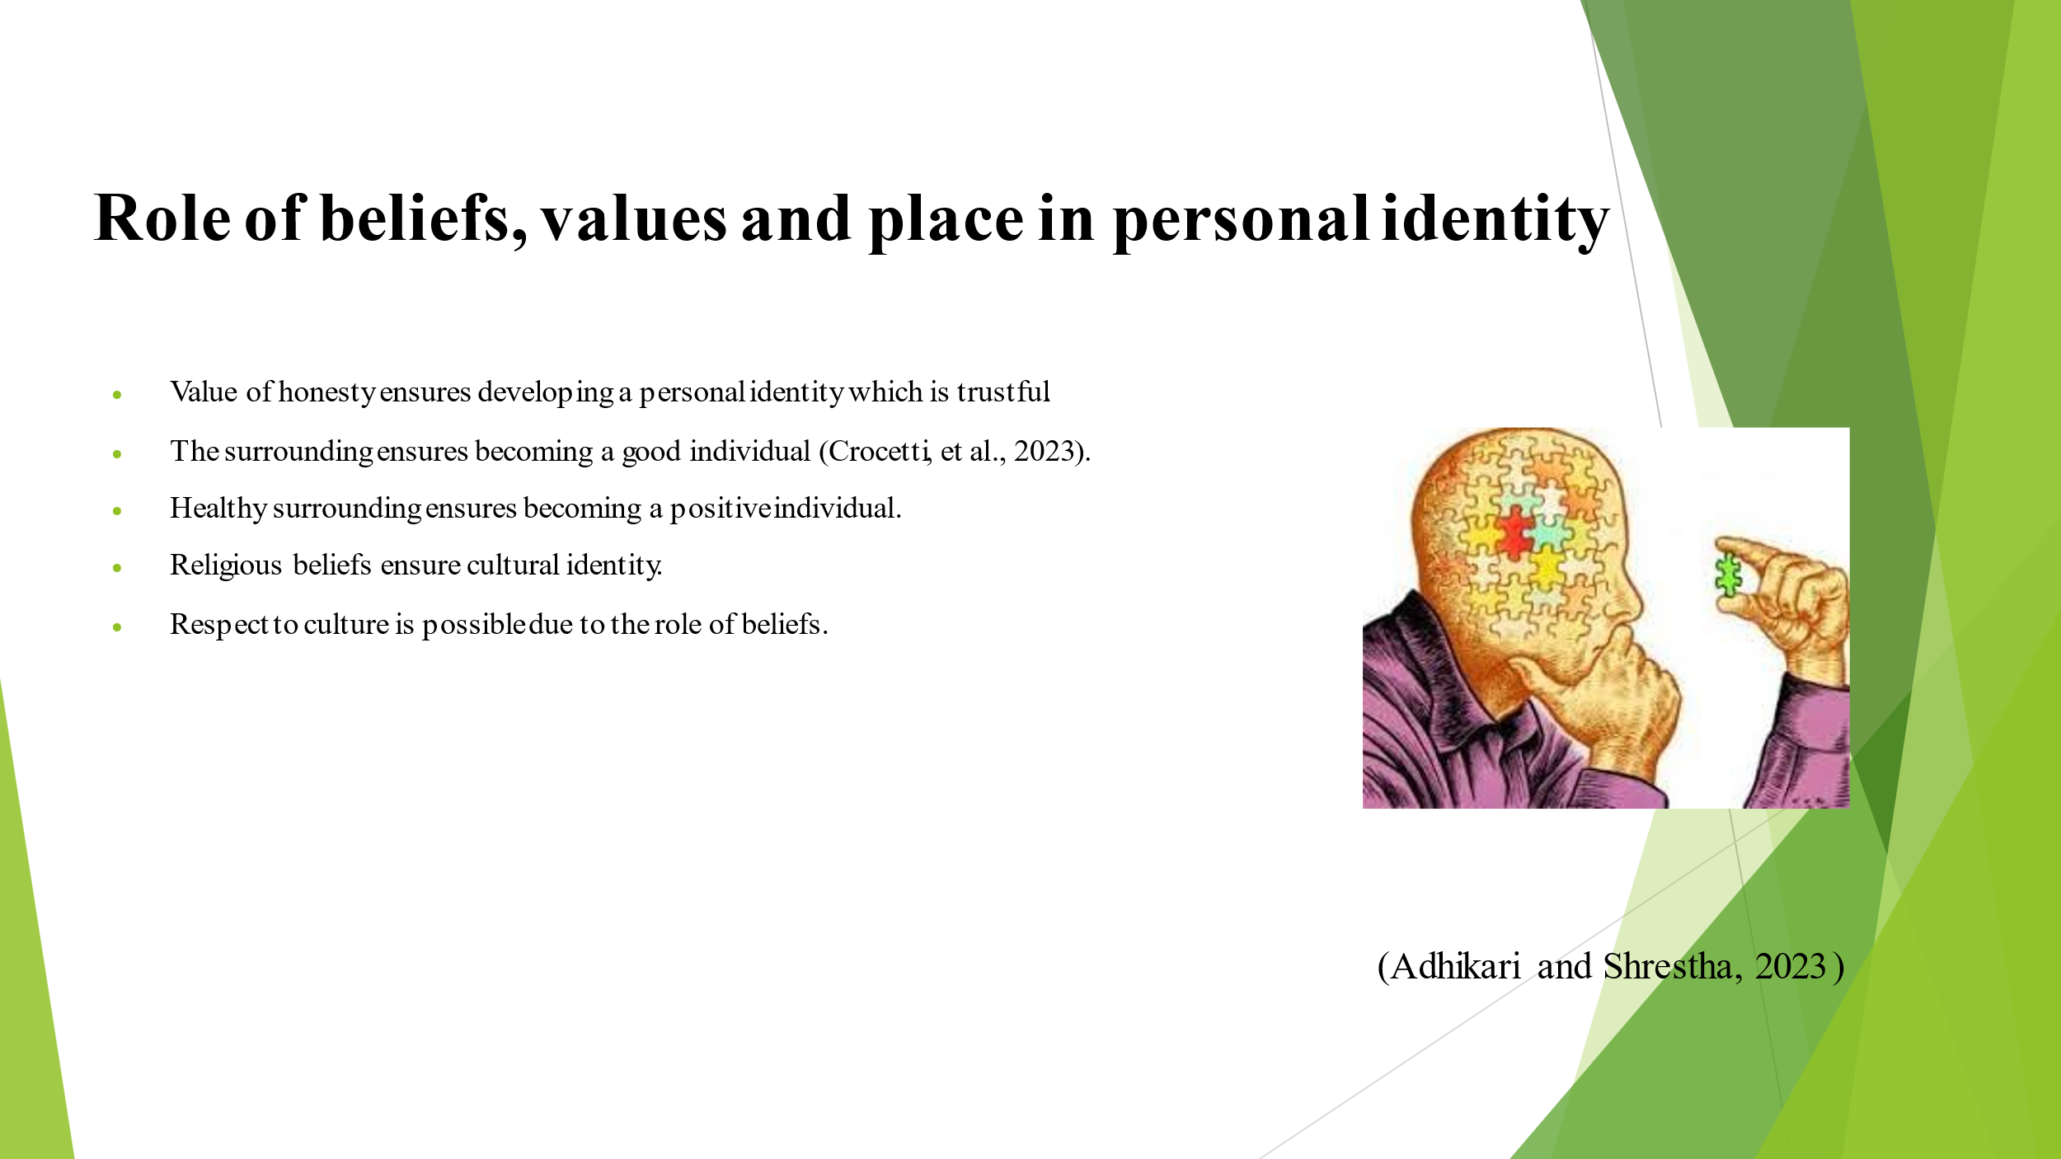The role of beliefs, values and place in personal identity includes developing a personal identity which is trustful, becoming a good individual, becoming a positive individual, ensure cultural identity and providing respect to culture.

Ways of becoming a good team player
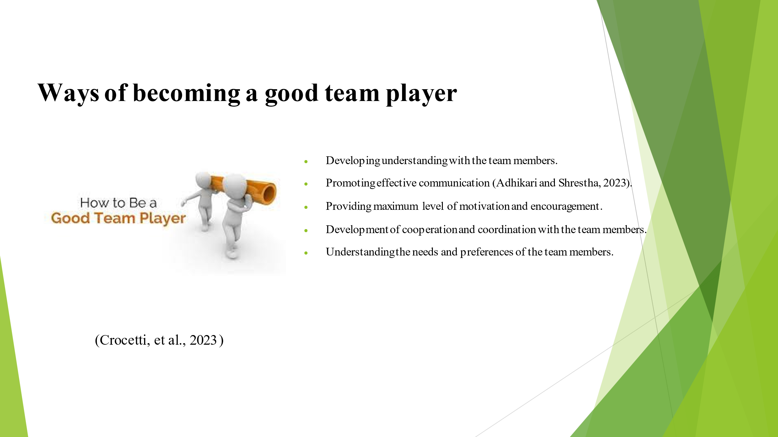The ways of becoming a good team player are developing understanding with the team members, promoting effective communication, providing motivation and encouragement, development of cooperation and coordination and understanding the needs and preferences of the team members.

Conclusion
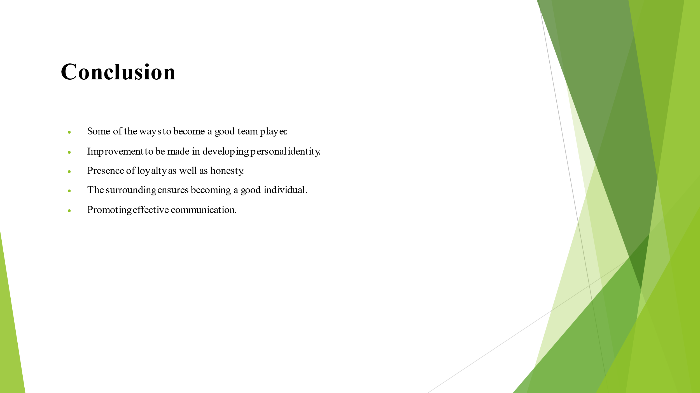A proper connection and communication can be established through the presence of higher Education. This ensures promoting development in personal identity of an individual.
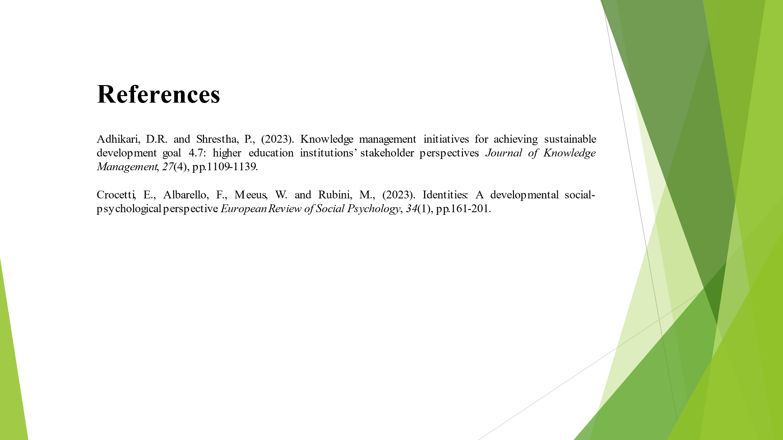

Task 4 – Reflection
Borton’s reflective tool: With the help of the reflective model an effective reflection can be provided regarding the entire learnings gathered from the university as well as the significance of using only resources in the preparation of assignments.
1. What: After joining the universities for higher education I was able to develop a lot of knowledge and idea about my area of discipline (Richards, 2023). The University has provided me an opportunity to learn new things and to promote interaction with my professors. I have been able to develop a new perspective towards higher education after joining the university. However, the university has helped me to determine the various ways in which online resources and online learnings can promote individual development and professional development. The university has played a vital part for me in helping me to determine the process of writing my assignment in order to give in the academics.
2. So What: I have determined that taking admission in the university for pursuing higher education was a significant decision since it will help me to move a step forward towards my career path. I have also identified that I have been able to get introduced to online resources and learnings (Wilkinson, 2023). These are very much important because they help me to gather a lot of knowledge and information which are not easily available in the textbooks. These study materials are very much significant for completing high education with good grades. The process of writing my first assignment was explained to me by my professors. This has helped in enhancing my knowledge about the process of writing.
3. Now What: All the knowledge which I have gathered from the university will be utilised by me in my future activities. I will make sure that all the learnings which I have got it from the university courses are applied by me in my future career path for achievement of my personal goals as well as professional goals (Adhikari and Shrestha, 2023).

Conclusion
Through the report a proper discussion about the Task 1 which is a written summary have been provided. This included an overview of the topic of “Preparing for Higher Education” along with the significance and benefits of Higher education. The Task 2 included preparation of a mind map. In Task 3 a presentation has been prepared. This presentation included an introduction, an overview of personal identity, the role of beliefs, values and place in personal identity, some of the ways of becoming a good team player and an effective conclusion. Task 4 included as reflection by using the Borton’s reflective tool.

Reference list
Adhikari, D.R. and Shrestha, P., (2023). Knowledge management initiatives for achieving sustainable development goal 4.7: higher education institutions’ stakeholder perspectives. Journal of Knowledge Management, 27(4), pp.1109-1139.
Crocetti, E., Albarello, F., Meeus, W. and Rubini, M., (2023). Identities: A developmental social-psychological perspective. European Review of Social Psychology, 34(1), pp.161-201.
Freeman, S., Hagedorn, L.S., Goodchild, L. and Wright, D. eds., (2023). Advancing higher education as a field of study: In quest of doctoral degree guidelines-Commemorating 120 years of excellence. Taylor & Francis.
Gabriel, K.F., (2023). Teaching unprepared students: Strategies for promoting success and retention in higher education. Taylor & Francis.
Neumann, M., Rauschenberger, M. and Schön, E.M., (2023). “We Need To Talk About ChatGPT”: The Future of AI and Higher Education.
Orishev, J. and Achilov, S., (2023). DIGITAL TECHNOLOGIES AS AN EDUCATIONAL PROCESS IN PREPARING FUTURE TEACHERS FOR PROJECT ACTIVITIES. Science and innovation, 2(B3), pp.425-429.
Richards, J.C., (2023). Teacher, learner and student-teacher identity in TESOL. RELC Journal, 54(1), pp.252-266.
Wilkinson, D., (2023). The harm principle, personal identity and identity-relative paternalism. Journal of Medical Ethics, 49(6), pp.393-402.

