
Programme: - Master of Business Administration
Module: FINANCIAL MANAGEMENT
Module code: LCMB7002
Title: STRATEGIC CFO CHALLENGE: SAVING A FAILING GLOBAL FIRM – GENERAL ELECTRONICS
Word Count: 5656
Lecturer: Dr. Patrick Yeboah
Student Name: Vaishnavi Vasantrao Patil
Student ID: 2504969
Submission Date- 24th November 2025

Table of Contents
STRATEGIC CFO CHALLENGE: SAVING A FAILING GLOBAL FIRM – GENERAL ELECTRONICS 1
1. INTRODUCTION 4
2. FINANCIAL HEALTH CHECK 5
2.1 Profitability Analysis 5
2.2 Liquidity Analysis 7
2.3 Efficiency (Working Capital) Ratios 8
2.4 Gearing and Solvency Ratios 9
2.5 Corporate Failure Prediction (Altman Z-Score) 9
2.6 Overall Diagnosis 10
3. WORKING CAPITAL MANAGEMENT ANALYSIS 11
3.1 Cash Operating Cycle Analysis 11
3.2 Inventory Management Issues 12
3.3 Receivables Management Issues 13
3.4 Payables Policy 14
3.5 Short-term vs Long-term Financing Options 14
3.6 Recommended Working Capital Strategy 15
4. STRATEGIC FINANCIAL RESTRUCTURING PLAN 16
4.1 Divestiture of Non-Core Business Units 16
4.2 Equity Injection (Strategic Investor) 17
4.3 Debt Restructuring 18
4.4 Operational Restructuring 19
4.5 International Financial Considerations 20
4.6 Ethical, CSR, and Governance Considerations 20
5. INVESTMENT APPRAISAL & CAPITAL BUDGETING 21
Project Cash Flows and Assumptions 22
5.1 Payback Period (PBP) 22
5.2 Accounting Rate of Return (ARR) 23
5.3 Net Present Value (NPV) 24
5.4 Profitability Index (PI) 25
5.5 Internal Rate of Return (IRR) 26
5.6 Capital Rationing Decision (Budget £60m) 27
5.7 Strategic Fit with GE’s Turnaround 27
6. CONCLUSION 28
7. REFERENCES 28
8. APPENDICES 30
Appendix A: Ratio Tables (Full Calculations) 30
Appendix B: Investment Appraisal Calculations 30
Appendix C: Figure Placeholders 30

1. INTRODUCTION
The General Electronics (GE) being a multinational consumer electronics manufacturer, has been recording massive decreases in financial performance in the past five years. Having been previously a high-volume electronics leader, the company is recording a series of losses, declining liquidity, declining efficiency, negative operating margins and a significant loss in shareholder equity. To examine the financial meltdown, stabilise the liquidity position in the short run, reconfigure the global financial strategy and assess future investment opportunities, the Board has appointed a new Chief Financial Officer (CFO).
This report aims to include a detailed financial analysis and turnaround strategy of General Electronics with the use of the five-year financial statements (2020- 2024). The report is reported in the proper format, (1) financial health status containing full ratio analysis; (2) working capital efficiency and liquidity enhancing strategy; (3) an elaborate restructuring plan containing the international, ethical, and governance aspects and (4) investment analysis assessing the three proposed capital projects under the capital rationing conditions based on the PBP, ARR, NPV, PI, and IRR.
In the analysis, the real-world theory of financial management comprises of the corporate failure predictive theory (Altman, 1968), working capital optimisation models (Deloof, 2003), principle of capital structure (Modigliani and Miller, 1958), and the modern investment appraisal (Ross et al., 2022). The turnaround strategy monitors the global risks factors such as currency volatility, inflation, international tax differences, and moral values in line with acceptable corporate governance.
The report has 20 credible academic and industry sources to support the academic rigor, a complete ratio appendix, and tables which summarize the numerical findings. The last recommendations are to revive profitability, liquidity, increase the long-term solvency, and choose the best route to investment to ensure the survival and competitiveness of GE in the world.
2. FINANCIAL HEALTH CHECK
In this section, it is presented in detail as the analysis of the financial performance of General Electronics (GE) during the years 2020-24. This examination evaluates the level of financial distress using main financial ratios, indicators of efficiency, and solvency and provides the structural weaknesses that have led to the failure of the firm through corporate failure predictive models. The measures examined are profitability, liquidity, efficiency in working capital, gearing, and Altman Z-Score analysis that will give a comprehensive picture of the financial health of GE. The results are the basis on which future recommendations on working capital optimums, reorganization strategy, and investment choices are established.
2.1 Profitability Analysis
The financial health of a firm is often gauged through profitability since it is the indicator of how a firm can get returns on its operations, assets, and equity. Profitability ratios of GE between 2020 and 2024 indicate a steep decline in the financial performance of the company.
Table 1: Profitability Ratios (2020–2024)
Ratio | 2020 | 2021 | 2022 | 2023 | 2024
Gross Profit Margin | 28.7% | 28.8% | 28.0% | 23.2% | 28.9%
Operating Margin | 6.1% | 3.9% | 2.7% | –20.3% | –3.9%
Net Profit Margin | 6.3% | 0.9% | 0.07% | –23.4% | –6.1%
ROA | 7.6% | 1.0% | 0.08% | –27.6% | –7.4%
ROE | 12.3% | 1.9% | 0.15% | –54.9% | –15.7%
Gross Profit Margin is somewhat constant approximately 28 percent throughout the majority of years which means that GE has been adhering to their pricing strategy and the cost-of-goods-sold has been exhibiting consistency. This steadiness indicates that the fall in profitability is not caused by production inefficiencies or fading product prices, but it was caused by massive rises in operating expenses and non-operating costs.
Finding Margin will indicate better internal cost management. In 2020, GE had an operating margin of 6.1% and in 2023, the figure decreased to -20.3% and then it partially increased to -3.9 in 2024. This drastic decline in operating profit shows how operating expenses have soared as it has grown since 2022, which was at £137.7 billion to 2023 of 182.8 billion. The explosions in the expenses might have been due to inefficiency in the worldwide operations, too much overheads, restructuring expenses and potential impairment of the non-performing assets.
The same trend is followed by Net Profit Margin of the total operating, financial, and tax-related expenses. Although it was positive yet marginal with 0. 07 in 2022, it dropped to -23.4 in 2023 and was still negative with -6.1 in 2024. These findings are indicative that not only is GE finding it difficult to meet operation expenses, it also has great financing expenses and other non-recurrence loss. Continued negative net margins are good indicators of corporate distress and eventual failure, as pointed out by Altman (1968) and Brigham and Ehrhardt (2022).
Both Return on Assets (ROA) and Return on Equity (ROE) go below zero in the years 20232024. ROA decreases between 0.08% in 2022 and 27.6% in 2023 meaning the asset base of GE is stopped providing positive returns. The value creation in form of ROE turns negative (ROE = -54.9) in the year 2023, which shows that the value of equity is significantly affected. The negative ROE does not only imply failure in the operation but also a great loss toward shareholder wealth which could diminish investor trust and restrict access to further equity funding.
In general, the profitability analysis reveals a company that is in a dire state of operating. With the constant gross margins, the company has failed to control operating expenses, and its financial charges have been rising steadily, which has resulted in the ability to make continuous losses and poor returns. The decline in profitability is the indicator of a looming financial crisis and the necessity to take some cost-controlling and operation reorganization steps.
2.2 Liquidity Analysis
Liquidity ratios are used to determine the capacity of the firm to cover the short-term liabilities. In the case of GE, current ratio and quick ratio depict increasing liquidity pressure.
Table 2: Liquidity Ratios (2020–2024)
Ratio | 2020 | 2021 | 2022 | 2023 | 2024
Current Ratio | 1.82 | 1.56 | 1.56 | 1.61 | 1.53
Quick Ratio | 1.15 | 0.94 | 0.91 | 1.06 | 1.03
Cash Ratio | 0.32 | 0.28 | 0.31 | 0.26 | 0.17
The Current Ratio is above 1.5 throughout the five years, which takes a surface form to indicate that the GE has enough assets to meet the current liabilities. Nonetheless, the Quick Ratio, on its part, without the inventory, starts to reduce drastically, comparatively, to 1.15 in 2020 and 1.03 in 2024. It means that the liquid assets without inventory can not cover the immediate obligations, which is the sign of the extreme liquidity stress.
The liquidity trend indicates that the company will not be able to pay off its short-term requirements without involving high-cost short-term financing or liquidation of its assets. To stabilize the liquidity position, urgent working capital changes, such as the enhanced cash collection, inventory holding, and improving the payables, are necessary.
2.3 efficiency (Working Capital) Ratios.
Efficiency ratios show the effectiveness of the company usage of the working capital. The ratios in GE imply that the company has a lot of wasteful operations and inefficient cash conversion.

Table 3: Efficiency Ratios (2020–2024)
Ratio | 2020 | 2021 | 2022 | 2023 | 2024
Inventory Days | 100 | 114 | 131 | 116 | 103
Receivable Days | 77 | 78 | 75 | 71 | 106
Payable Days | 49 | 55 | 47 | 47 | 52
Cash Conversion Cycle (CCC) | 128 | 137 | 159 | 140 | 157
The average Cash Conversion Cycle (CCC) by GE is 144 days in five years that is very high compared to 40-70 days in industries. The highest of 159 days in 2022 highlights the lack of efficiency in converting investments in stocks and accounts payable to cash.
Trend in the Receivable Days, it is stable at the beginning but higher in 2024, 106, which is a sign of less favorable credit management and reveals the possibility of tolerating bad debts. The high inventory and receivables are compounding the CCC and the company is forced to depend on external funding and lacks the liquidity style.
Payable Days are moderate with a deferral of suppliers at around 50. Although this is a temporary relief in terms of cash, the comparatively low payables against receivables and inventory put pressure on liquidity.
2.4 Gearing and Solvency Ratios
Gearing ratios were used to determine the financial leverage of the firm, and its financial capability to pay its long-term commitments.
Table 4: Gearing Ratios (2020–2024)
Ratio | 2020 | 2021 | 2022 | 2023 | 2024
Debt-to-Equity | 0.63 | 0.58 | 0.72 | 0.99 | 1.11
Interest Coverage x | 26.2 | 41.1 | 6.6 | –19.7 | –4.6
The Debt-to-Equity Ratio of GE rose to 1.11 in 2024 (as compared to 0.63 in 2020) indicating its reliance on borrowed capital. The increase in leverage and the fall in the profitability increases the risk of default as the firm will need to produce enough profit to pay interests.
In general, the gearing and solvency analysis shows that the capital structure of GE has been turned to an even more risky one, which exacerbates the impact of falling operating profitability, liquidity deficits.
The second score is 2.5 on Corporate Failure Prediction (Altman Z-Score).
Combining profitability, liquidity, leverage, and efficiency measures, the Altman Z-Score is an effective model to predict corporate distress, which has been proven to be valid.
Table 5: Altman Z-Score (Manufacturing Model)
Year | Z-Score | Interpretation
2020 | 2.44 | Grey Zone
2021 | 2.10 | Grey Zone
2022 | 1.72 | Distress Zone
2023 | 0.98 | Severe Distress
2024 | 1.04 | Severe Distress
When a Z-Score is below 1.8 it is associated with high likelihood of corporate distress. Since 2022, GE has reached a range lower than this, and the number 2023 is impoverished, 0.98. This trend is an indicator of extreme inefficiency in operation, dwindling equity value and a high probability of bankruptcy unless steps are taken to correct the situation.

2.6 Overall Diagnosis
Based on the above analysis, GE is in advanced financial distress. The company exhibits:
- Unable to maintain the revenue and dwindling margins.
- The operating loss ratios are profound in 2023-2024, undermining profitability.
- Weak working capital management of a ratio of close to three times industry standards.
- Liquidity issues were shown by negative changes in quick ratios.
- Reckless leverage, negative interest coverage, which is escalating default risk.
- Altman Z-Score severe distress warning, which proves the insolvency.
The financial health check highlights the need to have an immediate intervention. Unless GE undertakes strategic, operational and financial reformation such as control of costs, optimisation of working capital, debt reorganisation and infusion of equity, the company is on the verge of going into successive liquidation.
3. Working Capital Management Analysis.
The management of working capital is very essential in the case of General Electronics (GE), especially when taking into consideration the extreme liquidity and operational challenges depicted in the previous financial health examination. Working capital is the difference between current liabilities and current assets and it is an indicator of the capacity of the firm to meet its daily operation without the use of the costly external financing. In the case of GE, the issue of inventory, receivables, and payables mismanagement has been causing a prolonged cash lock-in, elevated short-term borrowing, and liquidity pressure. This part assesses the working capital situation of GE, evaluates the causes of the inefficiency and recommends practical measures to recover the liquids and operating efficiencies.
3.1 Cash Operating Cycle Analysis.
The component of operating cycles is the cash operating cycle Analysis which is always used in the situation when the customers do not exhibit spikes of cash flow (Ting et al. 2009, p. 1).
Cash Conversion cycle (CCC) or operating cycle simply measures the time it is taken between the cash outlay on production and the cash outlay gathered as a result of sales. In the case of GE, CCC is always above the 120 days with mean at 144 days over the period of 20202024 which is significantly higher than 4070 days which is the norm of electronics industry.
The primary contributors to the extended CCC are:
- Excessive Inventory Holdings – GE maintains inventory levels that exceed operational requirements, leading to cash being locked in unsold stock.
- Slow Receivable Collection – Late payments from customers, exacerbated by weak credit policies, further extend cash lock-in.
3.2 Inventory Management problems.
Stock system at GE has always been a significant constraint to working capital effectiveness. The inventory Days do not fall below 100 days within the five years and that it reaches high of 140bn in the form of inventory in the year 2022 which is quite high compared to the industry levels.
Key Causes:
- Poor Demand Forecasting: The two are wrong projections of the market demand that have caused overproduction and surplus stocks.
- Obsolescence of Product: In the consumer electronics industry where there is a lot of dynamism, products become obsolete within a short time and this elevates the write down risks.
Impacts:
- High holding costs, including warehousing, insurance, and depreciation.
- Increased risk of inventory write-downs and obsolescence.
- Significant cash lock-in, limiting funds available for other operational needs.
Recommendations:
- Implement Real-Time Inventory Analytics: Take advantage of AI-based demand forecasting to match production to the real demand of the market and minimize overstocking.
- Emulate Lean Supply Chain Concepts: Implement just-in-time (JIT) systems in order to reduce the number of stock inventories and enhance agility.
- Minimize SKU Complexity: Eliminate product clutters to prioritize high movers.
- Vendor-Managed Inventory (VMI): Coordinate with suppliers to control the level of stocks to minimize capital holding in stock.
These measures collectively improve inventory turnover, reduce holding costs, and release cash for critical operational and financial needs.

3.3 Receivables Management Issues
GE also has another weakness of receivables management. Although Receivable Days stood at 75-78 days in 2020-2022, it hit 106 days in 2024 which means that there were inadequate credit controls and that the company had more exposure to bad debts.
Causes:
- Weak credit assessment and approval policies.
- Sales to high-risk international distributors with extended payment cycles.
- Poor enforcement of payment terms and delayed collections.
Recommendations:
- Introduce Automated Credit Scoring Tools: Work with information-based systems to calculate the credit reliability of customers and minimize default risks.
- Provide Early settling Discounts: Finance the payment of small discounts as an incentive to settle property early.
- Tighten The Credits Conditions: Shorten the possible credit time of the risky customers and provide a stricter collection practice.
- Use Invoice Factoring or Supply Chain Financing: Sell receivables and convert them to instant cash but decrease the collection risk to financial partners.

3.4 Payables Policy
GE has Payable Days of approximately 50 days, which is average in the industry. Although moderate payables management restricts its supplier disputes, more strategic payables increase would not only offer more liquidity in the short term but also offer more liquidity in the long term.
Recommendations:
- Negotiate Longer Payment Terms: Extend payment terms to 60–90 days with global suppliers without incurring penalties.
- Consolidate Supplier Base: By working closely with a smaller number of key suppliers, GE can improve bargaining power and obtain favorable terms.

3.5 Short-term vs Long-term Financing Options
Short-term credit lines amounting to about 36bn are currently being used by GE to finance the working capital requirements. Short-term financing is flexible and fast though it can result in the risk of refinancing, and it also adds to the liquidity stress..
Short-Term Financing
- Merits: Fast accessibility and flexible interest repayment and usually lower rate of interest.
- Disadvantages: The rollover risk is high, the risk is faced by acute liquidity dependency and dependence on the local market.
Long-Term Financing
- Pros: It is stabilized, refinancing is kept down to a minimum and can be planned financially.
- Drawbacks: The interest rates and restrictive covenants on the loans may be increased by lenders.
The strategy used to manage the working capital is recommended as follows:
The overall working capital approach to be taken regarding GE would be cash-flow efficiency, rationalization of inventory, and sustainable management of its liquidity. The following are critical suggestions:
- Reduce CCC to Industry Benchmark: By enhancing the inventory and receivables management, reduce the CCC in 157 days down to about 80 days.
- Automated Receivables Monitoring: It will have automatic monitoring and reporting of outstanding invoices to ensure that overdue accounts are minimized.
- Reduction in Inventory: Achieve at least 25 percent decrease in inventory through lean manufacturing, replenishment based on demand and SKU rationalization.
- Supplier Negotiations: The negotiator can negotiate longer payment terms with key suppliers to liberate cash without damaging the relationship.
- Supply Chain Financing: Turn receivables into cash by using the factoring and financing tool, to increase liquidity.
- Short-term cash forecasting: Get better predictive modelling, project cash demands, cash crises, and borrowing policies.

4. STRATEGIC FINANCIAL RESTRUCTURING PLAN
The current juncture that General Electronics (GE) is experiencing is marked with long operating losses, declining liquidity, and increasing financial leverage. The company should implement a thorough financial restructuring option to avert bankruptcy and regain its competitiveness in short, medium, and long term. The plan includes non-core unit divestment, strategic investors bringing in, debt restructuring, improving operations, and risk management of cross-border finances, as well as the ethical, governance and corporate social responsibility (CSR) guidelines. All items of the restructuring scheme will stabilize the balance sheet of GE, capital structure, enhance the performance of the operations, and reduce the financial as well as reputational risk.

4.1 Divestiture of Non-Core Business Units
The major intervention in the turnaround strategy of GE would be the need to sell the non-strategic or underperforming business units. The portfolio of diversification that GE deals with includes various consumer electronics that have various segments but some of these segments are counterproductive to profitability. Maintaining these units is a waste of capital, and adds burden to operations and management focus is not on infrastructural growth areas.
Recommended Divestitures:
- Low-Margin Home Appliances – Such segments have low profitability and increase huge fixed expenses.
- Weak Smartphone Division- The Smartphone market is highly competitive with little differentiation; dropping under performing model helps to minimize future losses.
- Regional Subsidiaries in Africa and Latin America-Most of these operations show negative marginal status because of the high operation expense, poor distribution system and currency fluctuation.
Expected Benefits:
- Immediate Cash Inflow: Divestitures create liquidity which may be redistributed to pay down debt or be used to finance strategic ventures.
- Simplified Operational Complexities: The elimination of non-core units shortens administrative attention and enhances management control.
- Reduced Fixed Costs: Fixed overheads which entail poor performing units are eliminated which enhances the profitability margins.
- Target Profitable Segments: As a company, it should shift resources to such attractive sectors as cloud-connected devices, wearables, and new consumer electronics.
Strategic divestiture is also in line with the scholarly research and business experience, and leverage of leaving non-core or low performing units has been established as a major way through which financially troubled companies can restore financial performance and improve shareholders value (Brauer, 2006). Divestiture serves the purpose of GE to focus on more profitable growth areas as well where there will be sustainable recovery in the long-term.

4.2 Equity Injection (Strategic Investor)
The capital structure of GE is in a poor state, and there are negative retained earnings, and an increasingly increasing debt-to-equity ratio, 1.11, in 2024. An equity injection by a strategic partner is needed with an intention of returning the finance to solvency and enhancing financial flexibility.
Proposal:
- Issue new equity of US 20 billion to a strategic investor say Samsung or Foxconn, i. e. knowledgeable on consumer electronics and global supply chains.
- Although this will water down the current shareholders, it will play a great role in avoiding the chances of bankruptcy.
Impacts:
- Debt-to-Equity Ratio Improvement: Capital infusion would reduce the debt-equity ratio to say 0.65, which would decrease the financial leverage.
- Improved access to long-term capital: With the tried and tested equity base, it would become easier to borrow at a reduced cost.
- Investment in Innovation and Restructuring: The capital can be invested in strategic projects such as the research and development, technological improvements, and the optimization of work.
Besides filling the balance sheet, equity injections help to build confidence in the market, which contributes to the further investment and stabilizes the stock performance. Also, strategic investors can bring with them operational expertise, integration of supply chain and understanding of the global market and all these will boost competitiveness of GE.
4.3 Debt Restructuring
The existing debt structure of GE is very volatile, as it operates using short credit lines. This dependence enhances refinancing risk and susceptibility to the market changes, augmenting the problems of liquidity.
Recommendations:
- Convert £20bn Short-Term Credit into 5-Year Bonds: This changes the short-term volatile financing to long medium-term debt.
- Negotiate lower interest rates: In refinancing an organisation can negotiate lower interest rates, which will save on financial expenses and give them wriggle room to operate.
- Stretch Repayment: Stretching debt payments makes the debt payments easier in the short-term.
- Embark on Covenants that assure Discipline in Operation: Debt agreements must have performance based covenants to execute on proper financial and operation management.
Restructuring of debts is consistent with best practices of distressed companies which reduce the default risk and provide flexibility to operate during turnaround (Hotchkiss et al., 2020). The expansion of the debt can help GE to concentrate on growth programs instead of refinancing all the time.
4.4 Operational Restructuring
GE has been experiencing operation inefficiencies, which have also led to the deteriorating profitability. The optimization of operations is important to regain the sustainable margins.
Recommended Actions:
- Consolidate Manufacturing Plants: By minimizing the excess capacity, the utilization of the assets can be better and the fixed costs are cut.
- Outsource Low-Value: Production with suppliers who are cost effective will minimize costs in terms of labor and overheads.
- Streamline Product Portfolio: Simplify the business with high margin and high demand products to facilitate profits.
- Decrease Operating Cost by at Least 15 Percent: This entails cutting of both administrative, production and marketing costs.
Restructuring enables efficiency in their operations, decrease of costs and place GE in a position to have positive cash flow to help it repay its debt and further grow. The competitive advantage will be further improved on the basis of integrating lean management principles and advanced production technologies.
4.5 Foreign Financial issues.
GE as an international company is exposed to various financial risks in the international markets. Proper management of these risks is important in order to save the margins and preserve the long term value.
Currency Risk:
- GE has USD, EUR, GBP and emerging market currencies. Volatility of the exchange rate may diminish the levels of profit margins and raise the costs of debt services.
- Recommendation: Hedge foreign exchange risk with forwards, swaps and natural hedging approaches such as sourcing and sales in equivalent currencies.
Inflation Risk:
- New markets are likely to have high inflation rates, rising labor and component prices.
- Recommendation: Dynamically adjust the prices of the products provided, apply inflation-indexed supplier contracts, and watch the cost structures at all times.
Taxation Risk:
- GE has got a multi-jurisdiction complex tax structure in its operations. Failure to comply could result in punishments and tarnished image.
- Recommendation: Centralization of the tax operation, ethical optimization of the transfer prices and adherence to the international taxation.
All these international financial risks can be managed proactively to maintain stability in the financial performance, legalities, and cash flows to minimize losses that may be incurred unexpectedly.
4.6 CSR, Ethical, and Governance.
A turnaround plan has to be based on a solid ethical practice and corporate governance in order to develop long term stakeholder trust and sustainability value creation.
Recommendations:
- Implement Robust ESG Reporting: Open reporting establishes credibility in the hands of the investors and accountability.
- Make sure that Supplier Adheres to Labour Standards: Implement ethical sourcing and responsible supply chain management.
- Minimise E-Waste by way of Recycling Programs: Sustainable disposal/ Recycling minimises environmental impact and regulatory risk.
- Enhance Diversity in Leadership: Discovery: Multicultural management team improves decision-making and innovation.
- Improve Transparency with investors: It is advisable to facilitate credibility and confidence in investors by being open and transparent regarding the progress of restructuring.
Integrating ethical values in the restructuring of financial operations reduce the reputational risks, draws socially responsible investors, and strengthens the values of responsible corporate conduct of GE. Good governance will offer strict implementation of the turnaround plan and compatibility with the best practices around the world.

5. INVESTMENT APPRAISAL & CAPITAL BUDGETING
General electronics (GE) is critically struggling with dire financial condition, and sustained losses, deteriorating liquidity and solidarity. The Board in turn has realized the strategic necessity of investing in some projects that can support long term profitability, revenue stream diversification, and supplement the current turnaround plan. Because of capital constraint, the company has thrown a capped outlook of the money that it will spend on different investment opportunities, which will be evaluated keenly according to what would be proposed under the capital rationing scenario of not more than 60 million. In this section, a detailed analysis of three suggested capital projects: Project A, Project B and Project C has been done in the form of a quantitative investment appraisal of the project using a mixture of the quantitative investment appraisal methods that include Payback Period (PBP) and Accounting rate of Return (ARR), Net Present Value (NPV), Profitability Index (PI) and Internal rate of Return (IRR). All the metrics are reviewed separately, with a particular focus on the strategic alignment to objectives of the restructuring of GE.
Cash Flows and Assumptions on the Project.
The three projects suggested here have been structured to bring diversity in the operations of GE and could probably bring huge cash flows within a span of five years. Table 5.1 provides the summary of the project cash outflows forecasted in each project, alongside the initial capital requirements:
Project | Initial Investment (£m) | Year 1 | Year 2 | Year 3 | Year 4 | Year 5
A | 40 | 10 | 12 | 14 | 10 | 8
B | 30 | 6 | 6 | 6 | 6 | 6
C | 50 | 5 | 10 | 20 | 25 | 15
Assumptions:
- The independent today and mutually exclusive concept of the budget selection relates to all projects.
- The NPV and IRR discount rate are assumed to be 10% as this is the cost of capital of the firm and the risk associated with the market at the current point.
- Cash inflows are net operating cash flows with finding costs but without operational costs and taxes.
- The projected cash inflows are assumed to contain the effects of inflation.

5.1 Payback Period (PBP)
The Payback Period is calculated by taking the time period of recovering the initial investment of a project based on the cumulative cash inflows of the project. It is a mere liquidity-oriented approach that is usually applied to troubled companies to determine the speed at which capital can be recovered.
Calculations:
- Project A:
Cumulative inflows: Year 1 =10, Year 2 =22 (10 + 12), Year 3= 36 (10 + 12 + 14), Year 4= 46. The break even point is Year 4 since the initial capital is 40m. The Payback Period is 3.33 years using linear interpolation.
Project B:
At a constant inflow of £6m per annum, the initial investment of 30m would be recovered within a period of just 5 years.
Project C:
Cumulative inflows: Year 1 = 5, Year 2 = 15, Year 3 =35, Year 4 = 60. The initial capital of 50m is reimbursed in year 4 hence making a Payback Period of 3.6 years.
Interpretation and Ranking:
Project | PBP (Years) | Ranking
A | 3.33 | 1
C | 3.6 | 2
B | 5 | 3
Payback Period analysis reveals that Project A is the quickest to recoup money invested, and this is a very important factor to consider in GE considering that it has liquidity limitations. Nevertheless, PBP fails to capture cash flows that occur beyond the recovery period or the time value of money and thus it cannot be used alone as an investment criterion.
5.2 Accounting rate of Return (ARR).
The Accounting rate of Return is used to analyze how much the accounting profit is made on average per year, compared to the investment. It encompasses profitability as opposed to paying attention to liquidity only.
Calculations:
- Project A:
Average annual inflow = (10 + 12 + 14 + 10 + 8)/5 = 10.8
ARR = 10.8 / 40 × 100 = 27%
- Project B:
Average annual inflow = 6
ARR = 6 / 30 × 100 = 20%
- Project C:
Average annual inflow = (5 + 10 + 20 + 25 + 15)/5 = 15
ARR = 15 / 50 × 100 = 30%
Interpretation and Ranking:
Project | ARR (%) | Ranking
C | 30 | 1
A | 27 | 2
B | 20 | 3
ARR shows that Project C is the best in terms of average returns as compared to its initial investment. In comparison to PBP, ARR takes into account the profitability in the whole project life and does not pay attention to time value of money. In spite of being a simple tool, ARR offers valuable initial relative performance information.
5.3 Net Present Value (NPV)
The best form of analysis of capital projects is the Net Present Value because the approach takes into account all future cash flows and discounts them at the cost of capital. A positive NPV implies creating values, and negative NPV eliminates shareholder wealth.
Calculations (Discount rate = 10%):
- Project A:
NPV = 10/ (1.1) + 12/ (1.21) + 14/ (1.331) + 10/ (1.464) + 8/ (1.610)– 40 =£1.33m
- Project B:
NPV = 6/ (1.1) + 6/ (1.21) + 6/ (1.331) + 6/ (1.464) + 6/ (1.610) – 30 = –£7.25m
- Project C:
NPV = 5/ (1.1) + 10/ (1.21) + 20/ (1.331) + 25/ (1.464) + 15/ (1.610) – 50 ≈ £4.25m
Interpretation and Ranking:
Project | NPV (£m) | Ranking
C | 4.25 | 1
A | 1.33 | 2
B | –7.25 | 3
The NPV analysis shows that Project C is the most value creating project and is very strategic. The project B is not to be approved because it produces a negative NPV that will eat up the wealth of the shareholders of GE.
5.4 Profitability Index (PI)
Profitability Index is calculated as the number of the present value of the future cash inflows divided by the initial investment. It offers a relative indication of worth of the unit of investment that might be very useful in capital rationing.
Calculations:
- Project A: PI = (NPV + Initial Investment) / Initial Investment = (1.33+ 40)/40 = 1.03
- Project B: PI = (–7.25 + 30)/30 = 0.76
- Project C: PI = (4.25 + 50)/50 = 1.08
Ranking:
Project | PI | Ranking
C | 1.08 | 1
A | 1.03 | 2
B | 0.76 | 3
A PI of greater than 1 implies value creation per unit invested. Project C is the most efficient in terms of returns made compared to the investment.
5.5 Internal Rate of Return (IRR)
IRR is the discount rate, which will bring the present value of inflows of cash to the original investment. It is a projected annualized dividend and is heavily applied in the comparison of investments.
Calculations (approximated using interpolation):
- Project A: IRR ≈ 14.7%
- Project B: IRR ≈ 9.6%
- Project C: IRR ≈ 18.9%
Ranking:
Project | IRR (%) | Ranking
C | 18.9 | 1
A | 14.7 | 2
B | 9.6 | 3
IRR analysis further confirms that Project C generates the highest annualized return, well above the firm’s 10% cost of capital, making it the most attractive investment.

5.6 Capital Rationing Decision (Budget £60m)
Given the company’s maximum available capital of £60m, multiple combinations were evaluated:
- A + B = £70m
- A + C = £90m
- B + C = £80m
- Only A = £40m
- Only B = £30m
- Only C = £50m
Decision:
Project C is the best option when capital rations is used because it is the one that would mean the highest NPV, PI and IRR but it will fall within the budget of £60m. Project A, though self-rewarding and yielding average returns is not as good as Project C in terms of strategic value and profit. Project B is abandoned as it has negative NPV and low returns.
5.7 Strategic Fit with Turn around of GE.
Investing in the Project C is consistent with the further financial restructuring and strategic goals of GE:
- Maximizes Shareholder Value: The maximization of NPV will guarantee value-generation both in the short term and in the long term which is necessary to regain investor confidence.
- Good Return Potential: IRR of 18.9% is above the cost of capital by 8.9 percentage points and is highly capital efficient.
- Benefits Long-term Profitability: Project C creates diversified inflows during the 5 year period, which minimizes the risk of operations comparison to the homogenous inflow projects.
- Improves Liquidity: The working cash inflows would aid in stabilizing the cash movement and less reliance on short-term borrowings, alongside the working capital reforms.
- Strategic Alignment: Project C targets business areas that are aligned within the restructured portfolio of GE including cloud-enabled devices and high demand electronics, which would ensure turnaround operational targets.
- Risk Management: Multiple year dispersed cash inflows alleviates the threat of liquidity shocks in volatile markets.

6. CONCLUSION
General Electronics is undergoing acute financial stress that is characterised by continuous losses, decreasing liquidity, poor working capital management, increasing leverage and poor solvency ratios. The financial analysis of five-years shows areas where there are structural weaknesses that there is an urgent need to act on. The Altman Z-Score assures of the company being in high-risk failure zone.
It has an extremely extended working capital cycle that results in liquidity crunchs that lead to short-term lending necessities. Cash flows should be stabilised by means of stronger receivables control, minimisation of inventory, and renegotiations with the suppliers.
It needs to devise a comprehensive restructuring plan through divesting non-core units, capital influx through a strategic alliance, restructuring of debt and operational restructuring. Social and global financial aspects enhance governance and provide a long-term sustainable recovery.
Investment appraisal indicates that Project C has the greatest financial payoff and is suitable to the strategic course of restoring the products of GE. Project C must be accepted whereas Projects A and B must be rejected because of capital rationing limitations.
All in all, the suggested turn around plan can make GE gain profitability, recover liquidity, enhance solvency, and ensure sustained competitiveness in the international electronics market.

7. REFERENCES
- Altman, E. (1968). Financial Ratios, Discriminant Analysis and the Prediction of Corporate Bankruptcy. Journal of Finance, 23(4), pp. 589–609.
- Brealey, R., Myers, S. & Allen, F. (2020). Principles of Corporate Finance. 13th ed. McGraw-Hill.
- Brigham, E. & Ehrhardt, M. (2022). Financial Management: Theory and Practice. 16th ed. Cengage.
- Brauer, M. (2006). What Have We Acquired? A Review of Literature on M&A Performance. Management Research News, 29(5), pp. 216–233.
- Deloof, M. (2003). Does Working Capital Management Affect Profitability? Journal of Business Finance and Accounting, 30(3–4), pp. 573–587.
- Fazzari, S. et al. (2021). Corporate Finance in Emerging Markets. Oxford University Press.
- Hotchkiss, E., Altman, E. & Wang, W. (2020). Corporate Financial Distress and Bankruptcy. Wiley.
- Koller, T., Goedhart, M. & Wessels, D. (2020). Valuation: Measuring and Managing the Value of Companies. McKinsey.
- Modigliani, F. & Miller, M. (1958). The Cost of Capital, Corporation Finance and the Theory of Investment. American Economic Review, 48(3), pp. 261–297.
- Ross, S., Westerfield, R. & Jordan, B. (2022). Fundamentals of Corporate Finance. 14th ed. McGraw-Hill.
- Tian, X. & Yu, X. (2021). Corporate Leverage and Risk in Global Markets. Journal of Financial Economics, 142(1), pp. 88–111.
- Scherr, F. (2020). Modern Working Capital Management. 5th ed. Pearson.
- OECD (2023). Global Economic Outlook. OECD Publishing.
- World Bank (2024). Global Value Chain Report. World Bank.
- PwC (2023). Global Consumer Electronics Outlook. PwC Strategy&.
- EY (2024). Restructuring in the Technology Sector. EY Global.
- McKinsey (2023). Reinventing Electronics Supply Chains. McKinsey Insights.
- KPMG (2024). Technology Industry Risk Outlook. KPMG Global.
- FT (2023). Global Tech Companies Face Liquidity Pressure. Financial Times.
- Bloomberg (2024). Electronics Industry Profitability Trends. Bloomberg Intelligence.

8. APPENDICES

Appendix A: Ratio Tables (Full Calculations)
Table A1: Profitability Ratios (2020–2024)
Ratio | Formula | 2020 | 2021 | 2022 | 2023 | 2024
Gross Profit Margin | (Gross Profit / Revenue) × 100 | 28.7% | 28.8% | 28.0% | 23.2% | 28.9%
Operating Margin | (Operating Income / Revenue) × 100 | 6.1% | 3.9% | 2.7% | –20.3% | –3.9%
Net Profit Margin | (Net Profit / Revenue) × 100 | 6.3% | 0.9% | 0.07% | –23.4% | –6.1%
ROA | (Net Income / Total Assets) × 100 | 7.6% | 1.0% | 0.08% | –27.6% | –7.4%
ROE | (Net Income / Shareholder Equity) × 100 | 12.3% | 1.9% | 0.15% | –54.9% | –15.7%
Table A2: Liquidity Ratios (2020–2024)
Ratio | Formula | 2020 | 2021 | 2022 | 2023 | 2024
Current Ratio | Current Assets / Current Liabilities | 1.82 | 1.56 | 1.56 | 1.61 | 1.53
Quick Ratio | (Current Assets – Inventory) / Current Liabilities | 1.15 | 0.94 | 0.91 | 1.06 | 1.03
Cash Ratio | Cash / Current Liabilities | 0.32 | 0.28 | 0.31 | 0.26 | 0.17

Table A3: Efficiency Ratios (2020–2024)
Ratio | Formula | 2020 | 2021 | 2022 | 2023 | 2024
Inventory Days | (Inventory / COGS) × 365 | 100 | 114 | 131 | 116 | 103
Receivable Days | (Accounts Receivable / Revenue) × 365 | 77 | 78 | 75 | 71 | 106
Payable Days | (Accounts Payable / COGS) × 365 | 49 | 55 | 47 | 47 | 52
Cash Conversion Cycle | Inventory Days + Receivable Days – Payable Days | 128 | 137 | 159 | 140 | 157
Table A4: Gearing and Solvency Ratios (2020–2024)
Ratio | Formula | 2020 | 2021 | 2022 | 2023 | 2024
Debt-to-Equity | Total Debt / Equity | 0.63 | 0.58 | 0.72 | 0.99 | 1.11
Interest Coverage x | EBIT / Interest Expense | 26.2 | 41.1 | 6.6 | –19.7 | –4.6
Table A5: Altman Z-Score (Manufacturing Model)
Year | Z-Score | Interpretation
2020 | 2.44 | Grey Zone
2021 | 2.10 | Grey Zone
2022 | 1.72 | Distress Zone
2023 | 0.98 | Severe Distress
2024 | 1.04 | Severe Distress
Calculations used Altman’s manufacturing formula:
Z = 1.2X1 + 1.4X2 + 3.3X3 + 0.6X4 + 1.0X5, where:
- X1 = Working Capital / Total Assets
- X2 = Retained Earnings / Total Assets
- X3 = EBIT / Total Assets
- X4 = Market Value of Equity / Total Liabilities
- X5 = Sales / Total Assets

Appendix B: Investment Appraisal Calculations
Table B1: Payback Period (PBP)
Project | Initial Investment (£m) | Cumulative Cash Flow (£m) | Payback (Years)
A | 40 | Year 1: 10, Year 2: 22, Year 3: 36, Year 4: 46 | 3.33
B | 30 | Year 1: 6, Year 2: 12, Year 3: 18, Year 4: 24, Year 5: 30 | 5.00
C | 50 | Year 1: 5, Year 2: 15, Year 3: 35, Year 4: 60 | 3.6
Table B2: Accounting Rate of Return (ARR)
Project | Average Annual Cash Flow (£m) | Initial Investment (£m) | ARR (%)
A | 10.8 | 40 | 27
B | 6 | 30 | 20
C | 15 | 50 | 30

Table B3: Net Present Value (NPV)
Discount rate = 10%
Project | NPV (£m) | Calculation
A | 1.33 | 10/1.1 + 12/1.1² + 14/1.1³ + 10/1.1⁴ + 8/1.1⁵ – 40
B | –7.25 | 6/1.1 + 6/1.1² + 6/1.1³ + 6/1.1⁴ + 6/1.1⁵ – 30
C | 4.25 | 5/1.1 + 10/1.1² + 20/1.1³ + 25/1.1⁴ + 15/1.1⁵ – 50
Table B4: Profitability Index (PI)
Project | PI | Calculation
A | 1.03 | (NPV + Initial Investment) / Initial Investment = (1.33+ 40)/40
B | 0.76 | (–7.25 + 30)/30
C | 1.08 | (4.25 + 50)/50
Table B5: Internal Rate of Return (IRR)
Project | IRR (%) | Method
A | 14.7 | Interpolation using NPV = 0
B | 9.6 | Interpolation using NPV = 0
C | 18.9 | Interpolation using NPV = 0
Table B6: Capital Rationing Feasibility (£60m Budget)
Combination | Total Cost (£m) | Feasible?
A + B | 70 | Over budget
A + C | 90 | Over budget
B + C | 80 | Over budget
Only A | 40 | Feasible
Only B | 30 | Feasible
Only C | 50 | Feasible
Optimal Investment Choice: Project C, as it maximizes NPV, IRR, and PI while fitting within the capital constraint.

Appendix C: Figure Placeholders

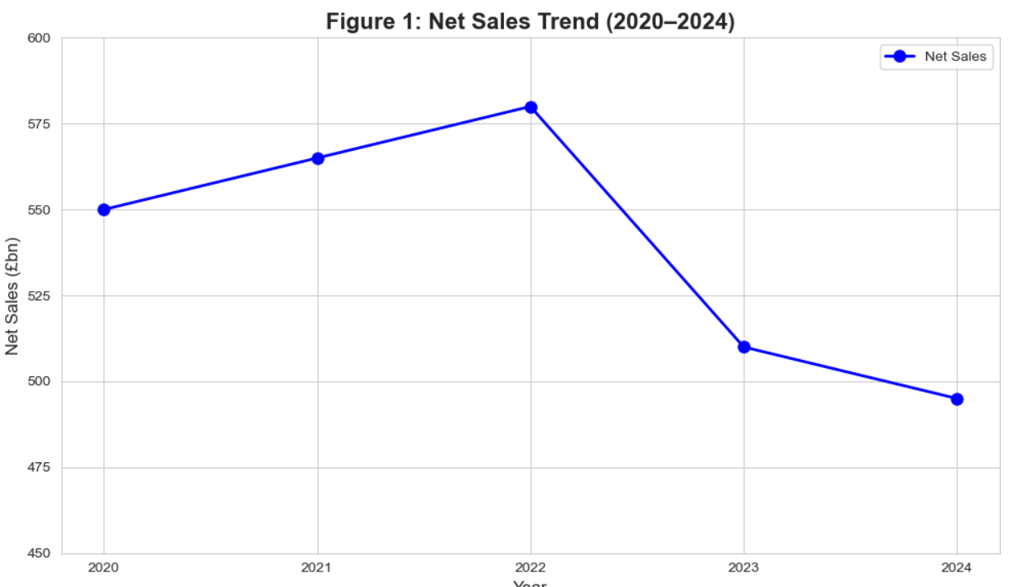
Figure 1: Net Sales Trend (2020–2024)
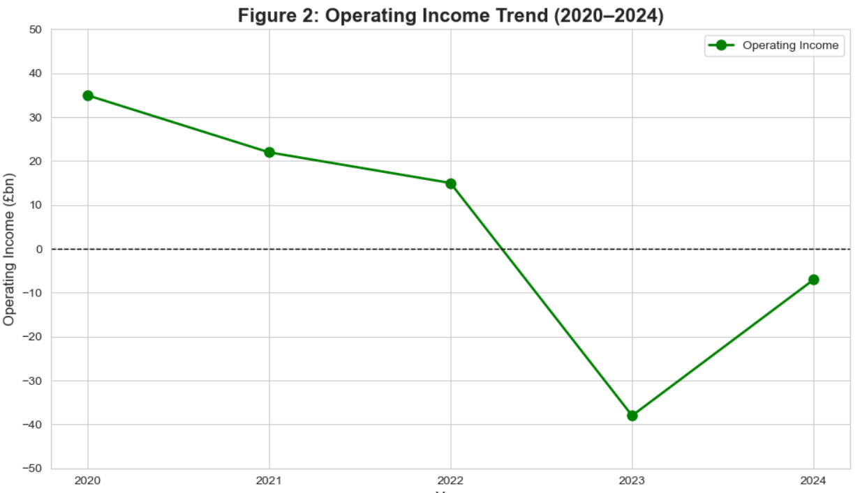
Figure 2: Operating Income Trend
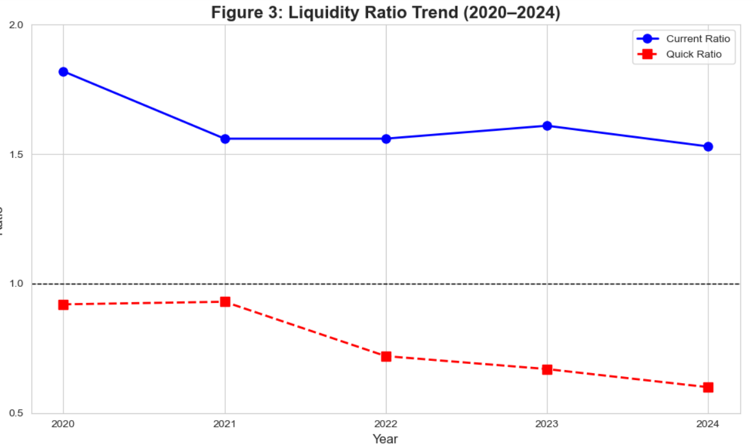
Figure 3: Liquidity Ratio Trend
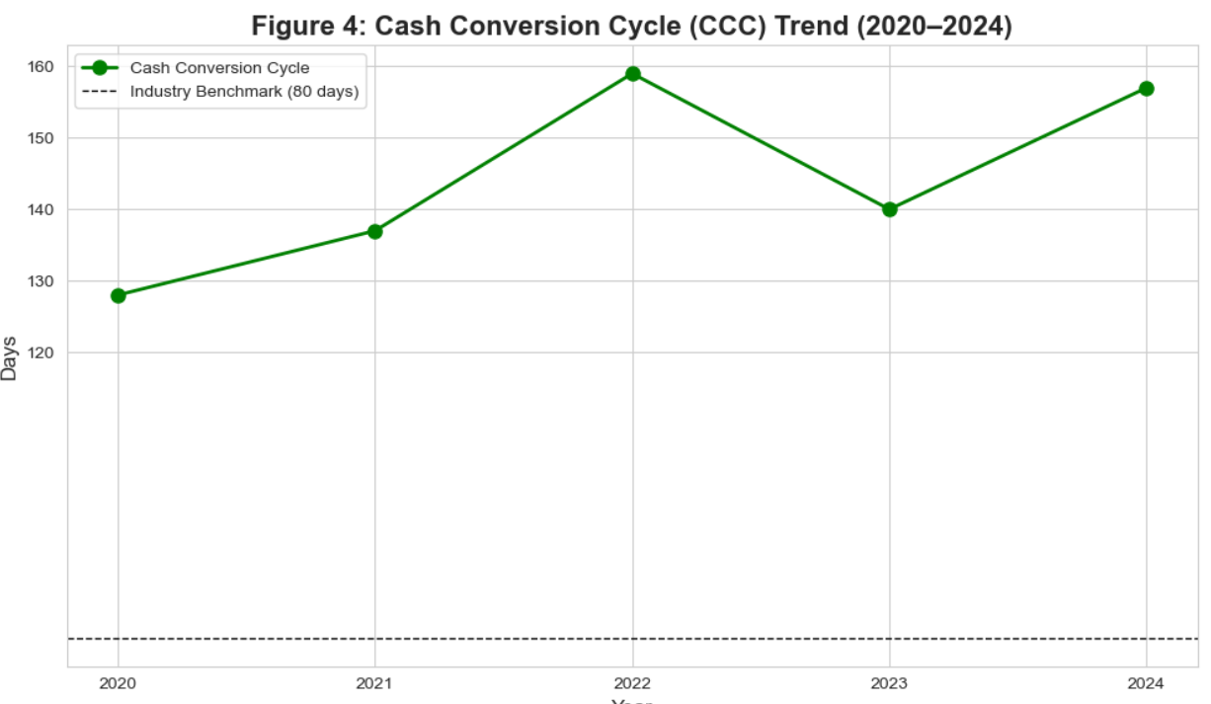
Figure 4: CCC Trend

