UNIVERSITY OF WALES:  TRINITY SAINT DAVID |  |  | PRIFYSGOL CYMRU:  Y DRINDOD DEWI SANT
LOCATION: LAMPETER |  | LLEOLIAD: LLAMBED
LEVEL 6 |  | LEFEL 6
EXAMINATION PERIOD |  | CYFNOD ARHOLIADAU
January 2016 |  | Ionawr 2016

CLAH6007
West meets East:
At the Borders of the Oikoumene and Beyond

TIME: 2 HOURS
answer Two OUT OF SIX QUESTIONS IN section A

answer ONE out of FOUR QUESTIONs in section B

Candidates should ensure that they avoid repetition of material in their answers to different sections, and between their answers and their coursework essays.

SECTION A (50 MARKS)

ANSWER TWO OUT OF SIX QUESTIONS IN SECTION A

Analyse the context and content of two of the following six passages/images:

1. “…it has fallen to our lot, however, to obtain a still more accurate knowledge of these people; for during the reign of the Emperor Claudius, an embassy came from even this distant island to Rome. The circumstances under which this took place were as follow: Annius Plocamus had farmed from the treasury the revenues arising from the Red Sea. A certain freedman of his, while sailing around Arabia, was carried away by a gale from the north beyond the coast of Carmania. In the course of fifteen days he had drifted to Hippuros, a port of Taprobane, where he was most kindly and hospitably received by the king; and having, after a study of six months, become well acquainted with the language, was enabled to answer all his enquiries relative to the Romans and their emperor. But of all that he heard, the king was more particularly struck with surprise at our rigid notions of justice, on ascertaining that among the money found on the captive, the denarii were all of equal weight, although the different figures on them plainly showed that they had been struck in the reigns of several emperors. By this circumstance in particular, the king was prompted to form an alliance with the Romans, and accordingly sent to Rome an embassy, consisting of four persons, the chief of whom was Rachias.” – Pliny HN 6.24.84-85 – Trans. from Bostock (1885) – adapted.

2. “So Eudoxus sailed away with presents; and he returned with a cargo of perfumes and precious stones (some of which the rivers bring down with the sands, while others are fortified by digging, being solidified from a liquid state, just as our crystals are). But Eudoxus was wholly deceived in his expectations, for Euergetes took from him his entire cargo. And after the death of Euergetes, his wife, Cleopatra, succeeded him on the throne; and so Eudoxus was again sent out, by her also, and this time with a larger outfit. But on his return voyage he was driven out of his course by the winds to the south of Ethiopia, and being driven to certain places he conciliated the people by sharing with them bread, wine, and dried figs (for they had no share of such things), and in return therefor he received a supply of fresh water and the guidance of pilots, and he also made a list of some of their words. And he found an end of a wooden prow that had come from a wrecked ship and had a horse carved on it; and when he learned that this piece of wreckage belonged to some voyagers who had been sailing from the west, he took it with him when he turned back upon his homeward voyage. And when he arrived safely in Egypt, inasmuch as Cleopatra no longer reigned but her son in her stead, he was again deprived of everything, for it was discovered that he had stolen much property.” – Strabo Geography 2.3.4. (Trans. from H. L. Jones 1917).

3. “He captured ten of the Gymnosophists who had done most to get Sabbas to revolt, and had made the most trouble for the Macedonians. These philosophers were reputed to be clever and concise in answering questions, and Alexander therefore put difficult questions to them, declaring that he would put to death him who first made an incorrect answer, and then the rest, in an order determined in like manner; and he commanded one of them, the oldest, to be the judge in the contest…
… These philosophers, then, he dismissed with gifts; but to those who were in the highest repute and lived quietly by themselves he sent Onesicritus, asking them to pay him a visit. Now, Onesicritus was a philosopher of the school of Diogenes the Cynic. And he tells us that Calanus very harshly and insolently bade him strip off his tunic and listen naked to what he had to say, otherwise he would not converse with him, not even if he came from Zeus…” – Plutarch Alexander 64.1, 65.1-2. (trans. from B. Perrin 1919).

4. 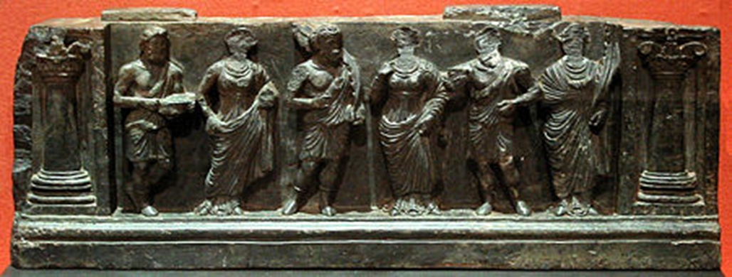

5.
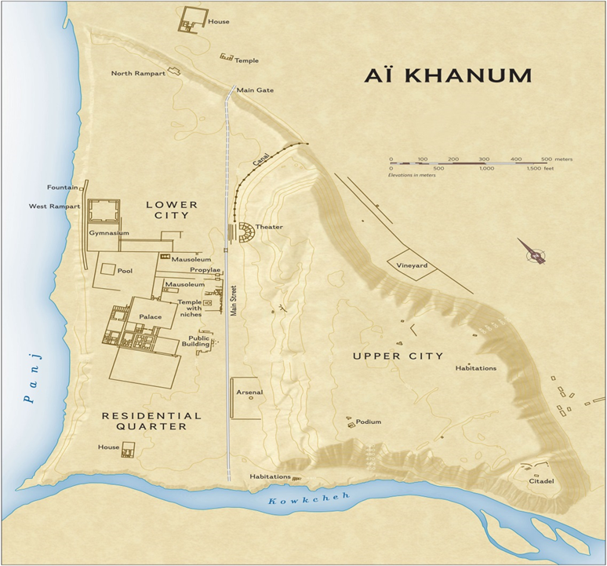

6.
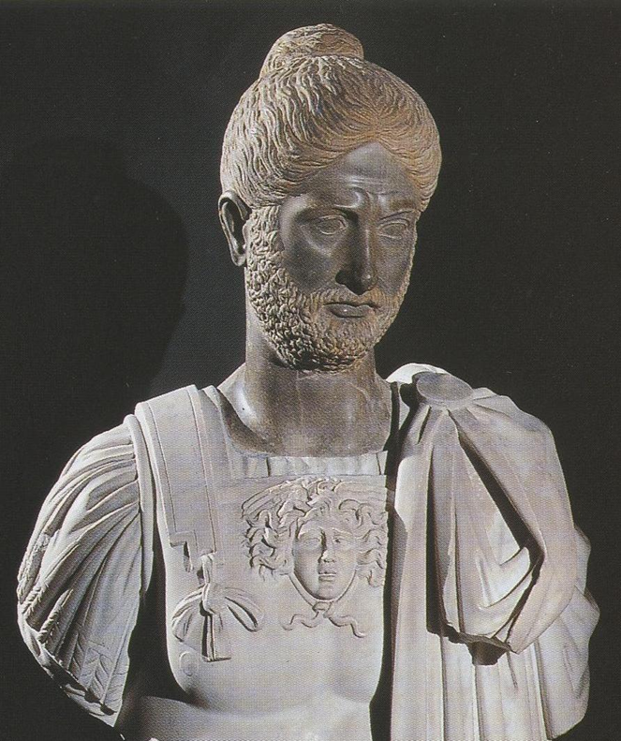

SECTION B (50 MARKS)

answer ONE out of FOUR QUESTIONs in section B

Write an essay on one of the following titles. You must ensure that you do not choose questions which will involve your repeating a significant amount of material from any of your answers in Section A.

1. To what extant does the evidence allow for a detailed reconstruction of the development of the Graeco-Bactrian and Indo-Greek kingdoms?

2. Compare and contrast Graeco-Roman ideas about the Seres with Chinese ideas about the kingdom of Da Qin.

3. Does the currently available evidence substantiate the idea that Roman diaspora existed in India?

4. Critically discuss the portrayal of Utopian societies in Greek literature with specific reference to Iambulos’ Island of the Sun and Euhemeros’ Island of Panchaea.

